CMSC 495
User Guide
Breakout Game in C++
Team Members:
- Ethan Wasniak
- Brendan Laird
- Steven Dickinson
- Kenise Balton,
- Francini Clemmons
Course Deliverable: User Guide
Project Context: Built from the approved Project Plan and Theory/Design documents

Version / Date | Version 2.0, April 17, 2026
Repository / Branch | https://github.com/blaird96/BreakoutGame  Branch: main
Build Environment | C++20 with SFML 3.0.2. The final build can be launched from the repository root through the shared PowerShell toolchain resolver (`scripts/Resolve-Toolchain.ps1`) or through the CMake preset workflow (`CMakeLists.txt`, `CMakePresets.json`). The repository documents both local script-based builds and CMake/CTest-based validation for Windows GCC + SFML environments.  Both script-based and CMake-based workflows were validated to ensure consistent build behavior across supported development environments.

1. Introduction
The Breakout Game is a desktop application developed in C++ using the SFML 3.0.2 library. The objective of the game is to control a paddle to keep a ball in play while destroying all bricks displayed on the screen.
Players lose a life each time the ball falls below the paddle. The game ends when either all bricks are cleared (win condition) or all lives are lost (game over).
This guide provides step-by-step instructions for installing, building, running, and playing the game.

2. System Requirements
- Operating system: Windows 10/11, Linux, or macOS
- C++ compiler with C++20 support (GCC or Clang)
- CMake 3.23+ (recommended for cross-platform builds)
- SFML 3.0.2 installed on your system
- Keyboard (required for gameplay)
Recommended Windows environment:
- MSYS2 UCRT64 or another GCC toolchain compatible with SFML 3.0.2
- PowerShell for running the included build and launch scripts.

Optional asset support:
- A compatible font file for the full HUD and menu display.
- If no project font is present, the application falls back to common system fonts when available.
Notes:
- The projects current CMake configuration uses C++20.
- On Windows, the easiest workflow is to build from the repository root and launch the game with the included PowerShell script so the required runtime libraries are available.

3. Installation and Setup

Step 1: Install required tools
Install these first:
- Git
- C++20 compiler (GCC or Clang)
- CMake 3.23 or newer
- SFML 3.0.2
Use the official SFML 3.0.2 download page: https://www.sfml-dev.org/download/sfml/3.0.2/
Note: SFML installation steps vary by operating system. Refer to the official SFML documentation for platform-specific instructions. Ensure that both the development files (include/lib) and runtime libraries are properly installed.

Step 2: Get the project files
Clone the repository and move into the project folder:
git clone <repository-url>
cd BreakoutGame

Step 3: Point the project to SFML
Set BREAKOUT_SFML_ROOT to your SFML install folder (the folder that contains include, lib, and bin).
Examples:
Windows (PowerShell):
$env:BREAKOUT_SFML_ROOT="C:\path\to\SFML-3.0.2"
Linux/macOS (bash/zsh):
export BREAKOUT_SFML_ROOT=/path/to/SFML-3.0.2

Step 4: Configure and build
From the project root:
cmake --preset default-debug
cmake --build --preset default-debug

If presets are not available in your environment, use:
cmake -S . -B build
cmake --build build

4. Running the Application
After building, run the generated executable.
The compiled executable will typically be in the build directory (or the directory specified during configuration).
Example:
./build/BreakoutGame
Common options:
- Use your IDE run configuration
- Run the executable directly from the build output directory
- On Windows, you can also use the project script:
.\scripts\run-game.ps1

If the app fails to start with SFML DLL/shared-library errors, make sure SFML runtime libraries are discoverable (for example, SFML bin on PATH on Windows, or equivalent library path setup on Linux/macOS).

5. What to Expect
When the application starts, the main menu will be displayed. From here, you can:
- Start a new game
- Access the settings screen
- Exit the application
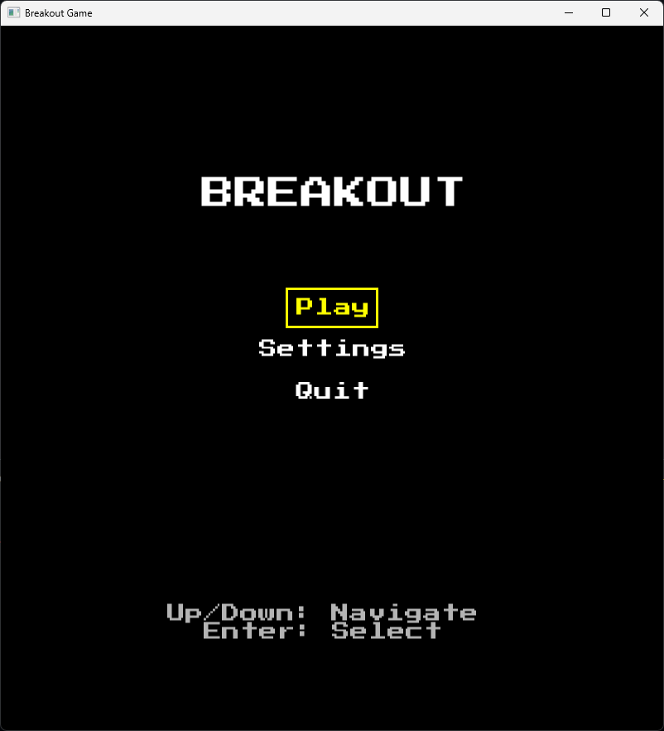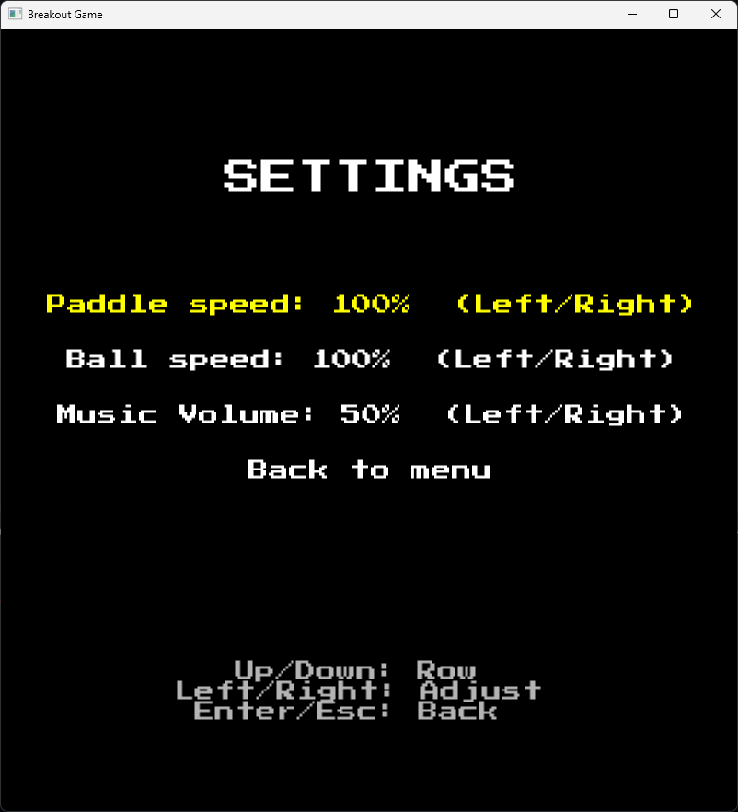
During gameplay:
- The paddle appears at the bottom of the screen
- The ball launches into play and interacts with walls, the paddle, and bricks
- Score and remaining lives are displayed on screen
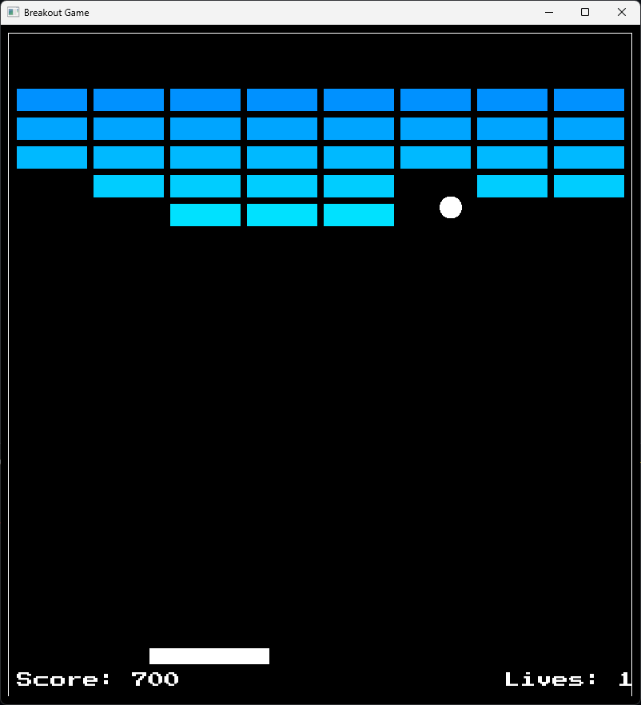
At the end of a round:
- A win screen appears if all bricks are cleared
- A game-over screen appears if all lives are lost
From either state, you can restart or return to the main menu.
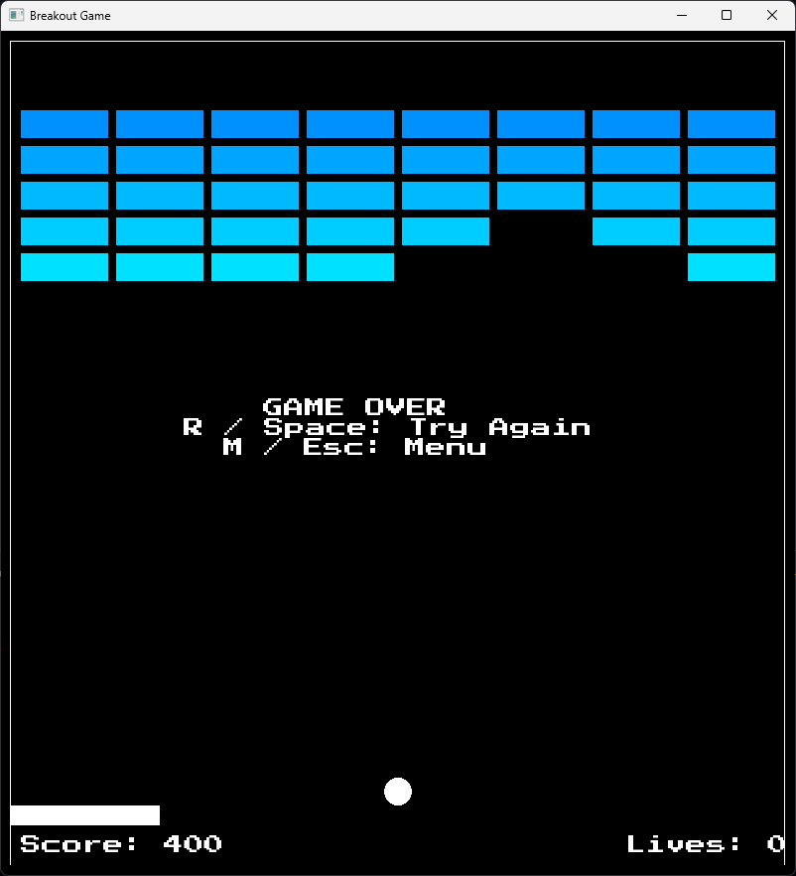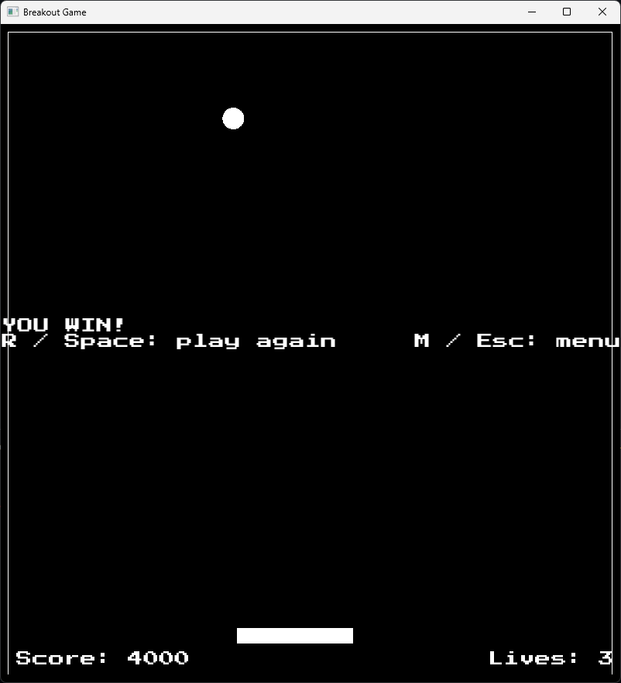

6. Controls

Main menu
- Up / Down: move menu selection
- Enter: confirm selection

Settings screen
- Up / Down: select option
- Left / Right: adjust selected value (if applicable)
- Enter on "Back", Esc, or Backspace: return to main menu

During gameplay
- Left Arrow or A: move paddle left
- Right Arrow or D: move paddle right
- Esc: return to menu during active play

After win or game over
- R or Space: restart a new round
- M or Esc: return to main menu

7. Gameplay Overview
- Start from the main menu, then choose Play.
- Move the paddle to keep the ball from falling.
- Each brick hit removes a brick and increases score.
- If the ball falls below the paddle, you lose one life and the ball resets.
- Win condition: all bricks are destroyed.
- Loss condition: lives reach zero.
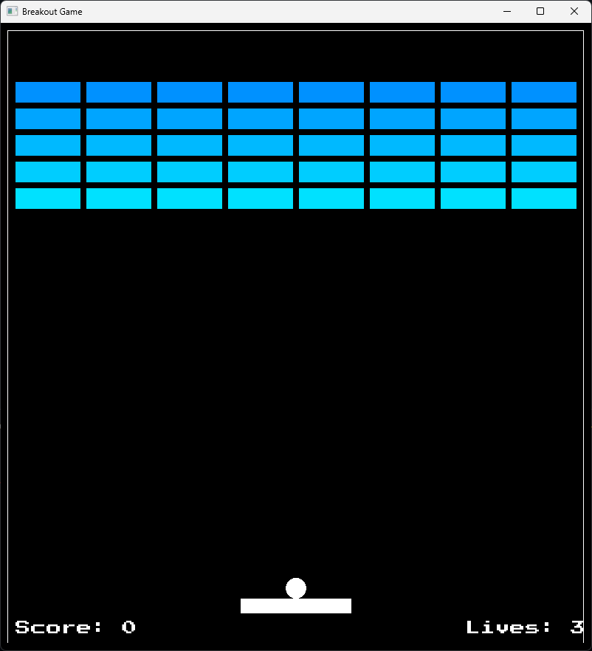

8. Game Features
The current implementation includes the following features:
- Main menu with Play, Settings, and Quit options
- Settings screen with adjustable gameplay parameters (such as paddle speed and ball speed)
- Keyboard-based paddle control (Arrow keys or WASD)
- Ball physics with wall, paddle, and brick collisions
- Brick grid layout (5 rows × 8 columns) with active/inactive state tracking
- Score tracking based on brick collisions
- Lives system with reset on ball loss
- Win condition when all bricks are cleared
- Game-over condition when all lives are lost
- Restart flow and return-to-menu functionality after game completion
Some features are implemented at a functional level, but may still receive additional refinement or polish.

9. Troubleshooting
- Build fails with SFML header errors
SFML include/library paths are not configured correctly. Verify SFML 3.0.2 is installed and BREAKOUT_SFML_ROOT points to the correct folder.
- Program starts but immediately closes or shows missing library errors
Runtime SFML libraries are not found. Ensure SFML runtime files are available to the executable (for example, SFML bin on PATH).
- Keyboard input does not respond
Click the game window first so it has focus.
- No text appears in menus or HUD
A supported font may not be available. The game can fall back to limited title-bar instructions.

10. Known Limitations
- The application is distributed as source code and requires local compilation.
- Setup may require manual configuration of compiler and SFML library paths depending on the operating system.
- Audio features (music and sound effects) are not fully implemented.
- Collision behavior is functional but may not handle all edge cases (e.g., high-speed or multi-surface interactions).
- The game currently includes a single level with no progression system.
- Some UI and visual feedback elements are implemented at a basic level and may be further refined.

