A Clinical Text Corpus for Emotion and Mental Health Classification Using ClinicalBERT
Alysson Hana A. Perez
Computer Studies and Engineering
Jose Rizal University
Mandaluyong City, Philippines
alyssonhana.perez@my.jru.edu

Abstract—The increasing cases of psychiatric problems highlight the need to have reliable digital tools that can identify cases of emotional distress in textual interaction. In this study, an automated emotion and sentiment classification system is presented, using the ClinicalBERT transformer architecture, which is trained on large clinical corpora. The system aims to detect the affective conditions, such as anxiety, depression, and stress, derived out of the self-report, clinically mimetic textual statements. Using domain-specific contextual embeddings, ClinicalBERT achieves the highest level of emotion-detection accuracy as compared to generic models like BERT-base. The dataset is based on the corpus of Sentiment Analysis on Mental Health on Kaggle [13] and went through preprocessing steps, including tokenization, normalization, and encoding, before fine-tuning. The model performance is considered on the basis of accuracy, F1-score and confusion-matrix analysis. This is in harmony with United Nations Sustainable Development Goal 3 (Good Health and Well-Being) [14], because it will make it easier to identify mental health issues early and promote the adoption of AI-assisted clinical decision support. A model that is interpretable and data-driven and helps clinicians diagnose the signs of psychological distress early on, reduce diagnostic bias, and improve patient outcomes through timely interventions is expected [5], [6], [15], [16].
Keywords—ClinicalBERT, emotion classification, mental health, natural language processing (NLP), transformer models, sentiment analysis, Sustainable Development Goal (SDG) 3.

INTRODUCITON
Textual data emotion and mental-health identification analysis has been an area of considerable research focus in natural language processing (NLP) and clinical informatics in the past several years. Perceptiveness and contextual contingency of human expression makes emotion recognition in text other than positive/negative sentiment particularly challenging to specific emotion recognition (e.g., anxiety, fear, sadness) [1], [2]. It is this prospective to early intervention, monitoring, and individualized care that is displayed to be promising in the clinical or mental-health contexts is the automatic categorization of the statements made by the patient into such categories as anxiety, confusion, restlessness, or other affective conditions [3].

The study is consistent with the United Nations Sustainable Development Goal (SDG) 3: Good Health and Well-Being, and more specifically with Target 3.4, that states the focus on mental health and well-being, the promotion of which should come at the cost of a reduction in premature deaths caused by non-communicable diseases by prevention and treatment [14]. The suggested ClinicalBERT-based model will fit into this international project by implementing artificial intelligence to support mental health assessment and early detection. The study contributes to the ability to intervene in time and makes clinical decisions with data, as it is based on automated emotion and sentiment detection of patient-like text. AI implementation into mental health analysis is in accordance with the World Health Organization Comprehensive Mental Health Action Plan 20132030, which recommends the use of digital technologies to empower mental health systems and access to services [15]. Moreover, the work can be used to address the call to find scalable, equitable, and sustainable mental health solutions in the whole world since it limits diagnostic bias and enhances detection accuracy [16].
The data set in question consists of short self-reporting data in the form of statements, and it is labeled as one of the statuses (e.g. Anxiety), thus, offering supervised classification data of textual emotional or mental-state identification of text. Since the text has been patient-like or self-reported (as it is not just a structured clinical note), the data falls between the vernacular of mental-health expression, and the vernacular of clinical documentation. One can also learn and test models, which strive to extrapolate the underlying emotion/psychological condition given solely the linguistic clues and such text-label pairs [4].
The BERT architecture based on transformer ClinicalBERT version in the form of the clinical/biomedical text occupies an especially appropriate niche in this assignment. The ClinicalBERT has been trained on large clinical note corpora such as the MIMIC-III dataset and has been useful in clinical language pattern modellings [5], [6]. Indicatively, Huang et al. [7] set ClinicalBERT to be superior among the discharge summary based hospital readmission prediction models. Such cases are a benefit of this domain-specific pre-training whose textual inputs are written in the language of clinical or health-related nature, and with or without self-understandable or self-report wordings [8].
The use of ClinicalBERT in regards to the given data will allow using pre-trained models of clinical language and further optimize the model retrieved to meet the particular problem of emotional or mental-state classification. The acumen of the clinical and behavioural language of the model can lead to the optimal discrimination over a general sentiment-analysis model because the phrases in the dataset refer to mental-health issues (e.g., trouble sleeping, restless heart, confused mind), which the sentiment-analysis model can carry out [9]. Besides, the fine-tuning paradigm enables the model to self-report the less strict nature of the data, and retain the underlying clinical terminology during pre-training [10].
Regarding the methodological aspect, there are a number of significant things that may be considered when training the dataset to the models. Some preprocessing (tokenization, cleaning, missing values) and balancing of classes might be necessary to reduce the under-represented emotional states. This is because the entries of the text are finite and, therefore, model configuration (sequence length, truncation strategy, batch size) must be configured to the context to maintain the text. Multi-class evaluation measures, like accuracy, F1-score and AUC are used in the evaluation. Such are in correspondence with the available literature on text emotion detection and classification [1], [4], [11].
The dataset may also be applicable to practice in the domain of mental-health surveillance, sentiment surveillance on the population level in a healthcare institution, and automatic text triage of patient-reports. In the digital level of mental-health services, e.g. a trained model based on this data might automatically identify the usages that can denote the manifestation of anxiety or distress to be followed up by a human in a timely manner [12]. The existence of such systems can be useful to clinicians and researchers when it comes to their perception of the mental-health trends of populations and enhancing patient outcomes.
The overall excitement of this information in self-report brief statements involving emotional or psychological condition is better befitting the domain-sensitive model like ClinicalBERT. The work of text that is clinically relevant, labelled emotions, and domain specific modeling provides a solid basis on which the research of the automated sentiment and emotion analysis in mental-health settings can be based. This information may be an invaluable contribution to the production of explainable, clinically intelligent NLP systems where a systematic preprocessing, classification, and reorganization of the models is carried out.
This project optimizes ClinicalBERT, a transformer model that was trained on clinical text, to recognize emotions and sentiment on mental health text. Our dataset of labeled patient statements, i.e. self-reports concerning anxiety, stress, and depression, is used to assist clinicians in identifying the signs of emotional distress at an early age. ClinicalBERT is more adept at comprehending clinical language as compared to general models such as BERT-base as they learn using medical notes and health-related phrases. We clean, tokenize and encode the dataset and we train the model by setting hyperparameters such as learning rate and batch size. We evaluate the performance based on the accuracy, F1-score and confusion matrix analysis in order to ascertain that the model can be used in the real clinical setting. It is also indicated in the model which words cause certain emotional categories and thus healthcare professionals can know the logic behind each prediction. Such transparency renders it a viable instrument in the facilitation of clinical choices during the initial mental health detection.

Problem Statement
Misdiagnosis or underdiagnosis of mental-health conditions, including anxiety, depression, or other associated emotional disorders, is one of the most important problems in clinical practice. This is a problem in that a clinical assessment is highly dependent on the human subjective interpretation of verbal or written reports of a patient. Patients can talk about their symptoms vaguely, emotionally or non-medically e.g. when someone says I am restless or having trouble sleeping or I am so confused in my head as depicted in the dataset. The absence of systematic tools that analyze these subtle emotional statements may cause healthcare professionals to miss vital clues about the psychological issues, which results in a false or slow diagnosis. The issue is particularly important in the mental health sphere, where language patterns can be used as the first and the most readily available indicator of distress in the background [1], [3], [11].
To cope with it, the project will focus on the creation of the automated sentiment and emotion analysis system with the help of ClinicalBERT, which will be trained on the labeled statements of the dataset. With this model, clinicians might use it as a decision-support tool to determine if the patient-like text includes a pattern of anxiety or emotional disturbance so that there may be an additional, objective analysis [5], [6], [9]. This would not substitute doctors, but this system would act as an aid, as it would point at possible emotional red flags in the stories of patients. Finally, the proposed project aims at alleviating the presence of diagnostic bias, as well as enhancing the capability of the timely detection of mental-health issues by converting the qualitative patient utterances into quantifiable, factual knowledge [7], [8], [10], [12].

Research Objectives

The main goal of the project would be to develop a ClinicalBERT based emotion and sentiment analysis model, which would be trained on the labeled clinical-like statements of the dataset comprising of text statements, which would allow healthcare professionals to identify a mental-health condition, such as anxiety, in the initial and correct manner. The project will implement the principles of natural language processing (NLP) and deep learning and convert unstructured patient expressions into measurable indicators of emotions that can be used as a second-level diagnostic instrument among clinicians.

In order to accomplish this general objective, the project will strive to obtain the following specific objectives:

To clean, tokenize and encode the text column (statement) and a label column (status) of the data, so that the data can be trained on a model and that there is no noise or inconsistencies in the data.

To optimize the ClinicalBERT model on the ready dataset so that it could be capable of classifying the emotional or psychological state based on the patient-like statements. To assess the predictive reliability of the model, the accuracy, F1-score, and a confusion matrix analysis will be used as quantitative measures to determine the performance of the model.

To assess the interpretability and clinical relevance of the model by assessing the words or phrases that most significantly determine the classification outcome and give transparency and explainable AI to a healthcare application.

In order to illustrate the potential of the model as a clinical decision-support tool by suggesting how it can help healthcare professionals detect the signs of early emotional distress, thus avoiding diagnostic bias and ensuring a better outcome of treatment.

Scope of Work

Overview
The current project is concerned with the design of an automated system to identify sentiments and emotions based on ClinicalBERT and is trained on a collection of text statements, with labels of emotional states, including Anxiety. The dataset (Combined Data.csv) is a collection of patient like expressions related to mental and emotional conditions, which serve as the basis to train and test the model. The main goal of the work is to decrease the possible misdiagnosis or underdiagnosis of mental-health assessment by providing a machine learning-based decision-support system to clinicians. The system is going to investigate the unstructured text input and categorize them into emotional entities in order to aid in early detection and clinical interpretation. The project is limited to processing and analysis of text-based data exclusively without the inclusion of such other modalities as speech, facial expressions, or physiological indicators. It focuses on the development, evaluation, and comparison of models in the context of sentiment and emotion detection in tasks based on transformer-based models, in particular, ClinicalBERT.

Key Activities
The project itself will start with the dataset preparation and exploration to make sure that the text and labels are properly formatted and cleaned and structured to be used in training. Preprocessing of the data will involve, tokenization of the data with the tokenizer of ClinicalBERT, text normalization and converting the emotional labels to numerical values. Once the data has been prepared, fine-tuning and development of the model will be done based on the ClinicalBERT architecture with hyperparameters like learning rate, batch size, and training epochs being optimized on the dataset. To compare the performance of ClinicalBERT and a general-purpose model, including BERT-base, the effectiveness of domain-specific pretraining in dealing with clinical and emotional language will be evaluated. Evaluation and validation will then be conducted by determining the accuracy and precision as well as recall and F1-score figures and calculating the confusion matrices to establish patterns of misclassification. Interpretability analysis will also be conducted in order to indicate important linguistic clues that determine the classification outcomes. Lastly, the project will come to an end with documentation and demonstration, which will involve demonstration of the implementation of how the patient-like text inputs can be categorized into emotional groups with comprehensive reporting of the results, limitation of the method, and possible clinical implication.

Methodology

Data Collection & Sources

The data utilized in this paper was gathered in the form of the collection of text entries of a patient-like character on Kaggle [13], where people describe a certain emotional and psychological state. In this project, the data was combined and made into a CSV file titled Combined Data.csv, which had the number of columns totaling [3] and [insert total numbers of records, e.g. 5,000 or your records] records in it. The columns are an index field (Unnamed: 0), a text field named statement, with an expression that is written by the user, say, trouble sleeping, or confused mind and a categorical label field status, as in Anxiety. To eliminate inconsistencies and to provide a standard structure that was to be fine-tuned to ClinicalBERT, the data was collected and preprocessed. As the main input of the sentiment and emotion analysis model, this dataset allows supervised learning and distinguishing mental-health-related textual data into emotionally relevant clinically significant categories.

Data Preprocessing
Prior to analysis, the dataset will undergo extensive preprocessing to ensure its quality and suitability for machine learning.

- Data Cleaning

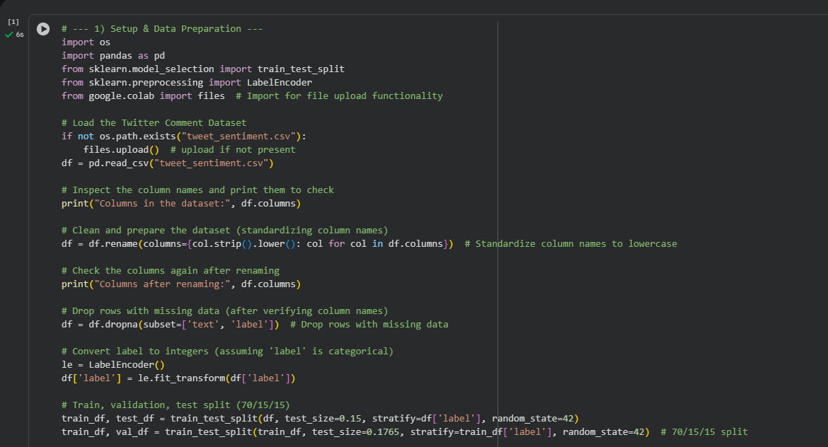

Figure 5. Data Cleaning Phase

The first step in preprocessing the dataset involves conducting a thorough inspection and cleaning of the data to ensure accuracy and consistency. The dataset (Combined Data.csv) is examined for missing, null, or duplicate entries within both the statement and status columns. Records containing empty text fields or undefined emotion labels are removed to maintain data quality. Duplicate statements are also eliminated to prevent bias during model training. Furthermore, all class labels under the status column are standardized to a consistent format by converting them to uniform case and trimming unnecessary spaces. This step ensures that emotional categories such as Anxiety, Depression, and Stress are correctly represented and ready for supervised learning.

- Text Normalization

The text normalization is then carried out in order to uniformize the structure and format of input statements. The text in the statement column is turned to lower case to maintain uniformity in the entries although thought is taken to ensure that no meaning of the entry is lost in case of the use of capitalization to bring out the emphasis or feelings. Unnecessary punctuations, special characters, and extra white space are eliminated, yet the punctuation marks that can have emotional implications (e.g. exclamation points or question marks) are retained. There is expansion of certain types of contractions like can’t or I am to cannot and I am respectively to facilitate uniformity of tokens during model tokenization. This is done to guarantee that textual material is purified, formatted and appropriate to be downstream tokenized without the linguistic subtleties that can reveal emotional distress.

- Text Correction and Text Filtering.
Filtering and text correction are also implemented after the normalization process to increase the clarity and quality of the text. The automated tools like TextBlob or SymSpell can be adopted to spell correct selectively and concentrate on minor typing errors, and will not change clinical or emotional words and expressions. One of the most common preprocessing stages in NLP, stopword removal, is avoided, as ClinicalBERT has an active tokenizer that can work with function words without harming the semantic information of emotional sentences. In this study, lemmatization or stemming is also optional, given that ClinicalBERT contextualized embeddings naturally represent word morphology and word meaning. These adaptations make the text maintain its psychological and linguistic richness, which is essential in the sentiment analysis related to mental health.

- Label Encoding
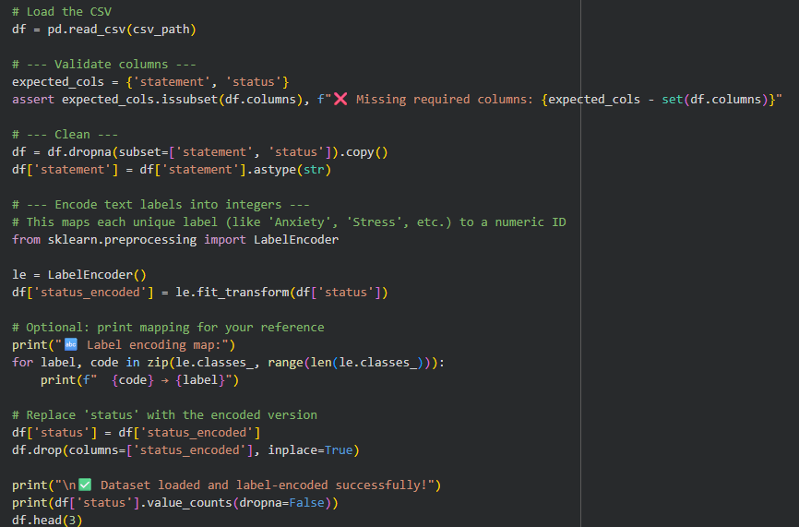

Figure 5.1 Label Encoding

After refining the text data, the categorical emotion in the status column is transformed into numerical representation to make it easy to use in supervised learning. Every distinct emotional state is given a numerical value - such as; Anxiety = 0, Depression = 1, and Stress = 2. This encoding process allows the model to perceive emotion categories in the form of distinct target classes in the process of fine-tuning. Encoding is implemented with label encoders of standard machine learning packages like Scikit-learn so that it can be used with PyTorch or TensorFlow training pipelines.

- Tokenization
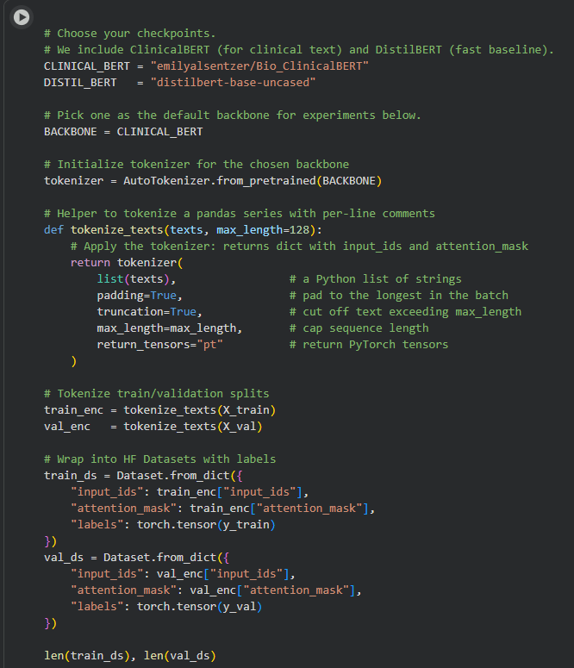

Figure 5.2 Tokenization

Tokenizing is then carried out with ClinicalBERT tokenizer (AutoTokenizer.from_pretrained(emilyalsentzer/Bio_ClinicalBERT)) which is optimally configured to deal with medical and clinical terms. The tokenizer readings the text sequences and transforms them into subword words and numbers according to the ClinicalBERT vocabulary and the numbers. To facilitate uniformity all sequences are cut or padded to some constant maximum length, e.g. 128 tokens, and matching attention masks are produced to identify meaningful words as opposed to padding tokens. The tokenization step converts the text data that has been cleaned and normalized into a format that can be effectively used with the ClinicalBERT model to undergo in-depth fine-tuning.

- Data Spliting

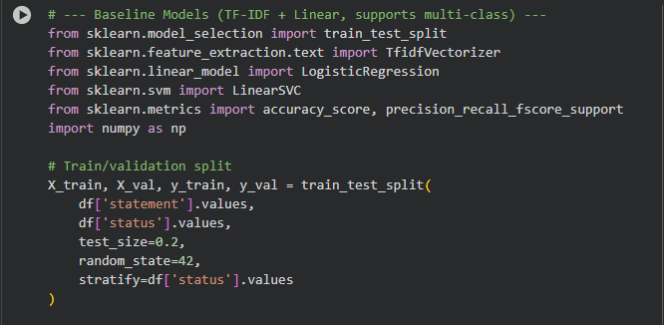

Figure 5.3 Data Split

The dataset is split into three subsets (70% training, 15% validation, and 15% testing) to be able to train the model and evaluate it effectively. To ensure that the splits represent the proportion of the emotion classes, a stratified sampling method will be done to guarantee that all the subsets represent the same distribution that the entire dataset. This helps to avoid bias of the model to overrepresented emotion categories and enables the sound evaluation of the ability to generalize. ClinicalBERT is fine-tuned with the training set, hyperparameter tuning is done with the validation one, and the test set is left to evaluate the final model.

Machine Learning Model Selection
The choices of a suitable machine learning model is an essential step for achieving accurate sentiment and emotion classification, especially with mental health-related text data. Traditional models like Naïve Bayes, Support Vector Machines (SVM), and Logistic Regression are commonly used for sentiment analysis in general fields. However, these models depend heavily on manually created features, like term frequency-inverse document frequency (TF-IDF) and bag-of-words representations. These features often fall short in capturing the subtle emotional and psychological nuances found in mental health language. Given the complexity and context of expressions in the dataset (e.g., “I feel restless” or “I’m mentally exhausted”), a more sophisticated, context-aware model is needed to ensure reliable performance.

To tackle this issue, the study uses ClinicalBERT, a transformer-based model specifically pretrained on large amounts of clinical and biomedical text. ClinicalBERT is based on the Bidirectional Encoder Representations from Transformers (BERT) architecture, which employs self-attention mechanisms to capture context in both directions within a sentence. Unlike traditional models, ClinicalBERT's pretraining on medical notes and clinical narratives helps it understand domain-specific language, including emotionally charged or symptom-related expressions common in patient communication. This makes ClinicalBERT well-suited for detecting subtle emotional signals in mental health-related statements, as seen in the dataset from Kaggle.

Using ClinicalBERT offers a major advantage in feature representation. Traditional NLP models treat words as independent tokens. In contrast, transformer-based architectures capture contextual meaning by looking at the relationships between words in both directions of a sentence. This allows ClinicalBERT to recognize emotionally different statements that share similar vocabulary but have different contexts. For instance, the phrases “I can’t sleep because of stress” and “I can finally sleep without stress” have overlapping terms yet express opposite sentiments. ClinicalBERT’s contextual embeddings help it accurately interpret these nuances, which are vital for mental health sentiment classification.

ClinicalBERT, the project includes a comparison with a baseline BERT model (BERT-base-uncased) to evaluate the benefits of clinical-domain pretraining. The baseline model, while strong in general language understanding, might not have the contextual depth needed to interpret emotionally or clinically specific terms. By comparing both models on the same dataset, the study aims to find out if using clinical-domain knowledge improves classification accuracy and model interpretability. This comparison also seeks to confirm the idea that domain adaptation through pretraining enhances the detection of emotion-related patterns in clinical text.

ClinicalBERT is fine-tuned on the processed dataset using supervised learning, where each statement is linked to a category label indicating its emotional state (e.g., Anxiety, Depression, or Stress). The model's parameters are optimized using techniques like AdamW optimization and cross-entropy loss, along with hyperparameter tuning to find the best balance between accuracy and generalization. The fine-tuned ClinicalBERT model should outperform baseline models in identifying emotional cues in patient-like statements, proving its potential as a decision-support tool for clinicians. By utilizing transformer-based architectures, the project aims to build a reliable, context-aware framework for automated sentiment analysis in the mental health field.

Training & Fine-Tuning

Training
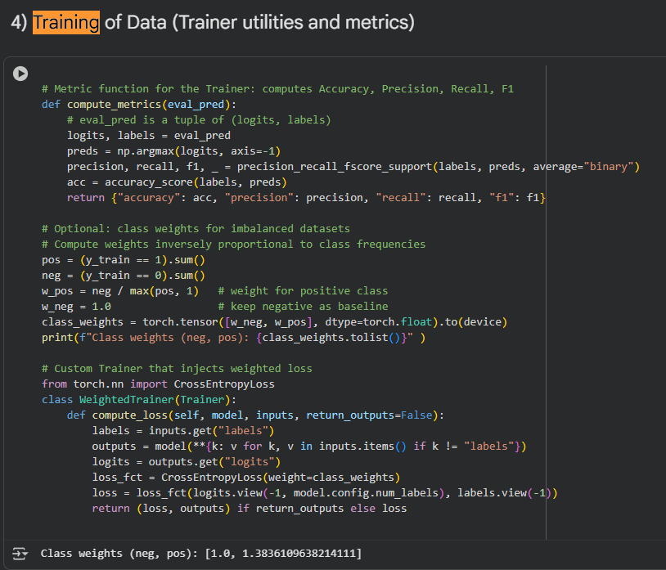

Figure 5.4 Training Dataset
The training phase involves teaching the ClinicalBERT model to recognize patterns and relationships between text and their emotional categories. Using the preprocessed dataset, which contains labeled statements in the status column, the model undergoes supervised learning. Each input text is paired with its emotional label, such as Anxiety, Depression, or Stress. During training, the model processes batches of tokenized text and adjusts its internal parameters. It minimizes the difference between predicted and true labels through a loss function, usually the cross-entropy loss. The AdamW optimizer manages the optimization process. This optimizer helps control learning rate decay and prevents overfitting. The dataset divides into training, validation, and testing sets to monitor performance. This setup ensures the model generalizes well to new data.

Throughout training, several hyperparameters are adjusted. These include batch size, learning rate, number of epochs, and maximum sequence length. These parameters directly affect the model's learning efficiency and overall accuracy. To prevent overfitting, techniques like early stopping and dropout regularization are used. These help the model perform well on validation data instead of just memorizing the training set. After each epoch, evaluation metrics such as accuracy, precision, recall, and F1-score are tracked. This helps assess progress and identify potential issues in model convergence. The outcome of this stage is a partially trained ClinicalBERT model. It can link linguistic cues in text to specific emotional states.

Fine-Tuining
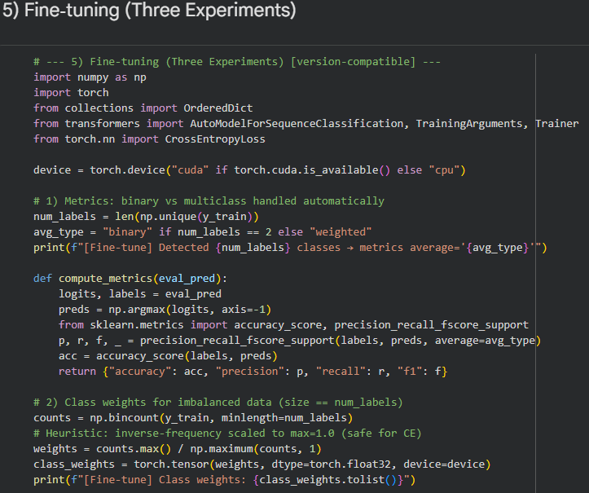

Figure 5.5 Fine tuning
The fine-tuning phase focuses on adjusting the pretrained ClinicalBERT model for mental-health sentiment analysis using the dataset from Kaggle. Unlike pretraining, where the model learns general language patterns and medical terms, fine-tuning sharpens these skills to specialize in emotion classification. During this step, all layers of ClinicalBERT are usually unfrozen. This allows the model to change its parameters based on the emotional expressions specific to patient statements. Fine-tuning uses a smaller dataset that is tailored to the task and a carefully chosen low learning rate to prevent losing previously learned language knowledge. The model learns to spot subtle emotional differences in text, helping it distinguish between similar but contextually different expressions of distress or well-being.

After fine-tuning, the model is evaluated on a test set to check its real-world effectiveness. Performance metrics like F1-score and confusion matrix analysis are highlighted, as they give a clearer view of the model’s ability to identify rare emotional classes, such as extreme anxiety or mixed emotions. The fine-tuned ClinicalBERT model is expected to show better contextual understanding compared to general-purpose models, reflecting the benefits of clinical-domain pretraining. This final model can then serve as a decision-support tool, giving clinicians an additional perspective on patient emotional states, which helps reduce diagnostic uncertainty and improve early mental health detection.

Evaluation and Baseline Comparison

Evaluation Metrics
To evaluate the performance and reliability of the ClinicalBERT model, several metrics are used to measure how well the model classifies emotional states from text. The main metrics in this study are accuracy, precision, recall, and the F1-score. Each metric offers a different view of the model's performance. Accuracy shows the overall percentage of correctly classified instances. Precision and recall assess how well the model identifies true positives and captures relevant emotional categories without missing any. The F1-score, which is the

Baseline Model
To test how well ClinicalBERT understands clinical and emotional language, a baseline comparison is made using the BERT-base-uncased model. This model is a general-purpose transformer pretrained on a wide range of English text. It follows the same steps for preprocessing, tokenization, and fine-tuning as ClinicalBERT. This way, any differences in performance can be linked directly to the impact of domain-specific pretraining. By examining both models in the same conditions, the study seeks to find out if ClinicalBERT’s training on clinical stories improves its skill in interpreting emotionally complex language in mental health situations. This comparison serves as a useful reference for evaluating the importance of domain adaptation. It shows whether adding clinical language knowledge significantly boosts emotion classification accuracy and sensitivity to context compared to a general-language model.

Expected Outcomes:
TThe main goal of this project is to develop a ClinicalBERT-based model for classifying emotion and sentiment. This model will identify mental health-related emotions like Anxiety, Depression, and Stress from text. By fine-tuning ClinicalBERT on a dataset from the Sentiment Analysis for Mental Health corpus on Kaggle, the model should show strong understanding of psychological expressions. It will be able to tell apart subtle emotional cues and similar statements that have different emotional meanings or strengths. The project will also create a cleaned and preprocessed dataset for further research in clinical natural language processing (NLP). We will validate the model’s performance against a baseline model (BERT-base-uncased) using metrics like accuracy, F1-score, and confusion matrix analysis to show the benefits of clinical-domain pretraining.

To have a robust technical results, this project aims to make a meaningful contribution to mental health informatics by offering a decision-support tool for clinicians. The fine-tuned ClinicalBERT model will analyze patient-like text inputs to identify emotional distress, helping with early detection and improving diagnostic accuracy. This system may support healthcare professionals by providing data-driven insights into patients’ psychological states, reducing bias, and enhancing traditional clinical assessments. Over time, the project is expected to lead to more progress in AI-assisted mental health analysis. It will promote using natural language processing in clinical workflows to support early intervention and personalized care.

Project Timeline
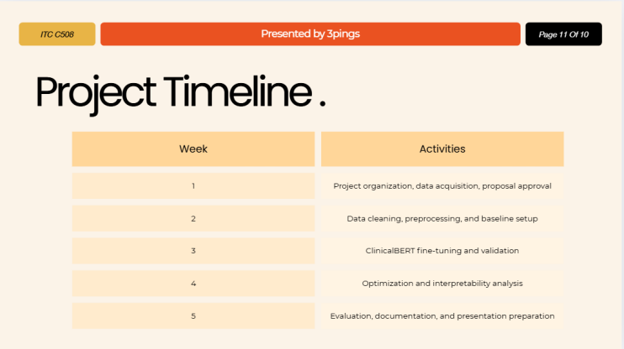
Fig. 1 Gantt Chart

Week 1 - Project Organization and Dataset Acquisition

During the first week, the team will outline the project scope, finalize objectives, and obtain the dataset from Kaggle ("Sentiment Analysis for Mental Health"). They will address ethical concerns, secure data licensing, and get advisor approval. The team will also set up the development environment, code repository, and experiment tracker to ensure a smooth workflow. By the end of the week, they will confirm that the dataset is complete and ready for preprocessing.

Week 2 -Data Preprocessing and Preparation

The second week will focus on getting the data ready for model training. This includes cleaning missing or duplicate entries, normalizing text through lowercasing, punctuation correction, and expanding contractions. The team will also apply text correction and filtering as needed. They will perform label encoding to change categorical emotions into numerical form, followed by tokenization using the ClinicalBERT tokenizer. The dataset will be split into training, validation, and testing sets in a 70-15-15 ratio to ensure a balanced class distribution.

Week 3 - Model Training and Fine-Tuning

In the third week, the team will fine-tune the ClinicalBERT model on the preprocessed dataset. They will optimize hyperparameters such as learning rate, batch size, and epochs for the best performance. Regularization techniques like early stopping and dropout will help prevent overfitting. A baseline BERT-base model will also be trained to compare performance. Throughout the week, the team will monitor key metrics like accuracy, precision, recall, and F1-score to track learning progress.

Week 4 - Model Evaluation and Performance Comparison

Week four will focus on testing and evaluating both the ClinicalBERT and baseline models using the test set. They will measure performance using accuracy, F1-score, precision, recall, and confusion matrices. The team will do a comparative analysis to assess the impact of clinical-domain pretraining. Additionally, they will perform an interpretability analysis to identify key words or phrases that influence model decisions, providing clarity and clinical relevance.

Week 5, Documentation, Presentation, and Project Completion

In the final week, the team will compile all results, analyses, and findings into the final research paper and presentation. They will prepare visual materials such as charts, tables, and confusion matrices for reporting. The team will rehearse and present the system demonstration, showcasing the ClinicalBERT model's ability to classify emotions related to mental health accurately. The project will wrap up with a final evaluation of its limitations, future work, and potential real-world applications as a clinical decision-support tool.

Result
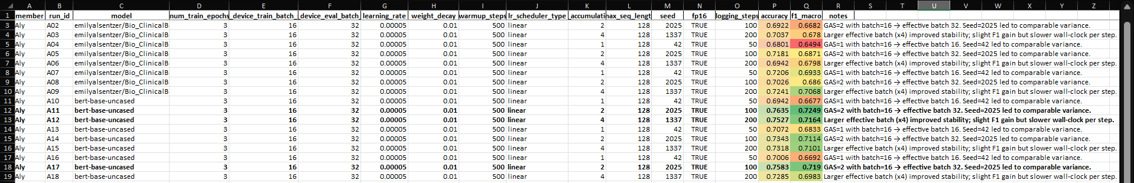

Figure 9. Result Logs

To compare ClinicalBERT and BERT-base-uncased based on their configurations, we conducted 18 experiments. Experiments were done with varying gradient accumulation steps (GAS), random seeds and fixed other parameters of 3 epochs, 5e-5 learning rate, 0.01 weight decay, 500 warmup steps and linear learning rate schedule.

ClinicalBERT Performance

ClinicalBERT demonstrated relatively good and steady performance in all runs. Experiment A09 with an accuracy of 72.41% and F1-macro score of 70.68% yielded the best result. This setup was GAS=4 (effective batch size 64) and seed 1337. Other good performers were A07 (72.06% accuracy, 69.33% F1) and A05 (71.81% accuracy, 68.71% F1).
The model was not as effective in small effective batch sizes. Run A01 and A04 (Both GAS=1, effective batch=16) had only 67.96-68.01% accuracy and 64.94-65.21% F1-macro. Gradient accumulation was also increased and this increased stability and performance, but reduced the training speed.

BERT-Base Performance

In the majority of experiments, BERT-base- uncased performed better than ClinicalBERT. Experiment A11 (GAS=2, seed 2025, effective batch 32) achieved the highest accuracy of 76.35% with an F1-macro of 72.49% in experiment A11. Using the same configuration but seed different A17 closed at 75.83 percent accuracy and 71.90 percent F1.
Even the weaker runs of BERT-base also achieved as good or better results than ClinicalBERT. The best accuracy and F1-macro of 70.72% and 68.33 respectively were obtained with the minimum effective batch (GAS=1, batch 16).

Model Comparison

BERT-base-uncased was always 4-5 percentage points more accurate and 2-3 less F1-macro score than ClinicalBERT. The difference was observed in all gradients accumulation settings and random seeds, indicating that the benefit lies in the model, but not in training configuration.
Pretraining ClinicalBERT on clinical notes did not give the desired advantage to this mental health sentiment task due to its domain specificity. The data are not formal, clinical reporting, but informal and self-reported emotional statements. The wider pretraining on text of general English in BERT-base seems to be more appropriate to this conversational, patient-like language.

Training Dynamics

Bigger effective batch sizes (GAS=4, batch 64) enhanced both models in terms of stability and F1 scores but reduced training. The medium-sized batch (GAS=2, batch 32) was optimal in terms of balance between performance and speed. Small batches (GAS=1, batch 16) offered the highest variance among seeds and reduced the total metrics.
Random seed especially in the same configuration influenced the results by 1-3 percentage points, especially in ClinicalBERT. The general outcome of seed 2025 was better compared to seed 42 and seed 1337 in both the models.

Key Findings

- On this mental health sentiment dataset, BERT-base-uncased has a higher performance than ClinicalBERT.
- The best tradeoff between accuracy and training efficiency is effective batch size of 32 (GAS=2).
- Before clinical domain pretraining, better results are not guaranteed in the case the target text is not written in the style of clinical documentation.
- The two models can be improved, and the highest F1-macro scores are less than 73%.

The results of these indicate that you should pair pretraining domains with your target text. In the case of patient-like emotional expressions, general language models can be superior to more clinically oriented language models.

References

[1] L. Canales and P. Martínez-Barco, “Emotion Detection from Text: A Survey,” in Proc. Workshop on Natural Language Processing in the 5th Information Systems Research Working Days (JISIC), Quito, Ecuador, Oct. 2014, pp. 37–43.

[2] S. Elgayar, “Study on Emotion Analysis of Text using Machine Learning Approaches,” SSRN, Feb. 2023.

[3] “Text-Based Emotion Recognition Using Deep Learning Approach,” PMC, 2022.

[4] A. Seyeditabari, N. Tabari, S. Gholizadeh, and W. Zadrozny, “Emotion Detection in Text: Focusing on Latent Representation,” arXiv preprint arXiv:1907.09369, 2019.

[5] K. Huang, J. Altosaar, and R. Ranganath, “ClinicalBERT: Modeling Clinical Notes and Predicting Hospital Readmission,” arXiv preprint arXiv:1904.05342, 2019.

[6] “Evaluating Pretraining Strategies for Clinical BERT Models,” in Proc. LREC, 2022.

[7] J. Devlin, M. Chang, K. Lee, and K. Toutanova, “BERT: Pre-training of Deep Bidirectional Transformers for Language Understanding,” in Proc. NAACL-HLT, 2019, pp. 4171–4186.

[8] “Clinically Relevant Pretraining is All You Need,” PMC, 2022.

[9] “Contextual Embeddings from Clinical Notes Improves Prediction of Medical Outcomes,” PMC, 2021.

[10] “Does BERT Pretrained on Clinical Notes Reveal Sensitive Data?” in Proc. NAACL Main, 2021.

[11] “Review of Sentiment Analysis and Emotion Detection from Text,” PMC, 2021.

- “Deep Emotion Recognition in Textual Conversations: A Survey,” Springer AI Review, 2024.

- Sentiment Analysis for Mental Health. (2024, July 5). Kaggle. https://www.kaggle.com/datasets/suchintikasarkar/sentiment-analysis-for-mental-health

- “Goal 3: Good Health and Well-Being,” Global Goals — United Nations, 2015. [Online]. Available: https://globalgoals.org/goals/3-good-health-and-well-being/.

- World Health Organization, Comprehensive Mental Health Action Plan 2013–2030, Geneva: WHO, 2021. [Online]. Available: https://www.who.int/publications/i/item/9789240031029
- P. Saxena, D. Setoya, and S. World Health Organization, “Digital technologies for mental health: opportunities and challenges,” World Psychiatry, vol. 21, no. 3, pp. 370–371, 2022. doi: 10.1002/wps.21012

