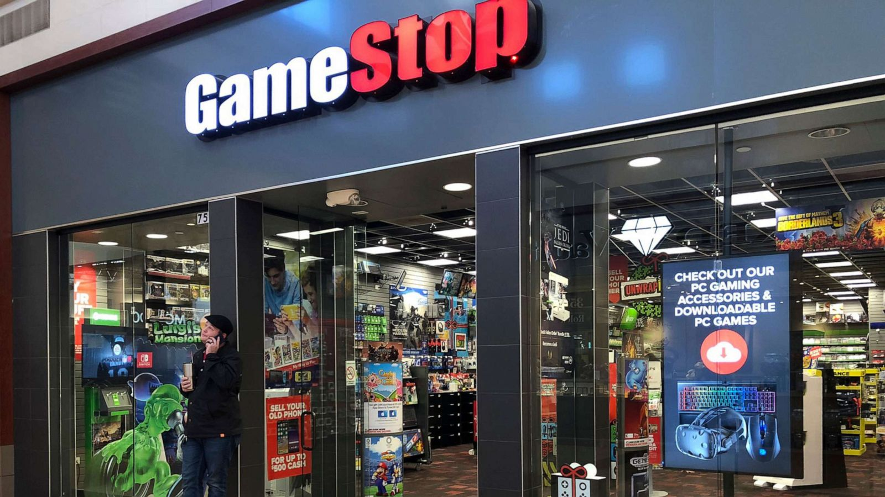

**GameStop Capitalism**

**Wall Street vs. The Reddit Rally[1]**

**PART I**

**Commentary**

**Tim Di Muzio**

**Associate Professor of International Relations and Political Economy**

**University of Wollongong**

[**tdimuzio@uow.edu.au**](mailto:tdimuzio@uow.edu.au)

**2021**

The phrase, ‘there’s a sucker born every minute’ is typically attributed to the American showman, P.T. Barnum and was made infamous since the mid-19th century by gamblers, hucksters and confidence artists (con men). On Wall Street, the ‘sucker’ is supposed to be the ‘dumb money’ retail traders who populate Main Street as evidenced by a long string of capitalist crashes, crises and public money bailouts to the big boys, not to mention the recurrent fraudsters in three piece suits ripping people off like Bernie Madoff. The latter is said to have ‘made-off’ with US$65 billion through a long-running Ponzi scheme – most of it the life savings of his victims (granted they were also wealthy).[2] So the saying goes: ‘There’s a sucker born every minute.’

But while some claim that there is nothing new under the sun, in an interesting turn of events over the last few day of January 2021, some hedge fund managers on Wall Street became the ‘unusual suckers’, losing billions of dollars from shorting GameStop (stock ticker GME).[3] For those not in the know, a hedge fund is an investment fund for the very wealthy (or the 1%) and its managers and analysts typically trade relatively liquid assets and take advantage of leverage (borrowing money) and risk management techniques such as short selling (betting that the price of company stock will go down rather than up). Short selling typically involves a hedge fund manager borrowing shares in a company from a broker and then selling them on the market to realize the money. This is done in the hope that the share price will plummet (for whatever reason, e.g. bad financial reports, costly lawsuits, new regulations, outdated business model). As the shares decrease in value, the hedge fund can repurchase the amount of shares borrowed from the broker at a lower monetary value and return them to the broker, thus making a profit. See Box 1 for an example (I use small numbers to keep it simple but hedge fund managers are typically trading in the millions and billions and more shares than 1000).

**Box 1**

**Short Selling**

**Step 1:** A hedge fund manager borrows 1000 shares in Company X from a broker at US$10 a share and immediately sells them, realizing US$10,000 dollars. The manager promises to give the broker the 1000 shares borrowed at a specific point in time and will pay a fee to the broker for his part in the transaction.

**Step 2:** The hedge fund manager waits to see if the share price goes down. Suppose it goes down to US$5 dollars a share. The hedge fund manager can then acquire 1000 shares in Company X for $5000.

**Step 3:** The hedge fund manager returns the shares to the broker and collects a profit of US$5000 dollars minus whatever fee/interest the broker takes.

Ok, so far so good. But what happens if the share price doesn’t plummet and instead not only starts to increase, but actually starts to grow exponentially? ‘Houston, we have a problem called the short squeeze!’ Meet GameStop, a gaming merchandise retailer with over 5000 brick and mortar stores littered across the American landscape. On the 8th of January 2021 shares in GameStop were trading at US$17.69 and by January 28th the price skyrocketed to US$193.60 for an increase of 994.4% (see Figure 1 below).

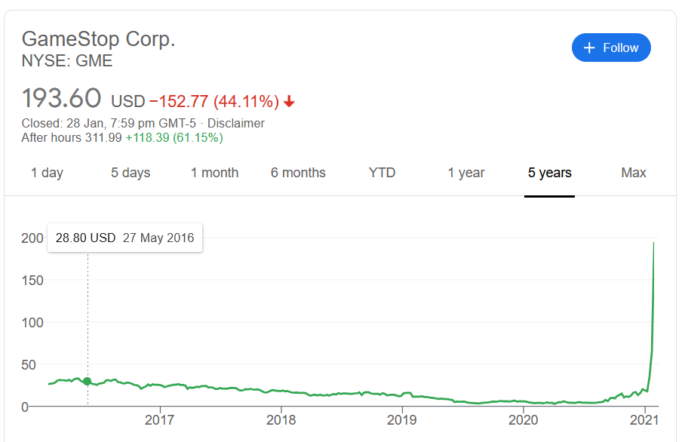Figure 1

The next day, as the market closed, GameStop shares were valued at US$325 and the company’s capitalization rested at US$22.7 billion, up from US$299 million in September, 2020 (see Figure 2).[4] That’s an increase from January 8th, 2021 of 1737 percent. That’s a lot of tendies![5] Part of the explanation for this massive spike can be attributed to the near consistent generation of hype by members of r/WallStreetBets, the fact that many are inexperienced investors and believe the hype, the fact many from around the world rushed to join the fight by buying GameStop stock and easy to use platforms (apps) that want to ‘democratize finance’ like Stake and Robinhood. There is virtually constant use of the rocket ship emoji and members enjoy saying they will hold the stock ‘to the moon’ or eve ‘the outer edges of the universe’. Moreover, at the time of this writing (February 1, 2021, in Sydney, Australia, NYSE not open), members of r/WallStreetBets continue to support holding and purchasing GameStop shares despite a steadily declining valuation of the company’s shares since the first of February in the USA (there are however significant obstacles to the stock blowing up and remaining in the stratosphere – see below).

Figure 2

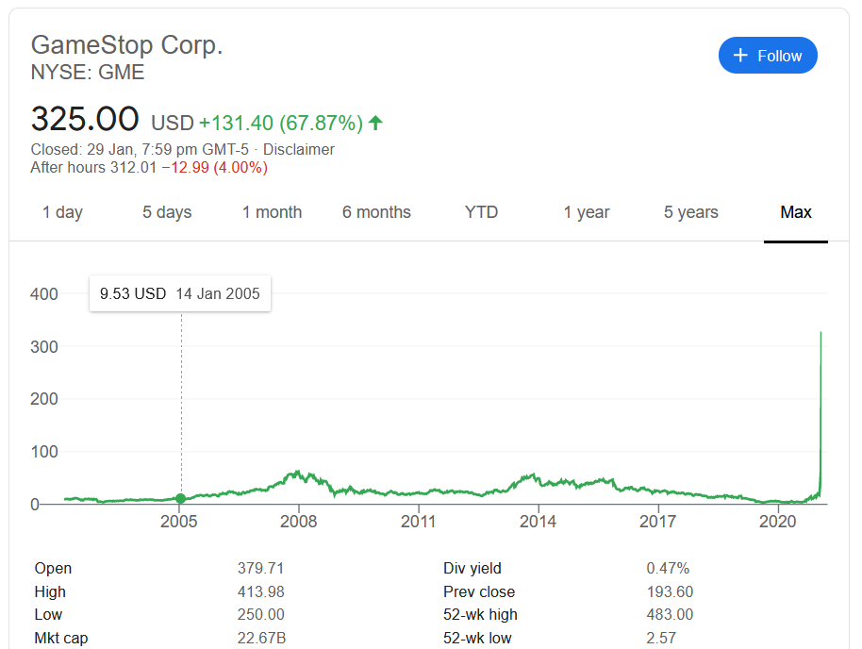

This kind of share price magic happens very rarely and is typically attributed to some major event like a corporate merger or acquisition, a quarterly profit report that beats the expectations of investors, a new business model, the introduction of a new invention or product, or a once in a century Pandemic. Consider the communications technology company Zoom. Just before the Pandemic shares were trading at US$107.47 on the 13th of March 2020. Then, most of the world entered lockdown and with evermore people working from home and communicating with Zoom, the share price skyrocketed to US$559 on the 16th of October for a 420% increase in value. This, like the rise in Amazon shares, can be explained by a locked down world due to the spread of Covid-19 and its variants and a change in the future expectations of investors in Zoom and Amazon. But how to explain the moon shot rise in GameStop? Did Americans all of a sudden go crazy for games? Did expectations of GameStop’s future profitability improve that significantly? Can we ever know the ‘true value’ of GameStop? Nope. Can its capitalization continue ‘to the moon’ and become unchained to earnings? Technically, yes.

**Capital as (Social) Power**

In order to think about what just happened to the market valuation of GameStop, we need a little framing from the capital as power approach to political economy introduced by Jonathan Nitzan and Shimshon Bichler. The capital as power approach argues that capitalization is the most important act in capitalism (investing in an income generating asset or holding claims on an income-generating asset). Capitalization involves investors discounting future flows of income into a present value adjusted for risk – it’s an imperfect science but it exists.[6] What this means when it comes to investing in company shares is that share prices are a strong indicator of the future expectations of investors regarding the future profitability of a corporation. In short, the anticipated future is built into the share price. Investors and speculators may get it wrong, but the monetary level of capitalization and share price movements remain important indicators that can tell us about the *expected* success or failure of a company. So, if the share price of a firm is decreasing, then we would expect that investors are losing confidence in that firm’s ability to use their power to garner greater profits. This is what the hedge funds thought regarding GameStop – that the company was overvalued and that its share price would eventually plunge. If share prices are increasing, then we can assume that investors anticipate greater prospects for profitability as in the cases of Amazon and Zoom we have already mentioned. But the capital as power approach goes a few steps further than this fairly straightforward recognition. From a theoretical point of view, the capital as power approach to understanding the corporate universe argues that what is being capitalized is the *organized power* of a firm to shape and reshape the terrain of social reproduction for the sake of their own differential profitability (and those of their investor/stock owners). What this suggests is that corporate earnings are not simply a matter of producing goods and services for the market, but result from a broad array of corporate power strategies exerted over the social, economic, cultural and political field. Examples abound in the capital as power literature so I will just provide one example here ***excerpted*** from my 2015 *The 1% and the Rest of Us* before moving on to discuss the GameStop phenomenon.

As of January 29, 2020, Facebook had a market capitalization of US$754 billion, ranking it the sixth largest company by market capitalization.[7] Facebook is a software and computer services firm that the *Financial Times* called the ‘world’s dominant social networking site.’[8] After Google, Facebook is the most accessed site in the world and has over a billion active users worldwide.[9] The company provides its users with a platform for social interaction and information sharing with individuals, organizations and for-profit companies. It also helps users capture ‘life events’ in the form of photos, status updates, likes and comments. According to Fuchs, Facebook users can be considered what Toffler called ‘prosumers’ or productive consumers ‘who work without pay’ when they create content on their pages.[10] Since it does not charge its user base for the use of their software platform, the monetization and capitalization of Facebook compelled the company to rely on revenue from advertisers. This makes up the vast majority of the corporation’s revenue stream. The second largest source of revenue comes from Facebook Credits or a virtual currency that allows users to buy virtual goods and services in games for actual money. Facebook will likely attempt to diversify its revenue stream over time but the point now is to ask what is being capitalized when investors purchase shares in Facebook?

Once again, the simple answer is that investors capitalize the expected future earnings of Facebook adjusted for some risk factor. And since earnings come from revenue and revenue is primarily generated by advertising, then we are led to the conclusion that Facebook sells the human sociality and individual experiences of its user base to advertisers. So in one sense, investors are capitalizing Facebook’s power to maintain the website, target advertisements to its users and ensure that the user base is stable or growing so that advertising firms have a target audience for their clients. Earnings obviously depend on active users and a paid workforce – from computer programmers and designers all the way to sales people and legal and financial advisers. But Facebook’s earnings are contingent on far more than its paid and unpaid laborers and the desire to monetize user content. And this is the point of theorizing *capital as (institutional/social) power*. Facebook’s owners and directors must be concerned with shaping politics, society and culture more broadly while dealing with potential competitors and the threat of anti-trust legal action. For example, Facebook was found to have hired a well-known public relations firm to plant false stories about Google in major media outlets.[11] Facebook is also in the game of lobbying and must seek to resolve legal disputes, fend off cyber-attacks, influence privacy and data protection laws, acquire potential competitors, attract advertisers, influence the tax code and intellectual property legislation and the list could continue.[12] These are just some of the ways in which the firm’s earnings are contingent upon its power to shape and reshape politics, society and culture. Now typically, all these power plays are mobilized to increase earnings since this is what investors are largely chasing.

Why?

The answer is that in normal times (if there is such a thing) rising earnings or company profits means that share prices (or ownership claims) will be bid up. And here’s where it gets interesting. GameStop’s earnings hardly warrant the share price skyrocketing to the levels it has achieved. In fact, the latest post on the company’s Investor Relations page noted the following:

Total sales declined 3.1% driven by an 11% decrease in the company’s store base due to its planned de-densification strategy, temporary store closures around the world due to government mandates and lower store traffic, particularly later in December, due to the significant impacts of COVID-19.  The Company believes the industry-wide traffic decline during the Holiday period adversely impacted comparable sales for the nine-week period in the high single-digit to low double-digit percentage point range.  In addition, significant worldwide supply chain constraints impacted the ability to distribute products to customers across all sales channels.[13]

Not the greatest news for sure. Yet the share price for GameStop shot up 1737 percent and the members of r/WallStreetBets (previously 300,000 members and now in early February 2021 8.1 million) are calling on members to hold or buy GME when the market opens on Monday, 1 February, 2021. There is also a threat that this ‘decentralized democratic hedge fund’ (the r/WallStreetBets members and their global supporters) will boost the fortunes of other stocks like AMC and BlackBerry. It seem that the world of market capitalization has been turned upside down and hedge fund owners and Wall Street are writhing. This is particularly true for the hedge funds that shorted GameStop like Steve Cohen’s Point72 – losing an estimated 10 to 15 percent.[14] What happened?

**Somethings New Under the Sun *or* Revenge of the Nerds**

We have to think of social media as an ongoing and novel human experiment with unpredictable outcomes for the political economy of global capitalism. Never has the world been so connected and r/WallSteetBets is a perfect example of this connectivity and what it can do to corporate capitalism rather than just inflame identity politics and hideous racism. An online army has formed under the ‘this is the way’ slogan and all evidence thus far suggests that no one wants to break rank on pushing up GameStop shares prices regardless of nationality, race, religion, skin colour, gender or creed.[15] There is definitely a sense that members of r/WallStreetBets are all in this together. ‘This is the way’. It is difficult to pinpoint an exact moment for the emergence of this ‘decentralized democratic hedge fund’ but its origins seem to go back to a video posted on YouTube by DeepFuckingValue also known as Roaring Kitty and in ‘real life’ as Keith Gill – a certified financial analyst from Massachusetts, USA who used to hock life insurance. It is true that r/WallStreetBets has really run with GameStop and that it is potentially overvalued now, but the rally in GameStop shares was not inspired by complete randomness and a desire to stick it to Wall Street hedge funds (even if this is what it has, in large part, become). Here are some of the highlights from the YouTube video by Roaring Kitty:

* When the YouTube clip is broadcast in September of 2020, shares in GameStop are US$4.61 and its market capitalization US$299 million.
* He begins by saying that GameStop is one of the most compelling asymmetric opportunities in the market and that Michael Burry of *The Big Short* fame has GameStop in his portfolio.[16]
* He goes on to suggest that GameStop has a healthy market share in the gaming market.
* It’s the only major brick and mortar store dedicated to gaming and about 25% of people buy their new games and 40% buy their used games in the store.
* The company has new management and a reboot plan along two lines: 1) right-sizing costs of the legacy business which will free up cash flow helping with, 2) rebranding itself as a premier gaming hub with leading gaming partners and experiential products (the gaming industry is US$150 billion dollars).
* Video game spending is up 30% year over year across physical and digital games.
* GameStop is the most heavily shorted company on the market with the short interest/adjusted float over 100%.[17]

So as this brief analysis suggests, Roaring Kitty’s examination of GameStop’s prospects was not without merit and definitely impacted the view of the company among the members of r/WallStreetBets.

The trouble for some hedge funds and Wall Street more broadly is that individual retail investors are realizing that collectively they have incredible power to move markets and set prices for company shares. *Even worse*, new initiates are learning about finance and how ‘free’ the market is for the little guy. There is little doubt that social media and anonymity have a lot to answer for for extreme and divisive politics but r/WallStreetBets seems to be an example of the multitude coming together to target big institutional investors and in the process make a profit (I am not lionizing or speaking for this group in any fashion – these are my individual observations reading the threads and only preliminary statements can be made as the issue is ongoing at the time of this writing). In future, the organized ‘diamond hands’ may not even have to target short sellers but simply by being organized, bid share prices up above their so-called ‘fundamentals’ based solely on their desire to back one or many horses.[18] That some individuals have made a massive profit out of the stratospheric rise in GameStop cannot be doubted (many, perhaps smarter investors, have cashed in and broken rank), but it is unclear whether they were solely motivated by profit unlike their Wall Street counterparts. Whether it started as a political movement to ‘stick it’ to hedge funds and the men (and they are mostly men) that run Big Finance can be questioned, but there is considerable evidence that the political bent is leaning that way – a mission for an online army of organized nerds sick of Wall Street taking advantage of Main Street and the destruction of jobs, communities and families that often coincide with their financial practices. In some senses, if this is not revenge of the nerds (and I say ‘nerd’ is a kind way), it is revenge of the hopeful trampled over. One telling example is the following post by u/space-peanut on r/WallStreetBets that garnered 758 comments:

# **This is for you, Dad**



I remember when the housing collapse sent a torpedo through my family. My father's concrete company collapsed almost overnight. My father lost his home. My uncle lost his home. I remember my brother helping my father count pocket change on our kitchen table. That was all the money he had left in the world. While this was happening in my home, I saw hedge funders literally drinking champagne as they looked down on the Occupy Wall Street protestors. I will never forget that.

My Father never recovered from that blow. He fell deeper and deeper into alcoholism and exists now as a shell of his former self, waiting for death.

This is all the money I have and I'd rather lose it all than give them what they need to destroy me. Taking money from me won't hurt me, because i don't value it at all. I'll burn it all down just to spite them.

This is for you, Dad.

28 AMC 1/21/22 $22 calls

Most of the replies to this thread share either support or similar stories and anger towards a rigged system in the United States that has seen the wealthier get wealthier and the poor, poorer not to mention sick. Another example of the solidarity being built around a desire for revenge against Big Finance is by u/lesmiserobert (responding to the comment above):

I feel your pain, brother. Reposting my similar shared experience in solidarity. We are in this together!

I could not put a price tag on $GME. I will keep these shares until the day that I die.

This isn’t about the money.

The Great Recession of ’08 turned my life inside-out. I lived with my single mother, who was a small business owner and part-time dental hygienist. She had just been diagnosed with breast cancer. Even through the chemotherapy, she continued to bust her ass every day to keep us from going under. She was fired from her part-time job for having cancer, and was struggling to keep up with the mortgage, car payment, medical bills, etc. My mother died in October of 2009 and the business, the house, everything went along with her.

My mother did not get bailed out. I did not get bailed out. You and your parents did not get bailed out. You know who did? Wall Street. And on our dime. These hedge funds, like Melvin Capital Management LP, continue to manipulate and exploit working Americans like you and me, and they do so with relative impunity.

The abhorrent avarice of Wall Street has earned my contempt, and I stand with you…

If you have any ounce of humanity, any ounce of decency, the stories on this thread just shatter your heart into a million pieces.[19] But out of this existential pain and perhaps for many other reasons, the r/WallStreetBets has become a global phenomenon – most everyone is watching. The genie is out of the proverbial bottle and no one knows exactly what wishes will be granted. What is certain, is that unlike the Occupy Wall Street movement that fizzled out for a variety of reasons – perhaps the largest one being the lack of cohesion over political and economic demands – this movement shows little signs of abating because r/WallStreetBets members have witnessed their own collective power and agency beyond marching in the streets with placards (in my mind a worthy cause but a different tactic). Members have also bought advertising billboards across the US, including a giant electronic one in Time Squares, New York City that reads $GMC go burrrr. They actively made hedge funds that shorted GameStop take a giant haircut. That said, there are some obstacles to be wary of: 1) r/WallStreetBets have built up solidarity and there is much to be said for the supportive messages, educational practices and rallying cries on the subreddit but as in any large group (reminder: now 8.1 million), there could (and likely will) be divisions that could threaten a united cause – indeed, some may be suggesting others hold the shares while others are secretly selling[20]; 2) as it is an open forum there is a danger that it could be used by Wall Street and hedge funds to ride along with the group or bet against the current or possibly post false or misleading information, 3) there is an issue with trading platforms (apps) that have been a real snafu for the movement –with Robinhood being perhaps the most infamous. Mark Cuban, the billionaire investor and owner of the NBA’s Dallas Mavericks chimed in to r/WallStreetBets on the matter:

Final thought. First thanks for the great questions. Thanks for changing the game. Thanks for taking on Wall Street. Thanks for making kids around the country if not the world (including my son and daughter). WSB changed the game far more than everyone on this board will ever get credit for.

That said, you will do all this again. You will go after WS and the next time you will be smarter. There was only one thing that messed you all up: RobinHood and the other zero commission brokers that everyone used didn’t (sic) have enough capital to fund the fight. They let you down in a big way.

When you load back up, fight (sic) a broker with TRILLIONS OF DOLLARS in assets on their balance sheet. Someone that can be there when the fight starts and wont (sic) blink an eye.

No disruption is easy or happens in a straight line. Stay with it. I am a believer.[21]

However, Cuban, who appears to side with r/WallStreetBets, has argued that the group can be more powerful if they continue to buy as the hedge funds try to drop the price. With these three things in mind, r/WallStreetBets remains an interesting social experiment and one that currently has much of the world’s attention. There will be much to write about in future regarding this new development in finance and social media and this commentary is just Part I. At the moment (now February 3, 2021) GameStop has closed out February 2, 2021 at US$90 per share making the value of the company a mere US$6.28 billion. AMC and BlackBerry, two other companies favoured by r/WallStreetBets members are also down. Some believe that (due to the trading amounts and the speed of the transactions) it’s the hedge funds trading their shares back and forth with each other to bring down share values. Let’s see if r/WallStreetBets can hold the line.

1. I’d like to thank Frances Cowell for her thoughtful comments and suggestions on this piece.
2. Email correspondence ~~with~~ Frances Cowell recounting informal audience discussion of a presentation by Dan DiBartolomeo of Northfield Information Services at a London Quant Spring Seminar in London in May 2009. “The biggest turkey was of course the SEC, which had, for at least ten years, ignored warnings by other market participants that the profits he boasted were infeasible, given prevailing market prices and the strategy he said he was pursuing. Informed sources also have it that, when as much money as possible could be received wreckage, less than half of the investors in the fund came forward to claim their share, suggesting that many decided that recovering their money would not be worth forfeiting their anonymity..... We note also that Madoff surrendered himself to the police, clearly figuring that he would be safer in their hands than anywhere else.” More details on Frances Cowell can be found here: <http://www.francescowell.com/about/>
3. <https://fortune.com/2021/01/28/gamestop-hedge-fund-losses-steven-cohen-dan-sundheim/> (accessed 1/2/2021).
4. At this point in time shares in GameStop were valued at US$4.61.
5. Tendies refer to chicken tenders and are used by the subreddit r/WallStreetBets to refer to gains or profits. It should be noted that the shares reached a high of US$469.42 by 10am on Thursday, January 28, 2021.
6. The basic formulation is Present Value = Expected Future Profit/Rate of Interest
7. The statistics have been updated from the 2015 version.
8. Robert Budden, Emily Steel and April Dembosky (2013) ‘Facebook Looks to New Video Ads as it Seeks New Revenue Stream’, *Financial Times*, May 6.
9. <http://www.alexa.com/topsites> and Alex Hern (2013) ‘The Faces of Facebook App Shows All 1.2 Billion Users’, *Guardian UK*, October 1. <http://www.theguardian.com/technology/2013/sep/30/faces-of-facebook>
10. Christian Fuchs (2012) ‘The Political Economy of Privacy on Facebook’, *Television New Media*, Vol. 13, p. 143. Fuchs attempts to demonstrate how Facebook exploits its user base from a Marxist perspective. He fails to realize that Facebook’s earnings are contingent on many more factors than Facebook workers and its worker bee user base.
11. Danielle Kucera (2013) ‘Facebook Hires Burson-Marsteller to Pitch Story on Google’ *Bloomberg*, May 13. <http://www.bloomberg.com/news/2011-05-12/facebook-enlists-pr-firm-burson-marsteller-to-pitch-google-privacy-story.html> (2/03/2014).
12. A list of issues that Facebook has paid lobbyists working on can be found here: <http://www.opensecrets.org/lobby/clientissues.php?id=D000033563&year=2013> (20/11/2013).
13. <https://news.gamestop.com/news-releases/news-release-details/gamestop-reports-2020-holiday-sales-results> (accessed 1/2/2021)
14. <https://www.bloomberg.com/news/articles/2021-01-27/cohen-s-point72-loses-10-15-amid-month-s-hedge-fund-carnage> (accessed 1/2/2021)
15. ‘This is the way’ is the mantra of the warrior tribe the Mandolore in Disney’s The Mandalorian – a popular television series with many.
16. Burry was the manager of Scion Capital, a hedge fund that profited from the greed and malfeasance of the banking and real estate markets that lead to the Global Financial Crisis of 2007-8.
17. <https://www.youtube.com/channel/UC0patpmwYbhcEUap0bTX3JQ> (accessed 2/2/2021). It should be noted that there are additional videos where he discusses the upside and fundamentals for investing in GameStop.
18. Diamond hands is a term used on the r/WallStreetBets to mean an investment is profitable and they will be holding on to their investment for maximum value. Paper hands is the reverse.
19. <https://www.reddit.com/r/wallstreetbets/comments/l7wulr/this_is_for_you_dad/> (accessed 1/2/2021).
20. I thank Frances Cowell for this point who suggested those holding during a mass sell-off might end up ‘the real suckers’. There is the total possibility that Keith Gill (DeepFuckingValue) wittingly or unwittingly stoked a movement and exited, leaving everyone holding the proverbial bag.
21. <https://www.reddit.com/r/wallstreetbets/comments/lawubt/hey_everyone_its_mark_cuban_jumping_on_to_do_an/> (accessed 3/2/2021).