**Suggestions/modifications for the RECASP section in capitalaspower.com**

**Issue 1. RECASP’s general appearance**

Jonathan (2020-09-06): Several pages now deviate from the site’s universal appearance. The Blog page below shows the ruler in red, the “Blog” logo below it against a set of pictures, and below that three columns of items. All three blocs have the same left-right width.

By contrast, the Publications section -- as well as some of the other sections -- has the contents re-arranged in two columns only, whose left-to-right width is narrower than the three columns in other pages.

Personally, I prefer the original three-column structure. Narrow contents area are restrictive with respect to figures, etc. Also, in my opinion it is visually unappealing to have different structures for different pages.

We can change these structures if we want to, of course, but perhaps this is something to do later, for the entire site.

Blair (2020-09-09): I’ve reverted to the original website width. I had changed it to try and fix a width problem when viewing content through the ‘featured’ view. For instance: https://capitalaspower.com/category/publications/

The content below is too wide.

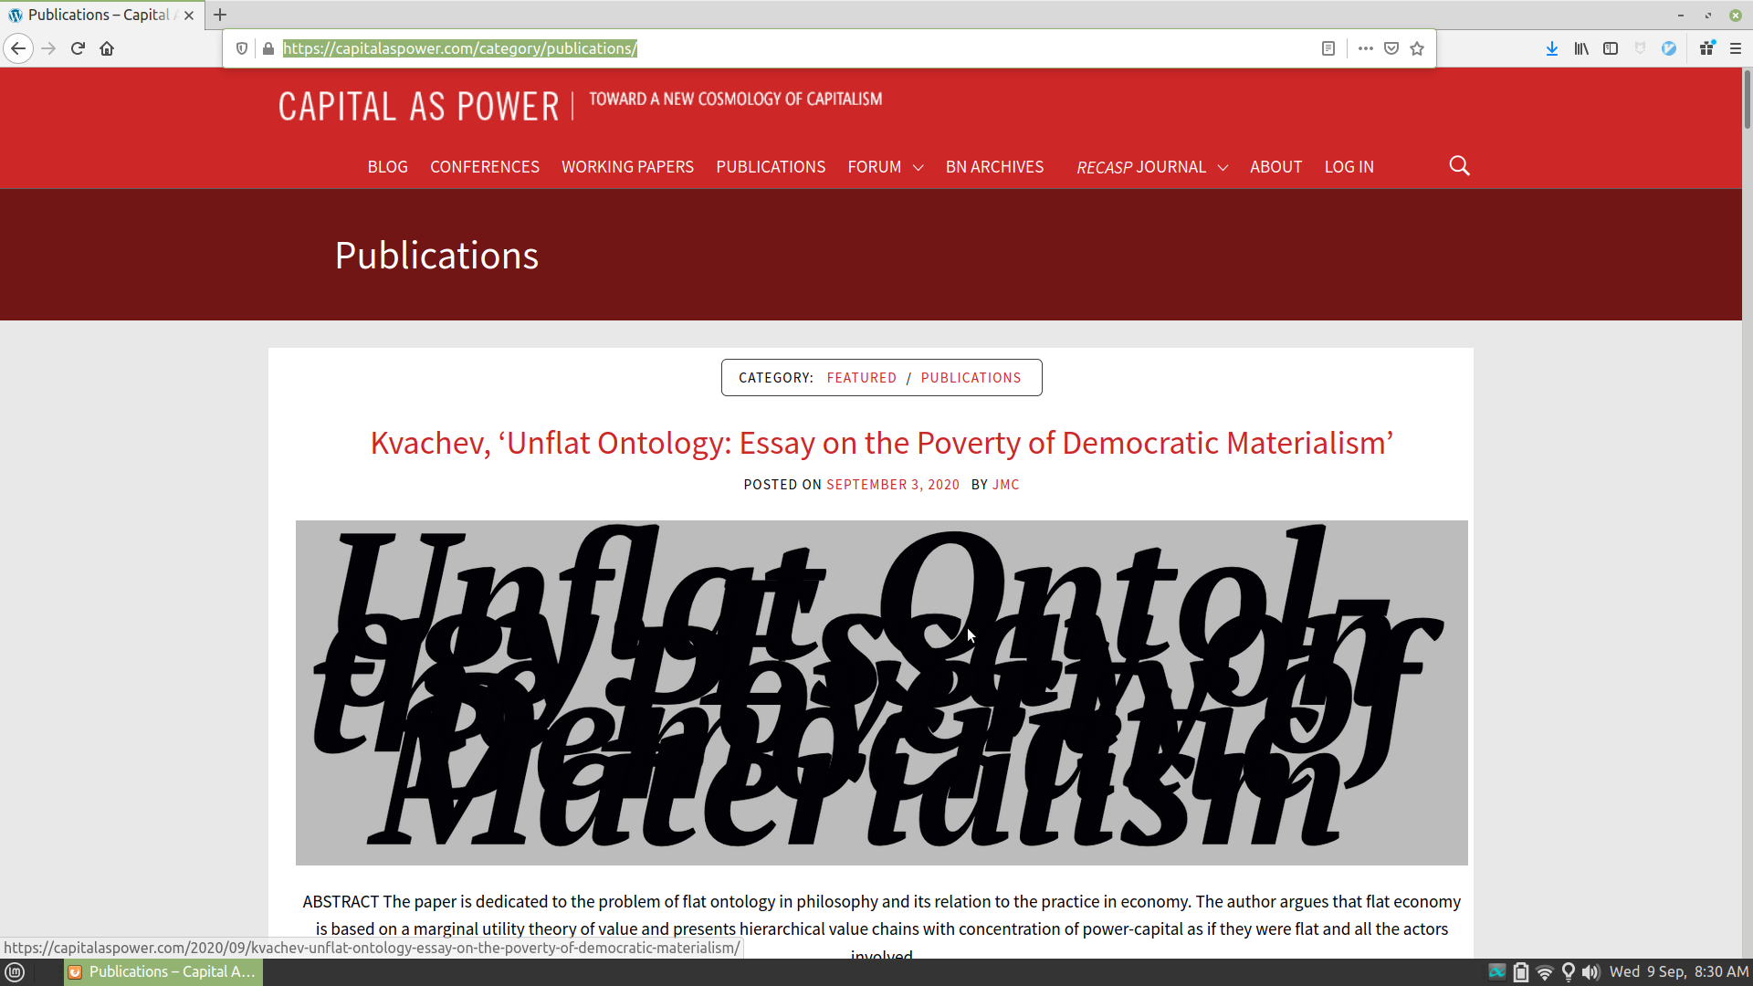

**Issue 2. RECASP’s background pictures**

Jonathan (2020-09-06): In the following pages, the background pictures of the page titles need to be reinstated instead of the current brown/red color:

Blair (2020-09-09): I’ve created a new banner for RECASP. It should now be up on all the pages. A qualm I have with the banners on casp is that they’re busy, and make the text in the title difficult to read. I personally prefer a muted banner that highlights the text.

Jonathan (2020-09-09): Agreed. Perhaps play with the transparency to reach a balance that pronounces the text while adding some visual delight.

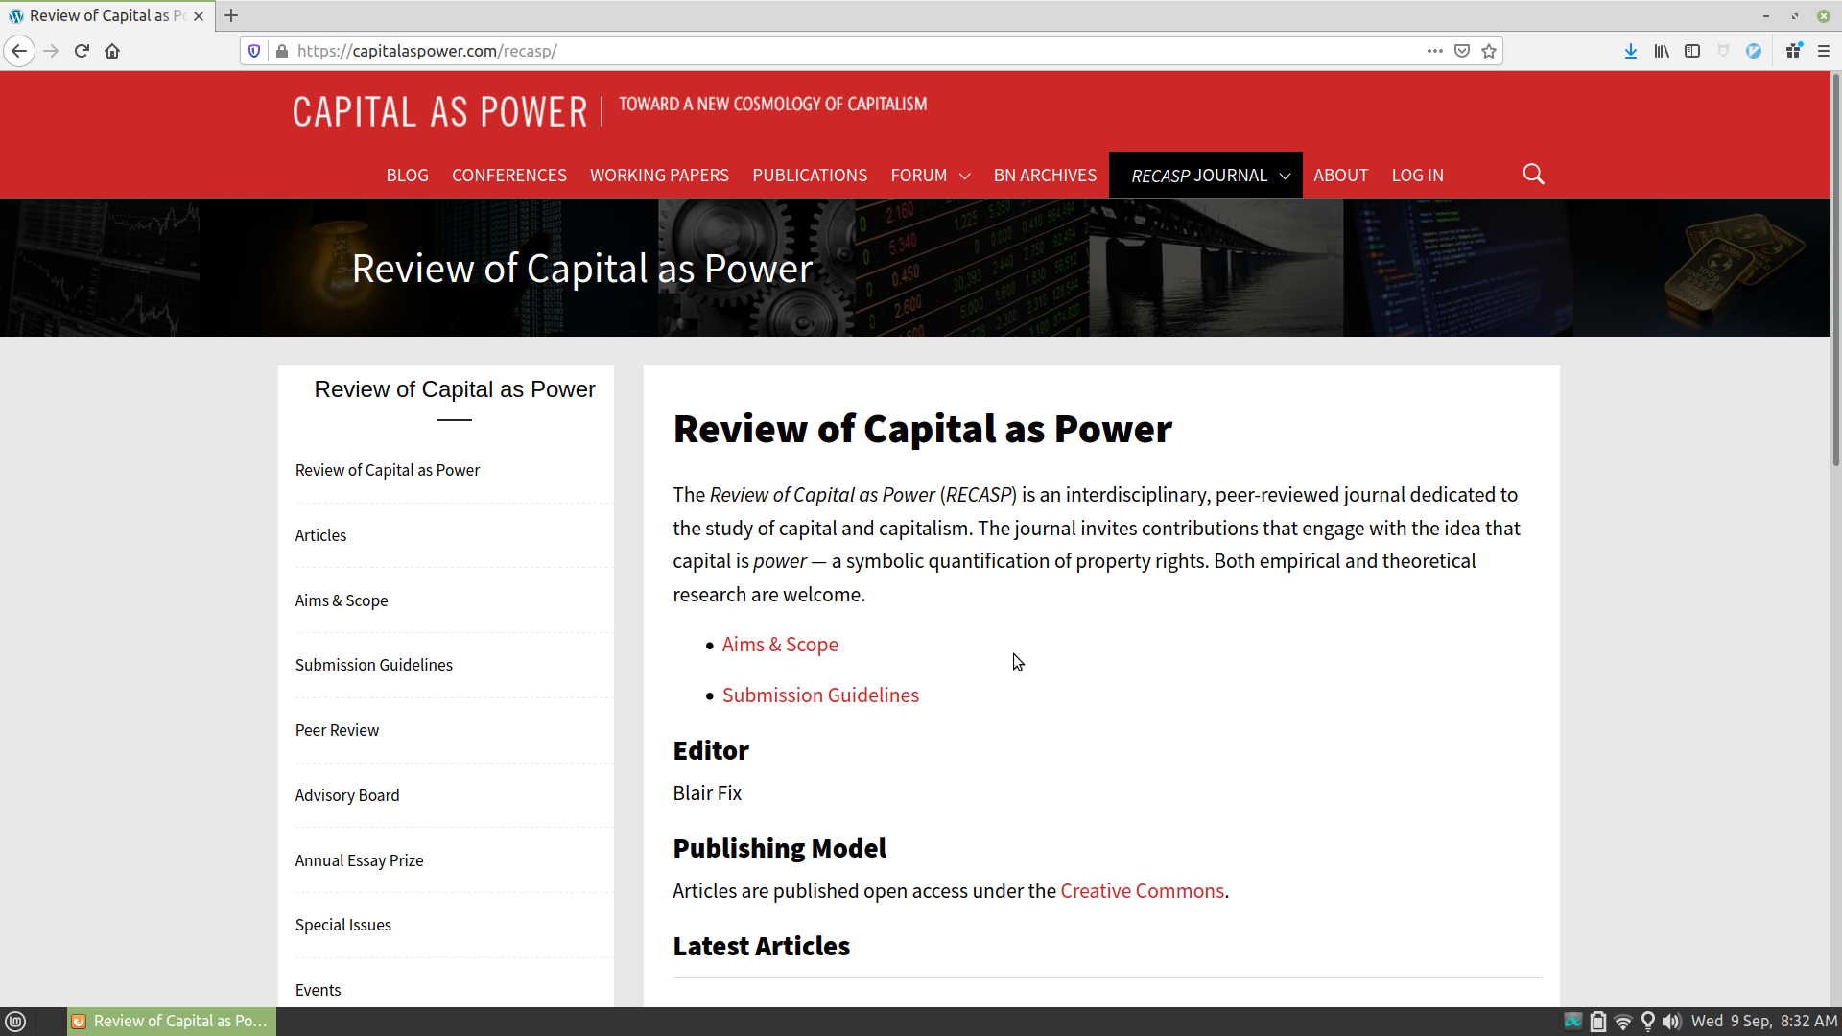

**Issue 3. RECASP titles**

Jonathan (2020-09-06): The RECASP acronym is sometimes italicized and sometimes roman. Personally, I think the roman looks clear.

Blair (2020-09-09): I’ve reverted to roman style. A side note. I find that my browser heavily caches capitalaspower.com. Because of this, sometimes site updates don’t appear reliably. For instance, I’ve update the RECASP menu, and these updates appear throughout the site. Except on the main page, the updates don’t appear. Not sure why this happens.

Jonathan (2020-09-09): Yes, I have noticed the disparity yesterday. Add such issues to the Google Doc?



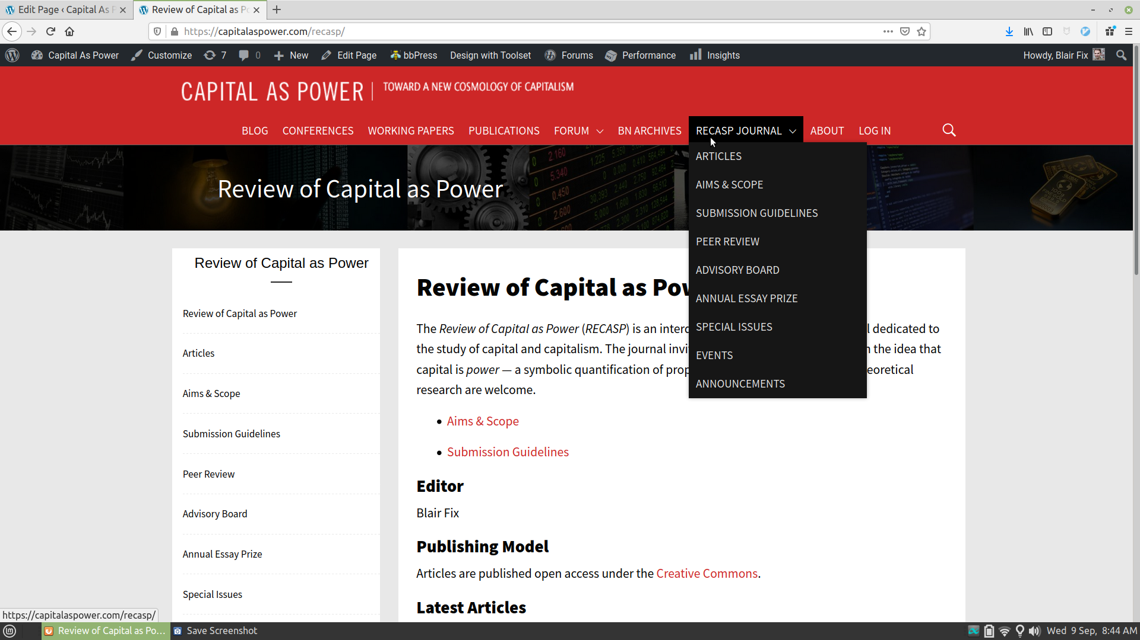

**Issue 4. Left menu**

1. Jonathan (2020-09-06): I think that title of the left menu (highlighted here) serves no apparent purpose and could be removed. The first menu item could then be shifted upward to align with the text/title on the right.
2. Jonathan (2020-09-06): I think that the left menu text is too small relative to the text on the right.
3. Jonathan (2020-09-06): When you hover on a menu item, it respond awkwardly, in my view. Perhaps it’s better simply to highlight the item?

Blair (2020-09-09): I have removed the menu title. I have globally changed the font size on the site. Menu font size should now match font size for all content.

Jonathan (2020-09-09): My impression is that the standard font now is a tad too big, but I may be wrong on that.

**Issue 5. RECASP homepage**

**Review of Capital as Power**

1. Jonathan (2020-09-06): There are several small but substantive issues here. (1) As I see it, CasP rejects disciplinary divisions when it comes to capital, so “non-disciplinary” might be more accurate than “interdisciplinary”; (2) property rights are only one dimension of capitalized power; (3) the power emphasis should relate not only to capital but also to capitalism as a whole. These issues inform my suggestions for the paragraph below:

The Review of Capital as Power (RECASP) is an non-disciplinary, peer-reviewed journal dedicated to the study of capital and capitalism. The journal invites contributions that engage with the idea of ‘capital *as* power’ – namely, the notion that capital is a symbolic quantification of organized power, and that capitalism as a whole can be studied as a mode of power. Both empirical and theoretical research are welcome.

Blair (2020-09-09): I’ve added these changes. I do have some reservations about the word ‘non-disciplinary’ ... not sure that people will know what it means. But I’m willing to try it out.

1. Jonathan (2020-09-06): perhaps add your email ?



Blair (2020-09-09): Add a link to my email.

1. Jonathan (2020-09-06): The two bullets below the introduction are available on the left menu. Should they be replicated here?

Blair (2020-09-09): Agreed. I’ve removed them.

1. Jonathan (2020-09-06): Perhaps consider being more precise/legalistic here:

<Articles are published as Open Access under the Creative Commons licence (Attribution-NonCommercial-NoDerivatives 4.0 International (CC BY-NC-ND 4.0)>

Also, maybe hyperlink to the specific license page: <https://creativecommons.org/licenses/by-nc-nd/4.0/>

Blair (2020-09-09): changed



1. Jonathan (2020-09-06): perhaps add volume/issue numbers on the date line?

Blair (2020-09-09): I’m hesitant to add this info. First, it adds clutter. Second, the move to online publishing has made this info mostly irrelevant. Academics (and journals) continue to use it mostly out of cultural inertia. I’ve modeled the design here after the page for the Journal of Computation Social Science, which doesn’t reference volume/issue data.

<https://www.springer.com/journal/42001>

Jonathan (2020-09-09): Your call!

**Issue 6. RECASP “Articles” page**

Jonathan (2020-09-06): Shouldn’t the right-hand side be titled “Articles” instead of “Review of Capital as Power”?

Blair (2020-09-09): I’ve removed the title from the side panel.

Jonathan (2020-09-09): On my end, it still show “Review of Capital as Power”.

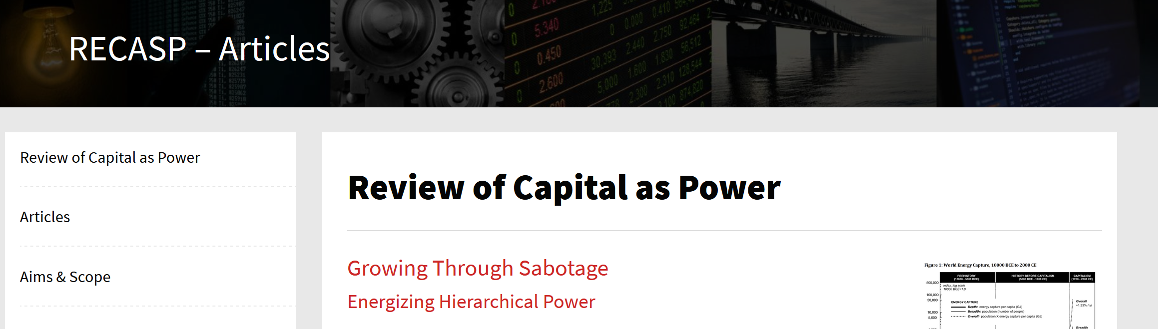

Jonathan (2020-09-06): Add volume/number information?

Blair (2020-09-09): I don’t think we need this info. If someone wants to cite an individual paper, the full details are available on the paper page.

Jonathan (2020-09-09): Your call.

**Issue 7. RECASP “Aim & Scope” page**

# Aims & Scope

Blair (2020-09-09): Unless noted, I’ve accepted these changes.

The Review of Capital as Power (RECASP) is an interdisciplinary, peer-reviewed journal dedicated to the study of capital and capitalism. The journal invites contributions that engage with the idea that capital is power — a symbolic quantification of property rights. Both empirical and theoretical research are welcome.

Jonathan (2020-09-06): I would replace the above text with the one below (the same text I suggested for the RECASP home page):

The Review of Capital as Power (RECASP) is an non-disciplinary, peer-reviewed journal dedicated to the study of capital and capitalism. The journal invites contributions that engage with the idea of ‘capital *as* power’ – namely, the notion that capital is a symbolic quantification of organized power, and that capitalism as a whole can be studied as a mode of power. Both empirical and theoretical research are welcome.

### +++++++++++++++++++++++++++++

### What is ‘Capital as Power’?

‘Capital as power’ is a framework for understanding and analyzing capitalism. First proposed by Jonathan Nitzan and Shimshon Bichler, capital as power treats ‘capital’ not as a ‘thing’, but as a quantification of ownership rights.

Jonathan (2020-09-06): If you accept my suggestion for the first paragraph, then the ‘What is Capital as Power’ section might be redundant. Also, we probably should keep BN out. In my view, it’s better for reader and writers to discover the ins and outs of CasP’s history on their own.

### +++++++++++++++++++++++++++++

### Methods

Jonathan (2020-09-06): Is it a good idea to dictate or even suggest a method of analysis? For example, your own analysis of hierarchy-energy connection is certainly differential, but it does not deal with monetary value. I think we are on the same page in thinking that many methods are better than one. If you agree, maybe it’s better to delete this section.

A defining feature of capital-as-power research is a focus on ‘differential’ (rather than ‘real’) measures of monetary value. This can include (but is not limited to) differential capitalization, differential profit, differential income, and differential prices.

### +++++++++++++++++++++++++++++

### Past Research

Jonathan (2020-09-06): In my view, it’s better to avoid calling CasP a ‘framework’. I prefer ‘approach’ or ‘notion’, which are looser and accommodate variation and dissent. Also, to broaden the range, I added a few topics. Perhaps the topics should be arranged alphabetically.

Blair (2020-09-09): I’ve made these changes.

The capital as power approach has been applied to a wide variety of topics, including:

* the origin of capitalism
* the growth of dominant capital
* capitalist income and business cycles
* the growth of hierarchy
* the nature of money and finance
* income inequality
* debt
* social movements
* mergers and acquisitions
* inflation and stagflation
* investment risk
* military conflicts
* education
* taxation
* the stock market
* cinema

### +++++++++++++++++++++++++++++

### Criticism Welcome

The Review of Capital as Power welcomes research that is critical of the capital-as-power approach. This research can include criticism of specific studies, methods and the very notion of capital as power ..

### +++++++++++++++++++++++++++++

### Replication and Null Results

Jonathan (2020-09-06): Excellent idea.

We welcome research that attempts to replicate past studies, including those published in the Review of Capital as Power. We also welcome empirical work with null results (i.e. where the evidence does not support the tested hypothesis).

**Issue 8. RECASP “Submission Guidelines”**

# Submission Guidelines

To submit an article, please email your manuscript to blairfix@gmail.com with the subject ‘RECASP submission’. Manuscripts should be sent as a PDF file.

### +++++++++++++++++++++++++++++

### Anonymous Peer Review

The Review of Capital as Power practices double-blind peer review. To facilitate review, please send two versions of your manuscript:

* Version 1: includes author information (including a max 200-word author biography)
* Version 2: identifying information redacted

### +++++++++++++++++++++++++++++

### Length

Jonathan Nitzan (2020-09-08): Do you really mean “any length”? Will you publish a 400-page paper? Perhaps recommend 8-12,000 words, or something like that, and add that under special circumstances, RECASP will consider longer paper (up to ???).

Manuscripts can be any length. However, authors should aim for brevity when possible.

Blair (2020-09-09): I’m taking a cue here from PLOS ONE, which has no word limits: https://journals.plos.org/plosone/s/submission-guidelines

Many of my papers exceed 12,000 words when the appendix is included. I find word limits infuriating. That said, I’m not going to review a book monograph.

Jonathan Nitzan (2020-09-09): Sure, I find them frustrating as well. And you can always revise your guidelines if you get flooded with book-long papers.

### +++++++++++++++++++++++++++++

### File Formats

Manuscripts for peer review should be sent in PDF format. Accepted manuscripts should [?] be sent in LaTex, markdown or DOC/DOCX/OTF.

Blair (2020-09-09): changed

### ++++++++++++++++++

### +++++++++++

### Referencing

RECASP uses the Harvard system of referencing. See [this guide](https://www.mendeley.com/guides/harvard-citation-guide) for instructions.

### +++++++++++++++++++++++++++++

### LaTex Template

RECASP provides a template for LaTeX submissions. [Download the template](https://github.com/blairfix/recasp_template/archive/master.zip).

### +++++++++++++++++++++++++++++

### Figures

Please include figures within your manuscript. Should your manuscript be accepted, we will ask for high-resolution figure files. Acceptable figure formats include:

* png
* jpg
* pdf
* [I think EPS is no longer recommended for security reasons]
* svg [scalable vector graphics]

### +++++++++++++++++++++++++++++

### Data

Jonathan Nitzan (2020-09-08): Important!

Data sources should be documented within the manuscript. If possible, data and code should be deposited in a public repository.

**Issue 9. RECASP “Review Process”**

Jonathan Nitzan (2020-09-08):

1. The menu entry on the left reads <Pear Review> -- should be changed to <Review Process>
2. For consistency, the text on the right should be titled <Review Process>

Blair (2020-09-09): I’ve changed both menu and title to ‘Peer Review’. I dislike using the word ‘process’.

**Issue 10. RECASP “Advisory Board” page**

Jonathan Nitzan (2020-09-08):

1. Mary Ann Tetreault passed away a few years ago.
2. Some of the affiliations have changed, so perhaps they should be updated.
3. Maybe refresh the list by asking new people to join and verifying that existing people want to stay:
4. Some obvious additions that come to mine:

* James McMahon
* Ulf Martin
* Steve Keen
* Timothy Mitchell

Blair (2020-09-09): I’ve updated the format to be more visually appealing

deleted Mary

added James

I searched affiliations for everyone else on the list. The only one I’m unsure about it is Joe Francis

I’ve asked Steve and Ulf if the want to participate.

Do you have contact info for Timothy Mitchell?

Jonathan Nitzan (2020-09-09): Timothy Mitchell: tm2421@columbia.edu

Jonathan Nitzan (2020-09-09): You have inadvertently deleted Di Muzio. Perhaps mention next to his name that he was the RECASP’s Founding Editor.