PROJECT BACKGROUND
Validation and Improvement of the
AI-IoT MooMe Dairy Farm Management Tool
for Smallholder Dairy Farmers in Rwanda
Kigali, Rwanda | 2026

1. BACKGROUND AND PROBLEM STATEMENT

1.1 The Challenge of Dairy Farm Management in Rwanda
Rwanda's dairy sector plays a critical role in national food security, rural livelihoods, and agricultural GDP. However, the vast majority of Rwanda's dairy farmers — particularly smallholder producers operating with 1 to 20 cows — continue to rely on manual, paper-based record-keeping systems or no formal records at all. This results in poor herd tracking, inefficient feed management, missed reproductive cycles, underestimated production costs, and ultimately reduced farm profitability.
International evidence is clear: precision farm management, enabled by digital tools, improves milk yield, reduces disease incidence, and increases farmer income. Yet the solutions that exist on the global market — originating from Europe, North America, or large-scale commercial farming operations — come at a prohibitive cost, require stable high-speed internet infrastructure, and are not adapted to the smallholder farming context in Sub-Saharan Africa.

1.2 Existing Solutions Are Too Expensive
Several AI-enabled farm management systems have been piloted in Rwanda and the wider East African region. While technically robust, these platforms present significant barriers to adoption:
- Hardware costs ranging from USD $10,000 to $50,000 per farm installation
- Annual software licensing fees beyond the reach of smallholder farmers
- Dependency on cloud infrastructure requiring consistent broadband connectivity
- Interfaces designed for Western farming contexts, not adapted to local languages or farming practices
- Lack of localized technical support and training capacity in-country

KEY PROBLEM: Rwanda needs an affordable, locally adapted, AI-IoT-powered dairy farm management solution that smallholder farmers can realistically adopt and use at scale. The existing high-cost platforms are not the answer.

2. INTRODUCING MooMe: AN AFFORDABLE AI-IoT SOLUTION

2.1 What is MooMe?
MooMe is an AI-powered, IoT-integrated dairy farm management mobile application developed and refined through field deployment across multiple African countries — including Kenya, Uganda, Nigeria, and Tunisia. It is purpose-built for smallholder and mid-scale dairy farms operating in environments with limited infrastructure.
Unlike its expensive counterparts, MooMe is designed to run on standard Android smartphones, integrates with low-cost IoT sensor kits (approximately USD $2,000 per farm), and delivers actionable farm intelligence through an intuitive mobile interface that requires minimal technical training.

2.2 MooMe in Action — Core Features
The MooMe application provides a comprehensive suite of farm management modules, all accessible from a single mobile dashboard. The following screenshots illustrate the key functionalities currently deployed in pilot farms:

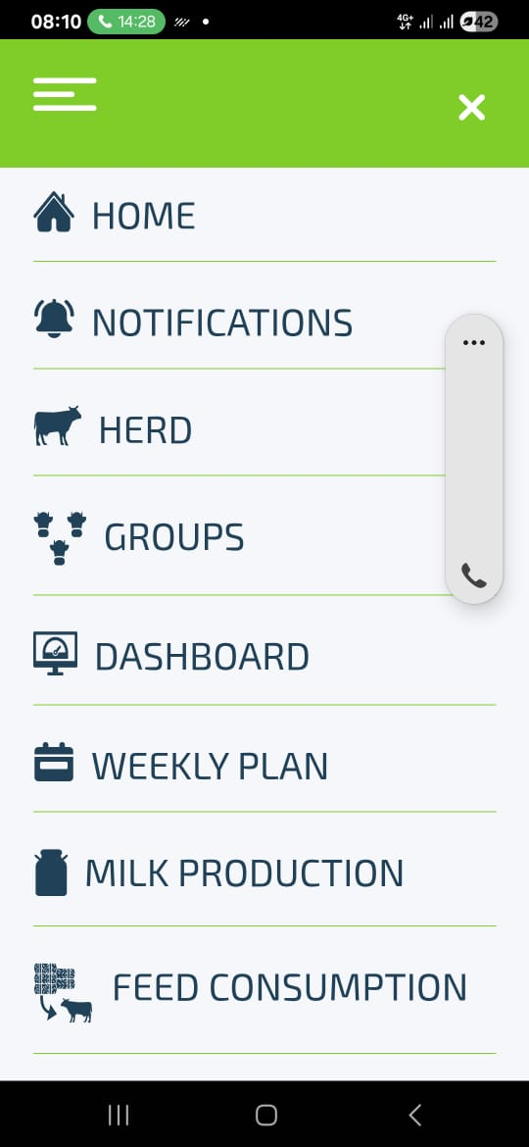 |  | 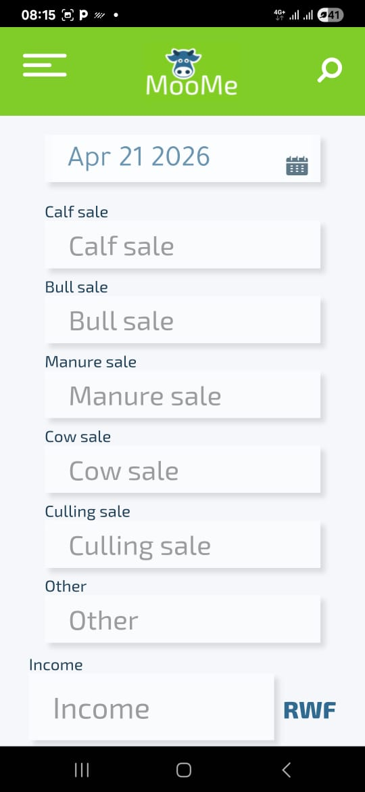
Dashboard — Farm Analytics Overview |  | Milk Production — Daily Recording & Tracking

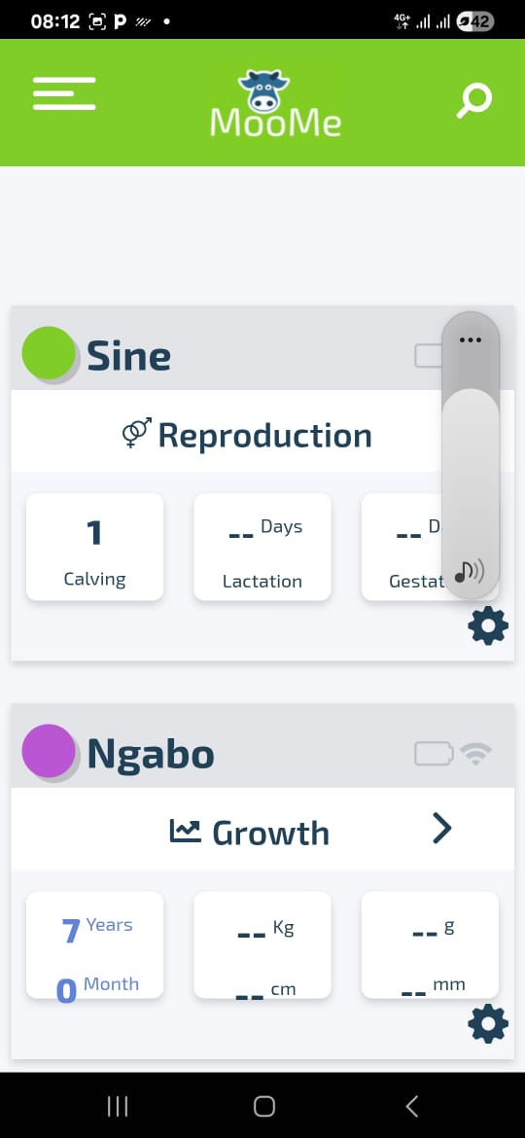 |  | 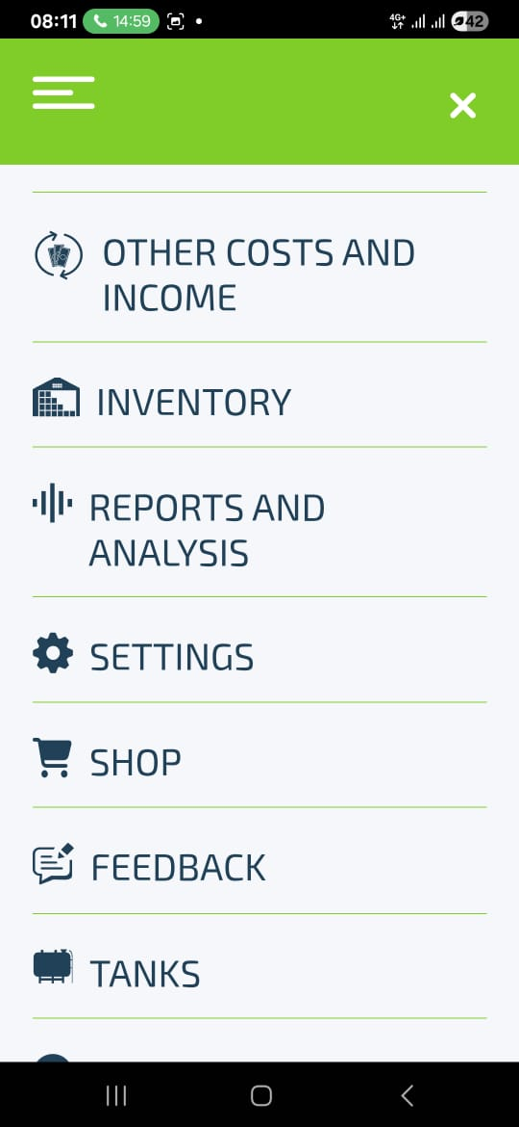
Feed Consumption — Group-Based Feed Management |  | Herd Overview — Animal Category Monitoring

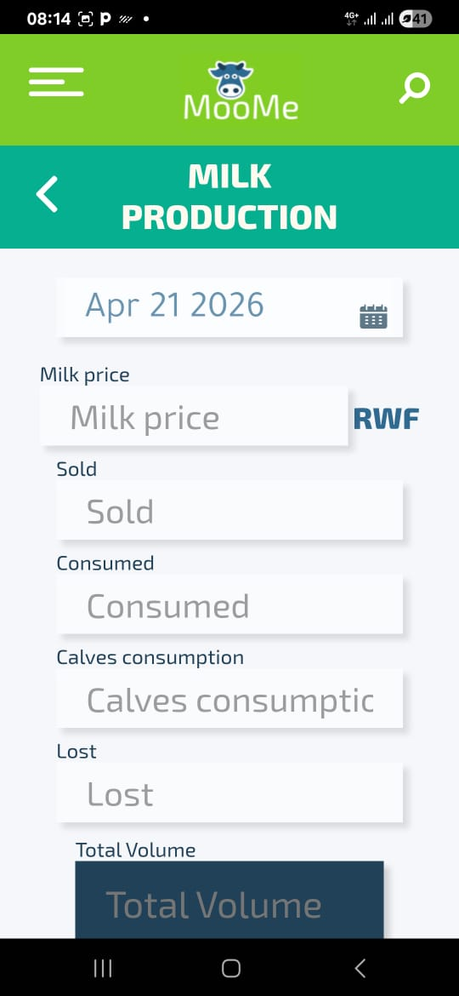 |  | 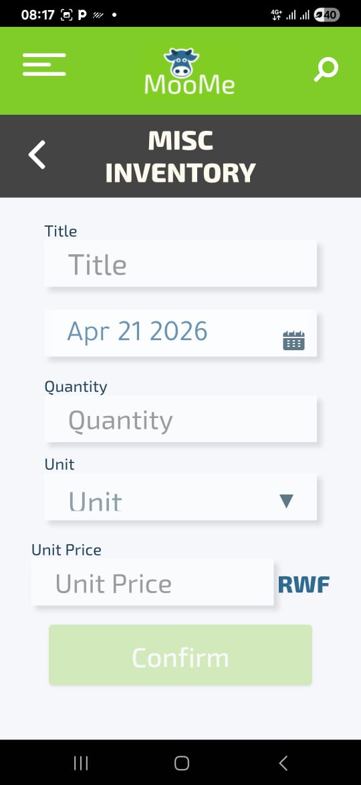
Income Recording — Sales by Category |  | Misc Inventory — Stock Management

The MooMe platform currently supports the following management modules:
- Milk Production: Daily recording of volumes sold, consumed, lost, and fed to calves — with automated income calculation in RWF
- Feed & Fodder Management: Feed consumption tracking by animal group with inventory integration
- Herd Management: Real-time monitoring of herd composition — production cows, heifers, calves, dry cows, fattening animals, sick animals
- Reproductive Management: Calving records, lactation days, gestation tracking per individual animal
- Farm Economics & Income: Comprehensive financial recording including calf sales, bull sales, manure, culling, and other income streams
- Inventory Control: Miscellaneous inventory tracking for farm supplies and equipment
- Reports & Analysis: Farm-level analytics dashboard for data-driven decision making
- Weekly Planning: Structured planning tools for feed, health, and reproductive management

3. PROVEN TRACK RECORD: REFERENCE COUNTRIES

3.1 Validated Across Africa — Kenya, Uganda, Nigeria & Tunisia
MooMe is not a prototype. It is a proven platform with active deployments and field-validated results across four reference countries in Africa, each presenting distinct dairy farming contexts and infrastructure challenges:

Country | Deployment Context | Key Validation | Relevance to Rwanda
🇰🇪 Kenya | Smallholder dairy farms in Rift Valley; mixed agro-pastoral systems | IoT sensor accuracy for milk yield; mobile app adoption by low-literacy farmers | Similar herd sizes and mobile penetration rates; comparable 4G infrastructure
🇺🇬 Uganda | Cooperative dairy farming clusters; Western Uganda highlands | Group-based feed management; multi-farm data aggregation | Rwanda's cooperative model (Imbaraga, RARDA clusters) is directly comparable
🇳🇬 Nigeria | Peri-urban commercial farms; Kaduna and Plateau states | Economic module validation: income tracking, cost analysis, profitability reporting | Financial management modules directly applicable to Rwanda's market-oriented farms
🇹🇳 Tunisia | Technology development hub; MooMe core engineering and expert base | Full platform development, AI model training, IoT hardware calibration | Tunisian experts will provide direct 3-day knowledge transfer to Rwanda local team

4. PROPOSED PROJECT ACTIVITIES FOR RWANDA

4.1 Activity 1 — Expert Training: Tunisia to Rwanda
The first core activity of this project is a structured, hands-on knowledge transfer from MooMe's technical team in Tunisia to a dedicated local team in Rwanda. This training is designed to build sustainable in-country capacity for deployment, support, and continuous improvement of the MooMe platform.

Duration: 3 days | Participants: 6 Rwandan technicians and farm advisors | Led by: MooMe Expert Trainers from Tunisia

The training curriculum covers:
- IoT hardware installation, calibration, and maintenance for dairy farm environments
- MooMe mobile application configuration, data entry protocols, and troubleshooting
- AI model interpretation: reading alerts, predictions, and farm analytics output
- Farmer onboarding methodology: how to train and support smallholder farmers in using the app
- Data quality assurance: ensuring reliable input data from all 12 pilot farms

4.2 Activity 2 — Hardware Acquisition for 12 Pilot Farms
The second core activity is the acquisition and deployment of IoT hardware kits across 12 selected pilot dairy farms in Rwanda. Each kit is purpose-designed for the MooMe platform and includes the sensors and connectivity hardware required for automated data capture.

Activity | Unit Cost (USD) | Total (USD)
Expert Training — Tunisia to Rwanda (3 days, 6 people) | Lump sum | Covered in budget
Hardware Kit — IoT Sensors & Mobile Device | $2,000 per kit | $24,000
12 Pilot Farms | 1 kit each | 12 kits
TOTAL HARDWARE INVESTMENT | 12 × $2,000 | $24,000

The $2,000 per-farm cost represents a 5× to 25× cost reduction compared to equivalent international precision farming systems, making MooMe uniquely viable for Rwanda's smallholder dairy sector.

5. MooMe vs. EXISTING HIGH-COST SOLUTIONS

The table below summarizes the key differentiators between MooMe and the types of precision dairy farming platforms currently available internationally but unaffordable at scale in Rwanda:

Criteria | Existing High-Cost Systems | MooMe (Proposed)
Hardware Cost | $10,000–$50,000+ per farm | ~$2,000 per farm
Connectivity | Requires stable internet & cloud servers | Mobile-first, works on basic 4G
Language Support | Mostly English/European languages | Multilingual incl. local languages
Target Market | Large commercial farms | Smallholder & mid-scale farms
Reference Countries | Europe, North America | Kenya, Uganda, Nigeria, Tunisia

6. EXPECTED OUTCOMES AND IMPACT

Successful implementation of this validation and improvement project is expected to generate the following outcomes:

Immediate Outcomes (Year 1) | Long-Term Outcomes (Years 2–5)
• 12 farms operating MooMe IoT kits  • 6 trained local technicians in Rwanda  • Validated IoT data accuracy benchmarks  • App improvements based on user feedback  • Localization for Rwanda (Kinyarwanda) | • Scale to 500+ farms nationally  • Increased farm profitability & milk yields  • Reduced production costs for farmers  • Rwanda as regional MooMe hub for EAC  • Integration with national dairy programs

MooMe © All Rights Reserved 2024 | Project prepared for Rwanda Dairy Sector Development | Kigali, 2026

