Douglas-fir GBS Dataset
SNP Pre-QC Diagnostic Report
Generated March 2026

1. Dataset Overview
This report summarises pre-quality-control diagnostics for a Douglas-fir (Pseudotsuga menziesii) genomic dataset generated via genotyping-by-sequencing (GBS) and variant-called with freeBayes. The dataset is structured as a two-generation pedigree (G1/G2) intended for multiple downstream applications including genomic prediction, GRM estimation, and association mapping.
The dataset comprises 1,872 samples distributed across 22 sequencing plates (P01–P22) and 8 S Groups (S1–S5, with overlap groups S1&2, S2&3, S4&5). Variants are spread across a highly fragmented scaffold-level reference assembly with tens of thousands of contigs (NCBI gi-format scaffold names). The total variant count is approximately 562,449 sites, of which a subset are canonical biallelic SNPs.
Key summary statistics from the per-sample data: median per-sample missing rate = 0.081, mean per-sample missing rate = 0.129; median heterozygosity rate (biallelic SNPs) = 0.143; median mean read depth = 30.4× (range 1.1–118.7×). A total of 86 samples exceed 50% missingness and 135 fall in the 20–50% range.

2. Diagnostic Overview
The four-panel diagnostic overview below shows the MAF distribution, per-site missing rate, per-sample missing rate, and per-sample heterozygosity in a single view. Reference lines mark conventional filter thresholds. All four distributions are right-skewed, with the bulk of sites and samples falling within acceptable ranges and long tails of poor-quality outliers.
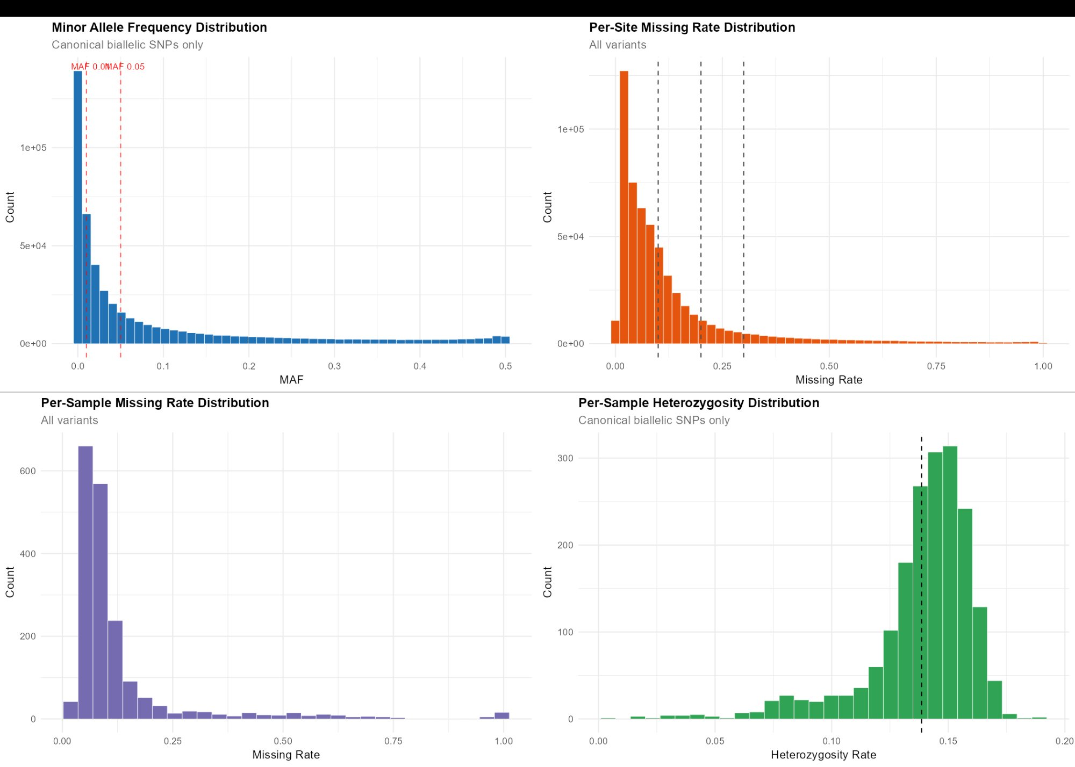
Figure 1. Four-panel diagnostic overview: MAF (top-left), site missingness (top-right), sample missingness (bottom-left), and sample heterozygosity (bottom-right). Dashed lines indicate candidate filter thresholds.

3. Site-Level Quality Control

3.1 Minor Allele Frequency Distribution
The MAF distribution is strongly L-shaped, with a large excess of very rare variants (MAF < 0.01). Reference lines are drawn at MAF = 0.01 and MAF = 0.05. With 1,872 diploid samples, MAF = 0.01 corresponds to a minor allele count (MAC) of approximately 37, which is well above the singleton/doubleton noise floor. A MAF ≥ 0.01 filter is recommended as a baseline for all downstream analyses; a stricter MAF ≥ 0.05 threshold is advisable for association mapping where statistical power at low MAF is negligible.
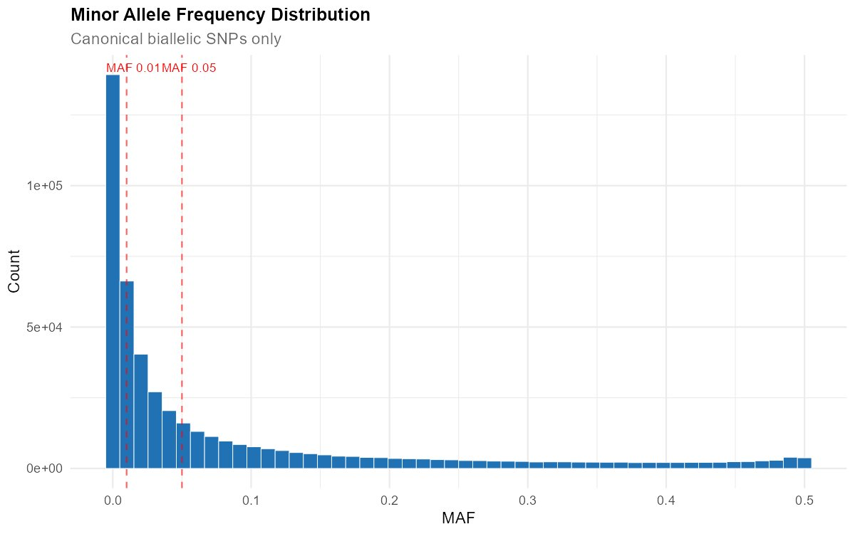
Figure 2. Minor allele frequency distribution (canonical biallelic SNPs). Dashed lines at MAF = 0.01 and 0.05.
Suggested cutoff: MAF ≥ 0.01 (general purpose); MAF ≥ 0.05 (GWAS). Alternatively, a MAC ≥ 3 filter can be applied for genomic prediction to retain rare-but-real variants while removing likely errors.

3.2 Per-Site Missing Rate
Most sites have missingness below 10%, consistent with the per-sample median of ~8%. The distribution has a long right tail extending to 100% missingness, representing sites in poorly captured or highly repetitive genomic regions. Three reference lines at approximately 0.10, 0.20, and 0.30 bracket the transition from the main distribution body to the tail. A site call rate filter at 0.70–0.80 (i.e., removing sites with >20–30% missingness) would trim the tail without cutting into the well-behaved core.
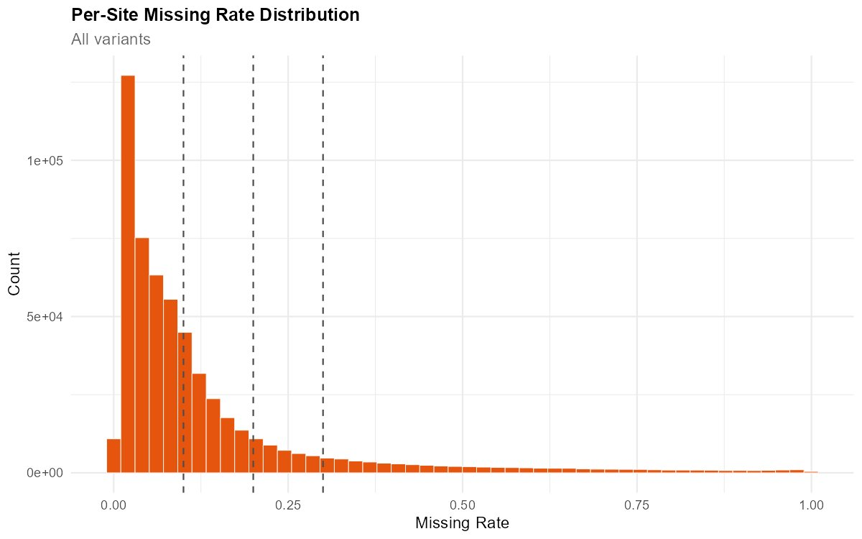
Figure 3. Per-site missing rate distribution (all variants). Dashed lines at ~0.10, 0.20, and 0.30.
Suggested cutoff: Remove sites with missingness > 0.20 (call rate < 80%). A more permissive threshold of 0.30 retains more sites at modest cost; a stricter threshold of 0.10 maximises data quality for GRM construction.

3.3 Variant Quality Score (QUAL)
The QUAL distribution is bimodal on the log scale. A low-quality shoulder below QUAL ~10 contains variants with weak statistical support—likely rare alleles at poorly covered sites or mapping artefacts. The dominant high-quality mode spans QUAL 10⁴–10⁷, representing well-supported polymorphisms. The gap between the two modes provides a natural separation point. The bimodality is characteristic of freeBayes output and differs from the more clustered QUAL distributions produced by GATK.
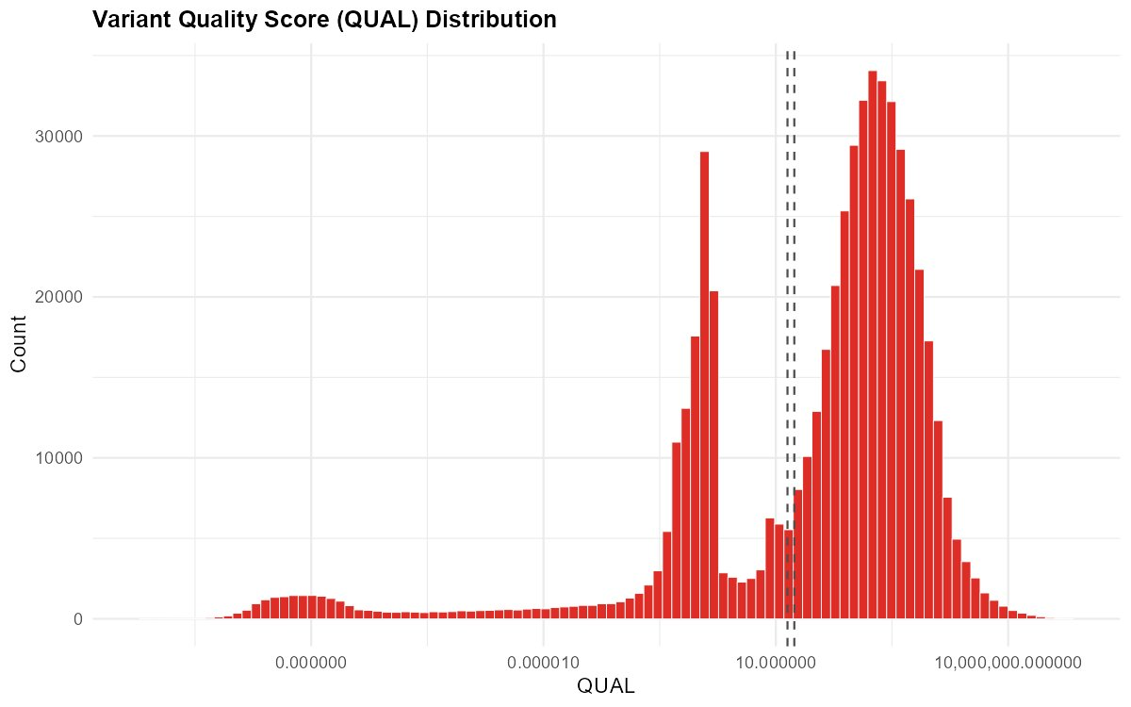
Figure 4. Variant quality score distribution (log-scaled x-axis). Dashed reference lines near QUAL 10⁵–10⁶.
Suggested cutoff: QUAL ≥ 20–30 (standard VCF convention). Most retained variants have QUAL far exceeding this threshold, so the filter primarily removes the low-quality shoulder.

3.4 Hardy-Weinberg Equilibrium p-value Distribution
The majority of sites have high HWE p-values (−log₁₀(p) near 0), but there is a substantial tail of extreme departures extending to −log₁₀(p) = 300. A spike at the far end (~300) represents sites where the p-value underflows to machine precision—almost certainly collapsed paralogs appearing as permanent heterozygotes. The reference line at p = 1×10⁻⁵ is a standard HWE filter for removing the most egregious violations. Given the structured pedigree in this dataset, a moderate HWE filter is preferred over a very strict one, since family structure itself causes mild HWE departures.
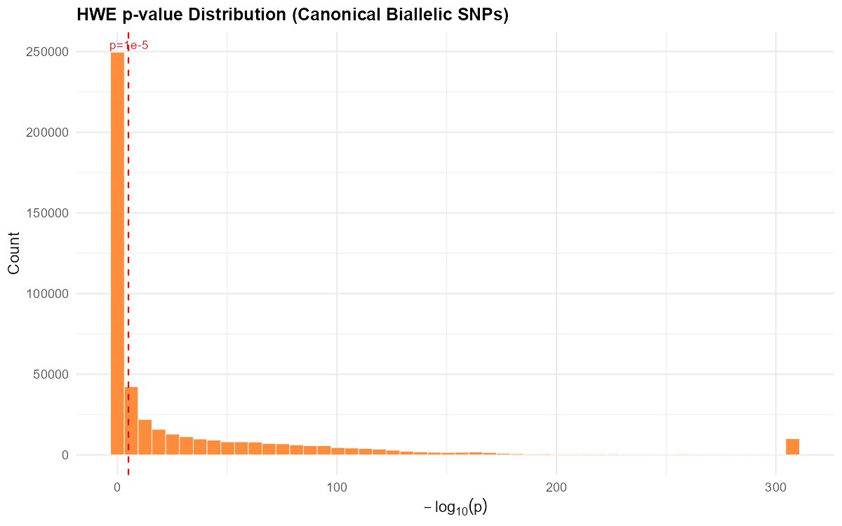
Figure 5. Distribution of −log₁₀(HWE p-value) for canonical biallelic SNPs. Red dashed line at p = 1×10⁻⁵.
Suggested cutoff: Remove sites with HWE p < 1×10⁻⁵ (excess heterozygosity direction only). This targets paralog artefacts while preserving sites with mild departures due to population/family structure.

3.5 Variants per Chromosome/Scaffold
The top 30 scaffolds carry between ~230 and ~490 variants each. Given that the total dataset has ~562K variants spread across tens of thousands of contigs, even the largest scaffold contains less than 0.1% of all variants. This extreme fragmentation is typical of scaffold-level conifer assemblies and means that chromosome-scale analyses (e.g., Manhattan plots, recombination-based LD decay) are not feasible without a more contiguous reference. Physical thinning for LD reduction must operate within-scaffold.
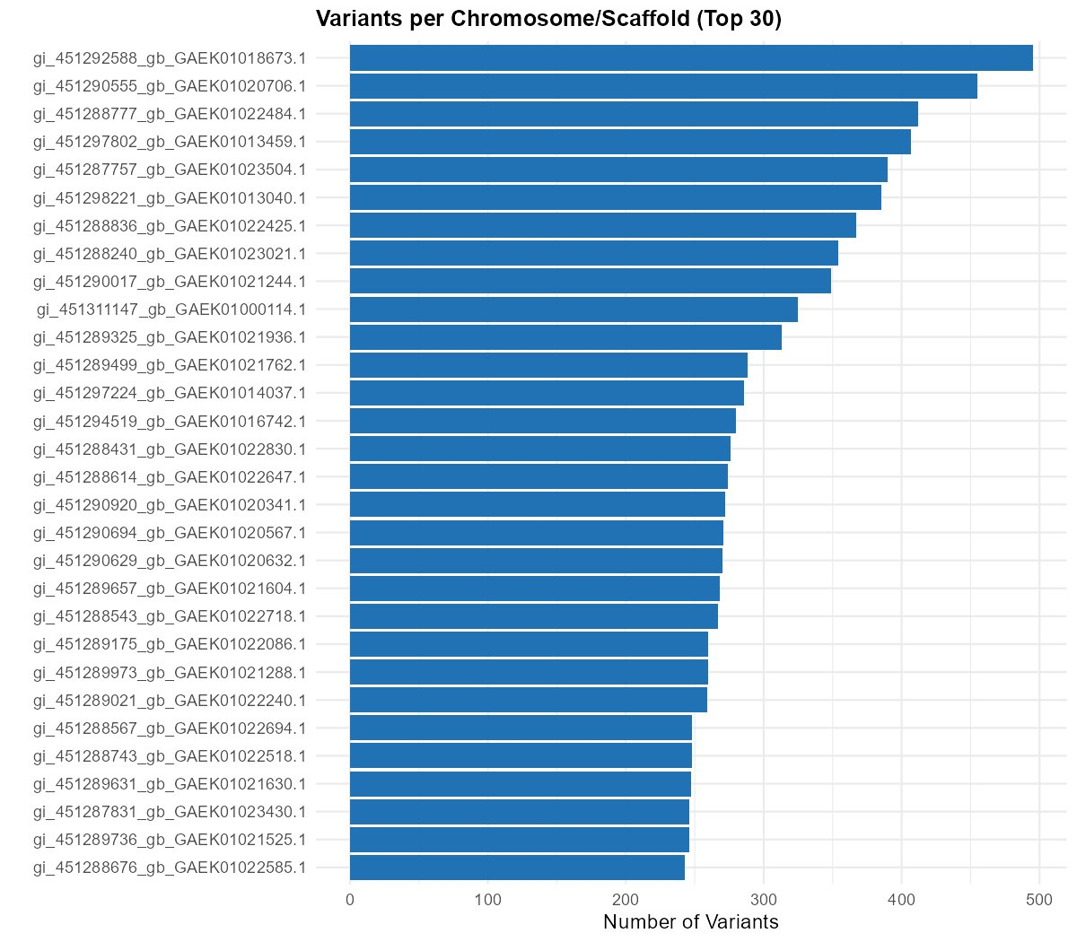
Figure 6. Number of variants on the 30 largest scaffolds (NCBI gi-format names).

3.6 Folded Site Frequency Spectrum
The folded SFS tracks the expected neutral 1/k decay through MAC 1–6, with bars closely following the theoretical curve (black line). The dominant “>20” bin contains over 300,000 SNPs, reflecting the large number of common polymorphisms and the GBS ascertainment bias toward variants that are sequenced in enough individuals to be called. A slight excess at MAC = 1 likely includes residual sequencing errors. The overall shape is consistent with a large, genetically diverse population without major demographic anomalies.
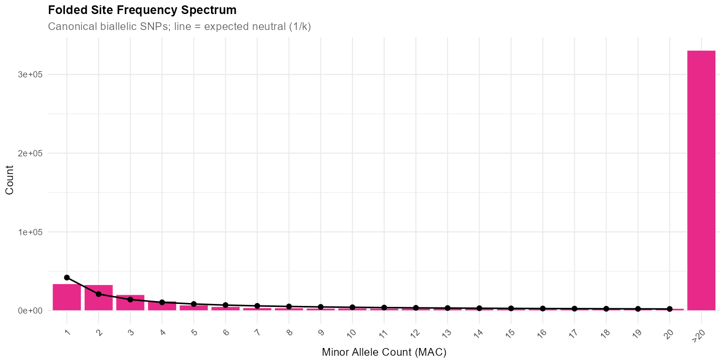
Figure 7. Folded site frequency spectrum (canonical biallelic SNPs). Black line = expected neutral (1/k) distribution.

3.7 SNP Clustering
SNP clustering quantifies how many neighbouring variants fall within a given window around each site. At 10 bp, the distribution is nearly uniform across 0–9 neighbours with a large 10+ bin (~84,000 sites), indicating extremely dense variant packing. At 50 bp, the 10+ bin explodes to ~400,000, dwarfing all other categories. This level of clustering is expected for a fragmented conifer assembly with dense freeBayes calling and reflects both biological variation and artefacts from paralogous alignments. The red dashed threshold at 3 neighbours marks a conventional SNP cluster filter.
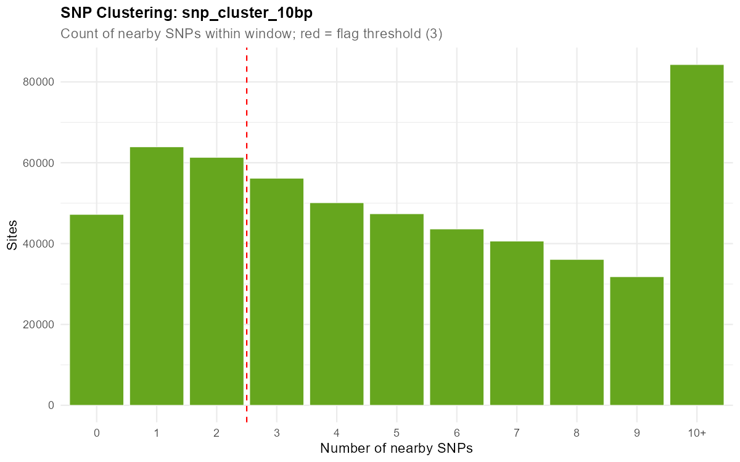
Figure 8a. SNP clustering within 10 bp windows. Red dashed line = flag threshold (3).
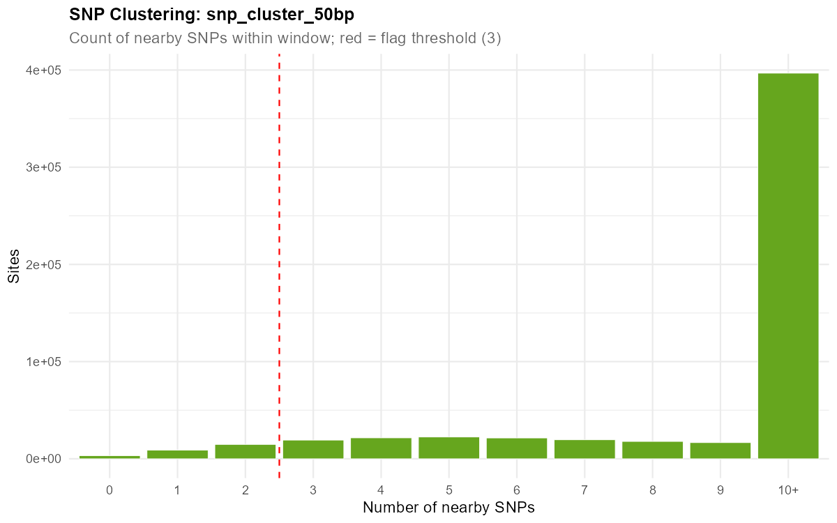
Figure 8b. SNP clustering within 50 bp windows. Red dashed line = flag threshold (3).
Suggested approach: Physical thinning to retain at most 1 SNP per scaffold per minimum distance (e.g., 100–500 bp) is strongly recommended, particularly for GRM/genomic prediction. Alternatively, LD pruning (r² threshold 0.5–0.7 within scaffold) achieves a similar goal.

4. Sample-Level Quality Control

4.1 Per-Sample Missing Rate
The bulk of samples cluster in the 0.04–0.15 range with a mode around 0.06–0.08. A secondary bump around 0.15–0.20 corresponds to samples on the lower-performing plates (P17, P18). The tail extends to 1.0, with approximately 15–20 near-complete-failure samples that returned almost no genotype data.
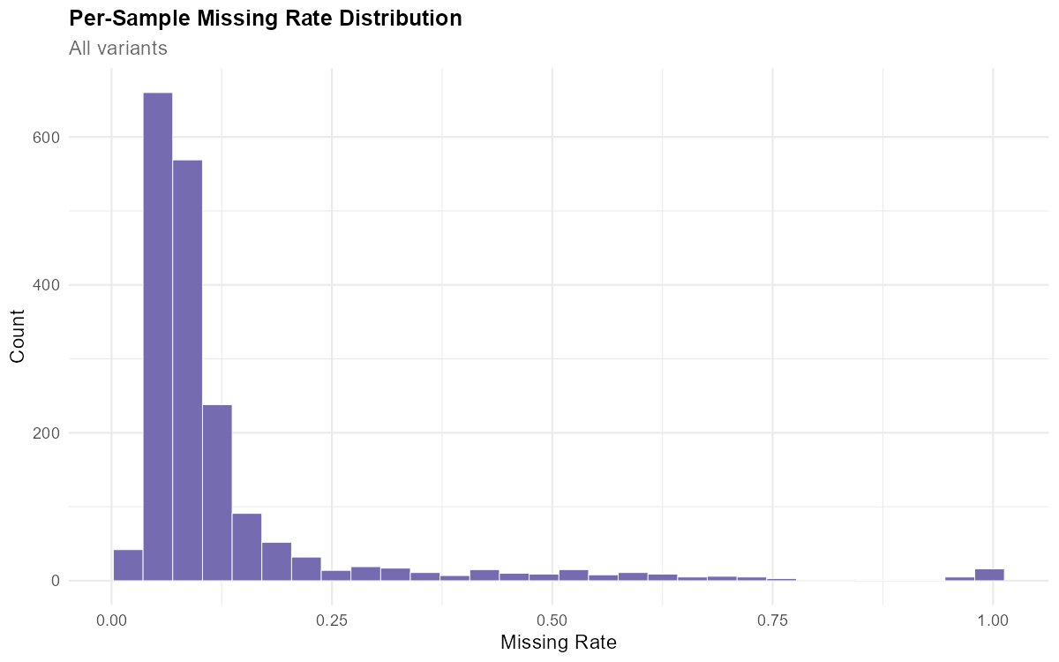
Figure 9. Per-sample missing rate distribution (all variants).
Suggested cutoff: Remove samples with missingness > 0.50 as an initial screen (removes ~86 samples). A stricter threshold of 0.30 would additionally remove the worst P17/P18 samples (~135 more affected). The final threshold depends on how many samples can be sacrificed for data quality.

4.2 Per-Sample Heterozygosity
Heterozygosity is unimodally distributed with a peak at 0.14–0.15 and a left tail extending to near zero. The left tail reflects depth-dependent heterozygote undercalling: at low depth, heterozygous genotypes are called as homozygous because supporting reads for the alternate allele are missing. No samples exceed ~0.19, indicating that contamination (which drives excess heterozygosity) is not a significant concern.
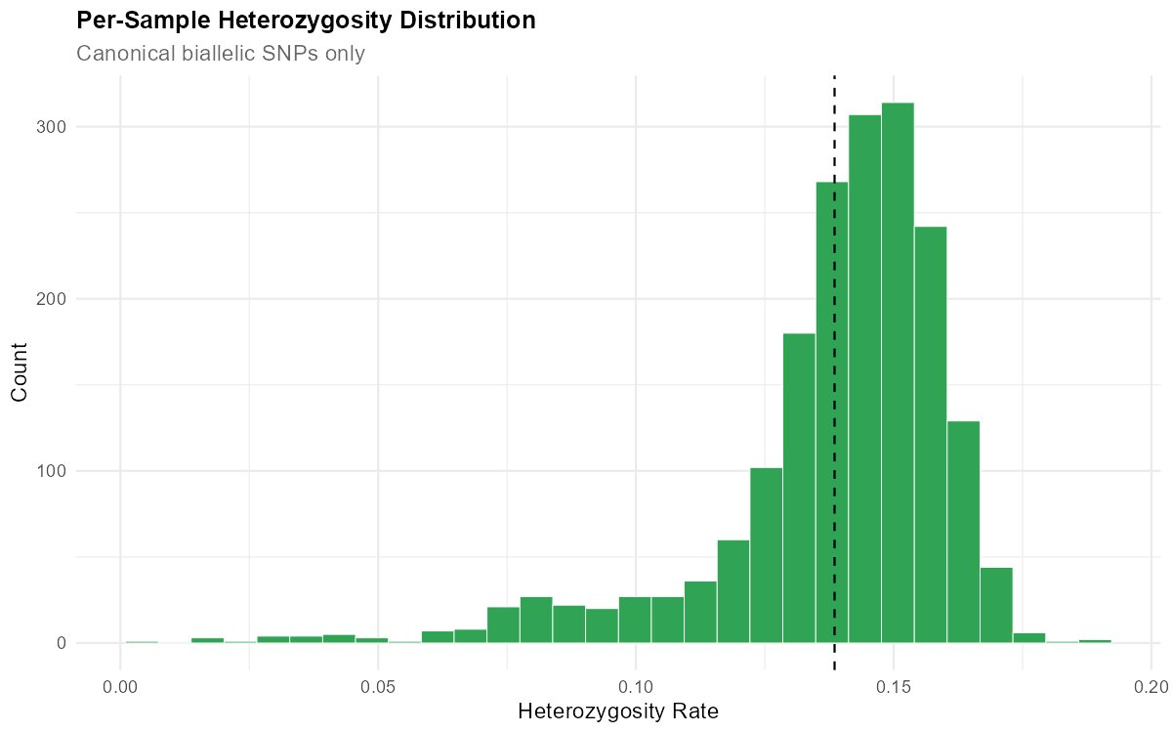
Figure 10. Per-sample heterozygosity distribution (canonical biallelic SNPs). Dashed line = median.
Suggested cutoff: Flag samples with het rate < 0.07 (lower dashed line in the het-vs-missingness plot) for review. These are almost exclusively low-depth samples that will also be caught by missingness or depth filters.

4.3 Sample Heterozygosity vs Missing Rate
This plot reveals a tight negative correlation between heterozygosity and missingness, driven entirely by read depth. Low-depth samples have both high missingness and depressed heterozygosity. The continuous curve (rather than discrete clusters) confirms a single population with varying data quality. Red dashed lines at het rate ~0.07 and ~0.21 define outlier bounds. No samples fall above the upper bound, ruling out cross-species contamination. Samples below the lower bound are all in the >50% missingness zone.
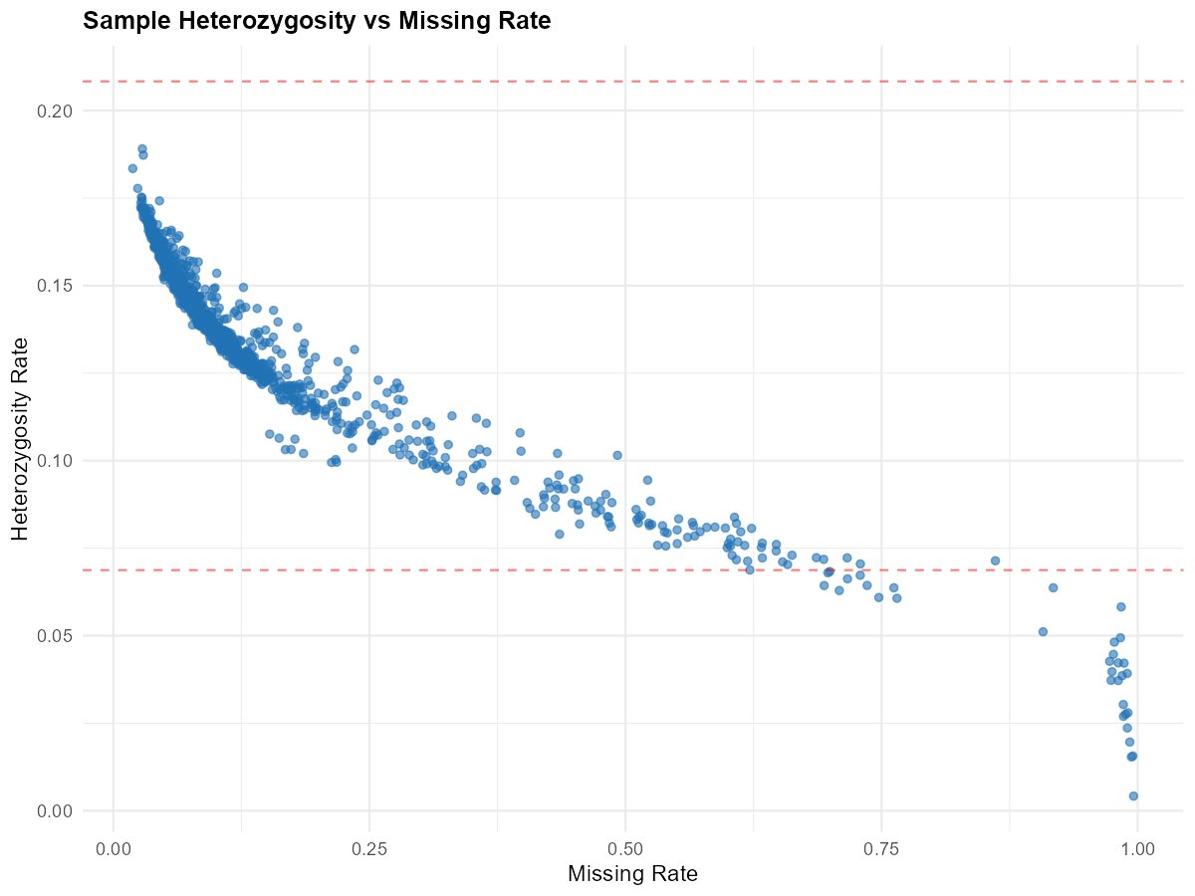
Figure 11. Per-sample heterozygosity vs missing rate. Red dashed lines = het rate bounds (~0.07, ~0.21).

4.4 Read Depth Distribution
The genotype-level depth distribution is heavily concentrated at low values (DP 0–100), with the first bin dominating and a long tail extending past DP 350. Red dashed lines near DP 2, 5, and 10 mark candidate genotype-level depth floors. The long tail at high DP represents genotype calls at paralogous or repetitive regions where reads from multiple genomic locations pile up. An upper DP cap is recommended to remove these.
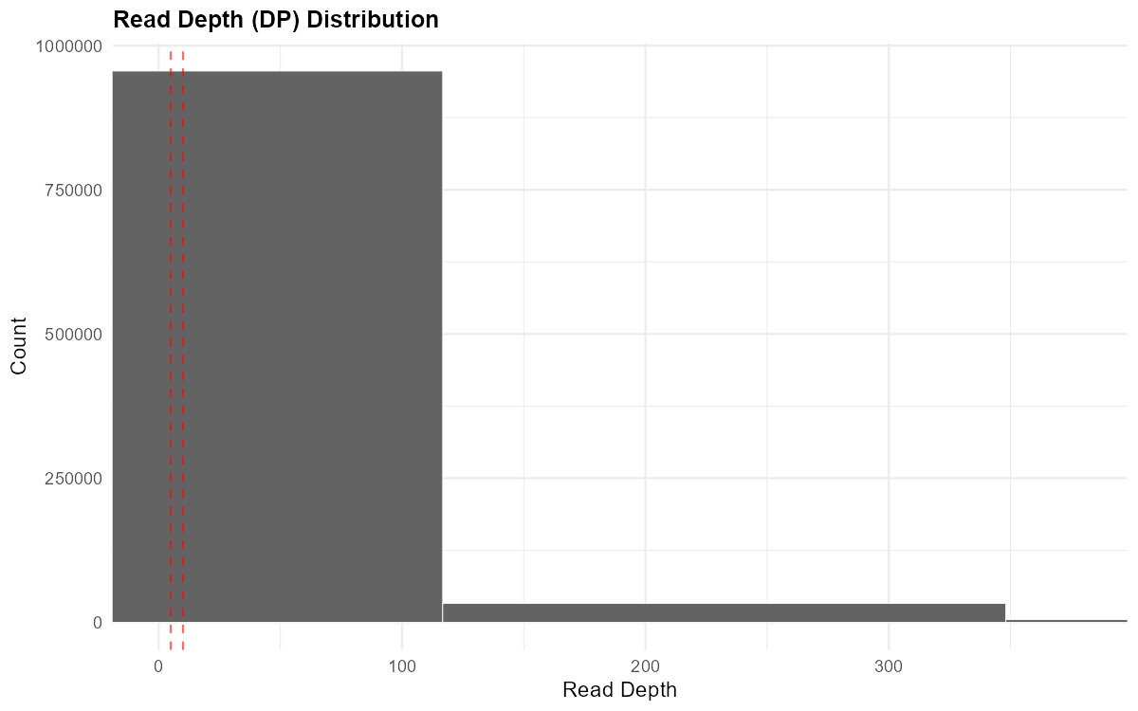
Figure 12. Genotype-level read depth distribution. Red dashed lines at DP ≈ 2, 5, and 10.
Suggested cutoff: Genotype-level DP ≥ 5 (minimum) to ≥ 10 (strict) for the lower bound. Upper bound of approximately 2× the sample mean depth (~60–70) to remove paralog pileups.

4.5 Per-Sample Mean Depth: Extremes
The lowest 80 samples by mean depth reveal ~15 samples below 2× coverage—effectively failed libraries. These are dominated by P15 (small plate with only 17 samples), P06, P08, P14, and P18. On the high end, the top sample (P17_WB06) reaches ~118×, followed by P22 and P05 samples at 80–90×. Extreme high-depth outliers from otherwise low-performing plates (P17, P18) may warrant investigation for index hopping, contamination, or library preparation errors.
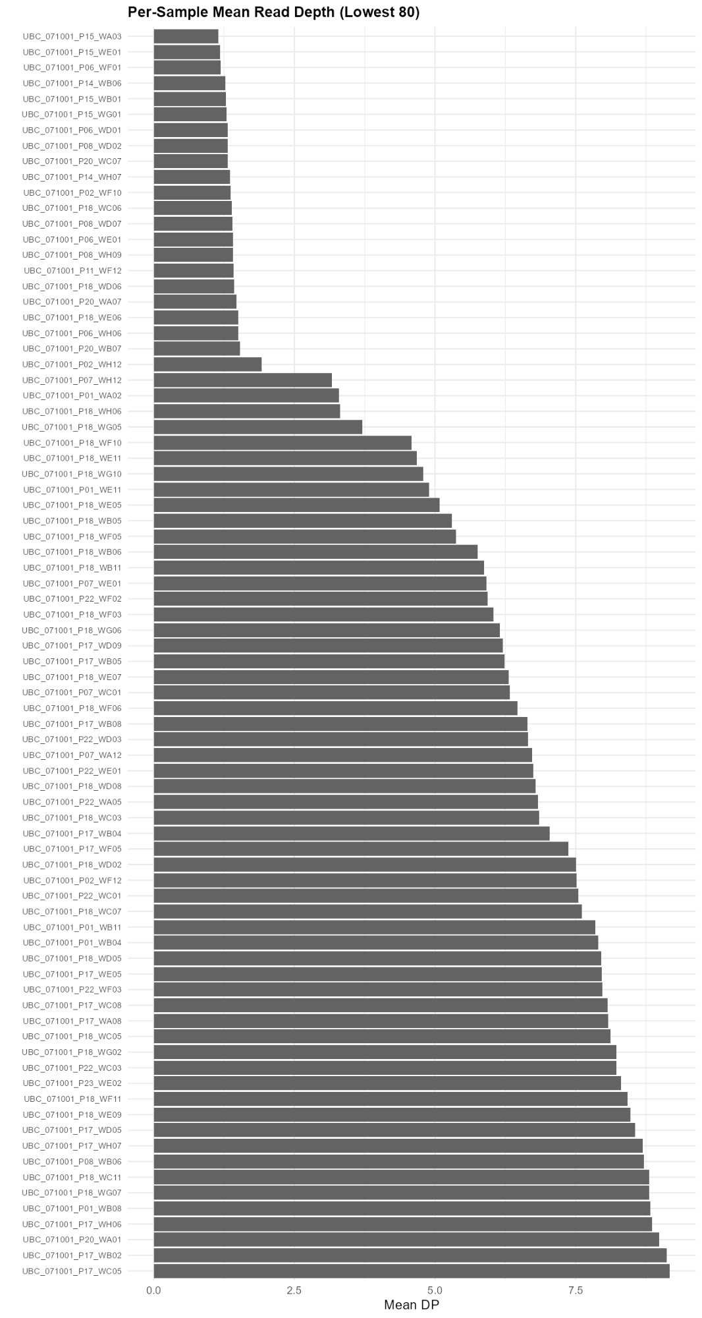
Figure 13a. Per-sample mean depth for the 80 lowest-depth samples.

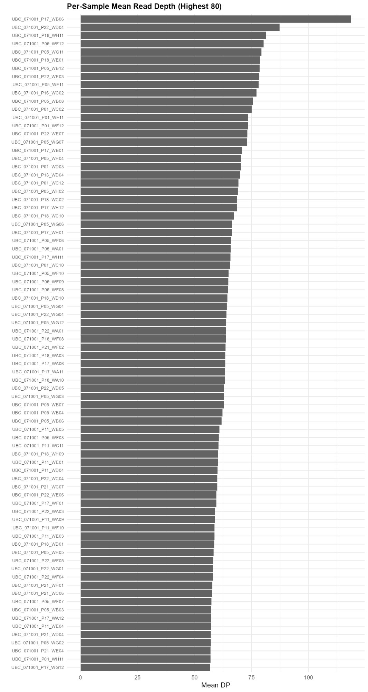
Figure 13b. Per-sample mean depth for the 80 highest-depth samples.
Suggested cutoff: Remove samples with mean DP < 5× (captures most failed libraries). A threshold of 10–15× is appropriate if prioritising genotype accuracy over sample retention.

4.6 Sample Mean Depth vs Heterozygosity
The classic asymptotic relationship: het rate rises steeply from ~0 at DP 1× to ~0.13 around DP 15×, then gradually plateaus at ~0.16 above DP 40×. The curve does not fully flatten even at 100×, suggesting continued marginal gains in het detection. Samples below ~15× are on the steep part of the curve where small depth differences cause large het rate differences, making their genotypes systematically biased.
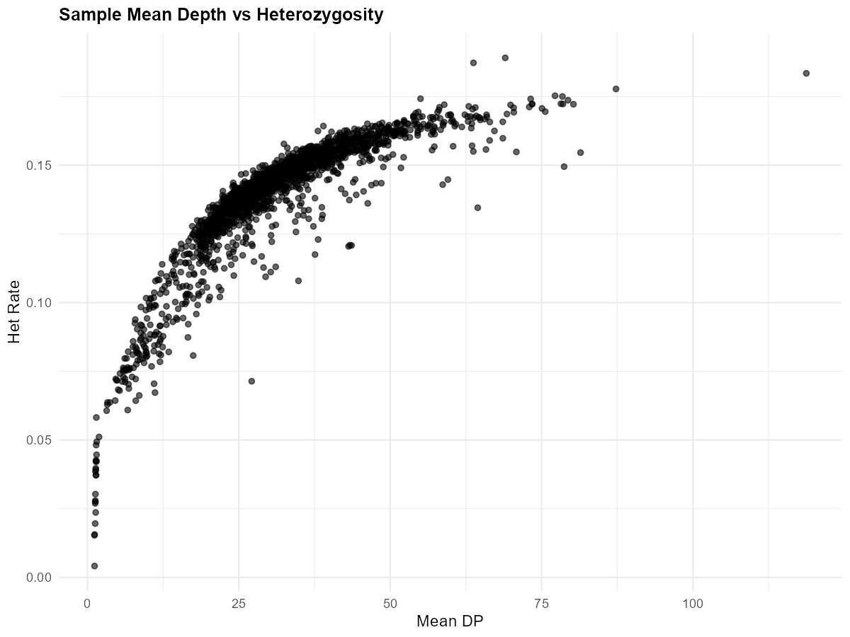
Figure 14. Per-sample mean depth vs heterozygosity rate.

4.7 Sample Mean Depth vs Missingness
Hyperbolic decay: missingness drops rapidly as depth increases from 1× to ~20×, then flattens below 10% for most samples above 25×. A cluster of points at DP < 5× with missingness near 1.0 corresponds to failed samples. One outlier at ~25× DP with ~88% missingness is anomalous and could indicate contamination, a mapping issue, or wrong-species material.
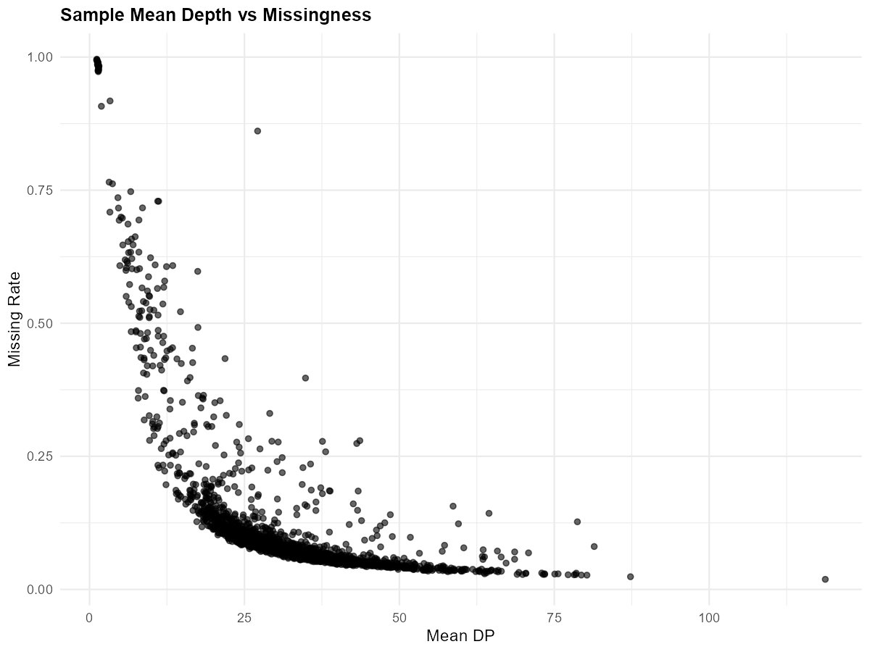
Figure 15. Per-sample mean depth vs missing rate.

4.8 Depth-Dependent Genotype Bias
Het rate rises monotonically with genotype-level DP: near zero at DP 0–2, ~0.09 at DP 2–5, ~0.15 at DP 5–10, and plateauing at ~0.21 for DP ≥ 10. The bulk of genotype calls fall in the DP 2–5 bin (~210M calls) and DP 5–10 bin (~189M calls), meaning a large fraction of the data sits in the range where het undercalling is significant. This is the core tension for genotype-level DP filtering: raising the floor improves het accuracy but increases missingness.
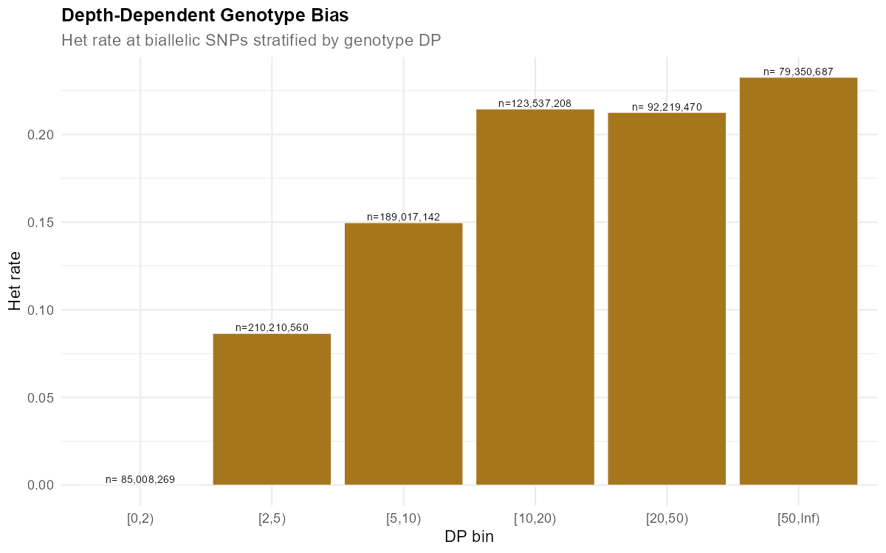
Figure 16. Heterozygosity rate stratified by genotype-level depth bin. Labels show total genotype call counts.
Suggested cutoff: Genotype-level DP ≥ 5 is the minimum recommended floor. DP ≥ 10 provides substantially better het accuracy but would set ~295M genotype calls (DP 0–10) to missing.

5. Batch Effects

5.1 Missingness by Sequencing Plate
Plates P17 and P18 are clear outliers with median missingness around 0.30 and wide variance (IQR extending to 0.50+). All other plates have median missingness between 0.04 and 0.11. P05, P11, P13, P16, and P21 are the best-performing plates (median < 0.06). Several plates (P01, P06, P07, P08, P14, P15) show scattered outliers reaching 0.90–1.00, representing individual failed libraries.
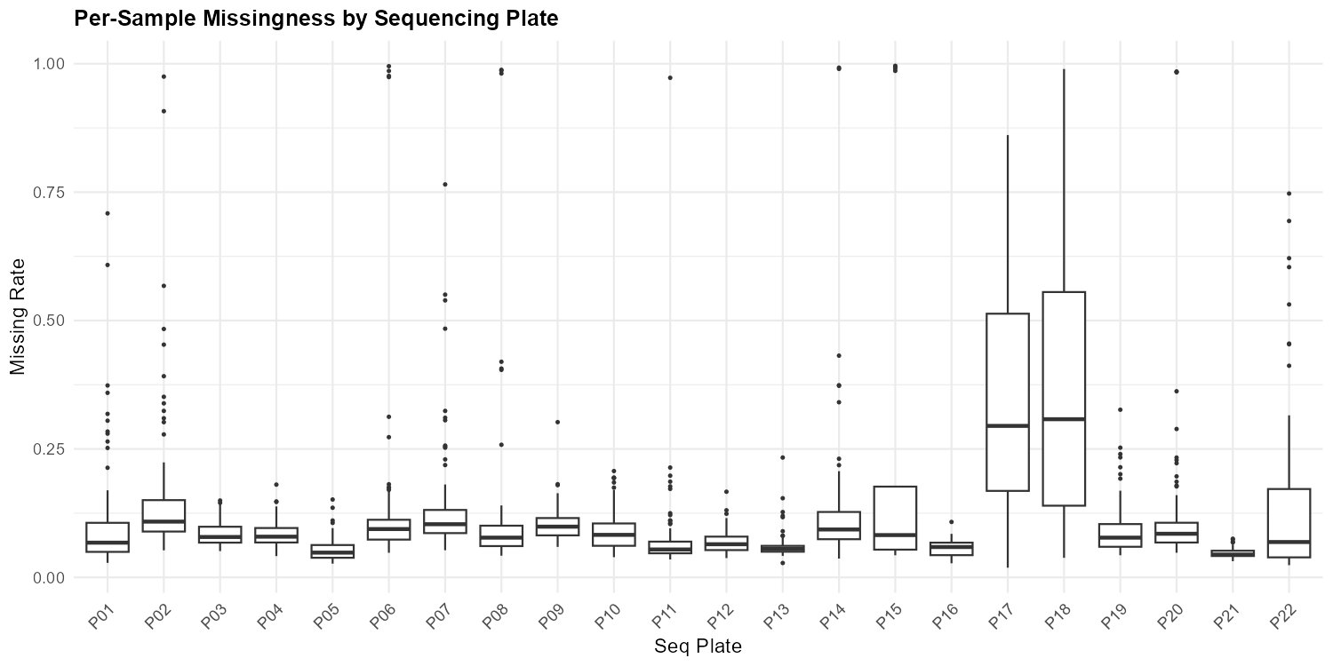
Figure 17. Per-sample missingness by sequencing plate.

5.2 Missingness by S Group
S4 mirrors the P17/P18 pattern (those plates correspond to S4), with a median missingness of ~0.30. All other S Groups have medians between 0.05 and 0.10. The overlap groups (S1&2, S2&3, S4&5) perform comparably to their constituent groups, except S4&5 which performs better than S4 alone (median ~0.08), suggesting the S5-side samples pulled up that group.
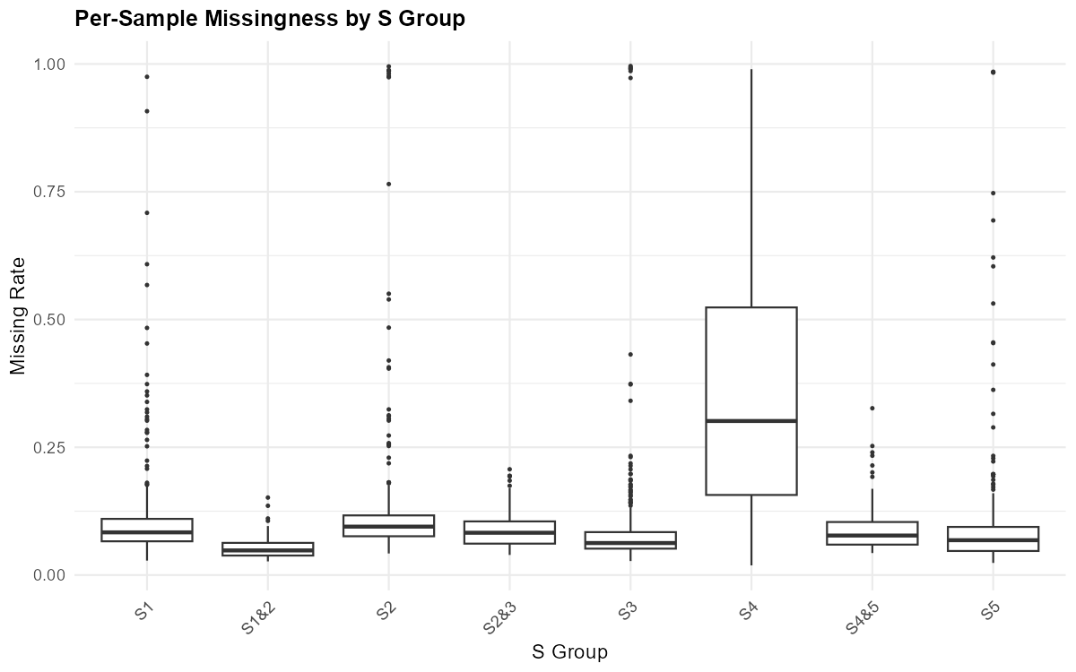
Figure 18. Per-sample missingness by S Group.

5.3 Mean Depth by Sequencing Plate
P17 and P18 have the lowest median depths (~19–20×), consistent with their elevated missingness. P05, P11, and P21 are the best at 40–48× median. Most plates fall in the 23–37× range, which is adequate for diploid genotyping. The depth variation across plates suggests uneven library pooling or sequencing lane allocation.
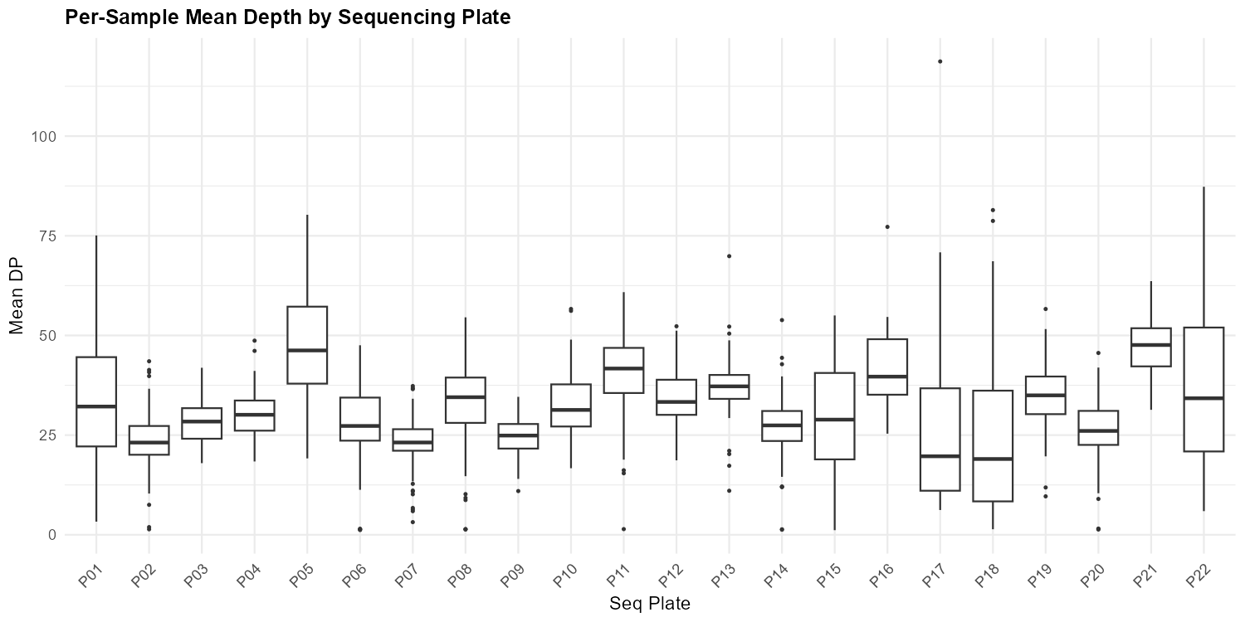
Figure 19. Per-sample mean depth by sequencing plate.

5.4 Heterozygosity by Sequencing Plate
Median het rates are relatively stable across plates (0.13–0.16), but P17 shows a marked downward shift (median ~0.11) with wide variance. This is a direct consequence of low depth: in the steep part of the depth-het curve, heterozygous genotypes are systematically undercalled. P05, P11, P16, P21, and P22 have the highest and tightest het distributions, corresponding to their higher depths.
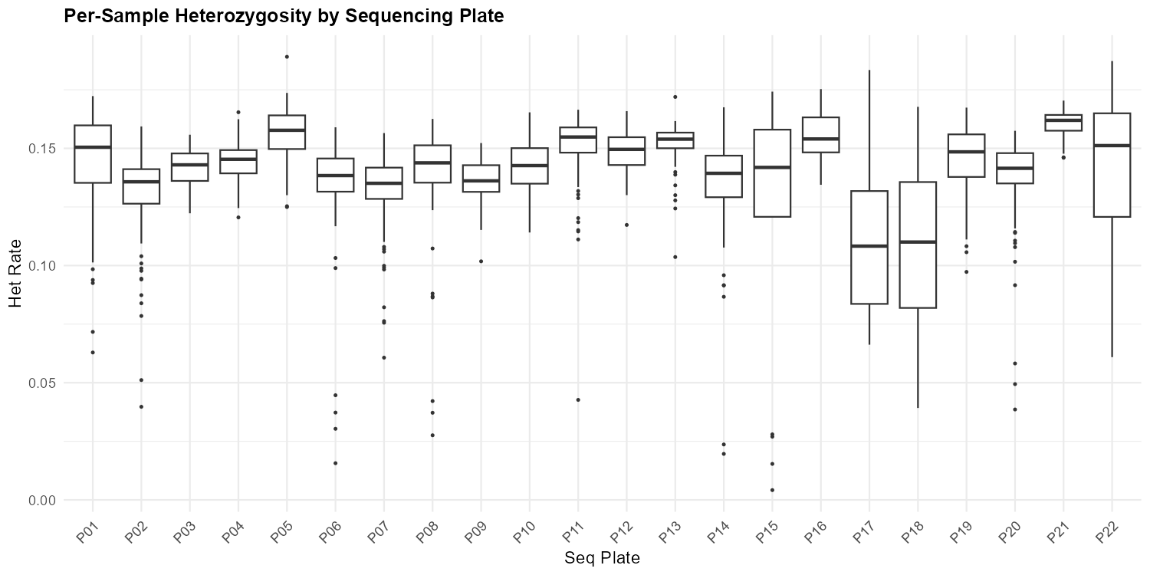
Figure 20. Per-sample heterozygosity by sequencing plate.

5.5 DNA Input vs QC Metrics
DNA concentration and total DNA show essentially no relationship with missingness or depth (flat LOESS curves). This indicates that the QC variation is driven by sequencing and library preparation rather than DNA quality. Extreme-missingness outliers do not cluster at low DNA concentrations, and high-concentration samples do not consistently achieve better depth. This is a positive finding—it means DNA extraction was not a bottleneck in this dataset.
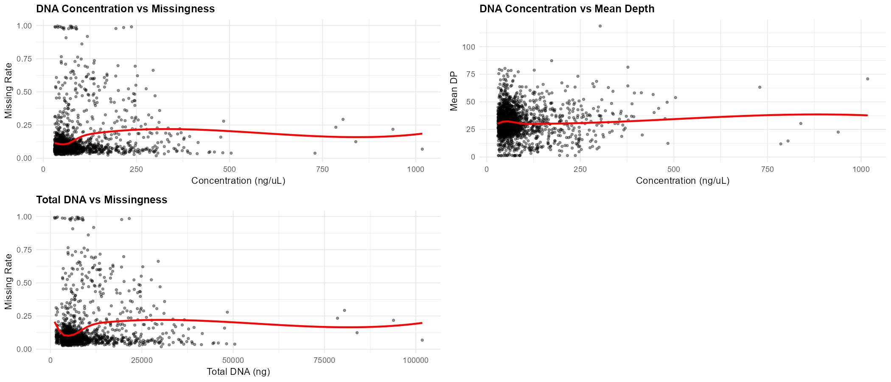
Figure 21. DNA concentration and total DNA vs missingness and mean depth (LOESS smoothers in red).

5.6 Well-Position Effects
The well-position heatmaps (averaged across all plates) show mild spatial patterns. Well E1 has notably elevated missingness. A gradient pattern is visible in the depth heatmap, with lower DP in some corner and edge positions (particularly rows A–C at columns 11–12). These patterns are suggestive of a plate-edge effect, but plate-specific effects (especially P17/P18) likely dominate the signal when averaged across all plates.
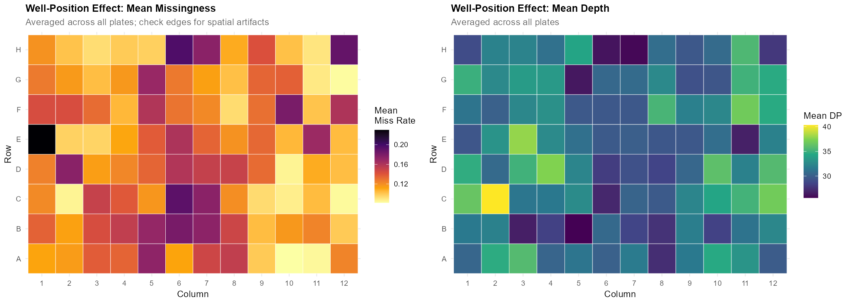
Figure 22. Well-position heatmaps for mean missingness (left) and mean depth (right), averaged across all plates.

6. Excess Heterozygosity and Paralog Detection
The KGD fin plot displays observed heterozygosity (Hobs) against alternate allele frequency (p) for each site. The black parabola represents the HWE expectation (2p(1−p)). Sites plotted in red exceed the HWE expectation and represent excess heterozygosity. The red region is dense and forms a prominent triangle at intermediate allele frequencies (0.25–0.75), extending to Hobs ≈ 1.0. This is a hallmark of collapsed paralogs: when reads from two distinct genomic loci map to the same reference location, nearly all individuals appear heterozygous regardless of their true genotype. This is common in conifer genomes, which have large duplicated regions and a draft-quality reference assembly.
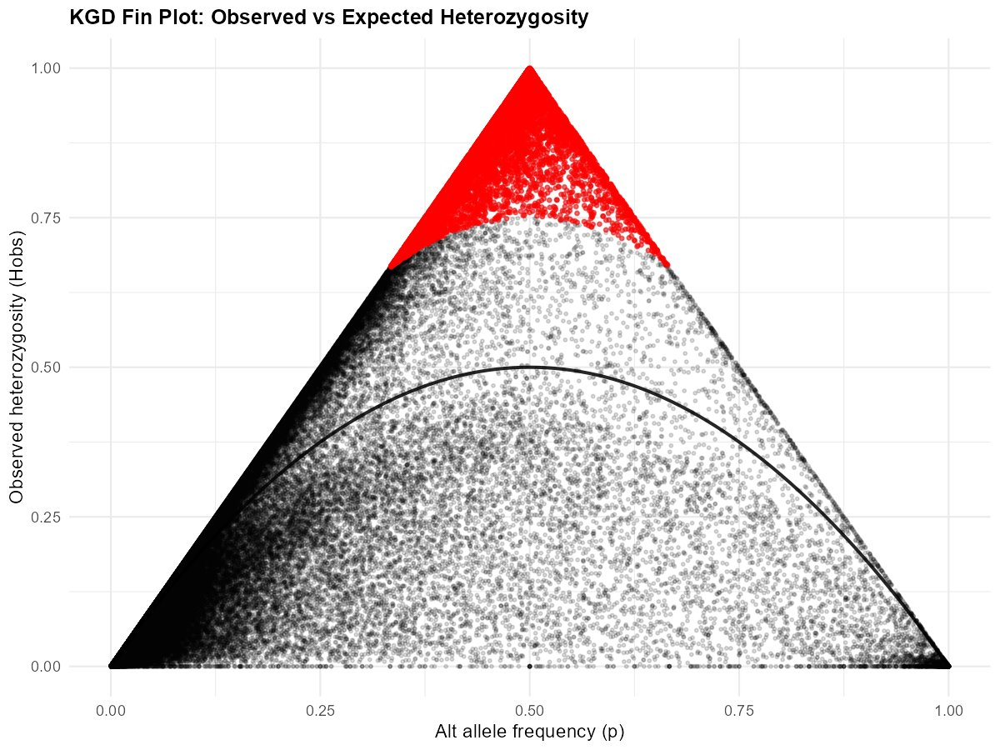
Figure 23. KGD fin plot: observed vs expected heterozygosity. Red = sites exceeding HWE expectation.
Suggested cutoff: An excess heterozygosity filter (e.g., removing sites where Hobs > 2p(1−p) + threshold, or equivalently an inbreeding coefficient F < −0.5) is essential. Combined with the HWE p-value filter (Section 3.4), this should capture most paralog artefacts.

7. Population Structure (PCA)

7.1 PCA Scree Plot
PC1 explains ~1.5% of variance, declining gradually to ~0.7% by PC10. There is no sharp elbow, which is typical for a moderately structured conifer population without deep divergence. The first 5 PCs collectively explain approximately 6.5% of total variance, indicating real but modest population structure.
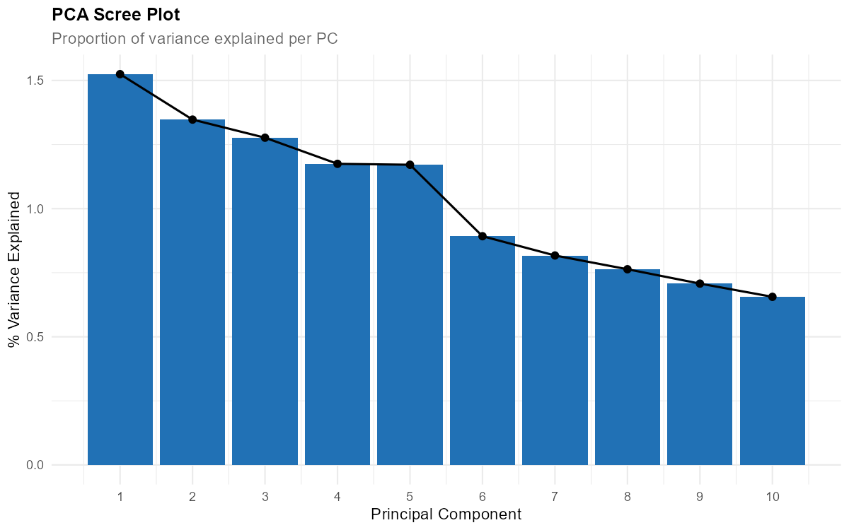
Figure 24. PCA scree plot showing proportion of variance explained per principal component.

7.2 PCA Coloured by Sequencing Plate
The PCA reveals 3–4 genetic clusters along PC1 and PC2. Critically, sequencing plates do not segregate cleanly by cluster—most clusters contain samples from multiple plates. This is strong evidence that the PCA structure reflects real biological/family structure in the pedigree rather than batch artefacts.
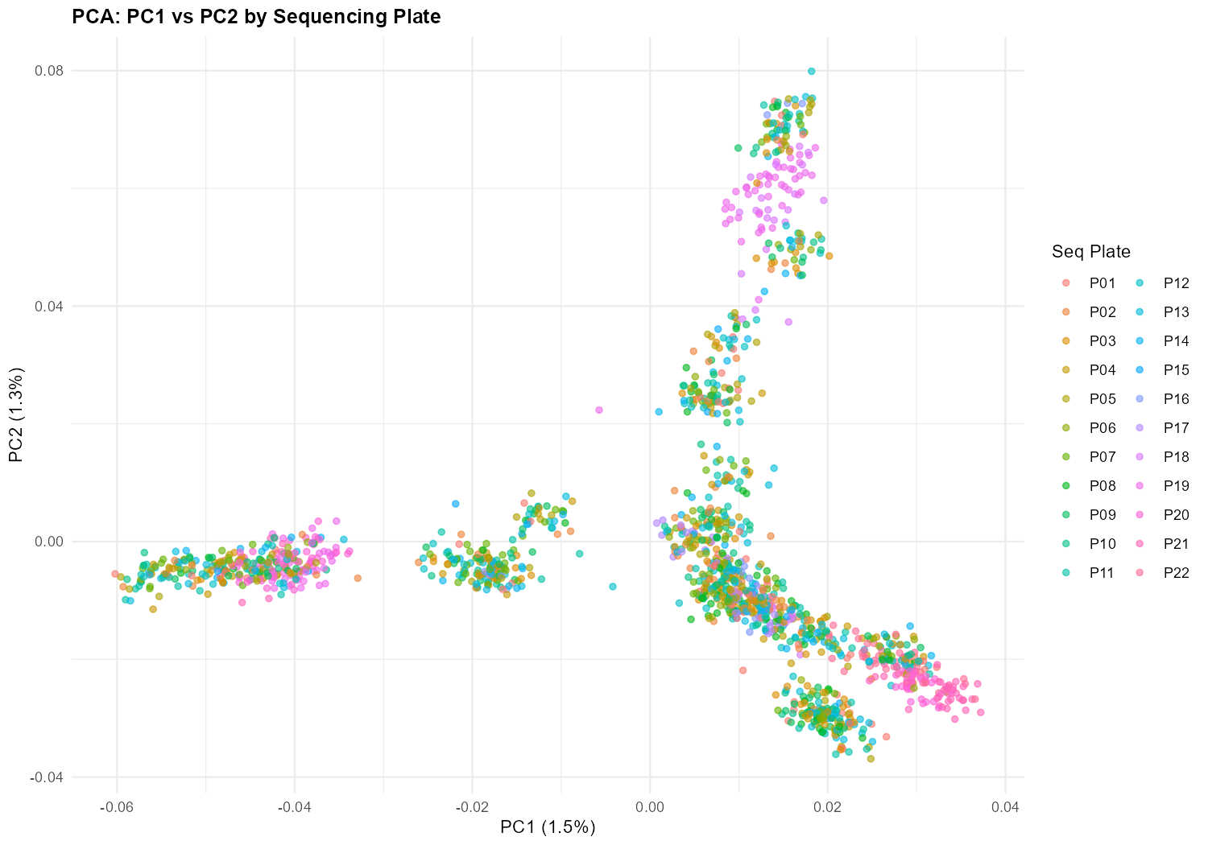
Figure 25. PCA (PC1 vs PC2) coloured by sequencing plate.

7.3 PCA Coloured by S Group
Some S Groups show partial sorting along PC axes (e.g., S5 concentrating in the bottom-right, S4 in the upper-right), consistent with S Groups representing different breeding zones or cross combinations within the pedigree. However, considerable overlap exists, indicating that S Group is not a clean proxy for genetic background.
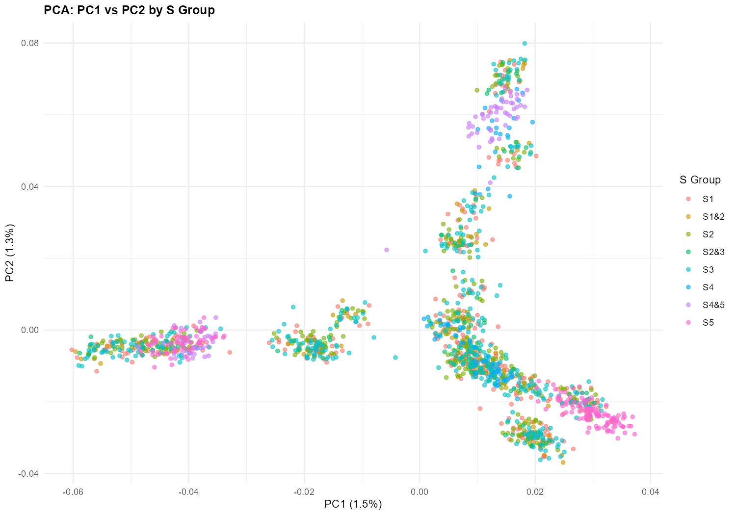
Figure 26. PCA (PC1 vs PC2) coloured by S Group.

7.4 PCA Coloured by Client Plate
Client plates show somewhat more structure in PCA space than sequencing plates, as expected—client plates are more likely to correspond to biological groupings (families, provenances) rather than arbitrary sequencing batches.
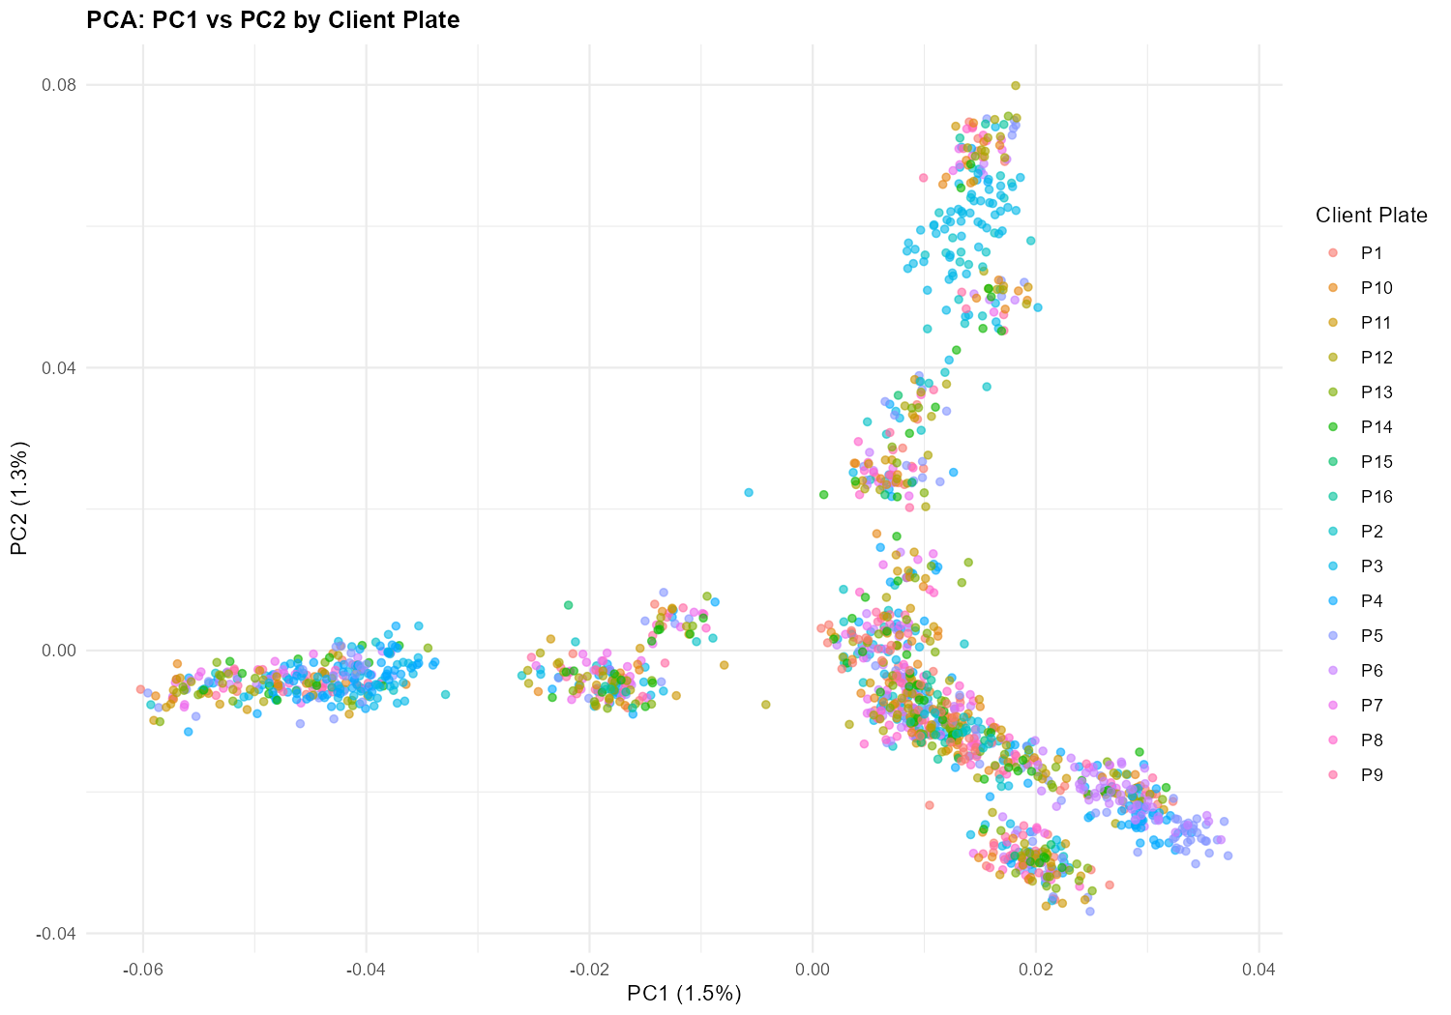
Figure 27. PCA (PC1 vs PC2) coloured by client plate.

7.5 PCA Coloured by Missingness
No PCA cluster is exclusively defined by high missingness. Higher-missingness samples (yellow) are scattered across clusters rather than forming a separate technical artefact cluster. This confirms that the principal components are capturing genuine genetic signal. Some elevation in missingness is visible in the upper-right cluster, which partially corresponds to the lower-performing plates.
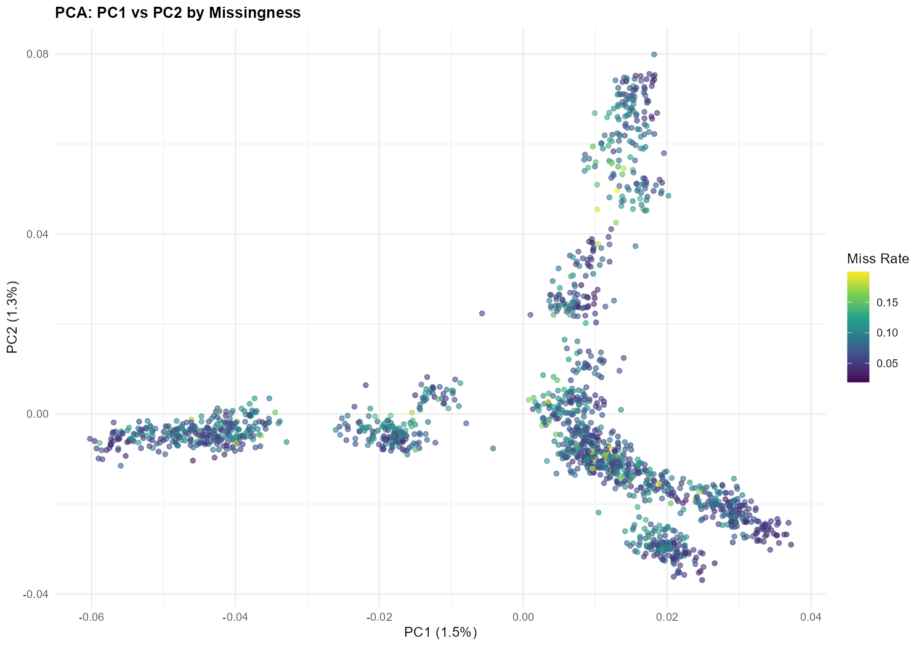
Figure 28. PCA (PC1 vs PC2) coloured by per-sample missing rate.

7.6 PCA Coloured by Mean Depth
Similarly, depth does not drive PCA clustering. Most samples are in the 20–50× range regardless of cluster membership. A few scattered higher-depth outliers (pink/orange) appear in multiple clusters. This further supports the conclusion that PCA structure is biological, not technical.
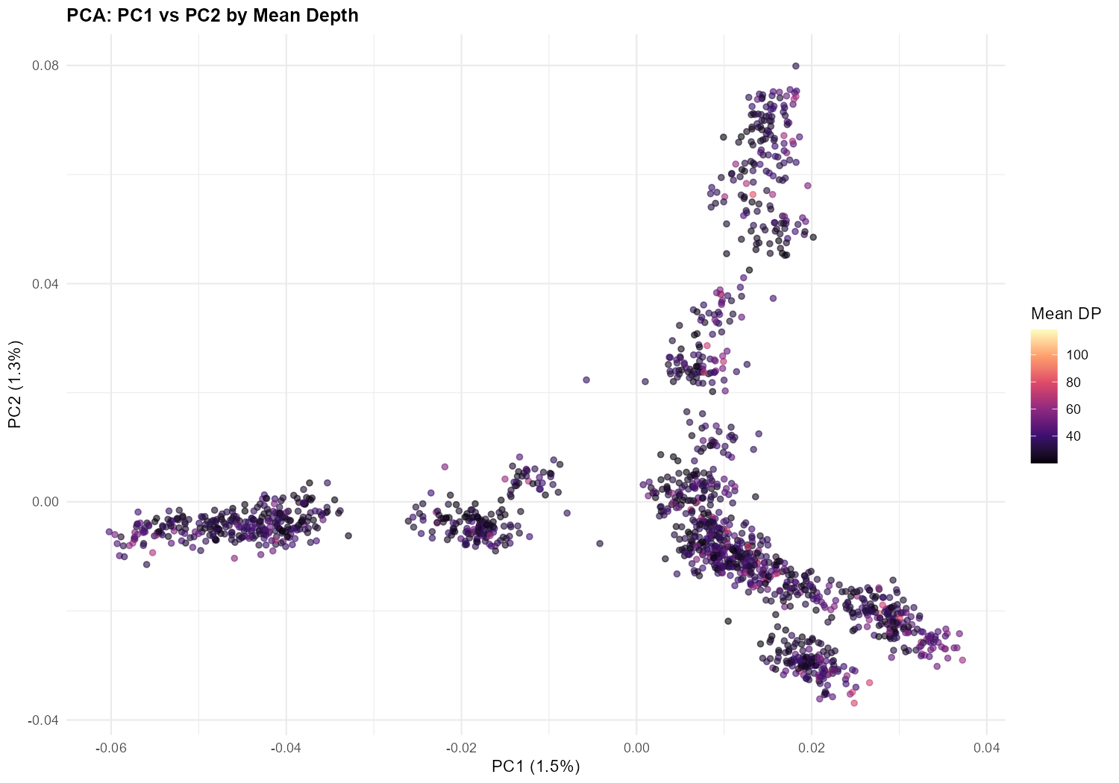
Figure 29. PCA (PC1 vs PC2) coloured by per-sample mean depth.

8. Relatedness (GRM Diagnostics)

8.1 GRM Off-Diagonal Distribution
The GRM off-diagonal distribution (computed on 1,555 samples and 50,000 SNPs) is centred slightly below zero with a long right tail extending to ~0.3. The mode near −0.02 is expected for an unrelated population with moderate structure. The right tail (0.05–0.30) is consistent with half-sib and closer relationships expected in the structured two-generation pedigree. No spikes at 0.5 (parent-offspring or full-sib) or 1.0 (duplicates) are visible, indicating no sample duplications or swaps.
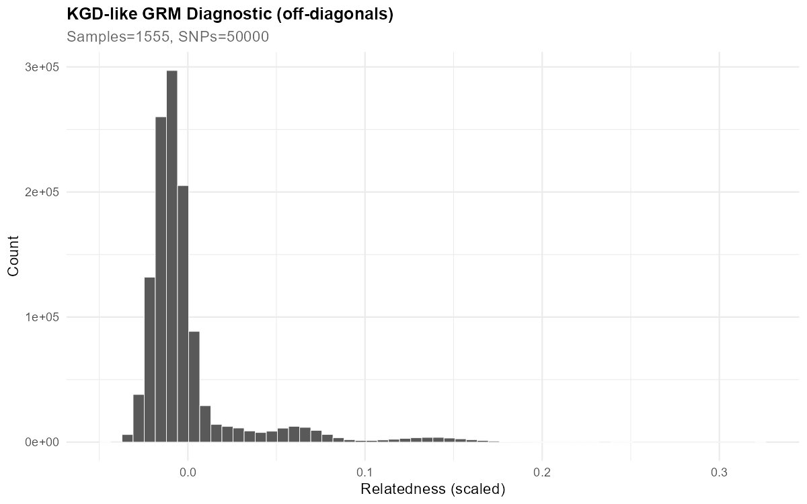
Figure 30. Distribution of GRM off-diagonal values (1,555 samples, 50,000 SNPs).

8.2 GRM Diagonal vs Mean Depth
A clear negative relationship exists between mean depth and GRM diagonal values: low-depth samples have inflated diagonals (~0.95–1.0) while high-depth samples converge toward ~0.75–0.85. This is the expected DP-dependent bias—at low depth, missing genotypes inflate the diagonal of the relationship matrix. One outlier at ~40× depth has a GRM diagonal above 1.0, suggesting potential issues with that sample. Samples with very high depth (>75×) also show depressed diagonals, which could reflect contamination pulling the apparent relatedness-to-self downward.
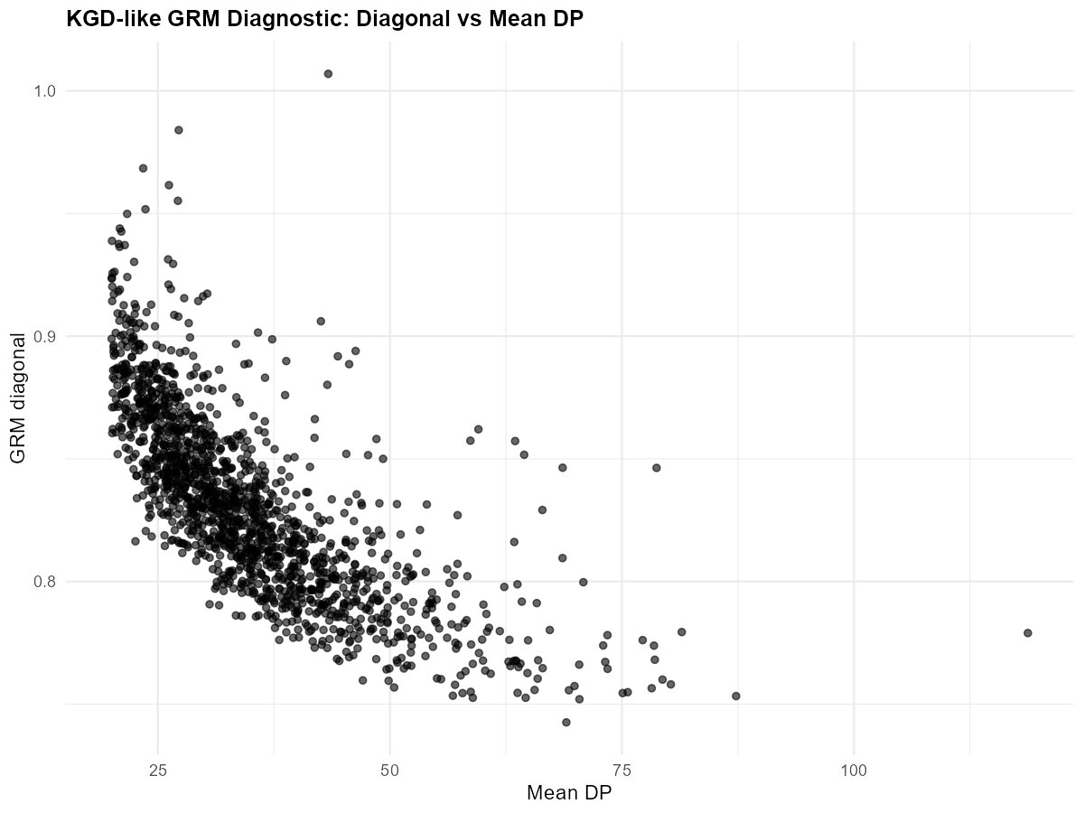
Figure 31. GRM diagonal values vs per-sample mean depth.

9. Recommended Filtering Cutoffs
The table below summarises suggested filtering thresholds for this dataset. Two tiers are provided: a moderate set that balances data retention with quality (suitable for genomic prediction and GRM estimation), and a strict set for analyses requiring high-confidence genotypes (e.g., GWAS, fine-mapping). These are starting recommendations; final thresholds should be tuned based on post-filter diagnostics and the specific analytical requirements.

Filter | Moderate | Strict | Rationale
MAF | ≥ 0.01 | ≥ 0.05 | Removes error-prone rare variants; strict threshold improves GWAS power
Site call rate | ≥ 0.70 | ≥ 0.90 | Removes poorly captured sites; strict threshold maximises completeness
Sample call rate | < 0.50 miss | < 0.30 miss | Moderate removes failures; strict also trims P17/P18 tail
QUAL | ≥ 20 | ≥ 30 | Standard VCF quality threshold; most variants far exceed this
HWE p-value | < 1×10⁻⁵ | < 1×10⁻⁵ | Targets paralog artefacts; excess het direction only
Genotype DP (min) | ≥ 5 | ≥ 10 | Floor for reliable het calls; strict adds ~295M missing genotypes
Genotype DP (max) | ≤ 2× mean | ≤ 2× mean | Caps paralog pileups (~60–70× for this dataset)
Sample mean DP | ≥ 5× | ≥ 10–15× | Removes failed libraries; strict ensures reliable het estimation
Excess het (Fis) | F < −0.5 | F < −0.5 | Removes collapsed paralogs visible in fin plot
Physical thinning | 1 per 100 bp | 1 per 500 bp | Reduces LD and clustering artefacts within scaffolds
SNP cluster | ≤ 3 in 10 bp | ≤ 3 in 10 bp | Flags densely clustered variants as potential artefacts

Table 1. Recommended filtering cutoffs (moderate and strict tiers).

Additional recommendations: (1) Plates P17 and P18 (S4 group) should be flagged for potential exclusion or analysed separately given their consistently poor performance across all metrics. (2) The ~15–20 near-complete-failure samples (>95% missingness) should be removed in all scenarios. (3) The anomalous sample at ~25× depth with ~88% missingness should be investigated individually. (4) Post-filter diagnostics should be re-run to confirm that filtering achieved the intended improvements.

