OneLab attends Business Continuity Meeting Phase 1 at Acacia Hotel Alabang, Muntinlupa City on August 30-Sept2

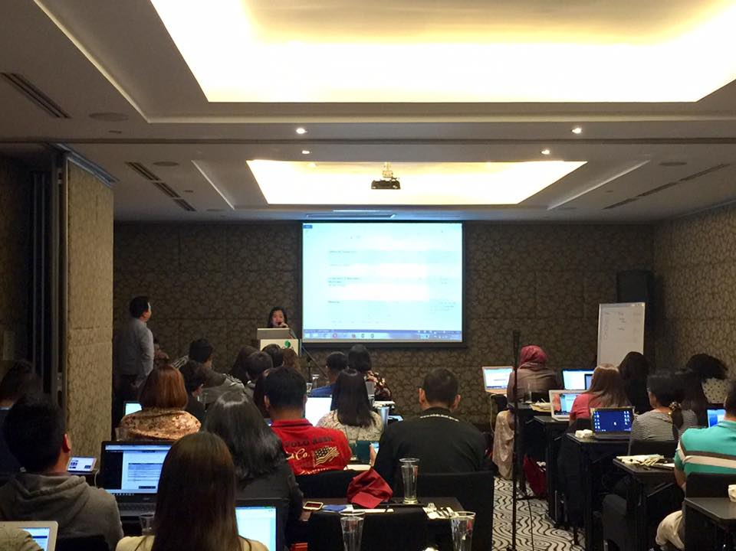

OneLab Team conducts Year 2 Planning Workshop at FNRI Training Room on September 11-12

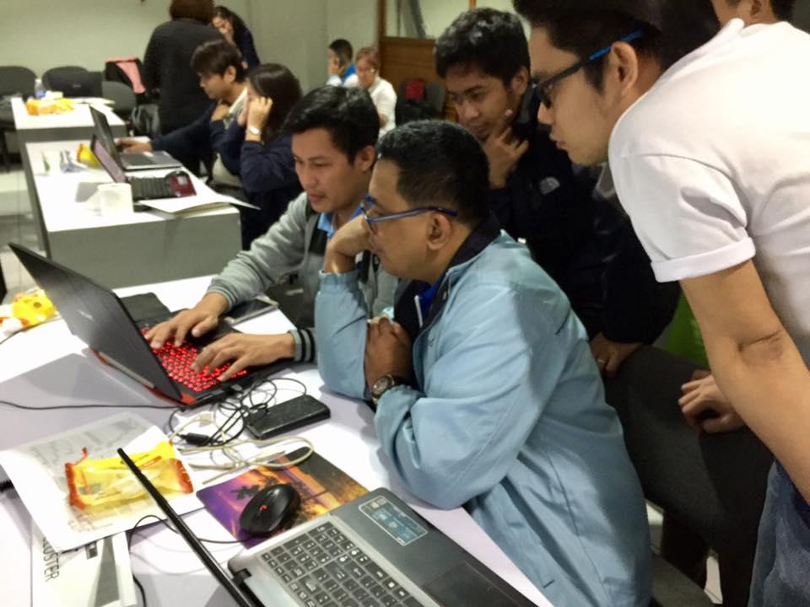

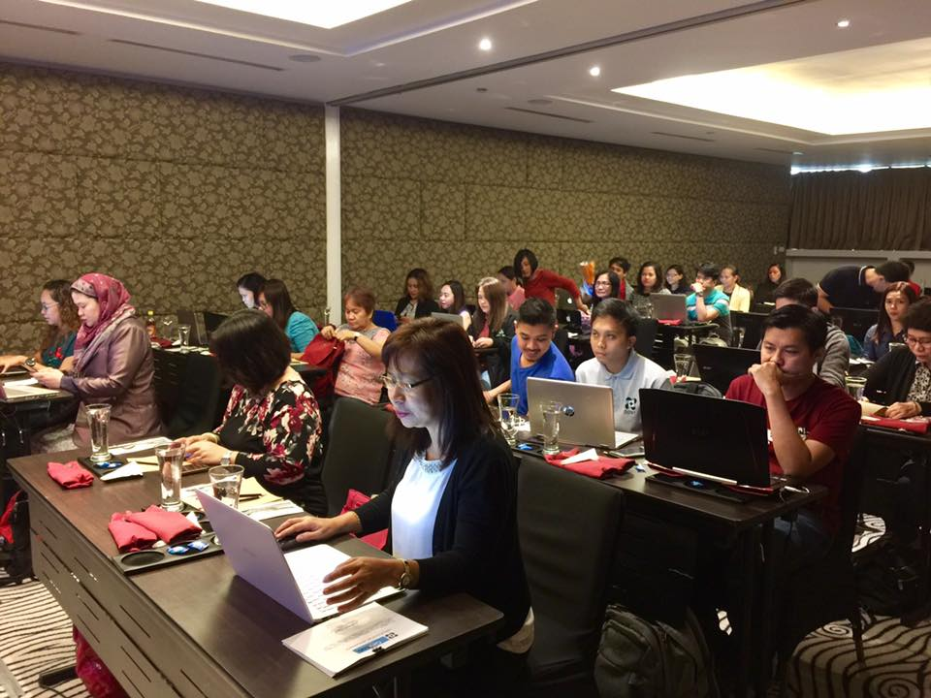OneLab attends the last leg of Business Continuity Meeting Phase 2 at Acacia Hotel Alabang, Muntinlupa City on September 13-16