Q1
import numpy as np
arrays = {
"From a list": np.array([17, 42, 68, 93]),
"Zeros": np.zeros((2, 4)),
"Ones": np.ones((3, 2), dtype=int),
"Using arange": np.arange(7, 32, 5),
"Using linspace": np.linspace(2.5, 9.5, 5),
}
for name, array in arrays.items():
print(f"\n{name}:\n{array}")
print(f"ndim={array.ndim}, shape={array.shape}, size={array.size}, dtype={array.dtype}")
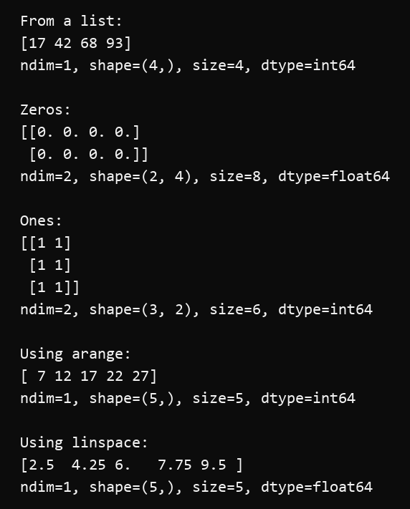

Q2
import numpy as np
one_d = np.array([14, 27, 39, 52, 68, 81])
two_d = np.array([[12, 25, 37], [41, 58, 63], [76, 84, 99]])
print("1-D array:", one_d)
print("Element at index 2:", one_d[2])
print("Last element using negative indexing:", one_d[-1])
print("Slice from index 1 to 4:", one_d[1:5])
print("Every second element:", one_d[::2])
print("2-D array:\n", two_d)
print("Element at row 2, column 3:", two_d[1, 2])
print("Last element using negative indexing:", two_d[-1, -1])
print("Second row:", two_d[1, :])
print("Third column:", two_d[:, 2])
print("Top-left 2 x 2 slice:\n", two_d[:2, :2])
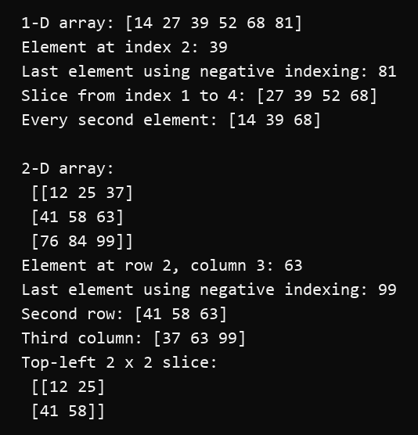

Q3
import numpy as np
numbers = np.arange(1, 25)
reshaped = numbers.reshape(4, 6)
flattened = reshaped.flatten()
ravelled = reshaped.ravel()
print("Original array:\n", numbers)
print("Reshaped to 4 x 6:\n", reshaped)
print("flatten():", flattened)
print("ravel():", ravelled)
print("flatten() shares memory:", np.shares_memory(reshaped, flattened))
print("ravel() shares memory:", np.shares_memory(reshaped, ravelled))
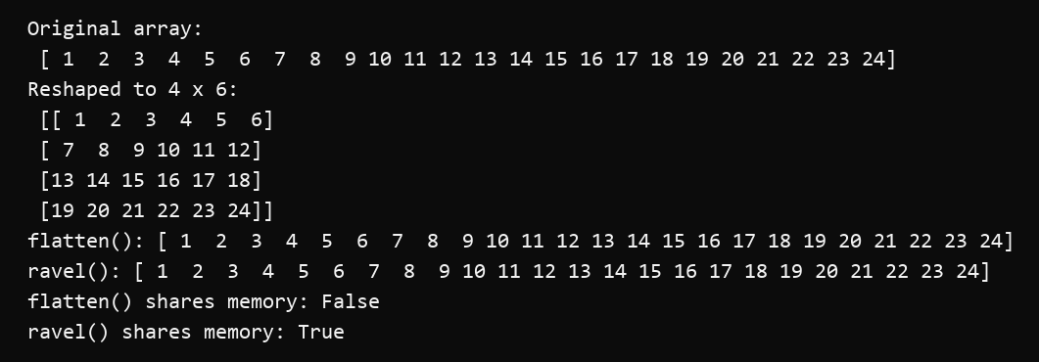

Q4
import numpy as np
one_d_a = np.array([11, 23, 37])
one_d_b = np.array([42, 58, 69])
matrix_a = np.array([[13, 26], [39, 47]])
matrix_b = np.array([[52, 64], [78, 91]])
print("1-D concatenation:", np.concatenate((one_d_a, one_d_b)))
print("Axis 0:\n", np.concatenate((matrix_a, matrix_b), axis=0))
print("Axis 1:\n", np.concatenate((matrix_a, matrix_b), axis=1))
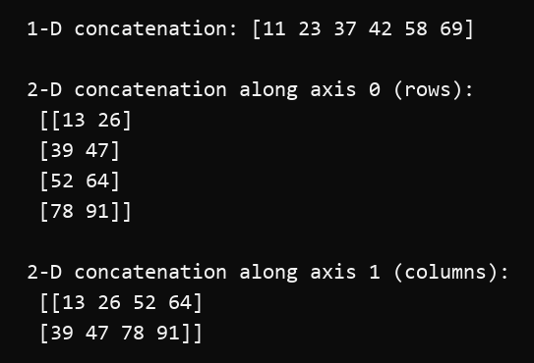

Q5
import numpy as np
array_a = np.array([12, 18, 27, 35, 44], dtype=float)
array_b = np.array([2, 3, 3, 5, 4], dtype=float)
print("A:", array_a)
print("B:", array_b)
print("Addition:", np.add(array_a, array_b))
print("Subtraction:", np.subtract(array_a, array_b))
print("Multiplication:", np.multiply(array_a, array_b))
print("Division:", np.divide(array_a, array_b))
print("Power:", np.power(array_a, array_b))
print("Minimum:", np.minimum(array_a, array_b))
print("Maximum:", np.maximum(array_a, array_b))
print("Mean:", np.mean(array_a))
print("Median:", np.median(array_a))
print("Standard deviation:", np.std(array_a))
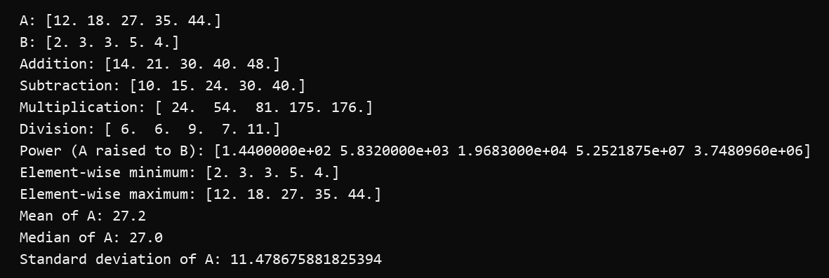

Q6
import numpy as np
matrix_1 = np.array([[6.0, 3.0], [4.0, 7.0]])
matrix_2 = np.array([[2.0, 5.0], [9.0, 1.0]])
print("Matrix 1:\n", matrix_1)
print("Matrix 2:\n", matrix_2)
print("Matrix multiplication:\n", matrix_1 @ matrix_2)
print("Transpose:\n", matrix_1.T)
print("Determinant:", np.linalg.det(matrix_1))
print("Inverse:\n", np.linalg.inv(matrix_1))
print("Eigenvalues:", np.linalg.eigvals(matrix_1))
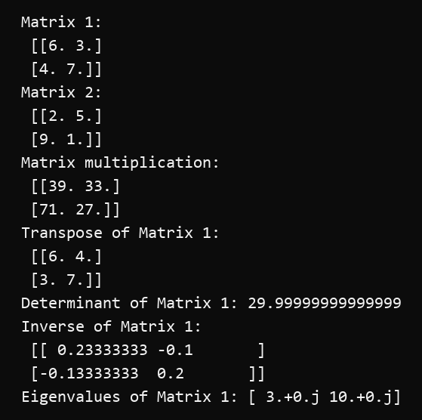

Q7
import numpy as np
rng = np.random.default_rng(seed=42)
random_integers = rng.integers(1, 101, size=10)
random_matrix = rng.random((3, 3))
random_floats = rng.random(20)
for name, values in [
("10 random integers from 1 to 100", random_integers),
("3 x 3 random matrix", random_matrix),
("20 random floating-point values", random_floats),
]:
print(f"\n{name}:\n{values}")
print(f"Minimum={np.min(values):.4f}, Maximum={np.max(values):.4f}, "
f"Mean={np.mean(values):.4f}, Standard deviation={np.std(values):.4f}")
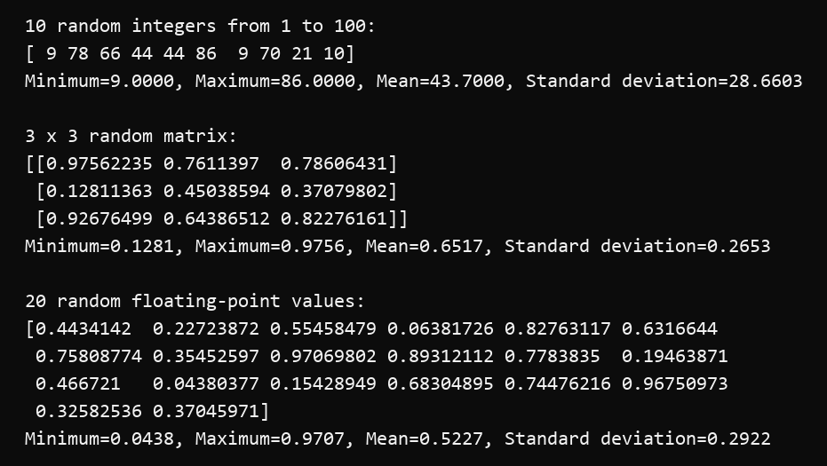

Q8
import numpy as np
student_marks = np.array([
64, 83, 71, 96, 58, 77, 89, 68, 92, 74,
81, 55, 87, 79, 66, 94, 72, 85, 61, 90
])
above_75 = student_marks[student_marks > 75]
print("All marks:", student_marks)
print("Marks above 75:", above_75)
print("Average of marks above 75:", np.mean(above_75))
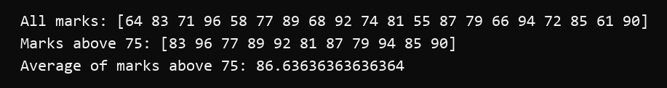

Q9
import numpy as np
marks = np.array([65, 78, 82, 56, 91, 73, 88, 69, 95, 61])
print("Mean:", np.mean(marks))
print("Median:", np.median(marks))
print("Variance:", np.var(marks))
print("Standard deviation:", np.std(marks))
print("Minimum:", np.min(marks))
print("Maximum:", np.max(marks))
print("Percentiles:", np.percentile(marks, [25, 50, 75]))
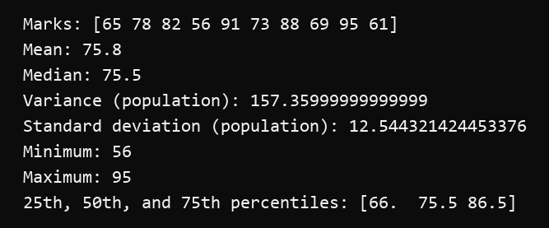

Q10
import matplotlib.pyplot as plt
x = [1, 2, 3, 4, 5]
y = [2, 5, 4, 8, 10]
plt.plot(x, y, marker="o", linewidth=2, color="royalblue")
plt.title("Simple Line Plot")
plt.xlabel("X values")
plt.ylabel("Y values")
plt.grid(True, linestyle="--", alpha=0.6)
plt.show()
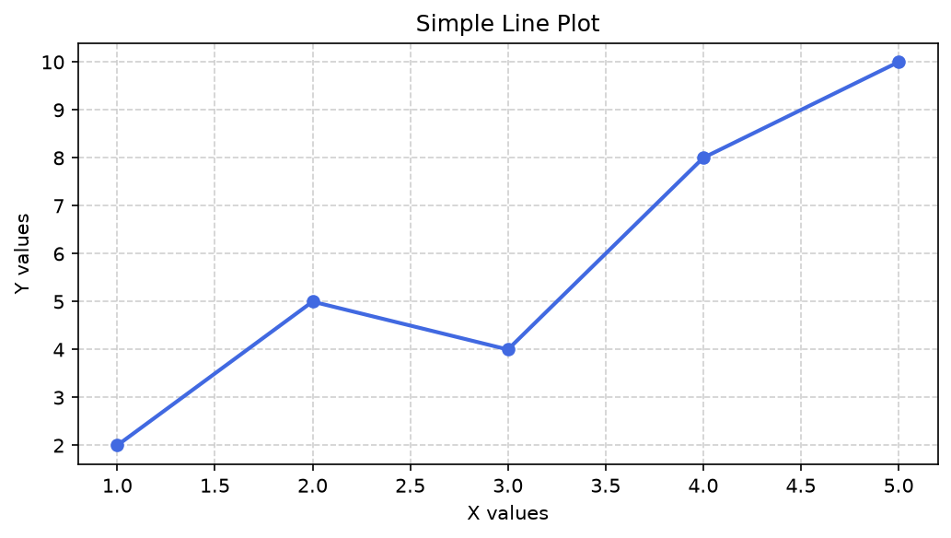

Q11
import matplotlib.pyplot as plt
months = ["Jan", "Feb", "Mar", "Apr", "May", "Jun", "Jul", "Aug", "Sep", "Oct", "Nov", "Dec"]
city_a = [22, 24, 27, 30, 32, 31, 29, 28, 27, 26, 24, 22]
city_b = [18, 20, 23, 26, 29, 30, 31, 30, 28, 25, 22, 19]
plt.plot(months, city_a, "o-", linewidth=2, label="City A")
plt.plot(months, city_b, "s--", linewidth=2, label="City B")
plt.title("Monthly Temperature Comparison")
plt.xlabel("Month")
plt.ylabel("Temperature (°C)")
plt.grid(True, linestyle=":", alpha=0.6)
plt.legend()
plt.show()
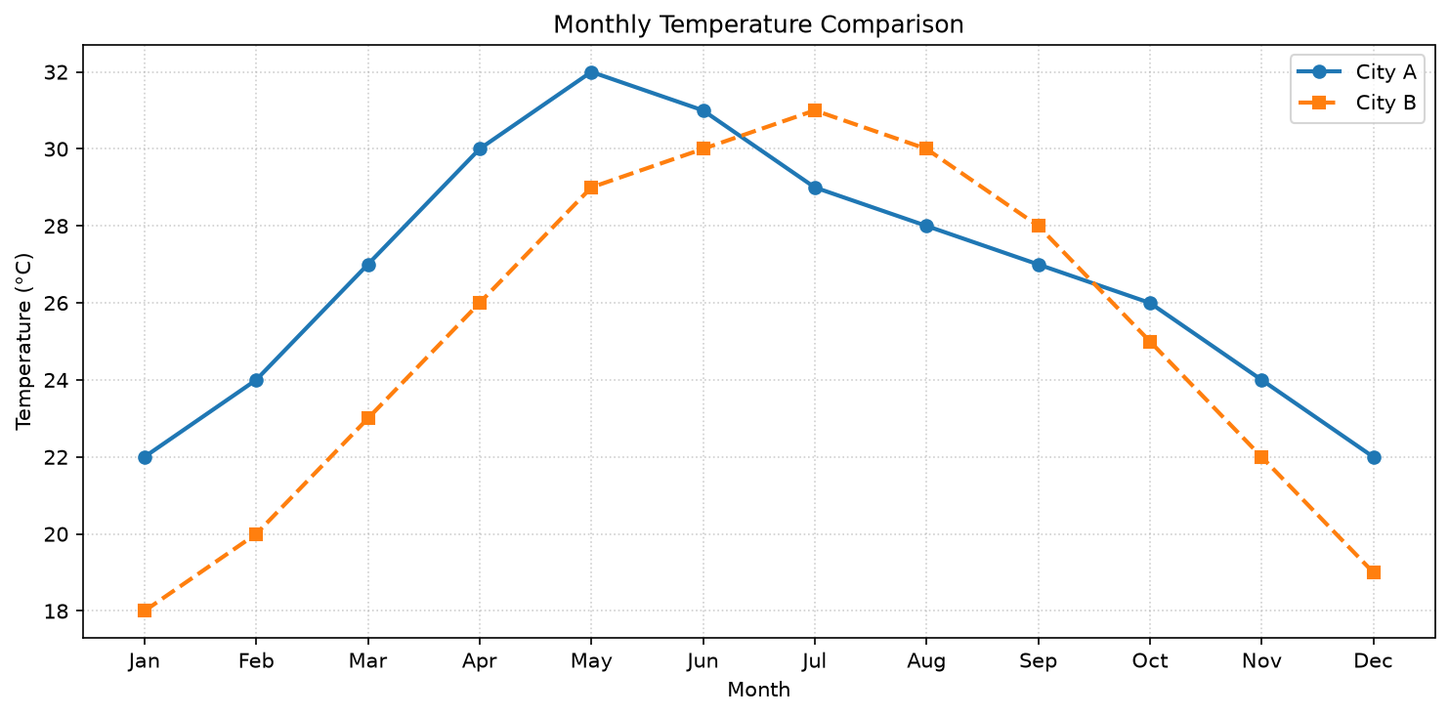

Q12
import matplotlib.pyplot as plt
courses = ["Python", "Data Science", "Machine Learning", "Computer Networks", "Image Processing"]
students = [45, 38, 42, 30, 35]
bars = plt.bar(courses, students)
plt.title("Students Enrolled in Different Courses")
plt.xlabel("Course")
plt.ylabel("Number of Students")
plt.xticks(rotation=15, ha="right")
plt.bar_label(bars)
plt.tight_layout()
plt.show()
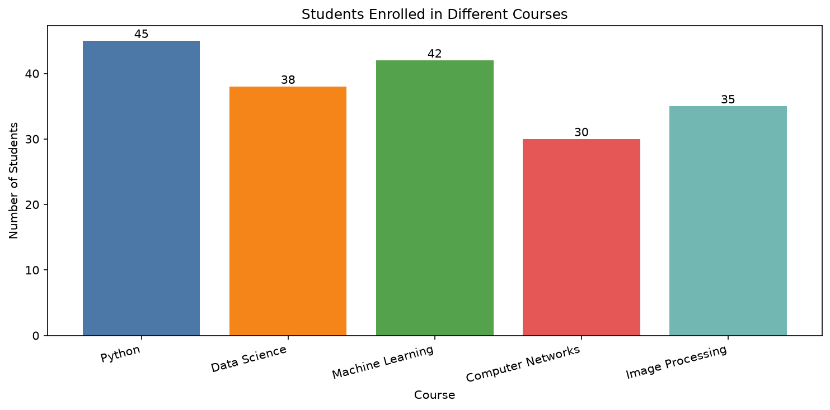

Q13
import numpy as np
import matplotlib.pyplot as plt
rng = np.random.default_rng(seed=13)
values = rng.normal(loc=0, scale=1, size=1000)
plt.hist(values, bins=30, color="mediumpurple", edgecolor="black", alpha=0.8)
plt.title("Distribution of 1000 Normally Distributed Values")
plt.xlabel("Value")
plt.ylabel("Frequency")
plt.grid(axis="y", linestyle="--", alpha=0.4)
plt.show()
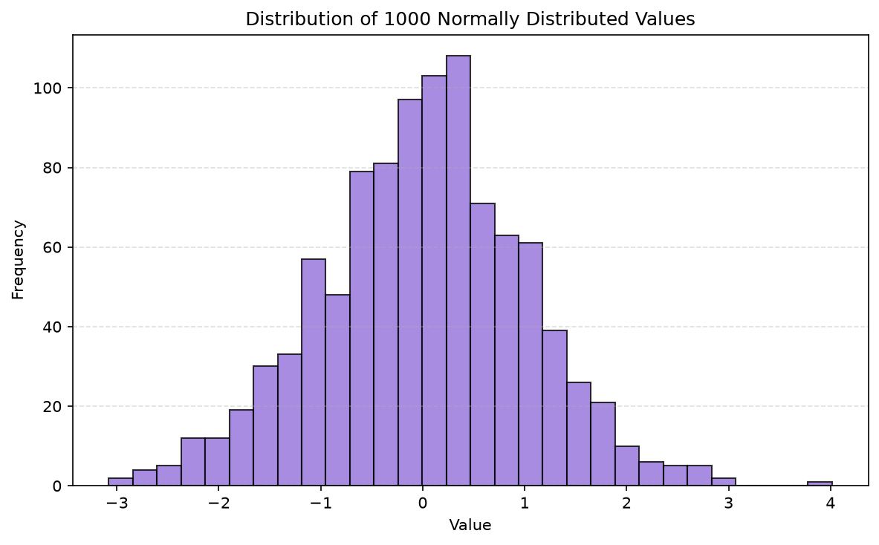

Q14
import numpy as np
import matplotlib.pyplot as plt
rng = np.random.default_rng(seed=14)
x = rng.random(50) * 100
y = 0.6 * x + rng.normal(0, 12, 50)
sizes = rng.integers(30, 250, size=50)
plt.scatter(x, y, s=sizes, c=y, cmap="viridis", alpha=0.7, edgecolors="black")
plt.title("Relationship Between Two Random Variables")
plt.xlabel("Random X values")
plt.ylabel("Random Y values")
plt.colorbar(label="Y value")
plt.grid(True, linestyle=":", alpha=0.4)
plt.show()
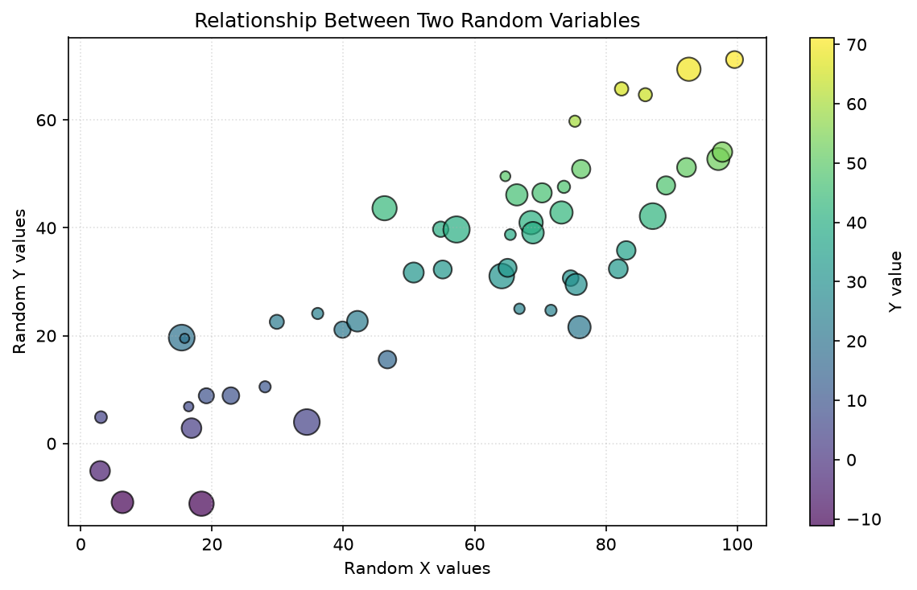

Q15
import matplotlib.pyplot as plt
departments = ["CSE", "ECE", "EEE", "Mechanical", "Civil"]
students = [60, 40, 35, 30, 35]
plt.pie(students, labels=departments, autopct="%1.1f%%", startangle=90,
wedgeprops={"edgecolor": "white"})
plt.title("Percentage Distribution of Students by Department")
plt.axis("equal")
plt.show()
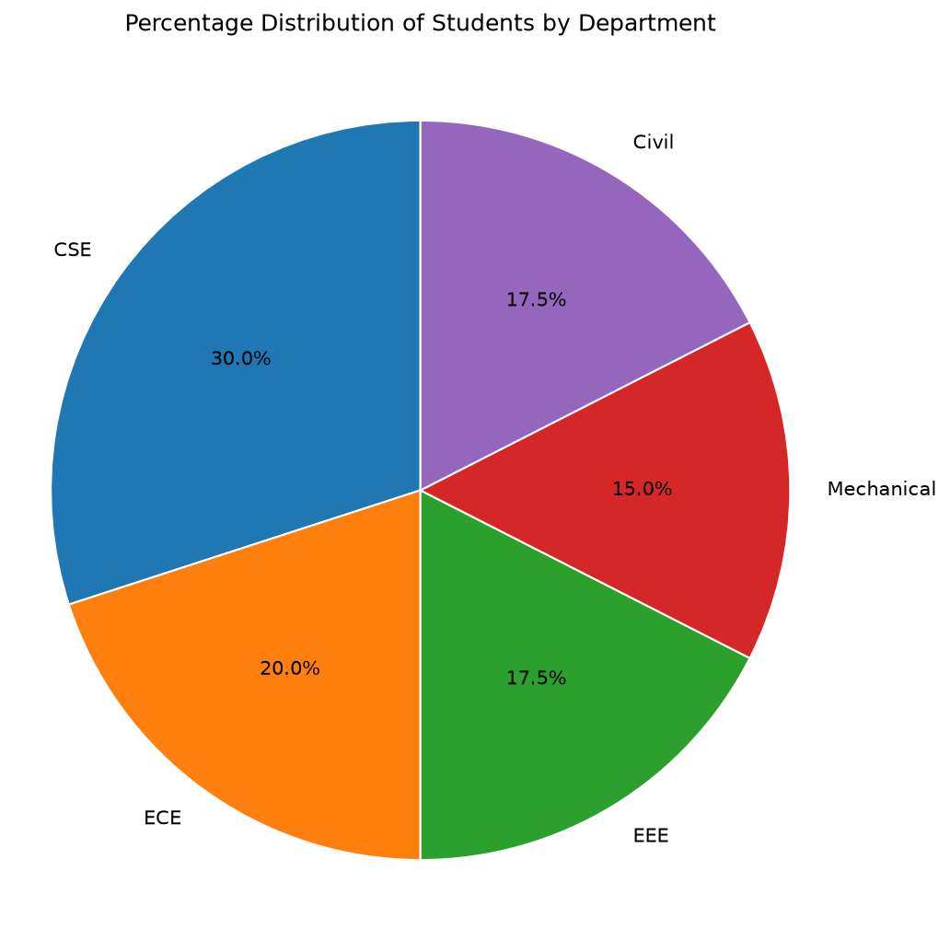

Q16
import numpy as np
import matplotlib.pyplot as plt
x = np.linspace(0, 2 * np.pi, 200)
plt.plot(x, np.sin(x), label="sin(x)", color="crimson", linewidth=2)
plt.plot(x, np.cos(x), label="cos(x)", color="navy", linestyle="--", linewidth=2)
plt.title("Sine and Cosine Functions")
plt.xlabel("x (radians)")
plt.ylabel("Function value")
plt.xticks([0, np.pi / 2, np.pi, 3 * np.pi / 2, 2 * np.pi],
["0", "π/2", "π", "3π/2", "2π"])
plt.axhline(0, color="black", linewidth=0.8)
plt.grid(True, linestyle=":", alpha=0.5)
plt.legend()
plt.show()
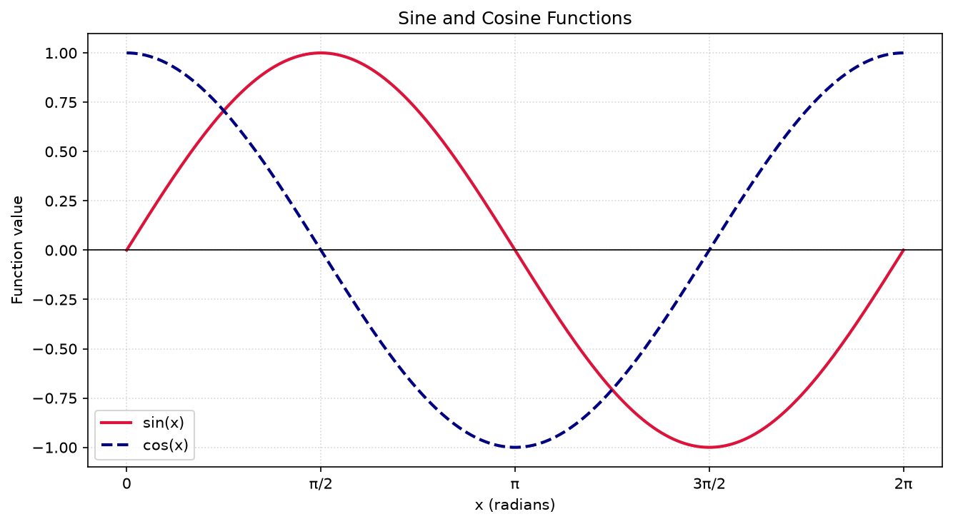

Q17
import networkx as nx
import matplotlib.pyplot as plt
nodes = ["Arun", "Diya", "Meera", "Nikhil", "Sara"]
edges = [
("Arun", "Diya"), ("Arun", "Meera"),
("Diya", "Meera"), ("Diya", "Nikhil"),
("Meera", "Sara"), ("Nikhil", "Sara")
]
graph = nx.Graph()
graph.add_nodes_from(nodes)
graph.add_edges_from(edges)
print("Number of nodes:", graph.number_of_nodes())
print("Number of edges:", graph.number_of_edges())
print("Degree of each node:", dict(graph.degree()))
print("Neighbors of node Diya:", list(graph.neighbors("Diya")))
print("Adjacency list:")
for line in nx.generate_adjlist(graph):
print(" ", line)
directed_graph = nx.DiGraph(edges)
print("In-degree:", dict(directed_graph.in_degree()))
print("Out-degree:", dict(directed_graph.out_degree()))
positions = nx.spring_layout(graph, seed=42)
nx.draw(graph, positions, with_labels=True, node_color="skyblue",
node_size=1500, edge_color="gray", width=2, font_weight="bold")
plt.title("Undirected Graph with Five Nodes and Six Edges")
plt.show()
