**RESULTS**

# Change in Negative Sentiment

**INTERCEPT AS INDICATED BY THE PRE-REG**

[QUALITY] ~ Ethnorace*Affiliation_Contrast*(Condition_Contrast or Date_index) + (1+Ethnorace*(Condition_Contrast or Date_index)|Subject_ID)

### Tweets Mentioning either Israeli and/or Jewish people or Arabic and/or Muslim people

*Changes in negative sentiment in tweets by the “Before” and “After” period*

## boundary (singular) fit: see help('isSingular')

Model Summary

|  | Estimate | Std. Error | df | t value | Pr(>|t|) |
| --- | --- | --- | --- | --- | --- |
| (Intercept) | 2.157893 | 1.189217 | 301.190757 | 1.8145495 | 0.0705879 |
| EthnoraceArabic and/or Muslim group | 7.148940 | 4.771941 | 2.804883 | 1.4981200 | 0.2371147 |
| Affiliation_ContrastLeft-leaning | 3.332712 | 1.651867 | 285.168207 | 2.0175427 | 0.0445755 |
| Condition_ContrastAfter 10/07/23 | 3.127981 | 1.319356 | 47.574604 | 2.3708399 | 0.0218480 |
| EthnoraceArabic and/or Muslim group:Affiliation_ContrastLeft-leaning | -8.639582 | 9.078019 | 2.896523 | -0.9517035 | 0.4137239 |
| EthnoraceArabic and/or Muslim group:Condition_ContrastAfter 10/07/23 | -8.462369 | 4.733700 | 2.765667 | -1.7876861 | 0.1795147 |
| Affiliation_ContrastLeft-leaning:Condition_ContrastAfter 10/07/23 | -3.431669 | 1.836748 | 59.327481 | -1.8683395 | 0.0666550 |
| EthnoraceArabic and/or Muslim group:Affiliation_ContrastLeft-leaning:Condition_ContrastAfter 10/07/23 | 8.777563 | 8.991652 | 2.874717 | 0.9761903 | 0.4037934 |

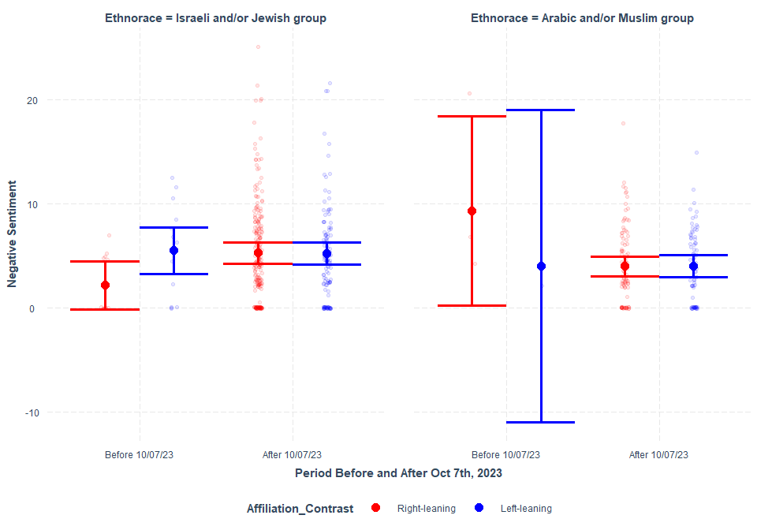

*Changes in negative sentiment in tweets between as date index (e.g., 10/07/23 as 0) moving backwards (min= -360) and forward (max= 362)*

## boundary (singular) fit: see help('isSingular')

Model Summary

|  | Estimate | Std. Error | df | t value | Pr(>|t|) |
| --- | --- | --- | --- | --- | --- |
| (Intercept) | 5.2497022 | 1.3505690 | 347.437251 | 3.8870301 | 0.0001215 |
| EthnoraceArabic and/or Muslim group | -1.3684428 | 1.7119709 | 20.068573 | -0.7993377 | 0.4334542 |
| Affiliation_ContrastLeft-leaning | -0.3125696 | 1.8880507 | 417.957200 | -0.1655515 | 0.8685900 |
| Date_Index | -0.0030929 | 0.0046383 | 9.299234 | -0.6668142 | 0.5210908 |
| EthnoraceArabic and/or Muslim group:Affiliation_ContrastLeft-leaning | 0.4315429 | 2.5249745 | 21.227460 | 0.1709098 | 0.8659133 |
| EthnoraceArabic and/or Muslim group:Date_Index | 0.0039280 | 0.0085666 | 13.611430 | 0.4585224 | 0.6538127 |
| Affiliation_ContrastLeft-leaning:Date_Index | 0.0045643 | 0.0063496 | 9.810700 | 0.7188235 | 0.4890163 |
| EthnoraceArabic and/or Muslim group:Affiliation_ContrastLeft-leaning:Date_Index | -0.0055245 | 0.0127331 | 15.645050 | -0.4338723 | 0.6703047 |

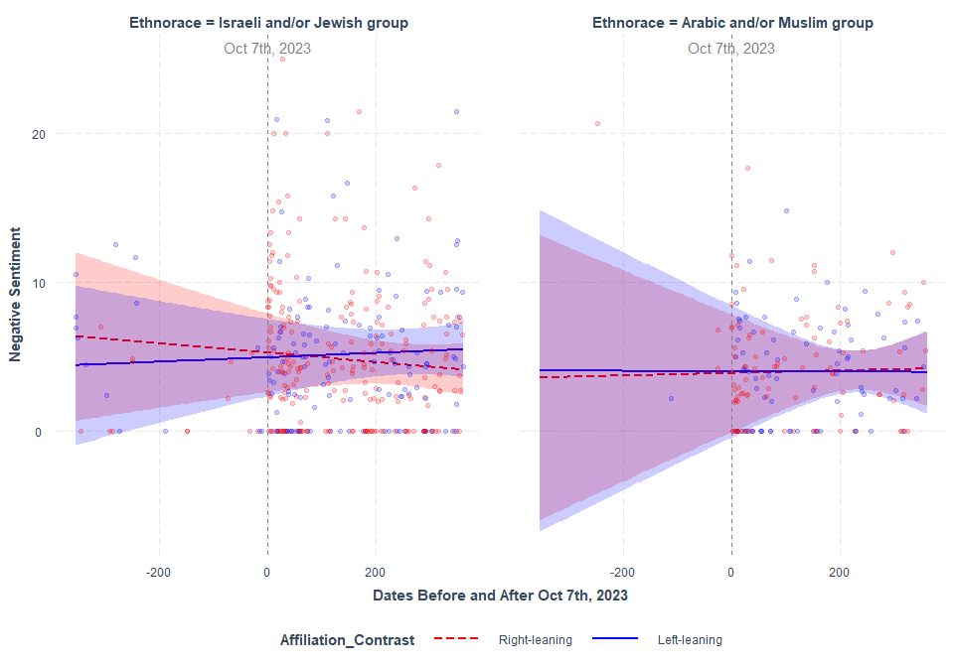

### Tweets Mentioning either IDF or Hamas

Changes in negative sentiment in tweets between as date index (e.g., 10/07/23 as 0) moving backwards (min= -360) and forward (max= 362). Note: IDF was not mentioned in any tweets between 10/07/22 and 10/06/23 (the “Before” period). So, the data was subsetted to only the ““After” period.

## boundary (singular) fit: see help('isSingular')

Model Summary

|  | Estimate | Std. Error | df | t value | Pr(>|t|) |
| --- | --- | --- | --- | --- | --- |
| (Intercept) | 1.6885940 | 2.995756 | 0.3667352 | 0.5636620 | 0.7623752 |
| MilitantHamas | 4.2079429 | 3.022227 | 0.5434213 | 1.3923319 | 0.5084851 |
| Affiliation_ContrastLeft-leaning | 0.8083810 | 5.206795 | 0.4933803 | 0.1552550 | 0.9175709 |
| Date_Index | 0.0546467 | 1.114661 | 317.3584923 | 0.0490254 | 0.9609299 |
| MilitantHamas:Affiliation_ContrastLeft-leaning | -2.7239265 | 5.284504 | 0.7420358 | -0.5154555 | 0.7188613 |
| MilitantHamas:Date_Index | -0.0592167 | 1.114694 | 299.6835895 | -0.0531237 | 0.9576687 |
| Affiliation_ContrastLeft-leaning:Date_Index | -0.0509858 | 1.441135 | 326.9169323 | -0.0353789 | 0.9717992 |
| MilitantHamas:Affiliation_ContrastLeft-leaning:Date_Index | 0.0600138 | 1.441212 | 316.4355746 | 0.0416412 | 0.9668110 |

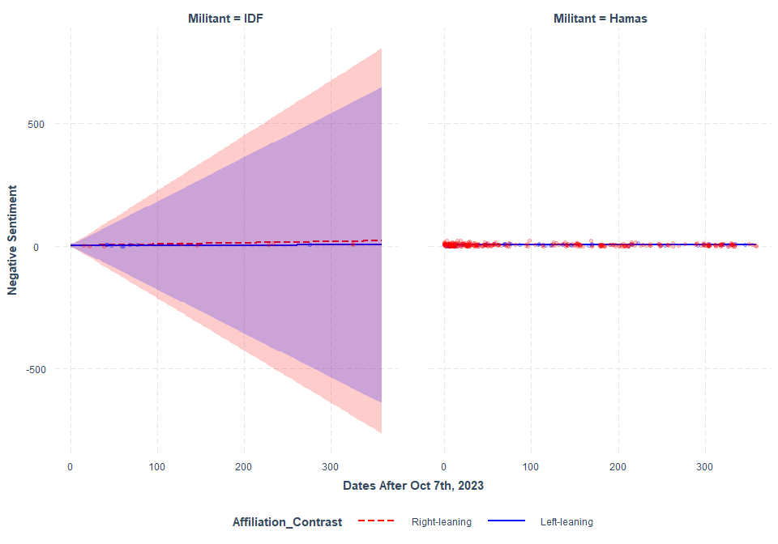

**SIMPLIFIED INTERCEPT**

[QUALITY] ~ Ethnorace*Affiliation_Contrast*(Condition_Contrast or Date_index) + (1|Subject_ID)

### Tweets Mentioning either Israeli and/or Jewish people or Arabic and/or Muslim people

Changes in negative sentiment in tweets by the “Before” and “After” period

Model Summary

|  | Estimate | Std. Error | df | t value | Pr(>|t|) |
| --- | --- | --- | --- | --- | --- |
| (Intercept) | 2.134729 | 1.222057 | 466.5418 | 1.746834 | 0.0813243 |
| EthnoraceArabic and/or Muslim group | 8.447642 | 2.785260 | 546.7029 | 3.032981 | 0.0025365 |
| Affiliation_ContrastLeft-leaning | 3.301992 | 1.698653 | 446.0416 | 1.943889 | 0.0525373 |
| Condition_ContrastAfter 10/07/23 | 3.021922 | 1.254289 | 513.0424 | 2.409270 | 0.0163357 |
| EthnoraceArabic and/or Muslim group:Affiliation_ContrastLeft-leaning | -11.440150 | 5.300000 | 546.8183 | -2.158519 | 0.0313220 |
| EthnoraceArabic and/or Muslim group:Condition_ContrastAfter 10/07/23 | -9.491227 | 2.836233 | 546.7152 | -3.346420 | 0.0008749 |
| Affiliation_ContrastLeft-leaning:Condition_ContrastAfter 10/07/23 | -3.430362 | 1.767134 | 472.1152 | -1.941201 | 0.0528286 |
| EthnoraceArabic and/or Muslim group:Affiliation_ContrastLeft-leaning:Condition_ContrastAfter 10/07/23 | 11.488763 | 5.359556 | 546.3413 | 2.143603 | 0.0325055 |

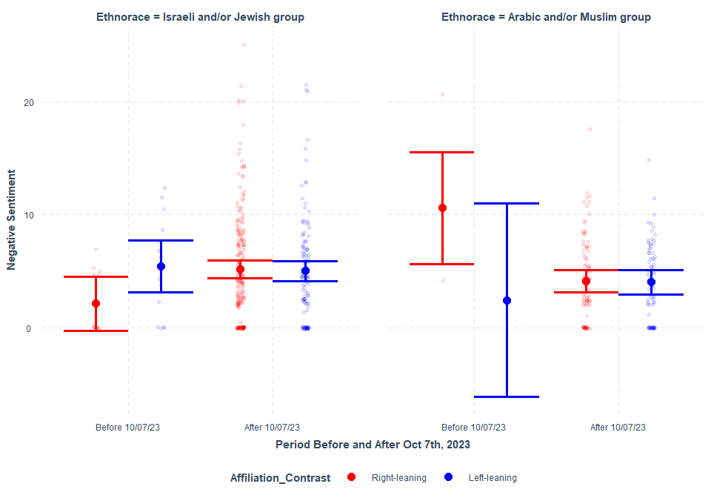

Changes in negative sentiment in tweets between as date index (e.g., 10/07/23 as 0) moving backwards (min= -360) and forward (max= 362)

Model Summary

|  | Estimate | Std. Error | df | t value | Pr(>|t|) |
| --- | --- | --- | --- | --- | --- |
| (Intercept) | 5.0361604 | 0.4548497 | 24.55851 | 11.0721406 | 0.0000000 |
| EthnoraceArabic and/or Muslim group | -0.5483524 | 0.7270375 | 546.93991 | -0.7542286 | 0.4510366 |
| Affiliation_ContrastLeft-leaning | 0.0106164 | 0.6730107 | 36.38799 | 0.0157746 | 0.9875004 |
| Date_Index | -0.0006444 | 0.0021415 | 539.14041 | -0.3009072 | 0.7636013 |
| EthnoraceArabic and/or Muslim group:Affiliation_ContrastLeft-leaning | -0.5662824 | 1.1605158 | 540.77440 | -0.4879575 | 0.6257777 |
| EthnoraceArabic and/or Muslim group:Date_Index | -0.0011019 | 0.0042920 | 534.60808 | -0.2567260 | 0.7974890 |
| Affiliation_ContrastLeft-leaning:Date_Index | 0.0007946 | 0.0031087 | 535.19890 | 0.2555990 | 0.7983587 |
| EthnoraceArabic and/or Muslim group:Affiliation_ContrastLeft-leaning:Date_Index | 0.0015998 | 0.0066767 | 520.23686 | 0.2396104 | 0.8107267 |

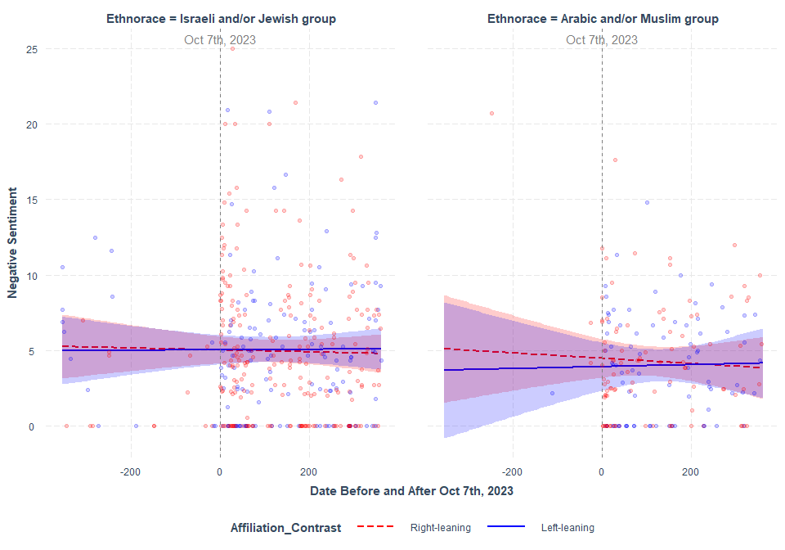

### 

### Tweets Mentioning either IDF or Hamas

Changes in negative sentiment in tweets between as date index (e.g., 10/07/23 as 0) moving backwards (min= -360) and forward (max= 362). Note: IDF was not mentioned in any tweets between 10/07/22 and 10/06/23 (the “Before” period). So, the data was subsetted to only the ““After” period.

Model Summary

|  | Estimate | Std. Error | df | t value | Pr(>|t|) |
| --- | --- | --- | --- | --- | --- |
| (Intercept) | 2.1157747 | 2.4064762 | 378.0572 | 0.8792004 | 0.3798511 |
| MilitantHamas | 3.5451747 | 2.3877397 | 372.0199 | 1.4847409 | 0.1384593 |
| Affiliation_ContrastLeft-leaning | 0.6544639 | 3.3132900 | 355.7051 | 0.1975269 | 0.8435281 |
| Date_Index | 0.0223508 | 0.0118492 | 370.0031 | 1.8862786 | 0.0600403 |
| MilitantHamas:Affiliation_ContrastLeft-leaning | -2.2589936 | 3.3626146 | 380.7376 | -0.6717968 | 0.5021205 |
| MilitantHamas:Date_Index | -0.0255376 | 0.0120156 | 370.7466 | -2.1253705 | 0.0342164 |
| Affiliation_ContrastLeft-leaning:Date_Index | -0.0144934 | 0.0231542 | 379.8728 | -0.6259512 | 0.5317228 |
| MilitantHamas:Affiliation_ContrastLeft-leaning:Date_Index | 0.0224421 | 0.0237573 | 378.6329 | 0.9446388 | 0.3454457 |

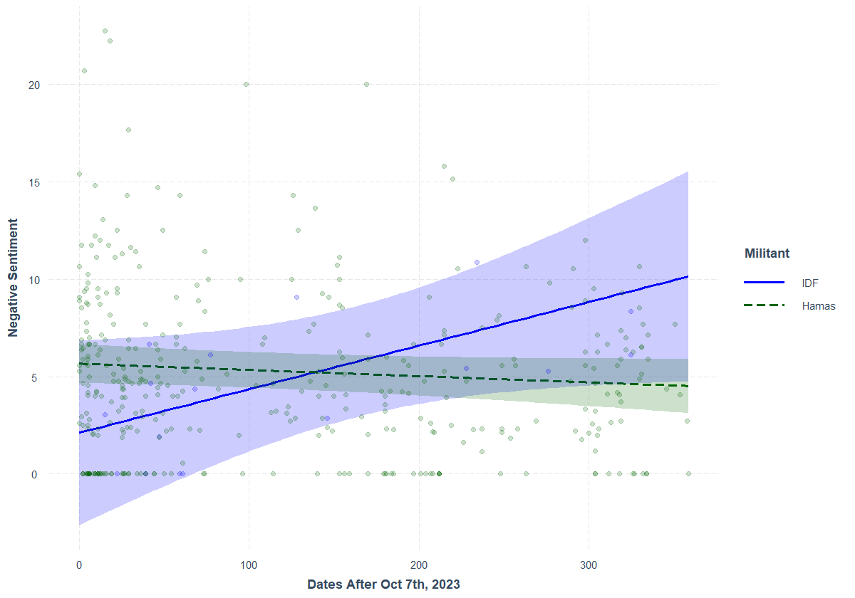

**2-way Interaction between Hamas Discussion and date passed Oct 7th, 23 in predicting negative sentiment in tweets. (left graph)**

# Change in Positive Sentiment

**INTERCEPT AS INDICATED BY THE PRE-REG**

[QUALITY] ~ Ethnorace*Affiliation_Contrast*(Condition_Contrast or Date_index) + (1+Ethnorace*(Condition_Contrast or Date_index)|Subject_ID)

### Tweets Mentioning either Israeli and/or Jewish people or Arabic and/or Muslim people

Changes in positive sentiment in tweets by the “Before” and “After” period

## boundary (singular) fit: see help('isSingular')

Model Summary

|  | Estimate | Std. Error | df | t value | Pr(>|t|) |
| --- | --- | --- | --- | --- | --- |
| (Intercept) | 3.7540068 | 1.425759 | 13.181520 | 2.6329888 | 0.0204759 |
| EthnoraceArabic and/or Muslim group | -3.1549952 | 2.277895 | 5.784519 | -1.3850483 | 0.2170851 |
| Affiliation_ContrastLeft-leaning | -1.1816824 | 1.996922 | 13.466833 | -0.5917520 | 0.5638194 |
| Condition_ContrastAfter 10/07/23 | -1.7358792 | 1.334909 | 12.198927 | -1.3003731 | 0.2175041 |
| EthnoraceArabic and/or Muslim group:Affiliation_ContrastLeft-leaning | 1.0380779 | 3.947035 | 12.923257 | 0.2630019 | 0.7966955 |
| EthnoraceArabic and/or Muslim group:Condition_ContrastAfter 10/07/23 | 2.8224405 | 2.168605 | 7.544741 | 1.3015004 | 0.2314189 |
| Affiliation_ContrastLeft-leaning:Condition_ContrastAfter 10/07/23 | 1.1903968 | 1.894830 | 13.320280 | 0.6282342 | 0.5404731 |
| EthnoraceArabic and/or Muslim group:Affiliation_ContrastLeft-leaning:Condition_ContrastAfter 10/07/23 | 0.0515584 | 3.841539 | 23.090524 | 0.0134213 | 0.9894070 |

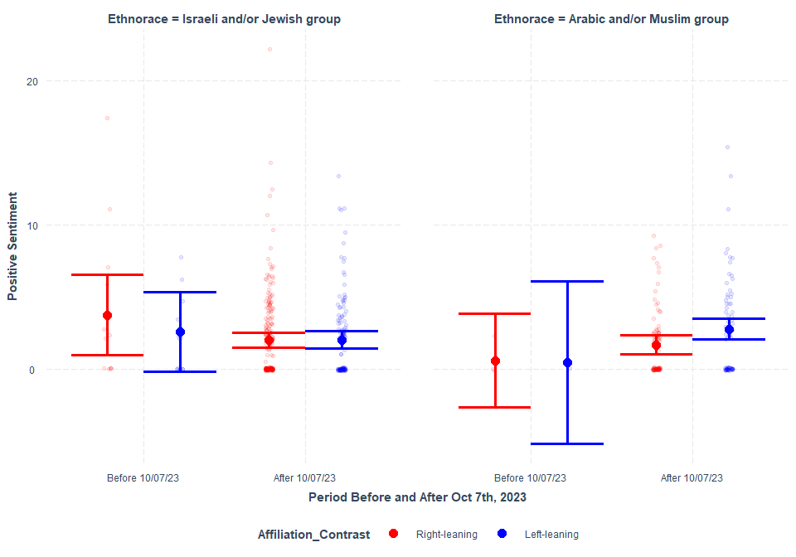

Changes in positive sentiment in tweets between as date index (e.g., 10/07/23 as 0) moving backwards (min= -360) and forward (max= 362)

## boundary (singular) fit: see help('isSingular')

Model Summary

|  | Estimate | Std. Error | df | t value | Pr(>|t|) |
| --- | --- | --- | --- | --- | --- |
| (Intercept) | 2.5009720 | 1.2095413 | 236.152383 | 2.0677029 | 0.0397574 |
| EthnoraceArabic and/or Muslim group | -1.0626311 | 1.1513353 | 4.916252 | -0.9229554 | 0.3990642 |
| Affiliation_ContrastLeft-leaning | -0.3983739 | 1.6902100 | 181.423669 | -0.2356949 | 0.8139353 |
| Date_Index | -0.0014622 | 0.0039605 | 13.016956 | -0.3691923 | 0.7179203 |
| EthnoraceArabic and/or Muslim group:Affiliation_ContrastLeft-leaning | 0.9016764 | 1.6662929 | 4.347503 | 0.5411272 | 0.6149659 |
| EthnoraceArabic and/or Muslim group:Date_Index | 0.0040871 | 0.0048617 | 1.368339 | 0.8406832 | 0.5219047 |
| Affiliation_ContrastLeft-leaning:Date_Index | 0.0004161 | 0.0055617 | 13.378453 | 0.0748157 | 0.9414685 |
| EthnoraceArabic and/or Muslim group:Affiliation_ContrastLeft-leaning:Date_Index | 0.0027385 | 0.0074753 | 1.473469 | 0.3663325 | 0.7598147 |

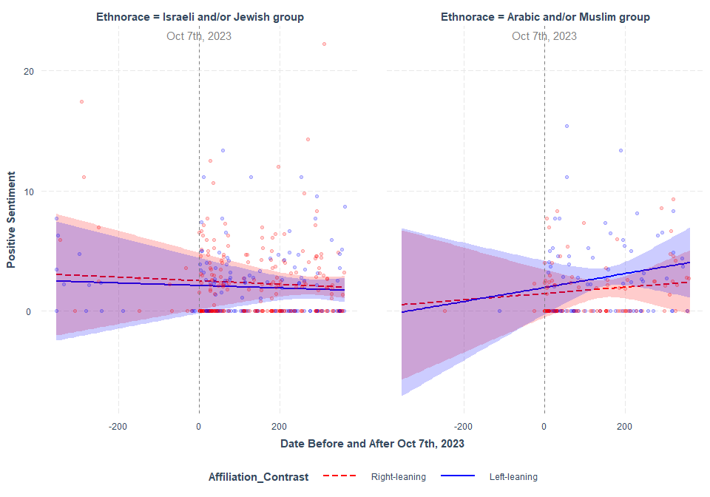

### Tweets Mentioning either IDF or Hamas

Changes in positve sentiment in tweets between as date index (e.g., 10/07/23 as 0) moving backwards (min= -360) and forward (max= 362). Note: IDF was not mentioned in any tweets between 10/07/22 and 10/06/23 (the “Before” period). So, the data was subsetted to only the ““After” period.

## boundary (singular) fit: see help('isSingular')

Model Summary

|  | Estimate | Std. Error | df | t value | Pr(>|t|) |
| --- | --- | --- | --- | --- | --- |
| (Intercept) | 1.0664990 | 2.490179 | 0.6203344 | 0.4282820 | 0.7720214 |
| MilitantHamas | 1.6901751 | 2.506564 | 0.9782139 | 0.6742996 | 0.6243336 |
| Affiliation_ContrastLeft-leaning | 0.0525433 | 4.337178 | 0.8203643 | 0.0121146 | 0.9925964 |
| Date_Index | -0.0034307 | 1.002447 | 362.5739016 | -0.0034223 | 0.9972713 |
| MilitantHamas:Affiliation_ContrastLeft-leaning | 0.0531469 | 4.393030 | 1.2914967 | 0.0120980 | 0.9919419 |
| MilitantHamas:Date_Index | 0.0019546 | 1.002434 | 359.4759657 | 0.0019499 | 0.9984453 |
| Affiliation_ContrastLeft-leaning:Date_Index | -0.0061768 | 1.295596 | 361.1483682 | -0.0047675 | 0.9961987 |
| MilitantHamas:Affiliation_ContrastLeft-leaning:Date_Index | 0.0015715 | 1.295576 | 359.1903480 | 0.0012130 | 0.9990329 |

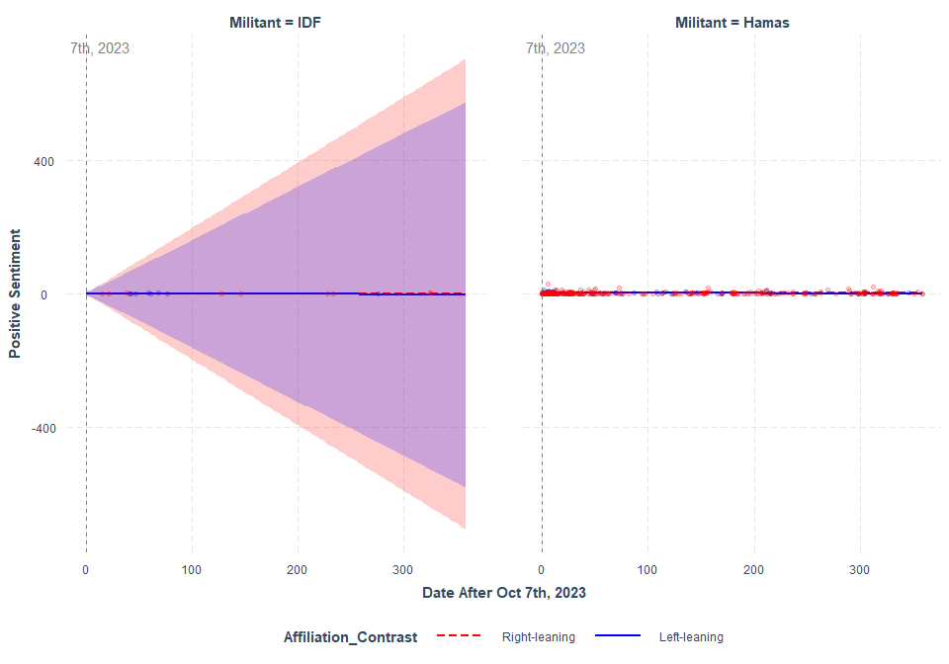

**SIMPLIFIED INTERCEPT**

[QUALITY] ~ Ethnorace*Affiliation_Contrast*(Condition_Contrast or Date_index) + (1|Subject_ID)

### Tweets Mentioning either Israeli and/or Jewish people or Arabic and/or Muslim people

Changes in positive sentiment in tweets by the “Before” and “After” period

## boundary (singular) fit: see help('isSingular')

Model Summary

|  | Estimate | Std. Error | df | t value | Pr(>|t|) |
| --- | --- | --- | --- | --- | --- |
| (Intercept) | 4.0223077 | 0.8159660 | 547 | 4.9295039 | 0.0000011 |
| EthnoraceArabic and/or Muslim group | -3.2656410 | 1.8843928 | 547 | -1.7329938 | 0.0836603 |
| Affiliation_ContrastLeft-leaning | -1.9630220 | 1.1331566 | 547 | -1.7323483 | 0.0837752 |
| Condition_ContrastAfter 10/07/23 | -1.9456709 | 0.8394129 | 547 | -2.3178949 | 0.0208230 |
| EthnoraceArabic and/or Muslim group:Affiliation_ContrastLeft-leaning | 1.2063553 | 3.5811432 | 547 | 0.3368632 | 0.7363492 |
| EthnoraceArabic and/or Muslim group:Condition_ContrastAfter 10/07/23 | 2.8375306 | 1.9185566 | 547 | 1.4789924 | 0.1397180 |
| Affiliation_ContrastLeft-leaning:Condition_ContrastAfter 10/07/23 | 2.0062277 | 1.1794110 | 547 | 1.7010421 | 0.0895034 |
| EthnoraceArabic and/or Muslim group:Affiliation_ContrastLeft-leaning:Condition_ContrastAfter 10/07/23 | -0.3011254 | 3.6238411 | 547 | -0.0830956 | 0.9338059 |

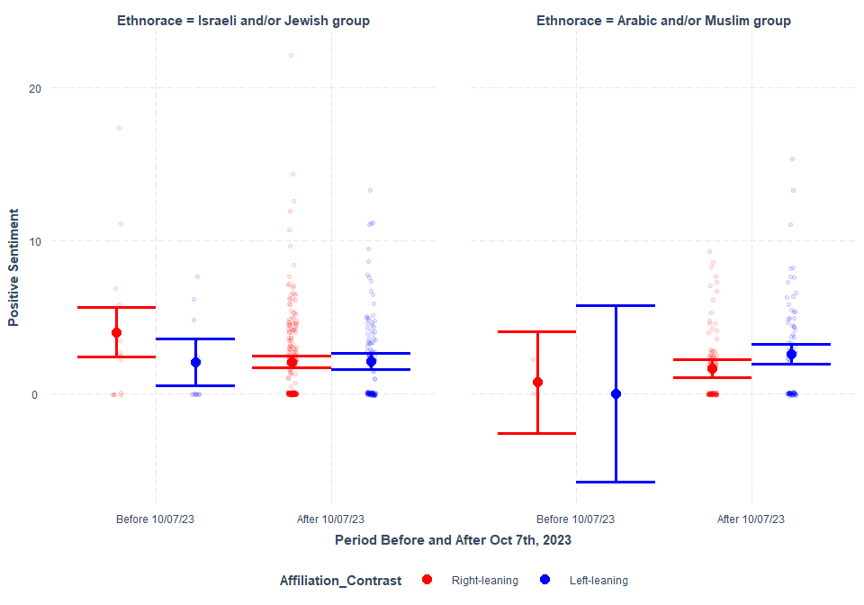

Changes in positive sentiment in tweets between as date index (e.g., 10/07/23 as 0) moving backwards (min= -360) and forward (max= 362)

## boundary (singular) fit: see help('isSingular')

Model Summary

|  | Estimate | Std. Error | df | t value | Pr(>|t|) |
| --- | --- | --- | --- | --- | --- |
| (Intercept) | 2.3865176 | 0.2619491 | 547 | 9.1106172 | 0.0000000 |
| EthnoraceArabic and/or Muslim group | -1.2361065 | 0.4859006 | 547 | -2.5439492 | 0.0112346 |
| Affiliation_ContrastLeft-leaning | -0.1533981 | 0.4017245 | 547 | -0.3818489 | 0.7027217 |
| Date_Index | -0.0016162 | 0.0014240 | 547 | -1.1349290 | 0.2569021 |
| EthnoraceArabic and/or Muslim group:Affiliation_ContrastLeft-leaning | 1.1229885 | 0.7728645 | 547 | 1.4530211 | 0.1467913 |
| EthnoraceArabic and/or Muslim group:Date_Index | 0.0057609 | 0.0028557 | 547 | 2.0173442 | 0.0441475 |
| Affiliation_ContrastLeft-leaning:Date_Index | 0.0006052 | 0.0020679 | 547 | 0.2926701 | 0.7698853 |
| EthnoraceArabic and/or Muslim group:Affiliation_ContrastLeft-leaning:Date_Index | -0.0013746 | 0.0044315 | 547 | -0.3101909 | 0.7565339 |

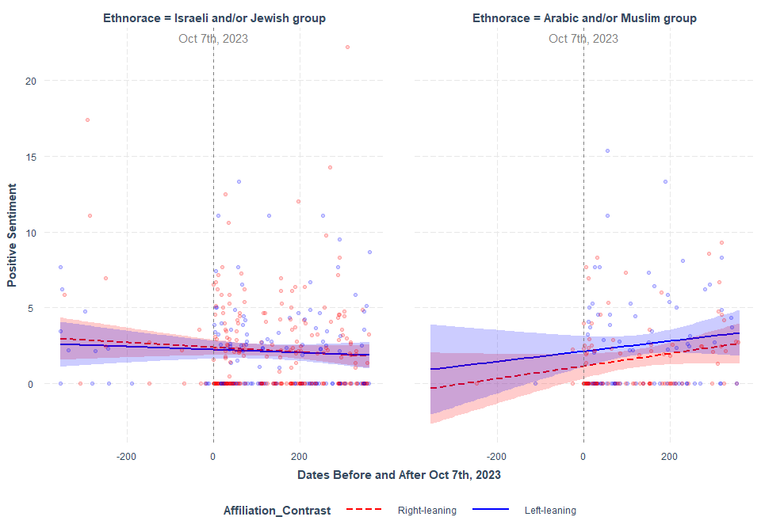

# Change in Warm-conveying Words

**INTERCEPT AS INDICATED BY THE PRE-REG**

[QUALITY] ~ Ethnorace*Affiliation_Contrast*(Condition_Contrast or Date_index) + (1+Ethnorace*(Condition_Contrast or Date_index)|Subject_ID)

### Tweets Mentioning either Israeli and/or Jewish people or Arabic and/or Muslim people

Changes in Warm-conveying Words in tweets by the “Before” and “After” period

## boundary (singular) fit: see help('isSingular')

Model Summary

|  | Estimate | Std. Error | df | t value | Pr(>|t|) |
| --- | --- | --- | --- | --- | --- |
| (Intercept) | 0.0071062 | 0.0041010 | 23.36500 | 1.7327772 | 0.0963165 |
| EthnoraceArabic and/or Muslim group | -0.0071062 | 0.0091611 | 135.34843 | -0.7756990 | 0.4392800 |
| Affiliation_ContrastLeft-leaning | -0.0029463 | 0.0056934 | 23.46444 | -0.5175048 | 0.6096486 |
| Condition_ContrastAfter 10/07/23 | -0.0001844 | 0.0042613 | 19.08341 | -0.0432804 | 0.9659277 |
| EthnoraceArabic and/or Muslim group:Affiliation_ContrastLeft-leaning | 0.0029453 | 0.0173449 | 397.44611 | 0.1698085 | 0.8652471 |
| EthnoraceArabic and/or Muslim group:Condition_ContrastAfter 10/07/23 | 0.0051543 | 0.0094371 | 58.50797 | 0.5461779 | 0.5870204 |
| Affiliation_ContrastLeft-leaning:Condition_ContrastAfter 10/07/23 | 0.0016352 | 0.0059650 | 21.00903 | 0.2741369 | 0.7866568 |
| EthnoraceArabic and/or Muslim group:Affiliation_ContrastLeft-leaning:Condition_ContrastAfter 10/07/23 | -0.0016497 | 0.0176422 | 171.42399 | -0.0935092 | 0.9256083 |

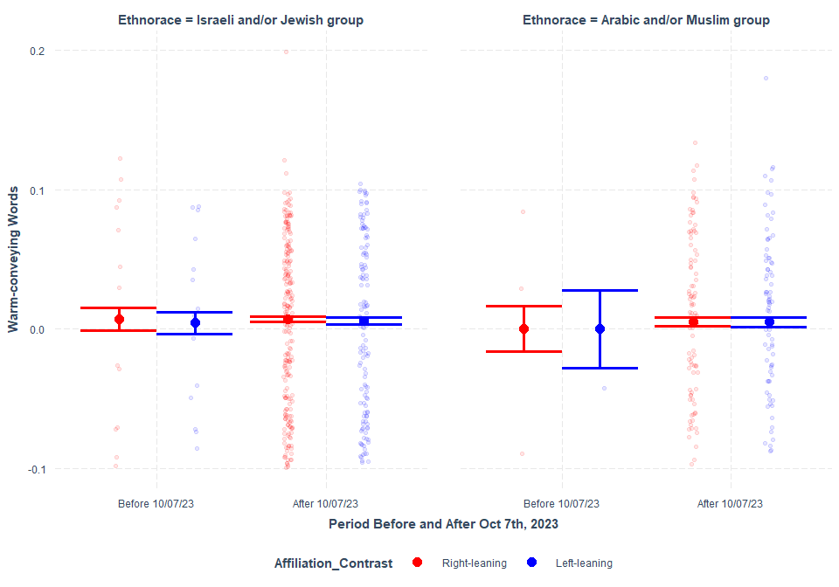

Changes in Warm-conveying Words in tweets between as date index (e.g., 10/07/23 as 0) moving backwards (min= -360) and forward (max= 362)

## boundary (singular) fit: see help('isSingular')

Model Summary

|  | Estimate | Std. Error | df | t value | Pr(>|t|) |
| --- | --- | --- | --- | --- | --- |
| (Intercept) | 0.0046309 | 0.0044959 | 220.723438 | 1.0300140 | 0.3041308 |
| EthnoraceArabic and/or Muslim group | 0.0019056 | 0.0053023 | 9.808157 | 0.3593980 | 0.7269143 |
| Affiliation_ContrastLeft-leaning | 0.0022054 | 0.0062838 | 319.481334 | 0.3509742 | 0.7258390 |
| Date_Index | 0.0000174 | 0.0000321 | 10.575821 | 0.5432331 | 0.5982322 |
| EthnoraceArabic and/or Muslim group:Affiliation_ContrastLeft-leaning | -0.0067564 | 0.0078609 | 10.792498 | -0.8594919 | 0.4087548 |
| EthnoraceArabic and/or Muslim group:Date_Index | -0.0000285 | 0.0000200 | 4.643090 | -1.4247156 | 0.2178402 |
| Affiliation_ContrastLeft-leaning:Date_Index | -0.0000188 | 0.0000450 | 10.529362 | -0.4171472 | 0.6849488 |
| EthnoraceArabic and/or Muslim group:Affiliation_ContrastLeft-leaning:Date_Index | 0.0000466 | 0.0000297 | 7.082103 | 1.5720137 | 0.1594487 |

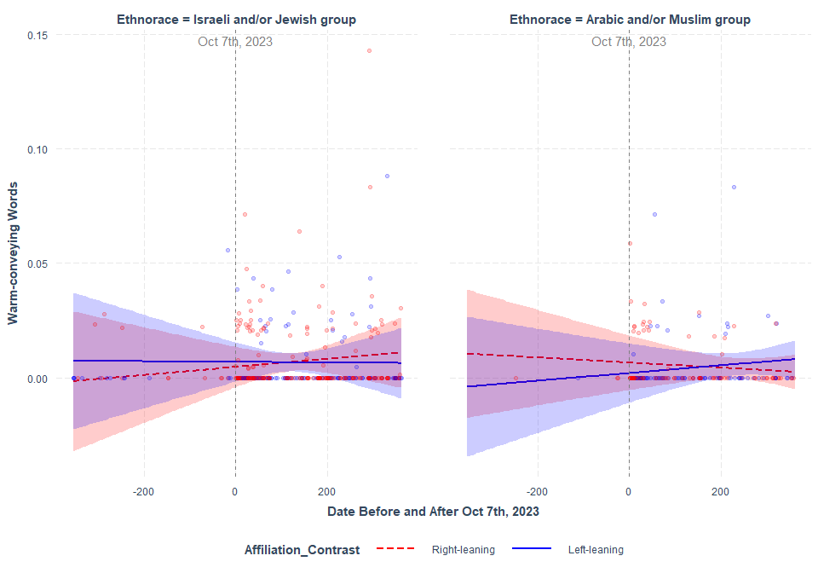

### Tweets Mentioning either IDF or Hamas

Changes in Warm-conveying Words in tweets between as date index (e.g., 10/07/23 as 0) moving backwards (min= -360) and forward (max= 362). Note: IDF was not mentioned in any tweets between 10/07/22 and 10/06/23 (the “Before” period). So, the data was subsetted to only the ““After” period.

## boundary (singular) fit: see help('isSingular')

Model Summary

|  | Estimate | Std. Error | df | t value | Pr(>|t|) |
| --- | --- | --- | --- | --- | --- |
| (Intercept) | 0.0067777 | 0.0104360 | 0.8408546 | 0.6494605 | 0.6491057 |
| MilitantHamas | 0.0006329 | 0.0104957 | 1.1923101 | 0.0603053 | 0.9604041 |
| Affiliation_ContrastLeft-leaning | -0.0081755 | 0.0180873 | 1.1171543 | -0.4520035 | 0.7233175 |
| Date_Index | 0.0000344 | 0.0039992 | 264.8751864 | 0.0086068 | 0.9931393 |
| MilitantHamas:Affiliation_ContrastLeft-leaning | 0.0099162 | 0.0182794 | 1.6194437 | 0.5424794 | 0.6527180 |
| MilitantHamas:Date_Index | -0.0000459 | 0.0039990 | 244.9800499 | -0.0114673 | 0.9908599 |
| Affiliation_ContrastLeft-leaning:Date_Index | -0.0000267 | 0.0051694 | 295.4798565 | -0.0051683 | 0.9958798 |
| MilitantHamas:Affiliation_ContrastLeft-leaning:Date_Index | 0.0000203 | 0.0051691 | 281.8841107 | 0.0039236 | 0.9968722 |

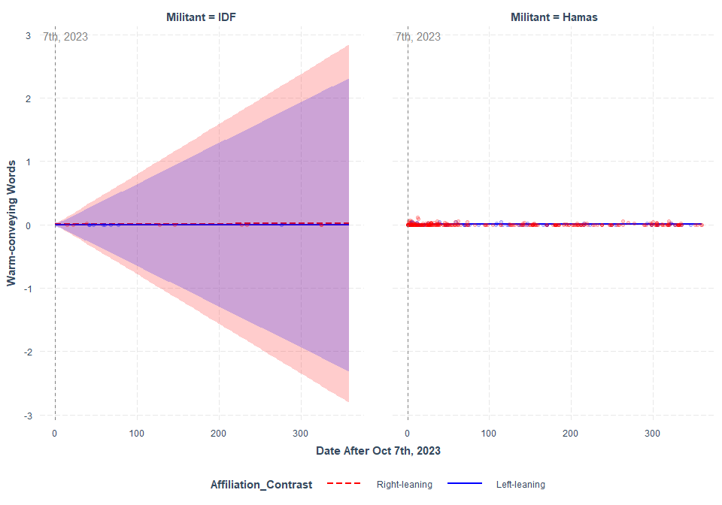

**SIMPLIFIED INTERCEPT**

[QUALITY] ~ Ethnorace*Affiliation_Contrast*(Condition_Contrast or Date_index) + (1|Subject_ID)

### Tweets Mentioning either Israeli and/or Jewish people or Arabic and/or Muslim people

Changes in Warm-conveying Words in tweets by the “Before” and “After” period

## boundary (singular) fit: see help('isSingular')

Model Summary

|  | Estimate | Std. Error | df | t value | Pr(>|t|) |
| --- | --- | --- | --- | --- | --- |
| (Intercept) | 0.0073073 | 0.0039448 | 547 | 1.8523898 | 0.0645084 |
| EthnoraceArabic and/or Muslim group | -0.0073073 | 0.0091101 | 547 | -0.8021083 | 0.4228386 |
| Affiliation_ContrastLeft-leaning | -0.0033390 | 0.0054783 | 547 | -0.6095091 | 0.5424401 |
| Condition_ContrastAfter 10/07/23 | -0.0004853 | 0.0040582 | 547 | -0.1195879 | 0.9048535 |
| EthnoraceArabic and/or Muslim group:Affiliation_ContrastLeft-leaning | 0.0033390 | 0.0173131 | 547 | 0.1928628 | 0.8471380 |
| EthnoraceArabic and/or Muslim group:Condition_ContrastAfter 10/07/23 | 0.0056237 | 0.0092753 | 547 | 0.6063068 | 0.5445625 |
| Affiliation_ContrastLeft-leaning:Condition_ContrastAfter 10/07/23 | 0.0021065 | 0.0057019 | 547 | 0.3694330 | 0.7119480 |
| EthnoraceArabic and/or Muslim group:Affiliation_ContrastLeft-leaning:Condition_ContrastAfter 10/07/23 | -0.0020844 | 0.0175195 | 547 | -0.1189782 | 0.9053363 |

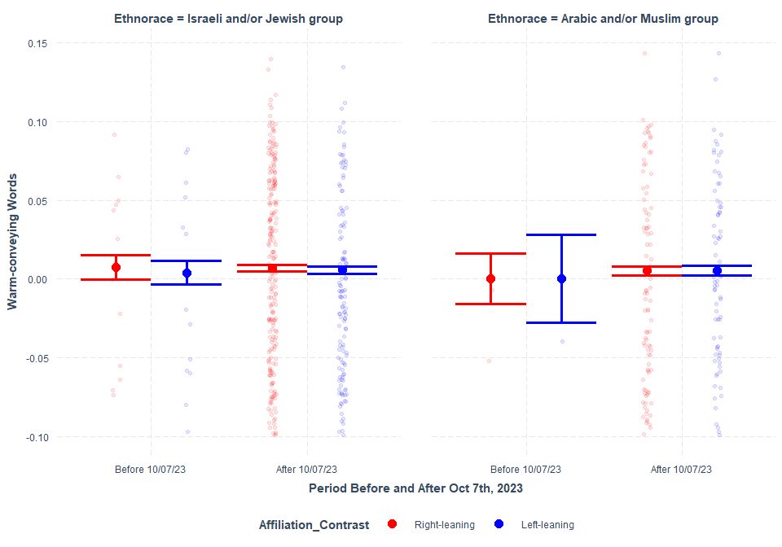

Changes in Warm-conveying Words in tweets between as date index (e.g., 10/07/23 as 0) moving backwards (min= -360) and forward (max= 362)

## boundary (singular) fit: see help('isSingular')

Model Summary

|  | Estimate | Std. Error | df | t value | Pr(>|t|) |
| --- | --- | --- | --- | --- | --- |
| (Intercept) | 0.0069147 | 0.0012629 | 547 | 5.4753395 | 0.0000001 |
| EthnoraceArabic and/or Muslim group | -0.0003593 | 0.0023426 | 547 | -0.1533615 | 0.8781697 |
| Affiliation_ContrastLeft-leaning | -0.0024437 | 0.0019367 | 547 | -1.2617781 | 0.2075664 |
| Date_Index | -0.0000005 | 0.0000069 | 547 | -0.0765815 | 0.9389845 |
| EthnoraceArabic and/or Muslim group:Affiliation_ContrastLeft-leaning | -0.0003791 | 0.0037260 | 547 | -0.1017459 | 0.9189956 |
| EthnoraceArabic and/or Muslim group:Date_Index | -0.0000133 | 0.0000138 | 547 | -0.9685041 | 0.3332207 |
| Affiliation_ContrastLeft-leaning:Date_Index | 0.0000086 | 0.0000100 | 547 | 0.8666529 | 0.3865122 |
| EthnoraceArabic and/or Muslim group:Affiliation_ContrastLeft-leaning:Date_Index | 0.0000156 | 0.0000214 | 547 | 0.7288791 | 0.4663875 |

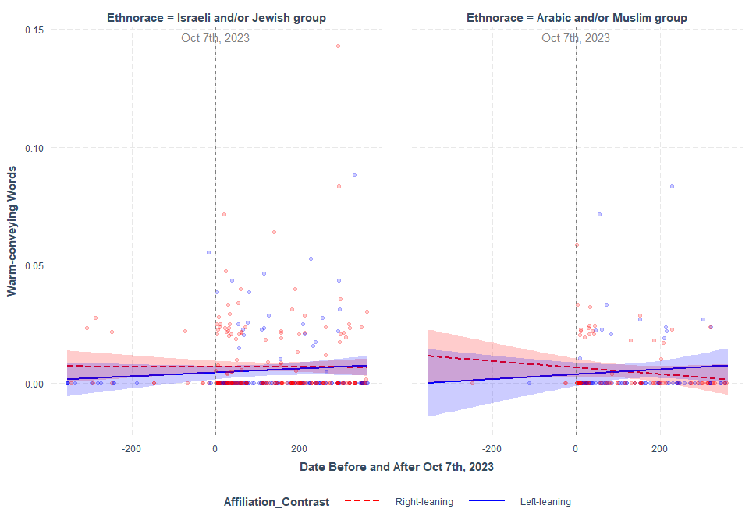

### Tweets Mentioning either IDF or Hamas

Changes in Warm-conveying Words in tweets between as date index (e.g., 10/07/23 as 0) moving backwards (min= -360) and forward (max= 362). Note: IDF was not mentioned in any tweets between 10/07/22 and 10/06/23 (the “Before” period). So, the data was subsetted to only the ““After” period.

Model Summary

|  | Estimate | Std. Error | df | t value | Pr(>|t|) |
| --- | --- | --- | --- | --- | --- |
| (Intercept) | 0.0058361 | 0.0080610 | 376.2490 | 0.7239824 | 0.4695265 |
| MilitantHamas | 0.0011657 | 0.0080671 | 377.7246 | 0.1444979 | 0.8851844 |
| Affiliation_ContrastLeft-leaning | -0.0061992 | 0.0110529 | 359.7849 | -0.5608650 | 0.5752387 |
| Date_Index | -0.0000239 | 0.0000401 | 375.7012 | -0.5970324 | 0.5508454 |
| MilitantHamas:Affiliation_ContrastLeft-leaning | 0.0073206 | 0.0113330 | 382.8384 | 0.6459578 | 0.5186937 |
| MilitantHamas:Date_Index | 0.0000130 | 0.0000406 | 375.9835 | 0.3209538 | 0.7484237 |
| Affiliation_ContrastLeft-leaning:Date_Index | 0.0000214 | 0.0000780 | 382.8620 | 0.2737972 | 0.7843881 |
| MilitantHamas:Affiliation_ContrastLeft-leaning:Date_Index | -0.0000251 | 0.0000801 | 381.6445 | -0.3129787 | 0.7544678 |

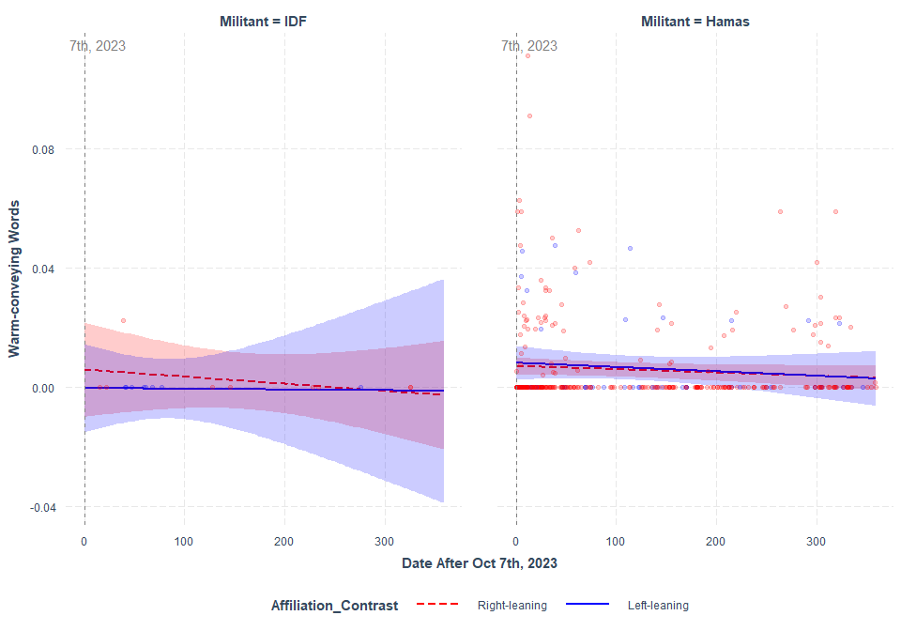

# Change in Cold-conveying Words

**INTERCEPT AS INDICATED BY THE PRE-REG**

[QUALITY] ~ Ethnorace*Affiliation_Contrast*(Condition_Contrast or Date_index) + (1+Ethnorace*(Condition_Contrast or Date_index)|Subject_ID)

### Tweets Mentioning either Israeli and/or Jewish people or Arabic and/or Muslim people

Changes in Cold-conveying Words in tweets by the “Before” and “After” period

## boundary (singular) fit: see help('isSingular')

Model Summary

|  | Estimate | Std. Error | df | t value | Pr(>|t|) |
| --- | --- | --- | --- | --- | --- |
| (Intercept) | 0.0049737 | 0.0039496 | 10.851981 | 1.2592866 | 0.2343390 |
| EthnoraceArabic and/or Muslim group | 0.0049586 | 0.0118588 | 3.054885 | 0.4181382 | 0.7035043 |
| Affiliation_ContrastLeft-leaning | -0.0014189 | 0.0054641 | 11.175372 | -0.2596755 | 0.7998358 |
| Condition_ContrastAfter 10/07/23 | -0.0003149 | 0.0040354 | 11.849291 | -0.0780393 | 0.9390991 |
| EthnoraceArabic and/or Muslim group:Affiliation_ContrastLeft-leaning | -0.0054496 | 0.0225565 | 2.892946 | -0.2415991 | 0.8251974 |
| EthnoraceArabic and/or Muslim group:Condition_ContrastAfter 10/07/23 | -0.0051017 | 0.0119938 | 3.099944 | -0.4253667 | 0.6983789 |
| Affiliation_ContrastLeft-leaning:Condition_ContrastAfter 10/07/23 | 0.0010871 | 0.0056329 | 12.640674 | 0.1929839 | 0.8500377 |
| EthnoraceArabic and/or Muslim group:Affiliation_ContrastLeft-leaning:Condition_ContrastAfter 10/07/23 | 0.0052257 | 0.0226848 | 2.900549 | 0.2303628 | 0.8330957 |

Changes in Cold-conveying Words in tweets between as date index (e.g., 10/07/23 as 0) moving backwards (min= -360) and forward (max= 362)

## boundary (singular) fit: see help('isSingular')

Model Summary

|  | Estimate | Std. Error | df | t value | Pr(>|t|) |
| --- | --- | --- | --- | --- | --- |
| (Intercept) | 0.0045082 | 0.0016763 | 9.373354 | 2.6894663 | 0.0239757 |
| EthnoraceArabic and/or Muslim group | -0.0001103 | 0.0029815 | 9.454476 | -0.0369870 | 0.9712646 |
| Affiliation_ContrastLeft-leaning | -0.0001673 | 0.0023593 | 11.494821 | -0.0709092 | 0.9446888 |
| Date_Index | -0.0000016 | 0.0000084 | 9.622077 | -0.1868510 | 0.8556582 |
| EthnoraceArabic and/or Muslim group:Affiliation_ContrastLeft-leaning | 0.0004762 | 0.0044800 | 11.097368 | 0.1062887 | 0.9172503 |
| EthnoraceArabic and/or Muslim group:Date_Index | -0.0000015 | 0.0000176 | 11.287607 | -0.0847755 | 0.9339249 |
| Affiliation_ContrastLeft-leaning:Date_Index | 0.0000006 | 0.0000115 | 12.028133 | 0.0513426 | 0.9598953 |
| EthnoraceArabic and/or Muslim group:Affiliation_ContrastLeft-leaning:Date_Index | -0.0000053 | 0.0000265 | 12.751389 | -0.1999576 | 0.8446673 |

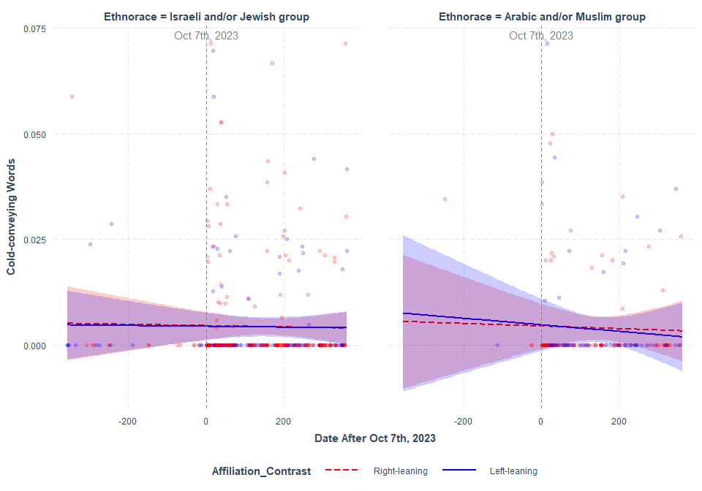

### Tweets Mentioning either IDF or Hamas

Changes in Cold-conveying Words in tweets between as date index (e.g., 10/07/23 as 0) moving backwards (min= -360) and forward (max= 362). Note: IDF was not mentioned in any tweets between 10/07/22 and 10/06/23 (the “Before” period). So, the data was subsetted to only the ““After” period.

## boundary (singular) fit: see help('isSingular')

Model Summary

|  | Estimate | Std. Error | df | t value | Pr(>|t|) |
| --- | --- | --- | --- | --- | --- |
| (Intercept) | -0.0011876 | 0.0094329 | 0.4072280 | -0.1259040 | 0.9367017 |
| MilitantHamas | 0.0049492 | 0.0094836 | 0.5757234 | 0.5218680 | 0.7366427 |
| Affiliation_ContrastLeft-leaning | 0.0068653 | 0.0164033 | 0.5483648 | 0.4185303 | 0.7847709 |
| Date_Index | -0.0028045 | 0.0031042 | 2.6115133 | -0.9034615 | 0.4417414 |
| MilitantHamas:Affiliation_ContrastLeft-leaning | -0.0084077 | 0.0166029 | 0.7910331 | -0.5063986 | 0.7182136 |
| MilitantHamas:Date_Index | 0.0028018 | 0.0030967 | 2.5552728 | 0.9047666 | 0.4426440 |
| Affiliation_ContrastLeft-leaning:Date_Index | 0.0033953 | 0.0042709 | 5.2924580 | 0.7949832 | 0.4607736 |
| MilitantHamas:Affiliation_ContrastLeft-leaning:Date_Index | -0.0033741 | 0.0042630 | 5.1693309 | -0.7914812 | 0.4634171 |

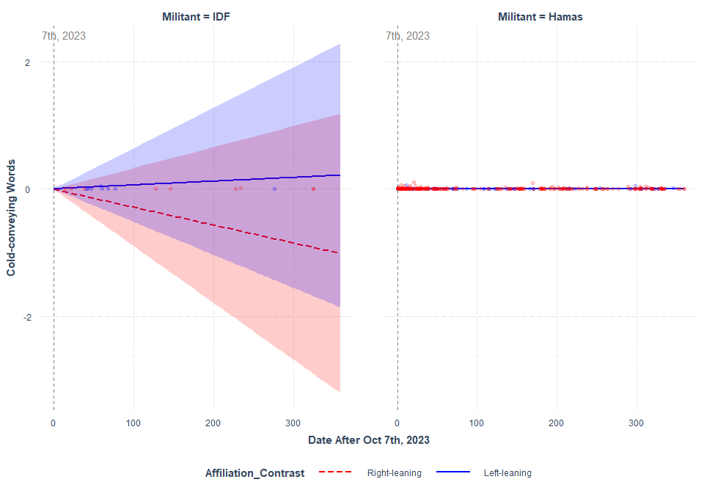

**SIMPLIFIED INTERCEPT**

[QUALITY] ~ Ethnorace*Affiliation_Contrast*(Condition_Contrast or Date_index) + (1 |Subject_ID)

### Tweets Mentioning either Israeli and/or Jewish people or Arabic and/or Muslim people

Changes in Cold-conveying Words in tweets by the “Before” and “After” period

## boundary (singular) fit: see help('isSingular')

Model Summary

|  | Estimate | Std. Error | df | t value | Pr(>|t|) |
| --- | --- | --- | --- | --- | --- |
| (Intercept) | 0.0045249 | 0.0033527 | 547 | 1.3496285 | 0.1776935 |
| EthnoraceArabic and/or Muslim group | 0.0069694 | 0.0077427 | 547 | 0.9001200 | 0.3684525 |
| Affiliation_ContrastLeft-leaning | -0.0007834 | 0.0046560 | 547 | -0.1682546 | 0.8664452 |
| Condition_ContrastAfter 10/07/23 | 0.0003844 | 0.0034490 | 547 | 0.1114545 | 0.9112968 |
| EthnoraceArabic and/or Muslim group:Affiliation_ContrastLeft-leaning | -0.0107109 | 0.0147144 | 547 | -0.7279161 | 0.4669764 |
| EthnoraceArabic and/or Muslim group:Condition_ContrastAfter 10/07/23 | -0.0072061 | 0.0078831 | 547 | -0.9141167 | 0.3610583 |
| Affiliation_ContrastLeft-leaning:Condition_ContrastAfter 10/07/23 | 0.0002111 | 0.0048460 | 547 | 0.0435538 | 0.9652759 |
| EthnoraceArabic and/or Muslim group:Affiliation_ContrastLeft-leaning:Condition_ContrastAfter 10/07/23 | 0.0105702 | 0.0148899 | 547 | 0.7098922 | 0.4780735 |

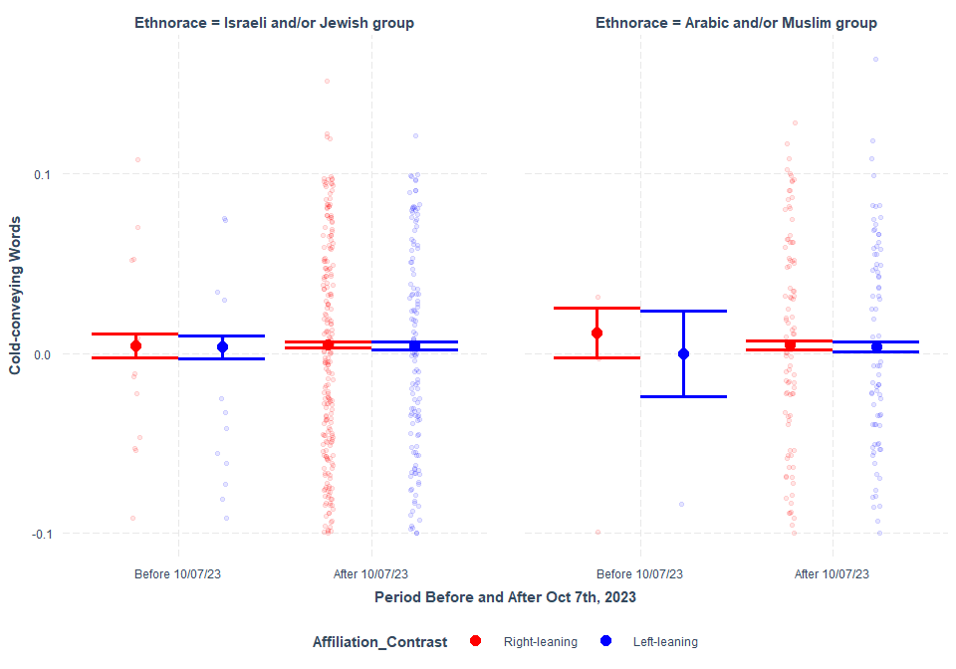

Changes in Cold-conveying Words in tweets between as date index (e.g., 10/07/23 as 0) moving backwards (min= -360) and forward (max= 362)

## boundary (singular) fit: see help('isSingular')

Model Summary

|  | Estimate | Std. Error | df | t value | Pr(>|t|) |
| --- | --- | --- | --- | --- | --- |
| (Intercept) | 0.0053919 | 0.0010745 | 547 | 5.0179685 | 0.0000007 |
| EthnoraceArabic and/or Muslim group | 0.0009836 | 0.0019932 | 547 | 0.4934918 | 0.6218632 |
| Affiliation_ContrastLeft-leaning | -0.0009831 | 0.0016479 | 547 | -0.5966059 | 0.5510173 |
| Date_Index | -0.0000040 | 0.0000058 | 547 | -0.6876239 | 0.4919811 |
| EthnoraceArabic and/or Muslim group:Affiliation_ContrastLeft-leaning | -0.0019799 | 0.0031703 | 547 | -0.6245003 | 0.5325595 |
| EthnoraceArabic and/or Muslim group:Date_Index | -0.0000091 | 0.0000117 | 547 | -0.7799522 | 0.4357564 |
| Affiliation_ContrastLeft-leaning:Date_Index | 0.0000029 | 0.0000085 | 547 | 0.3427106 | 0.7319478 |
| EthnoraceArabic and/or Muslim group:Affiliation_ContrastLeft-leaning:Date_Index | 0.0000140 | 0.0000182 | 547 | 0.7715136 | 0.4407357 |

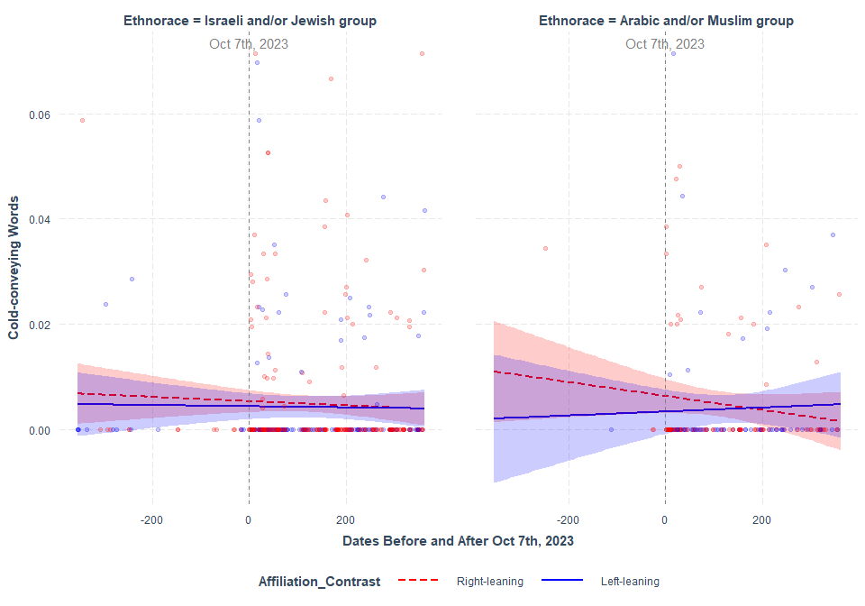

### Tweets Mentioning either IDF or Hamas

Changes in Cold-conveying Words in tweets between as date index (e.g., 10/07/23 as 0) moving backwards (min= -360) and forward (max= 362). Note: IDF was not mentioned in any tweets between 10/07/22 and 10/06/23 (the “Before” period). So, the data was subsetted to only the ““After” period.

Model Summary

|  | Estimate | Std. Error | df | t value | Pr(>|t|) |
| --- | --- | --- | --- | --- | --- |
| (Intercept) | 0.0002886 | 0.0074539 | 377.1102 | 0.0387217 | 0.9691328 |
| MilitantHamas | 0.0043722 | 0.0075239 | 383.7480 | 0.5811077 | 0.5615090 |
| Affiliation_ContrastLeft-leaning | 0.0096044 | 0.0101947 | 375.3298 | 0.9421019 | 0.3467464 |
| Date_Index | 0.0000129 | 0.0000374 | 383.9973 | 0.3449550 | 0.7303170 |
| MilitantHamas:Affiliation_ContrastLeft-leaning | -0.0133749 | 0.0105517 | 383.9267 | -1.2675607 | 0.2057231 |
| MilitantHamas:Date_Index | -0.0000135 | 0.0000379 | 383.7056 | -0.3573713 | 0.7210104 |
| Affiliation_ContrastLeft-leaning:Date_Index | -0.0000455 | 0.0000727 | 383.9783 | -0.6268380 | 0.5311380 |
| MilitantHamas:Affiliation_ContrastLeft-leaning:Date_Index | 0.0000662 | 0.0000747 | 383.5780 | 0.8868101 | 0.3757368 |

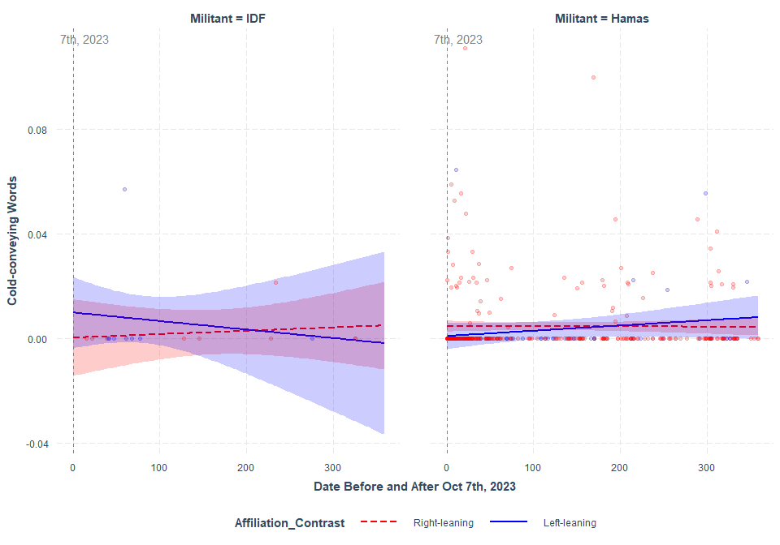

# Change in Competence-conveying Words

**INTERCEPT AS INDICATED BY THE PRE-REG**

[QUALITY] ~ Ethnorace*Affiliation_Contrast*(Condition_Contrast or Date_index) + (1+Ethnorace*(Condition_Contrast or Date_index)|Subject_ID)

### Tweets Mentioning either Israeli and/or Jewish people or Arabic and/or Muslim people

Changes in Competence-conveying Words in tweets by the “Before” and “After” period

## boundary (singular) fit: see help('isSingular')

Model Summary

|  | Estimate | Std. Error | df | t value | Pr(>|t|) |
| --- | --- | --- | --- | --- | --- |
| (Intercept) | 0.0098529 | 0.0035968 | 16.791577 | 2.7393277 | 0.0140901 |
| EthnoraceArabic and/or Muslim group | -0.0044815 | 0.0126972 | 5.741706 | -0.3529492 | 0.7367206 |
| Affiliation_ContrastLeft-leaning | -0.0101967 | 0.0050318 | 16.164248 | -2.0264420 | 0.0595479 |
| Condition_ContrastAfter 10/07/23 | -0.0045478 | 0.0055532 | 15.415491 | -0.8189376 | 0.4253019 |
| EthnoraceArabic and/or Muslim group:Affiliation_ContrastLeft-leaning | -0.0003716 | 0.0236370 | 2.683340 | -0.0157219 | 0.9885507 |
| EthnoraceArabic and/or Muslim group:Condition_ContrastAfter 10/07/23 | 0.0016743 | 0.0138564 | 4.934599 | 0.1208308 | 0.9085906 |
| Affiliation_ContrastLeft-leaning:Condition_ContrastAfter 10/07/23 | 0.0113741 | 0.0077351 | 15.683463 | 1.4704540 | 0.1612159 |
| EthnoraceArabic and/or Muslim group:Affiliation_ContrastLeft-leaning:Condition_ContrastAfter 10/07/23 | -0.0006818 | 0.0248428 | 5.280589 | -0.0274450 | 0.9791120 |

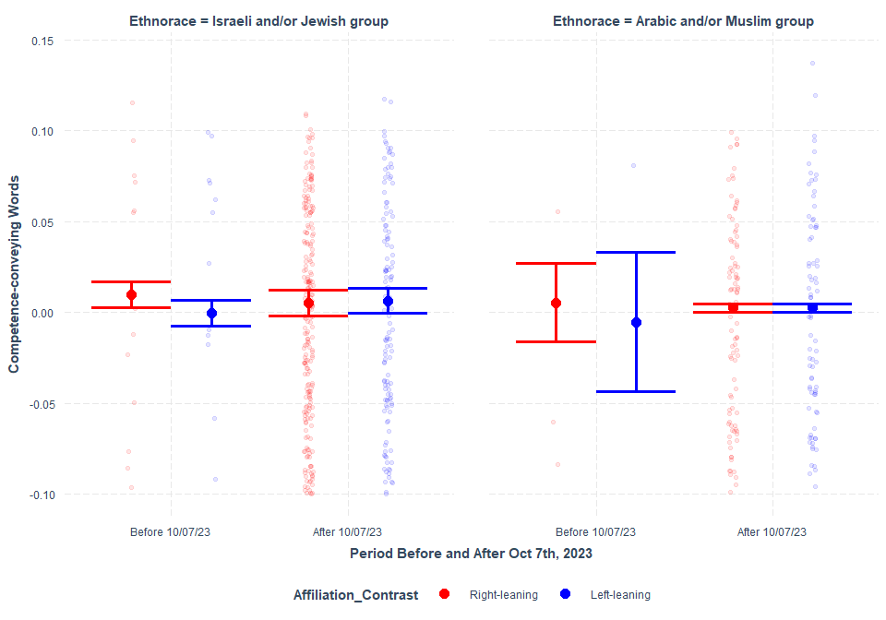

Changes in Competence-conveying Words in tweets between as date index (e.g., 10/07/23 as 0) moving backwards (min= -360) and forward (max= 362)

## boundary (singular) fit: see help('isSingular')

Model Summary

|  | Estimate | Std. Error | df | t value | Pr(>|t|) |
| --- | --- | --- | --- | --- | --- |
| (Intercept) | 0.0047213 | 0.0032453 | 8.246887 | 1.4547992 | 0.1827044 |
| EthnoraceArabic and/or Muslim group | -0.0016348 | 0.0048127 | 23.241596 | -0.3396785 | 0.7371492 |
| Affiliation_ContrastLeft-leaning | -0.0003718 | 0.0045289 | 7.920567 | -0.0820844 | 0.9366160 |
| Date_Index | -0.0000124 | 0.0000090 | 5.374184 | -1.3728060 | 0.2243336 |
| EthnoraceArabic and/or Muslim group:Affiliation_ContrastLeft-leaning | 0.0007670 | 0.0070823 | 23.116034 | 0.1083012 | 0.9146914 |
| EthnoraceArabic and/or Muslim group:Date_Index | 0.0000073 | 0.0000244 | 20.777521 | 0.2996669 | 0.7674085 |
| Affiliation_ContrastLeft-leaning:Date_Index | 0.0000239 | 0.0000125 | 6.205503 | 1.9069330 | 0.1035444 |
| EthnoraceArabic and/or Muslim group:Affiliation_ContrastLeft-leaning:Date_Index | -0.0000288 | 0.0000360 | 23.343023 | -0.8016354 | 0.4308491 |

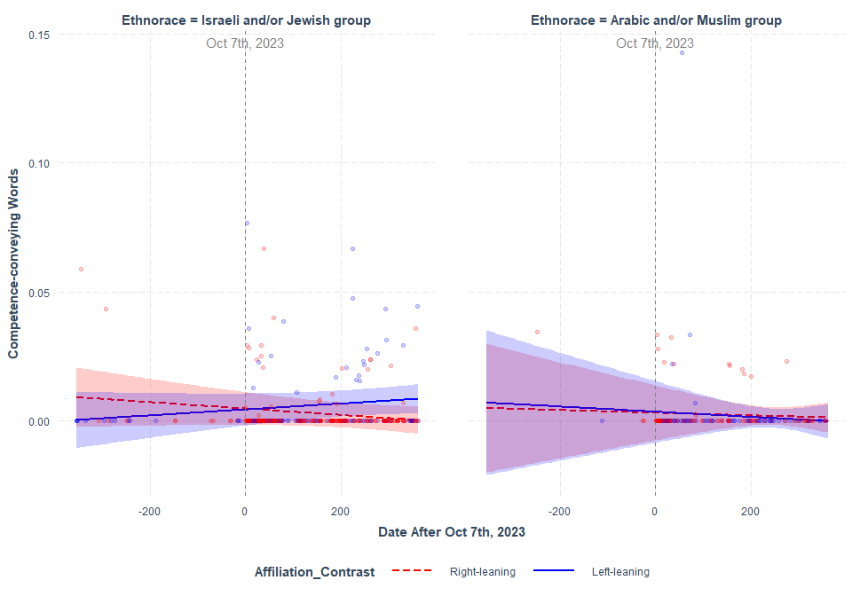

### Tweets Mentioning either IDF or Hamas

Changes in Competence-conveying Words in tweets between as date index (e.g., 10/07/23 as 0) moving backwards (min= -360) and forward (max= 362). Note: IDF was not mentioned in any tweets between 10/07/22 and 10/06/23 (the “Before” period). So, the data was subsetted to only the ““After” period.

## boundary (singular) fit: see help('isSingular')

Model Summary

|  | Estimate | Std. Error | df | t value | Pr(>|t|) |
| --- | --- | --- | --- | --- | --- |
| (Intercept) | 0.0065645 | 0.0082720 | 1.982571 | 0.7935821 | 0.5112673 |
| MilitantHamas | -0.0017984 | 0.0084142 | 2.679183 | -0.2137326 | 0.8459680 |
| Affiliation_ContrastLeft-leaning | -0.0113516 | 0.0144086 | 2.610445 | -0.7878391 | 0.4960325 |
| Date_Index | -0.0000277 | 0.0032669 | 375.293995 | -0.0084652 | 0.9932503 |
| MilitantHamas:Affiliation_ContrastLeft-leaning | 0.0089258 | 0.0146783 | 3.574131 | 0.6080941 | 0.5796253 |
| MilitantHamas:Date_Index | 0.0000180 | 0.0032669 | 376.767709 | 0.0055137 | 0.9956036 |
| Affiliation_ContrastLeft-leaning:Date_Index | 0.0001335 | 0.0042224 | 376.279110 | 0.0316170 | 0.9747943 |
| MilitantHamas:Affiliation_ContrastLeft-leaning:Date_Index | -0.0001347 | 0.0042224 | 378.600410 | -0.0318975 | 0.9745706 |

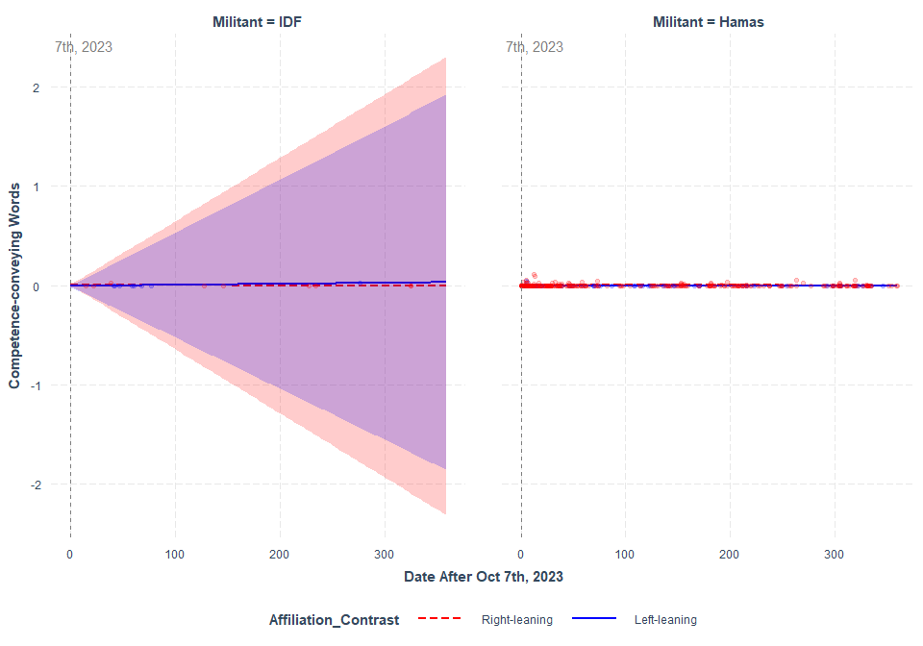

**SIMPLIFIED INTERCEPT**

[QUALITY] ~ Ethnorace*Affiliation_Contrast*(Condition_Contrast or Date_index) + (1 |Subject_ID)

### Tweets Mentioning either Israeli and/or Jewish people or Arabic and/or Muslim people

Changes in Competence-conveying Words in tweets by the “Before” and “After” period

Model Summary

|  | Estimate | Std. Error | df | t value | Pr(>|t|) |
| --- | --- | --- | --- | --- | --- |
| (Intercept) | 0.0073734 | 0.0031775 | 357.2783 | 2.3205475 | 0.0208738 |
| EthnoraceArabic and/or Muslim group | 0.0045334 | 0.0071627 | 546.6139 | 0.6329180 | 0.5270519 |
| Affiliation_ContrastLeft-leaning | -0.0073556 | 0.0044241 | 317.2592 | -1.6626189 | 0.0973763 |
| Condition_ContrastAfter 10/07/23 | -0.0050269 | 0.0032439 | 506.0259 | -1.5496675 | 0.1218465 |
| EthnoraceArabic and/or Muslim group:Affiliation_ContrastLeft-leaning | -0.0050424 | 0.0136269 | 545.2905 | -0.3700317 | 0.7115025 |
| EthnoraceArabic and/or Muslim group:Condition_ContrastAfter 10/07/23 | -0.0038925 | 0.0072936 | 546.4664 | -0.5336904 | 0.5937727 |
| Affiliation_ContrastLeft-leaning:Condition_ContrastAfter 10/07/23 | 0.0101333 | 0.0045882 | 412.6530 | 2.2085515 | 0.0277549 |
| EthnoraceArabic and/or Muslim group:Affiliation_ContrastLeft-leaning:Condition_ContrastAfter 10/07/23 | 0.0019205 | 0.0137753 | 543.8659 | 0.1394172 | 0.8891721 |

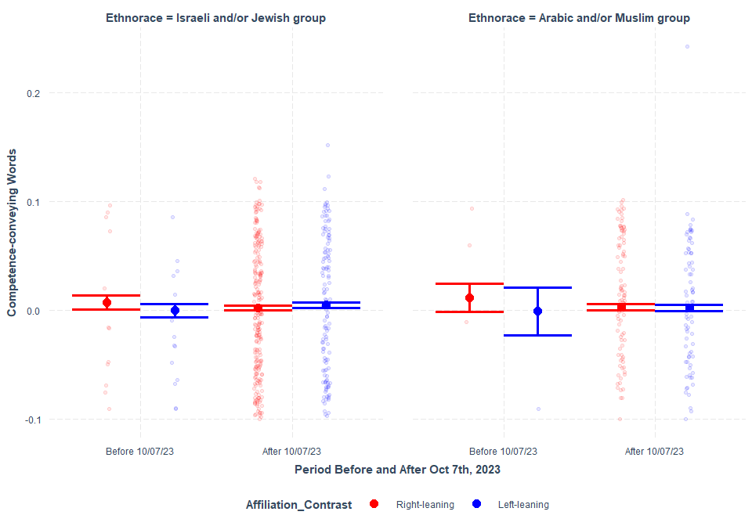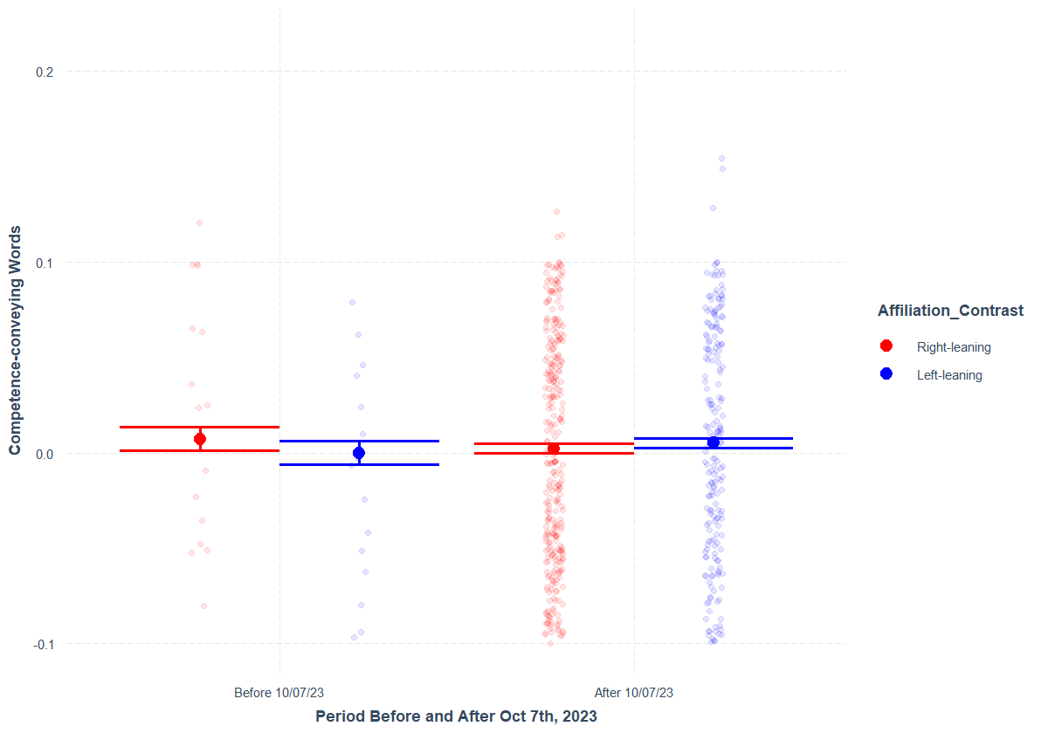

**2-way interaction between left-leaning influencers and the period after the start of the conflict in predicting competence stereotype. (Right graph)**

Changes in Competence-conveying Words in tweets between as date index (e.g., 10/07/23 as 0) moving backwards (min= -360) and forward (max= 362)

Model Summary

|  | Estimate | Std. Error | df | t value | Pr(>|t|) |
| --- | --- | --- | --- | --- | --- |
| (Intercept) | 0.0040543 | 0.0013138 | 14.59557 | 3.0859193 | 0.0077320 |
| EthnoraceArabic and/or Muslim group | 0.0008083 | 0.0018437 | 546.97406 | 0.4383991 | 0.6612701 |
| Affiliation_ContrastLeft-leaning | -0.0007608 | 0.0019062 | 18.52988 | -0.3991110 | 0.6943737 |
| Date_Index | -0.0000103 | 0.0000054 | 545.51023 | -1.8863667 | 0.0597764 |
| EthnoraceArabic and/or Muslim group:Affiliation_ContrastLeft-leaning | 0.0003389 | 0.0029496 | 542.53245 | 0.1148833 | 0.9085801 |
| EthnoraceArabic and/or Muslim group:Date_Index | -0.0000027 | 0.0000109 | 536.25500 | -0.2510894 | 0.8018412 |
| Affiliation_ContrastLeft-leaning:Date_Index | 0.0000214 | 0.0000079 | 533.50705 | 2.7100201 | 0.0069444 |
| EthnoraceArabic and/or Muslim group:Affiliation_ContrastLeft-leaning:Date_Index | -0.0000228 | 0.0000170 | 524.10216 | -1.3402828 | 0.1807341 |

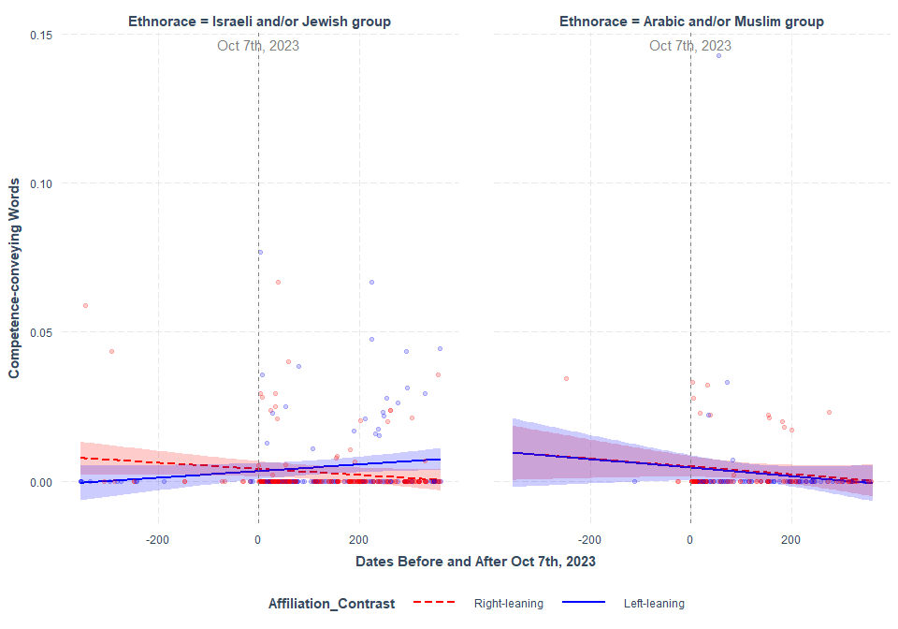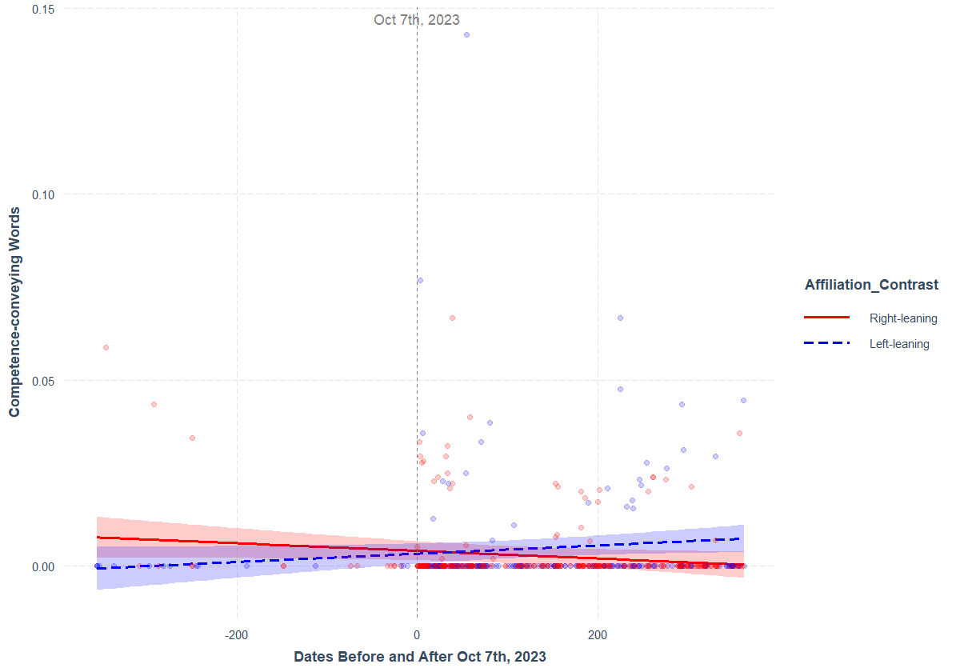**2-way interaction between left-leaning influencer and the amount of time passes by date before and after Oct 7th, 2023 in predicting competence-conveying words in tweet.**

### Tweets Mentioning either IDF or Hamas

Changes in Competence-conveying Words in tweets between as date index (e.g., 10/07/23 as 0) moving backwards (min= -360) and forward (max= 362). Note: IDF was not mentioned in any tweets between 10/07/22 and 10/06/23 (the “Before” period). So, the data was subsetted to only the ““After” period.

Model Summary

|  | Estimate | Std. Error | df | t value | Pr(>|t|) |
| --- | --- | --- | --- | --- | --- |
| (Intercept) | 0.0061636 | 0.0064545 | 378.6785 | 0.9549246 | 0.3402250 |
| MilitantHamas | -0.0024054 | 0.0065047 | 383.4127 | -0.3697924 | 0.7117413 |
| Affiliation_ContrastLeft-leaning | -0.0125862 | 0.0088299 | 375.6357 | -1.4254064 | 0.1548701 |
| Date_Index | -0.0000239 | 0.0000323 | 383.4627 | -0.7392357 | 0.4602161 |
| MilitantHamas:Affiliation_ContrastLeft-leaning | 0.0118419 | 0.0091239 | 383.8891 | 1.2978925 | 0.1951036 |
| MilitantHamas:Date_Index | 0.0000189 | 0.0000328 | 383.0808 | 0.5774669 | 0.5639634 |
| Affiliation_ContrastLeft-leaning:Date_Index | 0.0001406 | 0.0000628 | 383.9328 | 2.2383302 | 0.0257721 |
| MilitantHamas:Affiliation_ContrastLeft-leaning:Date_Index | -0.0001492 | 0.0000646 | 383.5478 | -2.3113653 | 0.0213421 |

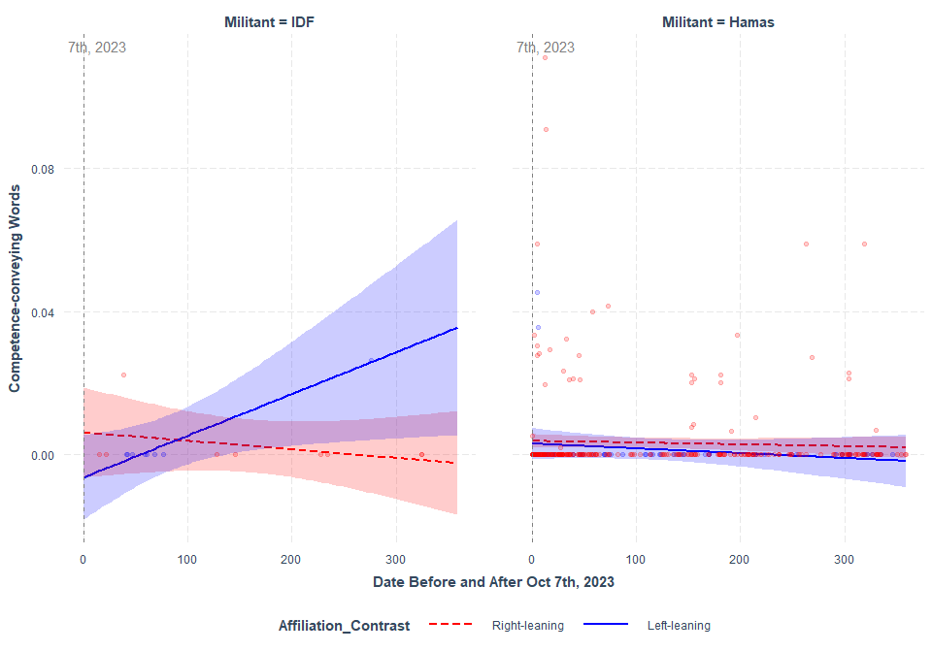

# Change in Incompetence-conveying Words

**INTERCEPT AS INDICATED BY THE PRE-REG**

[QUALITY] ~ Ethnorace*Affiliation_Contrast*(Condition_Contrast or Date_index) + (1+Ethnorace*(Condition_Contrast or Date_index)|Subject_ID)

### Tweets Mentioning either Israeli and/or Jewish people or Arabic and/or Muslim people

Changes in Incompetence-conveying Words in tweets by the “Before” and “After” period

## boundary (singular) fit: see help('isSingular')

Model Summary

|  | Estimate | Std. Error | df | t value | Pr(>|t|) |
| --- | --- | --- | --- | --- | --- |
| (Intercept) | 0.0164206 | 0.0055916 | 11.48300 | 2.936626 | 0.0129798 |
| EthnoraceArabic and/or Muslim group | -0.0164202 | 0.0083573 | 14.78680 | -1.964771 | 0.0685175 |
| Affiliation_ContrastLeft-leaning | -0.0174738 | 0.0078137 | 11.74305 | -2.236300 | 0.0455546 |
| Condition_ContrastAfter 10/07/23 | -0.0146831 | 0.0062266 | 12.93476 | -2.358099 | 0.0347871 |
| EthnoraceArabic and/or Muslim group:Affiliation_ContrastLeft-leaning | 0.0174730 | 0.0146755 | 53.21500 | 1.190624 | 0.2390852 |
| EthnoraceArabic and/or Muslim group:Condition_ContrastAfter 10/07/23 | 0.0165638 | 0.0088709 | 13.50271 | 1.867213 | 0.0837313 |
| Affiliation_ContrastLeft-leaning:Condition_ContrastAfter 10/07/23 | 0.0189803 | 0.0086350 | 12.95330 | 2.198075 | 0.0467330 |
| EthnoraceArabic and/or Muslim group:Affiliation_ContrastLeft-leaning:Condition_ContrastAfter 10/07/23 | -0.0188305 | 0.0152238 | 38.47739 | -1.236912 | 0.2236161 |

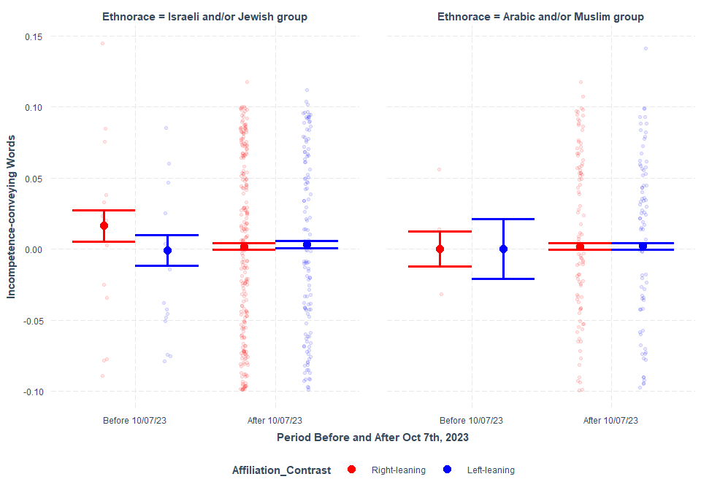

Changes in Incompetence-conveying Words in tweets between as date index (e.g., 10/07/23 as 0) moving backwards (min= -360) and forward (max= 362)

## boundary (singular) fit: see help('isSingular')

Model Summary

|  | Estimate | Std. Error | df | t value | Pr(>|t|) |
| --- | --- | --- | --- | --- | --- |
| (Intercept) | 0.0044660 | 0.0069104 | 34.655082 | 0.6462761 | 0.5223577 |
| EthnoraceArabic and/or Muslim group | -0.0011259 | 0.0032491 | 1.924216 | -0.3465400 | 0.7631456 |
| Affiliation_ContrastLeft-leaning | -0.0030962 | 0.0098798 | 36.028305 | -0.3133813 | 0.7557981 |
| Date_Index | -0.0000060 | 0.0000111 | 1.779451 | -0.5378050 | 0.6503119 |
| EthnoraceArabic and/or Muslim group:Affiliation_ContrastLeft-leaning | 0.0015038 | 0.0047037 | 2.216907 | 0.3197022 | 0.7768435 |
| EthnoraceArabic and/or Muslim group:Date_Index | -0.0000029 | 0.0000160 | 1.196273 | -0.1796631 | 0.8829842 |
| Affiliation_ContrastLeft-leaning:Date_Index | 0.0000170 | 0.0000161 | 1.847316 | 1.0561918 | 0.4093221 |
| EthnoraceArabic and/or Muslim group:Affiliation_ContrastLeft-leaning:Date_Index | -0.0000050 | 0.0000241 | 1.365491 | -0.2063893 | 0.8629809 |

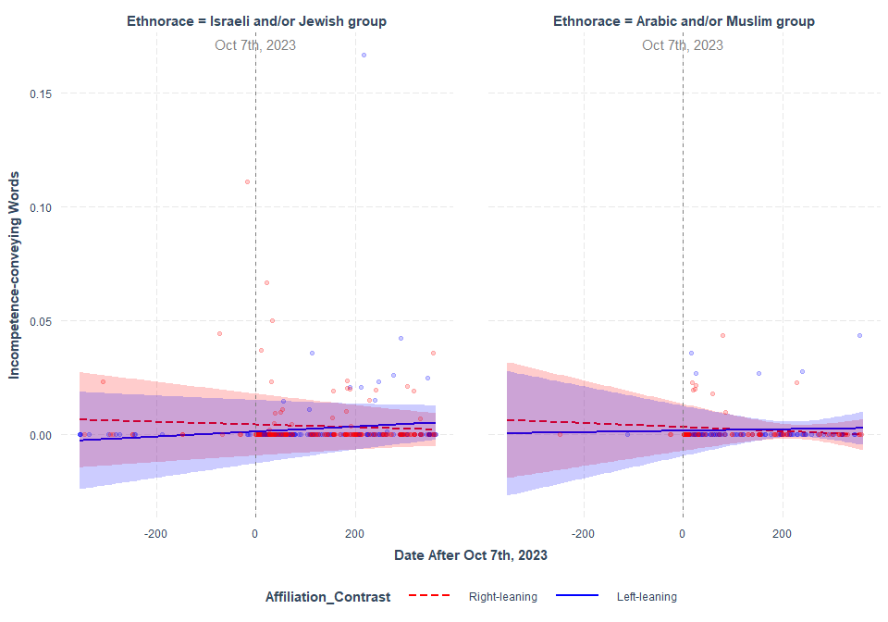

### Tweets Mentioning either IDF or Hamas

Changes in Incompetence-conveying Words in tweets between as date index (e.g., 10/07/23 as 0) moving backwards (min= -360) and forward (max= 362). Note: IDF was not mentioned in any tweets between 10/07/22 and 10/06/23 (the “Before” period). So, the data was subsetted to only the ““After” period.

## boundary (singular) fit: see help('isSingular')

Model Summary

|  | Estimate | Std. Error | df | t value | Pr(>|t|) |
| --- | --- | --- | --- | --- | --- |
| (Intercept) | 0.0138302 | 0.0051687 | 1.655300 | 2.6757393 | 0.1408250 |
| MilitantHamas | -0.0115545 | 0.0052397 | 2.368189 | -2.2051813 | 0.1381901 |
| Affiliation_ContrastLeft-leaning | -0.0200797 | 0.0090035 | 2.197843 | -2.2302101 | 0.1439670 |
| Date_Index | -0.0000988 | 0.0020042 | 232.133520 | -0.0492996 | 0.9607229 |
| MilitantHamas:Affiliation_ContrastLeft-leaning | 0.0173079 | 0.0091893 | 3.086780 | 1.8834848 | 0.1535645 |
| MilitantHamas:Date_Index | 0.0000907 | 0.0020038 | 215.814412 | 0.0452385 | 0.9639591 |
| Affiliation_ContrastLeft-leaning:Date_Index | 0.0002425 | 0.0025909 | 276.874668 | 0.0936025 | 0.9254926 |
| MilitantHamas:Affiliation_ContrastLeft-leaning:Date_Index | -0.0002198 | 0.0025903 | 261.194958 | -0.0848368 | 0.9324562 |

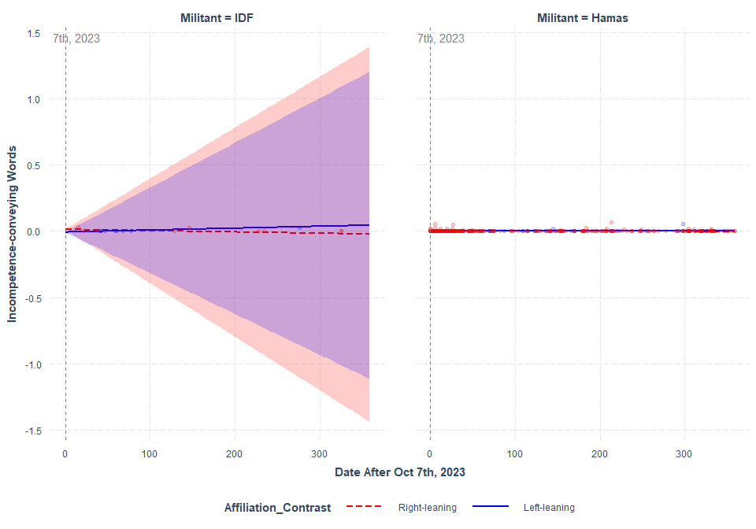

**SIMPLIFIED INTERCEPT**

[QUALITY] ~ Ethnorace*Affiliation_Contrast*(Condition_Contrast or Date_index) + (1 |Subject_ID)

### Tweets Mentioning either Israeli and/or Jewish people or Arabic and/or Muslim people

Changes in Incompetence-conveying Words in tweets by the “Before” and “After” period

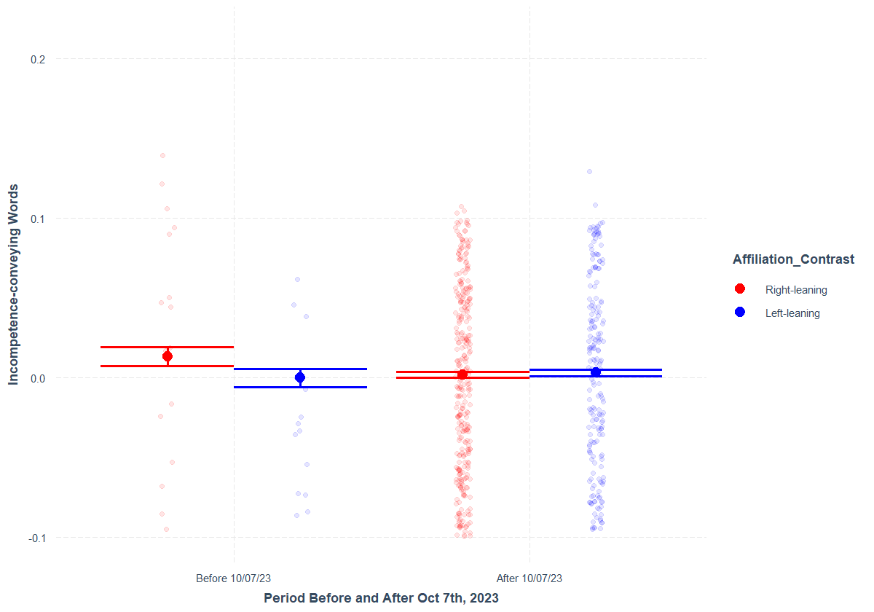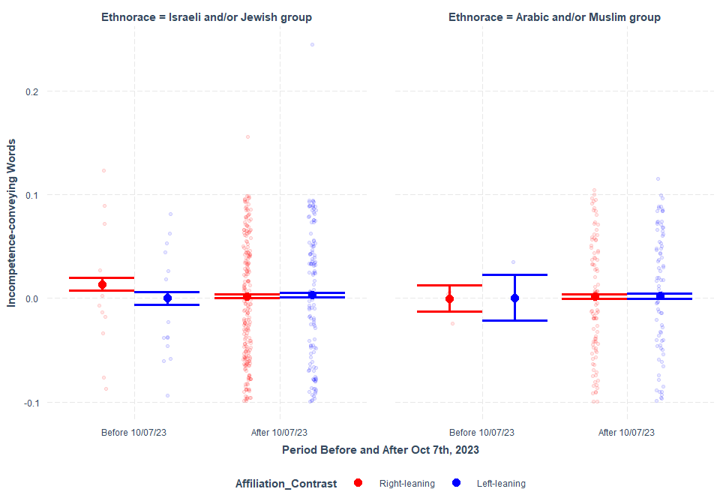Model Summary

|  | | Estimate | Std. Error | df | t value | Pr(>|t|) |
| --- | --- | --- | --- | --- | --- | --- |
| (Intercept) | | 0.0134985 | 0.0031037 | 481.8068 | 4.349108 | 0.0000167 |
| EthnoraceArabic and/or Muslim group | | -0.0137189 | 0.0071143 | 546.4593 | -1.928353 | 0.0543290 |
| Affiliation_ContrastLeft-leaning | -0.0135091 | | 0.0043112 | 469.5954 | -3.133453 | 0.0018357 |
| Condition_ContrastAfter 10/07/23 | | -0.0115372 | 0.0031906 | 503.7143 | -3.615982 | 0.0003293 |
| EthnoraceArabic and/or Muslim group:Affiliation_ContrastLeft-leaning | | 0.0142206 | 0.0135345 | 547.0000 | 1.050694 | 0.2938632 |
| EthnoraceArabic and/or Muslim group:Condition_ContrastAfter 10/07/23 | | 0.0135029 | 0.0072443 | 546.5862 | 1.863935 | 0.0628667 |
| Affiliation_ContrastLeft-leaning:Condition_ContrastAfter 10/07/23 | | 0.0147193 | 0.0044879 | 475.4040 | 3.279781 | 0.0011151 |
| EthnoraceArabic and/or Muslim group:Affiliation_ContrastLeft-leaning:Condition_ContrastAfter 10/07/23 | | -0.0149908 | 0.0136899 | 546.7858 | -1.095027 | 0.2739868 |

2-way interaction between left-leaning influencers and the period after 10/07/23

Changes in Incompetence-conveying Words in tweets between as date index (e.g., 10/07/23 as 0) moving backwards (min= -360) and forward (max= 362)

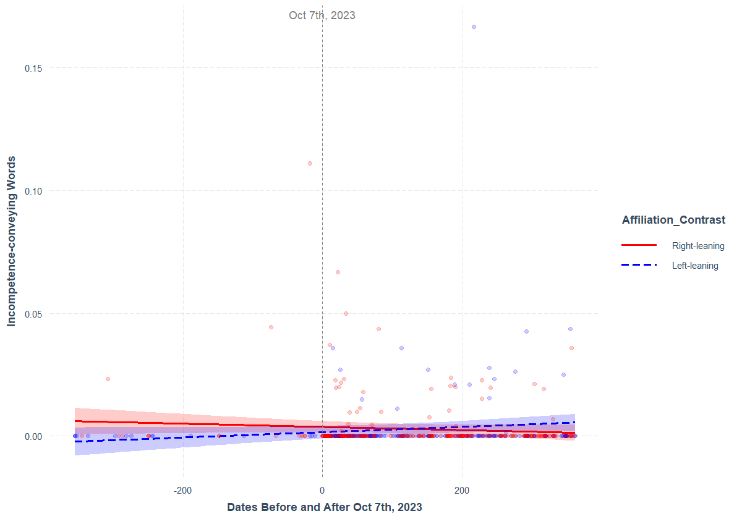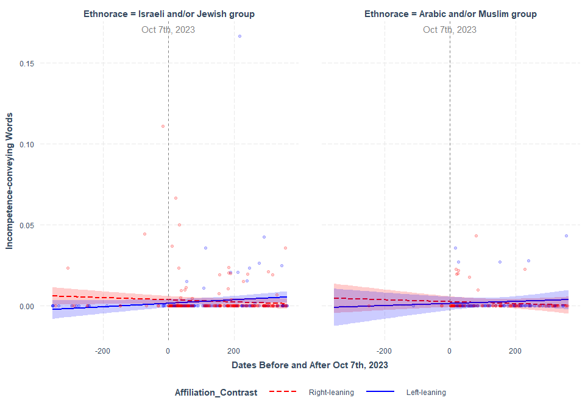Model Summary

|  | Estimate | Std. Error | df | t value | Pr(>|t|) |
| --- | --- | --- | --- | --- | --- |
| (Intercept) | 0.0036770 | 0.0011939 | 16.24532 | 3.0798399 | 0.0070767 |
| EthnoraceArabic and/or Muslim group | -0.0011581 | 0.0018497 | 546.92802 | -0.6261301 | 0.5314908 |
| Affiliation_ContrastLeft-leaning | -0.0021515 | 0.0017567 | 23.22311 | -1.2247623 | 0.2329435 |
| Date_Index | -0.0000066 | 0.0000055 | 538.78294 | -1.2021904 | 0.2298179 |
| EthnoraceArabic and/or Muslim group:Affiliation_ContrastLeft-leaning | 0.0010297 | 0.0029544 | 539.00679 | 0.3485258 | 0.7275814 |
| EthnoraceArabic and/or Muslim group:Date_Index | 0.0000007 | 0.0000109 | 530.01889 | 0.0619631 | 0.9506156 |
| Affiliation_ContrastLeft-leaning:Date_Index | 0.0000174 | 0.0000079 | 530.56153 | 2.1927291 | 0.0287604 |
| EthnoraceArabic and/or Muslim group:Affiliation_ContrastLeft-leaning:Date_Index | -0.0000049 | 0.0000170 | 510.74990 | -0.2885858 | 0.7730154 |

### Tweets Mentioning either IDF or Hamas

Changes in Incompetence-conveying Words in tweets between as date index (e.g., 10/07/23 as 0) moving backwards (min= -360) and forward (max= 362). Note: IDF was not mentioned in any tweets between 10/07/22 and 10/06/23 (the “Before” period). So, the data was subsetted to only the ““After” period.

Model Summary

|  | Estimate | Std. Error | df | t value | Pr(>|t|) |
| --- | --- | --- | --- | --- | --- |
| (Intercept) | 0.0125362 | 0.0041197 | 376.5176 | 3.042996 | 0.0025067 |
| MilitantHamas | -0.0110099 | 0.0041571 | 383.6428 | -2.648449 | 0.0084200 |
| Affiliation_ContrastLeft-leaning | -0.0190233 | 0.0056346 | 374.1741 | -3.376138 | 0.0008122 |
| Date_Index | -0.0000397 | 0.0000206 | 383.9449 | -1.924310 | 0.0550545 |
| MilitantHamas:Affiliation_ContrastLeft-leaning | 0.0169720 | 0.0058302 | 383.9085 | 2.911048 | 0.0038123 |
| MilitantHamas:Date_Index | 0.0000395 | 0.0000209 | 383.5270 | 1.888301 | 0.0597401 |
| Affiliation_ContrastLeft-leaning:Date_Index | 0.0001564 | 0.0000401 | 383.9655 | 3.896807 | 0.0001150 |
| MilitantHamas:Affiliation_ContrastLeft-leaning:Date_Index | -0.0001398 | 0.0000413 | 383.5094 | -3.389272 | 0.0007735 |

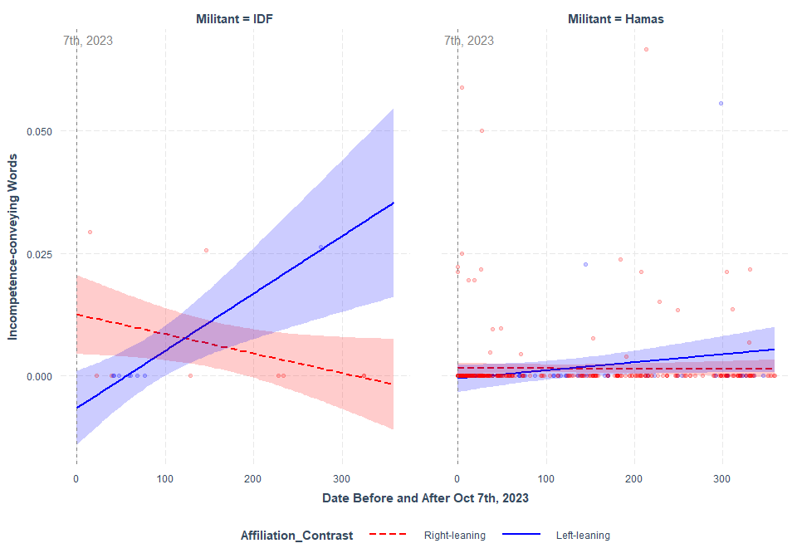

# Change in Hate-speech Content

**Intercept as indicated by the Pre-reg**

[QUALITY] ~ Ethnorace*Affiliation_Contrast*(Condition_Contrast or Date_index) + (1+Ethnorace*(Condition_Contrast or Date_index)|Subject_ID)

### Tweets Mentioning either Israeli and/or Jewish people or Arabic and/or Muslim people

Changes in Incompetence-conveying Words in tweets by the “Before” and “After” period

## boundary (singular) fit: see help('isSingular')

Model Summary

|  | Estimate | Std. Error | df | t value | Pr(>|t|) |
| --- | --- | --- | --- | --- | --- |
| (Intercept) | 0.0717728 | 0.0839367 | 20.17601 | 0.8550822 | 0.4025459 |
| EthnoraceArabic and/or Muslim group | -0.0254788 | 0.1564241 | 178.04481 | -0.1628828 | 0.8707955 |
| Affiliation_ContrastLeft-leaning | 0.1103239 | 0.1185652 | 20.36889 | 0.9304911 | 0.3630146 |
| Condition_ContrastAfter 10/07/23 | 0.0349597 | 0.0774365 | 29.15125 | 0.4514629 | 0.6549969 |
| EthnoraceArabic and/or Muslim group:Affiliation_ContrastLeft-leaning | -0.1049470 | 0.2944660 | 322.13886 | -0.3563975 | 0.7217762 |
| EthnoraceArabic and/or Muslim group:Condition_ContrastAfter 10/07/23 | 0.0633091 | 0.1606285 | 126.43013 | 0.3941336 | 0.6941464 |
| Affiliation_ContrastLeft-leaning:Condition_ContrastAfter 10/07/23 | -0.0992015 | 0.1122521 | 31.28305 | -0.8837390 | 0.3835787 |
| EthnoraceArabic and/or Muslim group:Affiliation_ContrastLeft-leaning:Condition_ContrastAfter 10/07/23 | 0.0467139 | 0.2987332 | 237.34670 | 0.1563735 | 0.8758716 |

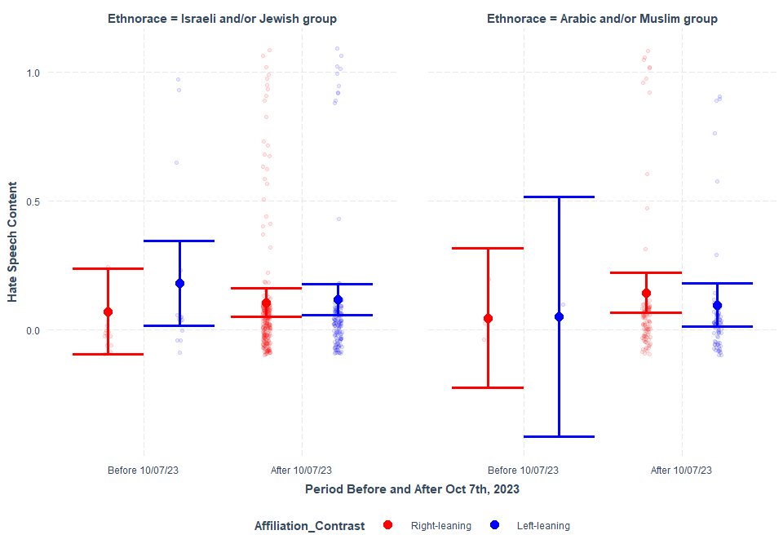

Changes in Hate Speech Content in tweets between as date index (e.g., 10/07/23 as 0) moving backwards (min= -360) and forward (max= 362)

## boundary (singular) fit: see help('isSingular')

Model Summary

|  | Estimate | Std. Error | df | t value | Pr(>|t|) |
| --- | --- | --- | --- | --- | --- |
| (Intercept) | 0.1329853 | 0.0785421 | 0.5645535 | 1.6931721 | 0.4547768 |
| EthnoraceArabic and/or Muslim group | -0.0081401 | 0.0805244 | 5.8836074 | -0.1010884 | 0.9228369 |
| Affiliation_ContrastLeft-leaning | -0.0037643 | 0.1111840 | 0.5617568 | -0.0338568 | 0.9811490 |
| Date_Index | -0.0001075 | 0.0002506 | 0.5541421 | -0.4290647 | 0.7793630 |
| EthnoraceArabic and/or Muslim group:Affiliation_ContrastLeft-leaning | 0.0093501 | 0.1182627 | 5.8352381 | 0.0790621 | 0.9396245 |
| EthnoraceArabic and/or Muslim group:Date_Index | 0.0004736 | 0.0005351 | 1.4076927 | 0.8849956 | 0.5012284 |
| Affiliation_ContrastLeft-leaning:Date_Index | 0.0001233 | 0.0003446 | 0.5254993 | 0.3579319 | 0.8150043 |
| EthnoraceArabic and/or Muslim group:Affiliation_ContrastLeft-leaning:Date_Index | -0.0005398 | 0.0007616 | 1.8667409 | -0.7087654 | 0.5564649 |

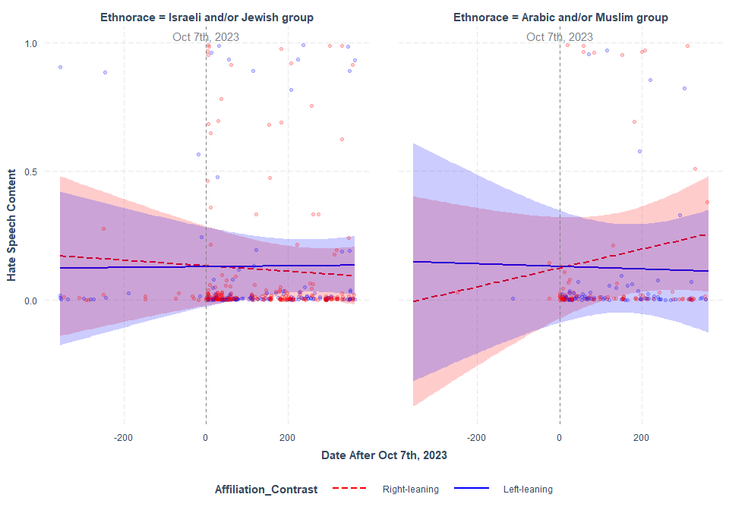

### Tweets Mentioning either IDF or Hamas

Changes in Hate Speech Content in tweets between as date index (e.g., 10/07/23 as 0) moving backwards (min= -360) and forward (max= 362). Note: IDF was not mentioned in any tweets between 10/07/22 and 10/06/23 (the “Before” period). So, the data was subsetted to only the ““After” period.

Model Summary

|  | Estimate | Std. Error | df | t value | Pr(>|t|) |
| --- | --- | --- | --- | --- | --- |
| (Intercept) | -0.0316456 | 0.1763983 | 0.8141154 | -0.1793985 | 0.8918222 |
| MilitantHamas | 0.1583700 | 0.1768151 | 1.4492132 | 0.8956816 | 0.4940895 |
| Affiliation_ContrastLeft-leaning | -0.0559130 | 0.3172105 | 0.9498581 | -0.1762648 | 0.8900733 |
| Date_Index | 0.0190559 | 0.0797508 | 32.1179980 | 0.2389427 | 0.8126682 |
| MilitantHamas:Affiliation_ContrastLeft-leaning | -0.0165362 | 0.3231452 | 1.5194298 | -0.0511728 | 0.9650883 |
| MilitantHamas:Date_Index | -0.0189345 | 0.0796766 | 30.6716857 | -0.2376425 | 0.8137387 |
| Affiliation_ContrastLeft-leaning:Date_Index | -0.0150490 | 0.1039512 | 51.5711725 | -0.1447696 | 0.8854571 |
| MilitantHamas:Affiliation_ContrastLeft-leaning:Date_Index | 0.0149627 | 0.1038399 | 48.9733544 | 0.1440940 | 0.8860176 |

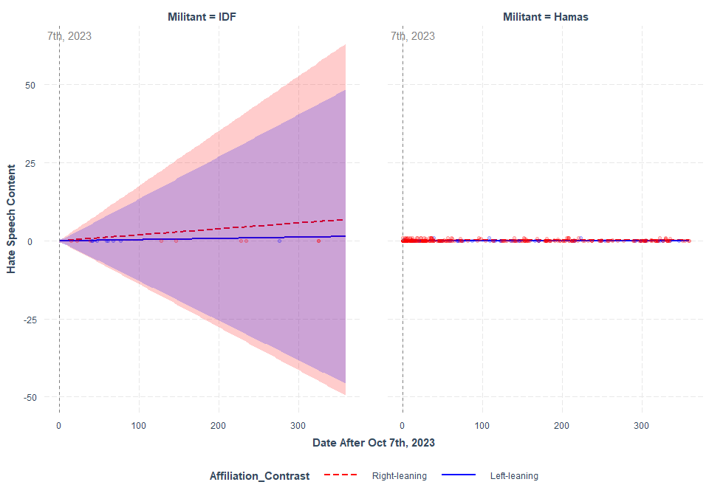

**SIMPLIFIED INTERCEPT**

[QUALITY] ~ Ethnorace*Affiliation_Contrast*(Condition_Contrast or Date_index) + (1|Subject_ID)

### Tweets Mentioning either Israeli and/or Jewish people or Arabic and/or Muslim people

Changes in Hate Speech Content in tweets by the “Before” and “After” period

Model Summary

|  | Estimate | Std. Error | df | t value | Pr(>|t|) |
| --- | --- | --- | --- | --- | --- |
| (Intercept) | 0.0516724 | 0.0718090 | 229.6100 | 0.7195804 | 0.4725152 |
| EthnoraceArabic and/or Muslim group | -0.0145414 | 0.1537189 | 544.4145 | -0.0945975 | 0.9246693 |
| Affiliation_ContrastLeft-leaning | 0.1357293 | 0.1007828 | 194.7148 | 1.3467501 | 0.1796262 |
| Condition_ContrastAfter 10/07/23 | 0.0635256 | 0.0704260 | 542.3015 | 0.9020203 | 0.3674465 |
| EthnoraceArabic and/or Muslim group:Affiliation_ContrastLeft-leaning | -0.0911573 | 0.2917942 | 540.4504 | -0.3124027 | 0.7548550 |
| EthnoraceArabic and/or Muslim group:Condition_ContrastAfter 10/07/23 | 0.0397444 | 0.1564632 | 543.7374 | 0.2540176 | 0.7995780 |
| Affiliation_ContrastLeft-leaning:Condition_ContrastAfter 10/07/23 | -0.1244813 | 0.1014121 | 453.5027 | -1.2274806 | 0.2202788 |
| EthnoraceArabic and/or Muslim group:Affiliation_ContrastLeft-leaning:Condition_ContrastAfter 10/07/23 | 0.0366357 | 0.2947002 | 538.4528 | 0.1243152 | 0.9011121 |

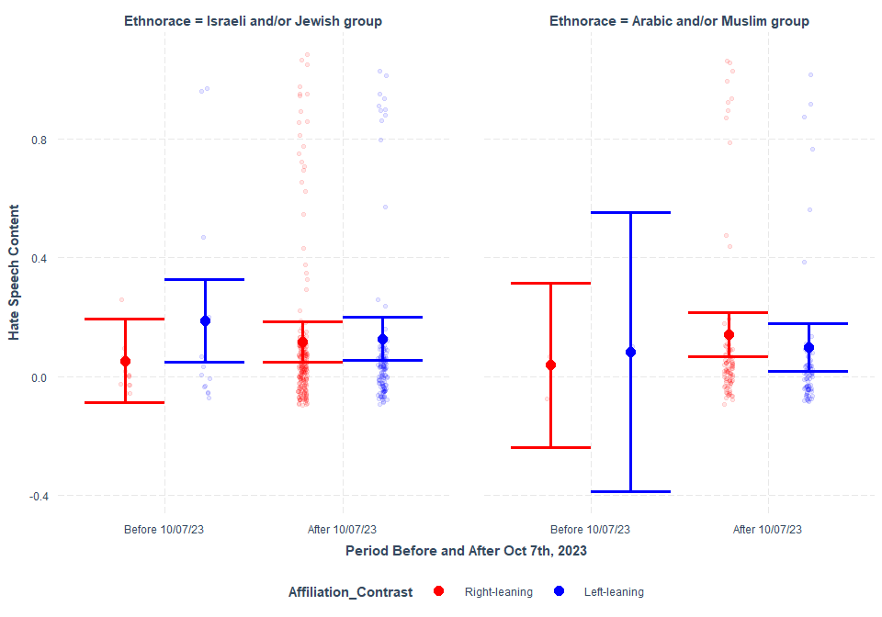

Changes in Hate Speech Content in tweets between as date index (e.g., 10/07/23 as 0) moving backwards (min= -360) and forward (max= 362)

Model Summary

|  | Estimate | Std. Error | df | t value | Pr(>|t|) |
| --- | --- | --- | --- | --- | --- |
| (Intercept) | 0.1074888 | 0.0365388 | 21.71402 | 2.9417682 | 0.0076122 |
| EthnoraceArabic and/or Muslim group | -0.0010717 | 0.0397960 | 546.32759 | -0.0269297 | 0.9785256 |
| Affiliation_ContrastLeft-leaning | 0.0286631 | 0.0521533 | 22.81004 | 0.5495931 | 0.5879396 |
| Date_Index | -0.0000079 | 0.0001174 | 543.22757 | -0.0671937 | 0.9464523 |
| EthnoraceArabic and/or Muslim group:Affiliation_ContrastLeft-leaning | -0.0492247 | 0.0638009 | 546.84271 | -0.7715361 | 0.4407225 |
| EthnoraceArabic and/or Muslim group:Date_Index | 0.0002445 | 0.0002365 | 546.94851 | 1.0337008 | 0.3017329 |
| Affiliation_ContrastLeft-leaning:Date_Index | -0.0000014 | 0.0001717 | 545.83262 | -0.0081275 | 0.9935183 |
| EthnoraceArabic and/or Muslim group:Affiliation_ContrastLeft-leaning:Date_Index | -0.0001129 | 0.0003692 | 546.99829 | -0.3059122 | 0.7597879 |

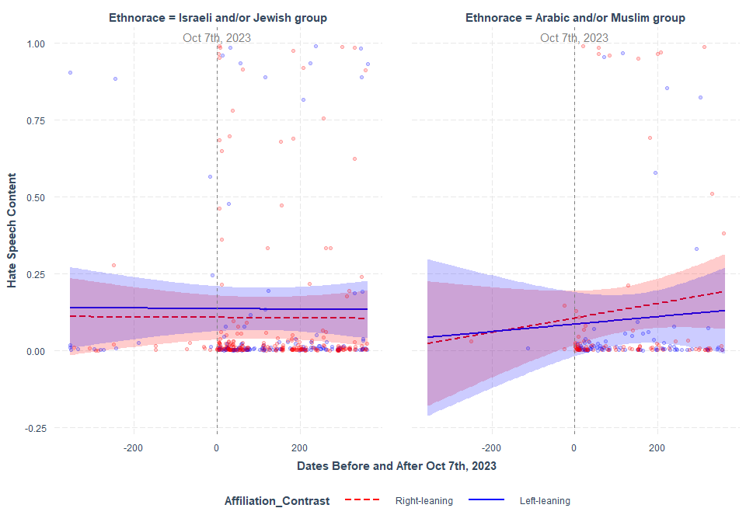

### Tweets Mentioning either IDF or Hamas

Changes in Hate Speech Content in tweets between as date index (e.g., 10/07/23 as 0) moving backwards (min= -360) and forward (max= 362). Note: IDF was not mentioned in any tweets between 10/07/22 and 10/06/23 (the “Before” period). So, the data was subsetted to only the ““After” period.

Model Summary

|  | Estimate | Std. Error | df | t value | Pr(>|t|) |
| --- | --- | --- | --- | --- | --- |
| (Intercept) | -0.0237975 | 0.1565768 | 379.7993 | -0.1519861 | 0.8792786 |
| MilitantHamas | 0.1958321 | 0.1546624 | 374.2409 | 1.2661906 | 0.2062324 |
| Affiliation_ContrastLeft-leaning | 0.0295536 | 0.2160783 | 362.6503 | 0.1367725 | 0.8912865 |
| Date_Index | 0.0001708 | 0.0007674 | 373.0039 | 0.2225578 | 0.8240015 |
| MilitantHamas:Affiliation_ContrastLeft-leaning | -0.1394556 | 0.2180789 | 380.8858 | -0.6394729 | 0.5228997 |
| MilitantHamas:Date_Index | -0.0003741 | 0.0007782 | 373.5534 | -0.4806702 | 0.6310323 |
| Affiliation_ContrastLeft-leaning:Date_Index | -0.0002813 | 0.0015013 | 379.8440 | -0.1873532 | 0.8514838 |
| MilitantHamas:Affiliation_ContrastLeft-leaning:Date_Index | 0.0004601 | 0.0015402 | 379.1245 | 0.2987184 | 0.7653186 |

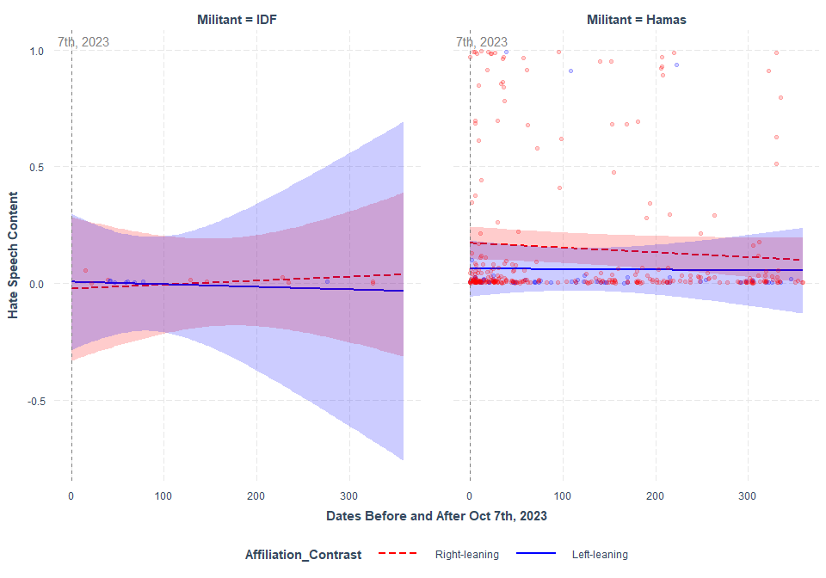

# Change in Stereotype Content using BERT

### Double-category WEAT results obtained using BERT embeddings.

**Table 1.** Ethnocultural groups’ associations to SCM attributes in the “Before” and “After” corpora using BERT embeddings.

|  | Israeli-Arabic,  Warm-Cold | | |  | IDF-Hamas,  Warm-Cold | | |  | Jewish-Muslim,  Warm-Cold | | |  | Israeli-Arabic,  Competence-Incompetence | | |  | IDF-Hamas,  Competence -Incompetence | | |  | Jewish-Muslim,  Competence -Incompetence | | |
| --- | --- | --- | --- | --- | --- | --- | --- | --- | --- | --- | --- | --- | --- | --- | --- | --- | --- | --- | --- | --- | --- | --- | --- |
| Corpus | *D* | *SE* | *p* |  | *D* | *SE* | *p* |  | *D* | *SE* | *p* |  | *D* | *SE* | *p* |  | *D* | *SE* | *p* |  | *D* | *SE* | *p* |
| Before | 1.33 | 0.04 | <.001 |  | n/a | n/a | n/a |  | -0.69 | 0.06 | <.001 |  | 0.58 | 0.03 | <.001 |  | n/a | n/a | n/a |  | -0.03 | 0.06 | 0.19 |
| After | 0.04 | 0.002 | <.001 |  | -0.05 | 0.004 | <.001 |  | 0.27 | 0.004 | <.001 |  | 0.09 | 0.002 | <.001 |  | -0.14 | 0.004 | <.001 |  | 0.19 | 0.004 | <.001 |

*Note*. We were unable to perform double-category WEAT for IDF and Hamas for the “Before” period, as the group IDF was not mentioned in the corpus.

**Table 2.** Full result of the ethnocultural groups’ associations to SCM attributes for the “Before” corpora using BERT embeddings.

|  |  |  |  |  |
| --- | --- | --- | --- | --- |
|  | Israeli- Arabic,  Warm-Cold | Jewish- Muslim,  Warm-Cold | Israeli- Arabic,  Competence -Incompetence | Jewish-Muslim,  Competence -Incompetence |
| Difference | 0.093376 | -0.02759 | 0.021478 | -0.000577 |
| SD | 0.070109 | 0.040129 | 0.037135 | 0.0222 |
| D | 1.331872 | -0.687531 | 0.578397 | -0.025995 |
| *pleft* | 1.00 | <.001*** | 1.00 | 0.157842 |
| *pright* | <.001*** | 1.00 | <.001*** | 0.843157 |
| *ptotal* | <.001*** | <.001*** | <.001*** | 0.187812 |
| Standard Error | 0.036346 | 0.057282 | 0.027952 | 0.059885 |

*Note*. We were unable to perform double-category WEAT for IDF and Hamas for the “Before” period, as the group IDF was not mentioned in the corpus.

**Table 3.** Full result of the ethnocultural groups’ associations to SCM attributes for the “After” corpus using BERT embeddings.

|  |  |  |  |  |  |  |
| --- | --- | --- | --- | --- | --- | --- |
|  | Israeli-Arabic  Warm-Cold | IDF-Hamas,  Warm-Cold | Jewish-Muslim,  Warm-Cold | Israeli-Arabic,  Competence -Incompetence | IDF-Hamas,  Competence - Incompetence | Jewish-Muslim,  Competence -Incompetence |
| Difference | 0.00055 | -0.000991 | 0.003931 | 0.001405 | -0.002778 | 0.002779 |
| SD | 0.014638 | 0.019909 | 0.014732 | 0.015173 | 0.020188 | 0.014687 |
| D | 0.037553 | -0.049791 | 0.266848 | 0.092613 | -0.137589 | 0.18919 |
| *pleft* | <.001*** | <.001*** | 1.00 | 1.00 | <.001*** | 1.00 |
| *pright* | 1.00 | 1.00 | <.001*** | <.001*** | 1.00 | <.001*** |
| *ptotal* | <.001*** | <.001*** | <.001*** | <.001*** | <.001*** | <.001*** |
| Standard Error | 0.00237 | 0.003819 | 0.004114 | 0.002336 | 0.004193 | 0.004188 |

### Single-category WEAT results obtained using BERT embeddings.

**Table 4.** Full result of the Israeli and/or Jewish ethnocultural group associations to SCM attributes for the “Before” corpus using BERT embeddings.

|  |  |  |  |  |
| --- | --- | --- | --- | --- |
|  | Warm/Cold  Israel | Competence/Incompetence  Israel | Warm/Cold  Jewish | Competence/Incompetence  Jewish |
| Difference | 0.08018 | 0.002213 | 0.04303 | 0.01033 |
| SD | 0.118428 | 0.059333 | 0.074552 | 0.049063 |
| D | 0.677040 | 0.037300 | 0.577184 | 0.210545 |
| *pleft* | 0.904096 | 0.513487 | 0.867133 | 0.605395 |
| *pright* | 0.096903 | 0.487512 | 0.133866 | 0.395604 |
| *ptotal* | 0.187812 | 0.974026 | 0.277722 | 0.764236 |

*Note*. We were unable to perform single-category WEAT for IDF and Hamas for the “Before” period, as the group IDF was not mentioned in the corpus.

**Table 5.** Full result of Hamas and the Arabic and/or Muslim ethnocultural group associations to SCM attributes for the “Before” corpus using BERT embeddings.

|  |  |  |  |  |  |  |
| --- | --- | --- | --- | --- | --- | --- |
|  | Warm/Cold  Arabic | Competence/Incompetence  Arabic | Warm/Cold  Hamas | Competence/Incompetence  Hamas | Warm/Cold  Muslim | Competence/Incompetence Muslim |
| Difference | -0.013196 | -0.019265 | 0.029625 | -0.003552 | 0.07062 | 0.010907 |
| SD | 0.071221 | 0.042484 | 0.053914 | 0.033209 | 0.118572 | 0.086299 |
| D | -0.185277 | -0.453478 | 0.549490 | -0.106947 | 0.595590 | 0.126387 |
| *pleft* | 0.355644 | 0.253746 | 0.851149 | 0.434565 | 0.852148 | 0.550450 |
| *pright* | 0.645355 | 0.747253 | 0.14985 | 0.567433 | 0.148851 | 0.451548 |
| *ptotal* | 0.712288 | 0.503497 | 0.277722 | 0.838162 | 0.278721 | 0.891109 |

**Table 6.** Full result of IDF and the Israeli and/or Jewish ethnocultural group associations to SCM attributes for the “After” corpus using BERT embeddings.

|  |  |  |  |  |  |  |
| --- | --- | --- | --- | --- | --- | --- |
|  | Warm/Cold  Israeli | Competence/Incompetence  Israeli | Warm/Cold  IDF | Competence/Incompetence  IDF | Warm/Cold  Jewish | Competence/Incompetence  Jewish |
| Difference | -0.017789 | -0.024909 | -0.01377 | -0.022192 | -0.019506 | -0.024791 |
| SD | 0.073509 | 0.071917 | 0.065274 | 0.065569 | 0.074765 | 0.071246 |
| D | -0.24199 | -0.346355 | -0.210953 | -0.338454 | -0.260898 | -0.34796 |
| *pleft* | 0.003996** | 0.001998** | 0.008991** | 0.002997** | 0.001998** | 0.001998** |
| *pright* | 0.997003 | 0.999001 | 0.992008 | 0.998002 | 0.999001 | 0.999001 |
| *ptotal* | 0.004995** | 0.003996** | 0.010989* | 0.005994** | 0.002997** | 0.001998** |

**Table 7.** Full result of Hamas and the Arabic and/or Muslim ethnocultural group associations to SCM attributes for the “After” corpus using BERT embeddings.

|  |  |  |  |  |  |  |
| --- | --- | --- | --- | --- | --- | --- |
|  | Warm/Cold  Arabic | Competence/Incompetence  Arabic | Warm/Cold  Hamas | Competence/Incompetence  Hamas | Warm/Cold  Muslim | Competence/Incompetence Muslim |
| Difference | -0.018338 | -0.026314 | -0.012779 | -0.019415 | -0.023437 | -0.027569 |
| SD | 0.080289 | 0.077349 | 0.061388 | 0.060922 | 0.079769 | 0.076504 |
| D | -0.228402 | -0.340196 | -0.20816 | -0.318678 | -0.293814 | -0.360367 |
| *pleft* | 0.003996** | 0.002997** | 0.004995** | 0.001998** | <.001*** | 0.001998** |
| *pright* | 0.997003 | 0.998002 | 0.996004 | 0.999001 | 1.00 | 0.999001 |
| *ptotal* | 0.005994** | 0.004995** | 0.00999** | 0.006993** | <.001*** | 0.004995** |