Below:

So my idea here was a simple login page for the company users creating the catalogue, then having a dashboard to include a logo and two colour themes, and company details.

When adding products they will search the product on icecat, then past the url of the product or the code in the add product box, and then our app will go get the products data and create the product page in the cataloge.

I havent included options of like filling in extra details and customising the text, so currently its as whatever comes from icecat is going to be in and they cant change it. We can do this differently though, though just want to keep the app simple, but we can see maybe we add boxes where they can adjust the received product data.

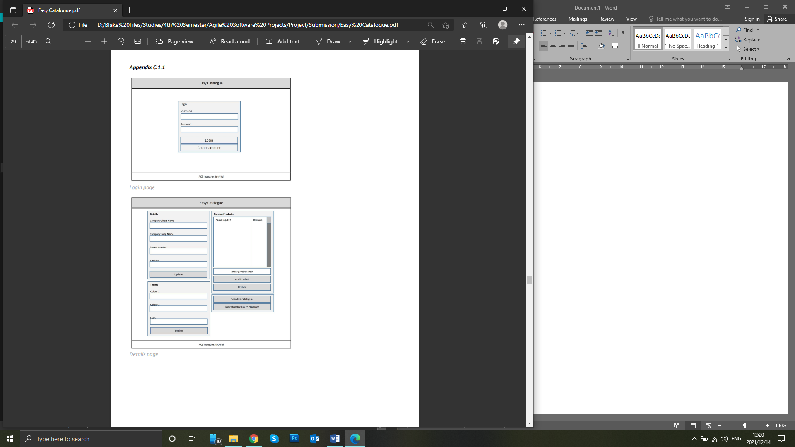

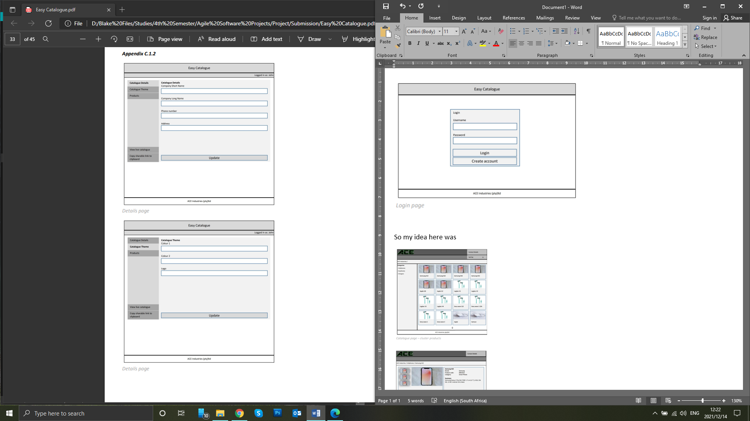



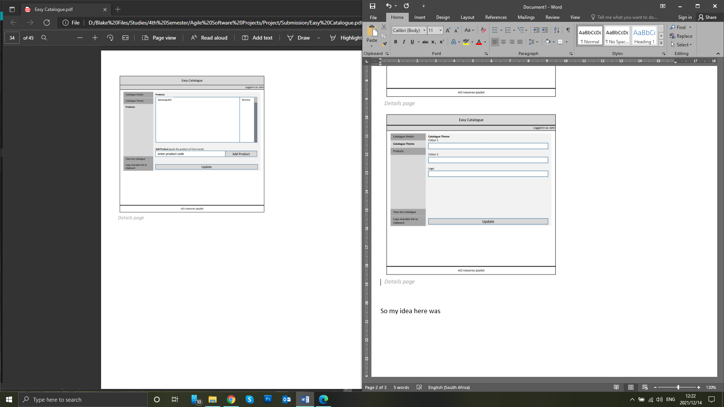

Below:

Would be the catalogue that customers view, so will be two pages, one with all the thumbnails of the products then a page for the product.

Sorting the products I have only included ‘category’, ‘brand’ and ‘date listed’.

I think we want to keep it as simple as possible, and im sure we can get category and brand nicely formatted from icecat. Though it will get very complicating if we include options like comparisons.

Also having a seachbar would be nice though also will be tricky to do, so I have left it our in my prototype.

The format of the catalogue is like a online shop, reason here is ‘heurics’, one of the issues with catalogues is that people do weird designs that customers cant find what they looking for, so one of my points on this design was having a ‘culturally’ accepted layout that most people are already familiar with.

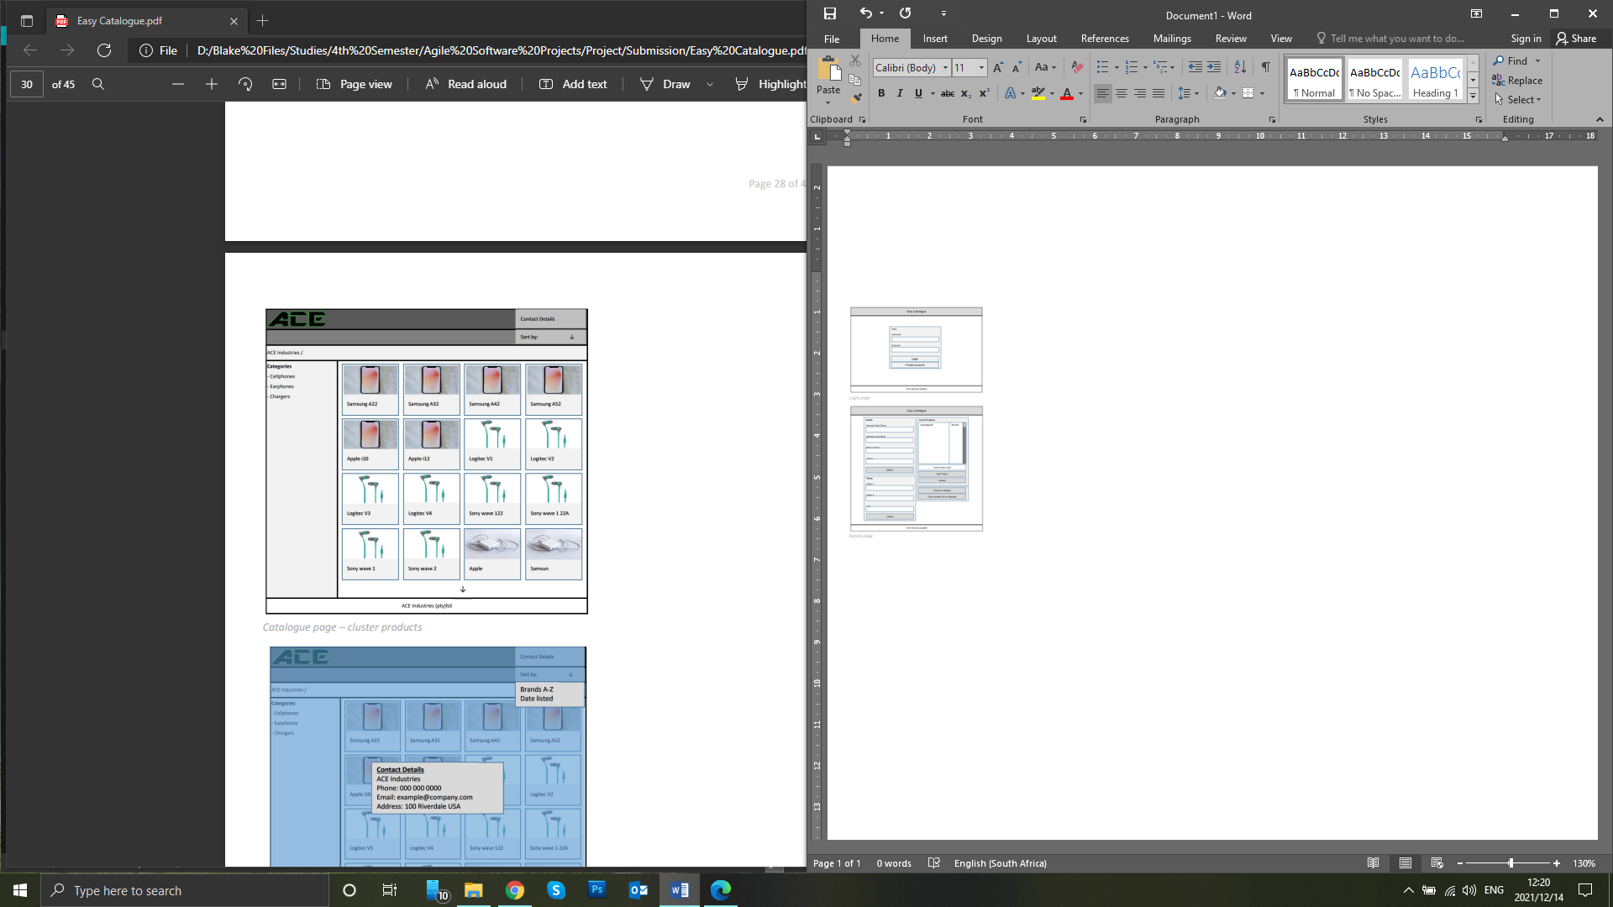

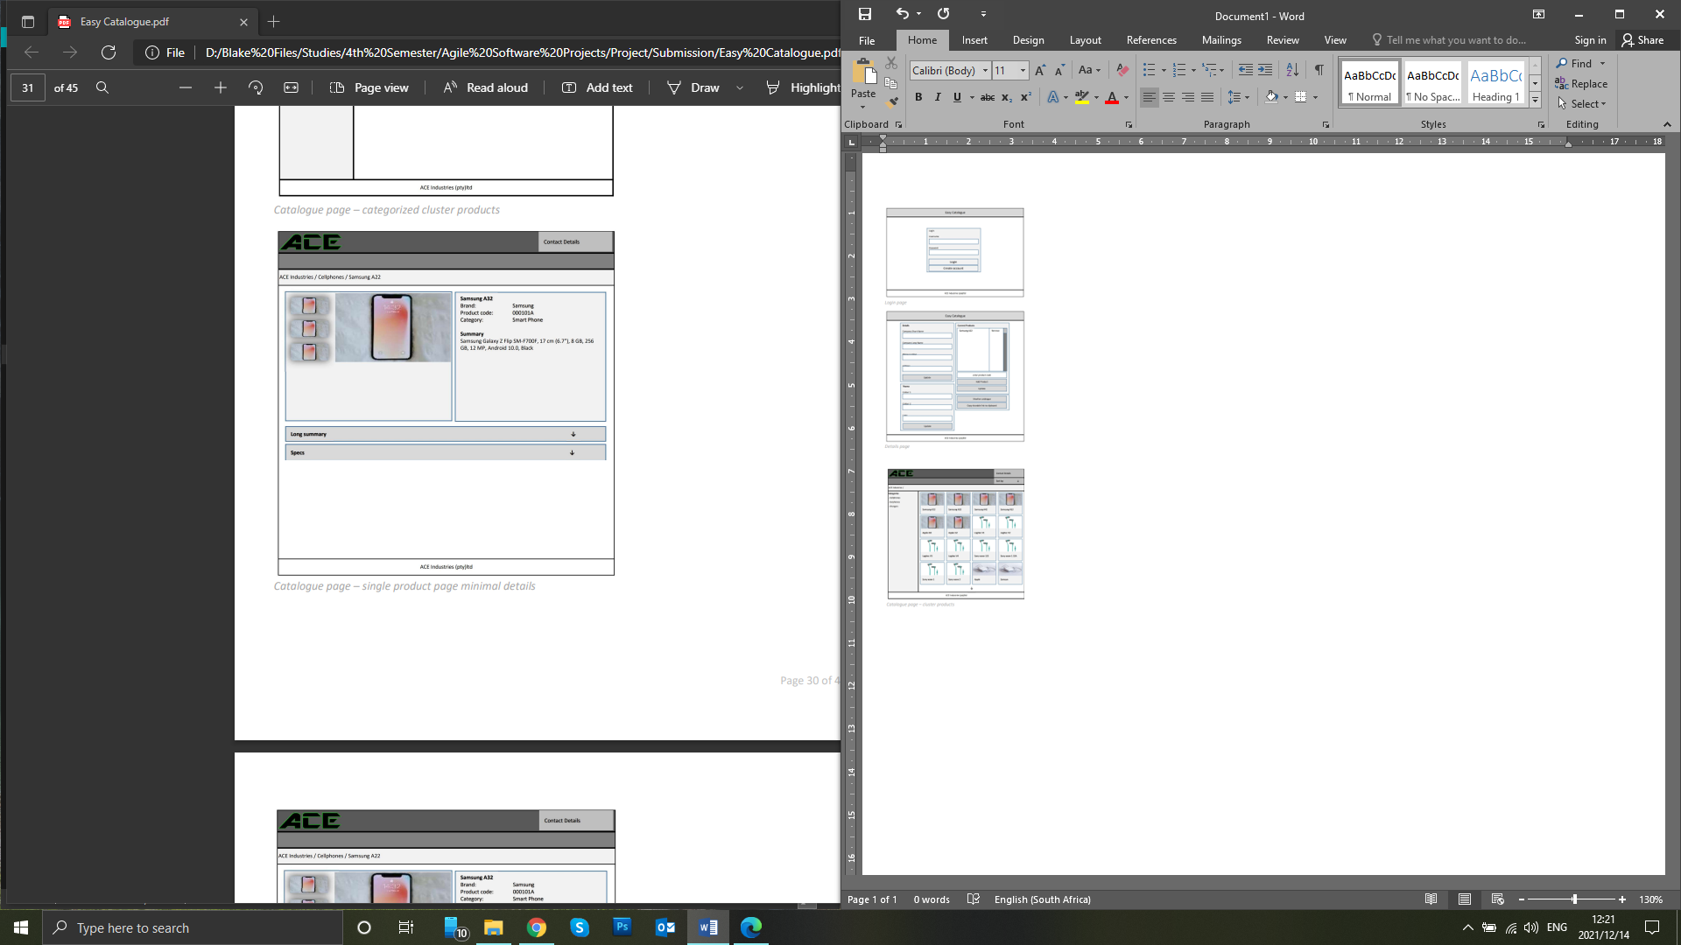

Swot analysis of design

