This is the index I was working with:

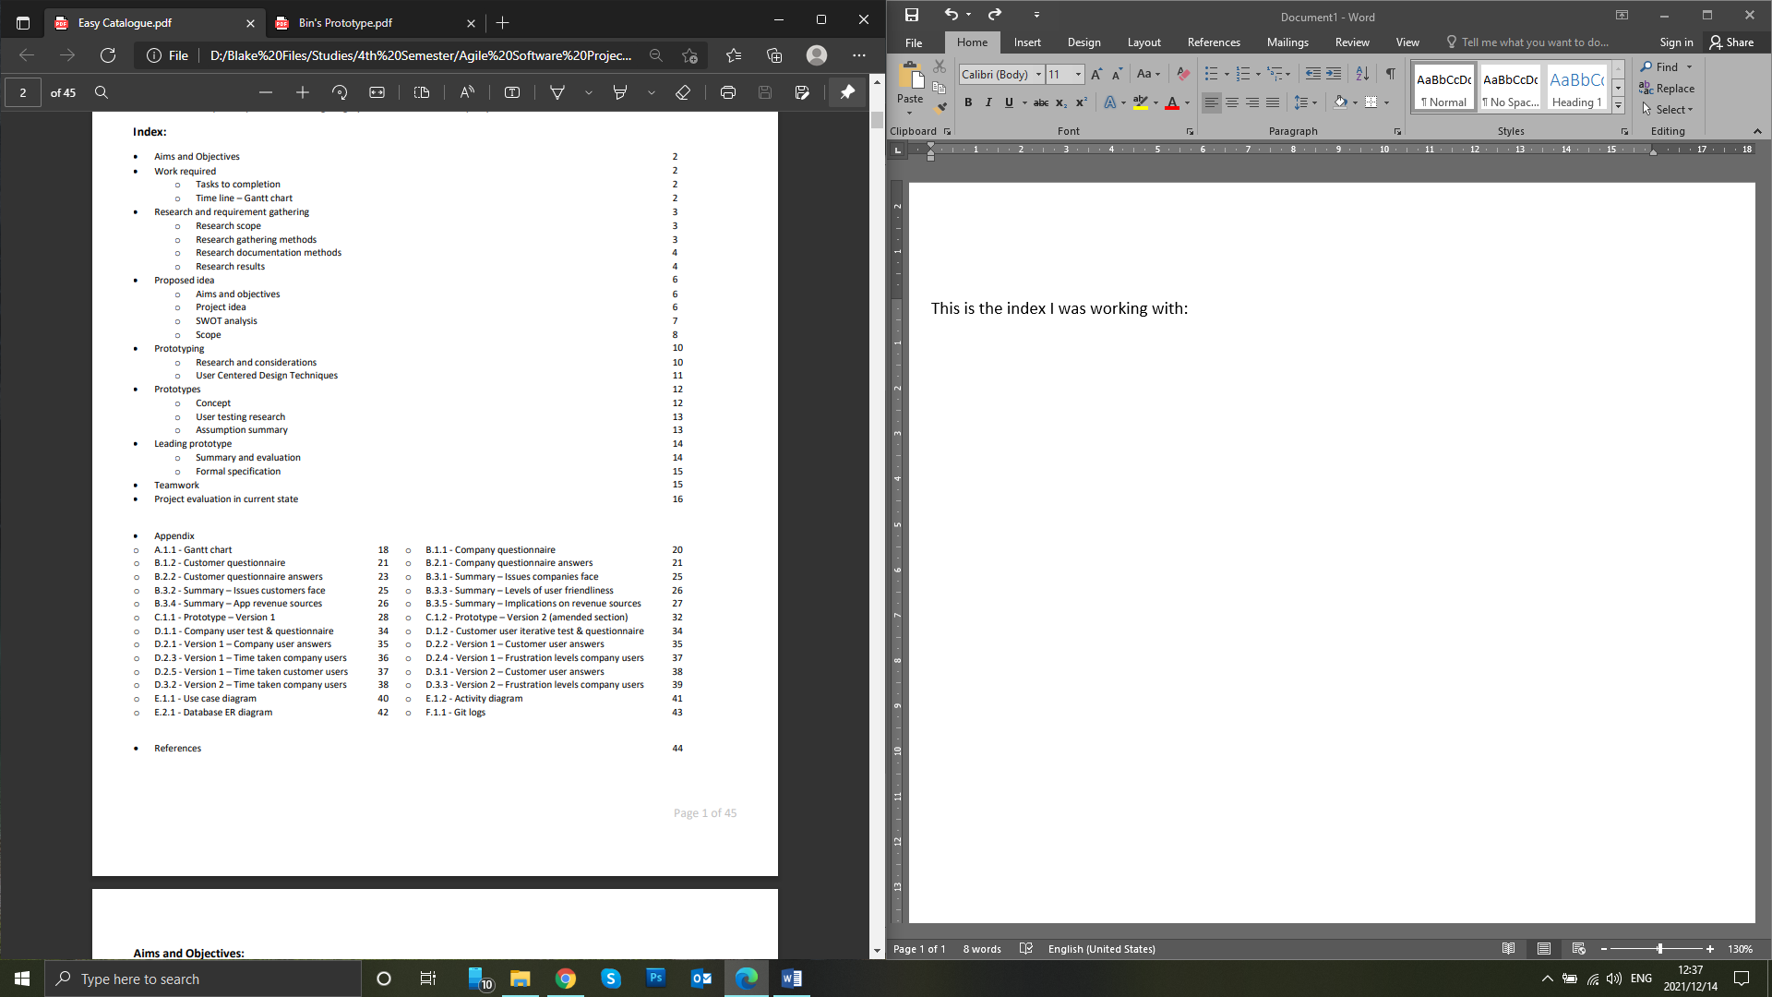

The languages that would make sense here would be javascript and mysql, which I have done some on so we should be fine. Only thing I haven’t done is work with APIs, so our contingency if we aren’t able to sync nicely with icecat, we can ‘live webscrape’ which I did last semester, or last resort we can webscrape some products and create our own database for the app to refer too.

These were my aims I came up with

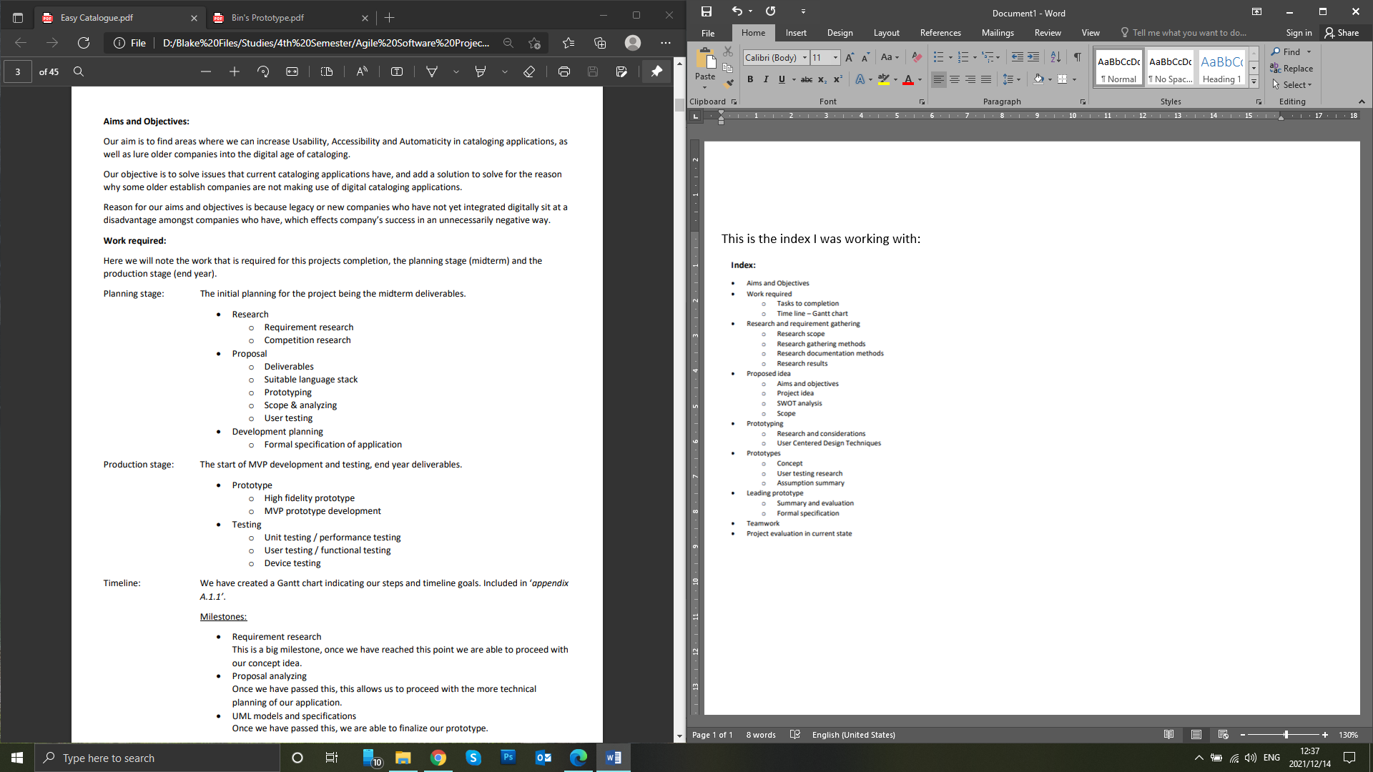

These were the issues that I found in my research

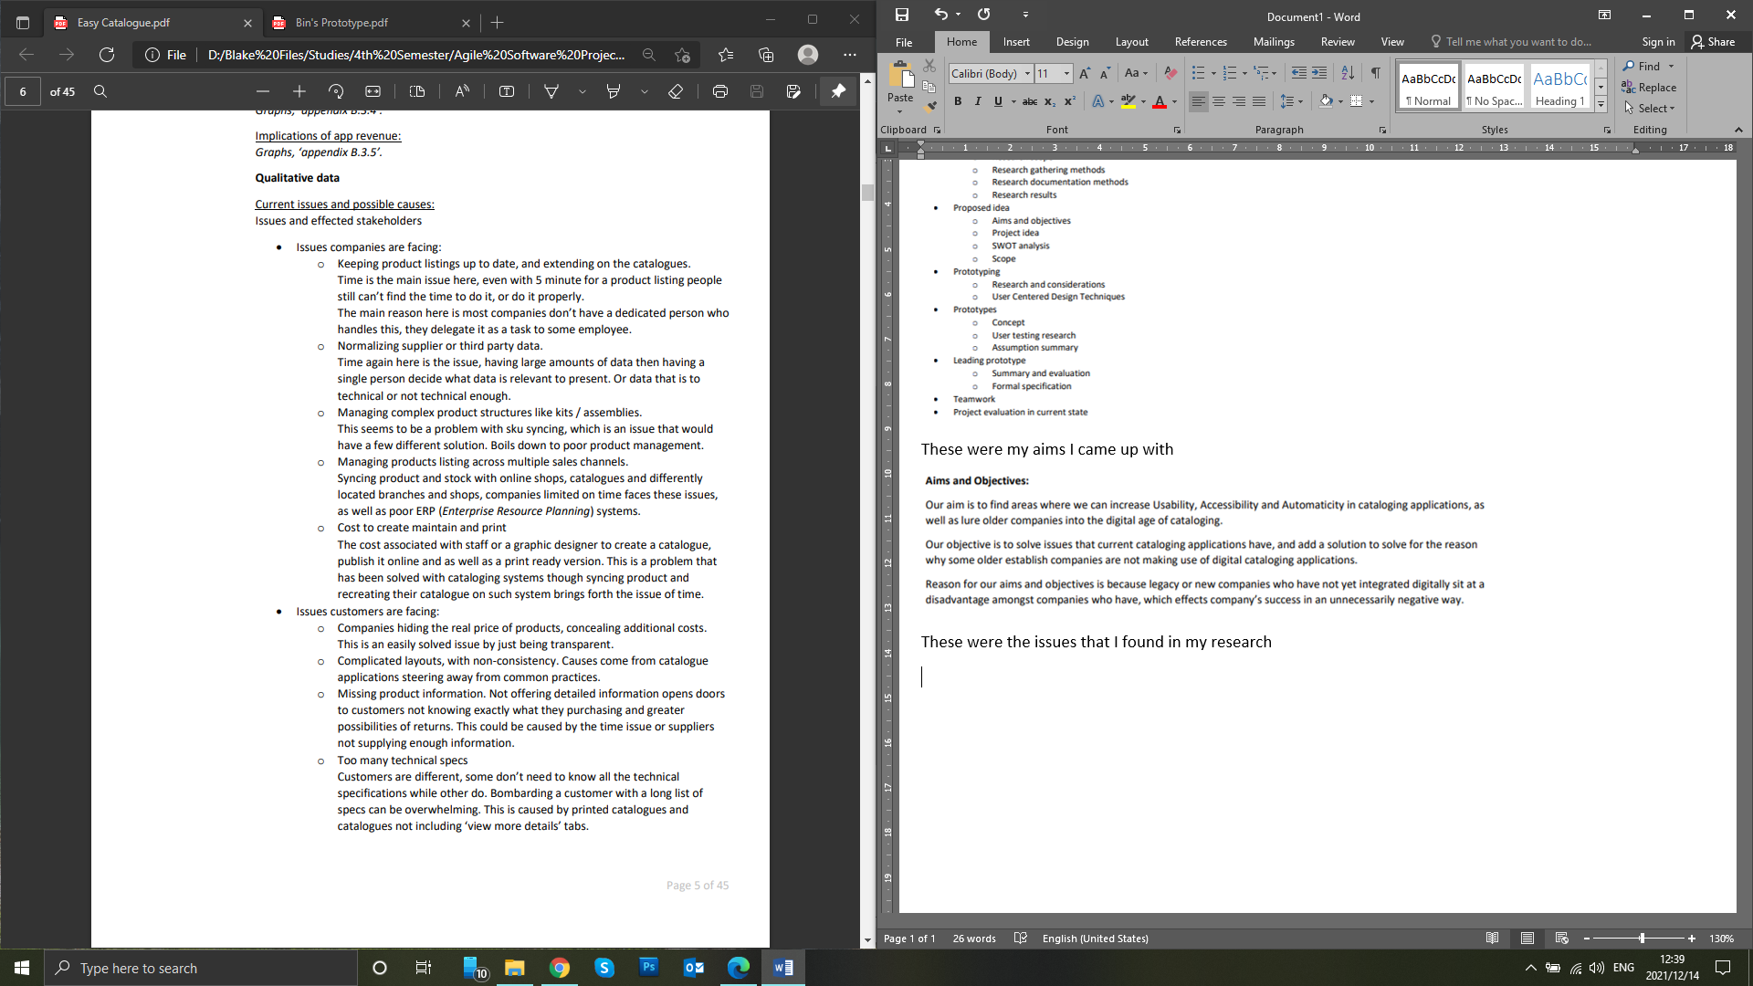

This is my idea

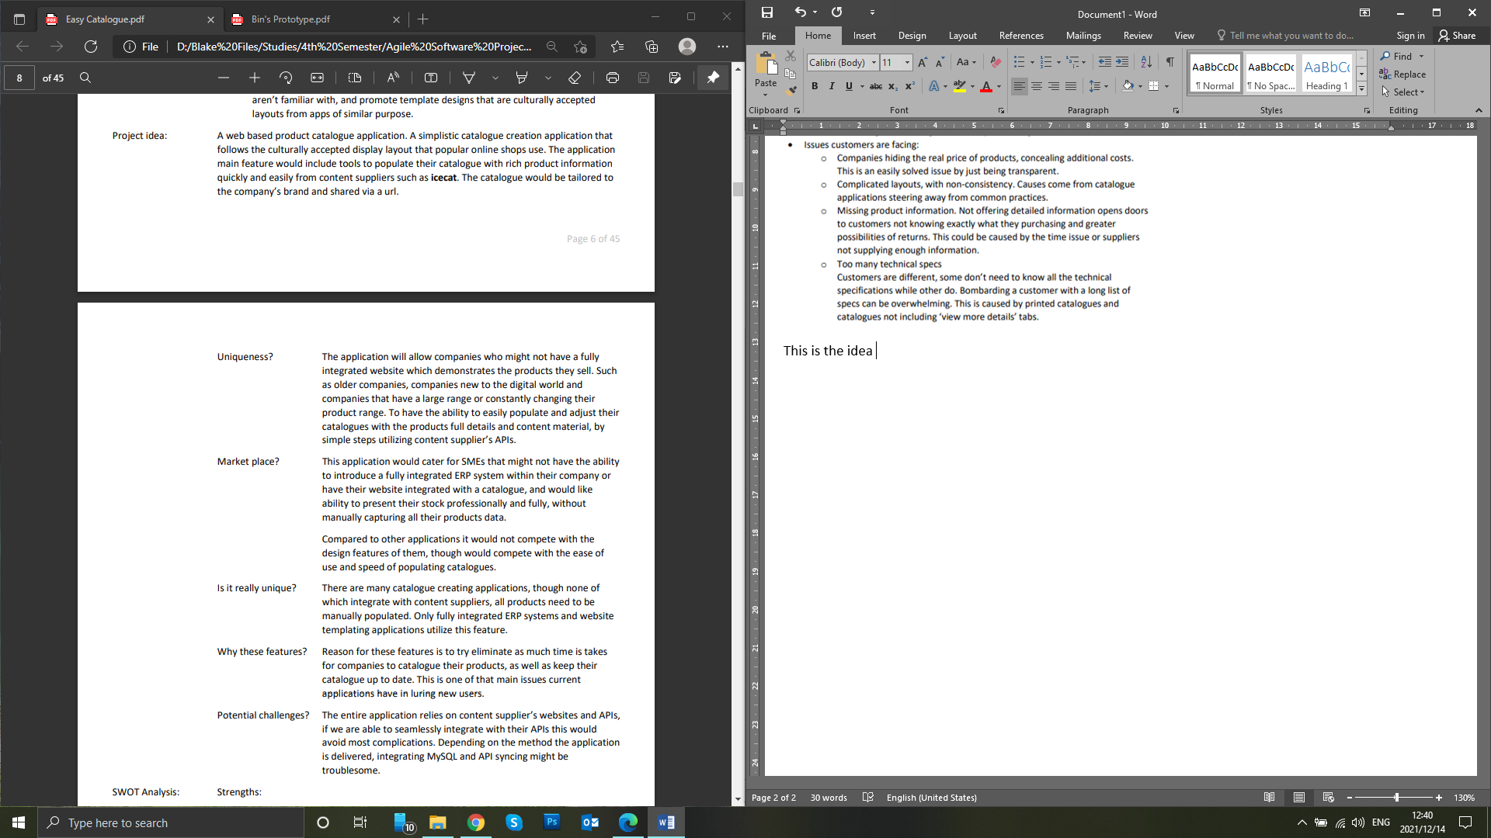

This is my aims and objectives for the idea

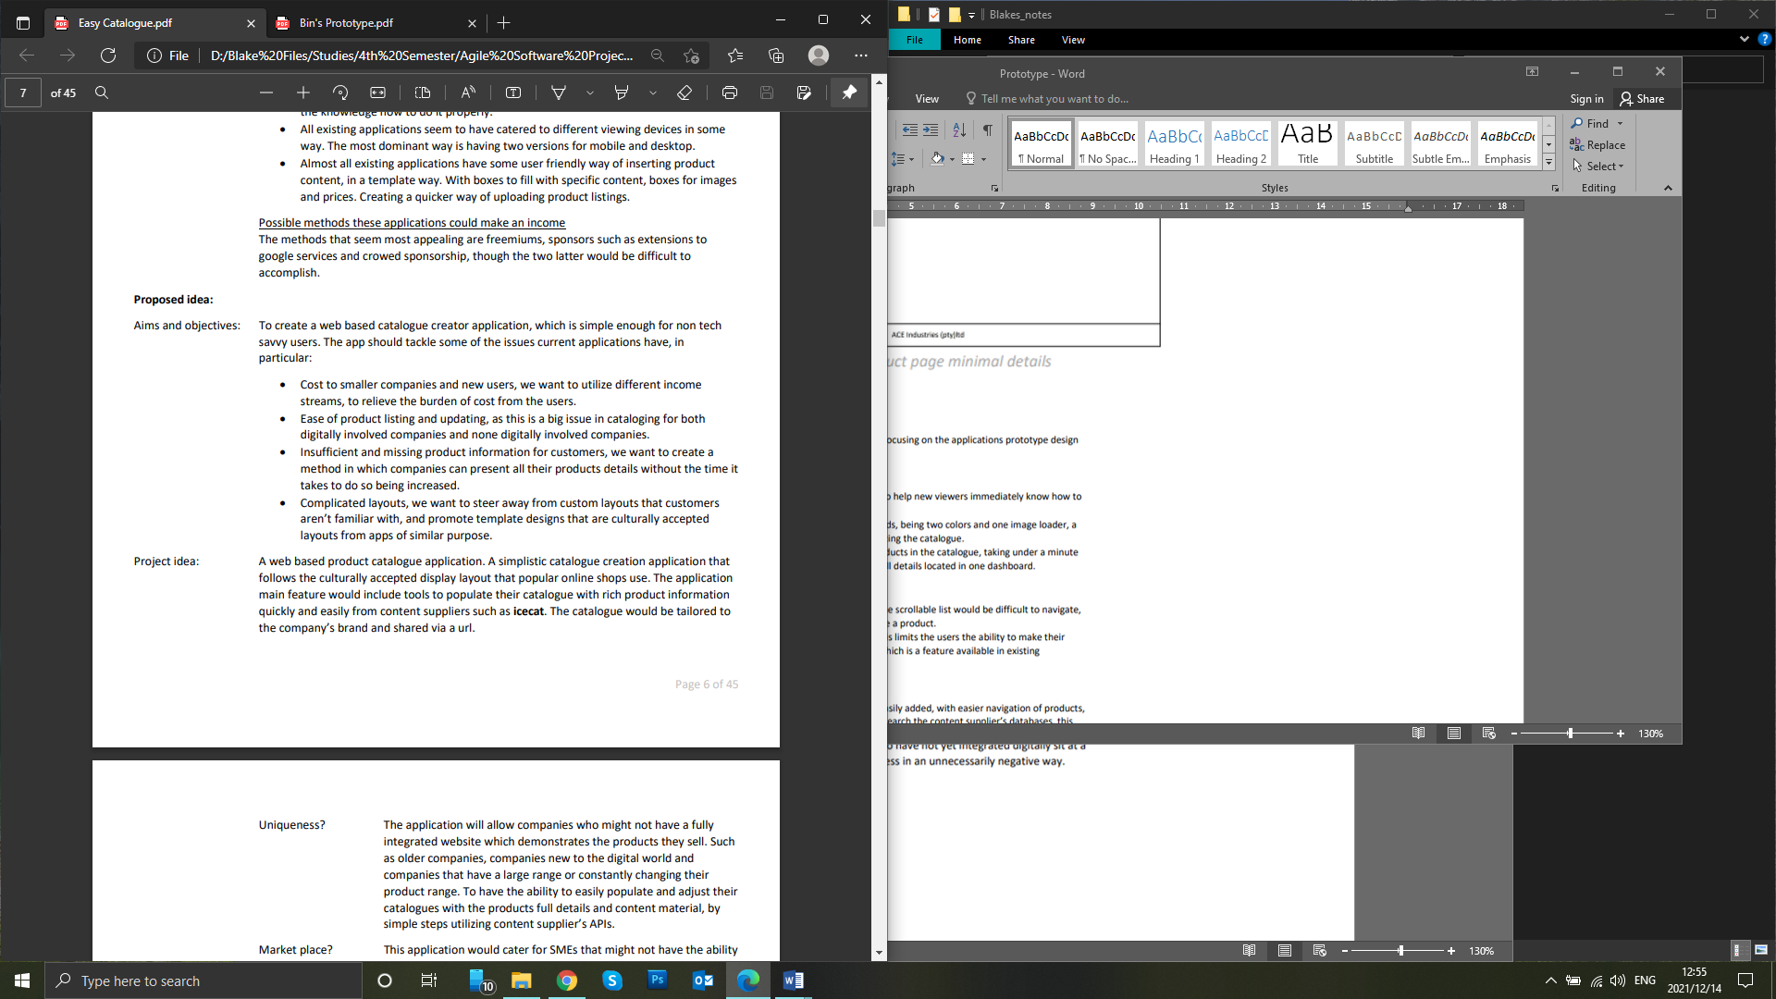

This is my scope

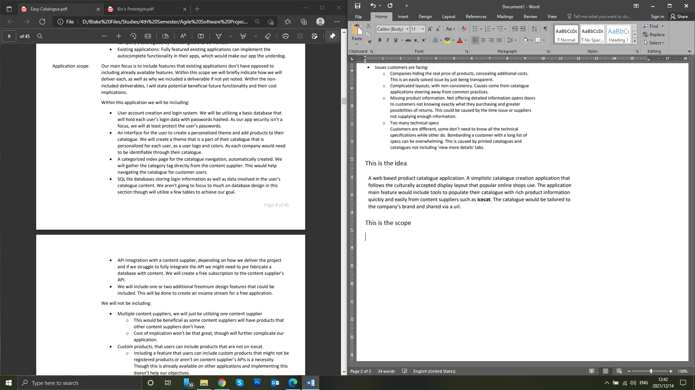

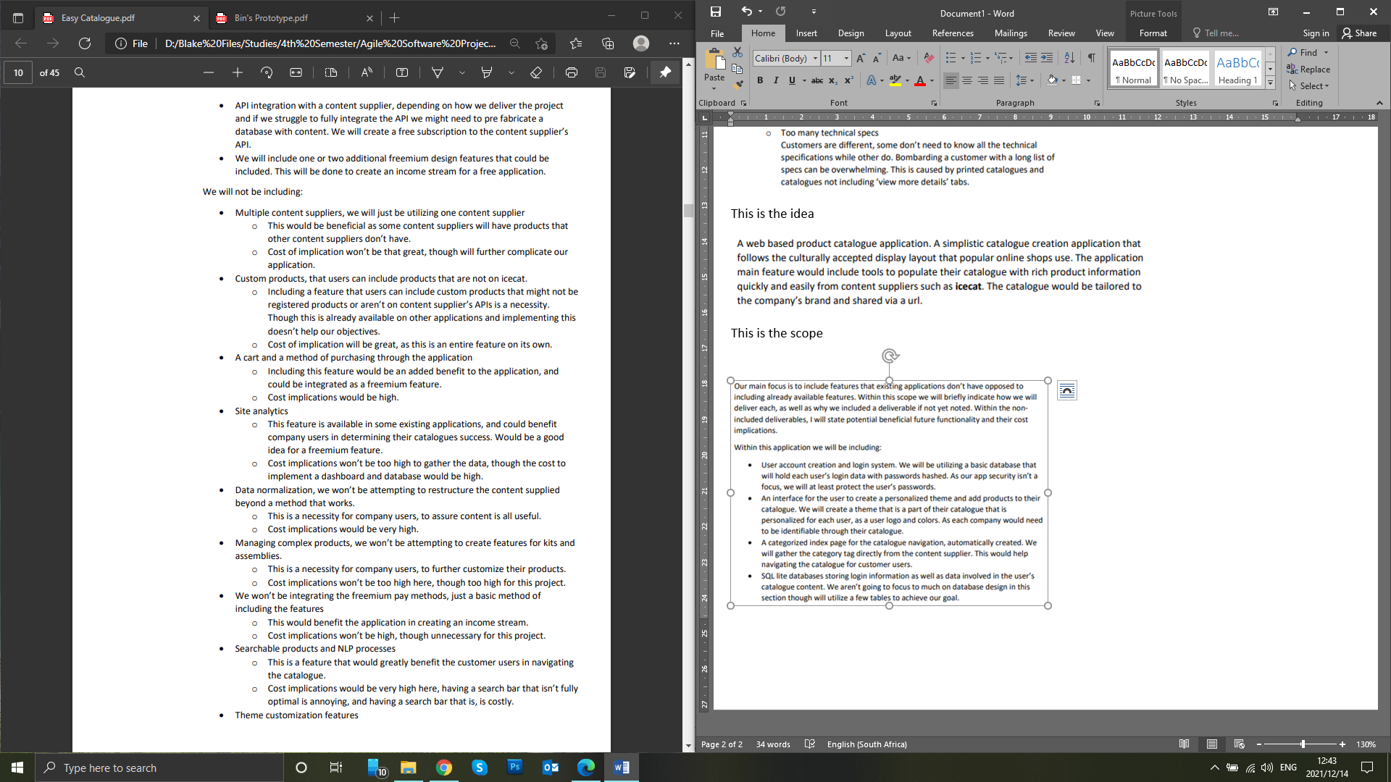

This is a use case uml

