Yogurt Maker PCB (designed by Grace Liu, Spr 2024)

Connector Pinouts:

LCD drive: (board connector)

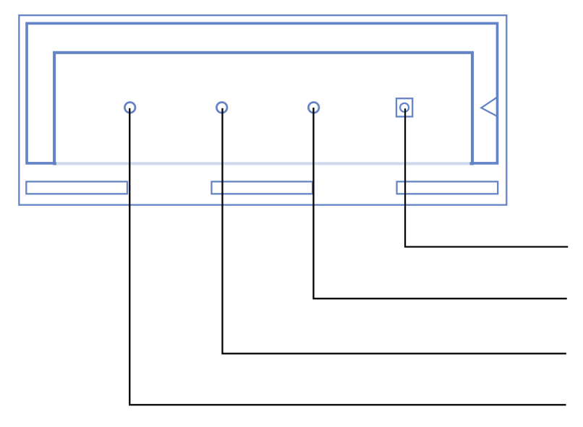

GND
+5V
A5 – SCL
A6 - SDA

Relay (board connector)

GND
+5V
(not connected)
Relay Active Low

Relay driven by pin D6

Board Photos:


