**a. Question: What happened with Folder1 and Folder2 on the Desktop?**

Folder2 was placed inside the Folder1 directory

**a. Question: What is the file extension for the text document?**

.txt

**a. Question: How would you do it?**

Highlight the text document and use ctrl+c to copy it, then use ctrl+v to paste it in the folder 2 directory.

**a. Question: What are the attributes associated with this file?**

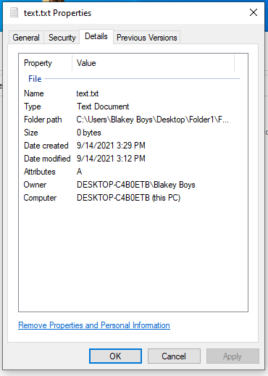

**a. Question: What is the complete path to Folder3? (Hint: One way to find this information is in the folder properties.)**

C:\Users\Blakey Boys\Desktop\New folder\Folder2

**b. Question: In Windows 10, which directories are listed under Folders? (Note: There is no Folders heading in Windows Explorer.)**

Desktop,Documents,Downloads,Music,Pictures,Videos,Local Disk(C:)

**a. Question: What happened? Why would you want to do this?**

It puts Folder1 under the main directories on the left side of the file explorer, you would want to do this because the user could put their folder of choice in an easy to find location.

**a. Question: What are folders listed in the Local Disk (C:)?**

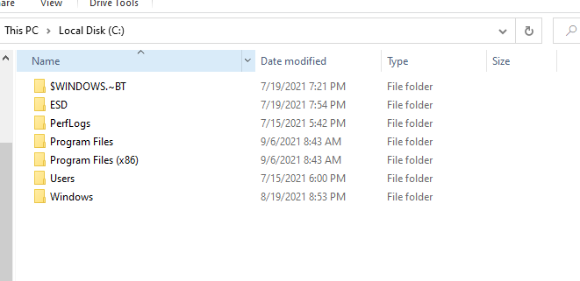

**a. Question: Were you able to open it? Explain.**

Yes, I believe that it is because my user is the administrator.

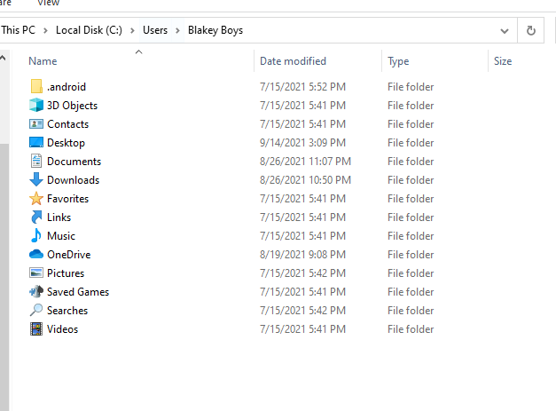

**a. Question: Were you able to open it? Explain**

There were no other users except for the public folder.

**a. Question: Open the Public folder. List all the folders in the directory.**

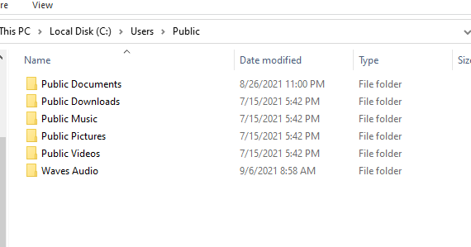

**a. Question: Which folders or files listed under the Libraries heading?**

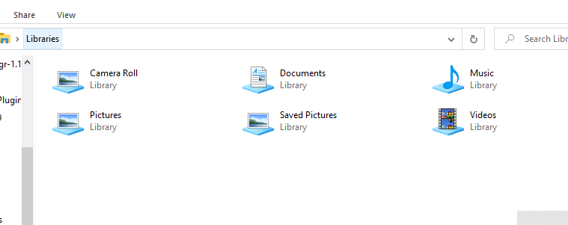

**a. Question: How would you remove the directory of Folder1 from the library without deleting Folder1 and its contents from the computer?**

Click the remove option in the manage libraries window, and then you click ok

