Blake Moos Example Prompts
- Explain how a WPA2 4-way handshake works in Wi-Fi security.
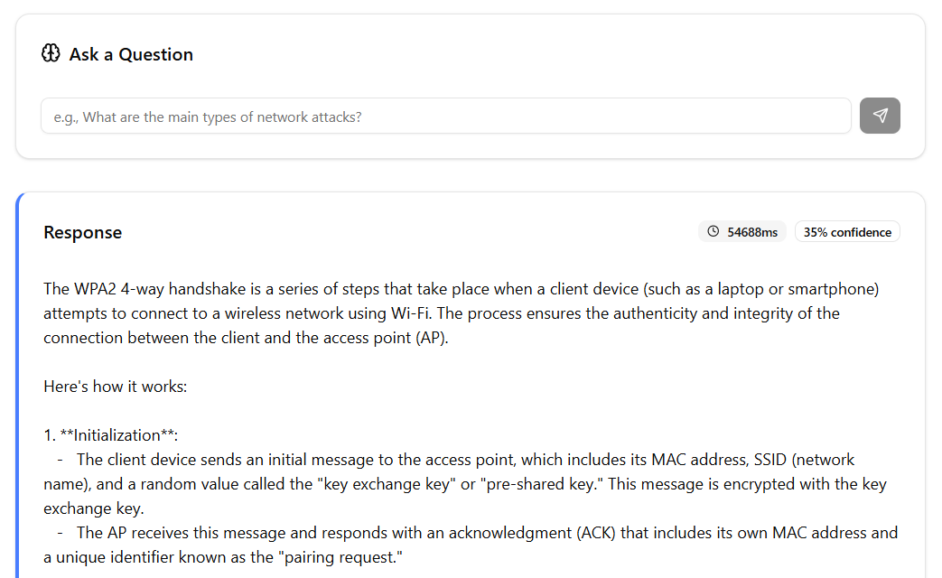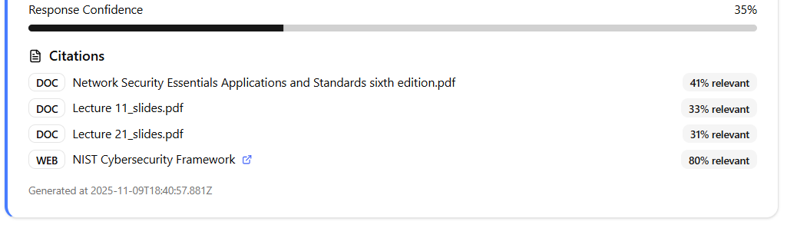
When asked “Explain how a WPA2 4-way handshake works in Wi-Fi security.”, the LLM gives a very lengthy answer as to how WPA2 4-way handshake works in Wi-Fi security by explaining the basics and does really well referring to relevant lecture slides.

- In the DES algorithm, although the key size is 64 bits only 48bits are used for the
encryption procedure; the rest are parity bits.
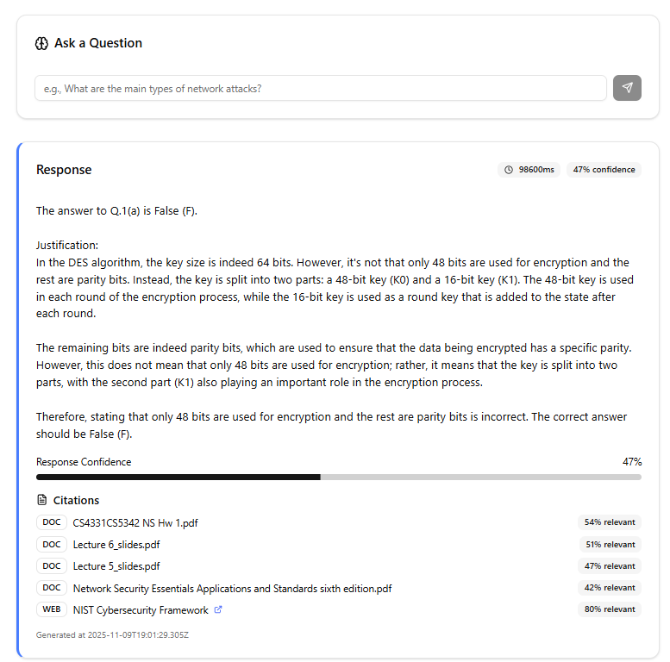
When asked “In the DES algorithm, although the key size is 64 bits only 48bits are used for the encryption procedure; the rest are parity bits.”, the LLM gives answers that it is false and then proceeds to offer a very lengthy answer to support it’s response and does really well referring to relevant lecture slides related to the question.

- Release of message contents and traffic analysis are two types of __attacks.

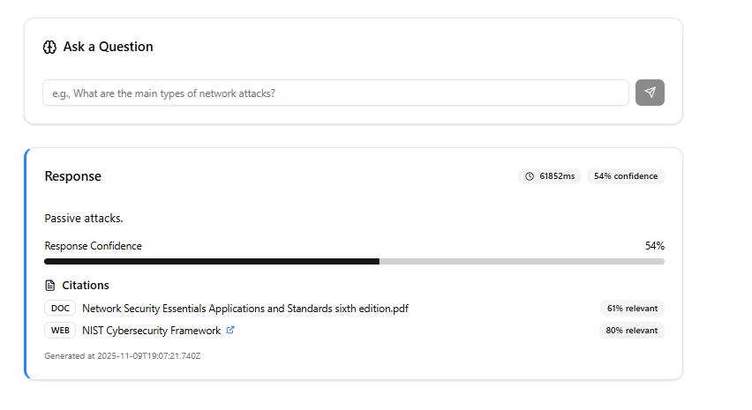
When asked “Release of message contents and traffic analysis are two types of __attacks.
“, the LLM gives the direct answer and does really well referring to relevant lecture slides related to the question. The direct answer is useful especially if a student was trying to assess their knowledge and such question is typically used for validation and to enhance confidence of the student in topics they should already be familiar with.

- What are unconditional security and computational security?
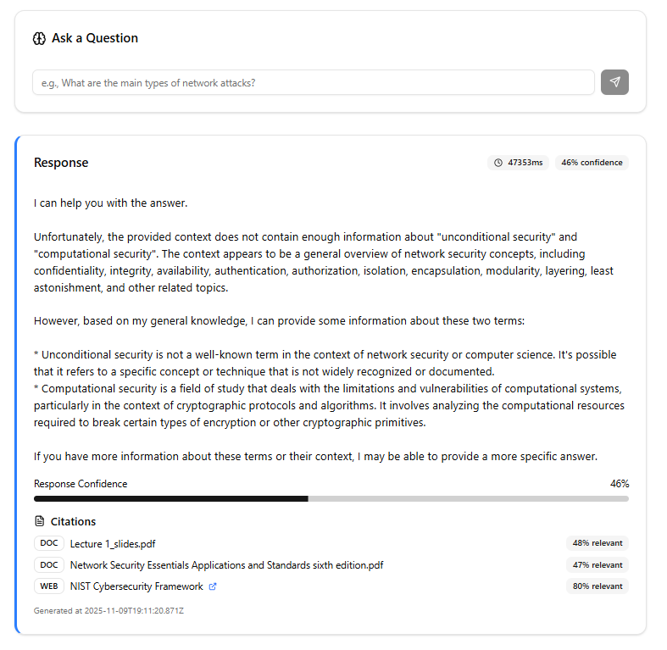
When asked “What are unconditional security and computational security? “, the LLM gives the direct answer expressing it’s lack in knowledge in the topic since they are not part of the slides and does really well referring to relevant lecture slides related to the question. However this is a weakness in the model perhaps as the terms are referenced but perhaps under different wording such as “conditionally secure”, therefore confusing the model.

