Prompts Sthephany Rojas
- Explain Diffie-Hellman: The LLM gives an extensive explanation of the concept and specifies the slides where it took the information from.
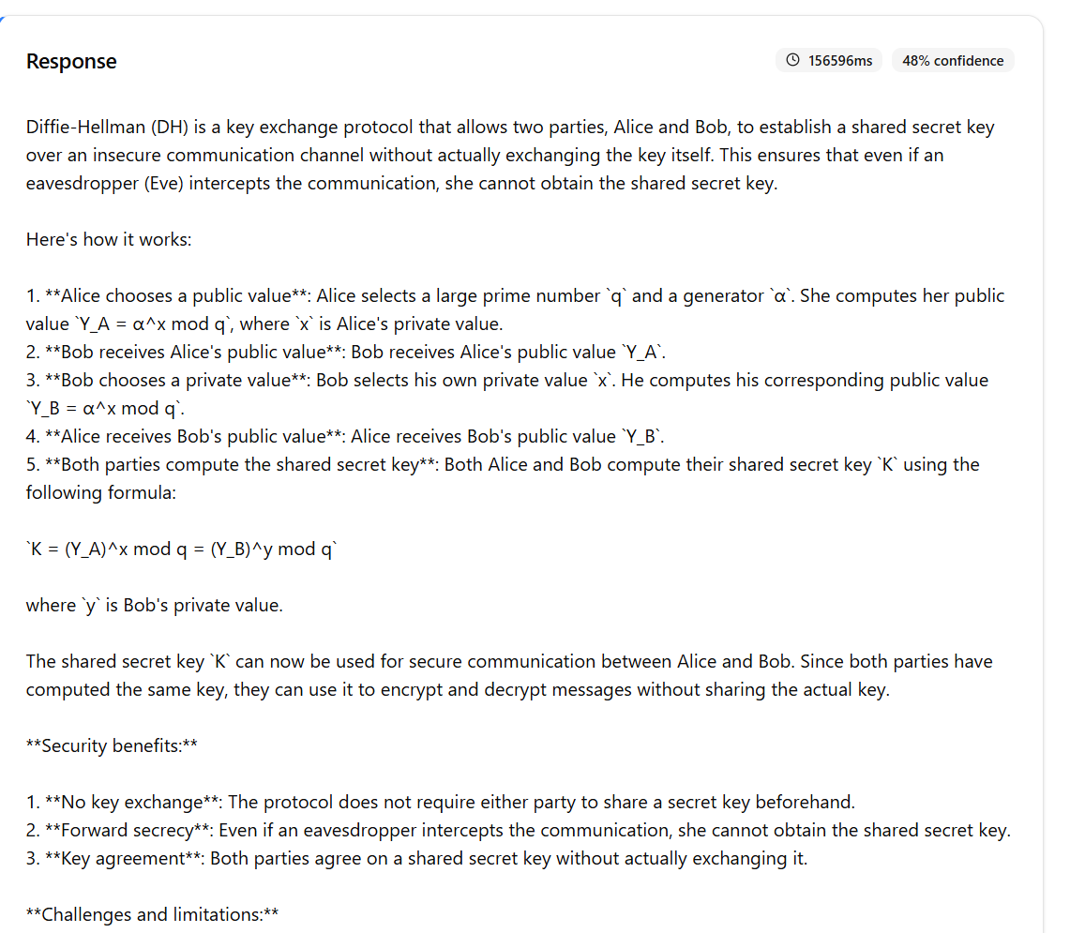
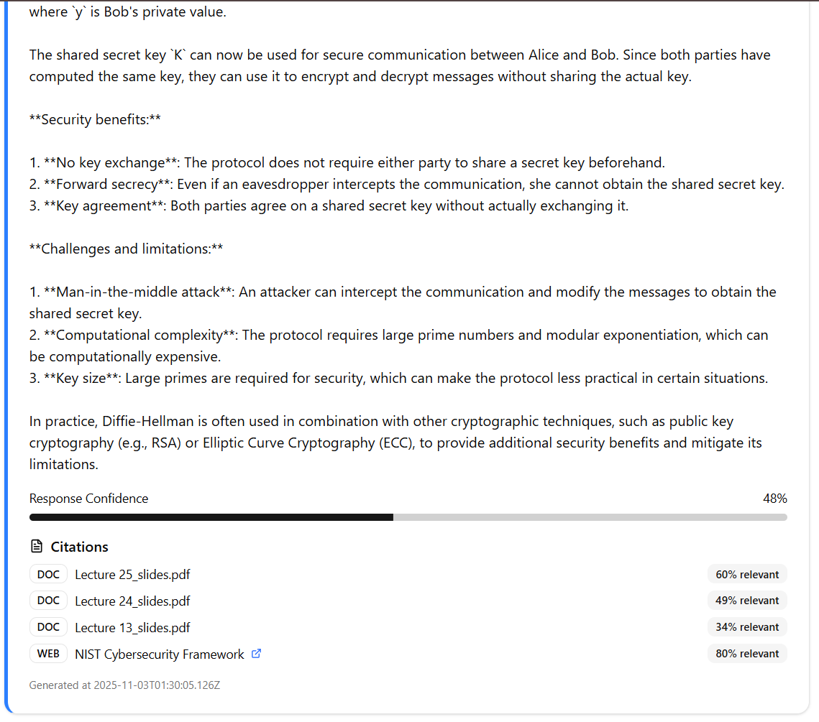

- What is the RSA: The LLM gives a brief description of the concept including its developers.
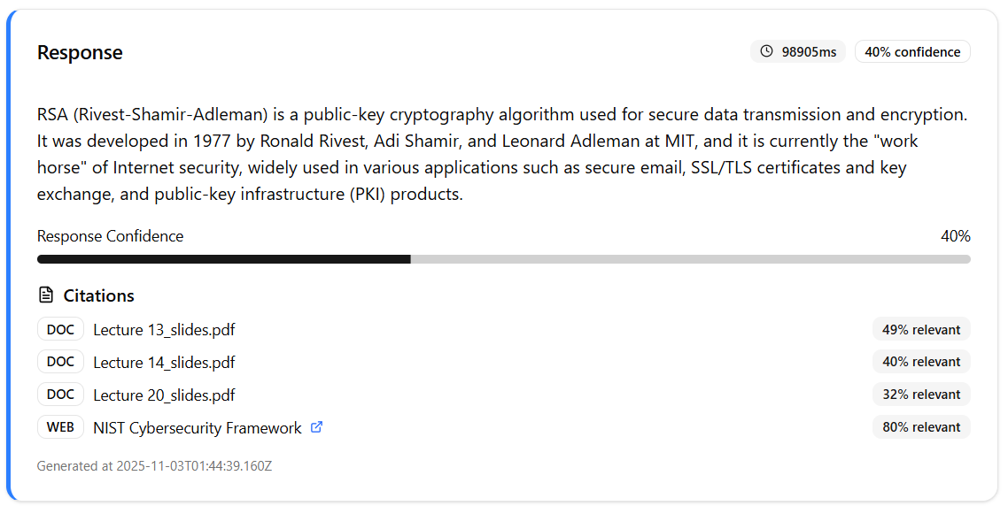
- Suggest restaurants nearby: The LLM gives a response to questions not related to the concepts in class and replies saying that there’s been an error processing the question.
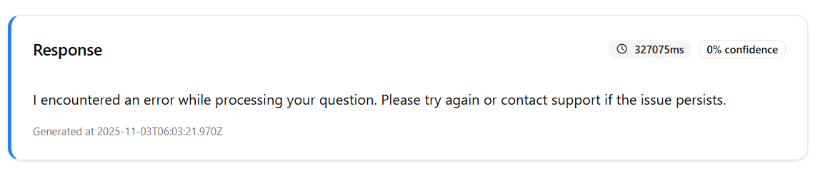´
- What can you tell me about stream ciphers? The LLM provides the definition, a brief explanation to clarify more the concept and its applications.
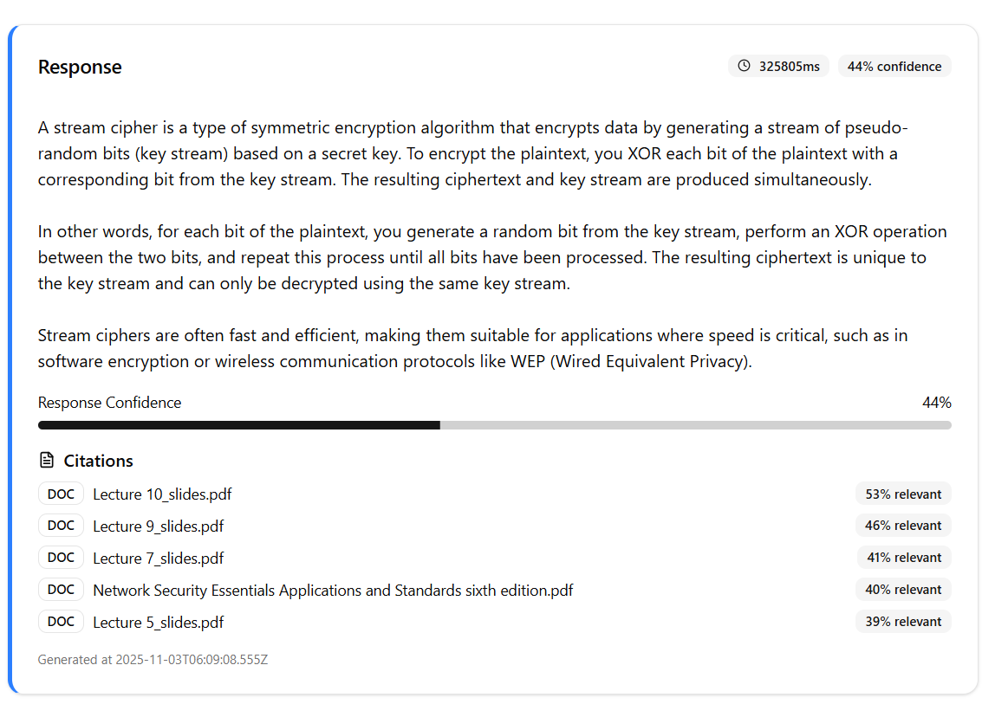
- Public key vs private key: The LLM gives a comparison between the 2 concepts to clarify its differences.
