- 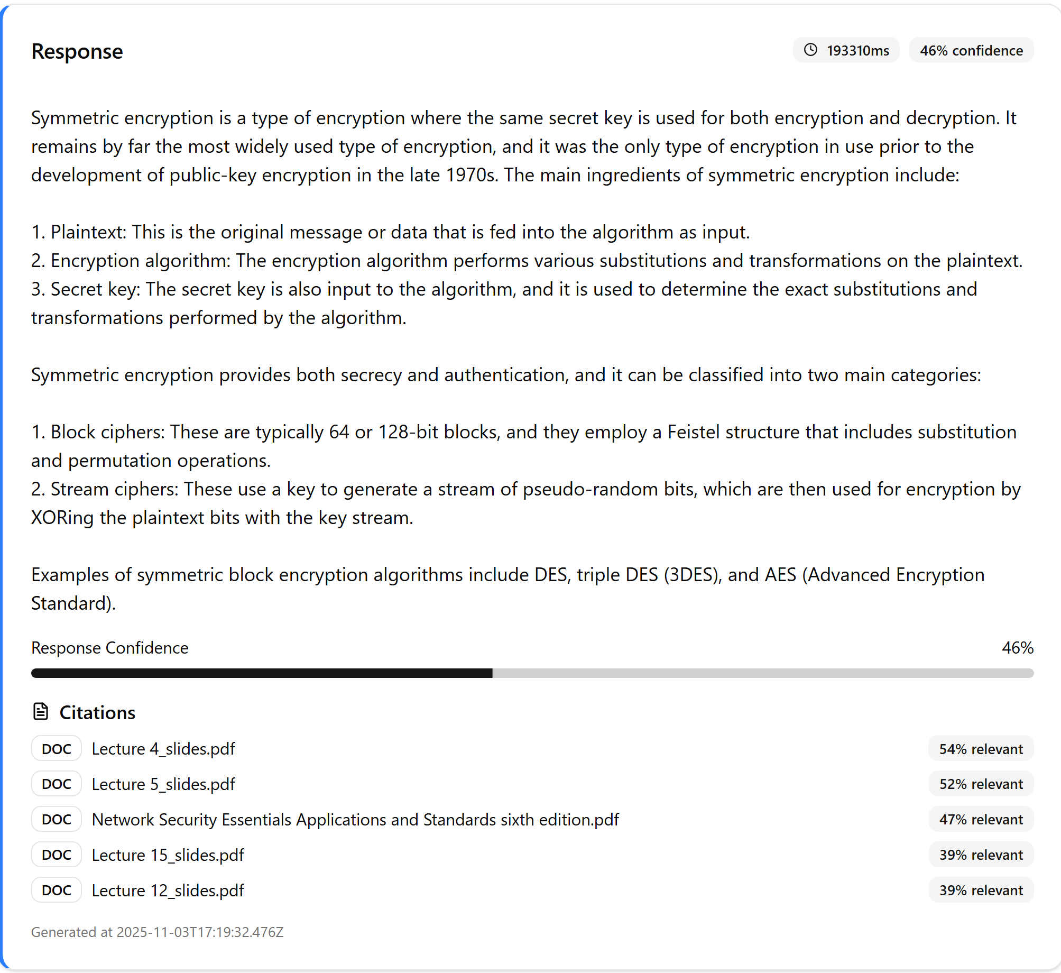When asking the tutor “What is symmetric encryption?” the LLM gives an explanation of what it is and how it is used.
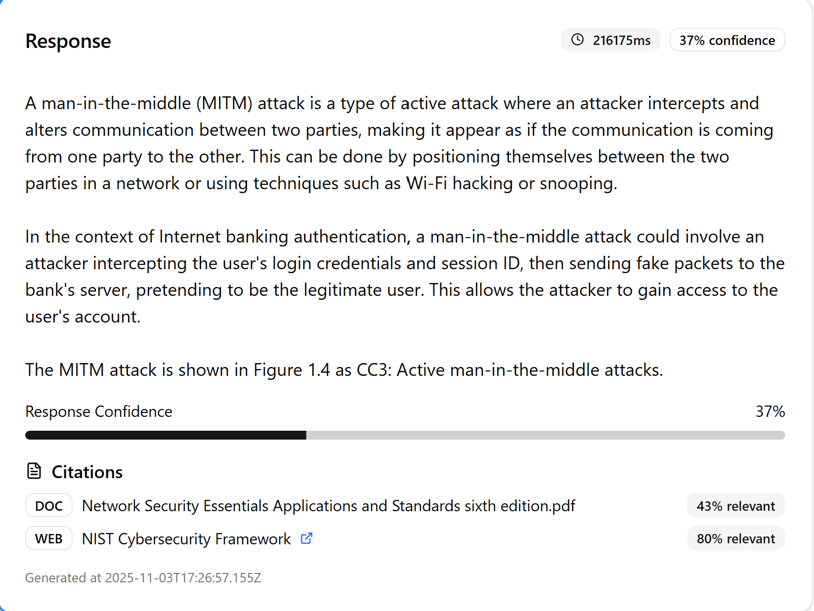
- Asking “how is man-in-the-middle attack used?” it gives a response of a definition and an example to go with it.
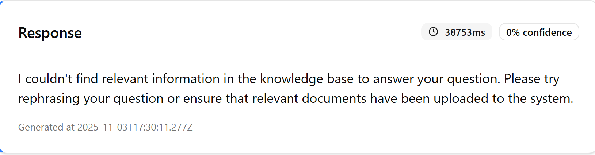
- Asking “how to tie a tie” will give an error since that information is not in the knowledge base for the tutor to pull any information.
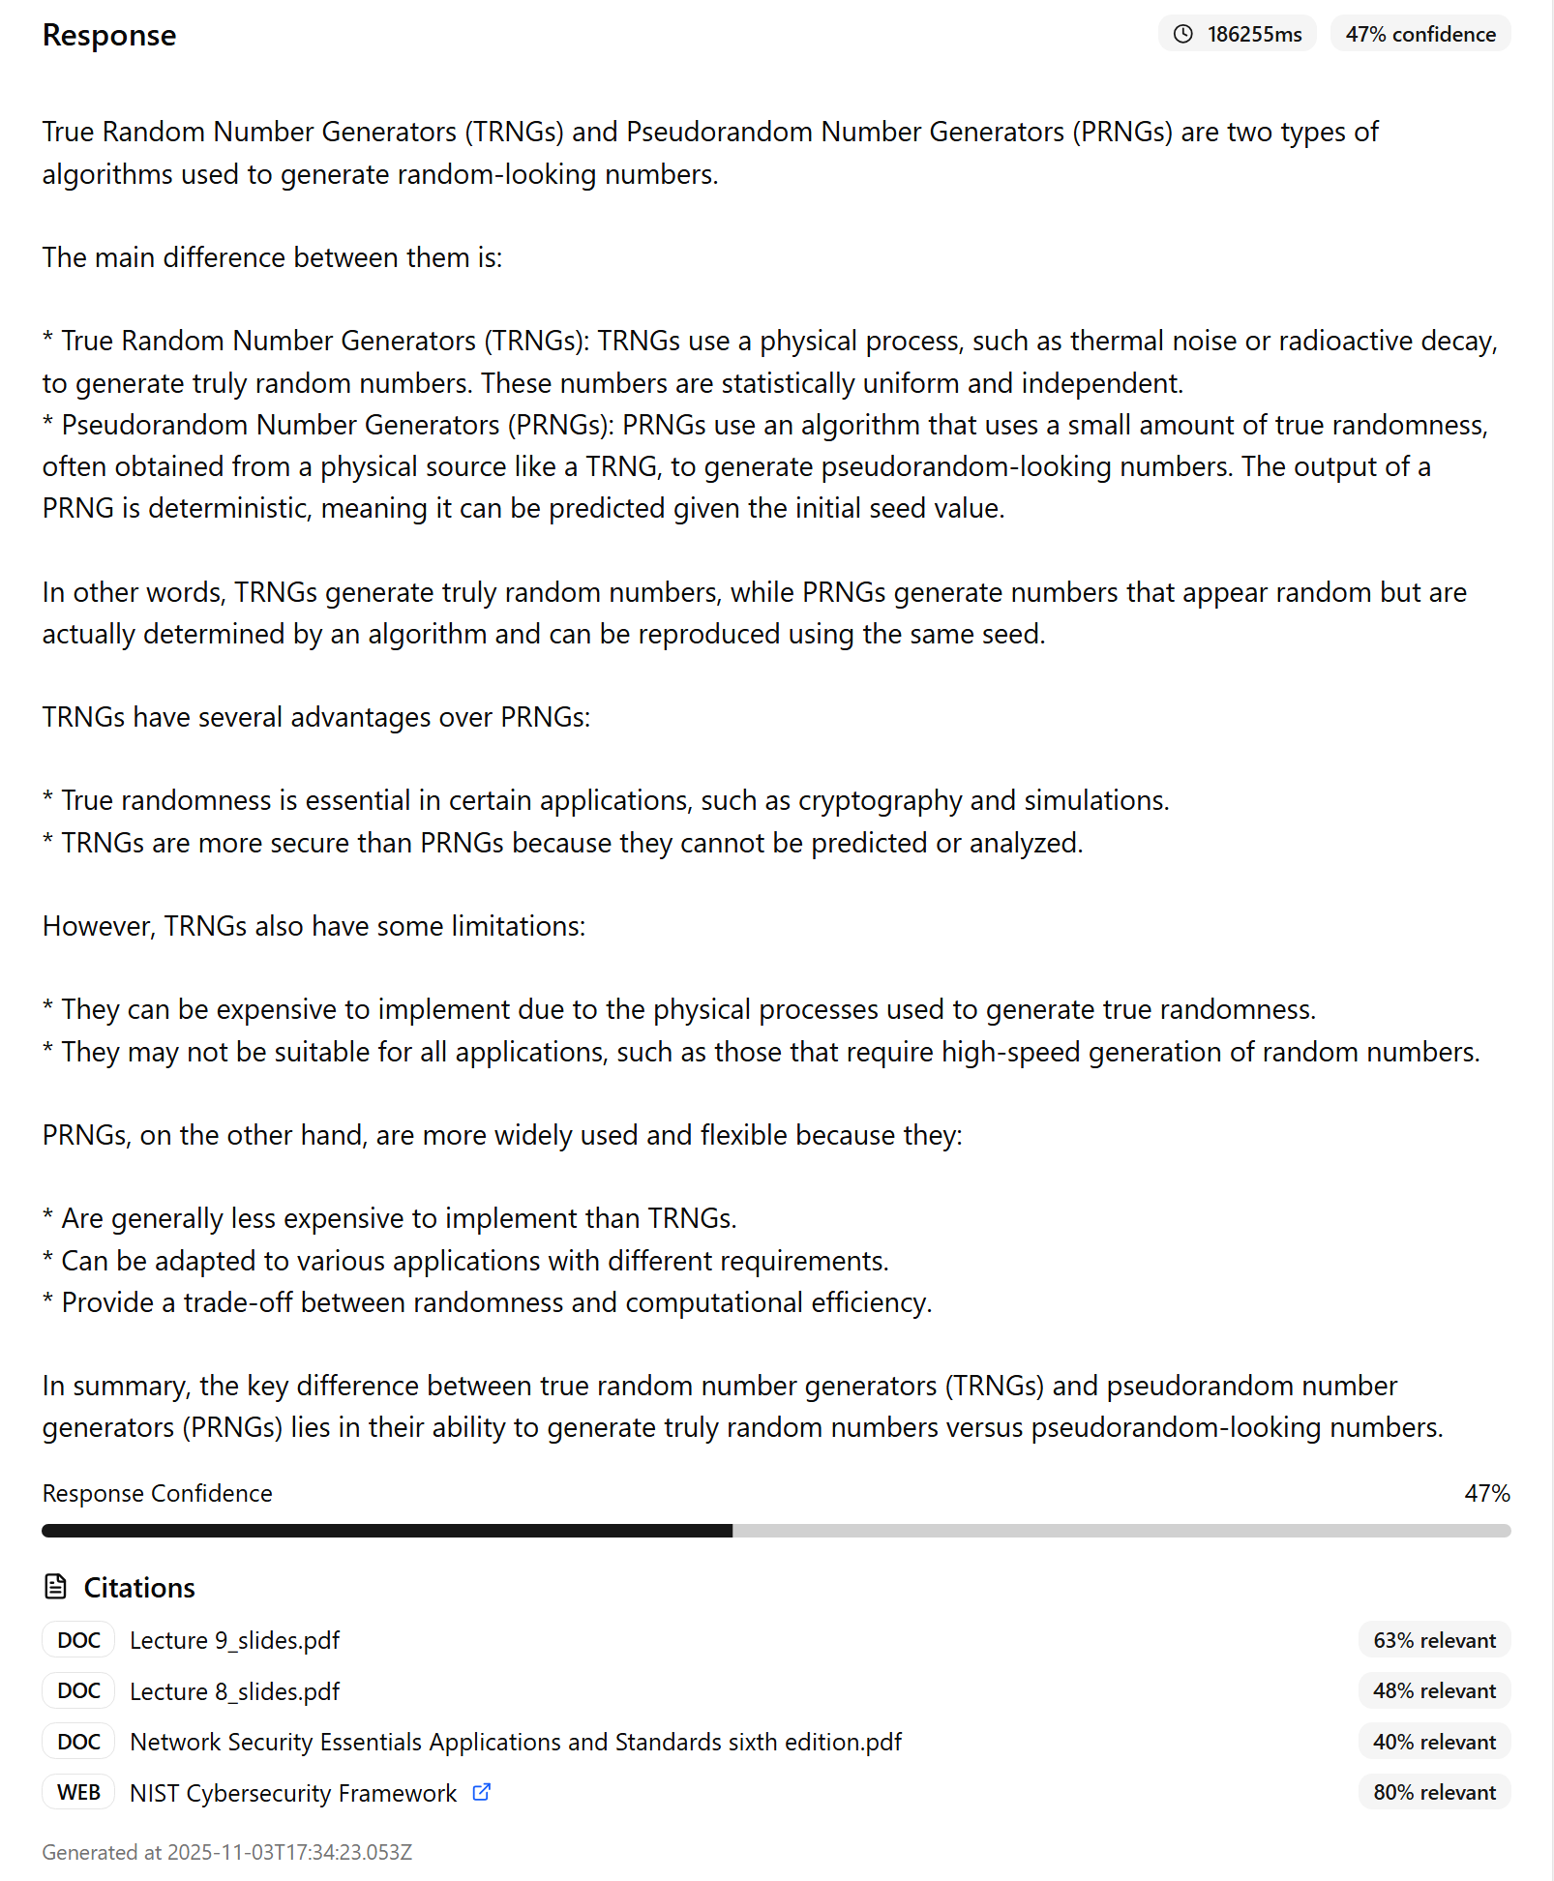
- Asking “what is the difference between a true random and pseudorandom number generator” the tutor responds with the definitions of both and how they compare to each other.
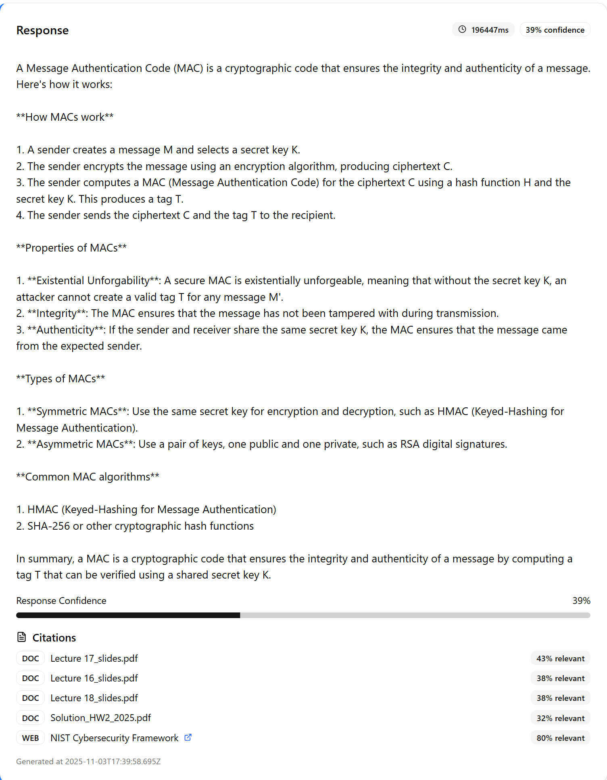
- Asking “explain MAC” the tutor gives a response of what it is and the types of MAC as it goes into great detail.

