Q: What is the difference between Asymmetric and Symmetric encryption?
A:
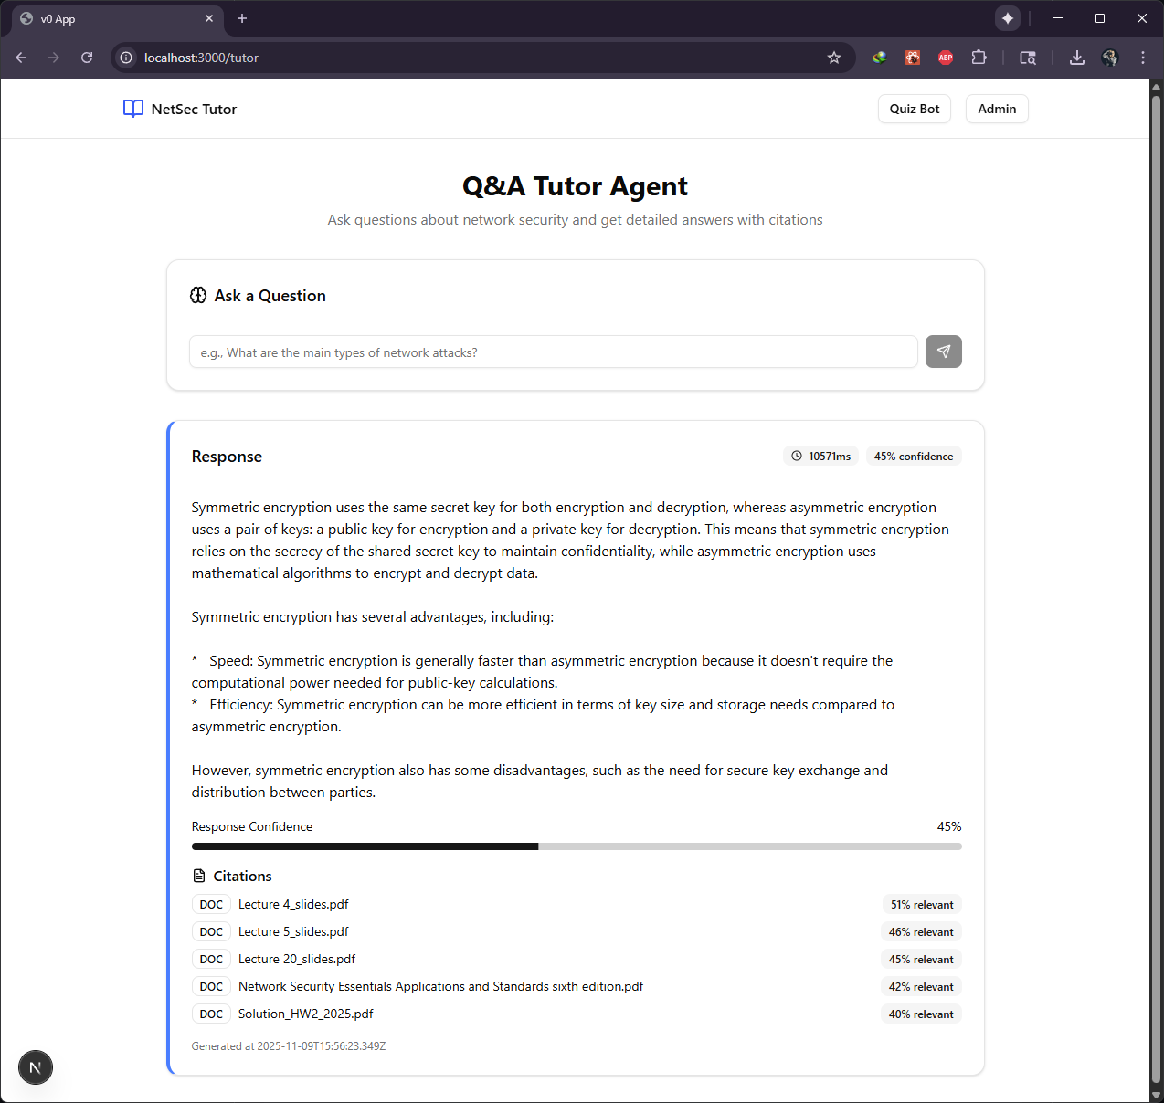

Q: what is the difference between MAC and HMAC?
A:
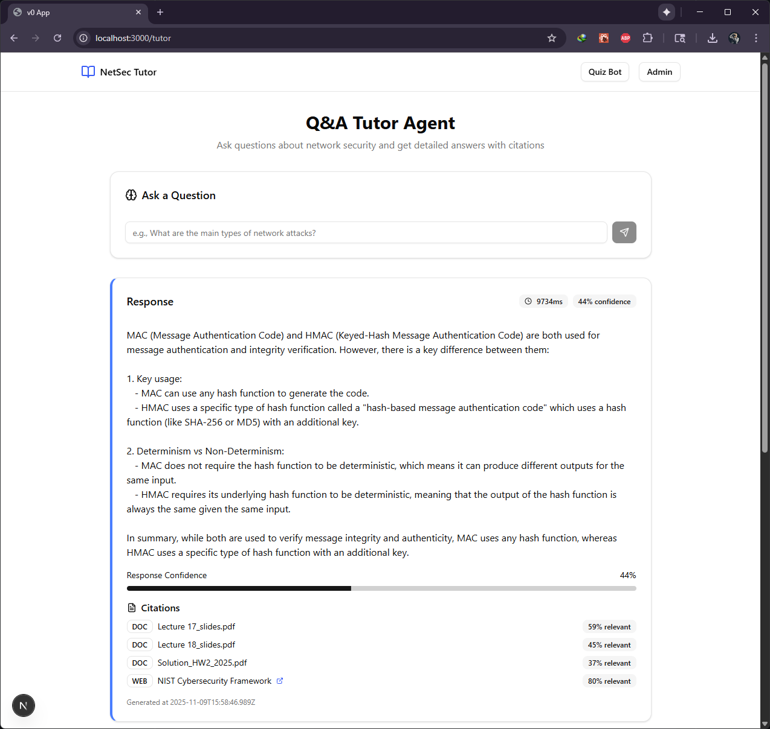

Q: what kind of attacks target availability?
A:
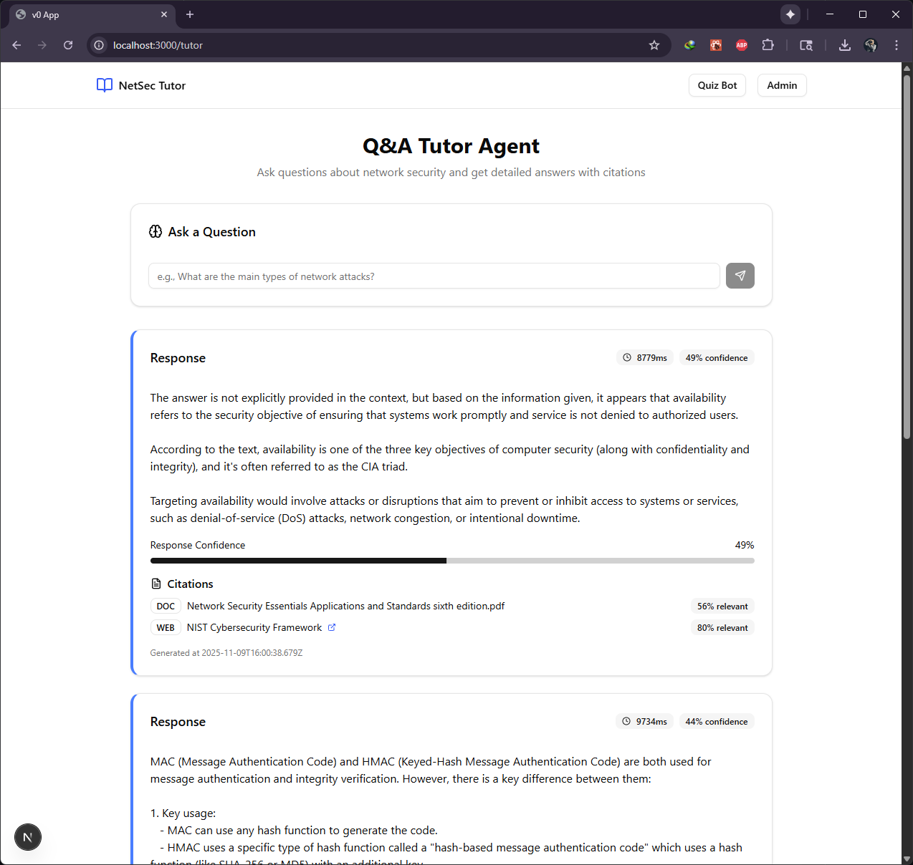

Q: give formula for RSA
A:
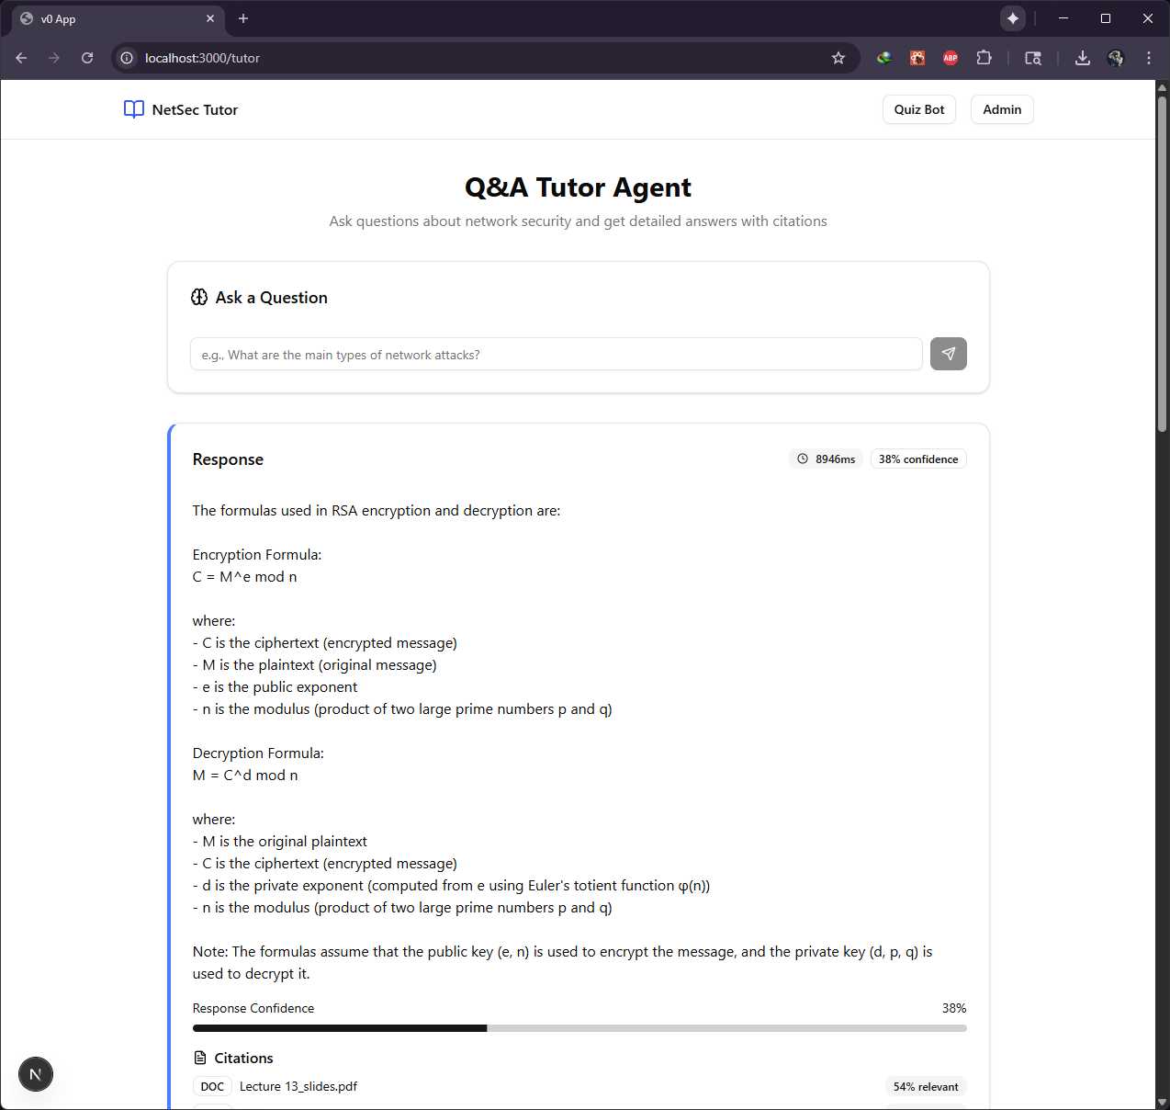

Q: what is key blinding?
A:
