Blake Moos Example Prompts
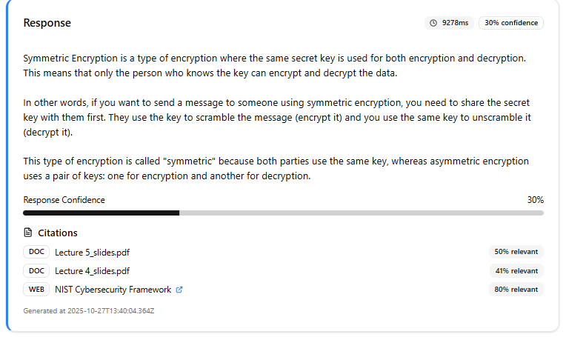
- When asked “Simply explain symmetric encryption”, the LLM gives a short answer as to how symmetric encryption works by explaining the basics: “the same secret key is used for both encryption and decryption”. It also sites lecture slides 4, 5, and the NIST cybersecurity framework as citations.
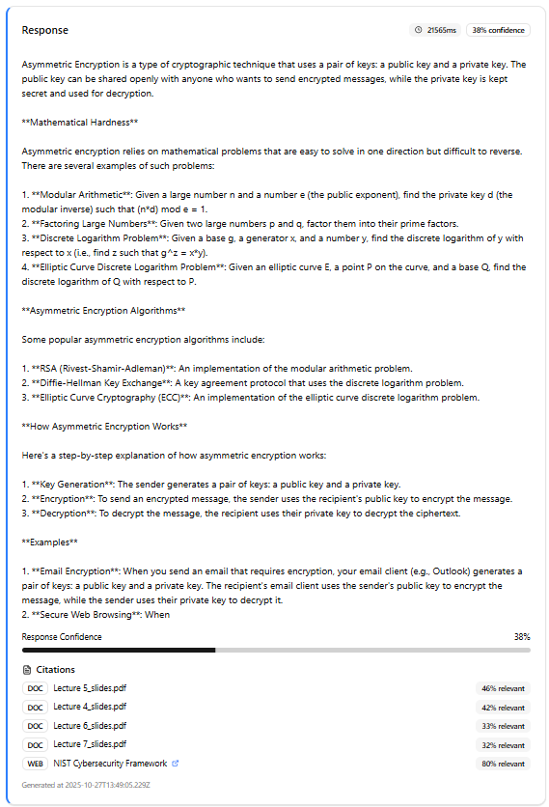
- When asked “In great detail, explain asymmetric encryption and give examples”, we can see that the LLM provides the user with a long and detailed explanation of the topic. Ways that asymmetric encryption works are listed, as well as common examples and algorithms that utilize asymmetric encryption. It pulls information from five of the stored documents.
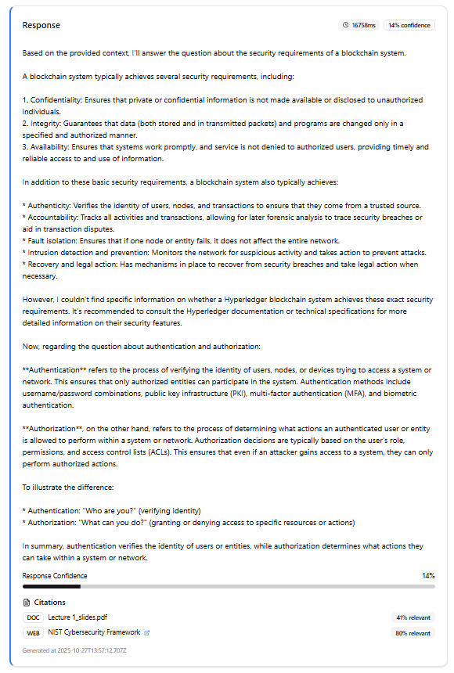
- When asked “Explain the difference between authentication and authorization”, the LLM actually provides more information that required, as it explains the CIA of security and other basic security requirements, finally explaining the actual difference between authentication and authorization at the end of its explanation.
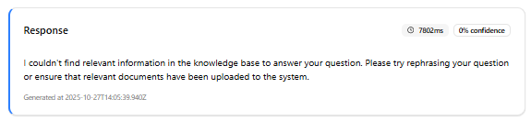
- When asked “How do you bake a cake”, the LLM responds with an error message, ensuring that it only is able to give answers that are relevant to the topic of network security, as there are no documents that provide information on how to bake a cake.
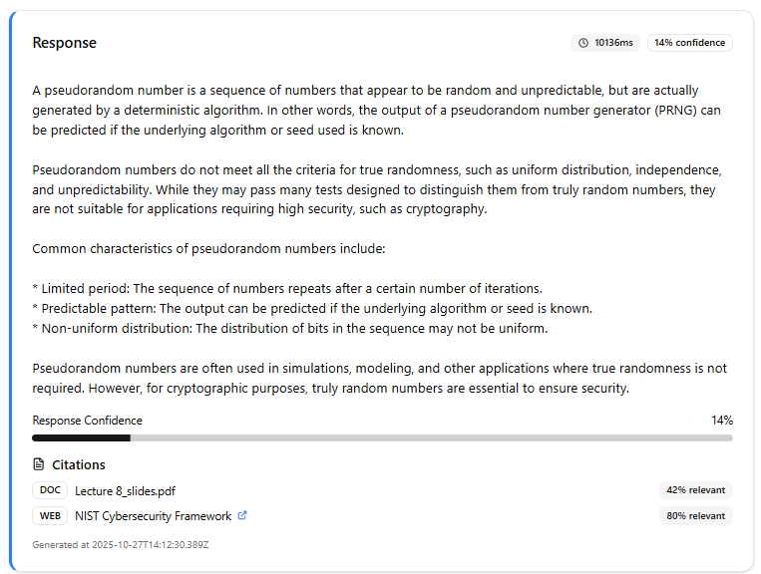
- When asked “What is a pseudorandom number”, the LLM explains what a pseudorandom number is, its purpose, some common characteristics, and what they are often utilized for.

