Q: what is RSA PSS
A:


Q: what are pros and cons of Public-key encryption?
A:
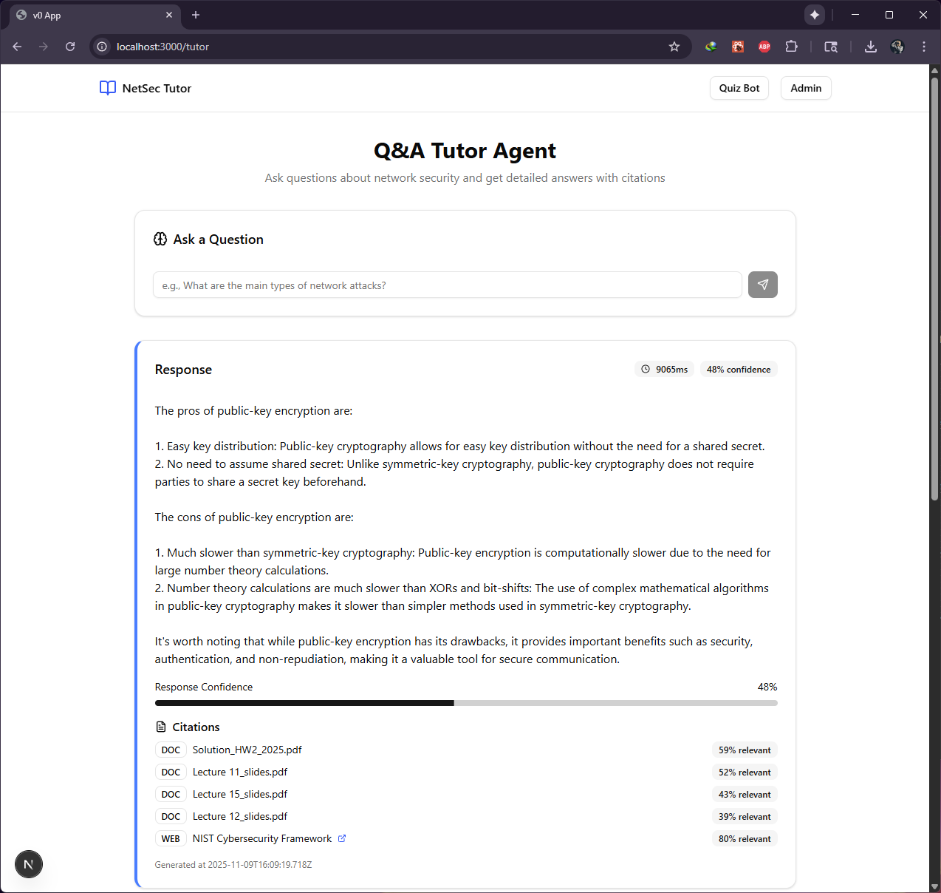

Q: what is CIA in context of network security?
A:
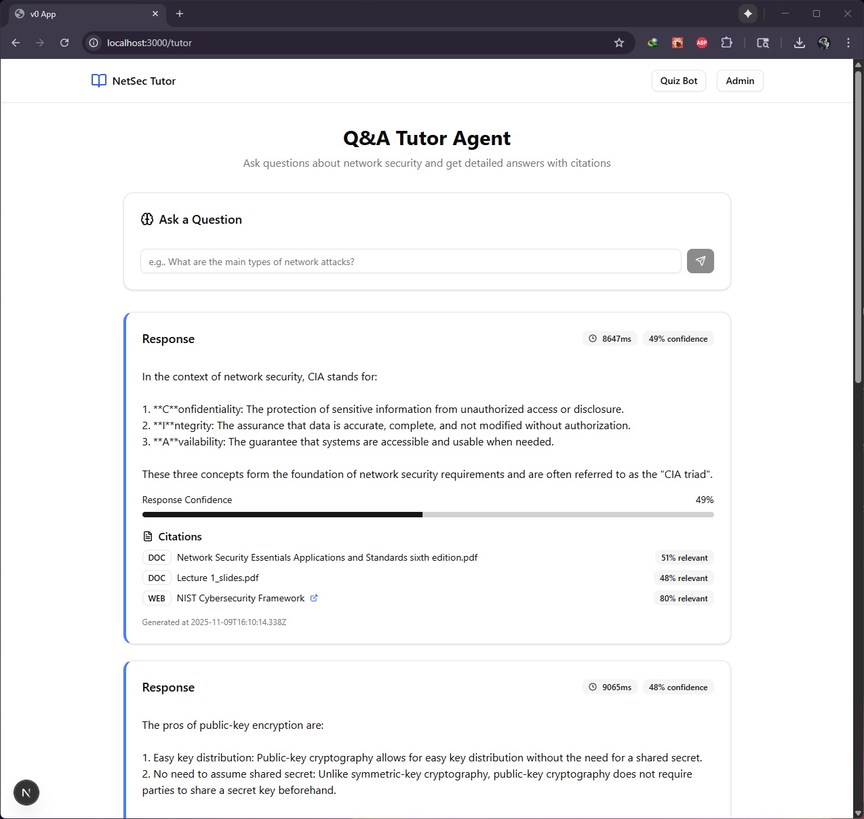

Q: what are public key and secret key used for in asymmetric encryption?
A:


Q: what are requirement for hash function?
A:
