**Project Team for Course # CS 4287-5287**

**___________**

**PROJECT TITLE**

**A Cloud-based Educational Competitive Programming Website______________________**

**TEAM MEMBERS (Alphabetical Order)**

NAME, MAJOR(S) only

1. Bao Nguyen, CS, cong.quoc.bao.nguyen@vanderbilt.edu

2. Blake Quigley, CS, blake.d.quigley@vanderbilt.edu

3. Leqiang Wang, CS, leqiang.wang@vanderbilt.edu

**ADVISER(S)**

NAME, TITLE

1. Aniruddha Gokhale, Professor of Computer Science and Engineering

**SPONSOR**

1. Department of Electrical Engineering and Computer Science

____________________________________________________________________________

**SPONSOR LOGO: IGNORE THIS** (this is a group, organization, or company**- NOT** an individual person)

* *This is the small logo that will identify your sponsor- and their group*
* *Make sure that this image is cleared by your advisors or sponsors*
* *This image will be printed at 5cm x 2cm or less*

**Put PROJECT Illustration Here:**

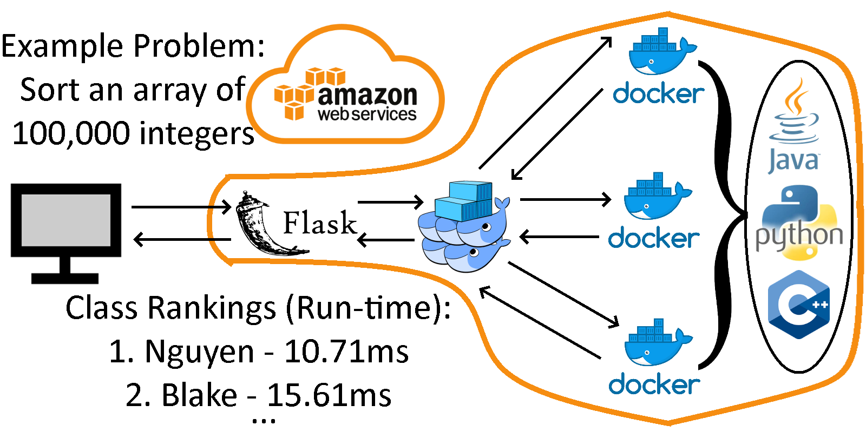

**Project Illustration caption here:**

**Cloud-based distributed architectural design with example user input and output**

**Text for your project Narrative:**

Worldwide, the demand for technical jobs continues to grow, yet a variety of barriers to entry, ranging from a psychologically steep learning curve to physically expensive computer hardware, dissuade students from pursuing Computer Science. The team developed a website to make programming entertaining and easily accessible. In a classroom environment, students enter the teacher’s generated class ID, complete an appropriate programming problem, and receive the output from their code executed in the cloud. To promote competitive drive, students are then ranked by various statistics such as time to first successful execution, average run-time, least lines of code, etc.

Compared to similar solutions such as LeetCode, our website emphasizes classroom engagement and group competition. Additionally, compared to a traditional classroom environment, the cloud enables fast, easily joinable sessions without the need for every student to have a laptop and take time to setup a complicated, confusing programming environment. The planned design runs on Amazon Web Services in the cloud using Docker Swarm to orchestrate tasks among Docker workers executing the user code. Ideally, the solution would be used in situations such as STEM summer camps, club interest meetings, AP Computer Science classes, interview prep, technology company on-campus visits, etc.