**Adventures in New Zealand**

**Team Members:** Blake Freeman, Matt Friske, Naveen Mudaliar, Sindhuja JayaKumar

**Project Outline:** We will be analyzing review data to determine the top attractions, hotels and restaurants to visit in New Zealand.

Analysis of the project:

**Research Questions to Answer:**

1. Out of the top three highest populated cities in New Zealand what is the best city to visit based on ratings?

By using the Yelp API, the best cities in New Zealand are pulled, based on the categories like best Hotels, Restaurants, Shopping centers and Active life. Out of the pulled data the top three cities with best ratings are Auckland, Wellington and Christchurch. A pie chart is plotted to find out which city has the best overall ratings. Auckland stands out of the three.

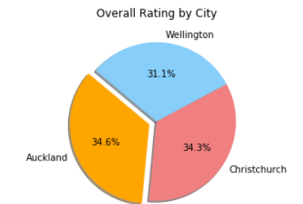

1. In the best rated city, what is the best Hotel to stay in each price category?

Once the best city is figured out, now based on the overall ratings and price range the best, cheap and mid hotels to choose in Auckland are plotted in bar charts.

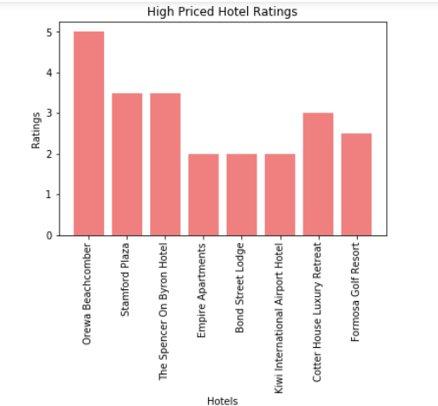

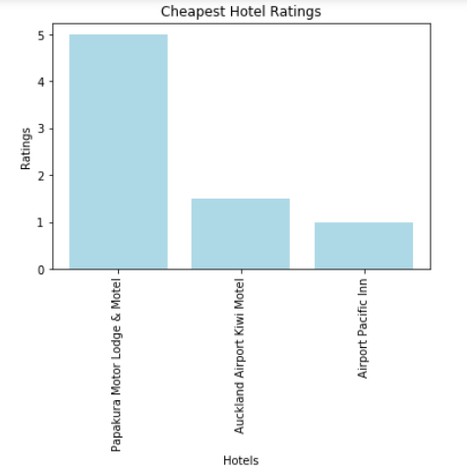

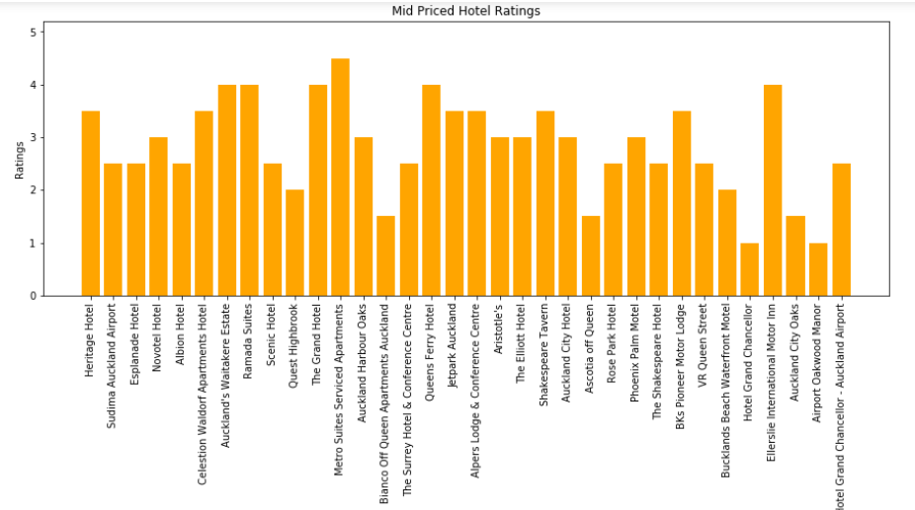

1. In the best rated city, what is the best Restaurants to eat based on number of reviews with 4.5 ratings and above?

For the restaurants a bar chart is plotted to find out the best and mid-range of restaurants to visit in Auckland, which have a 4.5 + ratings.

