**2D FDTD with PML (working Title)**

*Authors: Adedayo Lawal and Blake Levy*

**Abstract – A two dimensional finite difference time domain (FDTD) simulation is presented. The computational domain is surrounded by a perfectly matched layer (PML) which is terminated by a perfect electric conductor (PEC).**

1. **INTRODUCTION**

Many real world electromagnetic problems can be simplified by the elimination of one spatial dimension. For the problems that do not result in a closed form analytical solution, computational electromagnetics can offer an understanding of the field properties that exist in space. Finite Difference Time Domain (FDTD) is one way to provide a solution for these types of problems. In the following paper, formulations along with results are provided to solve for the fields of an X-directed current source radiating into a YZ-plane as shown in Figure 1.



y

z

Figure 1 Project Geometry

1. **FORMULATION**
   1. **Yee Cell**

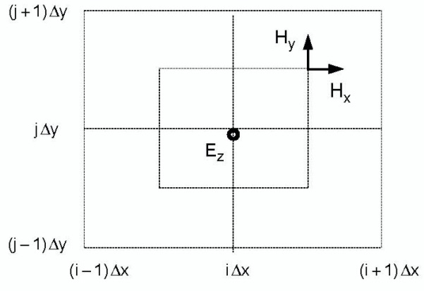In order to simulate the electric and magnetic fields in a 2-Dimensional geometry, a conventional Yee Cell method was used. Figure 1 shows the half-step offset of the magnetic field grid related to the electric field grid.

Figure 2 Staggered Grid1

The project defined a current source that was oriented in the plane perpendicular to the field grid. As a result of this current source, the only nonzero electric field component was in the direction of the current source, , whereas the nonzero magnetic field components corresponded to and which indicated transverse magnetic (TM) field behavior. Equations (2.1a)—(2.1c) are derived from Faraday and Ampere’s law in a Cartesian two-dimensional geometry based upon our source-free, non-zero electric and magnetic field components.

By applying a second order accurate central difference method to the above equations, update equations for , , and are determined. The “leap-frog” technique can be used to find the latest values of based off of the latest values of and .

* 1. **Dispersion Relation**

The update equations used in the “leap-frog” technique can also provide a necessary condition that relates the time-step, , to the space discretization of the computational domain, and . Assume the field components are plane waves propagating at a certain angle with respect to the positive y-axis, the wavenumber can then be defined as where and . By relating the update equations we can come up with a dispersion relation in Equation (2.2.1) and this can be used to put an upper limit on the time-step.

If and we note that the terms maximum value is one, then

* 1. **Permittivity Discontinuity**

The geometry used in this project contains a dielectric half-space, resulting in a discontinuity of permittivity in the z-direction. In order to enforce Equation (2.1.1a), we must revert to Ampere’s law and enforce it at the interface. Figure 2 shows the unit cell that is used to evaluate Ampere’s law in integral form. Equation (2.3.1) can now be used for the update equation (2.1.1a) with an appropriate value of permittivity.

Figure 3 Unit Cell

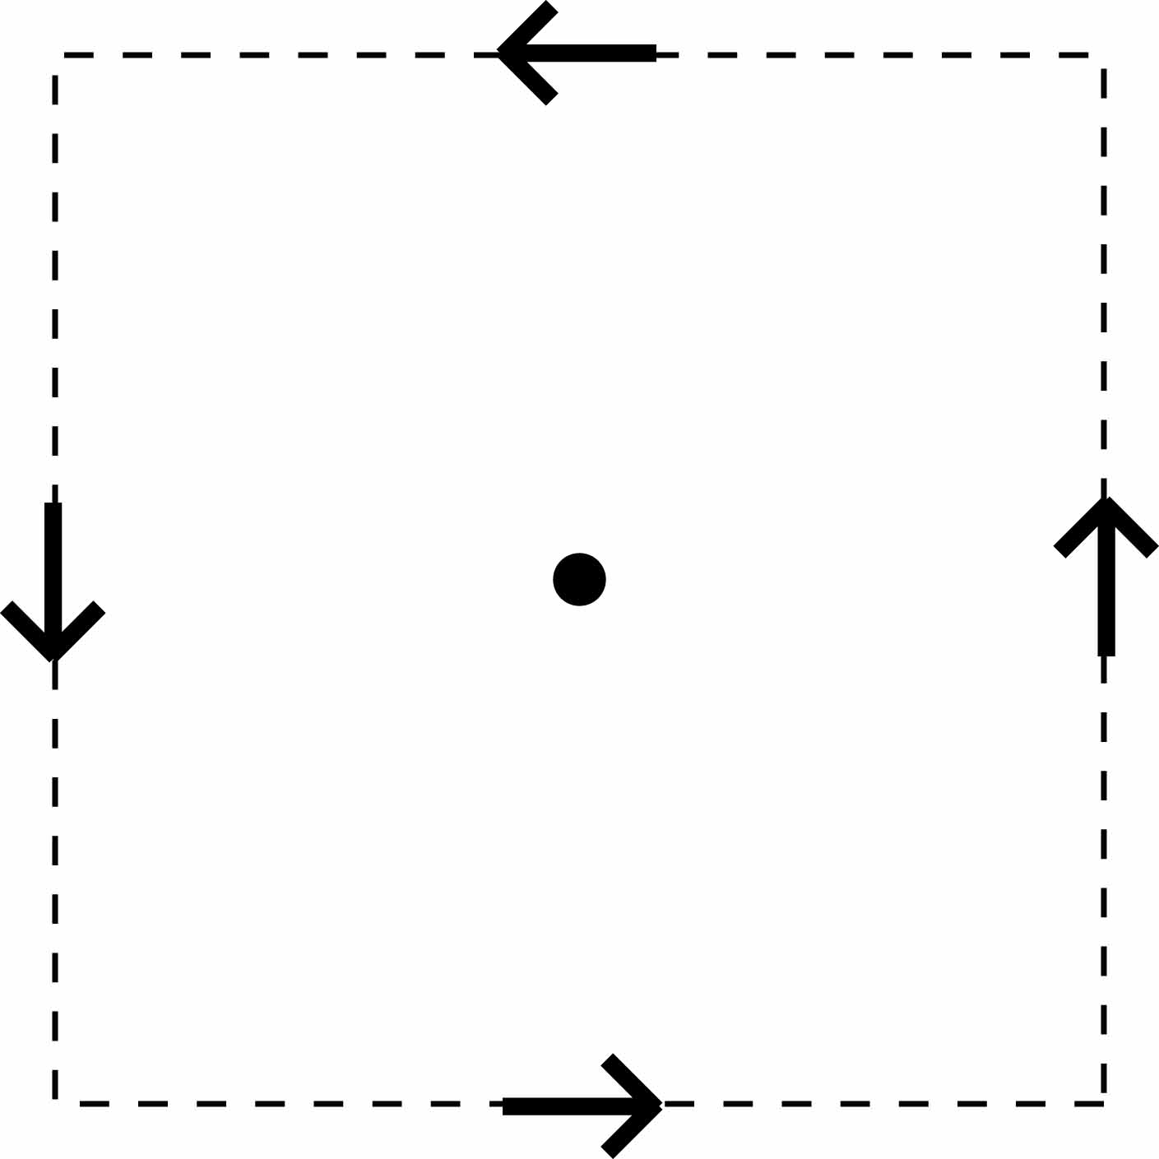

* 1. 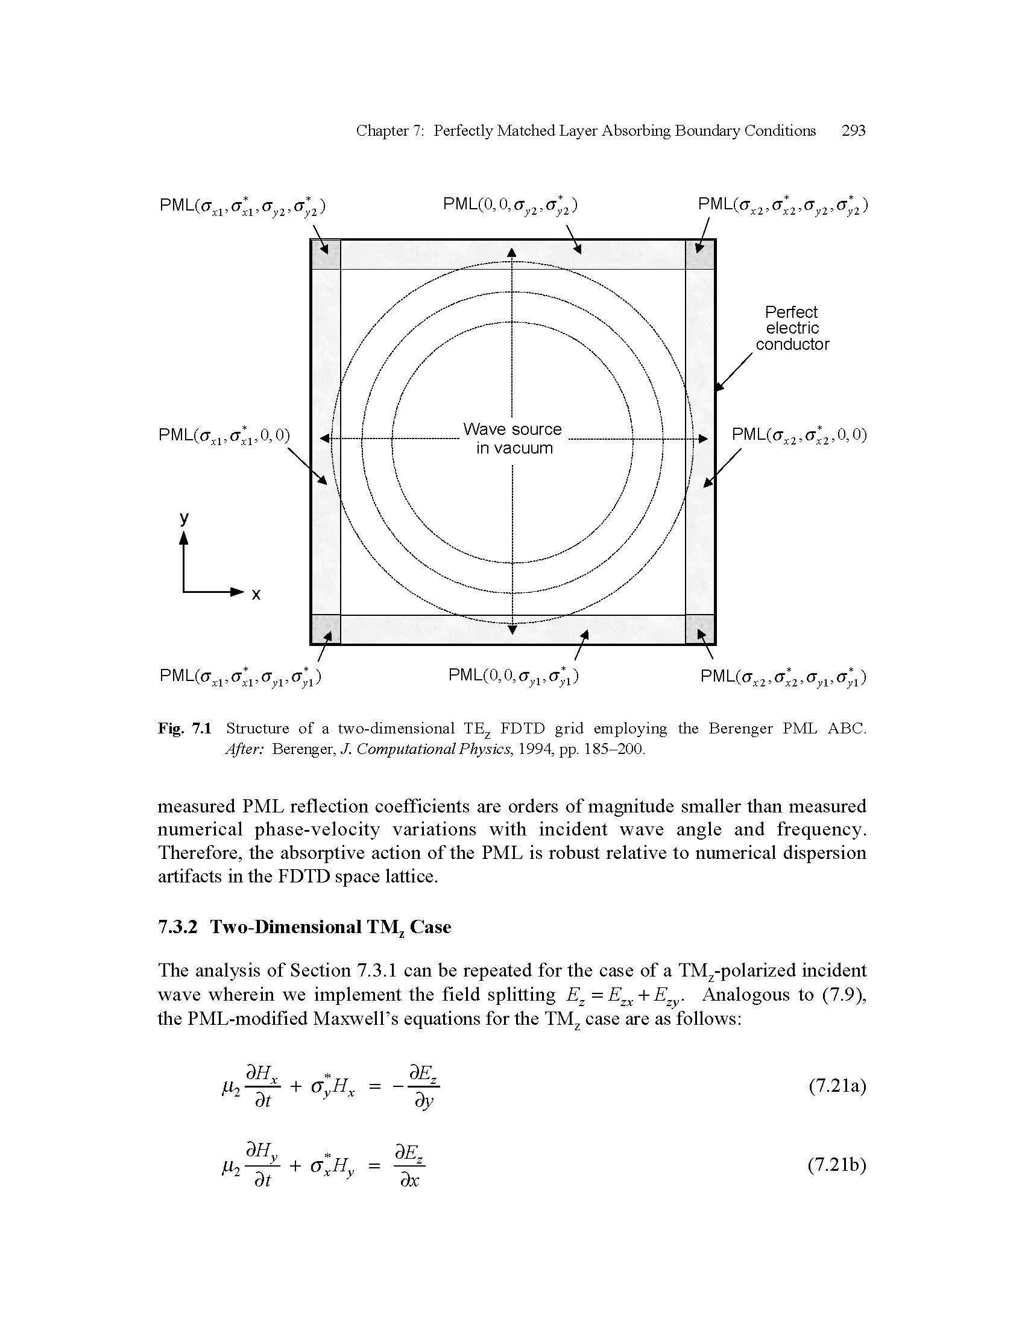**Perfectly Matched Layer (PML)**

Figure 4 2D Perfectly Matched Layer (PML)2

In order to terminate the computation region, a perfectly matched layer in conjunction with a perfect electric conductor was used. Figure 4 shows a 2D view of the geometry used for our computation. Based on the geometry for this project, transverse magnetic split field equations are required. From Berenger’s paper [3], this set of equations is given by Equations (2.4.1a-d). In order for no reflection to occur at the PML/computational domain interface, the simple relation of must be upheld. If this condition is met, the conventional central difference method is used on these equations and PML update equations are used.

1. **RESULTS**
   1. **Use of PML**

Upon implementation of the perfectly matched layer, the interface between the dielectric region of the geometry and PML interface yielded reflections as high as 33%. In order to mitigate these reflections, a graded PML was used. Equation (3.1.1) determined the conductivity inside the PML regions surrounding the computational domain. By experimentation, reflections on the order of <1% were found with a value of and with the PML width of 20 grid cells. Figure 5a. compares the electric field with and without a perfectly matched layer between a PEC boundary.

.

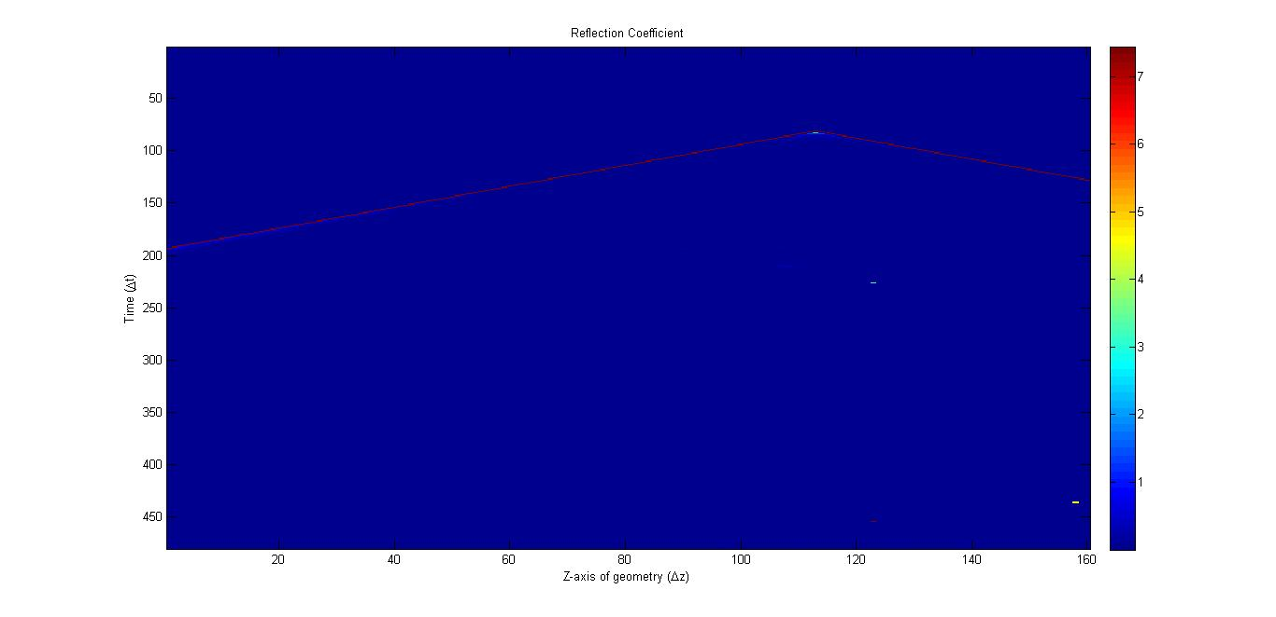To verify the operation of the PML, we can look at the electric field two the left and right of the PML. If there are any reflections at the PML interface, they will propagate back into the computational domain. We can quantify these reflections by Equation (3.1.2). Figure 5b. shows the reflection coefficient of the left PML boundary where almost all points are colored blue which corresponds to a value of approximately .3%. The vertex indicates where the wave has impinged on the z-axis of the boundary and the red line indicates the “light-line” or speed at which the wave moves along the boundary. The small spikes may indicate computational errors.

Figure 5 a) Left: Electric field with PEC boundary. Right: Electric field with PML boundary 5b) Reflection Coefficient

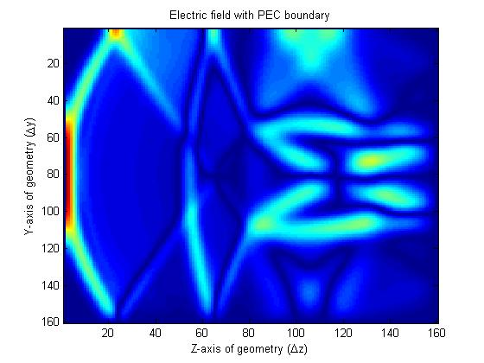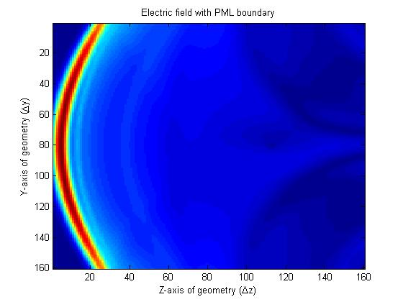

* 1. **Reflection at Interface**

A time harmonic analysis at the interface was performed using the FFT. The transmitted and reflected wave was observed at the interface. With the calculated reflection coefficient is given as

With and the above equation predicts a theoretical reflection of 1/3. The transmission coefficient into the bottom medium of the electric field is therefore 2/3. Figure 5 shows a cross-section of the Ez field at the moment when it impinges on the interface. The transmitted coefficient using the peaks in Figure 5b gives a value of

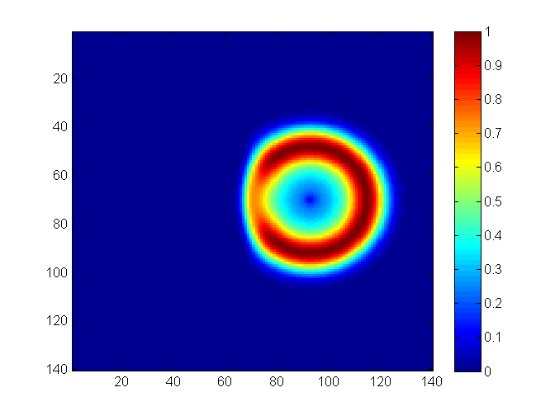

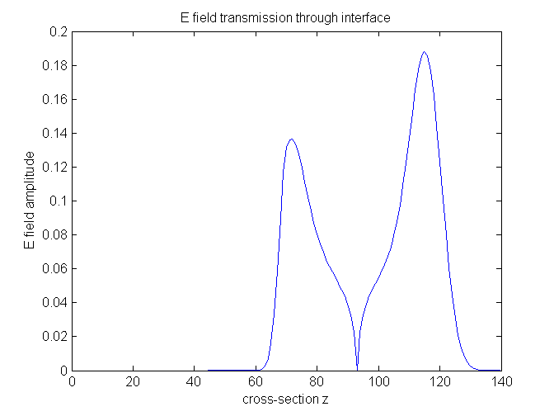

Figure 5 Top: Ez field on the dielectric interface. Bottom: Cross-section at of Ez field in the z-direction.

This value is very close to the theoretically predicted result. The % error is 8.8%. A similar procedure could be used to compute the reflection coefficient. However, unlike for transmission, the top interface will be a superposition of both the incident and reflected waves. This therefore requires additional steps to extract the incident field from the interface. A post 1D FDTD wave simulation to extract the incident fields is one method that could be performed to compute the incident fields.

* 1. **Time-Harmonic Results**

A time harmonic analysis of the computational domain was performed. Figure 6 shows snapshots of the 2D FFT for initial and later time steps. The FFT2 determines the spatial frequency components. This allows the spatial frequency evolution of the computational domain to be visualized.

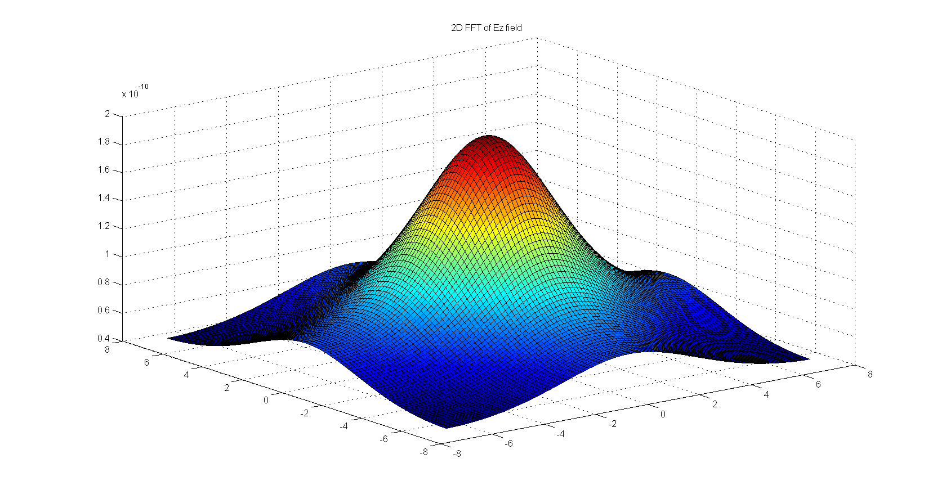

Figure 6 Top: 2D FFT of initial Ez field. Bottom: 2D FFT of Ez field at a later time step.

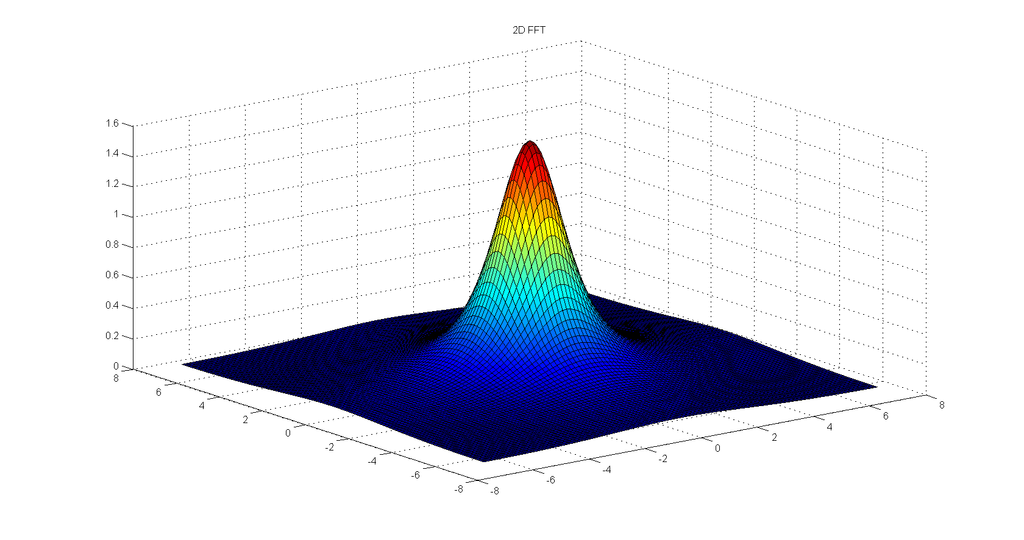

A time harmonic analysis of the computational domain was performed. Figure 6 shows snapshots of the 2D FFT for initial and later time steps. The FFT2 determines the spatial frequency components. This allows the spatial frequency evolution of the computational domain to be visualized. The narrowing of the spatial frequency components suggests at as time progresses most of the energy becomes both uniform and constant in space. What this suggests is that the wave propagates outside the region leaving behind a DC background. The initial expansion of the FFT arises as a result of the point source nature of the source. A narrow spatial component will have a broad spatial spectral component and vice-versa.

* 1. **Magnetic Source**

A magnetic current source can be used to replace the electric current source. Rather than computing new equations, an interesting property of the electromagnetic equations allows us to reuse our simulation. This is the duality property. In general this allows any solution for an electric source to be also used for a magnetic source. The following process can therefore yield the same a similar result once the appropriate dual transformation is performed.

1. **CONCLUSION**

In conclusion …

1. **REFERENCES**
2. Kane Yee, "Numerical solution of initial boundary value problems involving maxwell's equations in isotropic media," *Antennas and Propagation, IEEE Transactions on* , vol.14, no.3, pp.302,307, May 1966  
   doi: 10.1109/TAP.1966.1138693
3. Taflove, Allen, and Susan C. Hagness. *Computational Electrodynamics: The Finite-difference Time-domain Method*. Boston: Artech House, 2005. Print.
4. Berenger, J. P., “A perfectly matched layer for the absorption of electromagnetic waves,” *J. Computational Physics*, Vol. 114, 1994, pp. 185-200.
5. Garg, Ramesh. *Analytical and Computational Methods in Electromagnetics*. Boston, Mass.: Artech House, 2008. Print.