Bacteria Zapper

User Guide & Gallery

Computer Graphics -COMP4471

Panteli Marinis - 0571213

Blake McDonald – 0575698

**Objective:** Destroy the bacteria cells growing on your planet by using the mouse click. But watch out! once the bacteria reach a certain size you will lose life.

Score is achieved when a bacteria cell is successfully destroyed

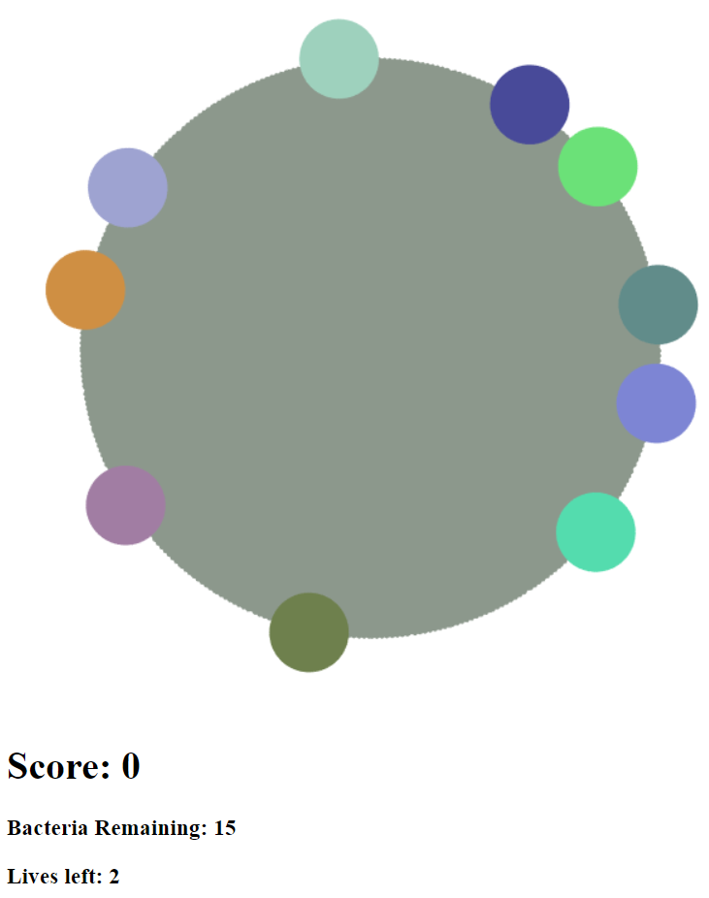**Gallery:**

Game begins with randomly spawned bacteria.

Random color generated bacteria

User starts with 2 lives.

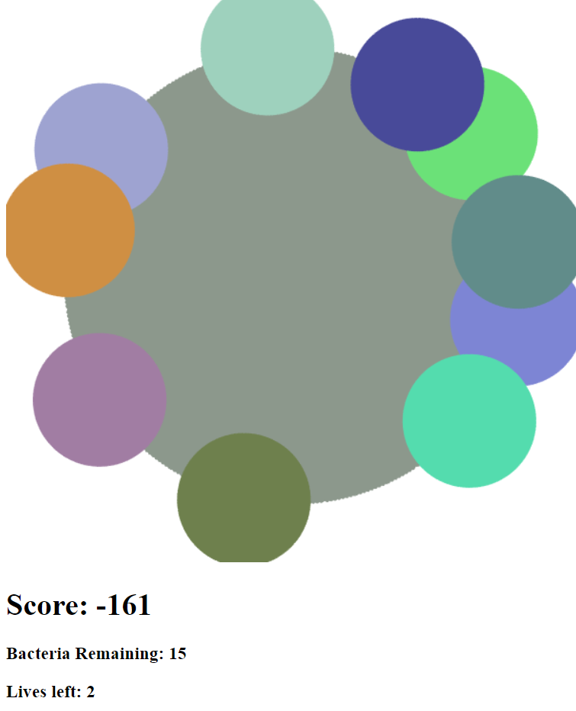Once bacteria grows too big you will lose score and life.