Evidence that Inclusion of Adaptive Priors in Correlated Chain Ladders Does Not Improve Loss Reserve Forecasts

Blake Shurtz

June 29, 2019

## Abstract

This paper investigates the substitution of adaptive priors for standard uninformed priors in an application of Bayesian stochastic loss reserve forecasting. Results show that both methods work similarly well in comparison to more analytical methods. However, both models generate outliers in loss prediction for some lower-valued claims.

## Intro

Unknown future costs, including claim re-evaluations and delayed litigation, create uncertainty in loss reserve forcasting. Chain ladders are essentially cost forecasting functions (Mack 1993) that predict the incurred losses in development period *d + 1* in year *w*.

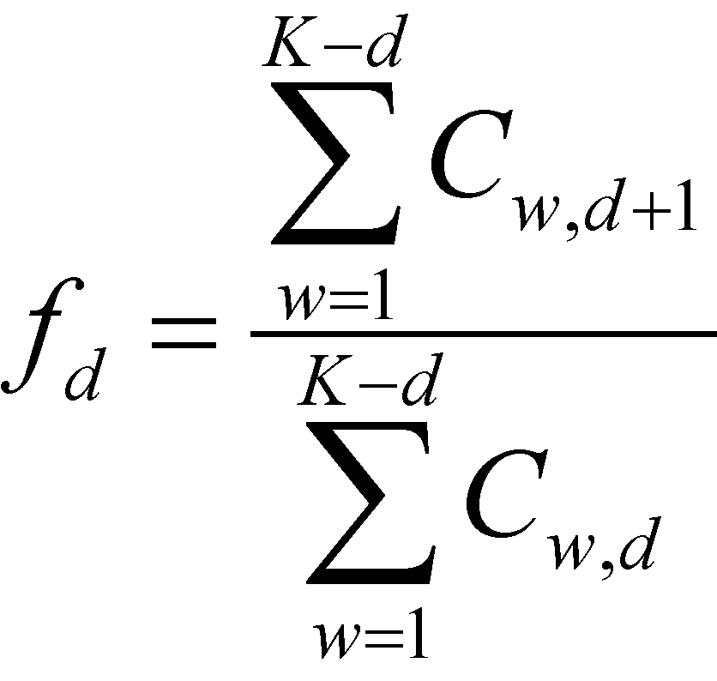

*Fig. 1: Chain-Ladder Model*

The assumptions of this model include that, for a given line of insurance, each year is independent. Also, the variance in future losses is conditional on the fixed effect *αd*.

Over the last two decades, Bayesian stochastic models have been adopted by the actuarial science community. Meyers finds that Bayesian stochastic models provide favorably more uniform predictions compared to strictly analytical models (Myers 2015). It does this by relaxing the fixed effect assumption for model parameters and by allowing for dependence *ρ* among accident years.

### Data

The loss reserving data comes directly from the Casualty Actuarial Society database, NAIC Schedule P (CAS 2011). Although the original analysis included four industries, this analysis compares results for the commercial auto sector only. Within that sector, cases were selected in which there was evidence that exogenous changes in business practices likely did not occur. (Meyers 2015)

### The Model

This paper makes a small contribution of testing Meyer’s model and data by adopting adaptive regularizing priors. Adaptive priors allow for prior distributions to have their own prior distributions. The use of these adaptive priors is recommended to prevent overfitting, particularly in environments where background information is unclear, such as in the case of a particular industry or firm. (Efron 2013)

A simplified presentation of the model is below:

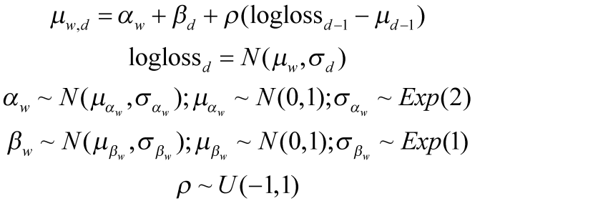

*Fig. 2: Bayesian Model with Adaptive Priors*

Rather than setting $α_{w}$ as a function of a fixed parameter, it is given its own adaptive priors that are a function of the data. Furthermore, variance hyperparameters $σ_{α}$ and $σ_{β}$ have been given exponential, rather than uniform, distributions.

### Results

Both Meyers original CCL model and the adaptive prior model were executed using the statistical software R and JAGs for MCMC. Results for Meyers model exactly matched the original monograph. The adaptive prior model generated similar, but not identical results.

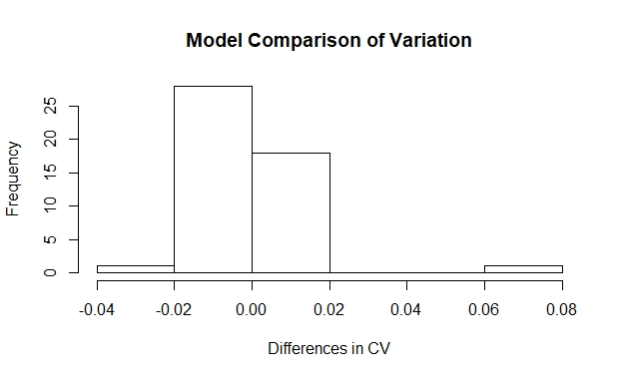

*Fig 3: Distribution of Differences in Coefficient of Variation*

A paired t-test rejects the hypothesis that the variation is different between models (p=0.42, df=47). However, the variation is smaller for the model with adaptive priors, indicating some potential improvement in accuracy.

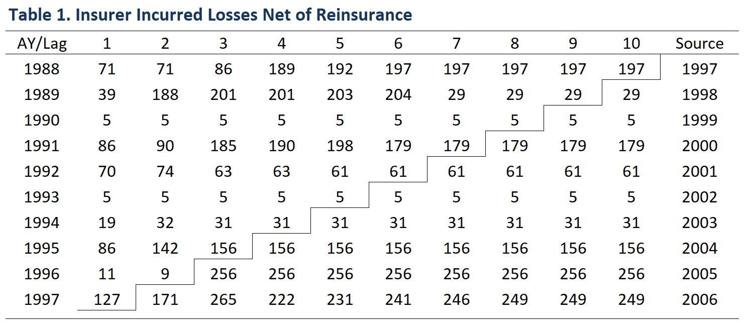

Both tests made large errors in predicting incurred losses for smaller, low-loss accounts. Future research may want to allow for an upper bound on within-year prediction of development lags when existing lags indicate not change (ex. 1990, above).

### Works Cited

Efron, Bradley. 2013. *Large Scale Inference*. Cambridge University Press.

Mack, Thomas. 1994. “Measuring the Variability of Chain Ladder Reserve Estimates.” Casualty Actuarial Society Forum (Spring):101–182.

Meyers, Glenn. 2011. “Loss Reserving Data Pulled from NAIC Schedule P.” Casualty Actuarial Society. <https://www.casact.org/research/index.cfm?fa=loss_reserves_data>

Meyers, Glenn. 2015. “[Stochastic Loss Reserving Using Bayesian MCMC Models.](https://www.casact.org/pubs/monographs/papers/01-Meyers.PDF)” CAS Monograph Series Number 1. Casualty Actuarial Society.