Supplementary Material

Supplementary Methods

Data extracts and constraint construction
The constrained Bayesian workflow modeled county-year latent counts while preserving public CDC WONDER suppression intervals and aggregate totals. Exact cells, zero cells, suppressed 1–9 cells, county-period constraints, state-year totals, national-year totals, and the reconciled 2019–2024 total of 58,380 deaths defined the feasible latent-count space.

Model specification
The primary model used a negative-binomial-2 mortality model with log population offset, rurality, SVI quartile, standardized percentage aged ≥65 years, standardized percentage male, centered year effects, and centered state/DC effects. Large metropolitan counties and SVI Q1 were reference categories. Prior distributions were normal for fixed and random effects, half-normal for state/year scale parameters, and log-normal for the negative-binomial shape parameter, as specified in the main Methods.

Sampler and validation
Latent counts were updated only through moves that preserved the hard public constraints. Eight chains used seeds 18291–18298, ran 300,000 iterations, discarded 75,000 burn-in iterations, and retained every 50th iteration. Saved latent-count draws were validated against county-year bounds, county-period constraints, state-year totals, national-year totals, and the grand total. Proposal acceptance fractions for some parameter blocks were outside the nominal 0.20–0.45 tuning target (approximately 0.082–0.085 for beta and 0.65–0.94 for log-scale hyperparameters); these are reported as efficiency limitations rather than convergence failures because all rank-normalized R-hat and bulk/tail ESS criteria passed.

Convergence gate
The final Wahab HPC production run completed 8 independent constrained Bayesian chains and reported 36,000 saved draws per retained parameter. The original primary gate passed. Release-time diagnostics covered all 69 parameters: maximum rank-normalized split R-hat 1.008554, minimum bulk ESS 1437.2, and minimum 5%/95% tail ESS 3199.4.

Sensitivity and contextual analyses
Sensitivity analyses included visible-only, fixed-value, residual-allocation, and interval-likelihood comparisons. COVID-19 co-mention and underlying-cause extracts were retained as contextual analyses rather than primary Bayesian outcomes.

Supplementary Results

Constraint validation
All 36,000 saved latent-count draws passed county-year, county-period, state-year, national-year, and grand-total validation checks. Supplementary Table S2 summarizes 489,696 validation records across eight chains.

Diagnostics
All-parameter convergence diagnostics are reported in Supplementary Table S1. Per-chain parameter draws, chain configurations/statuses, compressed validation evidence, and derived posterior outputs are archived in the reproducibility release; large latent arrays are represented by their cryptographic hashes and complete validation summaries. Supplementary Figure S1 summarizes the final all-parameter verification.

Sensitivity analyses
Supplementary Tables S3 and S4 provide scenario and sensitivity results. The scenario comparison clarifies which methods preserve the reconciled total, treat suppressed cells as latent positive counts, and provide posterior uncertainty.

COVID co-mention context
COVID-19 co-mention analyses were contextual and interpreted using CDC death-certificate coding context [17]. The 2020–2022 lower-bound COVID co-mention total was 1,575 deaths. The broader 2020–2024 bounded urbanization-year context was 1,923–1,963 deaths. These are different summaries because they use different calendar windows and lower-bound versus bounded definitions.

Underlying-cause context
Underlying-cause G40/G41 data were retained as contextual summaries because the staged public extracts did not support an equivalently constrained county-year primary Bayesian model.

Supplementary Tables
Supplementary tables S1–S8 are included below or as accompanying CSV/XLSX files. The full county posterior summary is supplied as CSV/XLSX. Supplementary Table S5 is a data dictionary for the county posterior file rather than a printed county listing.

Supplementary Figures
Supplementary Figures S1–S4 provide the convergence gate summary, posterior mortality-rate-ratio summary, posterior probability and uncertainty maps, and final latent-count constraint validation.

Supplementary Tables

S1_diagnostics
Parameter family | Tracked quantity | R-hat | Bulk ESS | Tail ESS | MCSE mean | Chains | Draws per chain | Diagnostic status
Fixed effect | Intercept | 1.001489 | 4204.0 | 10014.1 | 0.00030324 | 8 | 4500 | Pass
Hyperparameter | kappa | 1.001674 | 5911.5 | 19501.3 | 0.00756459 | 8 | 4500 | Pass
Rurality | Other metropolitan vs large metropolitan | 1.000381 | 6213.1 | 14258.5 | 0.000204423 | 8 | 4500 | Pass
Rurality | Nonmetro adjacent vs large metropolitan | 1.000910 | 4923.8 | 11027.5 | 0.000300746 | 8 | 4500 | Pass
Rurality | Nonmetro nonadjacent vs large metropolitan | 1.000935 | 4024.4 | 8819.1 | 0.000430244 | 8 | 4500 | Pass
Hyperparameter | sigma_state | 1.001446 | 6769.1 | 19025.3 | 0.000265347 | 8 | 4500 | Pass
Hyperparameter | sigma_year | 1.000510 | 11489.7 | 13312.8 | 0.000648734 | 8 | 4500 | Pass
State effect | state_effect[01] | 1.000621 | 10132.9 | 18900.1 | 0.000403144 | 8 | 4500 | Pass
State effect | state_effect[02] | 1.001020 | 2447.1 | 5120.7 | 0.00180504 | 8 | 4500 | Pass
State effect | state_effect[04] | 1.000806 | 6311.4 | 12587.1 | 0.00067234 | 8 | 4500 | Pass
State effect | state_effect[05] | 1.000318 | 9577.8 | 18328.3 | 0.000437067 | 8 | 4500 | Pass
State effect | state_effect[06] | 1.000240 | 12143.0 | 23820.2 | 0.000250682 | 8 | 4500 | Pass
State effect | state_effect[08] | 1.000730 | 11245.6 | 19563.5 | 0.000372129 | 8 | 4500 | Pass
State effect | state_effect[09] | 1.002001 | 4182.4 | 8713.1 | 0.00100769 | 8 | 4500 | Pass
State effect | state_effect[10] | 1.002553 | 2528.1 | 4762.5 | 0.00175995 | 8 | 4500 | Pass
State effect | state_effect[11] | 1.008554 | 1437.2 | 3199.4 | 0.0030068 | 8 | 4500 | Pass
State effect | state_effect[12] | 1.000412 | 8851.6 | 18992.3 | 0.000332859 | 8 | 4500 | Pass
State effect | state_effect[13] | 1.000604 | 13945.9 | 25340.0 | 0.000263021 | 8 | 4500 | Pass
State effect | state_effect[15] | 1.004655 | 1724.7 | 3793.6 | 0.00245899 | 8 | 4500 | Pass
State effect | state_effect[16] | 1.000791 | 5513.0 | 11225.6 | 0.000805815 | 8 | 4500 | Pass
State effect | state_effect[17] | 1.000301 | 11700.9 | 20529.3 | 0.000349822 | 8 | 4500 | Pass
State effect | state_effect[18] | 1.000294 | 13543.6 | 23999.6 | 0.000281647 | 8 | 4500 | Pass
State effect | state_effect[19] | 1.000639 | 8231.3 | 15665.2 | 0.000499631 | 8 | 4500 | Pass
State effect | state_effect[20] | 1.000961 | 7254.7 | 14098.2 | 0.00061866 | 8 | 4500 | Pass
State effect | state_effect[21] | 1.000657 | 12460.0 | 21872.4 | 0.000344878 | 8 | 4500 | Pass
State effect | state_effect[22] | 1.000251 | 9316.3 | 18826.4 | 0.000425893 | 8 | 4500 | Pass
State effect | state_effect[23] | 1.001396 | 5260.1 | 11220.8 | 0.000846205 | 8 | 4500 | Pass
State effect | state_effect[24] | 1.000373 | 8812.0 | 16914.2 | 0.000465659 | 8 | 4500 | Pass
State effect | state_effect[25] | 1.000441 | 7236.8 | 14159.3 | 0.00060456 | 8 | 4500 | Pass
State effect | state_effect[26] | 1.000091 | 14680.6 | 24979.0 | 0.000268341 | 8 | 4500 | Pass
State effect | state_effect[27] | 1.000197 | 11567.7 | 21603.8 | 0.000347063 | 8 | 4500 | Pass
State effect | state_effect[28] | 1.000796 | 9536.3 | 18358.0 | 0.000425837 | 8 | 4500 | Pass
State effect | state_effect[29] | 1.000547 | 11111.3 | 22442.7 | 0.000349097 | 8 | 4500 | Pass
State effect | state_effect[30] | 1.002418 | 3902.8 | 7695.0 | 0.00112999 | 8 | 4500 | Pass
State effect | state_effect[31] | 1.001384 | 5933.0 | 11963.2 | 0.000745595 | 8 | 4500 | Pass
State effect | state_effect[32] | 1.002670 | 3008.8 | 6630.1 | 0.00145147 | 8 | 4500 | Pass
State effect | state_effect[33] | 1.003328 | 3433.4 | 7351.5 | 0.00128699 | 8 | 4500 | Pass
State effect | state_effect[34] | 1.000446 | 8607.8 | 17301.6 | 0.000462467 | 8 | 4500 | Pass
State effect | state_effect[35] | 1.000969 | 6304.3 | 12637.9 | 0.000693759 | 8 | 4500 | Pass
State effect | state_effect[36] | 1.000389 | 13100.0 | 24623.0 | 0.000269422 | 8 | 4500 | Pass
State effect | state_effect[37] | 1.000300 | 15214.0 | 24413.5 | 0.000238048 | 8 | 4500 | Pass
State effect | state_effect[38] | 1.004566 | 2515.4 | 5061.1 | 0.00178712 | 8 | 4500 | Pass
State effect | state_effect[39] | 1.000075 | 15307.2 | 26712.3 | 0.000243204 | 8 | 4500 | Pass
State effect | state_effect[40] | 1.000675 | 10025.7 | 19104.0 | 0.000410483 | 8 | 4500 | Pass
State effect | state_effect[41] | 1.000956 | 10086.8 | 18679.0 | 0.000426562 | 8 | 4500 | Pass
State effect | state_effect[42] | 1.000265 | 15627.2 | 24528.3 | 0.000240271 | 8 | 4500 | Pass
State effect | state_effect[44] | 1.000797 | 2631.0 | 5818.8 | 0.00169236 | 8 | 4500 | Pass
State effect | state_effect[45] | 1.000612 | 11713.3 | 21610.6 | 0.000335682 | 8 | 4500 | Pass
State effect | state_effect[46] | 1.001681 | 3974.8 | 8673.1 | 0.00110893 | 8 | 4500 | Pass
State effect | state_effect[47] | 1.000146 | 13345.5 | 23704.8 | 0.000284982 | 8 | 4500 | Pass
State effect | state_effect[48] | 1.000678 | 12031.7 | 27008.9 | 0.000218809 | 8 | 4500 | Pass
State effect | state_effect[49] | 1.002362 | 5225.2 | 11229.9 | 0.000807986 | 8 | 4500 | Pass
State effect | state_effect[50] | 1.002284 | 2908.5 | 5990.9 | 0.00149017 | 8 | 4500 | Pass
State effect | state_effect[51] | 1.000144 | 15352.6 | 24739.7 | 0.00025823 | 8 | 4500 | Pass
State effect | state_effect[53] | 1.000422 | 10199.8 | 17586.0 | 0.000391351 | 8 | 4500 | Pass
State effect | state_effect[54] | 1.000854 | 6742.1 | 13006.1 | 0.000653677 | 8 | 4500 | Pass
State effect | state_effect[55] | 1.000247 | 10112.4 | 19270.3 | 0.000383219 | 8 | 4500 | Pass
State effect | state_effect[56] | 1.002065 | 2445.3 | 5020.8 | 0.00176066 | 8 | 4500 | Pass
SVI | SVI Q2 vs Q1 | 1.000541 | 4853.4 | 10643.1 | 0.000293925 | 8 | 4500 | Pass
SVI | SVI Q3 vs Q1 | 1.000611 | 4249.0 | 10178.9 | 0.000321584 | 8 | 4500 | Pass
SVI | SVI Q4 vs Q1 | 1.000803 | 3728.5 | 8794.6 | 0.000380942 | 8 | 4500 | Pass
Year effect | year_effect[2019] | 1.000149 | 30940.1 | 34656.1 | 8.04163e-05 | 8 | 4500 | Pass
Year effect | year_effect[2020] | 1.000230 | 32289.4 | 33603.2 | 7.4306e-05 | 8 | 4500 | Pass
Year effect | year_effect[2021] | 1.000375 | 31738.2 | 34666.0 | 7.35626e-05 | 8 | 4500 | Pass
Year effect | year_effect[2022] | 1.000077 | 30826.4 | 35359.4 | 7.33132e-05 | 8 | 4500 | Pass
Year effect | year_effect[2023] | 1.000632 | 32831.6 | 35036.8 | 7.09983e-05 | 8 | 4500 | Pass
Year effect | year_effect[2024] | 1.000106 | 34836.7 | 35454.2 | 6.79875e-05 | 8 | 4500 | Pass
Fixed effect | Percentage aged ≥65 years, standardized | 1.000675 | 7791.7 | 17777.8 | 9.74859e-05 | 8 | 4500 | Pass
Fixed effect | Percentage male, standardized | 1.000911 | 9004.0 | 21077.7 | 0.000123926 | 8 | 4500 | Pass
All 69 retained parameters are reported. R-hat is rank-normalized and folded; ESS values are multi-chain bulk and 5%/95% tail estimates. Release criteria were R-hat ≤1.01 and bulk/tail ESS ≥400.

S2_constraint_validation
Validation check | Units checked | Validation records | Failed records
All counts integer | 40808 | 40808 | 0
County-period constraints respected | 40808 | 40808 | 0
County-year bounds respected | 40808 | 40808 | 0
Exact county-year counts unchanged | 40808 | 40808 | 0
Explicit-zero county-year counts unchanged | 40808 | 40808 | 0
Grand total equals 58,380 | 40808 | 40808 | 0
National-year totals equal Q003 | 40808 | 40808 | 0
No counties silently dropped | 40808 | 40808 | 0
No negative counts | 40808 | 40808 | 0
Row count matches model frame | 40808 | 40808 | 0
State-year totals equal Q004 | 40808 | 40808 | 0
Suppressed county-year counts remain 1–9 | 40808 | 40808 | 0
Production validation contains 489,696 records across eight chains, 12 checks, and 40,808 chain-specific allocation/draw labels; all failed-record counts are zero.

S3_scenario_comparison_full
Method | Assigned deaths, full extract | Analytic model deaths | Preserves reconciled total | IRR | 95% interval | Models latent counts probabilistically | Provides posterior uncertainty | Treats suppressed cells as latent positive counts
Observed exact-positive only | 51,388 | 50,833 | No | 0.97 | 0.80–1.19 | No | No | No
Observed exact plus explicit zero | 51,388 | 50,833 | No | 0.91 | 0.78–1.06 | No | No | No
Suppressed = 1 | 53,110 | 52,552 | No | 0.98 | 0.88–1.10 | No | No | No
Suppressed = 4.06 (constant mean) | 58,380 | 57,812.8 | Yes | 1.24 | 1.14–1.36 | No | No | No
Suppressed = 5 | 59,998 | 59,428 | No | 1.29 | 1.18–1.42 | No | No | No
Suppressed = 9 | 66,886 | 66,304 | No | 1.42 | 1.27–1.60 | No | No | No
Population-scaled residual allocation | 58,380 | 57,817.4 | Yes | 1.04 | 0.98–1.10 | No | No | Partly
Conservative anti-rural residual allocation | 58,380 | 57,812.1 | Yes | 0.97 | 0.90–1.04 | No | No | Partly
Pro-rural residual allocation | 58,380 | 57,818.5 | Yes | 1.13 | 1.05–1.20 | No | No | Partly
Interval-likelihood negative binomial | Not assigned | Not assigned | Not assigned / not applicable | 1.07 | 0.63–1.80 | Partly | No | Partly
Bayesian constrained latent-count model | 58,380 | 58,380 latent-count system | Yes | 1.23 | 1.17–1.30 | Yes | Yes | Yes

S4_sensitivity_summaries
Sensitivity | Category | Counties | Posterior mean deaths | Person-years | Rate per 100,000 | Note
Rurality-only primary grouping | Large metropolitan | 441 | 28,890.3 | 1,129,455,502 | 2.56 | —
Rurality-only primary grouping | Other metropolitan | 738 | 18,461.8 | 572,315,982 | 3.23 | —
Rurality-only primary grouping | Nonmetro adjacent | 1,052 | 7,644.0 | 196,713,004 | 3.89 | —
Rurality-only primary grouping | Nonmetro nonadjacent | 911 | 3,383.9 | 88,527,893 | 3.82 | —
NCHS urban-rural sensitivity | Large central metropolitan | 66 | 16,621.0 | 612,030,008 | 2.72 | —
NCHS urban-rural sensitivity | Large fringe metropolitan | 367 | 12,006.1 | 505,589,853 | 2.37 | —
NCHS urban-rural sensitivity | Medium metropolitan | 390 | 12,982.3 | 408,957,782 | 3.17 | —
NCHS urban-rural sensitivity | Micropolitan | 656 | 6,234.0 | 166,765,732 | 3.74 | —
NCHS urban-rural sensitivity | Noncore | 1,307 | 4,793.9 | 118,475,165 | 4.05 | —
NCHS urban-rural sensitivity | Small metropolitan | 356 | 5,742.8 | 175,193,841 | 3.28 | —
Binary RUCC sensitivity | RUCC 1–3 | 1,179 | 47,352.1 | 1,701,771,484 | 2.78 | —
Binary RUCC sensitivity | RUCC 4–9 | 1,952 | 10,460.1 | 274,325,374 | 3.81 | —
Binary RUCC sensitivity | — | 11 | 567.7 | 10,915,523 | 5.20 | —
Covariate-unmatched sensitivity | Covariate-unmatched counties | 11 | 567.7 | 10,915,523 | 5.20 | —
Covariate-unmatched sensitivity | Covariate-matched counties | 3,131 | 57,812.3 | 1,976,096,858 | 2.93 | —
Underlying-cause context | Parallel constrained model not run | — | — | — | — | UCD has county-period and state-year context, but no equivalent public UCD county-year extract in Q011/Q012/Q014; not estimable with the same constraint set without inventing county-year constraints.
COVID context | 2020–2022 COVID co-mention lower-bound deaths | — | 1,575.0 | — | — | COVID co-mention remains contextual and was not modeled as the primary Bayesian outcome.

S5_county_posterior_dictionary
Column | Description
county_fips | Five-digit county FIPS code.
county_name | County or county-equivalent name.
state_name | State name.
posterior_mean_county_period_deaths | Posterior mean model-derived county-period deaths.
posterior_median_county_period_deaths | Posterior median model-derived county-period deaths.
deaths_credible_interval_lower_95 | Lower 95% credible limit for county-period deaths.
deaths_credible_interval_upper_95 | Upper 95% credible limit for county-period deaths.
posterior_mean_rate_per_100k | Posterior mean county-period rate per 100,000 person-years.
rate_credible_interval_lower_95 | Lower 95% credible limit for rate.
rate_credible_interval_upper_95 | Upper 95% credible limit for rate.
posterior_probability_rate_exceeds_national_rate | Posterior probability that county rate exceeds the national rate.
original_q001_status | Public county-period visibility status.
rurality | Collapsed rurality category.
svi_quartile | Social Vulnerability Index quartile.
The full county posterior summary is supplied as CSV/XLSX. The DOCX supplement prints the data dictionary only to avoid an unreadable county listing.

S6_data_audit
Metric | Value
county_year_rows | 18852
counties | 3142
national_total_constraint | 58380
saved_parameter_draws_final_summary | 36000
chains | 8

S7_covid_context
year | deaths | rate_per_100k | covid_lower | covid_upper | covid_pct_of_mcod
2019.0 | 7583.0 | 2.31020321096433 | 0.0 | 0.0 | 0.0
2020.0 | 9147.0 | 2.7761580487445827 | 548.0 | 556.0 | 6.034765496884225
2021.0 | 9733.0 | 2.932565059338494 | 549.0 | 557.0 | 5.6817014281311
2022.0 | 10575.0 | 3.1729357360917017 | 478.0 | 486.0 | 4.5579196217494085
2023.0 | 10546.0 | 3.148859652838074 | 198.0 | 206.0 | 1.915418168025792
2024.0 | 10796.0 | 3.174257927826784 | 150.0 | 158.0 | 1.4264542423119675

S8_underlying_cause_context
death_count_status | rows | lower | upper
aggregate_total | 1 | 22306.0 | 22306.0
exact | 504 | 16650.0 | 16650.0
suppressed_1_9 | 1866 | 1866.0 | 16794.0
zero | 772 | 0.0 | 0.0

Supplementary Figures
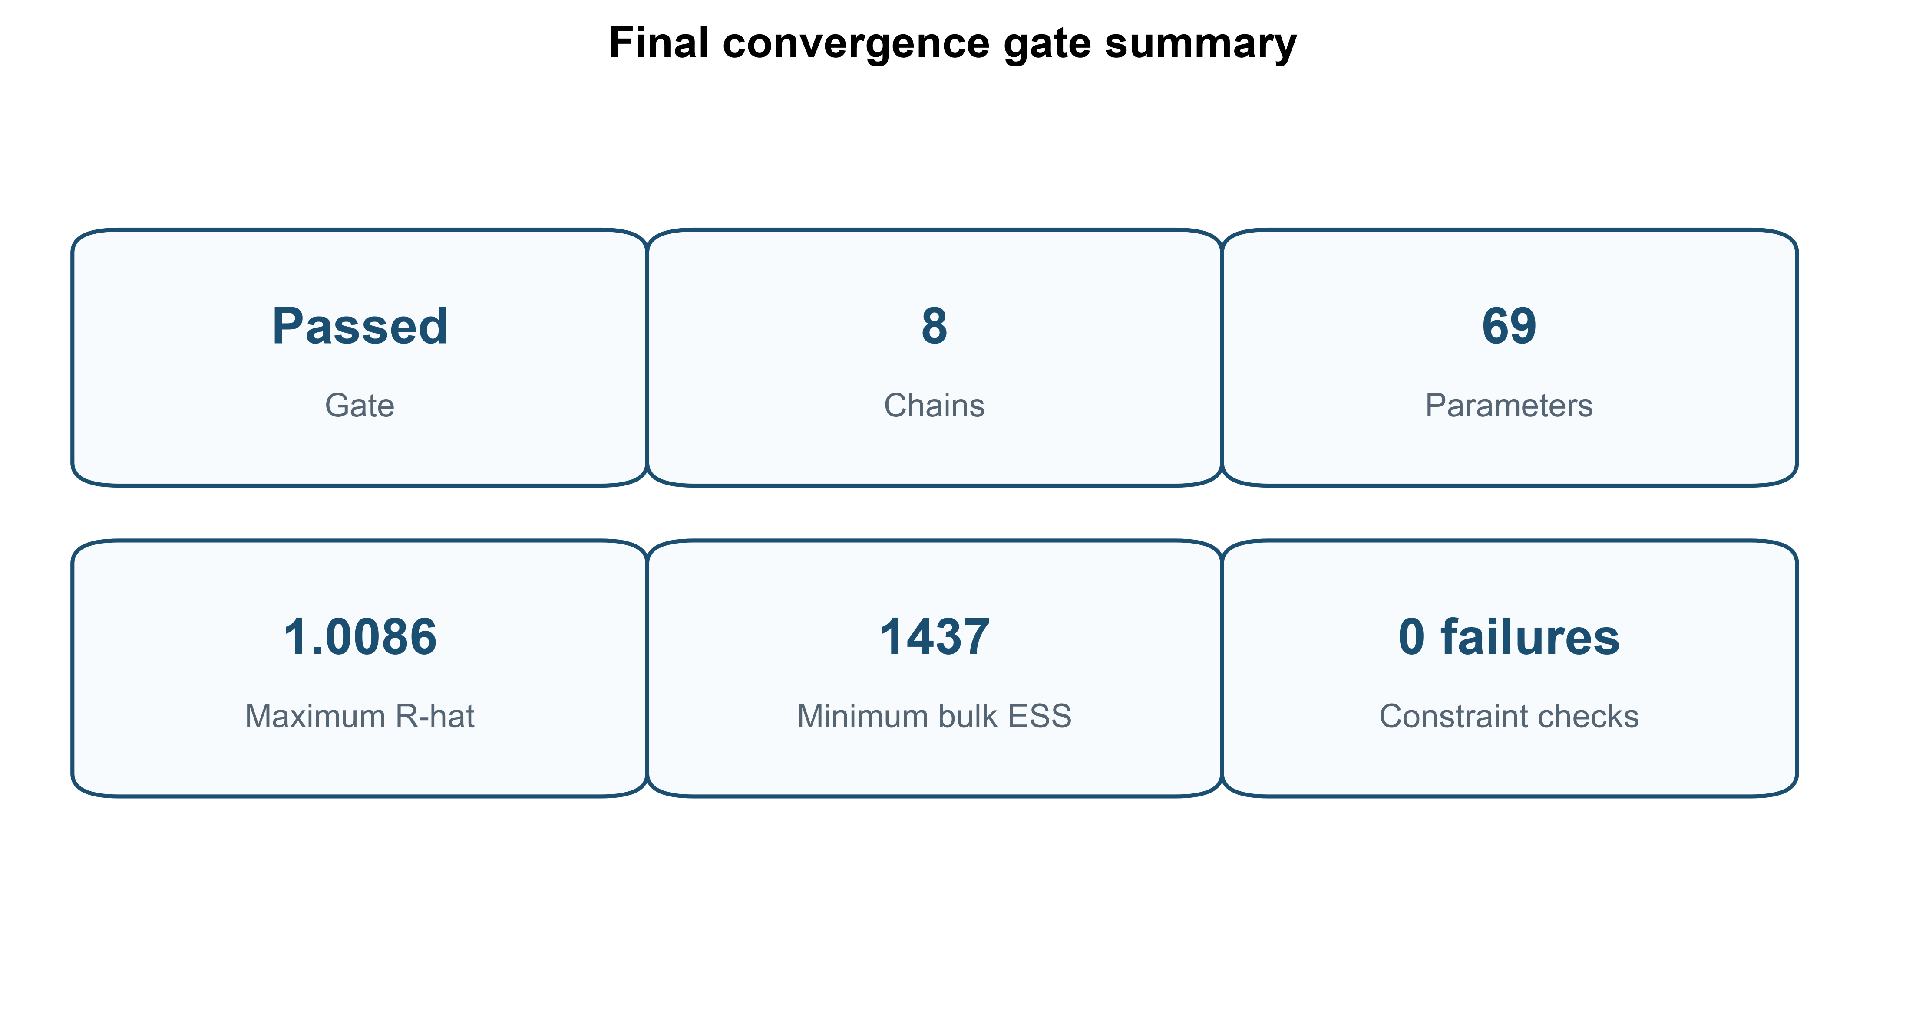
Supplementary Figure S1. Final all-parameter convergence verification. The card reports the maximum rank-normalized split R-hat and minimum bulk effective sample size across all 69 retained parameters.

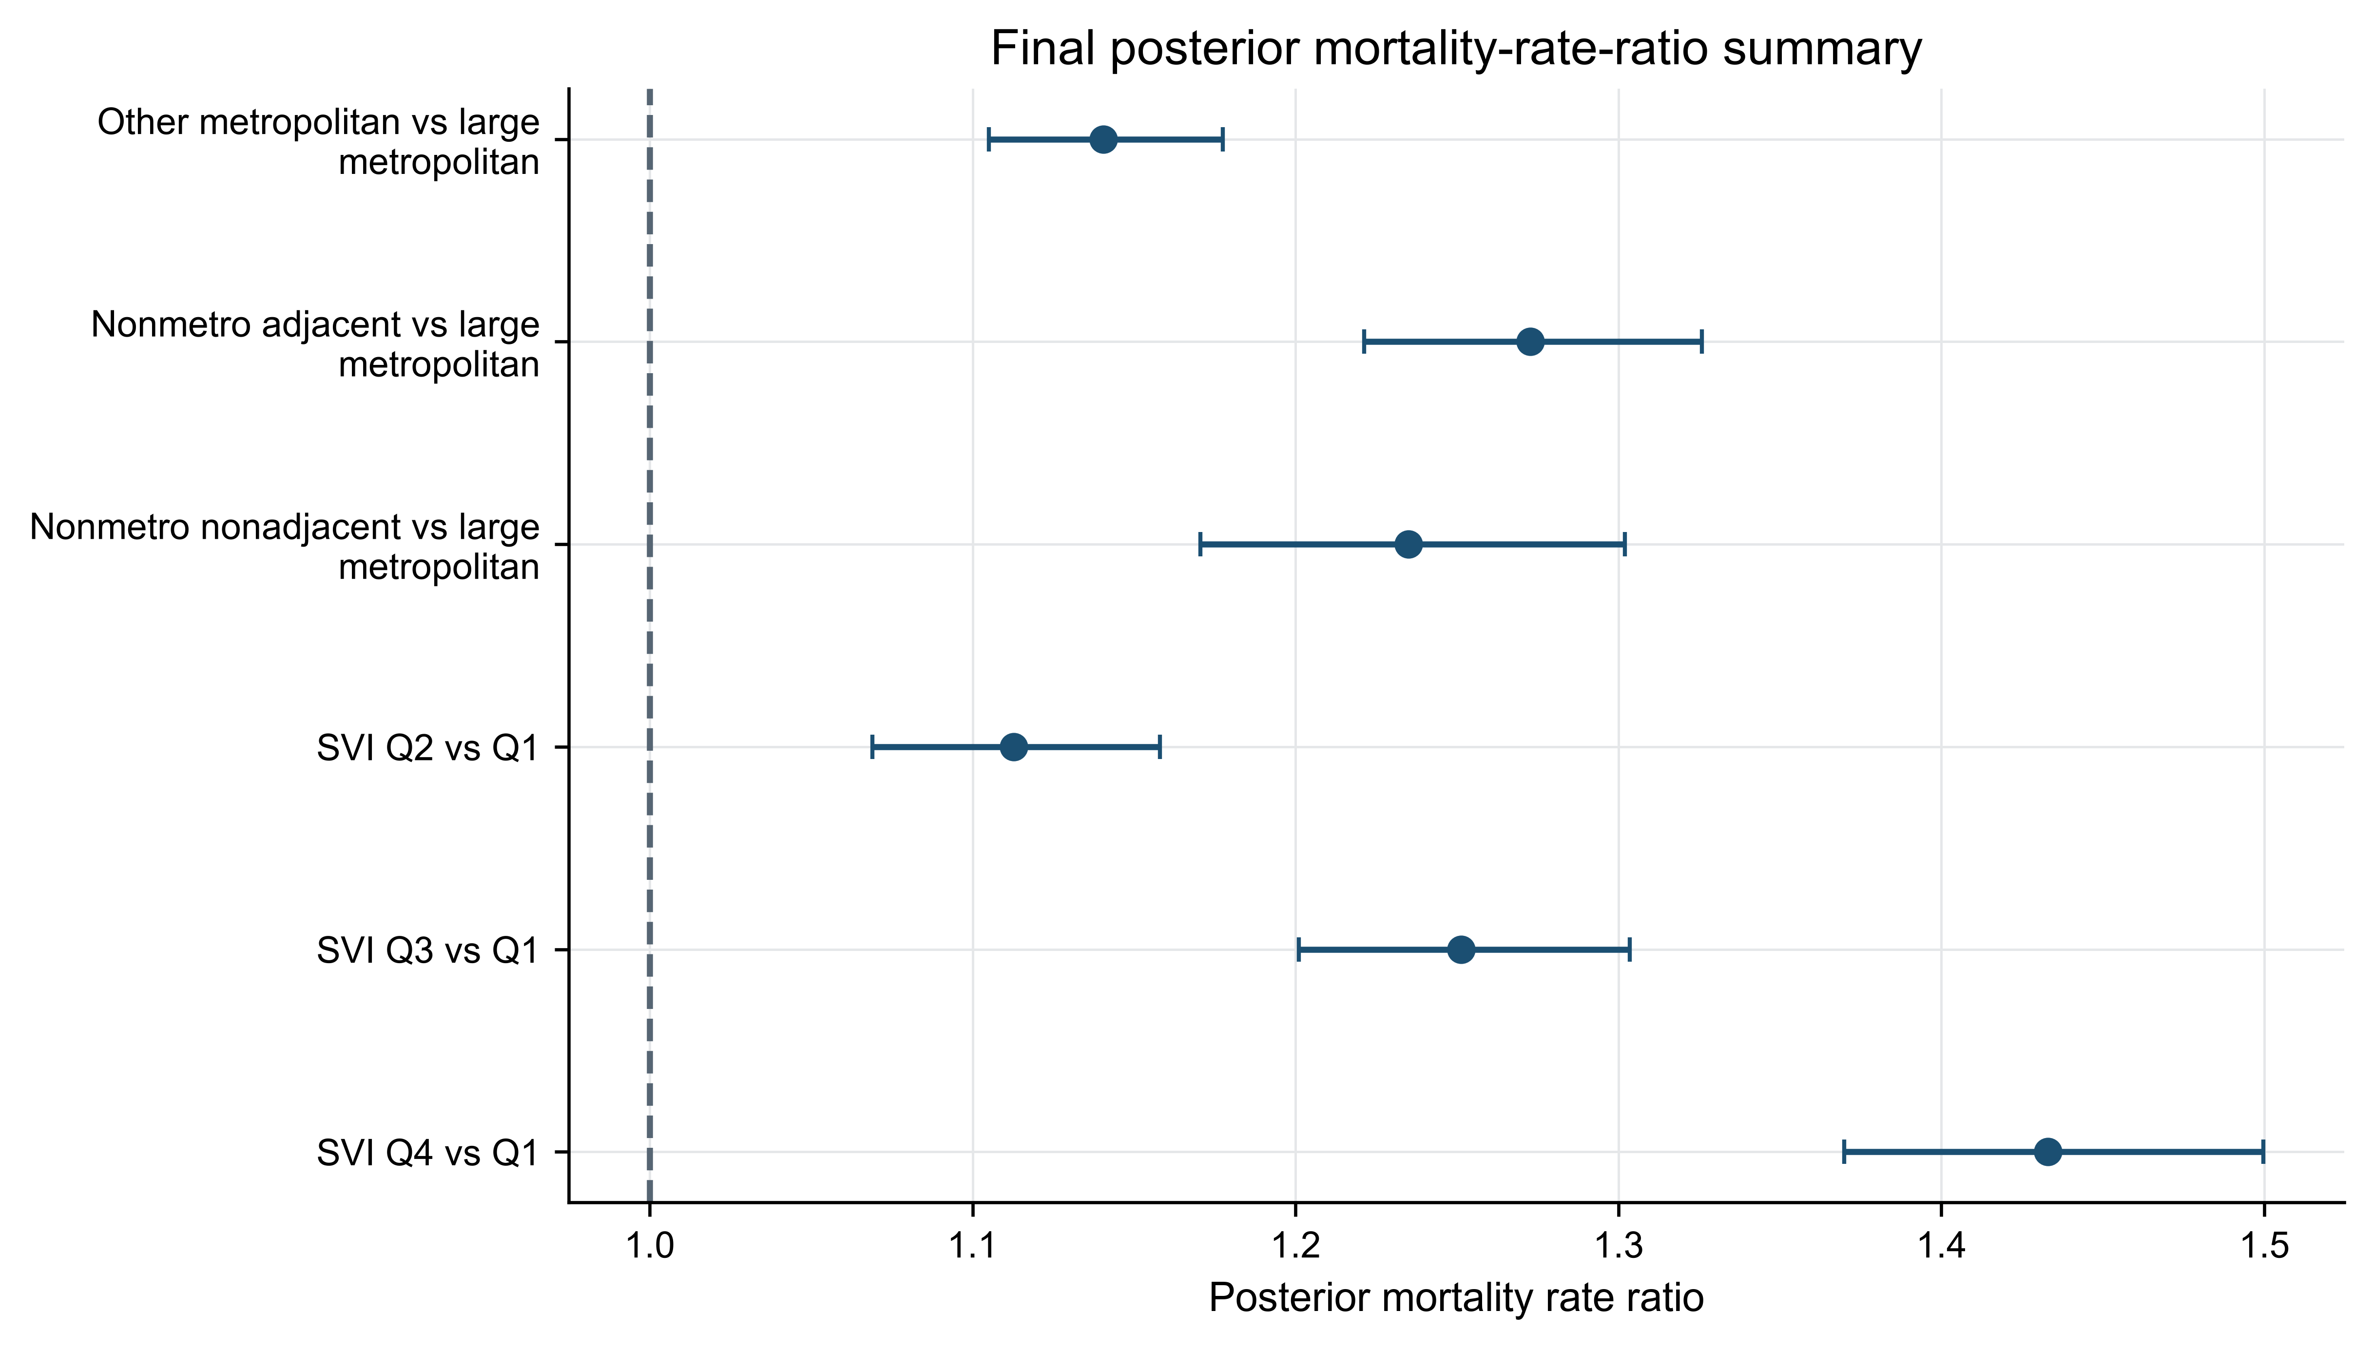
Supplementary Figure S2. Posterior mortality-rate-ratio summary for rurality and SVI contrasts.

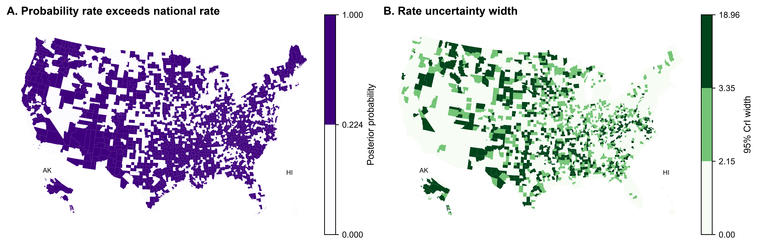
Supplementary Figure S3. Posterior probability and uncertainty maps for model-derived county-level quantities.

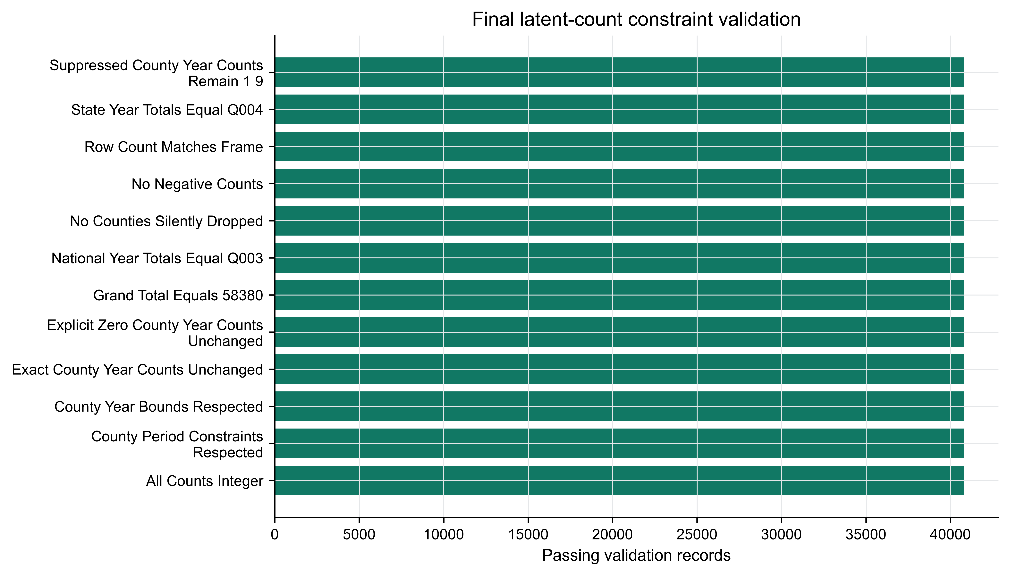
Supplementary Figure S4. Final latent-count constraint validation.

