## Load Verification

162 Hawthorne Ct. could not maintain 77 degree set-point during extreme temperatures. A 2-stage 3 ton A/C package unit with upstairs/downstairs zoning was installed in February. (Note: 2 stage means that the system can provide either 2 tons “low stage” or 3 tons “high stage” of cooling.)

An amp clamp was installed on 6/02 to monitor system run-times and staging. Analysis on 6/18 showed system was cycling between zones frequently and was drawing a maximum of 11 amps. *This is considered an irregular, low amp-draw for a 3-ton package unit.*

The install department made a site visit on 6/27 to diagnose the system. We determined that the system was running in low-stage (2 tons) only. This would explain the low amperage draw and the inability to maintain set-point temperatures. Because the HVAC system’s control of staging is made by the thermostat, it was decided to replace the thermostats.

Two thermostats were installed on 7/7. After this, the amp draw of the system increased from 11 amps to 16 amps, which is more in-line with a 3 ton system. We believe the system began running in high stage at this point.

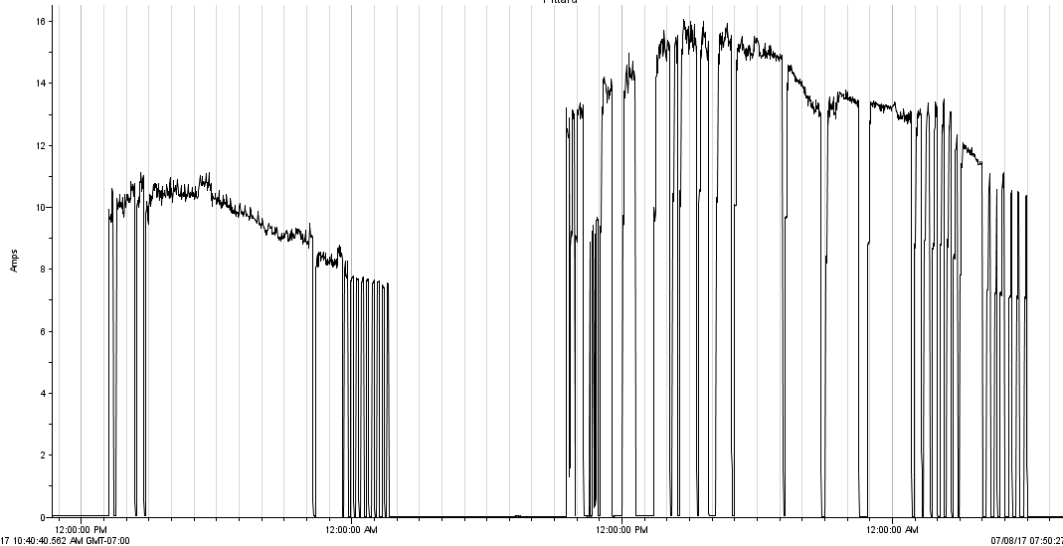

*On the left, the system is drawing 11 amps max on 7/6. On the right, the system is drawing 16 amps on 7/7.*

*We believe the system starting running in high stage on 7/7.*

In order to determine whether the system could maintain set-points at high-stage capacity, temperature data-loggers were installed on 7/14. The system was put to the test on 7/16, which was the 6th hottest day of the last 3 years, with an outdoor peak temperature of 109 degrees F.

The loggers report that the **downstairs** was able to maintain less than 77 degree temperatures at low stage in through the early afternoon. By 3 PM, the system was running in high stage and the downstairs maintained 77 degrees or less for the remainder of the day.

The loggers report that the **upstairs** was maintaining a 75 degree temperature set point at low stage throughout the early afternoon. As the system kicked into high stage in the afternoon, temperatures never exceeded 75.2 degrees, except for a brief, unexplained spurt to 75.5 degrees at 9 PM.