PEOPLE I WANT TO INTERACT WITH
RHETT ROSENBLEDT- Made an amazing post on his journey to heal his toxic past.
Paul R. S. Hanna- overcoming addiction.

An intimate relationship will push your buttons more than anything else.
You need to listen- You need to let her be mad and throw stones and be angry and afirm her anger.
As a man you're responsible for the masculine part of the relationship
You're wrong when you get triggered. Be present. Emotion is not a problem. Let her rage- and make changes.

Need to be in control of your own emotions. Women are more attaracted to emotionally strong men.
Don't be triggered, don't be trying to fix it.

From Andrew Ferebee to Everyone 02:28 PM
Hey Men! We will start on the half hour. Be ready with your question/focus/outcome in mind… and post below:

Want to focus on mindset what we belive, what we tell ourselves and the stories we tell ourselves
Take on a new identy. Human needs psycology. The strongest needs come out of our identity.
My identity- take on a new identity.

Ok we are

1. Your name, where you are in the course
I'm Blake- I'm brand new this is my second call. I am in the hero's journey
My Current situation is: I am rocking the business part of life. I am really sucking at the personal relationships- crashed a marriage, burned life long friendships. Struggling with a strong daily routine
My desired situation is the ability to be dedicated in my routine. I am strong in spurts, but then I break my routine and struggle to do what I need to do.
My question: How do you build an unshakable routine that you use to conquer the most out of a day. Because a day is a miniature lifetime and how we act in a day- is how our life turns out.
2.

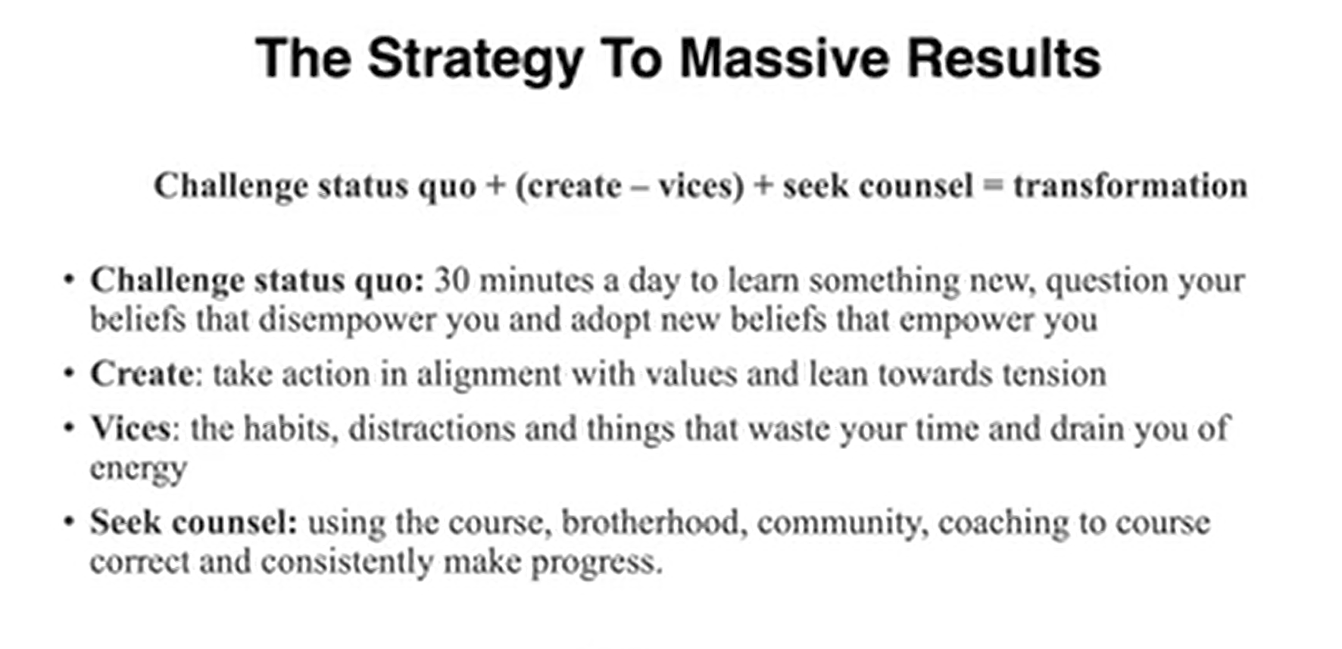
6/30/2022
1. The journey that lays ahead. Excise the toxic beliefs you've clung to for years and then rebuild me.

6/24/2022
HEY YOU RAD HUMANS! LET'S TAKE THIS WORLD BY STORM. Blake here! An explorer with viking blood in my veins, adventure in my heart, and a wild streak a mile wide. I am here to conquor my laziness, banish my dependence on vices, build unshakable habits that create progress daily towards my goals, and unlock the life of passion and love I know is in me.

I am a 34 year old man living in the mountains of Montana. I am a software engineer by trade. I worked hard and sacrificed things dear to me so I could have a job that allows me to work remote. I value freedom and exploration, but I want to build a tribe of loving chosen family and settle down on some beautiful land and build a homestead, after I've seen the world.

Freedom and travel are key for me right now. I travel unique places and do rad things. I surf, hunt, fish, mountain bike, snowboard, ski, snowmobile, jiu jitsu, ride harleys, skydive, scuba dive, build complex puzzles, and write intense fiction novels. I feel most at home waking up in the mountains near a stream, or of the coast in a sailboat anchored near a prime surf spot. I want to sail around the world in my own sailboat, write my novel that I've dreamed of for years, and own my own homestead that supports me and my chosen family.
My biggest take aways are humans are pack animals. I have found so much motivation in knowing I am in a group of men who are striving to be their best. Your success fuels mine! So let's get our dreams together!
Another take away is the deep look at yourself, honesty, and willingness to do hard things that are required here. So excited to really be the man I know I can be. Appreciate the accountability and drive here.
HOW I CAN ADD VALUE:
INTENSE ADVENTURE BUDDY I work remote and am location independent. I can and will travel the world to make great friends and have amazing experiences. Looking for an intense driven buddy to go scuba dive a ship wreck in Thailand, skydive into Burning Man, or hunt Elk in Alaska? I am your man. I have traveled to 13+ countries around the world and had amazing adventures. Let's go squeeze the most out of life!
FIRST HAND EXPERINCE CONQUORING VICES I have worked really hard to overcome some intense vices- alcoholism and drugs(sober 15 months), dishonesty, tobacco addiction (7years), I can give advice and support on those subjects.
ARTISTIC MADMAN, GAMER, AUTHOR I am a deeply creative person and love to collaborate on art, music, writing, or imaginative story telling. Ever want to use your imagination to conquer a castle, sail a ship across the sea of the dead, or survive a werewolf encounter? Want to build a warehouse rave? Write a book? Let's talk! Group game playing and story telling could be the outlet and connection you need instead of video games alone!

SUCCESSFUL ENTREPENEUR & EDUCATOR I have had experience in a diverse set of fields GPS satellite software engineering, English education, large scale commercial farming, auto mechanics and diesel engine repair. I love to teach. Thinking of changing jobs for a more fulfilling career? Let's talk.
DIVORCED You won't know what this means unless you've gone through it. I have experienced first hand the heart wrenching gut punch of loss. The drive to become a better man. The darkness and introspection it requires. If you need a hand I am here.
EARLY RETIREMENT EXPERINCE I am big into personal finance and very close to my FIRE(Financial Independence Retire Early) goals. If anyone wants to learn about the surprisingly simple math and bad ass lifestyle changes needed to retire early- I would love to talk.
PROGRESS IS SUCCESS!

6/23/2022
Coaching Call
Compare yourself to you in the mirror!!! Look at you and see what are you proud of ego driven comparison to others.
The book of questions
Coach Pete-
Deepening Connection-

Like Rhett I am brand new in the program-
Good things-Software engineer- do security on GPS Sattelites Writing Got a 1000 words on a novel yesterday- My company is 39 days out from a big win, I'm nailing the vices, Old and new, to the wall 7 years no smokless tobacco, 15 months sober drugs and alcohol, four days no porn,

Bad things where am I not showing up- Need to be present for my family. Need to determine what I want from relationships. Kind of just being selfish and playing with the feelings of multiple women.
Honesty is a challenge for me. I need to be ruthlessley honest no mater what. I've been good but that maladaptive coping mechanism is slipping back into my behavior and I'm not going to let it.
Using social media like reddit waaaay too much. Waste of time. Hiding behind that.
Dave thanks for being a good example-

Hunter Lane- Onboarding coach- contact me at support@knowledgeformen.com

One moduel per month.
Some are easy some are hard.

HOW MANY MODULES
Ron on Tuesday is RON-
Pete is Wednesday- This one. He is the divorce guy.
Brodie – Go to these

Brodie with the physical abuse.

Peter Wright- he is the divorce guy.

Coach Ron

Back ground in professional negotiator. Handle sales and 8 ½ billion dollars a year and he
his journey started at 2019. Walls was caving in lying to himself internally alone and struggling. Failed to take ownership for his mistakes over 300 pounds and 60000 in debt. Joined project grounded man.
Commited 100% to the program. Tackled this full on. Suffered from sleep apnia lost 55 pounds. Nice work on the debt.

Fly fishing on the Kenei River. Back packing elk hunting trip.
Starting the program still on the journey. Embrace the journey that we are on. Gonna be faced with some tough stuff and want to quit.

This call is to make sure we get the most out of this.

How do men achieve their goals- what are you afraid of?
Deal with uncomfortable situations.

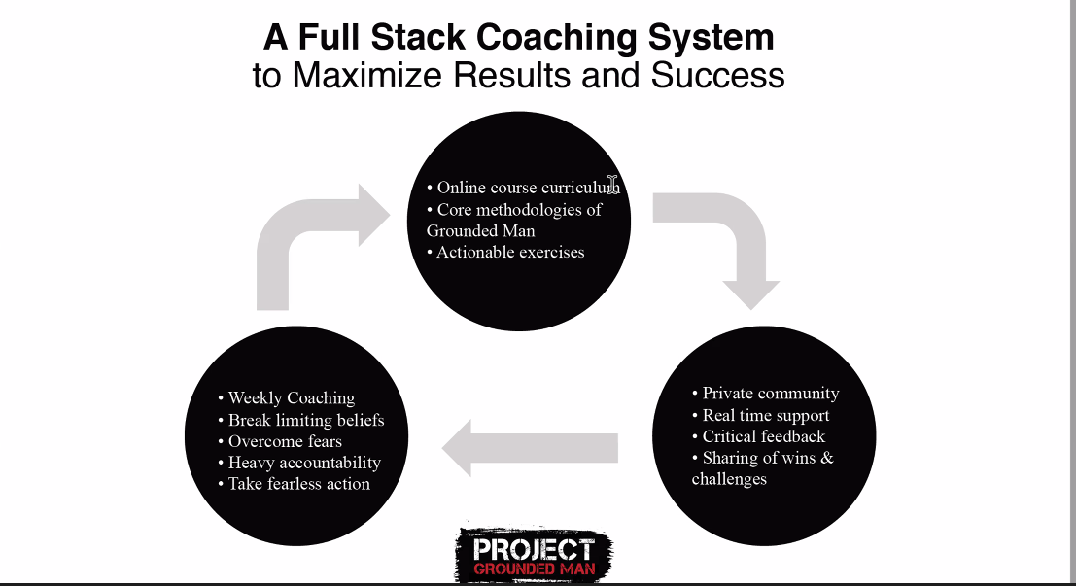
Fullstack coaching system.

80% needs to be taking action. 20% is consumption of material

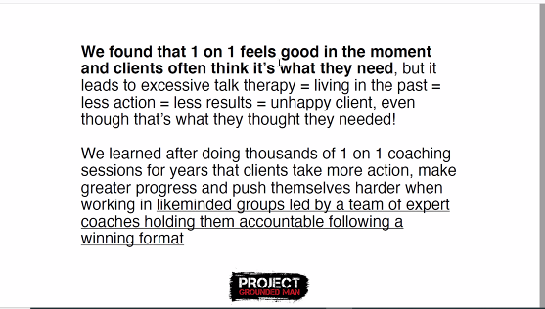
Fullstack coaching works better

What makes the cominity of men great-
Hungry motiveate commited men who want to live with greater purpose. United unter a purpose of being better.
Most know about it but few have results.

Being a vampire- sucking value out of people. A tribe of three to five men. That I truly share value with. Have you had the results. Most know abou tit but few live it.

Make this a priority.

Money replenishes time does not.

Energy- Eliminating and Controling these helps you get clarity on what you want
Energy to upgrate life. Long term benefits

Whenver you failed you tried again.
Intended-
unintened- caused you to study success, caused me to reframe failure. Failure is quitting not getting a hangup.

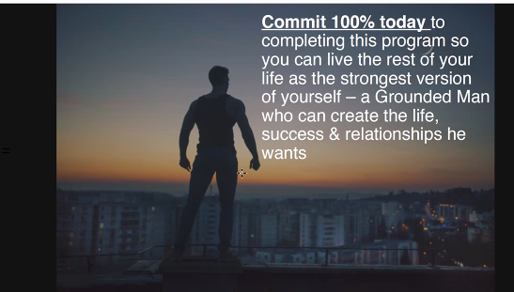
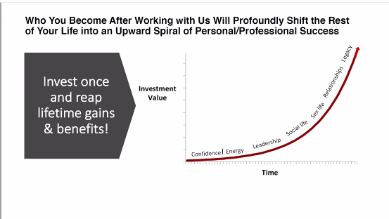

Tutorial Videos:

GROUP COACHING
power of coaching
Having the group of men
Think of it like this: The power of the group allows us to thrive in packs. Life alone is a fail.
Would you do navy seal training alone? No
Giving the tools and the accountability and support in relationships

SHOW UP!! Buckle up and show up for the stuff that you don't want to give up.
Highspeed internet connection.
Be in the right environment not an optimal position to become an optimal man. Come in muted.
Know what you want support with ahead of time.

Follow the format:
1. MY NAME, Where you are at in the program
- What your current situation
- what Is it that you want
- My question How I want to be supported is-
Other things to consider to get the truth
Where are you hiding where are you playing small?
Whera re you not showing up where have you been living in COMFORT for too long Where does anxiety fear prevent you form moving forward?
Where is the most resitance in you rlife? What major decisions are you resisting?
Is this question that you really want to ask? Is this the game changer? Make the most of the question.
Why did you really join the program?
Turn on your video-
Let go of expectations get the end results.

Open to what the coach has to say- drop the ego. Drop it and get the results.
If you do not have an action item after the group you need to ask for one.
It keeps motivated and keep it to rocking and rolling.
Enage in chat and don't try to
Post group call journal for 10 min an dshare in the gorup any key take aways and action items for the week.

Stay consistent witht eh course program and vital exercises
be patient and long term real transfomations that last.

HOW TO GET THE MOST OUT OF THE GROUP FACEBOOK.
We get the meeting throught the feed of the facebook group. We also need to do things called progress bell a win or progress update on journey
PROGRESS BELL: This is a big thing that is progress on my journey
TODAY I SHOWED UP: How we show up for partners
TODAY I INITIATED AND LED: We initated and led
Today I hid: This is where we fell short
Take responsibility to where you hid.
Don't be silent- be a part.
Results driven community- solve problems.
Get an accountability partner. After one month.
I am looking to create a powerful accountabilty call with another member who is in a similar palce once a week...

Move forward and don't let the victim mentality cloud our judgement.
The clients who get the most out of this do the things and are active every week. Live and breath project grounded man.

Be a leader here. Every man should undergo this leadership
PROGRESS IS SUCCESS
I commit to give my all to the Project Grounded Man community. I will bleed, sweet, and give. And in that giving I will grow. I will shoulder up with my brothers to the difficulties in our lives and together we WILL OVERCOME!
Questions: what does this cost?
James Poirier southern california
ZOOM LINK-
Where do you want to be in your personal life, relationships, and perfessional life
Personal life: A mentor to good people, a leader, a good friend. Want to have rich relationships with capable people- Build a tribe

Have a plan that I feel confident in and execute on.

Relationships: Resolve old problems with Mom and Dad. Have Better relationship with Jerin. Spend time with them. Resolve old problems with Stephanie.
Professional life: Writing daily. Creating art and books, Side business thriving. Picking people out of their old bullshit.
QUESTION 2: Why am I not there yet. I lack dicipline. I can see the things that I need to do but I am lazy, I am entitled, weak, and damaged.

I have achieved massive success financially but I've lost the most important things in life

NOTES FROM KNOWLEGE FOR MEN CALL
Need the accountablity
Need the tribe
Need the challenge

Can you help me- coach in a series of small groups high performance coach.
One year-

James had a lot of good things going on
Wife couple years married things going good.

Marriage tooka big hit- stuck in disfunctional patterns
sitting on a couch and talking about problems. Solution oriented
Approval seeker- loosing sigght of who he was
Had to break patterns and not do it himself
Mentorship
Guidance
Accountablity

What he got was authentic, confident, not an asshole not a dormat. Career. Focus on James first.

What are my goals-

Knowledge for Men
Podcast
Books

Being true to blake Establishing a grounding identity and who I am as a man
Like minded men that I can be a part of that callenge me

Prepare myself for a relationship

Get help-

Road blocks hurdles and challenges.

Break the cycle and change things.
Aware it is broken and continue it
Big on action- applying good knowledge
Educaiton alone isn't sufficient
Successful because of good information and apply it and back it up with accountability

Structure:
Simple principles

Education: what to do and how to do it.
Implementation: coach
Accountability: Like minded men who can be honest.

8 missions online course: Series of Principles that peel back the layers of Blake- what has prevented me from having success. What can we get the tools necessary to make me good.
52 Moduels
One moduel per week. Every moduel with an assignment. Take into a field

Weekly group coaching call- assign a high performance coach call and 8-10 other men. Zoom. Empowered and equipped to do things better. Guys that have worked here for years. Calls are 90 min per session
Coaching call. Make your assigned call. TUES- 6:30 pm mountain < WED- 6pm mountain THURS 2:30 pm mountain. Available virtually.

Private community: Guys who are building doing-
Private facebook group- Direct access to andrew and the active men through out the entire course.

Guys in the program:
Questions through out the week. Blast the facebook group or a direct message to coaches.

Cost- one time investment of $5995-
split payment $3200- 3200

