Object

Score more points than your opponent before time expires by forming as many words as you can on the Boggle board.

Forming Words

Consider the following board:

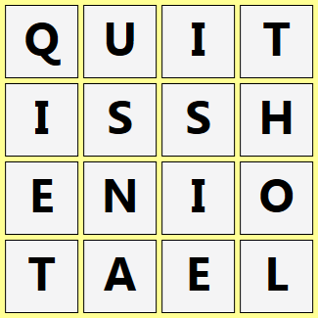

Points are awarded for known words whose letters are adjacent and in order. For example, QUIT, HIT, SIT, HOLE, and SHINE are legal words on the above board. Longer words receive more points (see Word Values).

One point is deducted for each incorrect word. For example, even though THOL can be formed, a point would be deducted because it is not a known word. Similarly, even though HAT is a known word, a point would be deducted because it cannot be formed on the board.

A word, regardless of its legality, has no effect on your score if it is less than three letters or you have already played it. If you play a legal word that has already been played by your opponent, its point value is subtracted from your opponent rather than added to your score. In other words, shared legal words cancel each other out.

Special note regarding Q:
Boggle Legend “implies” one U immediately following a Q if needed for your word. For example, QUIET and SQUUSH are legal words on the above board despite that they cannot be explicitly formed. Conversely, no implied U is needed for QUIT because it can be explicitly formed. Words containing two consecutive Us not immediately preceded by a Q, such as CONTINUUM, must be explicitly formed.

Word Values

Length in Letters Value
3 or 4 1
5 2
6 3
7 5
7+ 11

