Lab Assignment 5
Integers Summation

Objectives
- Advance file I/O – binary files
- Exception Handling
- GUI

Problem Specification
Write a Java application that allows a user to add the integers contained in a binary file using a GUI. User specifies the file name in a input box and when the accept button is clicked, the summation of the integers inside the binary file is to be calculated and the result displayed to the user. If the input file has at most 10 integer inputs, then display the integers below the input box along with the summation result, otherwise display a message: "Your input file contains NN integers and their summation is SUM" where NN is replaced by the number of integers in the file and SUM is the summation value. Your program MUST perform exception handling using try-catch-finally blocks. Furthermore, it should gracefully handle various commonly occurring exceptions that may occur for this problem, including the following two:
- FileNotFoundException
- IOException

Design and Coding
Here is the picture of how a simple GUI for your program may look like.

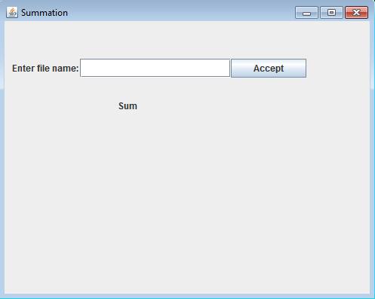

Write a pseudocode for the program (In lab portion).
Write Java code to implement this program (Home portion).

Testing
Example:
The input binary file has: 1 2 3 5 7
(Note: Obviously the binary file cannot be displayed as a text file without some sort of processing. We list the contents of the input file here using decimal digits and delimiters for clarity.)

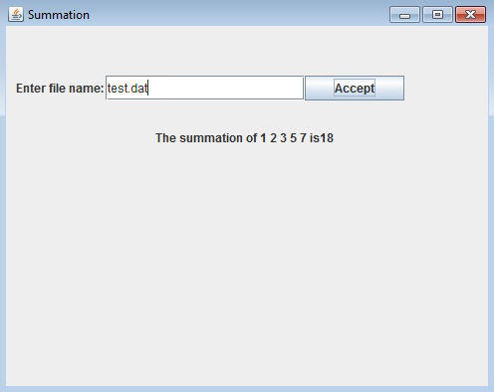

Example:

The input binary file has: 1 2 3 5 7 6 2 5 8 4 1 2 2

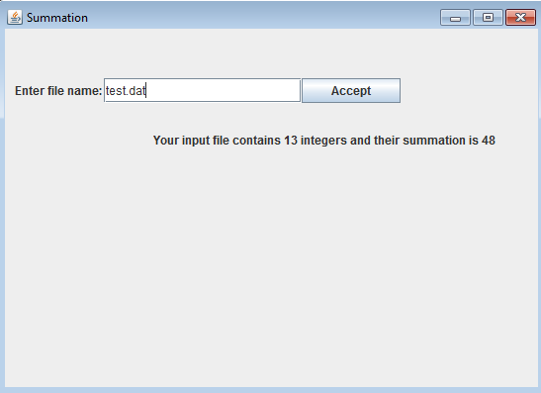

If the user does not enter a correct file name, then a window similar to the following should appear informing the user to enter a valid file name.
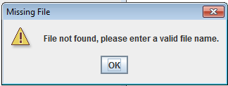

Use FileNotFoundException for the above window.

If the file is empty or contains non-integers then a window similar to the following should appear informing the user that file is empty.

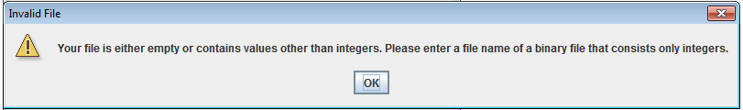
Use IOException for the above window.

Assignment Submission
- Five test files will be provided to you, please download them from your E-learning and test your program using those and your own test files. Test files names are la5a.dat, la5b.dat, la5c.dat, la5d.dat and la5e.dat.
- Generate a .zip file that contains all of your files in your Java project folder.
- Submit the .zip file via E-learning.

