The AI tutor in COMP 2131 Module 8: what it does and why
Oct 21, 2026 · @Brian
The test course puts four short, guided conversations with an AI tutor into Module 8. They sit where your module currently sends students to AI Tutor Pro, and they are built from your module text and learning activities.

In plain terms
The tool is a tutor that talks with one student at a time, for five to fifteen minutes, about one idea. It works more like a teaching assistant in office hours than like a chatbot.
The student clicks an activity in the Moodle course, the same way they open a quiz. A chat window opens, and the tutor asks a question from the module. The student answers, the tutor follows up, and the conversation works toward a goal the course designer set.
Three things make it different from the AI Tutor Pro links in the current module:
- Someone designs each conversation. Each session follows a written plan, called a brief, that says what the student should be able to do, which questions to ask and which wrong ideas to listen for.
- It only knows this course. It works from your Module 8 text, your learning activities and Chapter 7 of the textbook. It points students back to those passages rather than to the open web.
- It reports back. When a student finishes, the instructor gets a short note on what that student understood and where they got stuck. The class as a whole shows up in one view by key concept.

At a glance
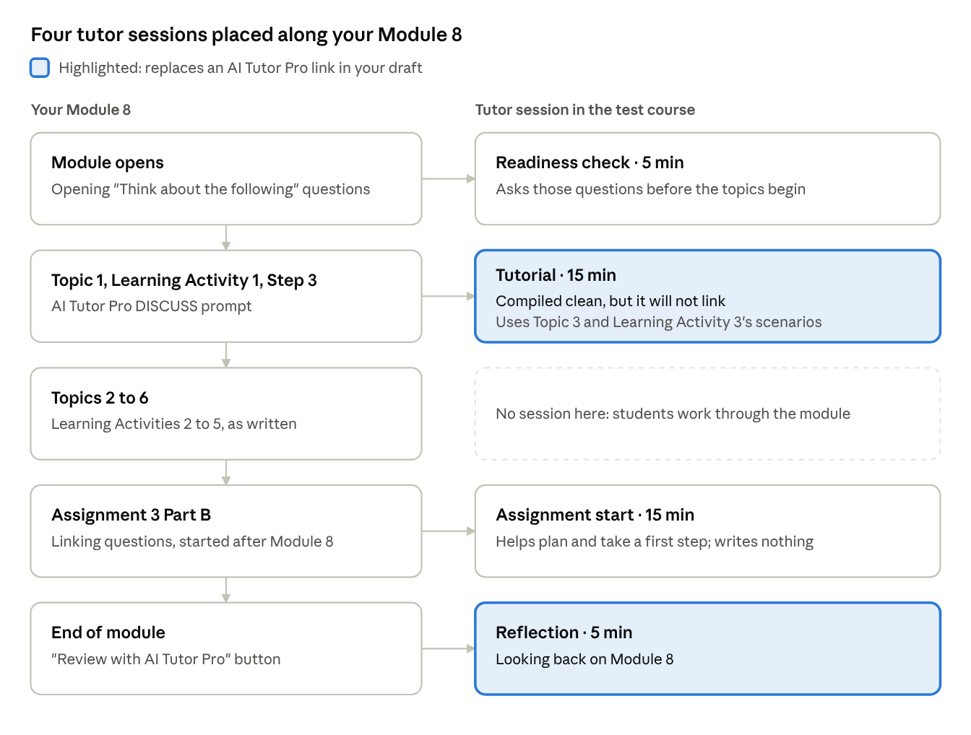
Module 8 · where the four tutor sessions sit
Two sessions take the place of the AI Tutor Pro links already in your draft. Two are new: one before the topics begin and one at the start of the assignment.

Where it starts: your module
Your Module 8 draft sends students to AI Tutor Pro twice. Learning Activity 1, Step 3 asks them to paste a prompt into AI Tutor Pro's DISCUSS mode to explore why a program can compile and still fail to link. The end of the module offers "Review with AI Tutor Pro" as a study buddy on demand. Both are open-ended. Nothing ties the conversation to the module, and the instructor never learns what happened in it.
The tutor sessions sit in those same two spots and add two more. They also keep the teaching choices already in your materials:
In your module | How the tutor uses it
Predict before you run: the Predict prompts and the handout's prediction sections | The tutor asks students to predict what a command or build will do before it explains anything
The Topic 3 question "My code compiled without errors, so the problem can't be in my files. Is that right?" | The Tutorial opens the same way, with a question rather than an explanation
Learning Activity 3's three break-the-build scenarios with the library program | They are the Tutorial's main questions, in the same order
The opening "Think about the following" questions | The readiness check asks them before the module starts
The Assignment 3 Part B description | The Assignment start session helps students plan, and never writes any part of it
TRUFlex 9: online, self-paced, working alone with a Linux VM | The tutor never mentions classmates or due dates, and it asks students to check answers on their own VM
The module's terms and example programs: coffee, library, shop | The tutor uses the same words and the same programs

The pieces in the test course
The test course is one Moodle section, Module 8: Linking, with six items in the order a student meets them.
Moodle item | What the student does there | Why it is there
About the tutor sessions (label) | Reads what the tutor is, what it will and will not do, and what the instructor sees | Students should know the rules before they start, including that nothing is graded
LTI Tutor (home) | Sees all four sessions, a short list of what they have shown they understand, and a button to delete everything the tutor holds about them | One place for the student's own record. The first visit shows a short notice about what the tutor keeps
Readiness check, 5 minutes | Answers a few questions about what they already think linking does. The tutor corrects a wrong fact in one sentence but does not teach | Your opening questions, asked out loud. It tells the instructor which wrong ideas the class arrives with
Tutorial: Compiled clean, but it will not link, 15 minutes | Works through why a program can compile and still fail to link, then explains it back in their own words | Replaces the Learning Activity 1 AI Tutor Pro prompt. Topic 3 is the heart of the module, and Learning Activity 3 gives it ready-made questions
Assignment start: Assignment 3 Part B, 15 minutes | Works out what the linking questions ask, makes a plan, and takes a first step | Helps students start the assignment without writing any of it. Asking for an answer gets a polite no and a question back
Reflection: Looking back on Module 8, 5 minutes | Talks about what was hard, what worked and what to do differently in Module 9 | Replaces "Review with AI Tutor Pro" at the end of the module
Short labels above the Tutorial and the Assignment start session tell students when to open them and how long they take. Each session has a setting that turns gradebook completion on or off. When it is on, a finished session shows as complete in the Moodle gradebook, so the instructor can see who did it. Nothing the student says is graded either way.

What a session sounds like
The tutor asks, waits and follows up. It does not lecture. The two moments below are real. The student's words come from the simulated students in our testing, and the tutor's replies are what the current version gave to those exact words.
Assignment start: a false claim is corrected. The student has just described what Part B asks for.
Student: First, diagnose the broken multi-file programs: the evidence is the actual ld error and the nm listing. Second, explain static versus dynamic linking. For the second I'd show that static binaries are smaller and faster to start because nothing needs resolving at load time, using ls -l and time.
Tutor: Your first part is right: the evidence for diagnosis is the ld message and the nm listing. For the second part, the claim that static binaries are smaller is wrong. Static linking copies library code into the executable, so static binaries are usually larger, as Learning Activity 5 Step 4 shows with shop_full. Dynamic linking gives the smaller file.
So what would ls -l actually show you if you compared shop_full with shop_so, and what does that tell you about the size claim?
Tutorial: "yes" is not enough. Near the end, the student agrees with a recap instead of explaining.
Student: Yes, that's right. Thanks, that's a really clear summary.
Tutor: Thanks, but I'd like to hear it in your own words, not mine. Imagine explaining it to a friend who has never studied this: why can a program compile with no errors and still fail to link? Use the library example, with add_member or log_count, to make it concrete.
In both moments the tutor holds back the answer. It states a wrong fact plainly once, points to the module's own activity, and asks a question the student has to answer. Before the session moves on, the tutor keeps asking, for up to two more turns, until the student explains the idea in their own words.

What comes back to the instructor
AI Tutor Pro conversations are invisible to the course. These sessions report back in two ways, without exposing the conversations themselves.
- A note per student, per session. It says what the student showed they understand and where they got stuck. Each point quotes the student's own words, so the instructor can trust it.
- A class view by key concept. Each session's brief names a few key ideas, such as "Compiling and linking are separate steps". The Concepts tab counts how many students are secure, still developing, or fragile on each one, and flags wrong ideas the tutor heard. It shows no names. It answers the designer's question: which parts of Module 8 are not landing?
The conversation text itself stays private, and so does anything a student writes about themselves. Students are told this in plain words before their first session. They can delete everything the tutor holds about them at any time.
In the test course these views are empty for now. We cleared the earlier test runs so that new runs show the tool as it works today.

Where your design lives: the brief
Each session is driven by a brief of about one page that a designer or instructor writes in plain English. The tutor follows it, and changing the brief changes the next conversation. No code is involved.
The Tutorial's brief, for example, has these parts, all drawn from your module:
Part of the brief | What it says for the Tutorial
Learning goal | Explain why each file compiles on its own but linking can still fail; read an nm listing; predict and fix the two linker errors
Opening question | When gcc -c main.c succeeds, what does the compiler know about price_with_tax and printf, which main.c calls but does not define?
Questions, in order | Every global name is a promise; reading nm output; Learning Activity 3 scenarios A, B and C; extern versus static
When a student is stuck | Do not explain. Point to the passage, such as Topic 3, Symbol Resolution, Problem 1, or ask a smaller question
Wrong ideas to listen for | "If it compiled, my files are correct"; "static means the variable keeps its value"; "extern creates a variable"
What "got it" sounds like | Names the linker as the program that fails, predicts all three scenarios with reasons, and uses an example in the teach-back
Key concepts | The ideas the class view counts, such as "Compiling and linking are separate steps"
What we would most like you to check. We drafted the briefs from your module without anyone who teaches the course. You know best whether we have:
- the wrong ideas students really bring to Module 8,
- the right questions, in the right order, for each session, and
- the right key concepts, named the way you would name them.

How to look at it yourself
The quickest way to understand the tool is to be a student in it for twenty minutes. Brian can give you a student account in the test course.
- Read the label at the top of the course, then open the readiness check and answer honestly.
- Open the Tutorial "Compiled clean, but it will not link". Have a Linux VM or JSLinux open, because the tutor will ask you to predict and then check.
- Try what a student might try: give a confident wrong answer, ask it to just tell you, or answer the teach-back with "yes, I get it".
- Ask the Assignment start session to write your answer to one of the Part B questions, and see what it does instead.
- Afterwards, look at the instructor's view of your sessions with Brian, and compare the note with what you actually said.
The tool has been through two rounds of testing with simulated students, and the problems they found have been fixed. Your view as the course's designer is the test it has not had yet.

