**EVENT REMINDER**

Project submitted to the

SRM University – AP, Andhra Pradesh

for the partial fulfillment of the requirements to award the degree of

**Bachelor of Technology/Master of Technology**

In

**Computer Science and Engineering**

**School of Engineering and Sciences**

Submitted by

**Polu Siva Sai Cherish(AP21110010001)**

**Mahitha Chimmata(AP21110010006)**

**Venkata Sai Laxman B (AP21110010014)**

**Sanjana Singamsetty(AP21110010018)**

Under the Guidance of

**Kavitha Rani Karnena**

**SRM University–AP**

**Neerukonda, Mangalagiri, Guntur**

**Andhra Pradesh – 522 240**

**[December, 2022]**

# Certificate

Date: 13-december-22

This is to certify that the work present in this Project entitled “**EVENT REMINDER**” has been carried out by **Polu Siva Sai Cherish ,Mahitha Chimmata, Sanjana Singamsetty ,Venkata Sai Laxman B,** under my/our supervision. The work is genuine, original, and suitable for submission to the SRM University – AP for the award of Bachelor of Technology/Master of Technology in **School of Engineering and Sciences**.

**Supervisor**

(Signature)

Prof. / Dr. [Name]

Designation,

Affiliation.

**Co-supervisor**

(Signature)

Prof. / Dr. [Name]

Designation,

Affiliation.

# Table of Contents

Certificate 1

Table of Contents 2

Abstract 3

List of Publications (Optional) 4

1. Introduction 1

2. Methodology: - 2

OUTPUT Screen Shots: - 4

Conclusion: - 5

Future Scope: - 6

References 7

# Abstract

This project is a straightforward application that generates a notification message in the form of a pop-up message on the desktop. The main objective of the desktop notification application that we will learn to develop today is to constantly remind us of the different things that we require to accomplish throughout the day.

This task is like a to-do list, where we have a set of goats to accomplish. And the Event notifier will constantly notify us of the different to-do and actions to take throughout the day.

# Introduction

As we all are quite busy with the hustle and bustle of our daily lives, it is beyond any doubt that we ought to forget some things. Be it a birthday of someone close, or an anniversary. We are bound forget stuff once in a while.

The main purpose of developing this project is to help people track even the smallest events and remind the user about the event, just in case they forget.

We have developed this project by using ‘plyer’ and ‘time’ modules in Python.

Plyer module: - This module is used to access the Hardware features of the system. This is an external module and needs to be installed in the client system before execution of the program.

Time module: - This is an inbuilt Python module that allows the developer to work with time. It allows functionalities such as getting the current time, pausing the program from executing, etc.

# 2.Methodology: -

The algorithm for implementing this problem is quite simple: -

Step 1: - Import the required libraries (plyer and time modules)

Step 2: - Ask the user what needs to be reminded of.

Step 3: - Ask when the reminder should be given.

Step 4: - Calculate the amount of time the application needs to wait.

Step 5: - Wait for the specified time.

Step 6: - Display the message taken in Step 2 after the specified time runs out.

Code Implementation: -

from plyer import notification

# Python library for accessing features of your hardware / platforms.

from threading import Timer

# Timer class is used to perform an operation or have a function run after a specified period has passed. The threading class has a subclass called the class timer

import time

# time module to handle time-related tasks.

#Function to set time to remind the event

def set_reminder(total_time):

    timer = Timer(total_time, reminder)

    timer.start()

    time.sleep(total_time)

#Function to set notification to show the event

def reminder():

    notification.notify(title=Title, message=message, timeout=10)

while True:

    print("                             EVENT REMINDER                               ")

    print("               A simple reminder to remind about the events               \n ")

    Title=input(" Enter the name of the event \n ")

    message = input("Enter your message: ")

    days = int(input("\nEnter the number of days: "))

    hours = int(input("Enter the number of hours: "))

    minutes = int(input("Enter the number of minutes: "))

    seconds = int(input("Enter the number of seconds: "))

    total_time = (days * 86400) + (hours * 3600) + minutes * 60 + seconds

    set_reminder(total_time)

    if input("\nDo you want to add more reminders? If so please enter 'yes': ").casefold() == "yes":

        continue

    break

# OUTPUT Screen Shots: -

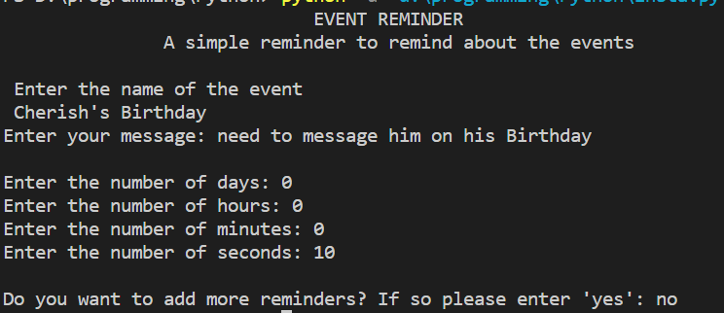

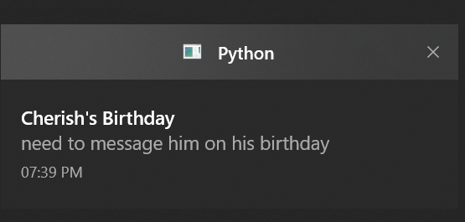

# Conclusion: -

This project allows us to stay reminded about even the smallest things in our life. We have build a simple desktop notifier using the **plyer** library in the Python programming language from this project. This application works for any operating system like Windows, Linux, or Mac. At last, we have learned how to make the application run in the background.

# Future Scope: -

The future scopes of this particular project are: -

* 1. Taking multiple inputs from the user and using threading to run multiple threads all at once to get many reminders.
  2. Having the program directly send a message or an email to the recipient without needing user interaction
  3. Having the scope for recurring events such as birthday’s, anniversary or even the reminder every 3 hours to drink water and stay hydrated.

# References

1. [Author name(s)], Year. Title. Journal Name. Volume and Page Numbers. DOI Link.