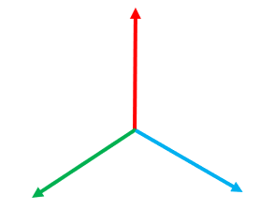,

Z

**ROTATION**

X

Y

X

**ROTATION**

**TRANSLATION**

Y

Y

Z

**Image 2 Coordinates**

**Image 1 Coordinates**

error_function(P1, PM’)

PN

PM’

P1’

P1



|  |  |  |
| --- | --- | --- |
| **Visual Curve-Fitting Accuracy** | **Camera 1** | **Camera 2** |
| Near Perfect Match | 0.6 | 0.6 |
| Slight Deviations | 0.22 | 0.28 |
| Failed to Fit | 0.12 | 0.06 |