Computing Therbligs

Background

Frank Bunker Gilbreth (1868–1924), an American engineer, and his wife, the psychologist Lillian Gilbreth (1878–1972), pioneered motion study together. They co-wrote the field’s defining texts, including Fatigue Study (1916) and Applied Motion Study (1917). After Frank's death in 1924 Lillian continued their work, and later collaborated with James S. Perkins and Ralph M. Barnes on a compilation of their research footage, analysed here.

The Gilbreths filmed workers performing tasks alongside a clock, timing their every movement. By examining the lengths of these movements, they claimed to be able to find the most effective way to carry out any task; the fewest, shortest movements necessary. Their aim was to remould workers’ habitual mechanisms, to drive industrial efficiency. Although this was a putatively economic concern, the nature of their project was theoretical. For that reason, it is a fitting project, to reattempt this work a century later, using their source material, with new methodologies of analysis; here, distant viewing.

The Gilbreths divided hand work into 17 elementary motions: reach, move, position, pre-position, grasp, hold, release, use, assemble, disassemble, search, select, inspect, plan, unavoidable delay, avoidable delay, and rest for overcoming fatigue. These they called therbligs—their surname backwards. Analysts were tasked with designating and timing each therblig on film, to work from their individual frames. This project attempts a computation of this work, with algorithmic annotation.

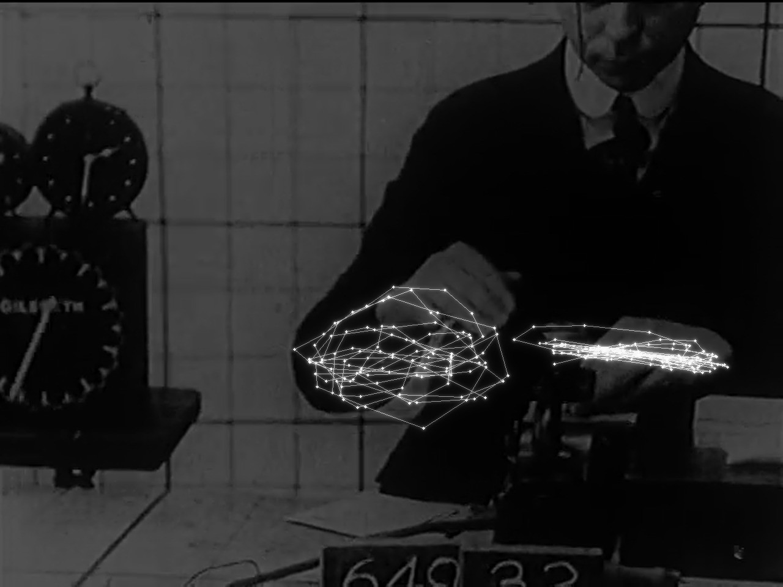

Figure 1. Wrist positions found by the pose model, 15 per second of film, illustrated as constellations over the Gilbreths’ footage of a clerk dating requisitions.

Material and tools

Film | Original Films of Frank B. Gilbreth, Part I (public domain). Footage 1910–1924; 15 min 24 s.
Analysed | 18 shots of work; 4,646 frames, 15 per second of film
Distant Viewing Toolkit 1.1.0 | Shot detector (TransNetV2) and pose model (Keypoint R-CNN, 17 body joints)
Tesseract | Reading the 30 title cards
Clock reader (OpenCV) | Written for this project: reads the on-screen clock in every frame
Python | pandas, SciPy, scikit-learn: tracking, measurement, grouping

Method

- Find each worker and their wrists in every frame; follow the wrists.
- Wherever the hand slows, cut the wrist’s path into motions (possible therbligs).
- Differentiate motions by length, speed, direction, and height—to group.
- Repeat the cutting of movement, but using every second frame, then every fourth, to test whether the motions recorded belong to the hand or to sampling.
- Time the work done using the on-screen clock, and check against the Gilbreths’ published figures.

Results

1. Timing: The camera was hand-cranked, so its timekeeping is unreliable. A clock reader was used to correct it. This proved a success: corrected by the clock, the rates fall within 3% of the figures on the film’s title cards.

Method | Sheets counted | Film time | By the clock | Title card figure
One hand | 11 | 1.00× | 1.00× | 1.00×
Two hands | 10 | 1.15× | 1.18× | 1.21×
Two hands + foot pedal | 11 | 1.87× | 1.65× | 1.61×

Table 1. Speed relative to one hand. Sheets were counted by eye.
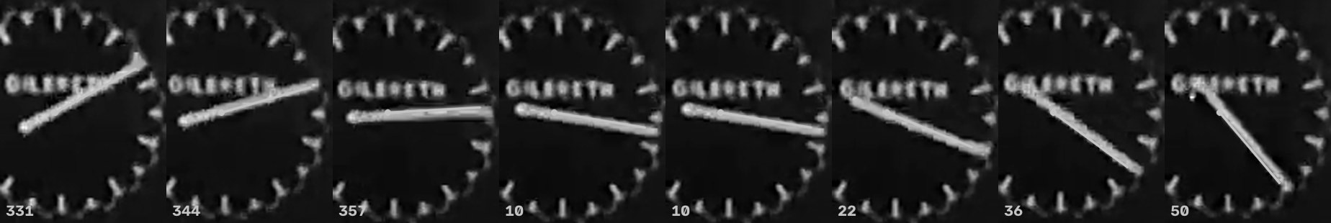

Figure 2. The clock reader on eight consecutive frames (shot 26, video frames 8131–8138). The numbers are the clock hand’s angle in degrees.

2. Tracking hands: The model is confident of a worker in 96–100% of frames in most close shots, 13–61% in wide shots, and none in close-ups of hands alone; there it identifies a person in a fleck of mortar.

3. Distinct motions: 1,084 motions were grouped into 7 types, but the types were weakly distinguished (silhouette score of 0.23, on a scale from −1 to 1).

4. Units that belong to the movement: Halving the frames examined halves the motions found:

Frames per second of film | Motions found per second | Median motion length
15 | 2.39 | 0.33 s
7.5 | 1.27 | 0.67 s
3.75 | 0.64 | 1.33 s
Table 2. The motions tracked depend heavily on the sample.

5. All 17 therbligs: It was not possible to track finger-level, eye-level, or movements regarding attention or thought, due to the model’s inability to see fingers, eyes, or intentions. Reach and move appear as hand paths but cannot be told apart; grasp and release happen at the fingers; search, select, inspect and plan are matters of eye and mind; hold, the delays and rest all look like a still hand.

Verdict

The machine matches the Gilbreths where they relied on a clock, but evidently falls short in designating human action.
Analysis | Outcome | Evidence
Timing movements accurately | Positive | Within 3% of the title card figures, once corrected by the clock in the frame
Following the hands in every frame | Partly Positive | Reliable in close shots; weak in wide shots; fails on hands shown alone
Finding distinct elementary motions | Negative | 7 weakly separated types, not 17
Ensuring units belong only to human movement, rather than the sampling | Negative | Halving the frames examined halves the motions found
Covering all 17 therbligs | Negative | Finger, stillness and eye motions leave no trace the model can register

To improve

A better quality recording, a hand and finger model, object detection, head or gaze direction, and custom annotations trained on frames labelled with therbligs.

Limits

- It is only one 15-minute film; with three shots in which the clock is readable.
- The timing check rests on 10–11 work cycles per method.
- The pose model was trained on modern photographs.

Sources

- Original Films of Frank B. Gilbreth (Part I), Internet Archive
- Distant Viewing Toolkit
- F. B. and L. M. Gilbreth, Applied Motion Study (1917)
- Definition of therbligs (1943 film record), ACMI

