2024 Regional Achievement Test (2024 RAT)

ENGLISH – GRADE 6

General Instructions: After reading each question carefully, choose only the letter that corresponds to your answer.

1. You attended an art exhibit. In the gallery, you see an image of a two-headed snake. This image is ____.
2. Fact because snakes can rarely have two heads.
3. Fact because it is a special breed of snake.
4. Non-fact because snakes can't have two heads.
5. Non-fact because it is a lizard not a snake.
6. While scrolling on your TikTok page, you see on your cellphone screen a picture of a polar bear in the desert. This type of image is _________.

A. Fact, because polar bears can live in the desert.

B. Fact, because it is a special kind of polar bear.

C. Non-fact because polar bears can't live in the desert.

D. Non-fact because it is a brown bear not a polar bear.

1. Maria is scrolling on Wikipedia and found a picture of a white bird sitting on the back of a carabao. Do you think the image is real?
2. No, since bird cannot sit on carabao's back.
3. Yes, since there are birds who love to sit on a carabao's back to rest.
4. No, since carabaos hate birds and therefore won’t allow birds to sit on them.
5. Yes, since carabaos allow birds to sit on their backs due to symbiotic relationship.
6. Mario and his friends decided to watch a movie in the cinema. One of the scenes they encountered was a scenario where a superhero saves the day by flying through the sky. If you were to comment, this scenario is _____.
7. Real because superheroes exist and can fly.
8. Real because it’s a special kind of superhero.
9. Make-believe because superheroes don't exist in reality.
10. Make-believe because the superhero is actually using a jetpack.
11. You read a certain article about a person solving complex math problem in a matter of seconds. Do you think the article is real or make-believe?
12. Real because some people have extraordinary math abilities.
13. Real because the person is genius.
14. Make-believe because solving complex math problems quickly is not possible.
15. Make-believe because the person is actually using a calculator.
16. Your group is assigned to discuss on class about the truthfulness of an image of a flying horse. What should you do to verify if the image is true or not?
17. Visit Wikipedia to confirm that the image is true.
18. Verify the image through searching on Encyclopedia Britannica.
19. Listen to personal blogs of the famous bloggers in the country about mysterious creature.
20. Search on YouTube about the personal experiences of people about flying horses.
21. In a conversation, your friend is boasting you a picture of his unique dog with rainbow-colored hair. Do you think the picture revealed the real color of the dog?
22. Yes, because dogs can have rainbow-colored fur.
23. Yes, because it is a special breed of dog.
24. No, because dogs cannot naturally have rainbow colored-fur.
25. No, because it is neither a cat nor a dog.
26. In your class, your teacher is showing you a picture of a man standing in the moon. Do you think the image is real or not?
27. Real because humans have landed on the moon.
28. Real because your teacher said so.
29. Make-believe because humans can't survive on the moon.
30. Make-believe because there is no camera on the moon to take pictures.
31. You happened to view online about images of "manananggal" as told by a blogger in a certain far-flung barangay. Would you believe on his claims as true?
32. No, because pictures can easily be edited nowadays.
33. Yes, because my Lola also told us stories about "manananggal."
34. No, because I was not physically there to witness the real "manananggal"
35. Yes, since my neighbor said that he saw "manananggal" before.
36. The National Geographic Channel features about Green Anaconda, the largest snake in the world found in South America. It can grow more than 29 feet and can weigh more than 550 pounds. You were so amazed with the data shown but doubtful if you would believe. Would you consider this information as true?

A. Yes, because as far as I know, snakes can grow this big and this heavy.

1. Yes, since the source of the information is reliable and reputable.
2. No, since I would only believe if I see it with my own eyes.
3. No, since National Geographic Channel is not a reliable source.

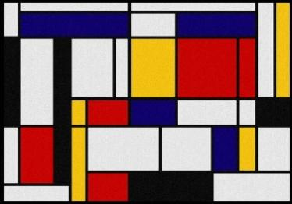

On the left is a painting, where there are bold, straight lines forming a grid -like pattern. These lines most likely convey a sense of:

A. calmness and tranquility C. order and structure

B. chaos and confusion D. playfulness and spontaneity

1. 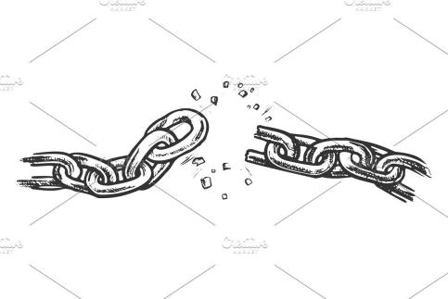

You are reading a newspaper, when you happen to see a political cartoon with a broken chain on the ground. What might the broken chain symbolize?

1. freedom and liberation
2. unity and strength
3. oppression and captivity
4. progress and development
5. 

What visual element is present as shown in the painting?

A. The painting shows multi-colored diagonal lines.

B. The painting shows a good framing using lines.

C. The painting shows multi-colored horizontal lines.

D. The painting shows an abstract symbolism.

1. If you were to interpret the meaning of the painting shown in Number 13, what do you think the painter wanted to convey to its audience?

A. He/She uses horizontal lines to convey playfulness and spontaneity.

B. He/She uses horizontal lines to convey movement and energy.

C. He/ She uses horizontal lines to convey tension and conflict.

D. He/ She uses horizontal lines to convey stability and calmness.

1. 

Your family decided to watch a movie together. You mother wanted you to decide which movie you would watch. Upon looking on the movie posters in the cinema entrance, you see a poster which features a combination of black, red and white colors. If your brother hates horror movies, would you recommend this movie to be watch by the family?

1. No, since it will likely feature mystery, horror and suspense.
2. Yes, since the poster conveys love and celebration.

C. No, since the poster color means sadness and melancholy.

D. Yes, since the movie will surely create serenity and calmness.

1. In a movie scene, two characters are having a conversation, but one character avoids eye contact and looks away. This indicate that the character ______.

A. is being dishonest or hiding something.

B. is extremely focused and attentive.

C. is feeling shy or anxious.

D. is bored and uninterested.

1. You belong to the Arts Club; you are assigned to make a poster about the clean and green program of your school. What should be the most suitable color motif of your work?

A. Yellow since it is associated with enthusiasm.

B. Green since it is frequently used to associate with nature.

C. Red since it is commonly associated to love and passion to work.

D. Blue since it often associates to peace and calmness.

1. There is a photo of a politician giving a speech with the camera angle positioned low, making the politician appear powerful and authoritative. The framing of this image suggests that:

A. The politician is confident and persuasive.

B. The politician is arrogant and untrustworthy.

C. The photographer has a personal bias against the politician.

D. The photo was taken by accident and has no intended meaning.

1. You come across an image of a person wearing a face mask and standing faraway from others in a crowded space. The image is most likely representing_______.

A. personal style and fashion choices.

B. a medical emergency.

C. social isolation and loneliness.

D. adherence to public health guidelines during a pandemic.

1. A TV segment on fashion uses the color purple as its general theme. By using it as color of the models' outfit, as well as the facilities used. What would possibly they want to express to the viewers?

A. The clothes they are selling can create an image of power and luxury.

B. The clothes they are selling can create a girlish outlook to anyone who would wear it.

C. The clothes they are selling can create a sense of dignity to whoever can wear it.

D. The clothes they are wearing can create a feeling of calmness and tranquility to whoever would wear it.

1. You read an article about the benefits of regular exercise and how it improves overall health. How can you relate this information to your personal experience?

A. Feeling more energetic and alert after exercising regularly.

B. Enjoying a sedentary lifestyle without any exercise.

C. Experiencing negative health effects despite regular exercise.

D. Having no personal experience related to exercise.

1. You watch a documentary about climate change and its impact on the environment. What specific experience can you relate this scenario?

A. having no personal experience related to climate change

B. Not believing in the concept of climate change

C. Seeing no changes in the environment around you

D. Witnessing extreme weather evets in your area

1. Directions: Read and understand the article below and answer the questions that follow.

**Social Media Addiction**

Social media addiction is when a person feels an extreme compulsion to log in or use social media. They may also feel an overwhelming concern about social media and devote a large amount of time to it.

It is a behavioral addiction, meaning that someone is dependent on an activity or action.

Due to the amount of time a person spends on social media, there may be a negative effect on their daily activities and personal relationships.

Symptoms of social media addiction may include a compulsion to check social media spending long periods on social pages spending less time doing offline activities

changes in mood, particularly when not looking at social media withdrawal symptoms

conflict as a result of social media use.

What does the author intend to tell you in this text?

*source:* [*https://www.medicalnewstoday.com/articles/social-media-addiction*](https://www.medicalnewstoday.com/articles/social-media-addiction)

1. That it is best not to involve oneself in social media.
2. That social media has negative effects on one's behavior.
3. That the young people today are considered social media addicts.
4. That people today are spending more time in front of gadgets than actual conversation.
5. What realization can you derive based on the article being read on *item number 23?*
6. Social media became harmful when being used oftentimes.
7. Social media can be addictive if being used abusively.
8. Social media is controlling the lives of people in this generation.
9. Social media can influence our perspective in life.
10. Your teacher often scolded you for submitting class projects beyond deadline. In one of your lessons, you read an article about effective time management. How can you use the information you just read?
11. By continue missing deadlines and struggling with time management.
12. By prioritizing tasks and meeting deadlines.
13. By not having any significant experience with time management
14. By having no personal experience related to time management
15. You came to read a brochure about making decisions and how it can affect one's life. How can you utilize this information in your daily life?

A. By deciding based on emotions.

B. By deciding hurriedly and thinking on its effect later.

C. By thinking on the possible consequences before deciding on something.

D. By having no considerations on the possible effect of one's decision.

1. You come across an infographic about recycling and its impact on the environment. You can connect this information to your personal experience of _________.

A. Participating in recycling programs at home or school

B. Never having heard or learned about recycling before

C. Not having any personal experience or knowledge about recycling

D. Having no personal experience to the topic

1. You read an article about the importance of reading books. You connect this information to your personal experience of:

A. enjoying reading books and finding them informative

B. Disliking reading books and finding them boring

C. Not having any personal experience with reading books

D. Having no personal experience related to the topic

1. Directions: Read and understand the article below and answer the questions that follow.

A Day to Remember

It has been six months since I last saw my father. We dropped him into the airport and bade farewell to him 180 days ago with a heavy heart.

But today, my lips can't stop smiling as well as my heart can't stop beating fast as we drive our way to the airport.

Based from the anecdote, we could tell that the author is ______________________.

1. a child of a father who works afar
2. a traveler who will ride on a plane for the first time
3. a little girl who will experience visiting the airport
4. a little boy who wants to go to the airport
5. The author in number 29 experienced sadness as his/her father left him. If you will experience the same situation, how will you cope up with it?
6. By continuing to be sad and wait for my father to come home
7. By locking inside my room and cry the whole day
8. By thinking positively on the fact that my father will be back soon
9. By telling my father to come home and never leave
10. You are reading a newspaper article about a recent political event. What is the likely purpose of this text?
11. To entertain the readers with a fictional story
12. To persuade the readers to support a particular party
13. To inform the readers about the details and significance of the vent
14. To promote a product or service related to politics
15. You come across a brochure about a new tourist attraction. Which structural feature is most likely be found in this text?
16. a problem-solution format
17. A chronological order of events
18. A comparison and contrast of different attractions
19. A description of the attraction's features and benefits
20. Your teacher assigns your group to assemble a furniture she bought online. What type of informational texts will you read in order to know how to do it?
21. Technical terminologies and definitions
22. instructional manual for assembling
23. Emotional language and anecdotes
24. Procedures on assembling furniture

Directions: Read the descriptive article below.

Chocolate Hills

Had you ever visited Bohol? One of its most unusual tourist spots is the Chocolate Hills. The Chocolate Hills is an unusual geologic formation that consists of over 1,200 conical mounds, each varying in height from 30 to 50 meters. The hills are made of limestone and are covered with lush green vegetation, which gives them their iconic chocolate color.

1. *The sentences "Chocolate Hills is an unusual geologic formation that consists of over 1,200 conical mounds, each varying in height from 30 to 50 meters. The hills are made of limestone and are covered with lush green vegetation, which gives them their iconic chocolate color." ___________________________________.*
2. describes the main topic of the paragraph.
3. shows cause and effect relationship.
4. compares the main topic to its sub-topic.
5. tells the sequence of events
6. The article on Item No. 4 is an example of a factual text. Which of the following is a key structural feature of a factual text?
7. It has dialogue between characters.
8. It uses descriptive language to create imagery.
9. It uses headings and subheadings to organize information.
10. It uses rhyme and rhythm.
11. When reading an information text, what should you do to ensure you understand the information presented?
12. Focus on the pictures and ignore the text.
13. Read the text quickly without taking any notes.
14. Skim the text and focus on the headings.
15. Take notes, highlight key points and look up unfamiliar words.
16. Maria is experiencing a hard time understanding her lessons in Math. ***Because of this, she decided to join the Mathematics Clubs in school who offers tutorial sessions in all its members.***

What is the relationship between the sentences? The italicized sentence __________________.

1. describes the underlined sentence
2. contradicts the underlined sentence
3. gives solution to the underlined sentence
4. repeats the underlined sentence

Directions: Read and understand the passage below.

Rice at its Finest

Rice is a staple food for Filipinos. But do you know how to cook it?

First, you need to rinse the rice under running water for three times. Then, add water before bringing it to boil. Next, simmer it for about 10 minutes. Lastly, when the rice is already cooked, let it rest for about three minutes before serving it.

1. The second paragraph ____________________.
2. describes rice as staple food.
3. compares rice to other sources of carbohydrates.
4. gives solution of the scarcity of rice in the country.
5. tells about the sequence on how to cook rice.

Directions: Read the passage carefully.

**Which is Which?**

Cats and dogs are the most popular pets in the world.

Cats are more independent and are generally cheaper and less demanding pets. They are typically solitary animals and don't mind being left at home alone.

On the other hand, dogs are loyal and obedient but require more attention and exercise, including regular walks. They are pack animals and are fine together. They will wait for you at the door all day.

1. Look at these two sentences:

" *Cats are more independent and are generally cheaper and less demanding pets." (1st sentence)*

*"Dogs are loyal and obedient but require more attention and exercise, including regular walks." (2nd sentence)*

What relationship can you derived from the two sentences?

1. The two sentences compare cats and dogs as suitable pets.
2. The two sentences show the effect of having pets at home.
3. The two sentences talk about the best time to have pets.
4. The two sentences give solution to pet problems.
5. One should think critically when reading in order to help in detecting bias and propaganda by:
6. accepting everything you hear or read without question
7. identifying the source of information
8. focusing on the emotional appeal of the message
9. understanding the speaker's perspective and potential biases
10. Which of the following is an example of an evaluative word choice that could indicate bias?
11. "The politician spoke at the rally."
12. The politician rambled at the rally."
13. "The politician was at the rally."
14. "The politician attended the rally."
15. A slimming pill product features only the testimonies of their customers who obviously lost weight while ignoring the others who fail to experience the same results. This form of advertisement uses what type of propaganda device?
16. Bandwagon
17. card stacking
18. testimonial
19. glittering generalities
20. Analyze the advertisement taglines given, which of these is NOT using bandwagon propaganda?
21. "Be one of us"
22. "We offer limited slots only"
23. "Happy wife, Happy Life"
24. "Join the millions of satisfied customers"
25. You are asked to construct a report about an event you attended, which of the following statement is likely to be biased and you should not include in your writing?
26. The event was attended by 500 people.
27. The event was a roaring success.
28. The event took place at the city hall.
29. The event was organized by the local community.
30. One should detect biases and propaganda devices when listening to a speech in order to:
31. Ignore the bias and focus on the facts
32. Understand the speaker's point of view
33. Analyze the information and make informed decisions
34. Agree with the speaker
35. A famous food chain in the country chooses to have an advertisement which has a concept of a happy family eating in their restaurants. If you are to analyze, what propaganda are they using?
36. Stereotyping
37. Transfer
38. plain folks
39. name-calling
40. The following taglines are using glittering generalities as propaganda device except ONE. Which of this is not?
41. "The secret to a clean home."
42. "Your ultimate driving experience"
43. "Be part of our team."
44. "Your key to success"
45. Which propaganda device is being used when emotionally charged words are used to sway the audience's opinion?
46. Bandwagon
47. Testimonial
48. loaded language
49. plain folks
50. How can you detect bias in a speaker's statement?
51. by looking for facts and statistics
52. by looking for emotional language and strong adjectives
53. by looking for neutral language
54. by looking for direct quotes
55. A beauty product is using the images of regular college students as models for their skincare items. Why do you think they are doing it?
56. To imply that their products are affordable and everybody can use it.
57. To tell the customers that their products are cheap.
58. To inform the consumers that their product is suitable for everyday use.
59. To show that their product is effective.
60. II & IV B. I,II,IV C. I & III D. I,II,III,IV
61. You read this line in a certain advertisement:

"Strong Child drink Goaty's MILK" to promote their goat milk product. This type of propaganda is ___________.

1. name calling B. bandwagon C. testimonial D. plain folks
2. A certain cellphone company is using the term "TechLow" to describe those who are not using their product. What type of propaganda was the company using?
3. plain folks
4. Testimonial
5. Bandwagon
6. name calling
7. Jeff is gathering data about the endangered species in the Philippines. He had already looked information online as well as in books. How does the content of online materials differ from print materials?
8. Online materials often include hyperlinks related to resources
9. Print materials have more up-to-date information than online materials
10. Online materials have a limited amount of text compared to print materials
11. Print materials are more visually appealing than online materials
12. Delivering breaking news, real-time updates and live events requires what type of material?
13. print materials
14. online materials
15. broadcast materials
16. all of the above
17. Given are the advantages of online materials and print materials. If you are to group them, what advantages can be categorized into online materials?
18. Can be accessed even without internet connection.
19. Very handy and can be read anytime, anywhere if there is internet connectivity.
20. Engaging to scan due to moving pictures and videos.
21. Characters have dialogues and scripts.
22. It uses still pictures or images to support the text.
23. I, II, III C. I, II, III, IV
24. II, III, IV D. I, II, IV
25. Your teacher asked you to do a report. You only have two days to do your research. Which type of material is easily searchable and provides quick access to information?
26. print materials
27. online materials
28. broadcast materials
29. all of the above
30. Miss Santos is a teacher assigned in a far-flung barangay with no internet and even local TV and radio stations. She wanted to know some updates to be used in her lessons, what type of materials can she access?
31. print materials
32. online materials
33. broadcast materials
34. all of the above
35. Mich loves to read novels. She wants to read it anytime but hates to bring bulky, big books. What possible suggestion can you give to her?
36. Tell her to use e-books that can be installed using playstore.
37. Advise her to stop reading since novels are really reproduce in big books.
38. Suggest her to read shorter stories since it is reproduced in thinner books.
39. recommend her to shift on other forms of reading materials
40. Which of the following is a unique feature of online materials compared to print and broadcast materials?
41. They can be accessed anytime
42. They can include hyperlinks
43. They can be accessed even without electricity
44. They can include moving images and sound
45. You are tasked to search about mental health awareness. You already read one magazine about it and presently, you are watching on YouTube about it as well. What is NOT a FACTUAL comparison you can get out from these two sources?
46. YouTube can be access online only while magazines can be access anytime even offline.
47. Magazines use still pictures while YouTube features real-life and moving pictures.
48. Magazines can be read repeatedly while YouTube can't be access offline.
49. Magazines are boring while YouTube is entertaining
50. What is the primary purpose of a narrative?
51. to inform
52. to persuade
53. to entertain
54. to argue

Directions: Read and understand the narratives. Then, answer the questions that follow.

**Karla**

Karla sat on the stairs singing to her doll. She wore red overalls with big patches of cartoon characters sewed all over the front of her clothes. Her hair was tied in a neat bun with wide red ribbons. Beside her lay a wide array of toys – teddy bears, a miniature piano, a doll which swung from a small tree, tiny animal toys from frogs to lizards to dogs. She was all alone and her eyes would dart every now and then to the doorway from where her mommy had earlier left. One can glimpse a trace of loneliness and emptiness midst all the affluence around her.

1. What detail shows that midst all her toys she seems to be lonely?
2. Beside her lay an array of toys such as miniature piano, teddy bears and dolls.
3. Her hair was tied in a neat bun with wide red ribbon.
4. Her eyes would dart every now and then to the doorway.
5. She sat on the stairs singing to her doll.

Maria lives in a small barrio near the lake. Every day, her father would go to the lake to fish. Her family depends on the lake as their source of living. But recently, they observed that the lake is getting dirtier due to the influx of tourist. So, his father called a meeting to all the settlers of the barangay and decided to have a cleanup drive to renew the beauty of the lake.

1. What is the problem/conflict faced by the main character of the story?
   1. They lived near the lake.
   2. They depend on the lake as their source of living.
   3. They found out that the lake is getting dirtier.
   4. They decided to have a cleanup drive.

Directions: Read and understand the narratives. Then, answer the questions that follow.

As Ricky passed by the sala on his way out, he saw the kitten curled up neatly by the door. He seized the kitten by its head. He dangled it at arm’s length and it let out a shriek. Ricky smiled to himself. Finally, he hurled the kitten out of the window. It fell with a thud outside. It was lucky to have missed the dog tied by its leash near the doorway. The dog howled and hearing this, Ricky rushed out to kick it hard. He had just received his report card, and he was not sure how his father would react to what he would see.

1. How do you know that Ricky was worried about something by his actions?
2. He hurled the kitten out of the window.
3. The dog howled upon hearing him.
4. The kitten shrieked as he seized it.
5. Ricky passed by the sala on his way out.
6. If you were Ricky, what would you possibly do in order to lessen the anger of your father?
7. Tell my father personally and promise to do better in the next grading.
8. Hide the card and allow him to see in the next grading if my grade is already good.
9. I will only let my mother sign it.
10. I will just put the card in the area where my father could see it and wait for his reaction.
11. Based on Item Number 4, what point of view was it written?
12. First Person Point of View
13. Second Person Point of View
14. Third Person Point of View
15. Omniscient

Directions: Read and understand the selection below.

Aling Sebia looked around her to make sure that she had not missed any corner of the house. She had gotten up early so she could give the house a thorough cleaning before his son arrived. Roly, his son, was arriving home from Saudi Arabia, and she wanted him to see how big a change the house had undergone since he had left. She hastily ran to the kitchen to check whether the pot of chicken was already boiling. She could imagine the whole family eating the delicious meal after the children had arrived from the airport.

1. Based on the narratives, Aling Sebia is a very thoughtful mother. How is this quality revealed in the selection?

I. She prepared a delicious meal for her children to eat upon arriving from the airport.

II. She got up early and thoroughly clean the house.

III. She looked around her house and make sure that she had not missed any corner of it.

IV. She wanted his son to see how the house had changed.

1. I, & II
2. I,II,III
3. IV only
4. I & IV

After breakfast, Sima called his son Pastor aside. “What’s the news?” she asked. “Can people now go through to Sta. Monica or San Anton?”

Pastor shook his head.

“Be on the lookout for someone coming from town,” she begged. You might hear something new.”

“I’ll go to town myself,” Pastor said.

“Your father might get angry,” her mother replied.

Pastor looked deep into his mother’s eyes. “I don’t care,” he said. “From now on I’ll go to town whenever I want to go to town.”

1. From what Pastor said, you can infer that ________.
2. His mother is right and he will follow what she said.
3. Pastor is afraid of his father
4. His father had forbidden him to go to town
5. Pastor is an obedient child.
6. Rene walks in the street when he saw his classmate being picked by a bully. He felt sorry for her but he did not stop to help her. Few weeks later, his classmate bullies him as well. What is the best theme of the story?
7. Everyone should be helping each other.
8. Bullies should be stopped in order to lessen the effect to others.
9. You will reap, what you sow.
10. Vengeance is ours.
11. It was a hot, sunny day. Rhaicca is wearing her favorite long sleeve dress and black boots as she walked down the hilly part of the road.

The paragraph above tells us about what element of the story?

1. Exposition
2. Climax
3. Resolution
4. Theme

Directions: Read and understand the story below and answer the questions.

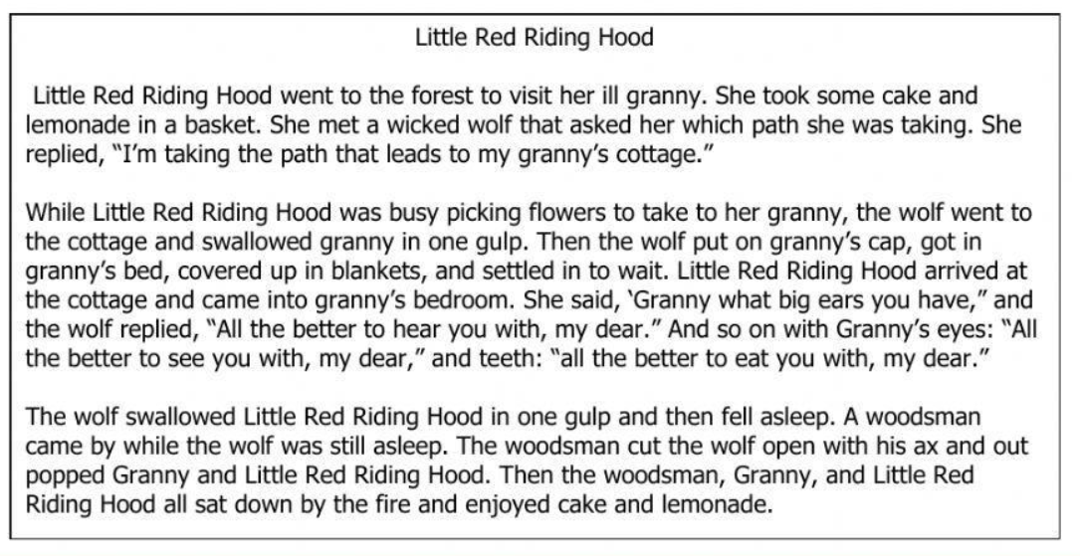

1. Analyzing the plot of the story, arrange the following events in its proper order.
2. A woodsman came by and cut the wolf open with his ax to help Little Red Riding Hood and his Granny.
3. Little Red Riding Hood went to the forest to visit her granny.
4. The woodsman, Granny and and Little Red Riding Hood enjoyed cake and lemonade.
5. The Wolf went to the cottage and swallowed Granny in one gulp.
6. The wolf fooled Little Red Riding Hood by pretending to be her Granny.
7. On her way, she met a wicked wolf.
8. I-II-III-IV-V C. II-VI-IV-V-I-III
9. I-III-II-V-IV D. V-VI-IV-III-II-I
10. Who is the antagonist or villain of the story “ Little Red Riding Hood”?
11. Woodsman B. Granny C. Red Riding Hood D. Wolf
12. Which is the climax or the most exciting part of the story?
13. The event when the woodsman helped the main character.
14. The part when the wolf pretended to be Little Red’s granny.
15. The event when the characters happily eating the cake.
16. The part when Little Red was visiting her granny.
17. Where is the setting of the story?
18. In the sea C. In the mountain
19. In the river D. In the forest
20. If you are to decide, what is the most valuable lesson you can learn out from the story?
21. Do not talk to strangers.
22. Listen to your parents.
23. Respect the elders.
24. Love your family always.

Directions: Read and understand the text below. Use it as a reference in answering items 16-17.

Cody and Jen bought their dream home after years of saving. It was a two-storey beach home in a secluded area. They thought it was absolutely perfect until they noticed termites. At first, there were only a few nibbling at the back deck, but soon there were thousands. So, they decided to to consult an expert of killing termites at home.

1. What type of conflict does the text have?
2. Man VS Man C. Man VS Society
3. Man VS Environment D. Man VS Self
4. How did the characters solve the problem they faced in the story?
5. By attending a conference on how to kill termites
6. By consulting an expert of killing termites at home
7. By securing public permit on applying termites
8. By referring to a friend about the problem

Directions: Read and understand the text carefully.

Mr. Pig and Mr. Dog relaxing at the food court of the animal shopping mall. Mr. Pig was eating a huge feast of pizza and drinking a large jug of fruit punch. Mr. Dog was watching him eat.

"Hey, Mr. Pig. If you give me a slice of your pizza, I'll let you have the next bone I find." Mr. Pig declined, even though it hurt his stomach to eat the last three slices of pizza. "I'm sorry, Mr. Dog," Mr. Pig said between grunts, "but I paid for this pizza and it's all mine." Mr. Dog sighed and waited for Mr. Pig to finish.

Then they left the animal mall together. On the way out, a hunter spotted them and gave chase. Mr. Pig normally could have escaped the hunter, but he was weighed down by the large meal. Mr. Pig collapsed and the hunter seized him. Mr. Dog easily escaped. Later that night, Mr. Dog returned to the scene. He caught the scent of something delicious and began digging around a trashcan. He found a large ham bone with lots of meat and marrow still stuck to it. Mr. Dog happily ate.

1. What do you think is the theme of the story you just read?
2. Greediness is bad.
3. Sharing is caring.
4. You reap what you sow.
5. Respect begets respect.
6. If you are Pig’s friend, what can you suggest to him?
7. Not sharing of food is considerable, as long as you are the one paying it.
8. Learn to share what you have, and be mindful to others needs.
9. Take good care of your friends since they will help you in times of need.
10. Be good to others so that they will do good to you as well.
11. If you are going to change the plot of the story to make it a happy ending, which part will it be?
12. The part when Mr. Pig refused to give some food to Mr. Dog.
13. The part when they left the animal mall together.
14. The part when the Dog escaped the hunter and ran away.
15. The part when Mr. Dog returned to the scene.

Directions: Read and understand the selection below.

Facebook Addiction

***Using Facebook can turn into an addiction*.** Social media is one way how people in today’s world are connected with each other. Kids are glued to their devices all the time. They use applications that allow them to be connected with young people like them in other parts of the world. These make them forget about other important tasks because they are addicted to these internet applications.

What is the purpose of the italicized sentence, “***Using Facebook can turn into an addiction.”*** in the selection?

1. It is an evidence that support the stand of the author.
2. It is the stand of the author regarding the issue discussed.
3. It is the reason that support the opinion of the author.
4. It is the viewpoint that explains the author’s idea.
5. The underlined sentences in the selection are the _______________.
6. evidences that support the stand of the author
7. stand of the author regarding the issue discussed
8. reasons that support the opinion of the author
9. viewpoints that explain the author’s idea of the topic
10. How should one prepare a clear, coherent and comprehensive viewpoints?

1. Know and research about the topic/main idea.  
2. Present two or more point of views. Provide support, reason or basis to these views.  
3. Bring out the strong points of your viewpoint using all the information as your basis for you to persuade your audience.  
4. You can also pose a question or a statement leaving your audience to decide for themselves which point of view they would choose to take.

1. 1-2-3-4 B. 2-1-3-4 C. 4-3-2-1 D. 3-2-4-1
2. Your teacher is assigning you to write a report about the issues on gender equality. You really believed that all should be equal regardless of their gender. How would you support your stand?
3. Cite evidences that would support your stand on the topic.
4. Gather opinions from your classmates and use it in your report.
5. Copy the opinions from other authors and made it as your evidence.
6. Scan ideas from the different online sites.
7. Rey is gathering ideas about the different viewpoints of Grade 6 learners on “Voluntary Wearing of School Uniform”. In writing his findings and reports, how will he make it coherent?

The following are strategies that Rey may use in order to make his report coherent, *EXCEPT ONE.*

✓

1. He may use transitional expressions to link ideas, sentences, and paragraphs.
2. He may use different viewpoints from varying sources.

C. He may use synonyms to link ideas and create variety. ✓

D. He may use parallel structures to link ideas, sentences, and paragraphs.

1. In your Health class, your teacher is asking you to read a column about the Effects of Teenage Pregnancy. You want to make a comprehensive stand about it. What are the things you should consider?
2. The source from which the author’s view was taken.
3. The facts and evidences that the author presented to support his/her claims.
4. The strategies used by the author in presenting his ideas.
5. The choice of language the author used in expressing his views.
6. I & IV B. III & IV C. I & II D. I & III

**Bullying Effects**

1. Kids who are bullied can experience negative physical, social, emotional, academic, and mental health issues. According to a study, kids who are bullied are more likely to experience, depression and anxiety, increased feelings of sadness and loneliness, changes in sleep and eating patterns, and loss of interest in activities they used to enjoy.

Based on the article, what is the opinion of the author?

1. The author believes that kids being bullied can commit suicide.
2. The author believes that kids being bullied is accompanied by many issues.
3. The author believes that kids being bullied is identified by appearance.
4. The author believes that kids being bullied can experience negative impacts.
5. What are the evidences cited by the author to support his stand?
6. He cited that according to a study, kids who are bullied may experienced depressions and anxiety.
7. He cited that according to a study, kids who are bullied is prone to suicide.
8. He cited that according to a study, kids who are bullied are stronger.
9. He cited that according to a study, kids who are bullied contribute to mass killings and suicides.

Directions: Study and understand the idea that the poster below wished to convey.

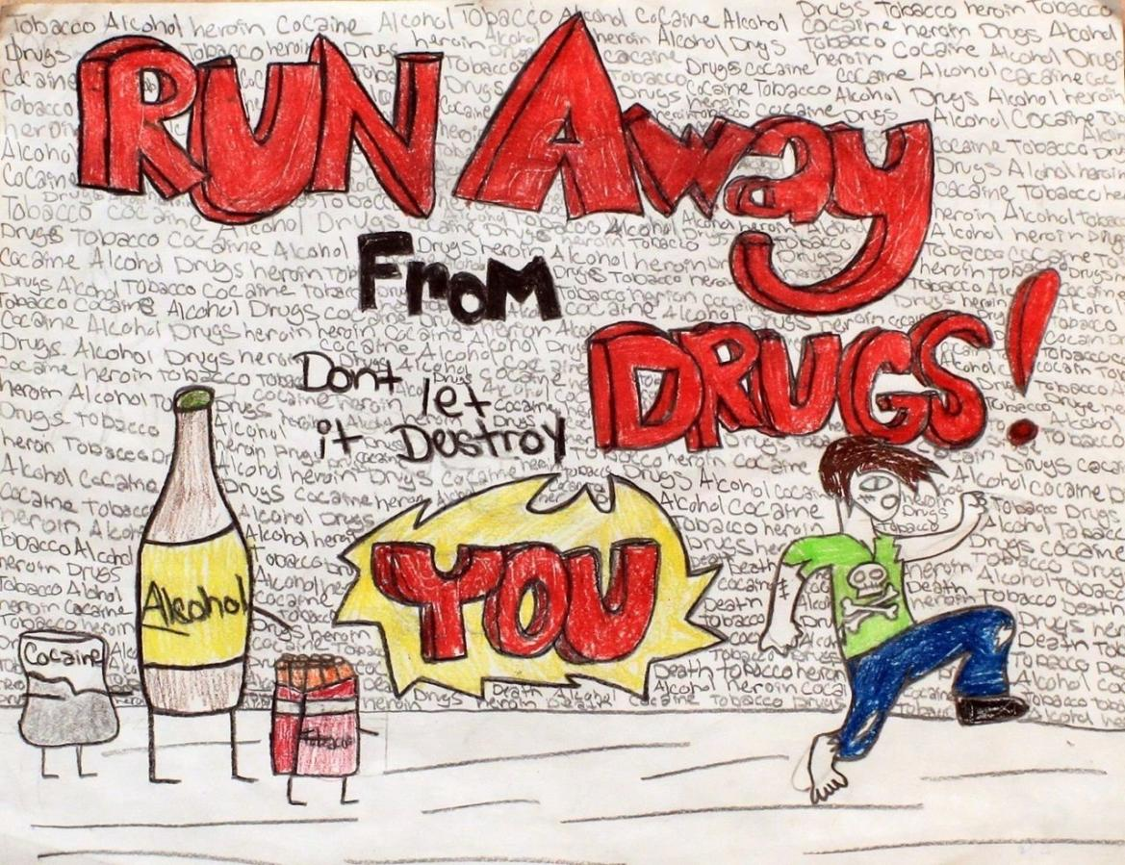

1. What informed opinion is presented in the poster?
2. One should avoid people who look like drug addicts because they are dangerous.
3. People who used drugs abusively can lost their lives in an early stage.
4. Anybody can be a drug addict even the young ones due to bad influence.
5. Everybody should stay away from drugs because it can destroy his life.
6. What is the best evidence can you give to support the stand of the poster creator?
7. According to the Dangerous Drugs Board (DDB), around 1.67 million Filipinos or two out of one hundred Filipinos aged 10-69 are current users of drugs.
8. **Consequences of drug abuse, are mental and behavioral health problems, and that in some areas in the Philippines injecting drug use comorbidity such as the spread of HIV and AIDS**
9. According to a primer of the United Nations Office on Drugs and Crime (UNODC) posted on its website, drugs are chemical substances that affect the normal functioning of the body, either physically and/or psychologically.
10. For 2022, a total of seventy (70) treatment and rehabilitation facilities reporting to the Treatment and Rehabilitation Admission Information System (TRAIS). Of this, sixty-two (62) are residential and eight (8) are outpatient.