STATEMENT – 1
EXVORA
Student Resource Network
Hackathon Project Report

Project Name | Exvora
Statement | Student platform for exchanging resources, services and opportunities.
Development | Next.js + Antigravity
Website | http://10.9.194.108:3001/

Share • Discover • Connect

1. Statement – 1
Problem Statement
Build and deploy a platform that makes it easier for students to exchange resources, services, and opportunities within their college community.
The problem focuses on unused value already present in a student community, such as textbooks, electronic accessories, event tickets, notes, study material, skills and items students are willing to give away.

2. Our Solution – Exvora
Exvora is a student-focused campus exchange platform. It helps students discover useful resources from other students and share resources they no longer need.
WHAT I HAVE ↔ WHAT YOU NEED

3. Exvora Home Page
The home page introduces Exvora as a student-powered campus exchange network. It highlights the main idea and provides quick actions to explore or share resources.
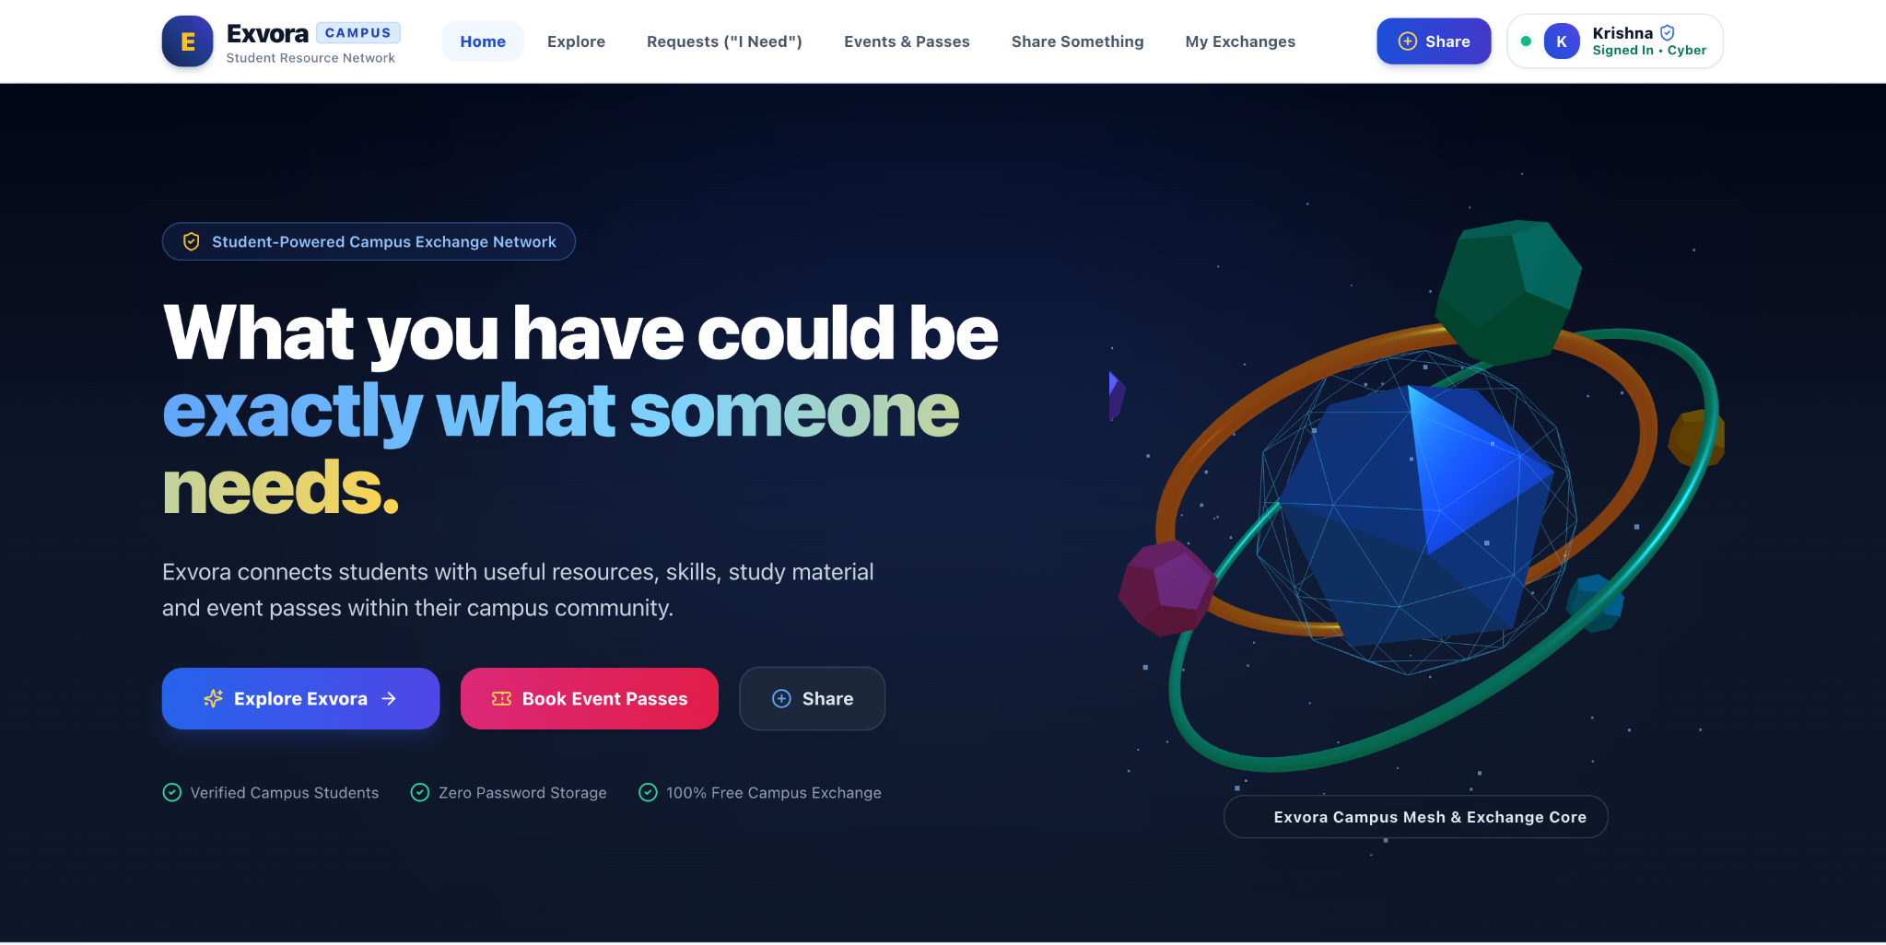
Figure 1. Exvora home page and 3D hero section.

4. What Students Can Exchange
Category | Purpose
Textbooks | Books students no longer need.
Electronics | Electronic accessories that can be reused.
Notes & Study Material | Academic resources students can share.
Event Tickets | Tickets students cannot attend and can pass to others.
Skills | Skills students can teach to other students.
Give Away | Useful items students are willing to give away.

5. Explore Page
The Explore page organizes campus resources into categories and displays them as visual cards. Students can browse different types of resources and choose an item or skill that interests them.
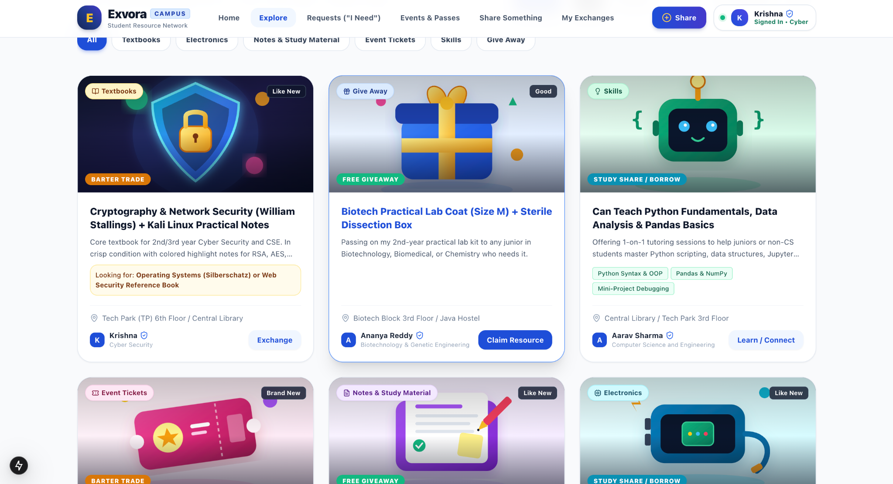
Figure 2. Exvora Explore page with category filters and resource cards.

6. Events & Passes
The Events & Passes section provides a dedicated view for campus events and student passes. It gives students a clear way to discover event-related opportunities.
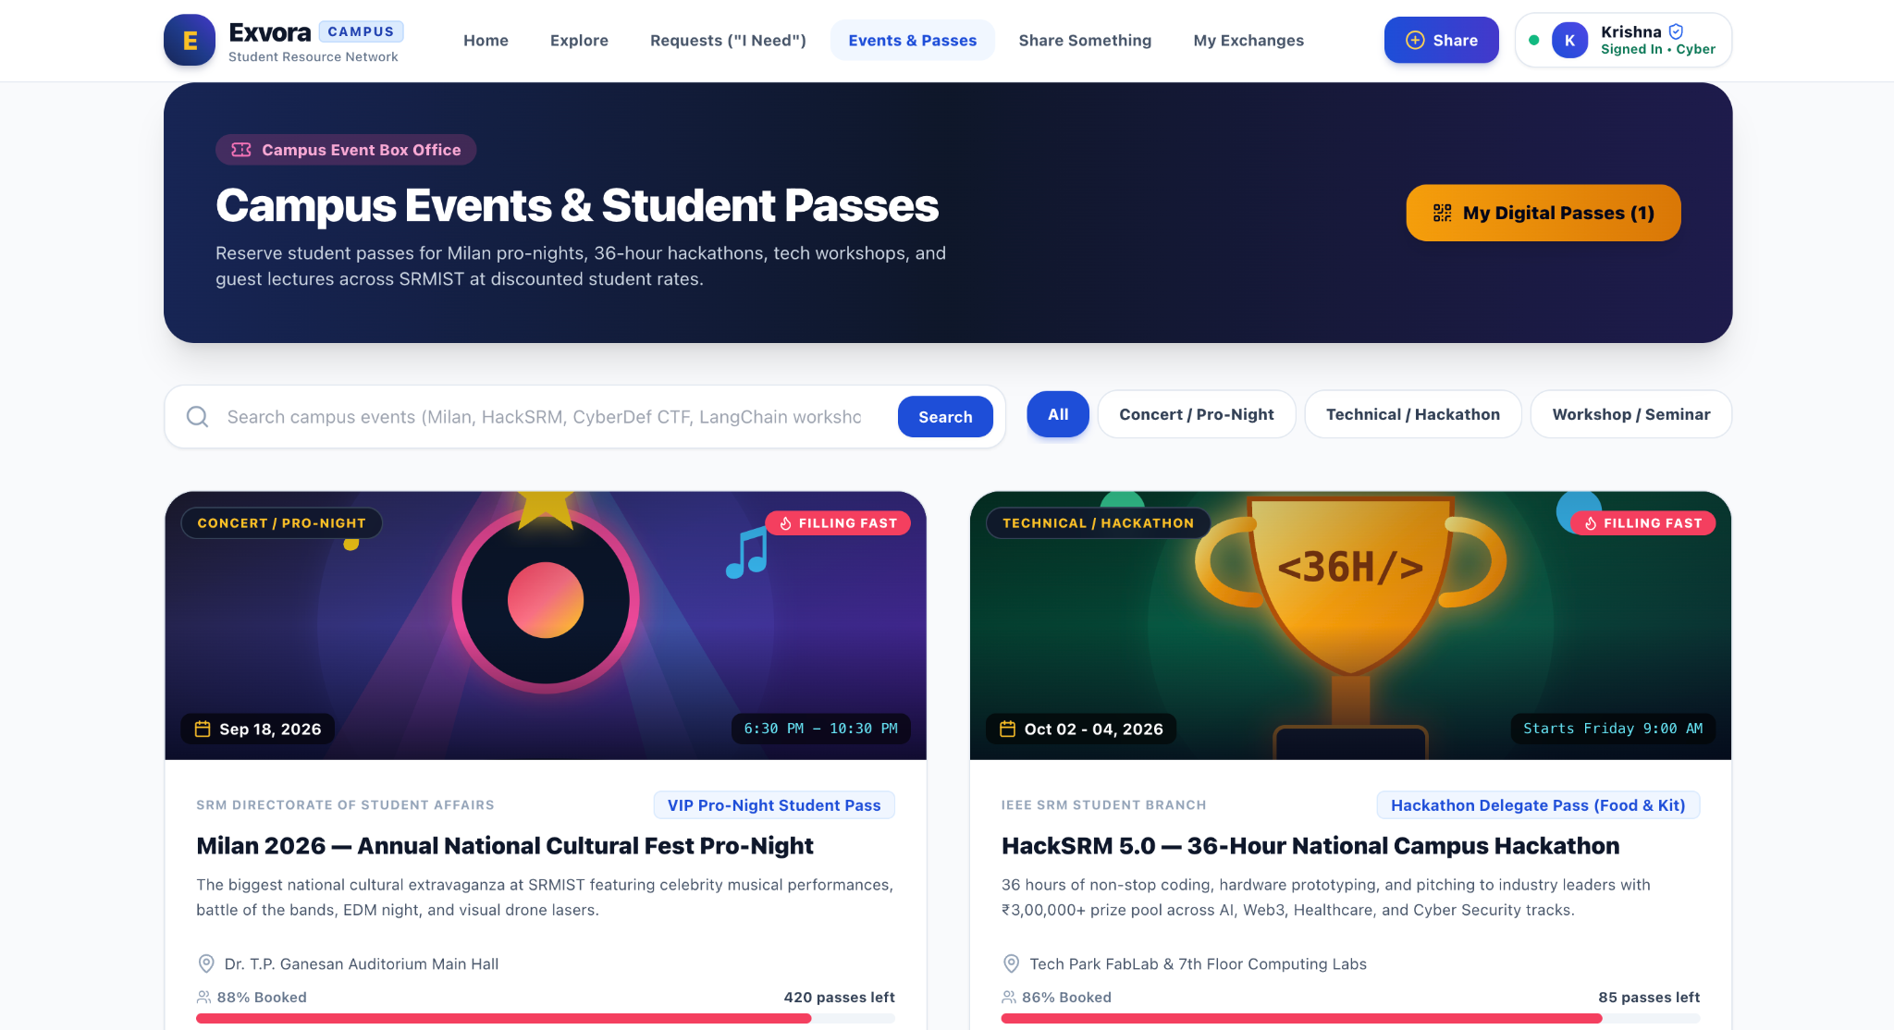
Figure 3. Exvora Events & Passes page.

7. Main Features
Feature | What it does
Home | Introduces Exvora and the main exchange concept.
Explore | Browse available resources and skills.
Requests (I Need) | Allow students to describe what they are looking for.
Events & Passes | Show campus events and student passes.
Share Something | Create a new resource or skill listing.
My Exchanges | View the student's exchange activity.
Profile | Provide a student account area.

8. Tools Used
Antigravity: AI-assisted development and implementation of the website.
Next.js: Main web development framework used by the existing project.
3D UI/UX: Used for the modern visual style, hero section and visual elements.
Local Development Server: Used to run and test the website at the supplied local address.
Official SSO Architecture: Prepared as a future authentication path; real institutional credentials/endpoints are not invented.

9. Prompt Used in Antigravity
The following simplified prompt was used to guide the AI while building the project:
Build a polished, hackathon-ready website called Exvora.
Exvora is a student-powered campus exchange platform. It helps students exchange resources, services and opportunities within their college community.
Main idea:
“Connect what students have with what other students need.”
Build the project using the existing Next.js application.
Main categories:
- Textbooks
- Electronics
- Notes & Study Material
- Event Tickets
- Skills
- Give Away
Main features:
- Home
- Explore
- Search
- Categories
- Listing details
- Share Something
- Skill sharing
- Requests
- Events & Passes
- My Exchanges
- Profile
Create a modern premium 3D UI/UX. Use 3D mainly for the hero section, category visuals and important visual elements. Keep navigation, forms and text simple.
Do not create fake users, fake transactions, fake ratings, fake prices, fake AI results or fake college information.
Do not invent SRM SSO URLs, credentials, APIs or database access. If official SSO is not configured, keep authentication in development mode and clearly label it.
Inspect the existing project before changing it. Reuse good existing code.
After implementation:
1. Run the website.
2. Test the main features.
3. Fix errors.
4. Check responsive design.
5. Check the browser console.
6. Run the production build.
7. Perform a final UI/UX check.
Actually implement and test the website instead of only creating a design mockup.

10. Project Timeline
Step | Stage | Work
1 | Understand Statement–1 | Study the problem and identify the need for a student exchange platform.
2 | Plan Exvora | Choose the product idea, name and main features.
3 | Create AI Prompt | Prepare the Antigravity prompt with clear requirements and rules.
4 | Design UI/UX | Create the layout, branding and 3D visual style.
5 | Build Website | Develop the pages and features using Next.js and Antigravity.
6 | Add Features | Implement Explore, Requests, Events, Sharing and My Exchanges.
7 | Test & Improve | Run the website, find issues and improve the user experience.
8 | Prepare Presentation | Collect screenshots, explain the project and prepare the hackathon demo.

11. Importance of Exvora
- Helps students reuse resources that might otherwise remain unused.
- Makes it easier to find books, notes, electronics and other useful resources within the campus community.
- Allows students to share skills and study material.
- Provides a place for students to discover event passes and opportunities.
- Encourages students to help and exchange resources with each other.
- Turns unused value already present in the student community into something useful.

12. Conclusion
Exvora is a practical solution to Statement–1. It connects students who have useful resources with students who need them. The project combines a clear student-focused idea, modern UI/UX, 3D visuals and AI-assisted development to create a strong hackathon prototype.

13. Project Website
Local website: http://10.9.194.108:3001/

