Final Exam Fall 2014, Version A
Student Name: ____________________________________

Question 1
Given the demand curve 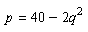 and the supply curve 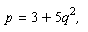 find the producer surplus when the market is in equilibrium.
28
41
40
32

Question 2
Find the average value of the function between and

Question 3
Using the Fundamental Theorem evaluate the definite integral below. 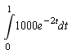

Question 4
Find the derivative of the following function.
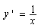

Question 5
The cost to produce q items is 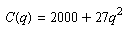 dollars. Find the marginal cost to produce the 25th item.
$1450/item
$1350/item
$1400/item
$1300/item

Question 6
The rate of population growth of Tokyo grew at a linear rate from 0.33 million/year in 1970 to 0.45 million/year in 1990. Estimate the total change in population between 1970 and 1990.
780,000
430,000
330,000
7,800,000

Question 7
Find the value of k such that 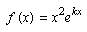 has a critical point at x=2.
-2
0
1
-1

Question 8
Determine whether or not the following function is a power function. 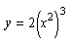
Yes
No

Question 9
Find the derivative of the following function. 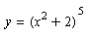
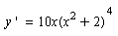
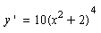
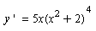
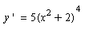

Question 10
Find the equation of the tangent line to at the point where

Question 11
Let represent the cost of producing q items. Suppose that and that Estimate the total cost in producing 105 items.
$1275
$1950
$1215
$1590

Question 12
Find the following indefinite integral. 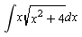
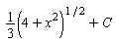
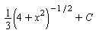
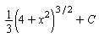
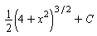

Question 13
A city’s population is 100,000 and is falling at a continuous rate of 3%. When will the population have halved?
Approximately years.

Question 14
Find the inflection points of 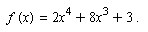

There are no inflection points.

Question 15
How long would you have to leave $50,000 in a bank account yielding 2% interest compounded continuously to have a balance of $65,000?
10.25 years
12 years
11.33 years
13.12 years

Question 16
Find the integral.
Find the following indefinite integral. 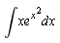
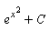
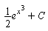
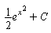
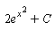
Question 17
At a price of $10, a theater can sell all 1500 tickets for a performance. For every $1 increase in the ticket price the number of people buying tickets decreases by 50. What ticket price maximizes revenue?
$15
$5
$20
$10

Question 18
The table below gives the revenues (in billions of dollars), R, of General Motors, the world’s largest auto manufacturer.
Year | 1999 | 2000 | 2001 | 2002 | 2003 | 2004
R | 176.6 | 183.3 | 177.3 | 177.3 | 185.5 | 193.0
Find the average rate of change in revenues between 2000 and 2004.
$9.7 billion
$2.425 billion/year
$2.425 billion
$9.7 billion/year

Question 19
If you deposit $20,000 into an account earning interest at 7% annual rate compounded annually, how much money is in the account after four years?
$167042
$2626
$26216
$262159

Question 20
Find the following indefinite integral. 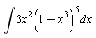
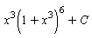
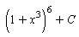
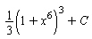
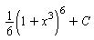

Question 21
A cell phone company charges a monthly fee of $30 plus $0.04 per minute. Find a formula for the monthly charge C, in dollars, as a function of the number of minutes, m, the phone is used during the month.

Question 22
Find all of the critical points of 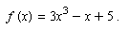 List them from smallest to largest, separated by commas.
-3,1
-1,1
-1,3
-1/3,1/3

Question 23
The quantity of a drug, Q mg, present in the body t hours after a tablet is taken is given by 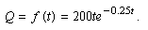 Find
-23.6183 mg/hour
2.3618 mg/hour
23.6183 mg/hour
23.6183 mg

Question 24
A company producing chairs has fixed costs of $8000 and variable costs of $100 per chair. The company sells the chairs for $300. Find formulas for the cost and revenue functions and use them to find the number of customers at the break-even point.
400
4000
4
40

Question 25
The following table gives the emissions, E, of nitrogen oxides in millions of metric tons per year in the US. Let t be the number of years since 1970 and E=f(t). Estimate the total emissions between 1980 and 2000.
Year | 1970 | 1975 | 1980 | 1985 | 1990 | 1995 | 2000
E | 26.9 | 26.4 | 27.1 | 25.8 | 25.2 | 25.0 | 22.6

744.25 million metric tons
74.4 million metric tons
37.2 million metric tons/year
504 million metric tons

