Test #3, Version 1
Student Name: ____________________________________

1. Chapter 7, Web Quiz, Question 7
Find an antiderivative with and 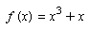
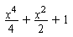
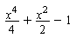
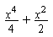

2. Chapter 4, Web Quiz, Question 8
Find constant a so that 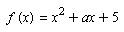 has a local minimum at (3,4).

3. Chapter 7, Section 7.4, Question 4
Find the integral.
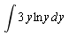

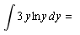 | 

4. Chapter 4, Web Quiz, Question 6
The function 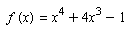 has a critical point at Use the second derivative test to identify it as a local maximum, point of inflection or local mimimum.
Local maximum
Point of inflection
Local minimum

5. Chapter 4, Web Quiz, Question 13
Use the first derivative test to find all critical points of Use a graph to identify each critical point as a local maximum, local minimum or point of inflection.
x = -1 is a local maximum and is the only critical point.
x = -1 is a local minimum and x = -2 is a point of inflection.
x = -1 is a local minimum and x = 0 is a point of inflection.
There are no critical points.

6. Chapter 4, Web Quiz, Question 2
Find all of the critical points of 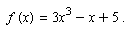 List them from smallest to largest, separated by commas.
-1,3
-1,1
-3,1
-1/3,1/3

7. Chapter 7, Web Quiz, Question 15
Find the following indefinite integral. 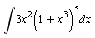
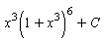
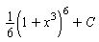
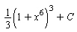
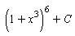

8. Chapter 7, Web Quiz, Question 12
Find the following indefinite integral. 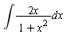
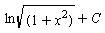
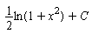

9. Chapter 4, Web Quiz, Question 11
Use the first derivative test to find all critical points of 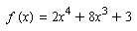. Use a graph to identify each critical point as a local maximum, local minimum or point of inflection.
x = -3 is a local minimum and x = 0 is a local maximum.
x = -3 is a local maximum and is the only critical point.
x = -3 is a local maximum and x = 0 is a local maximum.
x = -3 is a local minimum and x = 0 is a point of inflection.

10. Chapter 7, Web Quiz, Question 21
Using the Fundamental Theorem evaluate the definite integral below. 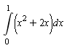
1

11. Chapter 4, Web Quiz, Question 4
Find the critical point of 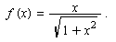
2
0
There are no critical points.
-2
-1

12. Chapter 7, Web Quiz, Question 1
Find an antiderivative of the following function. 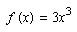
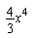
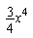

13. Chapter 7, Web Quiz, Question 9
Find the following indefinite integral. 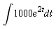
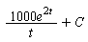
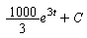

14. Chapter 7, Web Quiz, Question 14
Find the following indefinite integral. 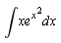
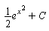
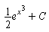
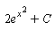
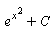

15. Chapter 4, Web Quiz, Question 10
The graph below shows the derivative, For what values of x does f have a local minimum? 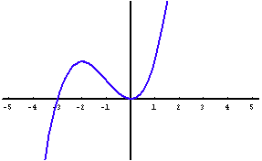
2
-2
-3
0

16. Chapter 7, Web Quiz, Question 5
Find an antiderivative of the following function. 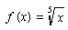
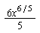
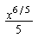
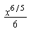
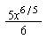

17. Chapter 4, Web Quiz, Question 16
Find the inflection points of 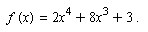
There are no inflection points.

18. Chapter 4, Web Quiz, Question 3
Find the critical point of
-1
1
There are no critical points.
0
-2

19. Chapter 7, Web Quiz, Question 4
Find an antiderivative of the following function. 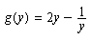
for y>0
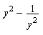
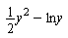
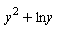
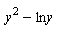

20. Chapter 7, Section 7.4, Question 15
Use integration by parts twice to evaluate the integral.
