Title: Modeling the impact of Ebola and bushmeat hunting on western lowland gorillas

Running Header: Gorillas, bushmeat and ebola

Keywords: Bushmeat, Ebola, Epidemiology, Gorilla, SIR model

Word Count: 2,494

Authors: Carol Rizkalla
Department of Forestry and Natural Resources
Purdue University
West Lafayette, IN 47907-2033

Francisco Blanco-Silva
Department of Mathematics
Purdue University
West Lafayette, IN 47907-2033

Stephanie Gruver*
Department of Mathematics
Purdue University
West Lafayette, IN 47907-2033

*Present Address: Department of Mathematics
Mount Marty College
Yankton, SD 57078-3725

Corresponding Author: Carol Rizkalla
Department of Forestry and Natural Resources
Purdue University
West Lafayette, IN 47907-2033
Email: crizkall@purdue.edu

Abstract
The 2003 outbreak of Ebola in the Republic of Congo killed 114 people and up to 800 western lowland gorillas. This outbreak began with human handling of infected animal carcasses. Ebola has since spread, putting the entire gorilla population at risk. An epidemiological model is presented to describe the combined effects of Ebola and harvest on persistence of gorillas. The number of infected gorillas also provides a means of assessing the risk of transmission to humans. Under current harvest rates and the estimated annual probability of an outbreak occurring, mean time to extinction was approximately 44 years. Controlling harvest may not be enough to prevent extinction if frequent outbreaks occur.

Introduction
Ebola hemorrhagic fever was first recognized in 1976 near the Ebola River in Congo (formerly Zaire) as a severe, often fatal disease in human and nonhuman primates (CDC 2002). In 13 occurrences since its discovery, human mortality has ranged from 50-100% (average 59.3%). There are four strains of the virus, Ebola-Zaire (which has the highest mortality rate and is the cause of the most recent outbreaks), Ebola-Sudan, Ebola-Ivory Coast, and Ebola-Reston, the latter of which only occurs in monkeys and apes (CDC 2002). Ebola typically appears in sporadic outbreaks coinciding with the rainy season, and is usually spread in humans within a health-care setting. Incubation is 2-21 days, and transmission occurs through direct contact of bodily secretions or contaminated objects, such as needles, or as will be described later, through contaminated meat (CDC 2002).
In 2003, a Congolese outbreak of Ebola-Zaire killed 114 out of the 128 humans who contracted it (Clover 2003). Around the same time, 600-800 western lowland gorillas (Gorilla gorilla gorilla), encompassing two-thirds of the local population, disappeared from the nearby Lossi Gorilla Sanctuary (Aveling 2003). An unknown number of chimpanzees (Pan troglodytes) also disappeared. Ebola virus was confirmed in 6 gorilla carcasses. Lossi is only 15 km from Odzala National Park, home to 20,000 gorillas, and by 2005, the park population had been devastated (Gross 2005). Congo and neighboring Gabon hold 80% of the world’s gorilla population, and all of these individuals appear to be potentially at risk of infection.
Preventative measures for Ebola have been hindered because the natural reservoir of the virus remains unknown. However, the virus is believed to be zoonotic, maintained in an (non-primate) animal host native to Africa. Fruit bats have been identified as potential carriers (Leroy et al. 2005). The authors suggest contact between bats and gorillas may occur as they compete for fruit during the dry season. This fails to explain how other animals, such as duikers, become infected.
The 2003 outbreak began with the handling and consumption of an infected carcass (Roquet et al. 2005). Wild animals have been hunted and eaten in Africa for years, but bushmeat hunting has increased in recent years because roads provide easier access to the forest. Commercial demand for bushmeat also exists in larger cities (Clarke 2003). Though apes make up only about 1% of the bushmeat trade, approximately 7.5 million red colobus monkeys (Colobus pennanti), 15,000 chimpanzees, and 6,000 gorillas killed each year across Africa. To be hunted sustainably, apes should lose no more than 1 animal per square kilometer every 20 years (Stein et al. 2002; Clarke 2003).
The combined threats of Ebola and overhunting prompted us to develop an epidemiological model to describe the persistence of Ebola and its effects on western lowland gorillas concurrently being harvested. The Kermack-McKendrick model, also known as the SIR model, consists of three differential equations, and has been applied to a variety of infectious diseases (Anderson & May 1979). When another organism is involved in disease transmission, the SIR model is typically coupled with an SIR model for the reservoir. For simplicity, we ignore the unknown host here. We have speculated on the annual probability of an outbreak occurring, and provide population projections. The model provides the additional value of estimating the risk to humans of harvesting an infected gorilla.

Methods
To model the epidemiology of Ebola in gorillas, we chose to develop an SIR model, where S represents the number of susceptible individuals, I and R represent infected and recovered individuals, respectively. As an instantaneous model, if individuals move between population classes, they do so within one time step, one year in this model. We have assumed exponential population growth. This is plausible, for if gorillas are well below carrying capacity, the population should grow exponentially. We also assumed some migration between gorilla populations, as reflected by our initial conditions in which we model the entire gorilla population (N = 100,000) and not just that of the Congo and Gabon. Given the rapid spread of Ebola (Walsh et al. 2005) and either numerous hosts (Roquet et al. 2005) or the mobility of bats as the single host (Leroy et al. 2005), there is no reason to believe that neighboring countries are safe from an outbreak. The number of susceptible gorillas that become infected is a function of the transmission rate and the number of infected gorillas. Susceptible gorillas also become infected due to contact with the Ebola host during an outbreak (see below). Infected animals either die or move to the recovered class by the next time step. We assume recovered animals become immune to further infection, and therefore, do not re-enter the susceptible class. In humans, those who die have not developed a significant immune response to the virus (CDC 2002). Thus, it is possible that those who recover have become immune to subsequent infection. Finally, the probability of being harvested is equal for each population class. Infected animals may have a lower probability of being harvested, if they leave their group. Conversely, being ill may make an individual more vulnerable as it is easier to kill.
The following equations are derived from these assumptions:
(1) 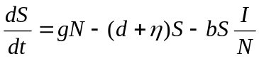
(2) 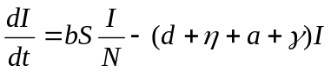
(3) 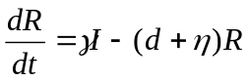
where N(t) = S(t) + I(t) + R(t). We extracted the birth rate (g) and death rate (d) from Alvarez (2000) (Table 1). Based on the statistic that 6,000 gorillas are taken annually from a total population of approximately 100,000 (Clarke 2003), we assumed a harvest rate (η) of 0.06. There is no data to provide an estimate for the Ebola transmission rate (b) among gorillas. Thus, we conservatively assumed a chance transmission rate of 0.5. As a highly infectious disease, the transmission rate may be much higher. We estimated the death rate due to ebola (a = 0.937) and recovery rate (γ = 1 – a = 0.063) as the average of three reports: Only 7 of 143 study gorillas in the Lossi sanctuary survived (Kaiser 2003); a 98% decline in gorilla density in the Minkebe forest of Gabon since 1994, likely due to Ebola (Huijbregts et al. 2003); and an 88% decline in chimpanzee indices in Lossi (Leroy et al. 2004). We set the initial conditions according to estimates of the Lossi outbreak of 2003: 800 infected animals, 50 recovered (6.3% of 800), and 99150 susceptible, summing to a total population of 100,000.
We did not account for demographic stochasticity, but we included environmental stochasticity in the form of future Ebola outbreaks. There have been 7 documented outbreaks in great apes in an 11-year period (1992-2003) (Formenty et al. 1999; Leroy et al. 2004). Therefore, we assumed the annual probability of an outbreak occurring as 0.636. Based on the initial conditions of 800 infected individuals, we also assumed that each outbreak leads to the additional infection of 0.8% of the susceptible population. Due to uncertainty, we also tested two lower outbreak probabilities (Table 1). We combined this range of probabilities with a range of harvest rates to determine the combined threat of future outbreaks and hunting. For each set of parameters, we ran 100 simulations for 500 years. Finally, we assessed sensitivity of the model to a 10% decrease in transmission, death, and harvest rates and initial number of infected animals. All model runs were seeded for outbreak probabilities to allow comparison.

Results
The model run used to test sensitivity had an outbreak occurring every year, such that the population was extinct by year 34. The model showed no sensitivity to initial conditions (same N in year 33), moderate sensitivity to transmission and death rates (2.2 and 2.4 times the population size), and high sensitivity to harvest rate (4.5 times the population size). All further results are reported in terms of the original values (Table 1). We calculated death rates as an average of several reports. If actual mortality due to Ebola is lower than 0.937, we would expect our projections could be extended by a few years. We previously suggested the actual transmission rate may be higher than 0.5. If this is the case, our projections are conservative.
We simulated a combination of harvest rates (η = 0, 0.04, and the current rate of 0.06) with three probabilities of outbreak (α = 0.1, 0.3, and the estimated probability of 0.636). Under current harvest rates with the estimated outbreak probability, mean time to extinction was 44.11 ± 3.38 years (Table 2). This increased to 110 ± 15.74 years with the lowest outbreak probability (Figure 1). Population growth was possible under the simulations with no harvest and the two lower probabilities. In simulations of no harvest with the higher estimated probability, the population initially grew. However, a constant infection rate lead to subsequent extinction in 197.67 ± 35.78 years.
According to the model with 6% harvest and the high outbreak probability, the proportion of infected gorillas in the population ranged from 0.33 – 5.5% (Figure 2). This translates to a 0.002-0.33% of chance that a harvested gorilla is infected. In other words, one of every 300-5000 harvested gorillas would carry Ebola.

Discussion
We realize our model may be simplistic and contain much uncertainty. However, it illustrates the potential combined effect of Ebola and harvest on gorillas. Walsh et al. (2003) uses historical surveys to estimate an 80% decline in ape populations within 33 years. Although we did not have historical data to validate our model, the scenario of current harvest rate and the highest outbreak probability resulted in an 80% decline in 36 years on average. We believe this adds support to our findings.
Efforts to control the bushmeat trade are ongoing, but unfortunately, largely unsuccessful. Walsh et al. (2003) calls for an immediate increase in law enforcement to control the illegal harvest of apes. We echo this sentiment. However, our results suggest that even with no harvest, gorillas cannot survive a high frequency of Ebola outbreaks. Two priorities have been proposed to address Ebola: 1) Develop a vaccine; and 2) Determine if natural barriers, such as rivers, can slow the spread of the virus (Tutin et al. 2005). The latter is unlikely if bats are the reservoir, due to their high mobility. Increased control of harvesting may be able to buy us the time we need to develop an effective vaccine. A hopeful strategy for development has already been devised (Sullivan et al. 2000; but see Geisbert et al. 2002).
Despite efforts to change the eating habitats of African villagers, many believe occult forces are behind Ebola. The probability of harvesting an infected gorilla (0.002-0.33%) appears quite low. Thus, to a hunter risking transmission, this may not serve as a deterrent. In actuality, Ebola outbreaks occur in localized pockets containing a subset of the gorilla population. Additionally, other hunted species such as chimpanzees and duikers would also likely be infected. Therefore, the risk in these areas would be much higher. If education efforts on the link between bushmeat and Ebola can succeed, the source of one mode of transmission to humans can be controlled, and gorilla populations may continue to persist.

Acknowledgements
We would like to thank Z. Feng for her guidance. N. Lichti and W. Karesh contributed valuable thoughts. R. Swihart provided comments an earlier draft.
Literature Cited
Alvarez, H.P. 2000. Grandmother hypothesis and primate life histories. American
Journal of Physical Anthropology 113:435-450.
Anderson, R.M. and R.M. May. 1979. Population Biology of Infectious Diseases: Part I. Nature 280: 361-367.
Aveling, C. 2003. Massive die-off of great apes reported in Republic of Congo.
Conservation et Utilisation Rationnelle des Ecosystèmes Forestiers d’Afrique Centrale. Available from http://www.bushmeat.org/html/ECOFACPressRelease2003 Feb05.htm (accessed March 2003)
Centers for Disease Control and Prevention. 2002. Ebola hemorrhagic fever information packet.
Available from http://www.cdc.gov/ncidod/dvrd/spb/mnpages/dispages/Fact_Sheets/ Ebola_Fact_Booklet.pdf (accessed January 2006).
Clarke, P. 2003. Wildlife on the menu: The bushmeat crisis is emptying Africa’s forests.
Available from http://www.emagazine.com/march-april_2003/0303curr_bushmeat.html (accessed April 2003)
Clover, C. 2003. Ebola fever killing lowland gorillas. The Age. Available from http://www. theage.com.au/articles/2003/04/01/1048962755859.html (accessed March 2003)
Formenty, P., C. Boesch, M. Wyers, C. Steiner, F. Donati, F. Dind, F. Walker, and B. Le
Guenno. 1999. Ebola virus outbreak among wild chimpanzees living in a rain forest of Côte d’Ivoire. The Journal of Infectious Diseases 179(Suppl 1):S120-126.
Geisbert,T.W., P. Pushko, K. Anderson, J. Smith, K.J. Davis, and P.B. Jahrling. 2002. Evaluation in nonhuman primates of vaccines against Ebola virus. Emerging Infectious Diseases 8:503-507.
Gross, L. 2005. Charting the path of the deadly Ebola virus in central Africa. PloS Biology 3:1846-1847.
Huijbregts, B., P. DeWachter, L.S.N. Obiang, and M.E. Akou. 2003. Ebola and the decline of gorilla Gorilla gorilla and chimpanzee Pan troglodytes in populations in Minkebe Forest, north-eastern Gabon. Oryx 37:437-443.
Kaiser, J. 2003. Ebola, hunting pushing ape populations to the brink. Science 300:232.
Leroy, E.M., B. Kumulungui, X. Pourrut, P. Rouquet, A. Hassanin, P. Yaba, A. Délicat, J.T. Paweska, J. Gonzalez, and R. Swanepoel. 2005. Fruit bats as reservoirs of Ebola virus. Nature 438:575-576.
Leroy, E.M., P. Roquet, P. Formenty, S. Souquière, A. Kilbourne, J. Froment, M. Bermejo, S. Smit, W. Karesh, R. Swanepoel, S.R. Zaki, and P.E. Rollin. 2004. Multiple Ebola virus transmission events and rapid decline of central African wildlife. Science 303:387-390.
Roquet, P., J. Froment, M. Bermejo, A. Kilbourne, W. Karesh, P. Reed, B. Kumulungui, P. Yaba, A. Délicat, P.E. Rollin, and E.M. Leroy. 2005. Wild animal mortality monitoring and human Ebola outbreaks, Gabon and Republic of Congo, 2001-2003. Emerging Infectious Diseases 11:283-290.
Stein, J.T., N.D. Bailey, D.L. Wade and BCTF. 2002. BCTF Fact Sheet: African Great Apes and the Bushmeat Trade. Bushmeat Crisis Task Force, Washington, D.C. Available from http://www.bushmeat.org/cd/fs/FSapesCD.pdf (accessed March 2003).
Tutin, C., E. Stokes, C. Boesch, D. Morgan, C. Sanz, T. Reed, A. Blom, P. Walsh, S. Blake, and R. Kormos. 2005. Regional action plan for the conservation of chimpanzees and gorillas in western equatorial Africa. Conservation International, Washington, D.C.
Sullivan, N.J., A. Sanches, P.E. Rollin, Z. Yang, and G.J. Nabel. 2000. Development of a preventive vaccine for Ebola virus infection in primates. Nature 408:605-609.
Walsh, P.D., K.A. Abernethy, M. Bermejo, R. Beyers, P. de Wachter, M.E. Akou, B.
Huijbregts, D.I. Mambounga, A.K. Toham, A.M. Kilbourn, S.A. Lahm, S. Latour, F. Maisels, C. Mbina, Y. Mihindou, S.N. Obiang, E.N. Effa, M.P. Starkey, P. Telfer, M. Thibault, C.E.G. Tutin, L.J.T. White, and D.S. Wilkie. 2003. Catastrophic ape decline in western equatorial Africa. Nature 422:611-614.
Walsh, P.D., R. Biek, and L.A. Real. 2005. Wave-like spread of Ebola Zaire. PloS Biology 3:1946-1953.
Table 1. Description of the model parameters and initial conditions. All rates are annual. Where a range of estimates was tested in the model, multiple values are listed.
Symbol | Description | Value
g | Birth rate | 0.113
d | Natural death rate | 0.066
b | Ebola transmission rate | 0.5
a | Additional death rate due to Ebola | 0.937
γ | Recovery rate | 0.063
η | Harvest rate | 0, 0.04, 0.06
N | Total population | 100000
S | Susceptible population | 99150
I | Infected population | 800
R | Recovered population | 50
α | Probability of an outbreak | 0.636, 0.3, 0.1

Table 2. Mean time to extinction of gorillas from 100 simulations under combinations of 3 harvest rates (η) and 3 probabilities of Ebola outbreak (α).
 | η = 0 | η = 0.04 | η = 0.06
α = 0.1 | -- | 206.07 ± 37.25 | 110 ± 15.74
α = 0.3 | -- | 95.41 ± 11.41 | 65.71 ± 7.51
α = 0.636 | 197.67 ± 35.78 | 56.62 ± 4.44 | 44.11 ± 3.38
-- Positive population growth in all runs
Figure Legends:
Figure 1. Mean population size of gorillas under current harvest rate (η = 0.06) with three annual probabilities of Ebola outbreak.

Figure 2. Mean proportion of infected gorillas in the population with an outbreak probability of 0.636. An example from one simulation is also shown, with the proportion of infected gorillas that would be harvested under current rates.

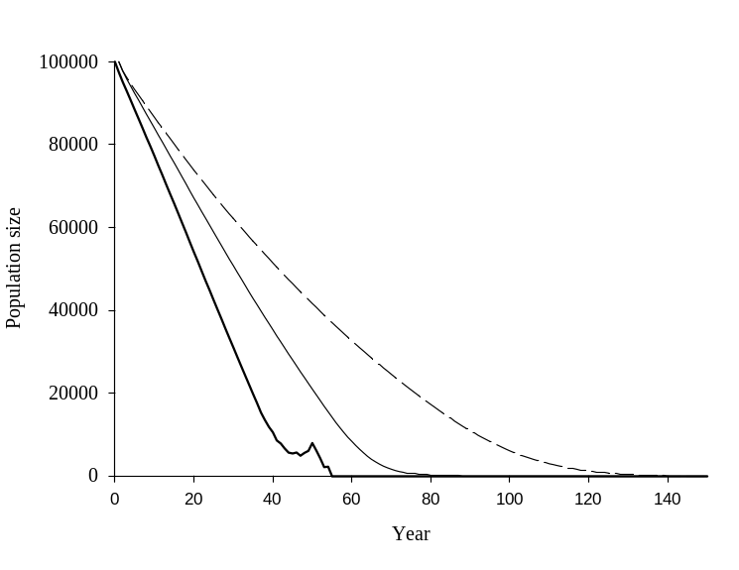
0.1
0.3
0.636

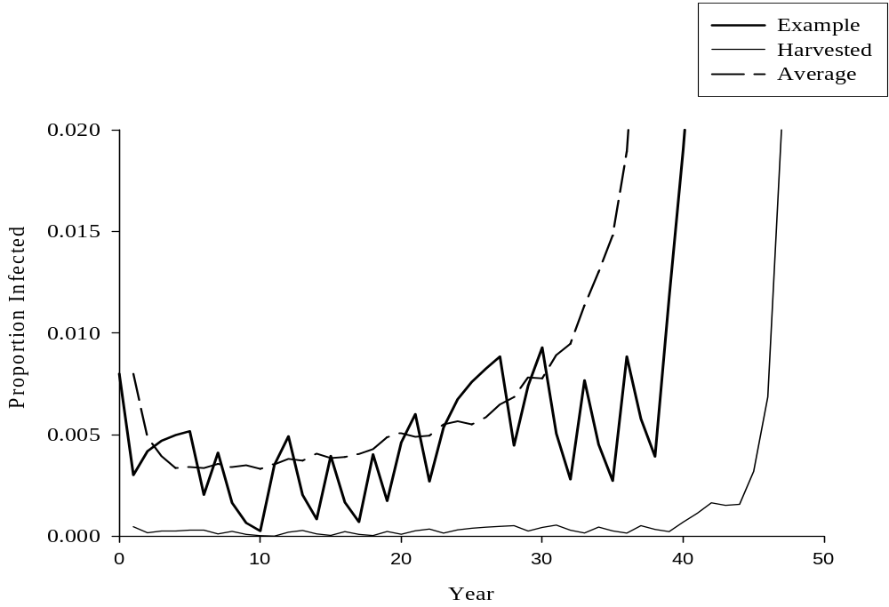
Average
Example
Harvested

