***BIANCHI MATTEO – ADVANCED ROBOTIC PROGRAMMING***

***FINAL GRADE: A***

*PROJECT 1:*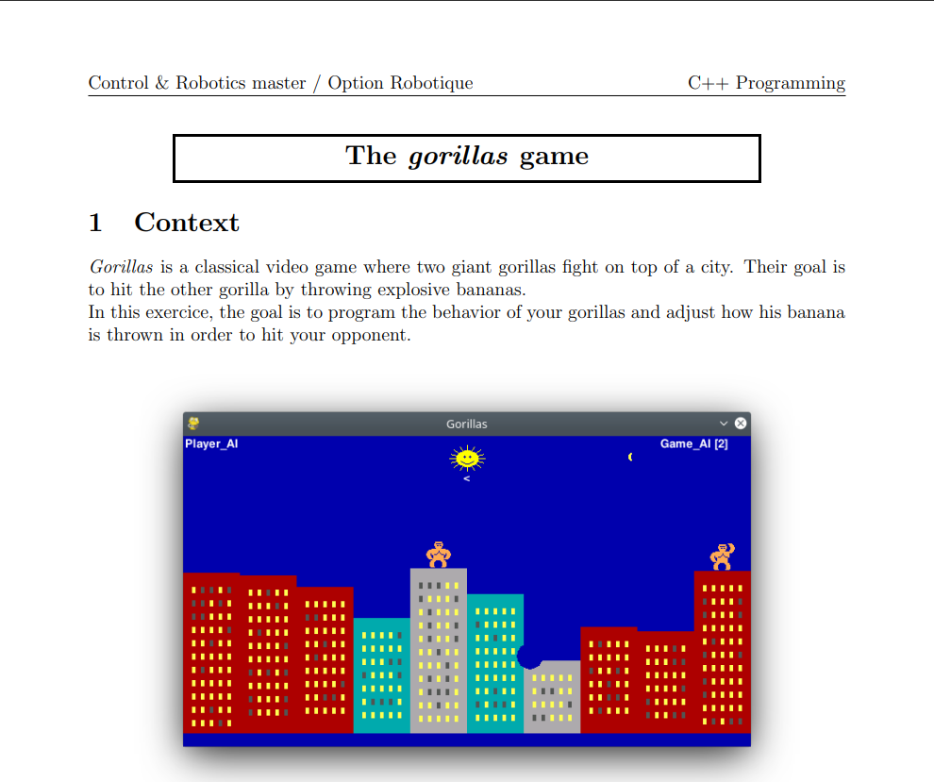

*PROJECT 2: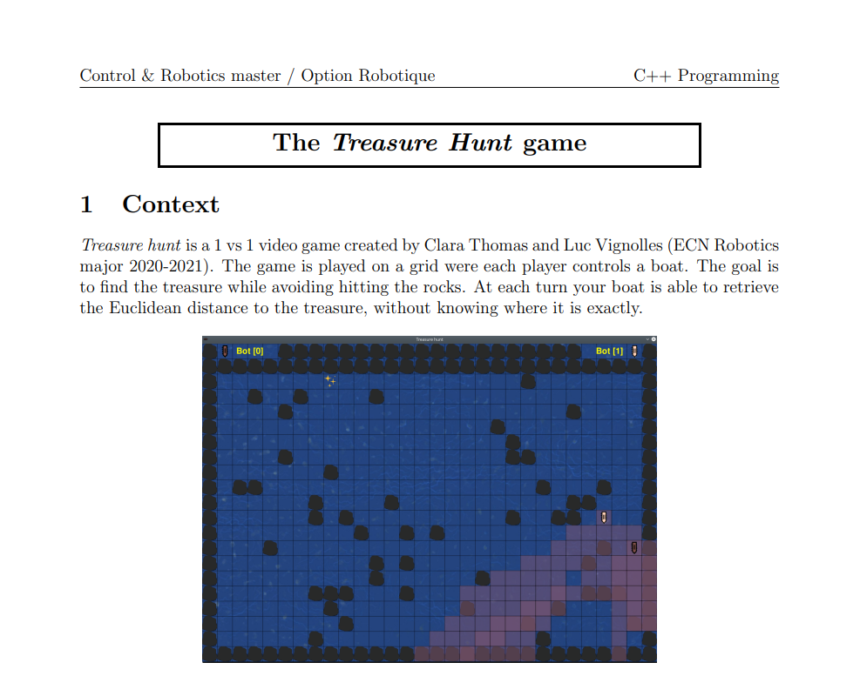*

*PROJECT 3:*

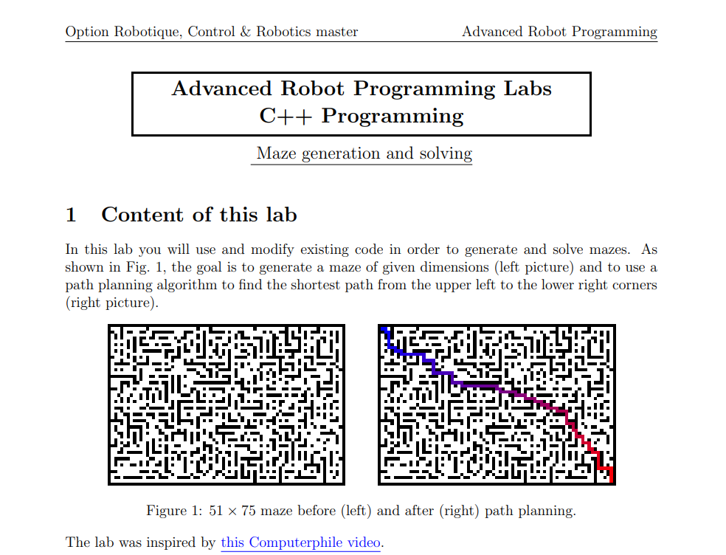

*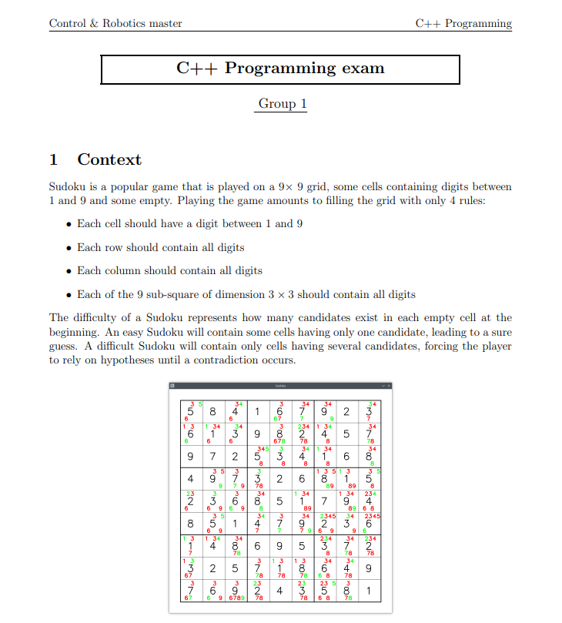EXAM:*