Article: Fill in PDF Form Fields using the Open Source iTextSharp Dynamic Link Library
Topics: Win Forms Programming, PDF, iTextSharp
Programming Level: Beginner
Programming Environment: Visual Studio 2005
Language: C# 2005
Author: Scott Lysle

Introduction:
This article describes a quick and simple approach to programmatically completing a PDF document through the use of the iTextSharp DLL. The article also discusses how one might go about using the iTextSharp DLL to discover and map the fields available within an existing PDF if the programmer has only the PDF but does not have Adobe Designer or even a list of the names of the fields present in the PDF.

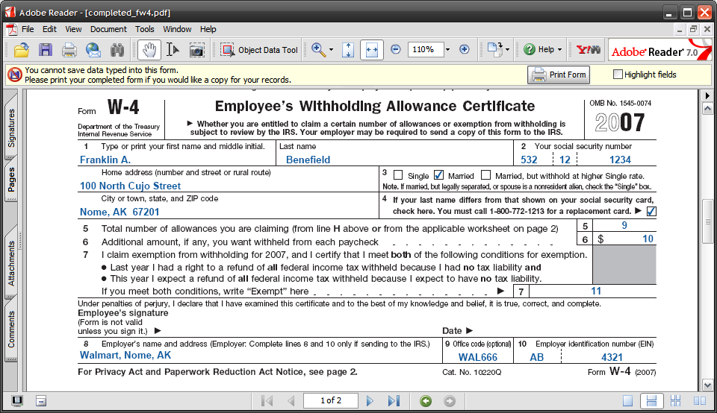
Figure 1: Resulting PDF after Filling in Fields Programmatically

iTextSharp is a C# port of a Java library written to support the creation and manipulation of PDF document; the project is available for download through SourceForge.net here: http://sourceforge.net/projects/itextsharp/
With the iTextSharp DLL, it is possible to not only populate fields in an existing PDF document but also to dynamically create PDFs. The examples here are limited to a description of the procedures associated with completion of a PDF; the download will contain examples of PDF creation in both Visual Basic and C#.
The examples contained herein are dependent upon the availability of the iTextSharp DLL; use the link provided previously in order to download the DLL locally to your development machine.
In order to demonstrate filling out a PDF using the iTextSharp DLL, I downloaded a copy of the W-4 PDF form from the IRS website. The form contains controls and may be filled out programmatically so it serves as a good example.
PDF documents that do not contain controls; those meant to be printed and filled in with a pencil, cannot be completed using this approach. Of course if you have access to the Adobe tools (Adobe Professional, Adobe Designer), you can always create your own PDFs with controls, or can add controls to existing PDFs. Further, though not demonstrated here, one can also use iTextSharp to create a PDF document with embedded controls.

Getting Started:
In order to get started, fire up the Visual Studio 2005 IDE and open the attached solution. The solution consists of a single Win Forms project with a single form.
I have also included a PDF that will be used for demonstration purposes; this form is the IRS W-4 form completed by US taxpayers; however, any PDF with embedded controls (text boxes, check boxes, etc.) is fair game for this approach. Note that a reference to the iTextSharp DLL has been included in the project.
All of the project code is contained with the single Windows form. The form itself contains only a docked textbox used to display all of the field names from an existing PDF document. The completed PDF is generated and stored in the local file system; the PDF is not opened for display by the application.
The application uses the existing PDF as a template and from that template; it creates and populates the new PDF. The template PDF itself is never populated and it is used only to define the format and contents of the completed PDF.
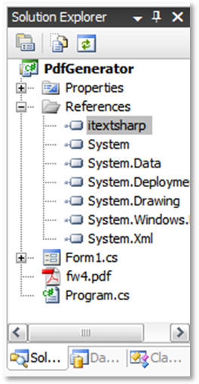
Figure 2: Solution Explorer

The Code: Main Form
As was previously mentioned, all of the code used in the demonstration application is contained entirely in the project’s single Windows form. The following section will describe the contents of the code file.
The file begins with the appropriate library imports needed to support the code. Note that the iTextSharp libraries have been included into the project. The namespace and class declaration are in the default configuration.

using System;
using System.Collections;
using System.ComponentModel;
using System.Data;
using System.Drawing;
using System.Text;
using System.Windows.Forms;
using iTextSharp;
using iTextSharp.text;
using iTextSharp.text.pdf;
using iTextSharp.text.xml;
using System.IO;

namespace PdfGenerator
{
public partial class Form1 : Form
{

The next section of code contains the default constructor and the form 1 load event handler. During form load, two functions are called; those functions are used to display all of the fields present in the template PDF and to create a new PDF populated with a set of field values.

public Form1()
{
InitializeComponent();
}

private void Form1_Load(object sender, EventArgs e)
{
ListFieldNames();
FillForm();
}

The next section of code contained in the demo application defines a function used to collect the names of all of the fields from the target PDF. The field names are displayed in a text box contained in the application’s form.

/// <summary>
/// List all of the form fields into a textbox. The
/// form fields identified can be used to map each of the
/// fields in a PDF.
/// </summary>
private void ListFieldNames()
{
string pdfTemplate = @"c:\Temp\PDF\fw4.pdf";

// title the form
this.Text += " - " + pdfTemplate;

// create a new PDF reader based on the PDF template document
PdfReader pdfReader = new PdfReader(pdfTemplate);

// create and populate a string builder with each of the
// field names available in the subject PDF
StringBuilder sb = new StringBuilder();
foreach (DictionaryEntry de in pdfReader.AcroFields.Fields)
{
sb.Append(de.Key.ToString() + Environment.NewLine);
}

// Write the string builder's content to the form's textbox
textBox1.Text = sb.ToString();
textBox1.SelectionStart = 0;
}

Figure 3 shows the field names collected from the target PDF using the ListFieldNames function call. In order to map these fields to specific fields in the PDF, one need only copy this list and pass values to each of the fields to identify them. For example, if the form contains ten fields, setting the value (shown next) to a sequential number will result in the display of the numbers 1 to 10 in each of the fields. One can then track that field value back to the field name using this list as the basis for the map. Once the fields have been identified, the application can be written to pass the correct values to the related field.

Checkbox controls may be a little more challenging to figure out. I tried passing several values to the checkbox controls before lining up a winner. In this example, I tried pass zero, one, true, false, etc. to the field before figuring out that ‘yes’ sets the check.

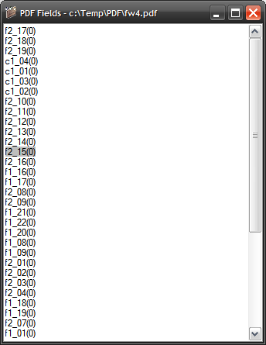

Figure 3: The Available PDF Fields

The next section of code in the demo project is used to fill in the mapped field values. The process is simple enough, the first thing that happens is that that the template file and new file locations are defined and passed to string variables. Once the paths are defined, the code creates an instance of the PDF reader which is used to read the template file, and a PDF stamper which is used to fill in the form fields in the new file. Once the template and target files are set up, the last thing to do is to create an instance of the AcroFields which is populated with all of the fields contained in the target PDF. After the form fields have been captured, the rest of the code is used to fill in each field using the field’s SetField function.

In this example, the first worksheet and the W-4 itself are populated with meaningful values whilst the second worksheet is populated with sequential numbers which are then used to map those fields to their location on the PDF.

After the PDF has been filled out, the application reads values from the PDF (the first and last names) in order to generate a message indicating that the W-4 for this person was completed and stored.

private void FillForm()
{
string pdfTemplate = @"c:\Temp\PDF\fw4.pdf";
string newFile = @"c:\Temp\PDF\completed_fw4.pdf";

PdfReader pdfReader = new PdfReader(pdfTemplate);
PdfStamper pdfStamper = new PdfStamper(pdfReader, new FileStream(
newFile, FileMode.Create));

AcroFields pdfFormFields = pdfStamper.AcroFields;

// set form pdfFormFields

// The first worksheet and W-4 form
pdfFormFields.SetField("f1_01(0)", "1");
pdfFormFields.SetField("f1_02(0)", "1");
pdfFormFields.SetField("f1_03(0)", "1");
pdfFormFields.SetField("f1_04(0)", "8");
pdfFormFields.SetField("f1_05(0)", "0");
pdfFormFields.SetField("f1_06(0)", "1");
pdfFormFields.SetField("f1_07(0)", "16");
pdfFormFields.SetField("f1_08(0)", "28");
pdfFormFields.SetField("f1_09(0)", "Franklin A.");
pdfFormFields.SetField("f1_10(0)", "Benefield");
pdfFormFields.SetField("f1_11(0)", "532");
pdfFormFields.SetField("f1_12(0)", "12");
pdfFormFields.SetField("f1_13(0)", "1234");

// The form's checkboxes
pdfFormFields.SetField("c1_01(0)", "0");
pdfFormFields.SetField("c1_02(0)", "Yes");
pdfFormFields.SetField("c1_03(0)", "0");
pdfFormFields.SetField("c1_04(0)", "Yes");

// The rest of the form pdfFormFields
pdfFormFields.SetField("f1_14(0)", "100 North Cujo Street");
pdfFormFields.SetField("f1_15(0)", "Nome, AK 67201");
pdfFormFields.SetField("f1_16(0)", "9");
pdfFormFields.SetField("f1_17(0)", "10");
pdfFormFields.SetField("f1_18(0)", "11");
pdfFormFields.SetField("f1_19(0)", "Walmart, Nome, AK");
pdfFormFields.SetField("f1_20(0)", "WAL666");
pdfFormFields.SetField("f1_21(0)", "AB");
pdfFormFields.SetField("f1_22(0)", "4321");

// Second Worksheets pdfFormFields
// In order to map the fields, I just pass them a sequential
// number to mark them; once I know which field is which, I
// can pass the appropriate value
pdfFormFields.SetField("f2_01(0)", "1");
pdfFormFields.SetField("f2_02(0)", "2");
pdfFormFields.SetField("f2_03(0)", "3");
pdfFormFields.SetField("f2_04(0)", "4");
pdfFormFields.SetField("f2_05(0)", "5");
pdfFormFields.SetField("f2_06(0)", "6");
pdfFormFields.SetField("f2_07(0)", "7");
pdfFormFields.SetField("f2_08(0)", "8");
pdfFormFields.SetField("f2_09(0)", "9");
pdfFormFields.SetField("f2_10(0)", "10");
pdfFormFields.SetField("f2_11(0)", "11");
pdfFormFields.SetField("f2_12(0)", "12");
pdfFormFields.SetField("f2_13(0)", "13");
pdfFormFields.SetField("f2_14(0)", "14");
pdfFormFields.SetField("f2_15(0)", "15");
pdfFormFields.SetField("f2_16(0)", "16");
pdfFormFields.SetField("f2_17(0)", "17");
pdfFormFields.SetField("f2_18(0)", "18");
pdfFormFields.SetField("f2_19(0)", "19");

// report by reading values from completed PDF
string sTmp = "W-4 Completed for " +
pdfFormFields.GetField("f1_09(0)") + " " +
pdfFormFields.GetField("f1_10(0)");
MessageBox.Show(sTmp, "Finished");

// flatten the form to remove editting options, set it to false
// to leave the form open to subsequent manual edits
pdfStamper.FormFlattening = false;

// close the pdf
pdfStamper.Close();
}

To finish up the PDF, it is necessary to determine whether or not additional edits will be permitted to the PDF after it has been programmatically completed. This task is accomplished by setting the FormFlattening value to true or false. If the value is set to false, the resulting PDF will be available for edits, if the value is set to true, the PDF will be locked against further edits.

Once the form has been completed, the PDF stamper is closed and the function terminated.
That wraps up the discussion of the form based demo project.

Summary
This article described an approach to populating a PDF document with values programmatically; this functionality was accomplished using the iTextSharp DLL. Further, the article described an approach for mapping the fields contained in PDF and may be useful if one is dealing with a PDF authored elsewhere and if the programmer does not have access to Adobe Professional or Adobe Designer. The iTextSharp library is a powerful DLL that supports authoring PDFs as well as using in the manner described in this document; however, when authoring a PDF, it seems that it would be far easier to produce a nice document using the visual environment made available through the use of the Adobe tools. Having said that, if one is dynamically creating PDFs with variable content, the iTextSharp library does provide the tools necessary to support such an effort; with the library, one can create and populate a PDF on the fly.

