1) Implement the following using conditional operators
A) And gate B) OR gate C) Not gate D) Nand gate E) Nor gate F) Half Adder

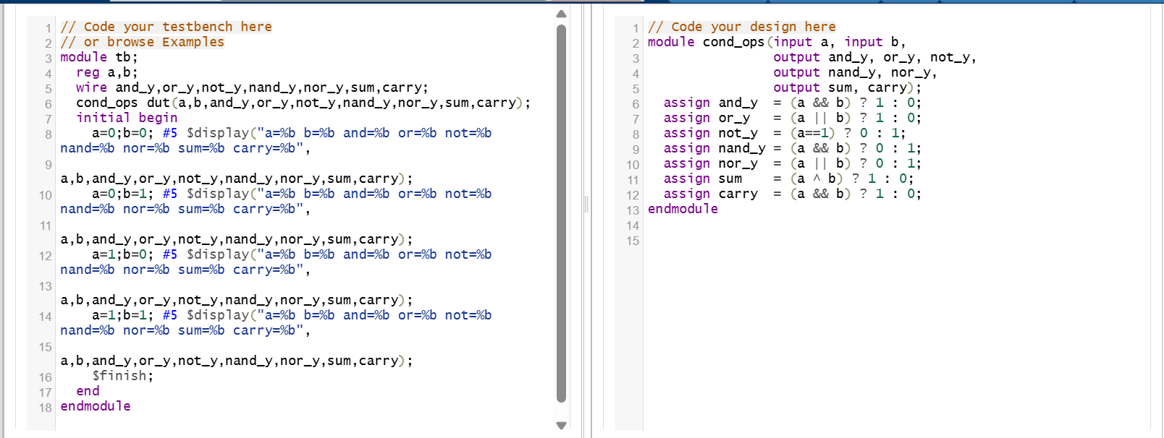
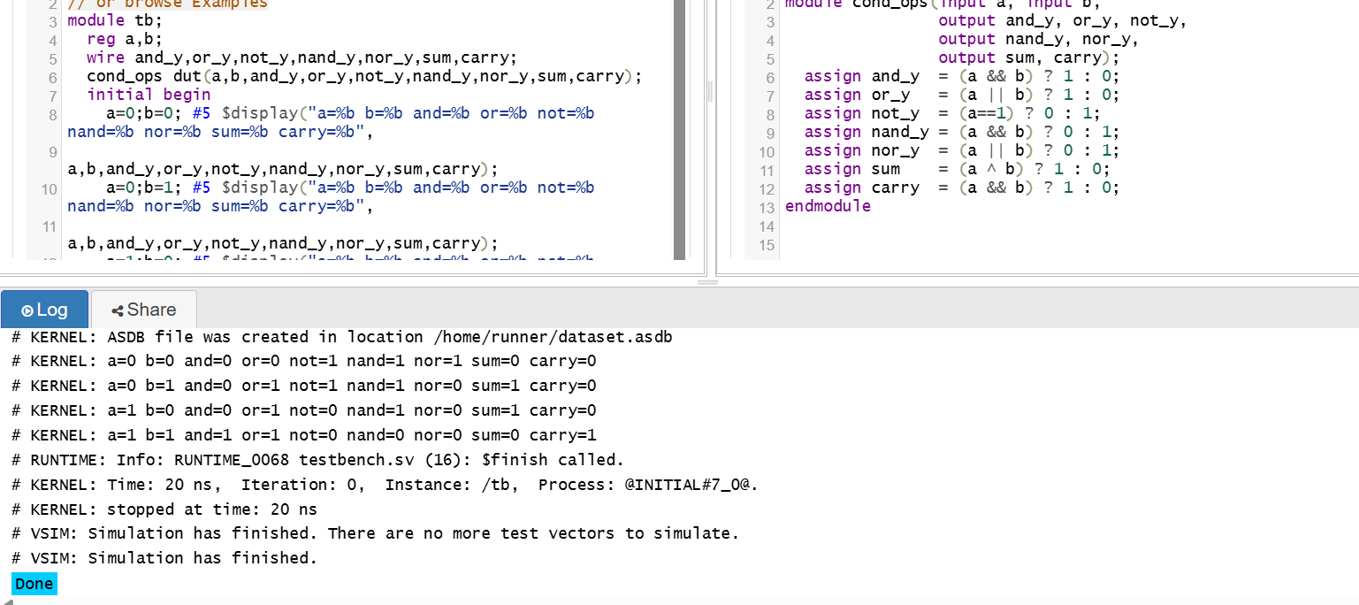

2) Implement the following using Bitwise operator and write Verilog code for the same
A=3'b101,B=3'b110,C=2'b10
A) A&B=?
B) ~(A|B)=?
C) A^B=?
D) ~(A^B)=?

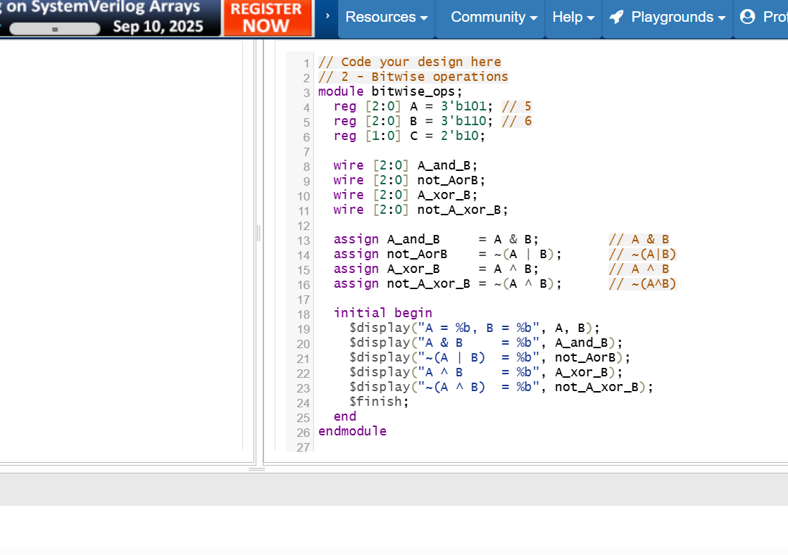
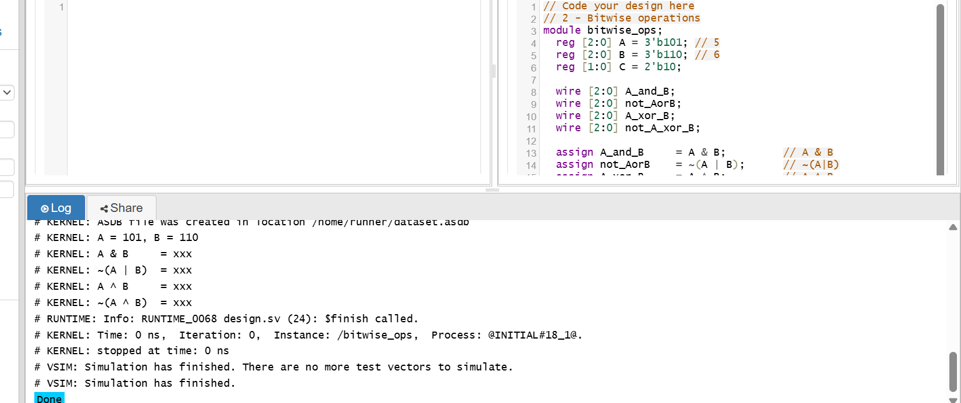

3) Write verilog code for Mux 16*1 using Gate level and Behavioral modelling.

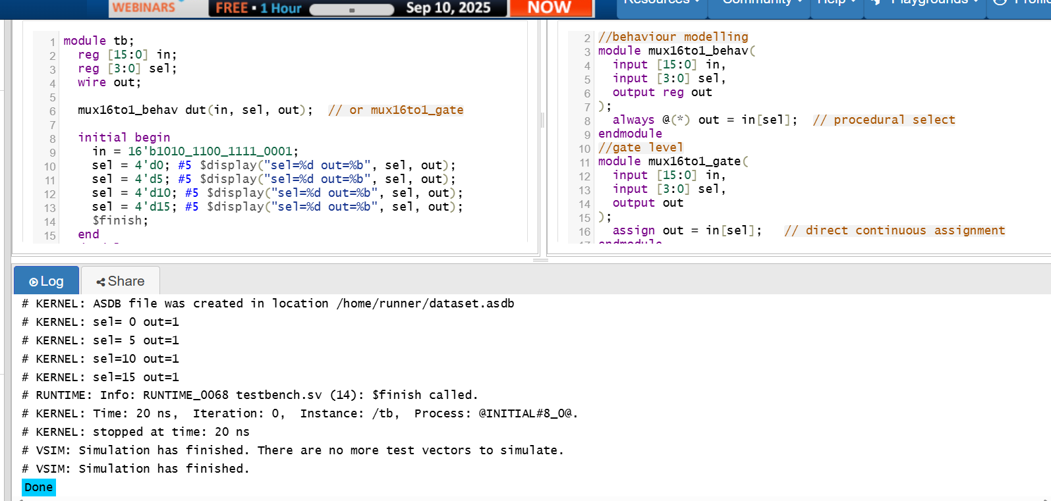

4) Write Verilog code for ALU
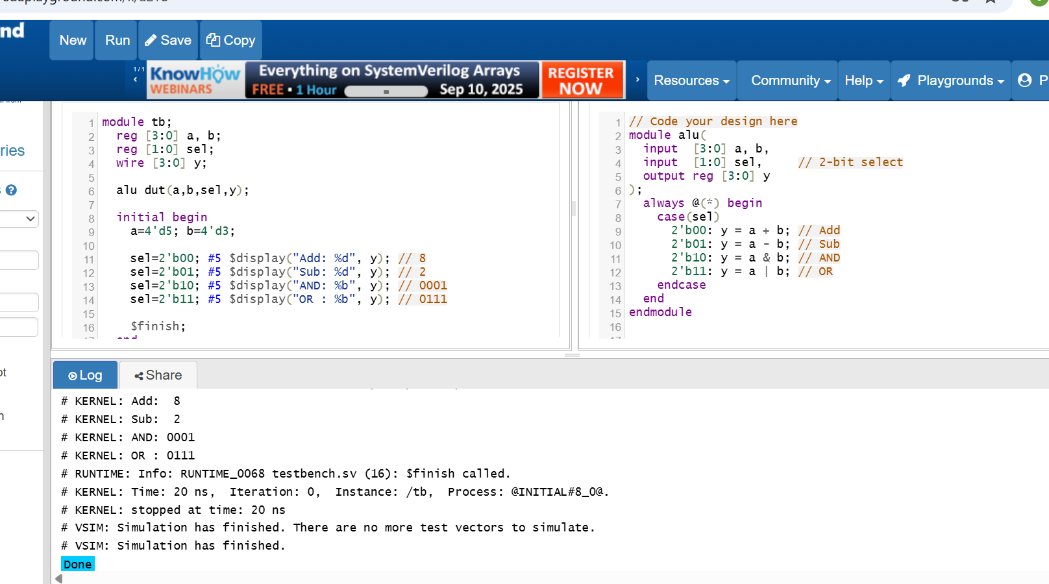

5) Write Verilog code for Decoder 4*1 using any levels of modelling.
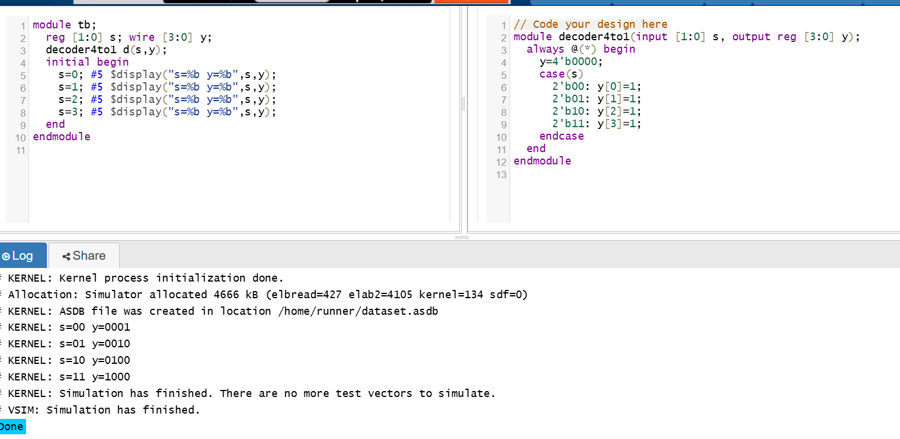

6) Write Verilog code for Mux 8*1 using different loops.
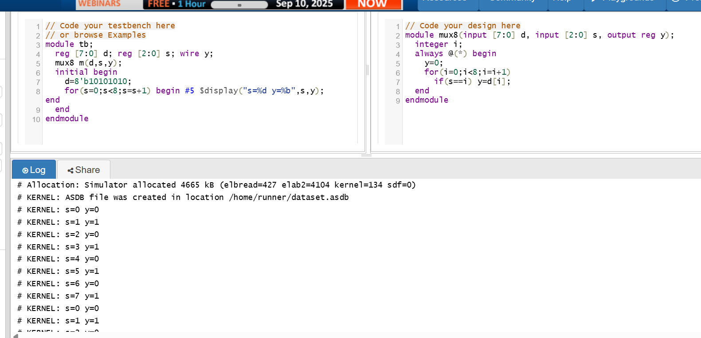

7) Write Verilog code for full adder 16-bit using full adder 4-bit using any one of the levels of modelling
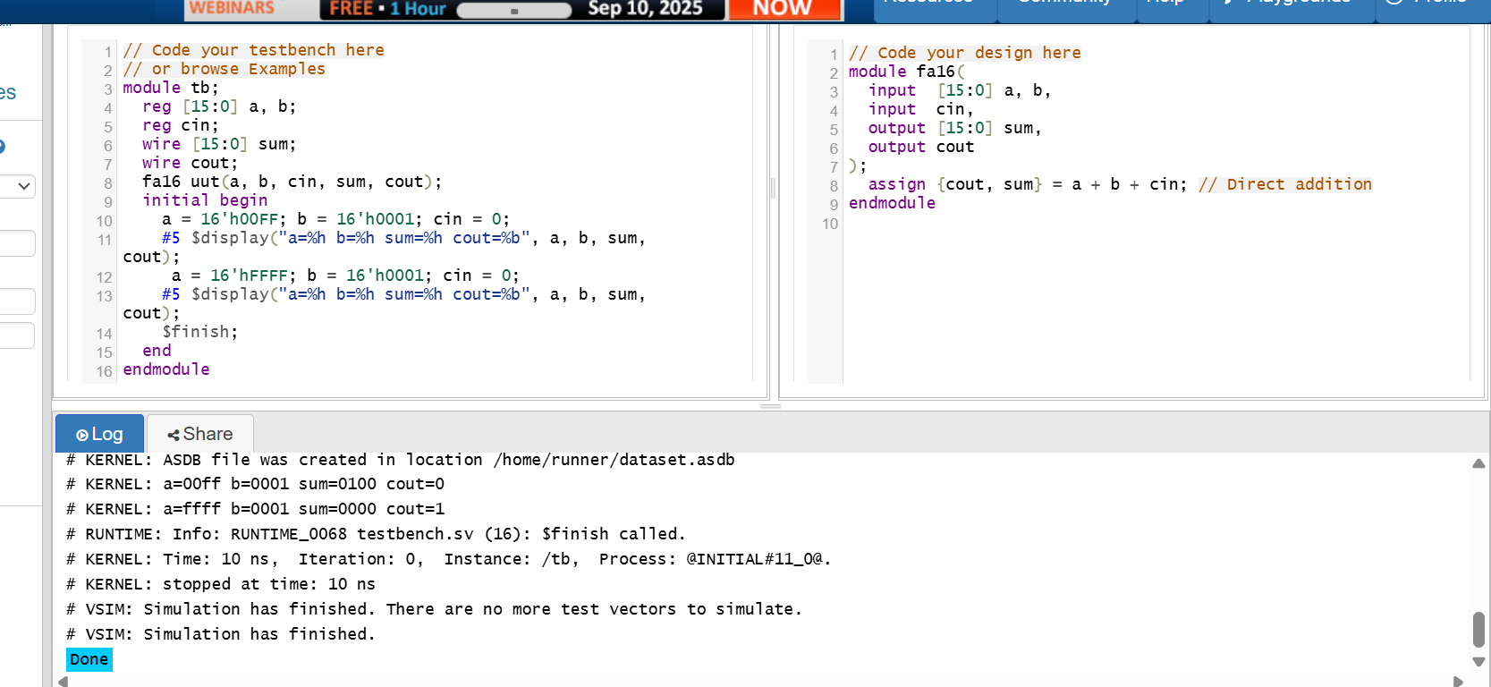

8) Write Verilog code for decoder 4*1 using decoder 2*1 using any levels of modelling
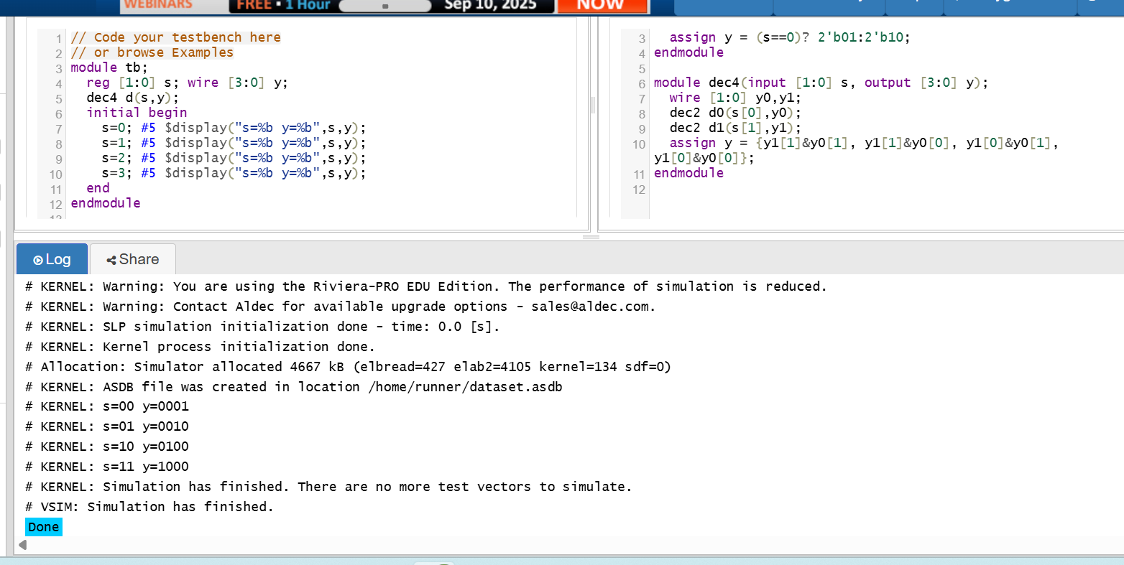

9) Write Verilog code for downcounter using loops
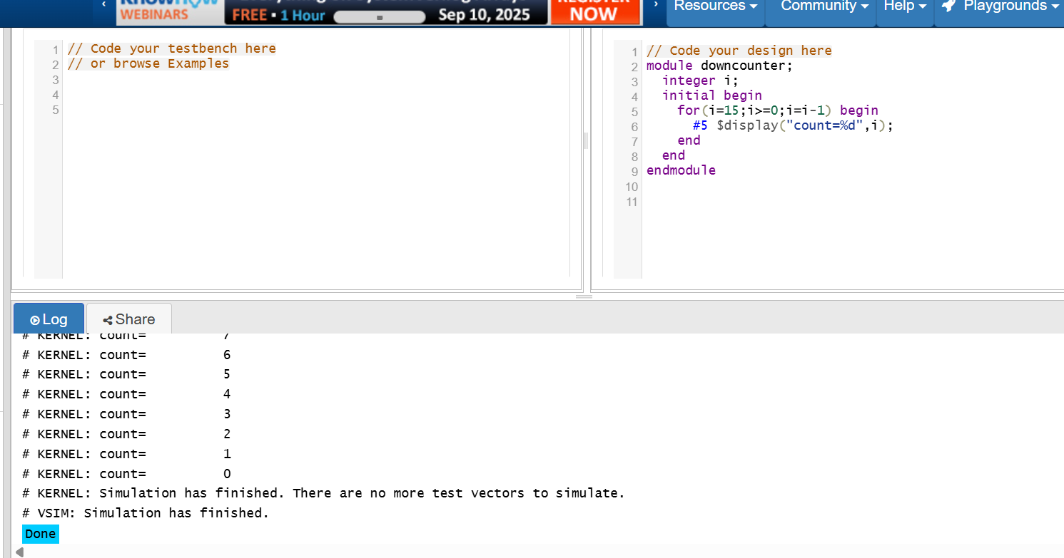

10) Write Verilog code for Half Adder using fork join.
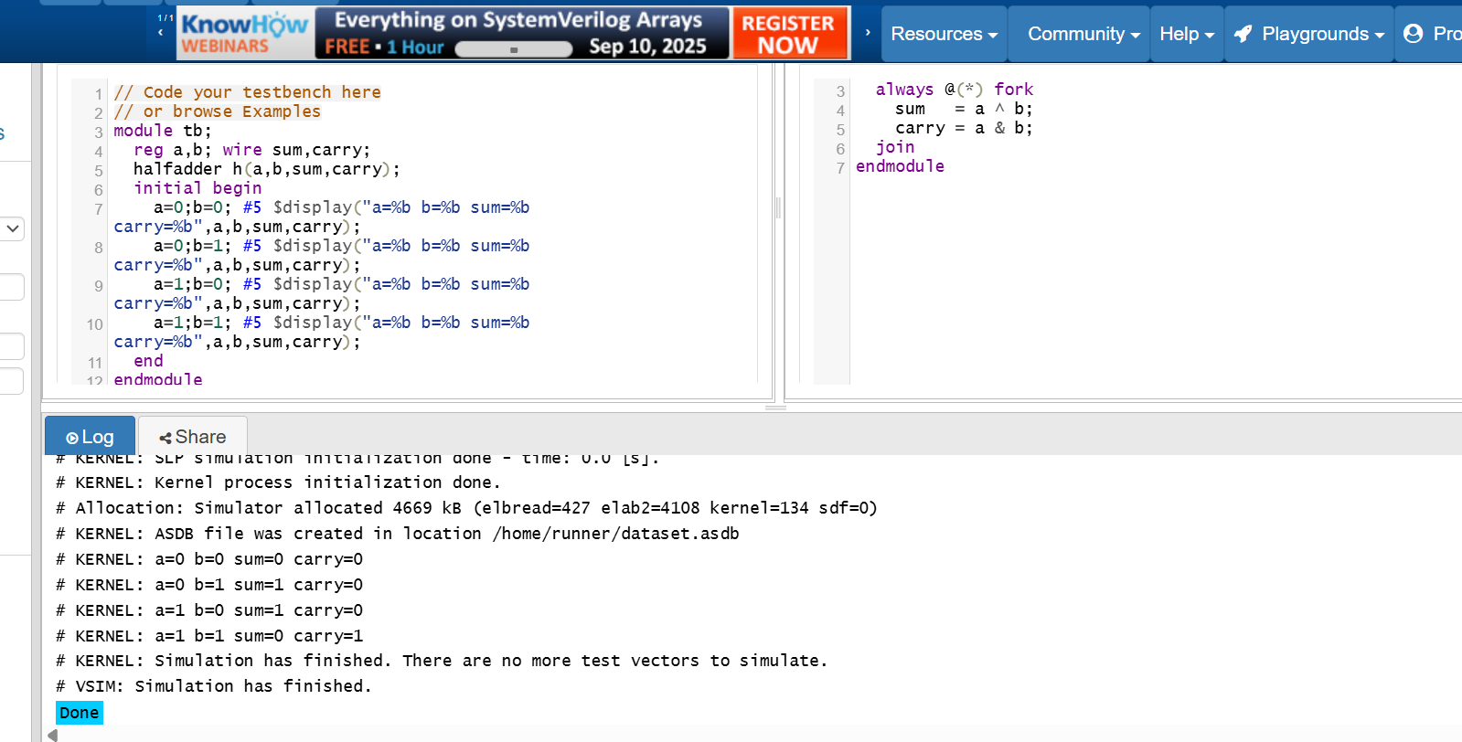

SAHMA.M

REG NO:311123106055
ECE

