1) Write a Verilog code for ALU using Function and Task
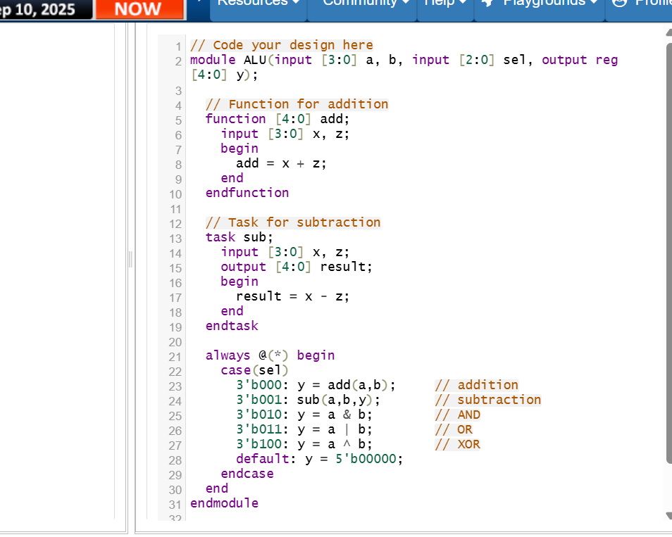

2) Write Verilog Code for demux 1*8 using compiler directives
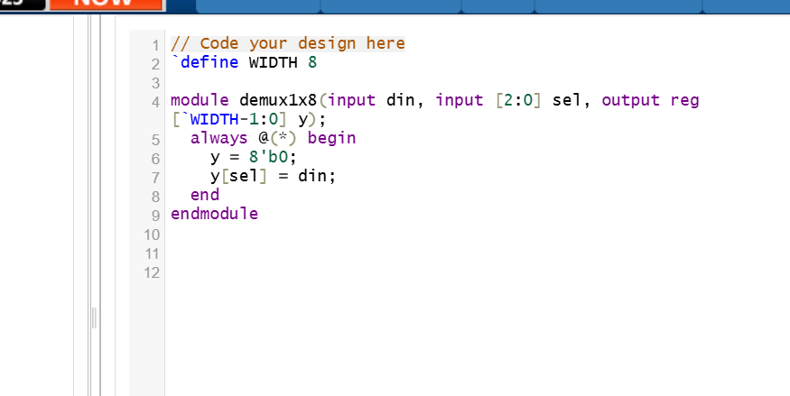

3) Write Verilog Code for full adder the circuit diagram using parameter
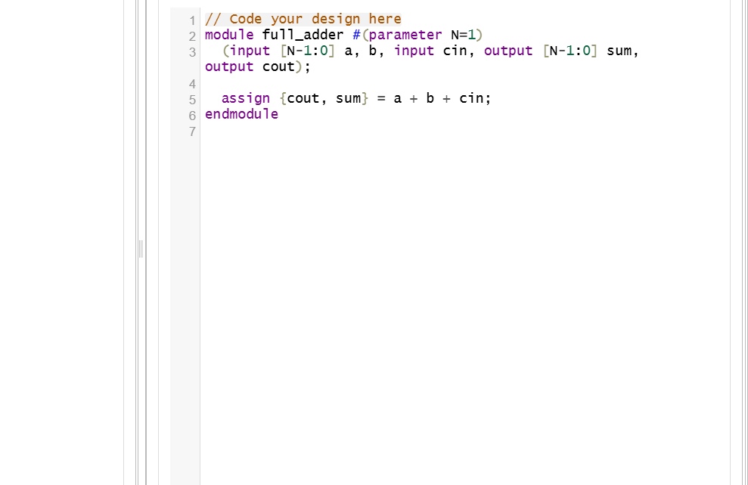
4) Write Verilog code for swapping two variables using blocking and non blocking assignments.
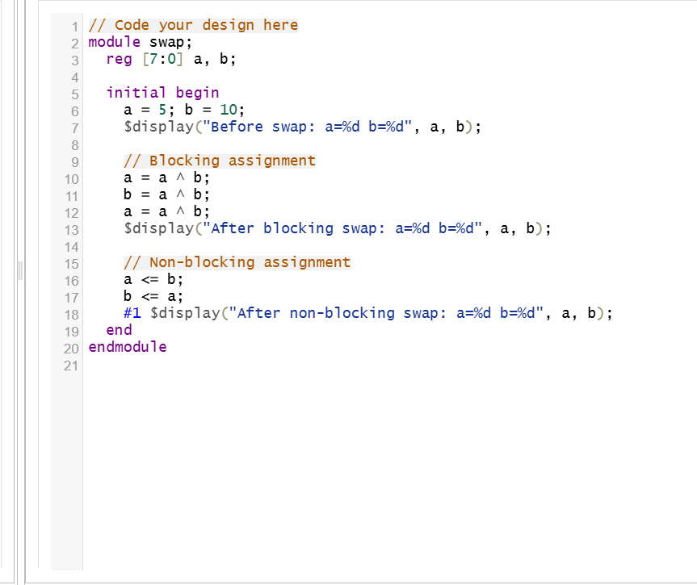

5) Write Verilog code for updowncounter using loops.
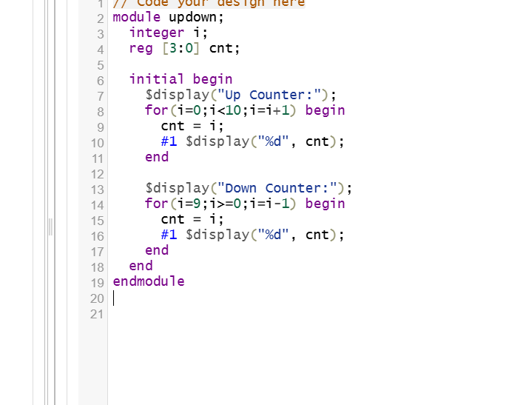

6) Write a Verilog code for implementing PIPO(PARALLEL IN PARALLEL OUT).
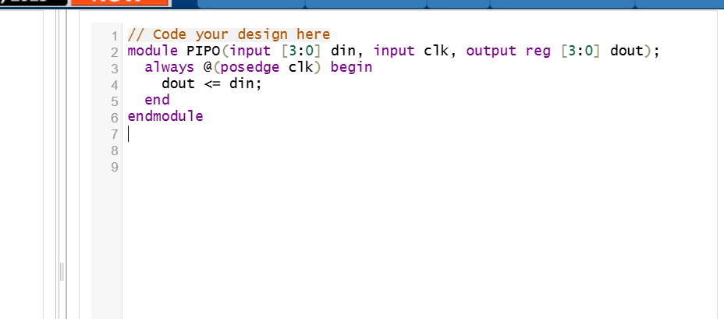

7) Write a Verilog code for generating 100 random numbers
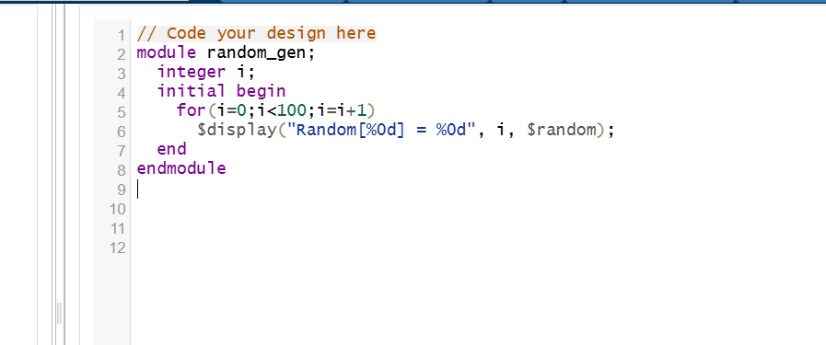

8) Write a task to add two numbers with a delay
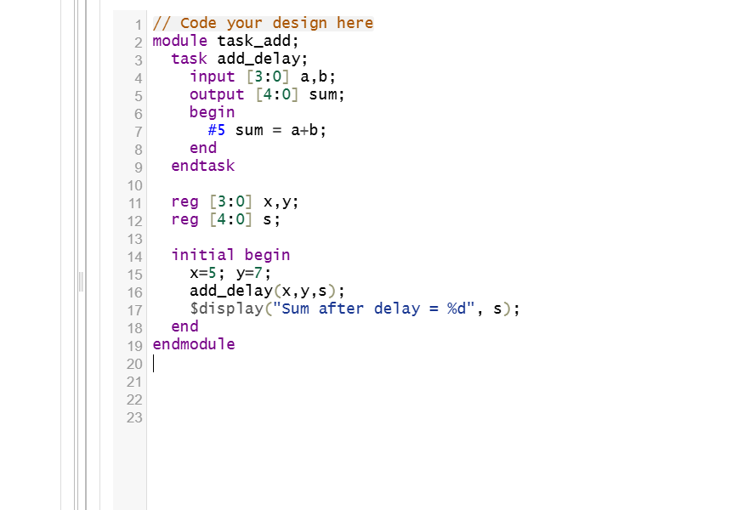

9) Write a Verilog code for Sequence detector for detecting the sequence 1010.
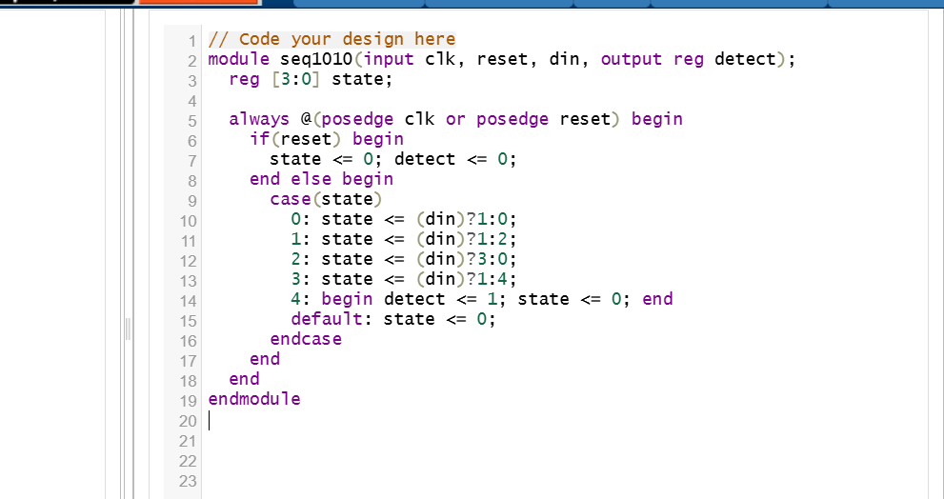

10) Write a Verilog code that uses a task to generate stimulus for a 4-bit counter testbench. The task should apply reset and toggle the clock.
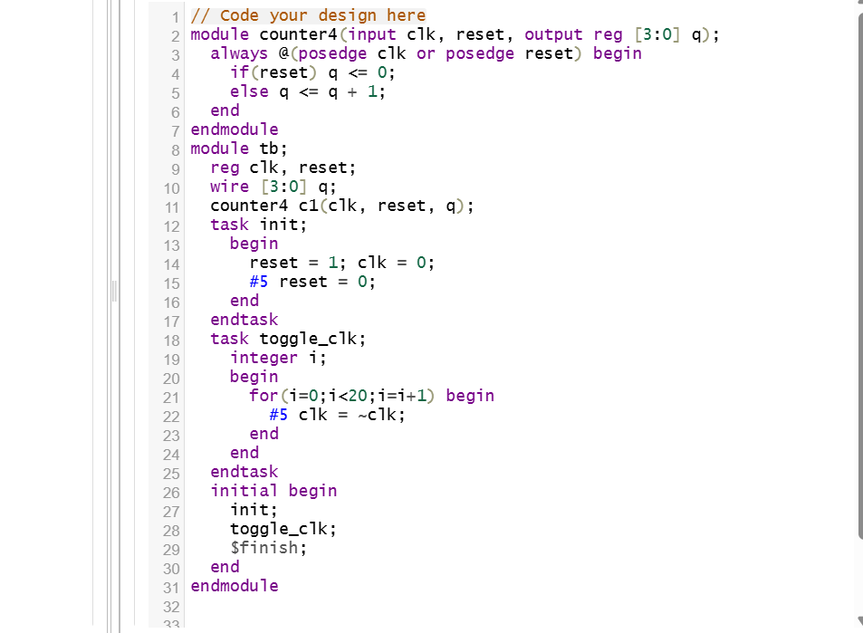

SAHMA.M
311123106055
ECE

