TECHNICAL REPORT
TaskTrail
A Cloud-Based Workforce Task Management System
Team-based task assignment, execution, and oversight — deployed live across web and mobile.

Team | Vitoria De Oliveria Lima · Rayna Alexandre-Petrie · Ximena Jara Cordero · Hardik Saini
Course | CSC 4311 — Section 17369
Instructor | Bingyi Xie
Date | 15 April 2026
Live Web | https://tasktrail.site
Live API | https://api.tasktrail.site/health

Cloud Computing Project · Spring 2026

Executive Summary
TaskTrail is a cloud-deployed task coordination platform that gives small teams a single, honest source of truth for the work they own. Managers define teams, generate join access, assign tasks, and monitor progress; employees join teams, see what is assigned to them, update progress, and close work through the same domain model on both web and mobile. The system is live at tasktrail.site and exposes its backend at api.tasktrail.site, backed by an Oracle Cloud Infrastructure virtual machine running a containerized Node.js + Express API behind the Caddy reverse proxy.
The architecture emphasizes correctness over breadth. A shared REST contract keeps business rules in one place, a strict six-layer backend (route → controller → validator → service → repository → database) isolates responsibilities, and a managed data plane built from Supabase Postgres, Supabase Auth, and Resend-backed SMTP removes classes of operational risk that would otherwise dominate an undergraduate project. Deployment is automated end-to-end: pushing to main runs tests, builds a Docker image, publishes it to GHCR, pulls it onto the OCI VM over SSH, restarts the container behind Caddy, and verifies the public /health endpoint before declaring a release successful.
This report documents TaskTrail against the course rubric: motivation, system design, implementation, basic evaluation, engineering challenges, and conclusion. It is written as a technical systems report rather than an essay, so architectural decisions, layering, CI/CD flow, and evaluation findings are organized to be quickly read and referenced.

Project Snapshot
The table below summarizes the concrete technology surface of the system as deployed today.
FRONTEND | BACKEND | DATA · AUTH | EMAIL
Static SPA hosted on Vercel · tasktrail.site | Node.js 22 + Express 5 in Docker on OCI | Supabase Postgres · Supabase Auth | Resend-backed SMTP for verification
MOBILE | CI / CD | EDGE | SCOPE
Flutter Android client · shared backend contract | GitHub Actions → GHCR → OCI → health probe | Caddy reverse proxy · HTTPS · api.tasktrail.site | Undergraduate cloud computing project

Table of Contents
Executive Summary 2
Project Snapshot 2
1 · Motivation 4
2 · System Design 4
3 · Implementation 7
4 · Basic Evaluation 10
5 · Challenges 11
6 · Conclusion 12
Appendix A · System References 12

FIGURES IN THIS REPORT
Figure 1 High-level system architecture 5
Figure 2 Backend request lifecycle 6
Figure 3 Core domain entities 7
Figure 4 End-to-end product flow 9
Figure 5 CI/CD pipeline 9

1 · Motivation

1.1 The Coordination Problem
In small teams, ownership of work is rarely lost because people are unwilling — it is lost because the system of record is scattered. Assignments live inside chat threads, follow-ups live in email, deadlines live in private calendars, and status lives in someone's head. The cost is predictable: tasks fall through cracks, managers cannot answer basic questions about progress, and employees do not have one place to see what they are responsible for. The overhead is not technology: it is the absence of a shared surface for team work.
TaskTrail was built to address this problem directly by giving teams a focused cloud system for team task assignment and execution. Rather than adopt the surface area of a productivity suite, the product is deliberately narrow — teams, tasks, assignments, updates, recurring rules, and the two views that matter most to a manager: the dashboard and the worker tracker.

1.2 Why This Project Matters
Beyond the product goal, TaskTrail matters as a course project because it stitches together the full set of cloud computing concepts required to operate a real multi-client system: a managed database, managed authentication with real verification email, a containerized backend running on a rented VM, a reverse proxy terminating TLS on a custom domain, a static frontend on a global edge network, a second client on a different runtime sharing the same API, and an automated deployment pipeline with health verification. Making those pieces agree end-to-end is the actual exercise.

1.3 What Success Looks Like
- A manager can create a team, generate a join link, and assign a task that an employee sees on both web and mobile within seconds.
- Authentication is real: users receive a verification email before they can sign in, and the backend enforces role-based access on every request.
- Deployment is automated: a merge to main results in a fresh production container or a blocked rollout — never a half-deployed system.
- Correctness is testable: the backend's validators, services, and repositories have unit and integration coverage, and the production API responds to live smoke checks.

2 · System Design
TaskTrail is designed around one shared backend that serves two clients. Both the web frontend and the Flutter mobile app speak the same REST contract; business rules, validation, authorization, and database access live in the backend, and the clients are kept deliberately thin. This choice prevents the two clients from drifting into two different products and keeps invariants in one place.
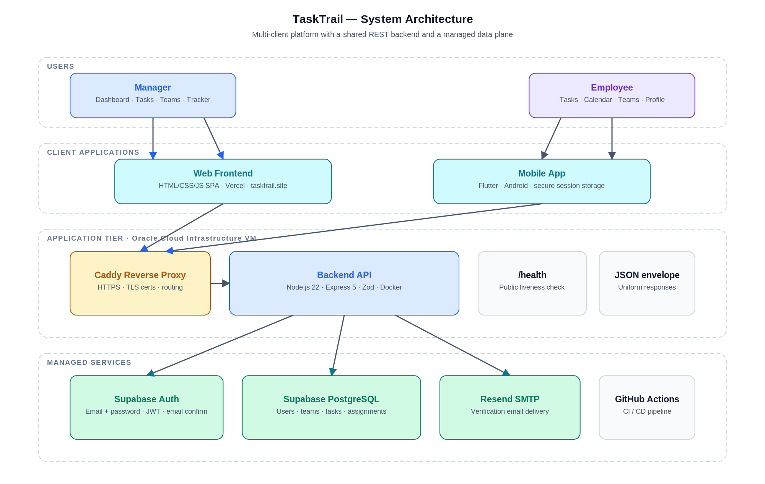
Figure 1. High-level system architecture. Users interact with one of two clients; both call the same REST API running on an OCI VM behind Caddy, which in turn communicates with the managed data plane.

2.1 Tiers
Presentation tier. The web frontend is a static HTML/CSS/JavaScript single-page application hosted on Vercel and served from tasktrail.site. Routing is hash-based, role-aware, and shares a small component library across Manager and Employee pages. The Flutter mobile app is a second independent client that targets the same backend contracts using dio for HTTP and go_router for role-aware navigation.
Application tier. The backend is a Node.js 22 + Express 5 API that runs as a Docker container on an Oracle Cloud Infrastructure virtual machine. Caddy sits in front of the container and handles TLS termination, automatic certificates, and routing to api.tasktrail.site. A public /health endpoint is used for liveness verification during deployment and for external monitoring.
Data and identity tier. Application data lives in Supabase-managed PostgreSQL. Authentication is provided by Supabase Auth with email and password, email confirmation, and JWT-based sessions. Verification email is delivered through a Resend-backed SMTP configuration that makes signup feel like a real product rather than a classroom simulation.

2.2 Backend Layering
The backend follows a strict six-layer structure. Each HTTP request passes through the same pipeline, and each layer owns exactly one concern. The result is a codebase where authentication, authorization, validation, business rules, and data access are separated cleanly enough that a new developer can find any piece of behavior in one place.
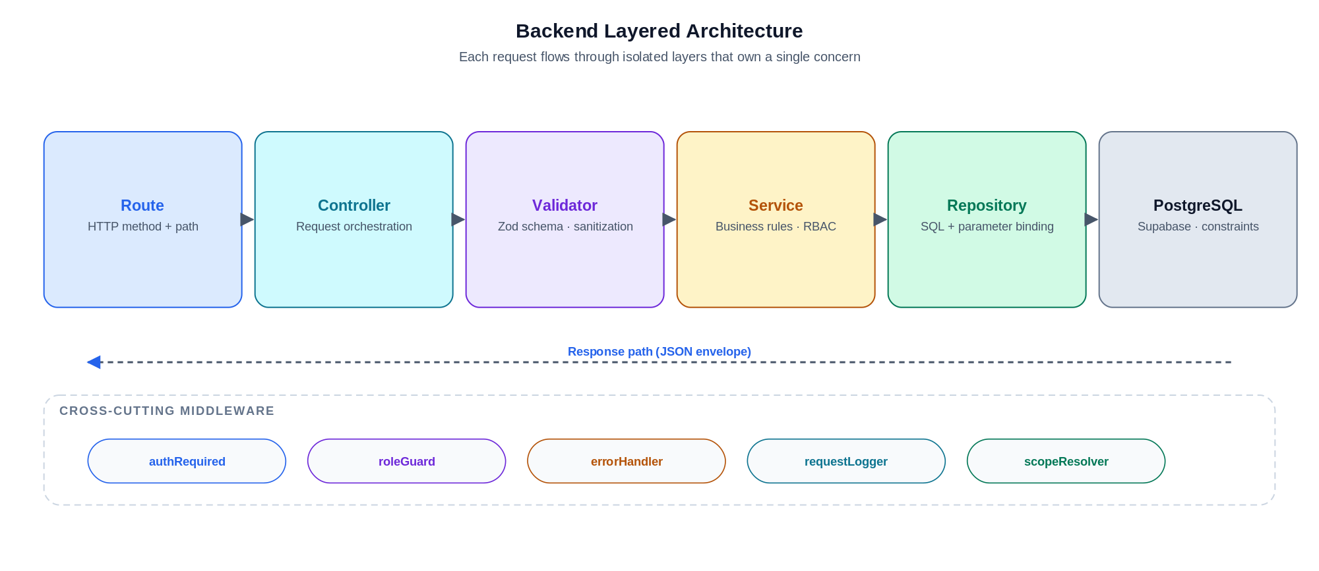
Figure 2. Backend request lifecycle. Cross-cutting middleware wraps the layer stack; the response returns through the same pipeline in reverse, wrapped in a uniform JSON envelope.
- Route. Declares the HTTP method and path and binds to the controller.
- Controller. Orchestrates the request, forwards validation, and shapes the response envelope.
- Validator. Runs a Zod schema that rejects malformed bodies and enforces type safety before any business logic runs.
- Service. Holds business rules — what a manager may do, what an employee may change, how assignments transition — independent of HTTP.
- Repository. Owns SQL. All parameters are bound, and queries are scoped to the requesting user's teams.
- PostgreSQL. Enforces the final layer of invariants with CHECK constraints, unique indexes, and foreign keys.

2.3 Roles and Access
TaskTrail has two first-class roles: Manager and Employee. Role is a property of the user, not of the client; both the web and mobile experiences adjust automatically. Managers see Dashboard, Worker Tracker, Tasks, Teams, and Profile; employees see Tasks, Calendar, Teams, Join Team, and Profile. Role is enforced server-side on every request through a dedicated roleGuard middleware, not derived from client-side state.

2.4 Domain Model
The data model is intentionally compact. Teams are the unit of scope; memberships are durable so a user can leave and rejoin without losing history; tasks belong to a team and flow through a finite set of statuses; assignments are first-class entities so the same task can be reassigned over time; updates preserve a trail of progress; and recurring rules generate real task instances rather than maintain parallel schedules.
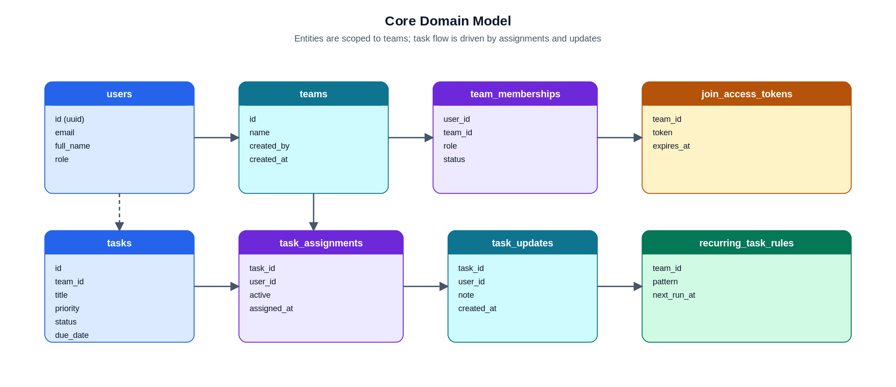
Figure 3. Core domain entities and their relationships. Team membership is the root of scope; assignment, update, and recurring rules drive task flow.

3 · Implementation

3.1 Web Frontend
The web client is a single static bundle shipped from Vercel. It avoids a heavy framework so that routing, state, and rendering are easy to reason about for a project of this size. Navigation uses hash-based routes; a small shared UI layer provides toasts, modals, loading skeletons, and forms; and role-aware guards hide pages the current session is not authorized to see. The manager surface includes Dashboard, Worker Tracker, Tasks, Teams, and Profile; the employee surface includes Tasks, Calendar, Teams, Join Team, and Profile.

3.2 Backend API
The API is built on Node.js 22 and Express 5. Incoming requests pass through authRequired, roleGuard, and request logging middleware before hitting the route layer. Zod validators reject malformed input early; services enforce business rules and team scoping; repositories speak SQL through the pg driver with parameter binding; and every response is wrapped in a consistent { ok, data, error } envelope. Endpoints cover authentication, user profiles, teams and memberships, team join flows, task CRUD, task assignment, task updates, manager dashboard summaries, worker tracker, and recurring task rules.

3.3 Authentication and Email Verification
Authentication is handled entirely through the backend. Users sign up through an API endpoint that provisions a Supabase Auth account and sends a verification email via Resend-backed SMTP. The user cannot sign in normally until their email is confirmed. On login, the backend verifies the token, loads the application-level profile, and returns a session the clients store securely. This design prevents the clients from talking to Supabase directly and keeps one single place where identity rules are enforced.

3.4 Database
PostgreSQL hosts the operational data model described in §2.4. Constraints are enforced at the database layer wherever possible: task status and priority are validated by CHECK constraints, active assignments are enforced by partial unique indexes, membership lifecycle events respect foreign key relationships, and recurring task rules reference their owning team. Keeping invariants at the database layer means even a hypothetical bug in the service layer cannot persist a row that violates the contract.

3.5 Mobile Client
The Flutter app is a fully independent client that uses dio for HTTP, go_router for role-aware navigation, and secure session storage for persistent login. It implements the employee flows — Join, Tasks, Calendar, Teams, and Profile — and the manager flows — Teams, Tasks, Recurring, Dashboard, Worker Tracker, and Profile — against the same backend contract. By treating the mobile client as a separate codebase that happens to call the same API, the project avoids the fragility of a web-view wrapper while keeping business logic out of the client entirely.
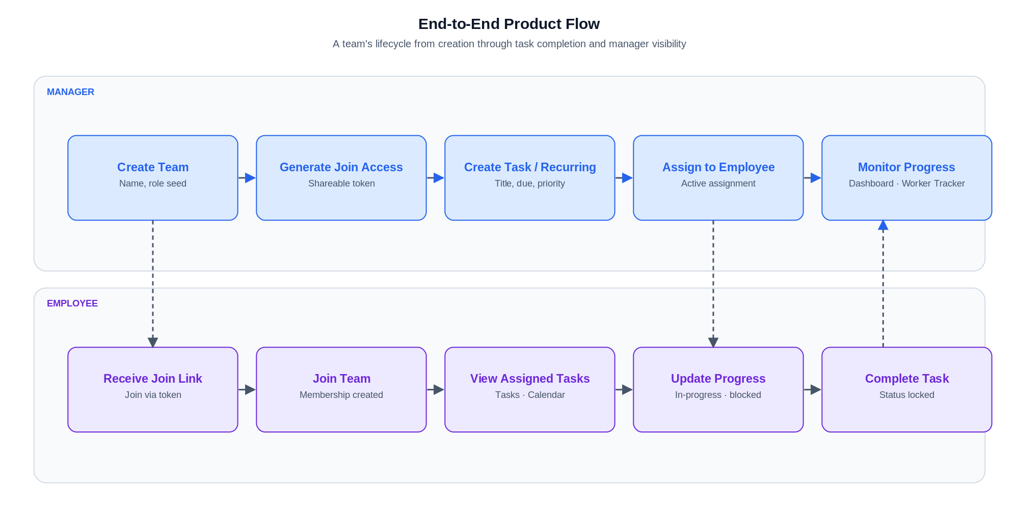
Figure 4. End-to-end product flow across roles. Dashed arrows cross the role boundary; solid arrows are within-role transitions. Together these movements form the basic lifecycle of a team.

3.6 Deployment and CI/CD
Deployment is automated and verifiable. The frontend is deployed by Vercel on every push to main. The backend is more involved because it runs on the team's OCI VM, but it is equally hands-off in practice: a push to main triggers a GitHub Actions workflow that runs backend tests, builds a Docker image, tags it, and pushes it to the GitHub Container Registry. The workflow then opens an SSH session to the OCI VM, pulls the new image, restarts the container behind Caddy, and finally issues a health check against the public API before declaring the rollout successful.
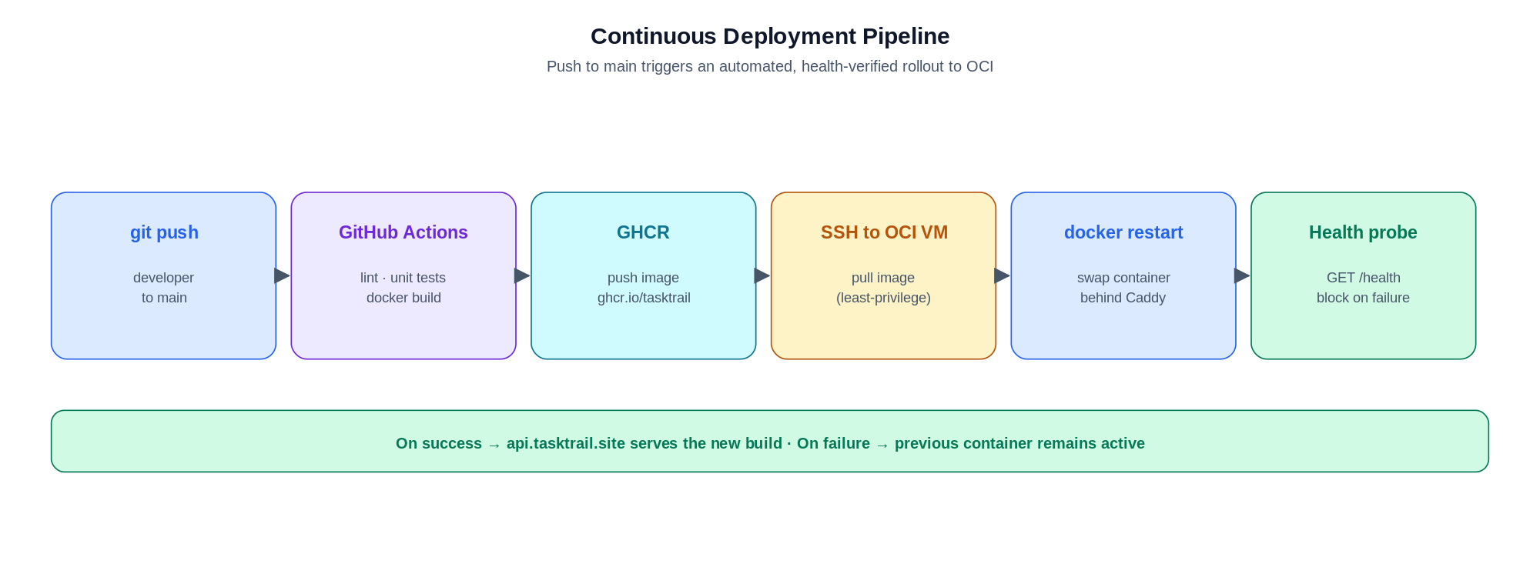
Figure 5. Backend continuous deployment pipeline. Every stage must succeed for the rollout to proceed; a failed health probe leaves the previous container running.
The workflow has two important properties. First, the entire pipeline is declarative and lives alongside the application code, so the deployment is reviewed the same way as any pull request. Second, because the health probe is the last gate, a broken build cannot quietly replace a healthy production container.

4 · Basic Evaluation
Evaluation for TaskTrail targets correctness and completeness rather than large-scale performance. The project is undergraduate in scope, and the goal of evaluation is to demonstrate that the system does what it claims, on the cloud, across both clients.

4.1 Backend Testing
The backend carries tests across the full stack: validators reject malformed input, middleware correctly authenticates and authorizes, services enforce role and team scoping, repositories return the expected rows, and routes wrap everything in the standard response envelope. Error paths are exercised alongside success paths, including 401, 403, and 422 responses where appropriate.

4.2 Live Smoke and Deployment Verification
Beyond unit and integration tests, the project runs live checks against the deployed API. The /health endpoint is probed after every rollout. A scripted smoke test signs in as seeded users, calls /auth/me to confirm session restoration, and verifies manager-only endpoints reject non-manager roles. Deeper audit tooling cross-checks that the authentication store, the application profile table, and team membership records stay consistent.

4.3 Web Validation
The web application is validated through both manager and employee journeys. Manager validation covers team creation, join access generation, task creation, recurring task creation, task assignment, Worker Tracker drilldown, and dashboard visibility. Employee validation covers login, joining a team via access token, viewing assigned tasks, updating task progress, completing tasks, viewing due dates in Calendar, and editing profile information.

4.4 Mobile Validation
The mobile client is validated with Flutter unit tests, widget tests, integration tests, emulator runs, and production API wiring. Mobile validation confirms the auth flow, session restore across app launches, employee join and task flows, employee team and calendar flows, manager team and task flows, recurring flow, dashboard and Worker Tracker flow, and profile load and save.

4.5 Bugs Found and Resolved
A disciplined evaluation also catches the real bugs that a systems project tends to accumulate. Concrete defects identified and fixed during development included stale local team state in the web UI, login and verification routing mismatches, role-guard issues around join flows, date-format validation problems during task creation, Worker Tracker default-selection problems, stale modal state, mobile controller lifecycle issues, mobile session persistence problems, unrealistic recurring demo data, and a deployment permission issue where the deploy user could not safely access a root-owned environment file on the OCI VM. Each was root-caused in the appropriate layer rather than patched at the UI.

5 · Challenges

5.1 Keeping the Product Focused
An earlier iteration of the backend carried areas such as hours logging, productivity metrics, and goals. Narrowing the promoted system to teams, assignment, execution, recurring work, calendar visibility, and manager oversight was the single most valuable decision in the project. The live surface became easier to describe, test, and demonstrate, and the architecture diagrams stopped fighting themselves.

5.2 Real Authentication
Supporting real authentication — rather than a classroom-only login form — required several pieces to agree. Supabase Auth had to be reachable from the backend with the correct service key; the backend had to provision and retrieve a paired application profile; the frontend had to redirect correctly after email confirmation; and the SMTP configuration had to deliver real email from a real sender domain through Resend. The final flow is opinionated: a user cannot sign in until their verification email has been confirmed.

5.3 Durable Team Membership
Membership is more than a join table. Users need to leave and rejoin teams without losing history, managers need to distinguish a current member from a former one, and join-access tokens need a lifecycle independent of the memberships they create. TaskTrail models membership as a durable record with explicit lifecycle events, which maps to real team behavior more honestly than a bare association would.

5.4 Keeping Two Clients Consistent
The web and mobile clients are intentionally different experiences, but they cannot diverge on the underlying rules. The project addressed this by refusing to put business logic in either client. Both go through the same endpoints, and both receive the same response shapes. When a rule changes, it changes once, server-side, and both clients pick it up.

5.5 Recurring Work Without a Separate Scheduler
Recurring tasks were introduced without turning the project into a scheduling product. The chosen approach is pragmatic: recurring rules generate real task instances, which then flow through the same assignment, update, worker tracker, and calendar machinery as any other task. This avoids parallel code paths and keeps generated work visible using the same primitives.

5.6 Cloud-Native Deployment
Running on OCI, behind Caddy, inside Docker, and updated from GitHub Actions introduced several operational concerns that classroom projects usually avoid. Secret handling had to use environment files owned by root while the deploy user remained non-root; the deployment script had to be adjusted so the backend container could read the environment file without widening file permissions. Caddy's automatic TLS removed an entire category of certificate management, but still required the DNS records for tasktrail.site and api.tasktrail.site to match the VM's public IP.

6 · Conclusion
TaskTrail is a complete, cloud-deployed undergraduate project that demonstrates full-stack design, role-aware workflows, durable persistence, real authentication with verification email, two clients against one backend, and an automated deployment pipeline with health verification. The strongest property of the project is its coherence: every piece — users, teams, memberships, tasks, assignments, updates, recurring rules, dashboard, worker tracker — serves the same goal of making team work visible, assignable, and trackable.
The project deliberately avoids claims about graduate-level scalability, synthetic benchmarks, or emergent behavior at scale. What it offers instead is a concrete, live system with a defensible architecture, a disciplined implementation, and an evaluation story that reports what actually happened rather than what would sound impressive. The live endpoints — tasktrail.site for the web frontend and api.tasktrail.site for the backend — are the final exhibit: the system exists, it runs, and it responds.

Appendix A · System References
Surface | Endpoint / Description
Live web frontend | https://tasktrail.site
Live backend API | https://api.tasktrail.site
Health check | GET /health — returns 200 OK when the container is live
Auth provider | Supabase Auth — email + password, verification required
Database | Supabase PostgreSQL
Email delivery | Resend-backed SMTP (verification email)
Container registry | GitHub Container Registry (GHCR)
Deployment | GitHub Actions → SSH → OCI VM → Docker → Caddy → /health probe

