**CSD311 Assignment-5**

**Members of the Team:**

Aditya Srivastava (1910110034) (30%)

Arinjay Srivastava (1910110087) (35%)

Prabhat Kumar Singh Gaur (1910110272) (35%)

**Relationship:**

From the relationship given below of each category with the sales we can see that while the first three categories i.e., Daily Customer, Electronics Item and Groceries Item they are in direct correlation with the sales while competition is inversely related to the sales. So, to assume the sales on the basis of our input we chose the first three as they will provide a simple and direct variation on how the sales depend on it.

We have chosen gauss2mf for the daily customers as they vary in slow ratio as compared to the other ones. This function clearly distinguishes between the bad, average and good quantity of customers. For the Electronics item and Groceries item, we ended up using trapmf. As the amount with which sales increases is quite high in relation with the two inputs. These check on how the increase in the quantity of the electronics and groceries item have affected the sales.

The fuzzy logic helps us to check the sales on a specific day based on more than one input and produce correct and expected results for the final sales value.

The following are the correlations between sales and respective factors:

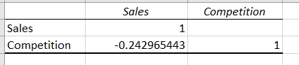

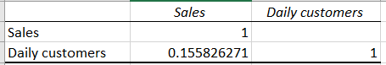

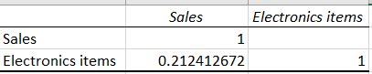

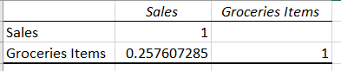

**Screenshots:**

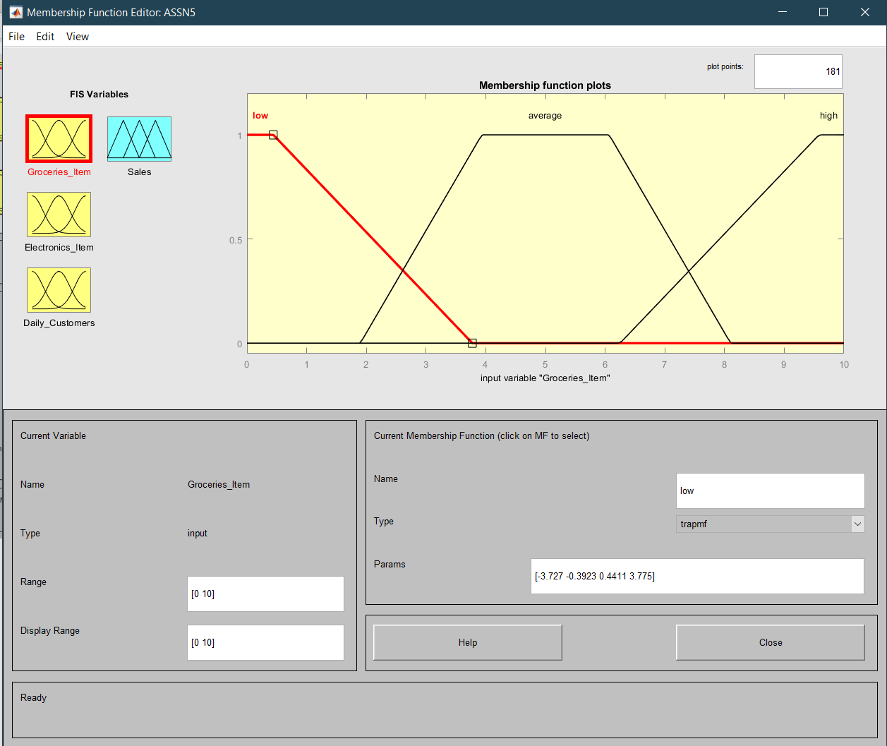

Groceries item plot

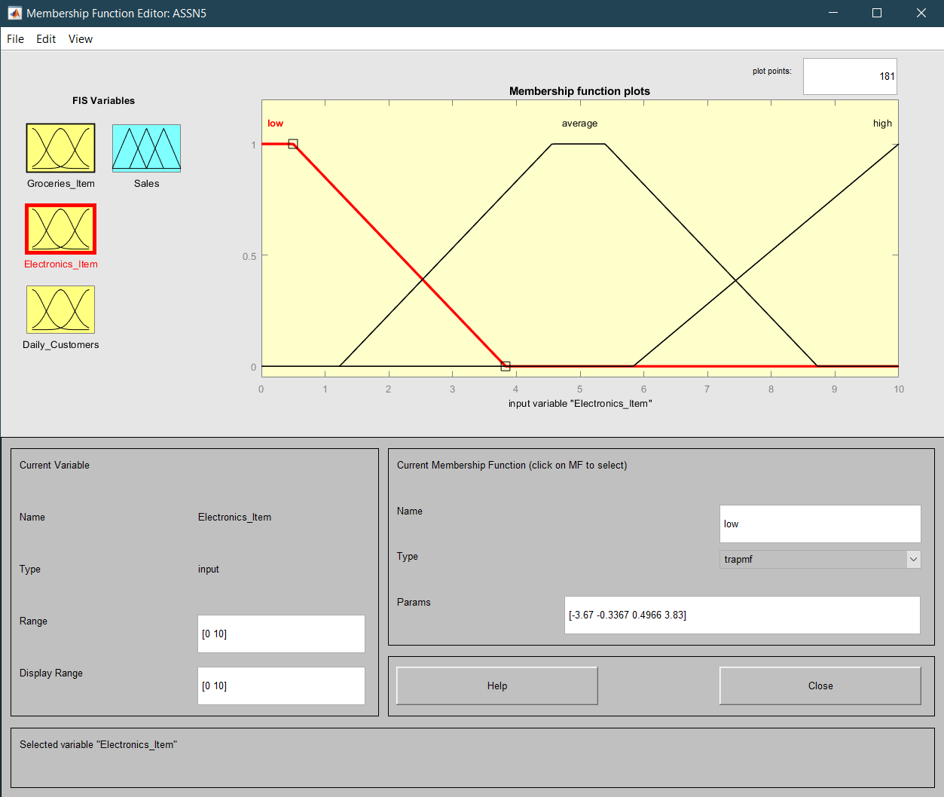

Electronics Item Plot

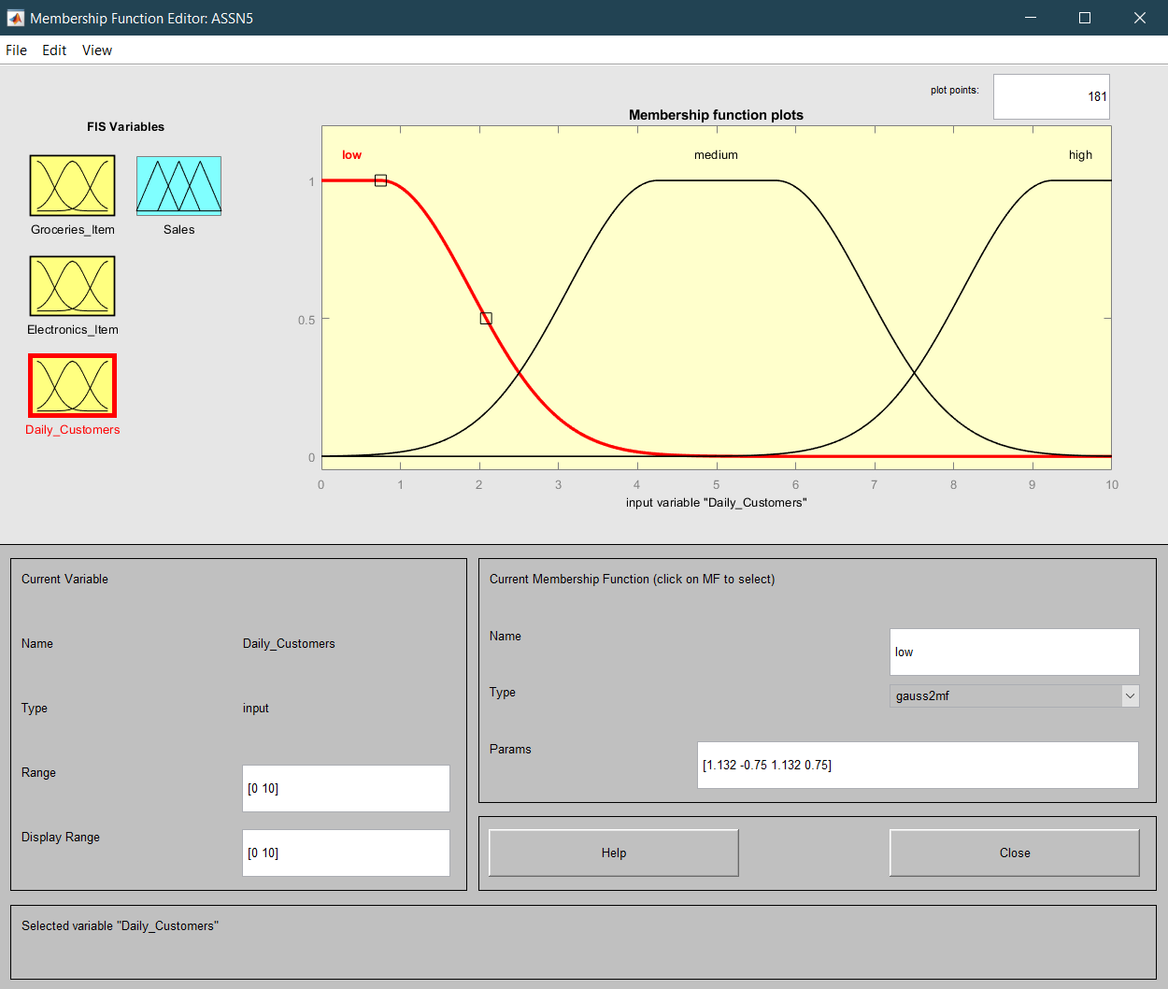

Daily customers plot

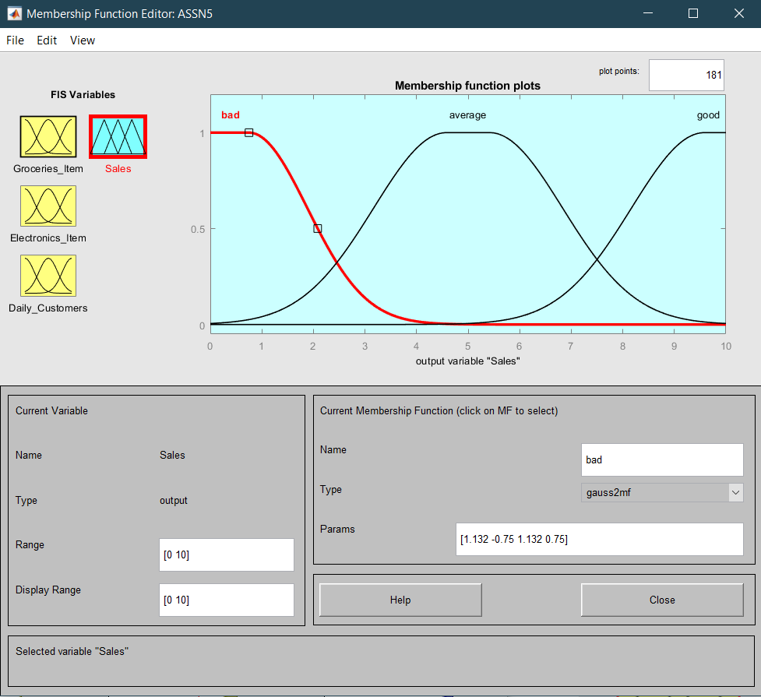

Sales Plot

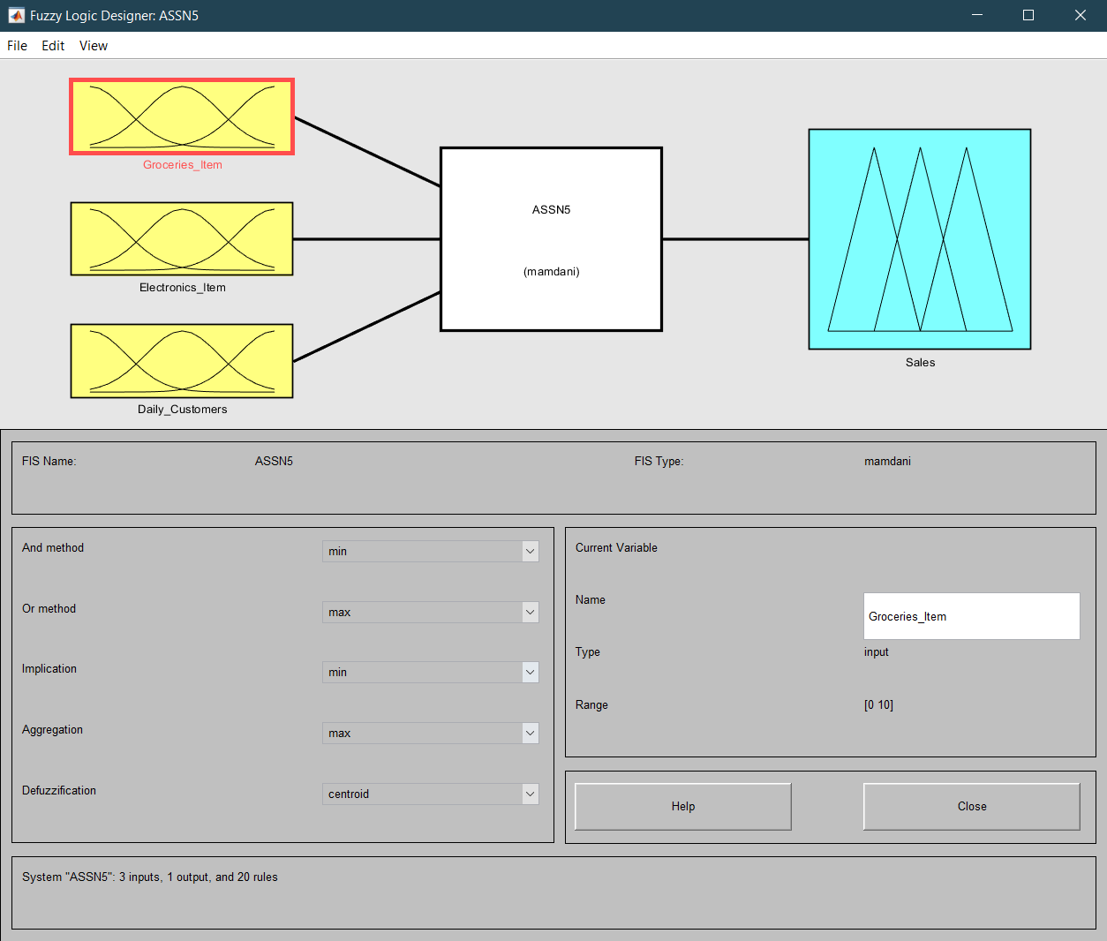

FIS System

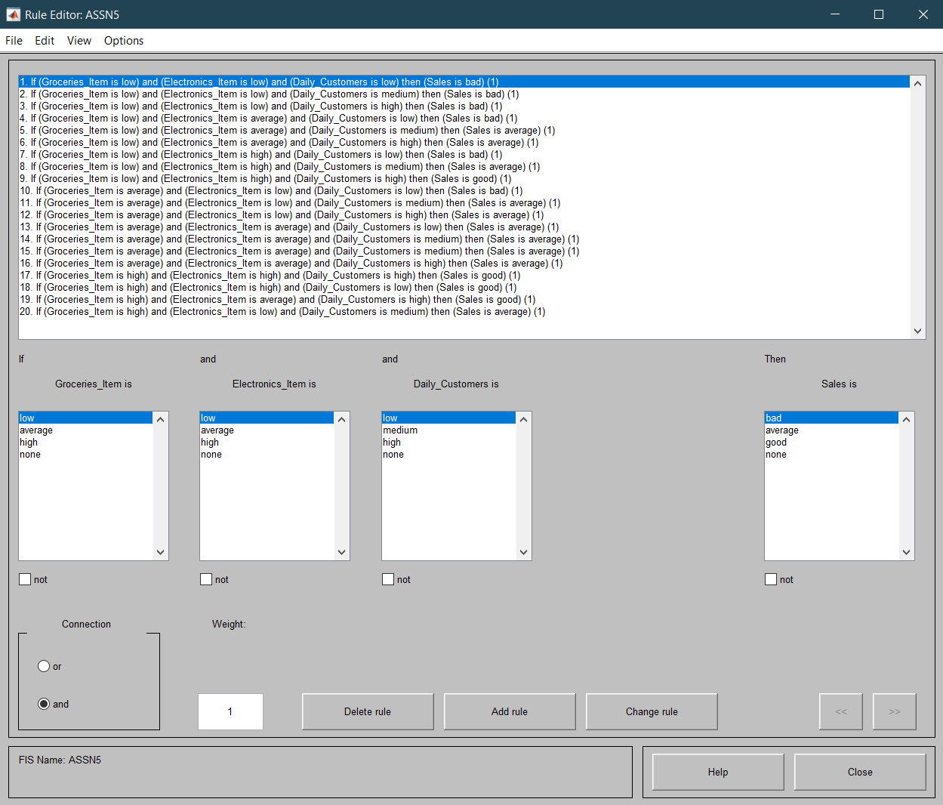

Rules

**OUTPUT FOR TEST INPUT**

1. **INPUT:**

**Groceries_Item: 7**

**Electronics_Item: 1**

**Daily_Customers: 2**

**OUTPUT:**

**Sales: 2.97**

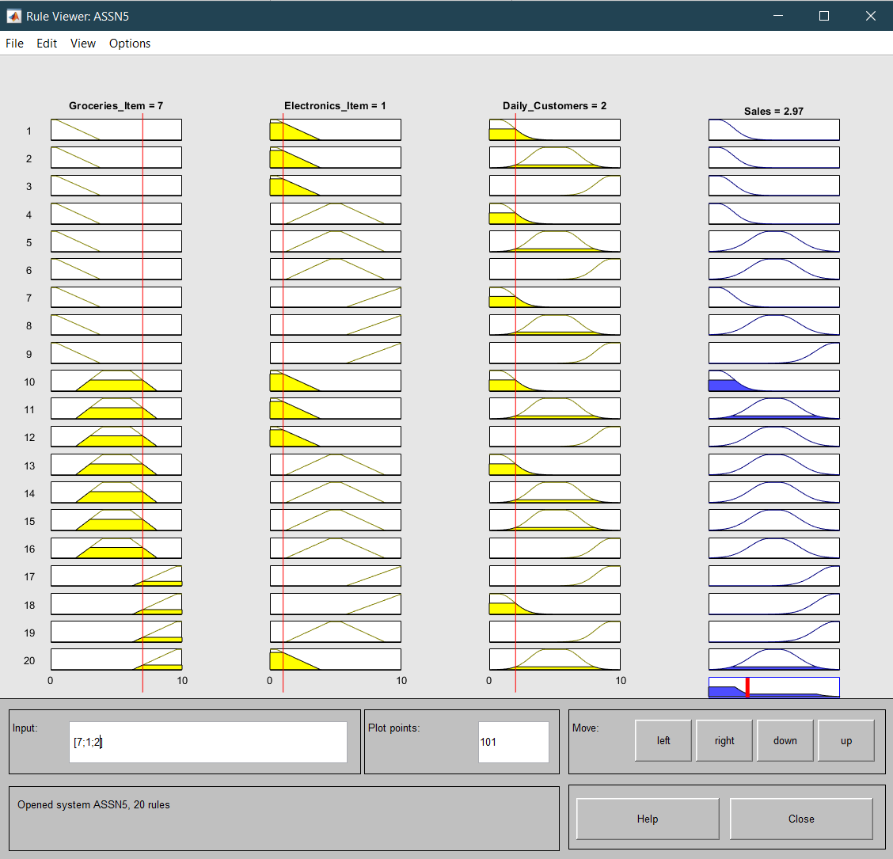

1. **INPUT:**

**Groceries_Item: 10**

**Electronics_Item: 8**

**Daily_Customers: 10**

**OUTPUT:**

**Sales: 8.50**

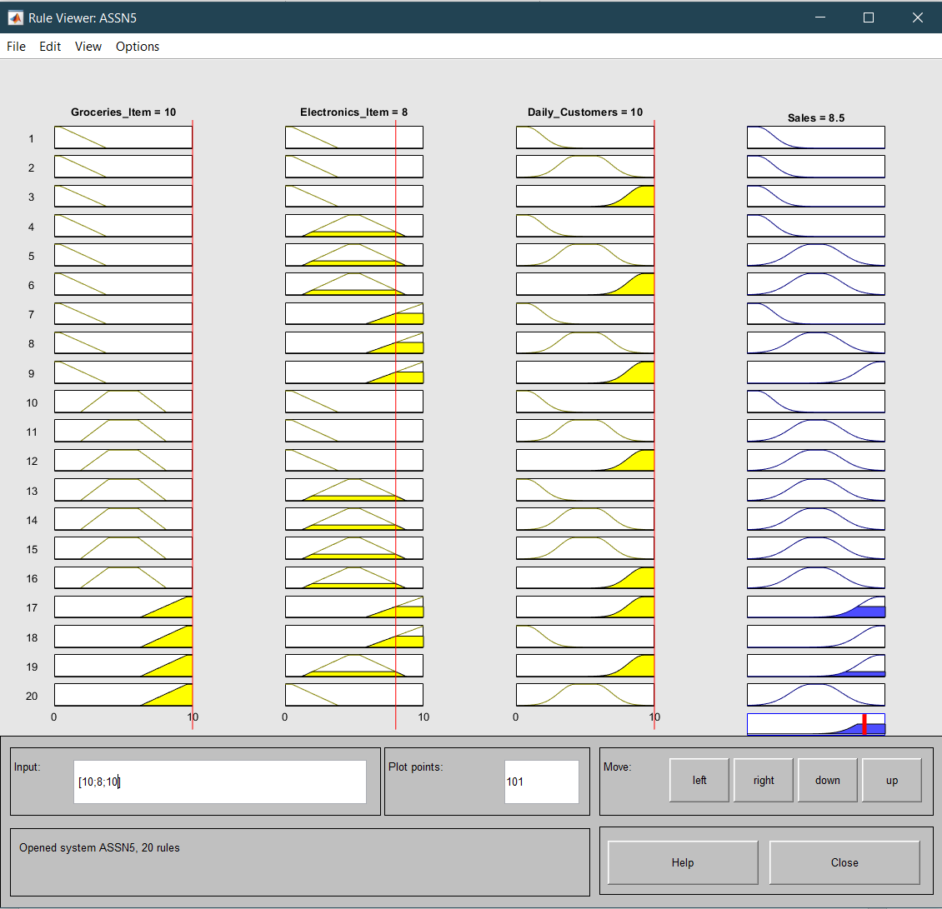

1. **INPUT:**

**Groceries_Item: 1**

**Electronics_Item: 3**

**Daily_Customers: 9**

**OUTPUT:**

**Sales: 4.52**

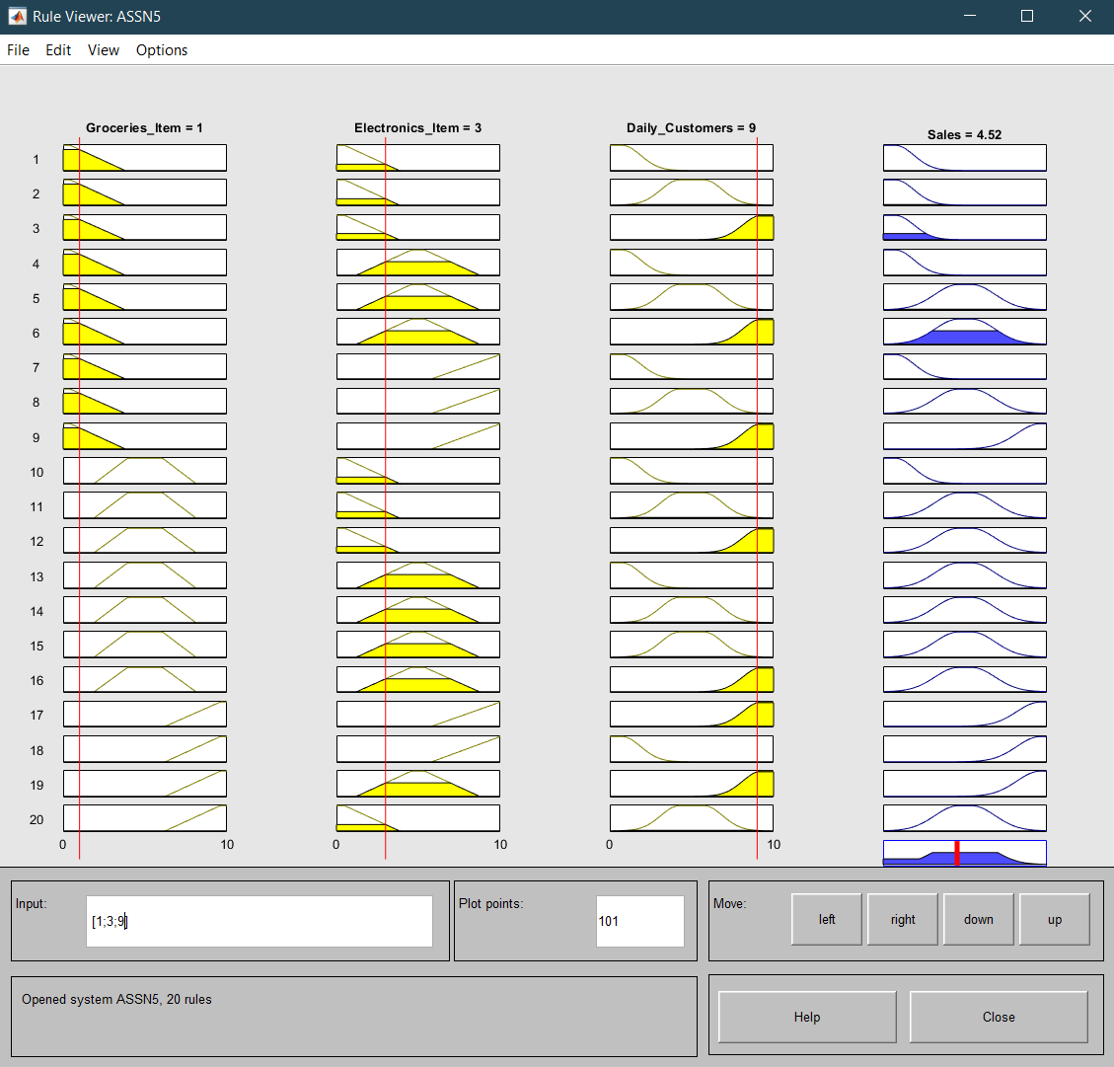

1. **INPUT:**

**Groceries_Item: 2**

**Electronics_Item: 7**

**Daily_Customers: 2**

**OUTPUT:**

**Sales: 3.01**

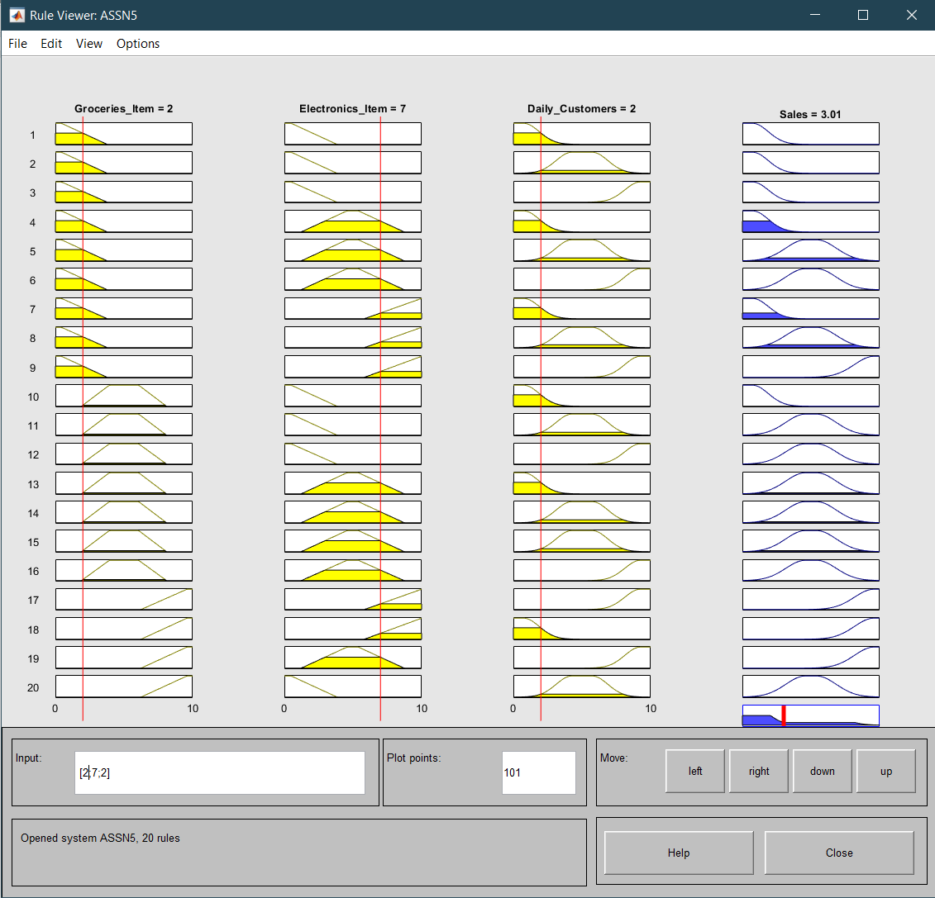

1. **INPUT:**

**Groceries_Item: 0**

**Electronics_Item: 8**

**Daily_Customers: 7**

**OUTPUT:**

**Sales: 5.23**

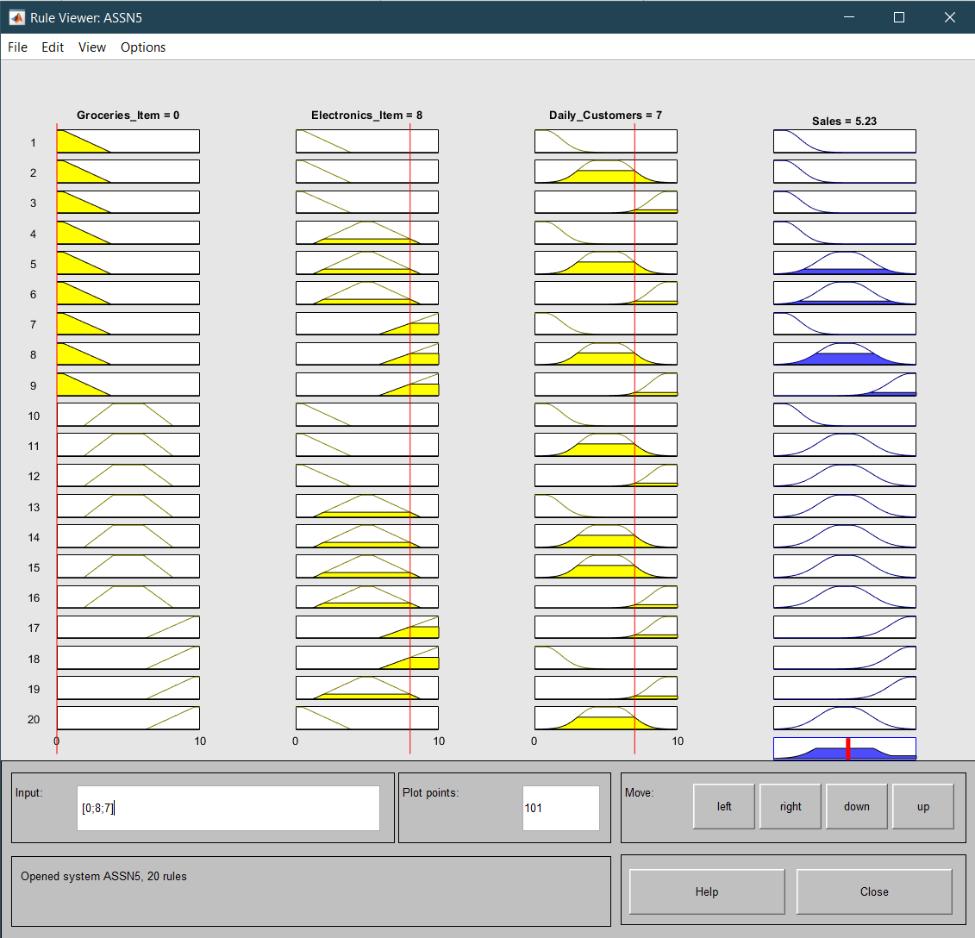

1. **INPUT:**

**Groceries_Item: 3**

**Electronics_Item: 6**

**Daily_Customers: 9**

**OUTPUT:**

**Sales: 5.04**

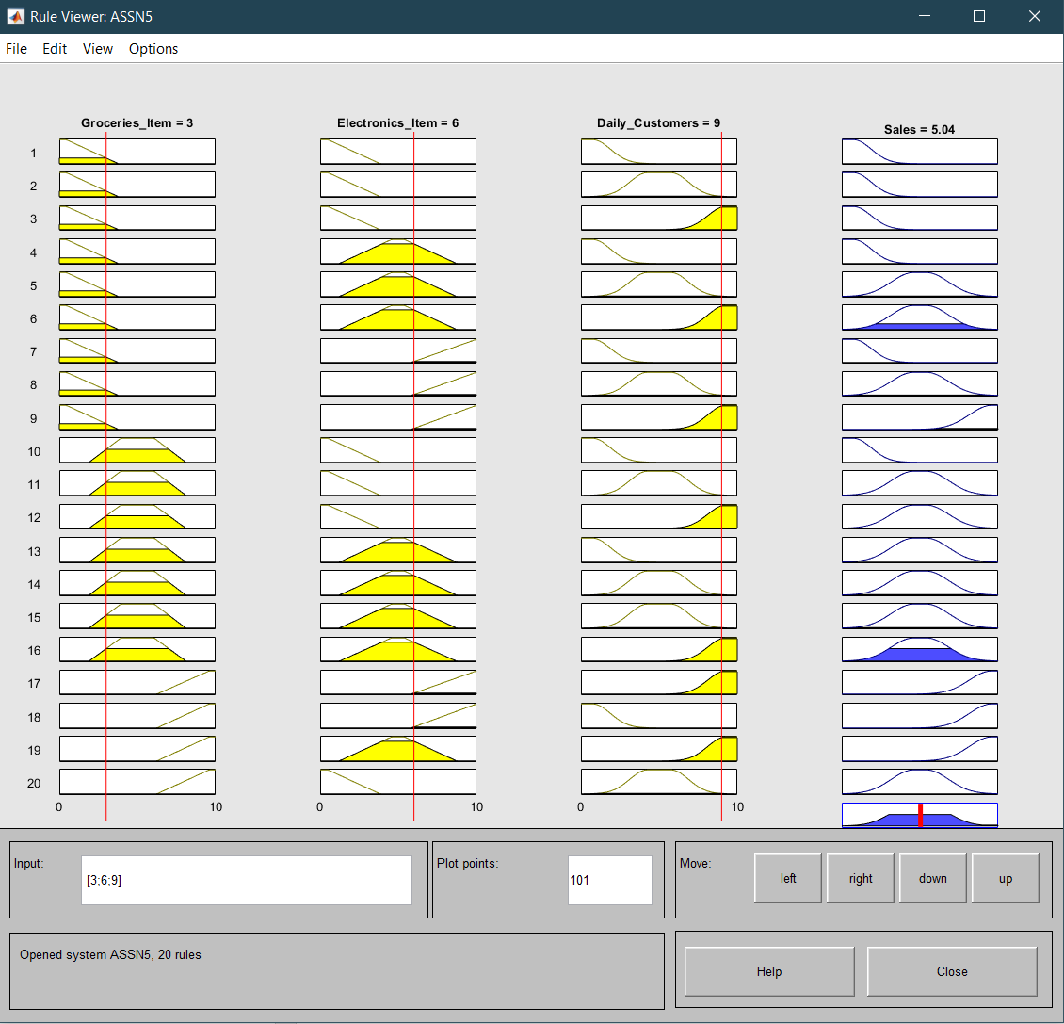

1. **INPUT:**

**Groceries_Item: 8**

**Electronics_Item: 2**

**Daily_Customers: 7**

**OUTPUT:**

**Sales: 5.23**

