**Application of the Method of Harmonic Balance**

**Date Due**: December 15, 2015

**Project Contributors:**

Admir Makas

Alec Blankenship

Shashankashekhar Dutta

ME 7160 Non Linear Dynamics and Vibrations

**Course Instructor**:

Dr. Joseph C. Slater

**Wright State University**

Table of Contents

1. Project Overview 1
2. Applied Models and Results 1
   1. Linear System 1
   2. Duffing Oscillator 3
   3. Van der Pol Equation 4
   4. Determining a Closed form Solution 5
3. Coding 7
4. Conclusions 13
5. Appendix 14

# Project Overview

The objective of this study is to utilize the method of harmonic balance (MHB) to find a solution of a harmonically excited system. The procedure involves finding a solution using FFT and comparing it with an analytical numerical solution. Python is used as the primary software platform for coding the solver routines.

The method is programmed using the following sequence

1. Define number of sample points (N).
2. Identify initial guess (1xN-1 matrix), in most cases just 1.
3. Define fourier transform frequencies given N.
4. Take FFT of initial guess matrix (X).
5. Take IFFT of resultant X to determine derivatives ***ẋ*** and ***ẍ***.
6. Substitute back into governing equation and set = 0 to define a residual function.
7. Use minimization scheme to minimize the residual and determine a one period, steady state solution to the nonlinear system.

It should be noted that using this perturbation method results in a solution that is only obtained over one period and at steady state of the governing system. For this study, four different linear and nonlinear oscillatory systems were reviewed to exhibit the application of the method of Harmonic Balance. The duffing equation and Van der pol oscillator were among the nonlinear systems studied.

# Applied models and results

The governing models used in this study are described in the following sections. To start, a linear system that has a known solution was used to write the python script that utilized the method of harmonic balance. The program was later adapted for more complex nonlinear systems. All codes used in each of the presented systems are available in the “Coding” section of the report. A sample MATLAB code is also provided in the appendix.

## Linear system

The initial linear system used to develop the initial code is given by the following equation:

$$\ddot{x}+ \dot{x}+x=\operatorname{Cos}\left(2t\right)Sin(5t)$$

The governing equation was found to have a solution of the form:

$$x=A*Cos\left(2t\right)Cos\left(5t\right)+B*Sin\left(2t\right)Sin\left(5t\right)+C*Cos\left(2t\right)Sin\left(5t\right)+D*Sin\left(2t\right)Cos\left(5t\right)$$

$$A= -\frac{3785}{171769};B= -\frac{3274}{171769};C= -\frac{11164}{171769};D=\frac{7660}{171769}$$

Using the method of harmonic balance, an approximate solution is found plotted over the analytical solution determined for this system for to show the accuracy of the method of harmonic balance. In fig.1 the method of harmonic balance is shown as dot points while the analytical solution is the dashed lines.

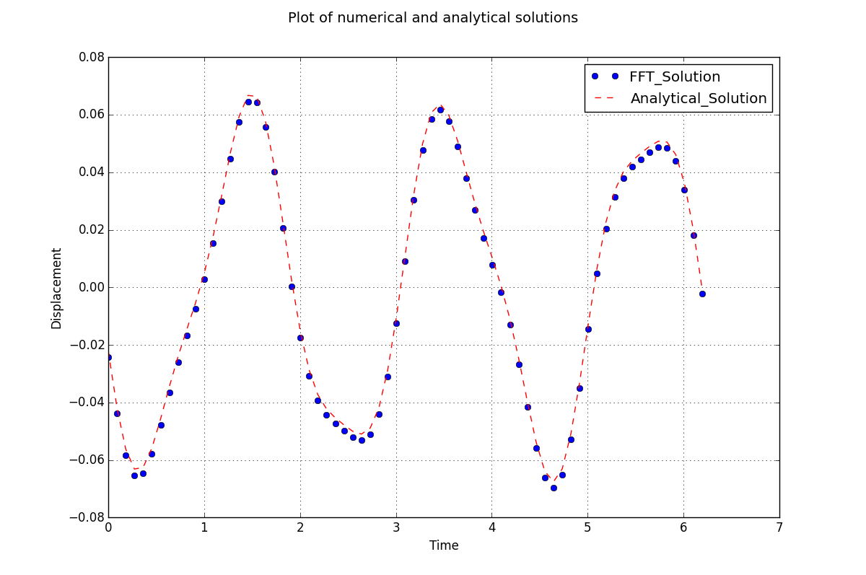

Figure 1- Method of harmonic balance approximation of linear system

This is a linear model has a unique forcing function which causes the complex oscillatory pattern. The MHB approach shows good agreement with the analytical solution with small negligible fluctuations at different points throughout the period. Depending on the tolerance for error, this perturbation method can be said to sufficiently approximate the governing equations. Since this approach works well with the linear system, the code can be applied to more complex systems.

## Duffing Oscillator

The following is an equation for the duffing oscillator with a unique forcing function. The MHB is used to approximate the system. Since the closed form solution was not found, the numerical solution will be plotted with the MHB solution to show accuracy. The equation is given as:

$$\ddot{x}+\dot{x}+x+x^{3}=Cos\left(2t\right)Sin(5t)$$

The solution is plotted in fig 2. Recall that the solution to the method of harmonic balance is only valid at the steady state condition, hence the shifted x axis values in fig. 2 for the duffing oscillator. The plot shows that the MHB approach yields an appropriate solution since only small deviations from the numerical solution are present.

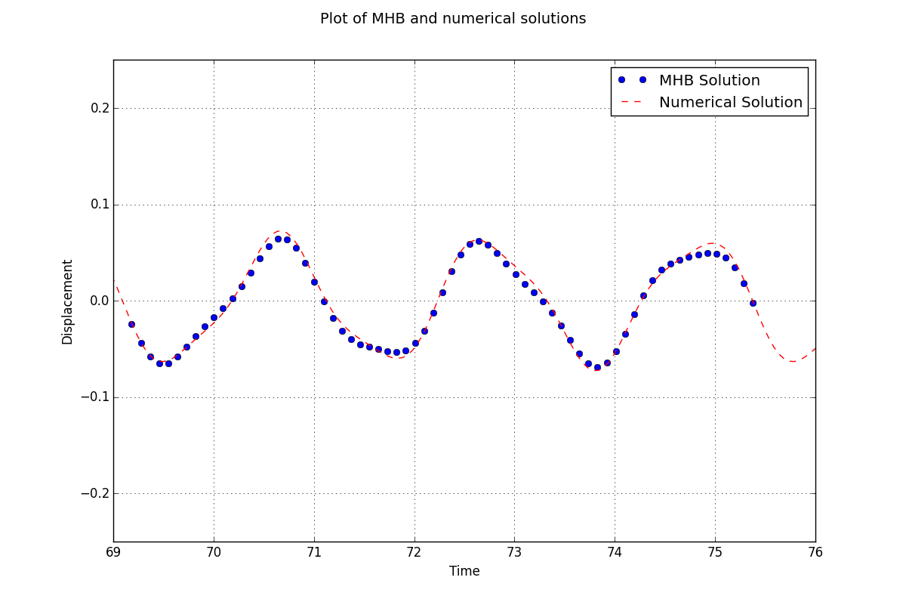

Figure 2- Method of harmonic balance approximation of duffing oscillator

## Van der Pol Equation

Finally, the MHB code was adapted to different variations of the Van der Pol equation. Those variations are different forcing function and are given below.

Variation 1 🡪

Variation 2 🡪

As was done before, the MHB approach was plotted with the numerical solution to determine accuracy. Since this solution has a transient regime, the x axis was shifted such that the MHB was plotted with the steady state regime of the numerical solution. The results for variation 1 and 2 are given in figs. 3 and 4 respectively.

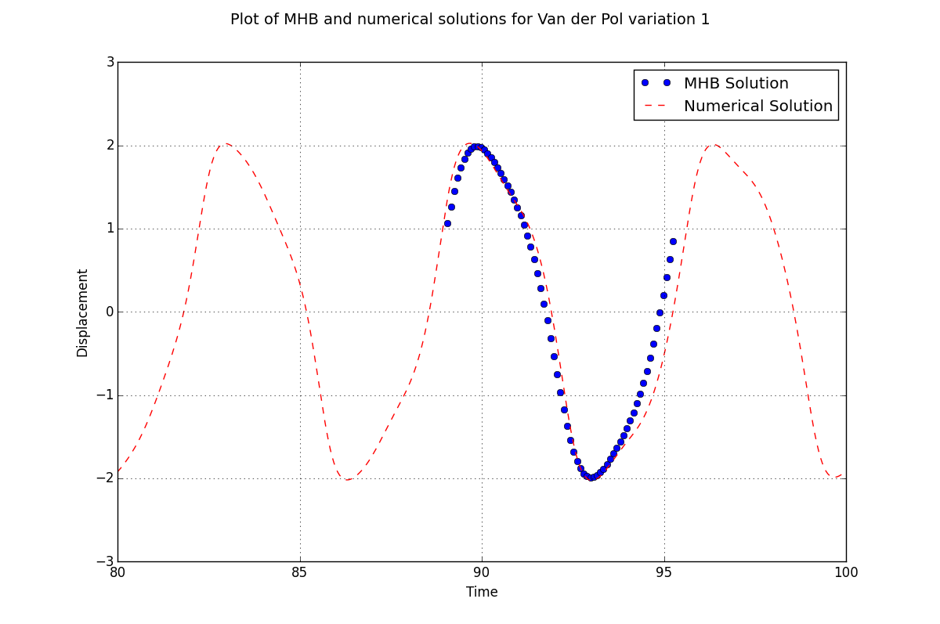

Figure 3-Method of harmonic balance approximation of Van der Pol equation, variation 1

For the first variation of the Van der Pol equation there is a compounding deviation of the MHB solution from the numerical solution at the end of the period. However this may be compensated for at the shift in the peak of the solution at the beginning of the period. More analysis may be done to ensure that this approximation does not compound into further error.

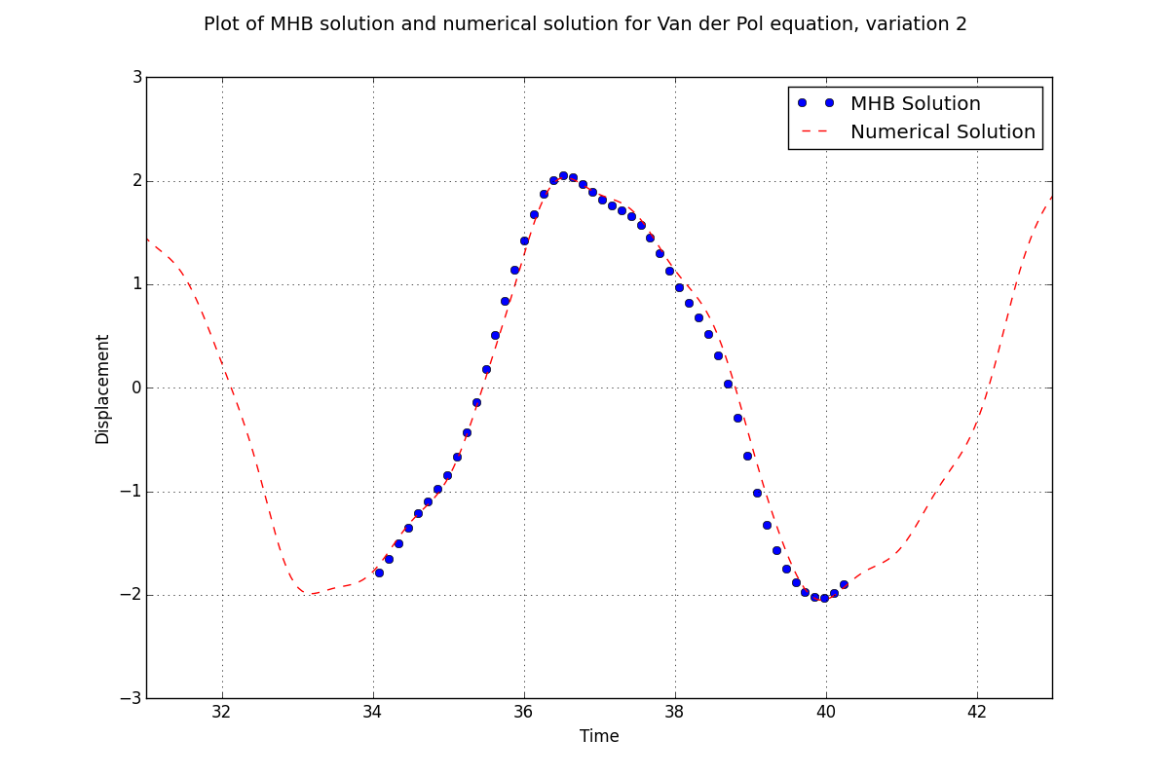

Figure 4-Method of harmonic balance approximation of Van der Pol equation, variation 2

## Determining a Closed Form Solution

Additional goal of the project is to use optimized results and attempt to generate an approximate function for the solution that can further be of use for additional analysis. There are a few ways to accomplish this feat. While the optimized Fourier coefficients can be used to generate a function, it was desirable to use other python methods in order to facilitate additional learning. Method used below is a fitting scheme that uses time domain **x** in order to generate the complementary function using a Fourier cosine series. Method below is crude but it can be easily optimized for better usability.

Assumed solution has 8 terms:

$$x\left(t\right)=A_{0}{+A}_{1}Cos\left(ωt+β\right)+A_{2}Cos\left(2ωt+2β\right)+A_{3}Cos\left(3ωt+3β\right)+A_{4}Cos\left(4ωt+4β\right)+A_{5}Cos\left(5ωt+5β\right)+A_{6}Cos\left(6ωt+6β\right)+A_{7}Cos\left(7ωt+7β\right)+A_{8}Cos(8ωt+8β)$$

Here, AN, ω, and β are the unknowns and will be solved for using least square fitting. For illustration purposes, an approximate closed solution for the second variation of the Van der Pol equation will be given however any of the governing models presented could also be used The following procedure was used to obtain the solution:

1. Define residual function to be minimized using the least squares function. The function must find the difference between the results from the MHB and the assumed solution form.
2. Make initial guess for the closed form solution coefficients, in this case 1
3. Run the least squares minimization scheme to minimize the error from the residual function
4. Simplify closed form and plot solution to check accuracy

This is a way to develop and approximate solution to the governing parameters. It can be a useful tool given that the closed form solution provides a close enough approximation.

Fig. 5 gives the numerical result plotted against the approximate closed form solution.

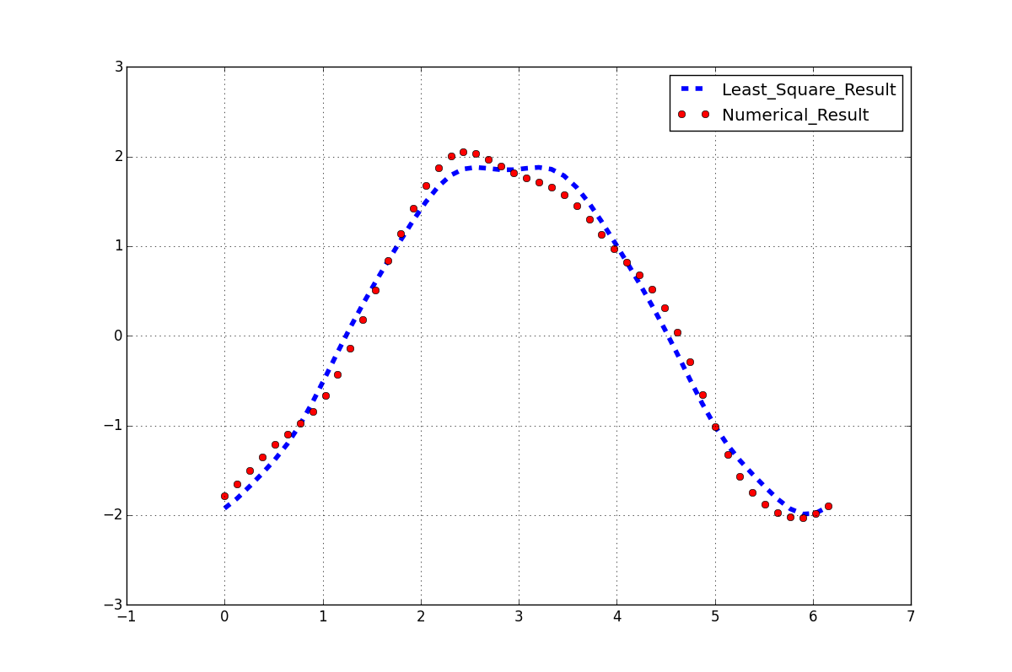

Figure 5-Least squares solution for an approximate closed solution for the Van der Pol equation, variation 2

The assumed closed form solution gives us a fairly close approximation. There are several deviations from the numerical solution but the fit may be sufficient depending on the desired error tolerance. Other forms of the solution including exponential and polynomial can be assumed and may provide a better fit depending on the governing system. The closed form solution of the form presented is given below.

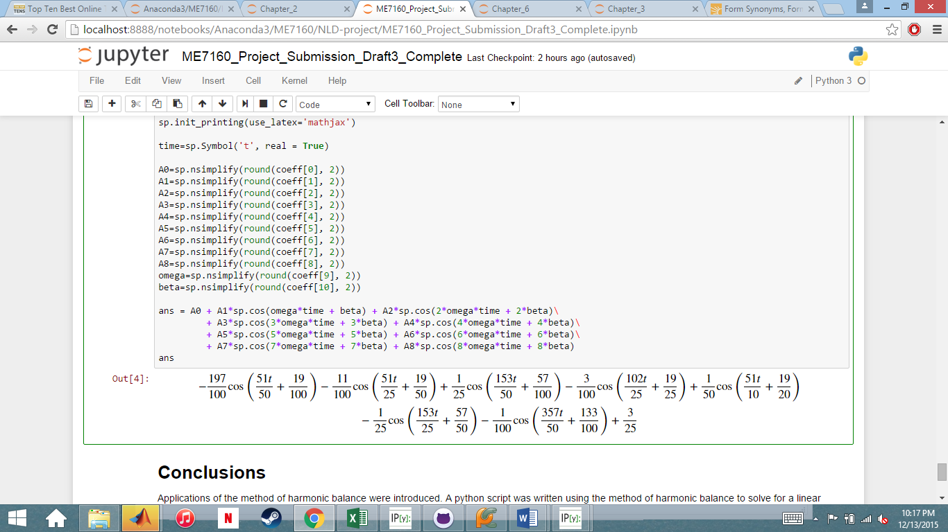

# Coding

## Linear System

import numpy as np

import matplotlib.pyplot as plt

import sympy as sp

N = 70 #define number of sample points

t=np.linspace(0, 2*np.pi, N)

t=t[0:-1]

x0=np.ones(N-1)

#x0=np.cos(2*t)

f = np.cos(2*t)*np.sin(5*t)

freq = np.fft.fftfreq(N-1, 1/(N-1))+.000000001 #define Fourier Transform sample frequencies

# Function resFun defines a residual term that will be used in the optimization operation

def resFun(x):

X = np.fft.fft(x)

xddot = np.fft.ifft(-freq**2*X)

xdot = np.fft.ifft(1j*freq*X)

res = xddot + xdot + x - f

RES = np.sum(np.abs(res**2))

return RES

# Goal of the function is to minimize error between solution guess x0 and response in order to

# converge to a solution

from scipy.optimize import minimize

sol = minimize(resFun, x0, method = 'BFGS', options={'maxiter':50000, 'disp':True})

#sol = minimize(resFun, x0)

print('Values of x after optimization:')

print(sol.x)

#Optional to plot Jacobian of the minimize function

#print(sol.jac)

A = (-3785/171769)

B = (-3274/171769)

C = (-11164/171769)

D = (7660/171769)

Analytical = (A)*np.cos(2*t)*np.cos(5*t) + (B)*np.sin(2*t)*np.sin(5*t) + (C)*np.cos(2*t)*np.sin(5*t)\

+ (D)*np.sin(2*t)*np.cos(5*t)

#Code for Plotting numerical and analytical solutions not shown

## Duffing Oscillator

import numpy as np

import matplotlib.pyplot as plt

import sympy as sp

N = 70 #define number of sample points

t=np.linspace(0, 2*np.pi, N)

t = t[0:-1]

x0=np.ones(N-1)

#x0=np.cos(2*t)

f = np.cos(2*t)*np.sin(5*t)

freq = np.fft.fftfreq(N-1, 1/(N-1))+.000000001 #define Fourier Transform sample frequencies

# Function resFun defines a residual term that will be used in the optimization operation

def resFun(x):

X = np.fft.fft(x)

xddot = np.fft.ifft(-freq**2*X)

xdot = np.fft.ifft(1j*freq*X)

res = xddot + xdot + x + x**3 - f

RES = np.sum(np.abs(res**2))

return RES

# Goal of the function is to minimize error between solution guess x0 and response in order to

# converge to a solution

from scipy.optimize import minimize

sol = minimize(resFun, x0, method = 'BFGS', options={'maxiter':50000, 'disp':True})

#sol = minimize(resFun, x0)

print('Values of x after optimization:')

print(sol.x)

#Optional to plot Jacobian of the minimize function

#print(sol.jac)

#Numerical solution for comparison

from scipy.integrate import odeint

def deriv(x, t):

return np.array([x[1], -0.25*x[1] - x[0] - x[0]**3 + np.cos(2*t)*np.sin(5*t)])

time = np.linspace(0.0, 100, 2000)

xinit=np.array([0,0])

x = odeint(deriv, xinit, time)

#Plotting of numerical and MHB solutions are not shown

## Van der Pol Variation 1

import numpy as np

import matplotlib.pyplot as plt

import sympy as sp

N = 70 #define number of sample points

t=np.linspace(0, 2*np.pi, N)

t=t[0:-1]

F = 1

#x0=1.5*np.ones(N-1)

#x0=1.48*np.cos(1*t)

x0=3.0*np.sin(4*t)*np.cos(1*t)

f = F*np.cos(1*t)*np.sin(4*t)

freq = np.fft.fftfreq(N-1, 1/(N-1))+.00000000001 #define Fourier Transform sample frequencies

# Function resFun defines a residual term that will be used in the optimization operation

def resFun(x):

X = np.fft.fft(x)

xddot = np.fft.ifft(-freq**2*X)

xdot = np.fft.ifft(1j*freq*X)

res = xddot + (x**2 - 1)*xdot + x - f

RES = np.sum(np.abs(res**2))

return RES

# Goal of the function is to minimize error between solution guess x0 and response in order to

# converge to a solution

from scipy.optimize import minimize

sol = minimize(resFun, x0, method = 'BFGS', options={'maxiter':50000, 'disp':True})

#sol = minimize(resFun, x0)

print('Values of x after optimization:')

print(sol.x)

#Optional to plot Jacobian of the minimize function

#print(sol.jac)

#Numerical solution

from scipy.integrate import odeint

def deriv(x,t):

return np.array([x[1], -(x[0]**2 - 1)*x[1] - x[0] + F*np.cos(1*t)*np.sin(4*t)])

time=np.linspace(0.0,100,2000)

xinit=np.array([-2, 0])

x=odeint(deriv, xinit, time)

#Plotting of numerical and MHB solutions not shown

## Van der Pol Variation 2

import numpy as np

import matplotlib.pyplot as plt

import sympy as sp

N = 50 #define number of sample points

t=np.linspace(0, 2*np.pi, N)

t=t[0:-1]

F = 2

#x0=1*np.ones(N-1)

x0=1*np.cos((2*np.pi*t)/1)

#x0=2.0*np.sin(1*t)*np.cos(1*t)

f = F*np.cos((2*np.pi*t))

freq = np.fft.fftfreq(N-1, 1/(N-1))+.00000000001 #define Fourier Transform sample frequencies

# Function resFun defines a residual term that will be used in the optimization operation

def resFun(x):

X = np.fft.fft(x)

xddot = np.fft.ifft(-freq**2*X)

xdot = np.fft.ifft(1j*freq*X)

res = xddot + (x**2 - 1)*xdot + x - f

RES = np.sum(np.abs(res**2))

return RES

# Goal of the function is to minimize error between solution guess x0 and response in order to

# converge to a solution

from scipy.optimize import minimize

sol = minimize(resFun, x0, method = 'BFGS', options={'maxiter':50000, 'disp':True})

#sol = minimize(resFun, x0)

print('Values of x after optimization:')

print(sol.x)

#Optional to plot Jacobian of the minimize function

#print(sol.jac)

#Numerical solution

from scipy.integrate import odeint

def deriv(x,t):

return np.array([x[1], -(x[0]**2 - 1)*x[1] - x[0] + F*np.cos((2*np.pi*t))])

time=np.linspace(0.0,100,2000)

xinit=np.array([-2.0, 0])

x=odeint(deriv, xinit, time)

#Plotting of numerical and MHB solutions

## Closed Form Approximations

#Define function to be called in the "leastsq" function

#sol.x is the method of harmonic balance solution

def errorFun(p, t):

A0, A1, A2, A3, A4, A5, A6, A7, A8, omega, beta = p

err = sol.x - (A0 + A1*np.cos(omega*t + beta) + A2*np.cos(2*omega*t + 2*beta)\

+ A3*np.cos(3*omega*t + 3*beta) + A4*np.cos(4*omega*t + 4*beta)\

+ A5*np.cos(5*omega*t + 5*beta) + A6*np.cos(6*omega*t + 6*beta)\

+ A7*np.cos(7*omega*t + 7*beta) + A8*np.cos(8*omega*t + 8*beta))

return err

#Initial guess for coefficients

p0 = [1, 1, 1, 1, 1, 1, 1, 1, 1, 1, 1]

#print(np.array(p0))

#Least square calculation

from scipy.optimize import leastsq

plsq = leastsq(errorFun, p0, args=(t))

#Function used for plotting purposes

def peval(t, p):

return p[0] + p[1]*np.cos(p[9]*t + p[10]) + p[2]*np.cos(2*p[9]*t + 2*p[10])\

+ p[3]*np.cos(3*p[9]*t + 3*p[10]) + p[4]*np.cos(4*p[9]*t + 4*p[10])\

+ p[5]*np.cos(5*p[9]*t + 5*p[10]) + p[6]*np.cos(6*p[9]*t + 6*p[10])\

+ p[7]*np.cos(7*p[9]*t + 7*p[10]) + p[8]*np.cos(8*p[9]*t + 8*p[10])

#Plot numerical and least square results

import matplotlib.pyplot as plt

fig = plt.figure(figsize=(12,8))

plt.plot(t, peval(t, plsq[0]), 'b--', linewidth = 4, label = 'Least_Square_Result')

plt.plot(t, sol.x, 'ro', label = 'Numerical_Result')

plt.legend(loc = 'upper right')

plt.axis([-1, 7, -3, 3])

plt.grid()

plt.show()

coeff = plsq[0]

#Plot calculated results the coefficients

print('Coefficient values listed below')

print(plsq[0])

import sympy as sp

sp.init_printing(use_latex='mathjax')

time=sp.Symbol('t', real = True)

A0=sp.nsimplify(round(coeff[0], 2))

A1=sp.nsimplify(round(coeff[1], 2))

A2=sp.nsimplify(round(coeff[2], 2))

A3=sp.nsimplify(round(coeff[3], 2))

A4=sp.nsimplify(round(coeff[4], 2))

A5=sp.nsimplify(round(coeff[5], 2))

A6=sp.nsimplify(round(coeff[6], 2))

A7=sp.nsimplify(round(coeff[7], 2))

A8=sp.nsimplify(round(coeff[8], 2))

omega=sp.nsimplify(round(coeff[9], 2))

beta=sp.nsimplify(round(coeff[10], 2))

ans = A0 + A1*sp.cos(omega*time + beta) + A2*sp.cos(2*omega*time + 2*beta)\

+ A3*sp.cos(3*omega*time + 3*beta) + A4*sp.cos(4*omega*time + 4*beta)\

+ A5*sp.cos(5*omega*time + 5*beta) + A6*sp.cos(6*omega*time + 6*beta)\

+ A7*sp.cos(7*omega*time + 7*beta) + A8*sp.cos(8*omega*time + 8*beta)

# Conclusions

Applications of the method of harmonic balance were introduced. A python script was written using the method of harmonic balance to solve for a linear system. Once accomplished, complex nonlinearities were introduced into other governing systems and the method was used to approximate those solutions. The approximations given by the method of harmonic balance were only at a systems steady state for the system and over one period. The only limitation that was encountered was that for more complex forcing functions, the accuracy depended on the quality of the guess.

The duffing oscillator and Van der Pol equation were the nonlinear systems used in this study. The approximations for both systems showed comparable levels of fidelity to the linear system approximation further validating this method. The accuracy of each approximation was determined by plotting with the numerically solved for solution. Based on the accuracy of each approximation it can be stated that the method of harmonic balance was successfully applied to each of the presented linear and nonlinear systems.

Finally, a cosine Fourier series fit for the second variation of the Van der Pol equation was approximated by using the least squares method. This was done to show that the method of harmonic balance can be used to develop an approximate closed form model to describe a wide range of nonlinear systems.

# APPENDIX

# MATLAB FIle for duffing oscillator

## Define number of sample points

N = 100;  
t = linspace(0,2*pi,N)';  
t(end) = [];

## [Defining forcing function](Defining)

%x"+x'+x+x^3=cos(2t)sin(5t)  
global func freq %Defining global variables  
func = cos(2.*t).*sin(5.*t);

## Frequency Spectrum

dt = 1/N;  
df=1./(N*dt); % Interval in freq  
fpos=[0:N/2-1]'*df; % Freqs of positive half of spectrum  
fneg=[N/2-1:-df:1]'*df*-1; %Freqs of negative half of spectrum  
freq =[fpos;fneg]; %Full frequency spectrum

## [Initial solution for x](Guessing)

x0 = ones(N-1,1); %x=1

## [Optimization toolbox to minimize residual and obtain x solution](Using)

%See associated function 'resFUN_Duff.m'  
options = optimset('MaxFunEvals',50000);  
[x_HarBal,RES] = fminunc(@resFUN_Duff,x0,options);

## Using ODE45 to numerically solve for the ode

[t_num,x_num]=ode45('derivFUN_Duff',[0 100],[0 0])

## Solution with numerical solution

t_shift = t+(2*pi*5);  
figure  
plot(t_num,x_num(:,1),t_shift,x_HarBal,'o')  
axis([2*pi*5 2*pi*6 -0.5 0.5]) %Shifting to steady state of solution  
xlabel('t')  
title('Duffing Oscilator')

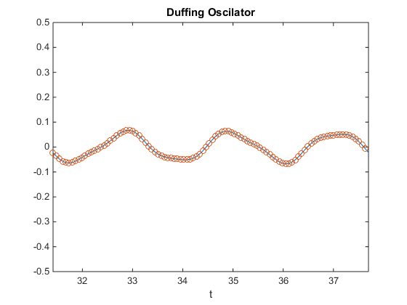

**Function Files**

%Function written for ODE45  
function xp = derivFUN_Duff(t,x)  
xp = zeros(2,1);  
xp(1) = x(2);  
xp(2) = -x(2)-x(1)-x(1)^3 + cos(2*t).*sin(5*t);

%Defining residual function for minimization scheme  
function RES = resFUN_Duff(x)  
% <Importing global variables>  
 global freq  
 global func  
% <FFT for given x to solve for derivatives xddot and xdot>  
 X = fft(x);  
 xdot = ifft(1i*freq.*X);  
 xddot = ifft(-freq.^2.*X);  
  
% <Identifying residual function>  
 res = xddot+xdot+x+x.^3-func;  
 RES = sum(abs(res.^2));

[*Published with MATLAB® R2014b*](http://www.mathworks.com/products/matlab)