POLYNURSE · 1V1 / SC WAR HALL
Flow State
Developer brief: what the demo does and how to build it
Flow State replaces the old “Double” points button in 1v1 duels. It is a pace mode, not a points mode. The player chooses how many seconds they get per question (3–12 s). While Flow State is on, every question has its own countdown and the app skips the question for them when it runs out. Nothing about scoring changes. The 90-second match clock never pauses.
Everything in this brief matches the playable demo (the HTML simulation). Where the demo fakes something (the opponent, the question bank) it is flagged as demo only.

The rules
Rule | Detail
Pace | Chosen on the setup screen before the duel with a slider, 3 to 12 s, default 6 s. Fixed for that duel.
Toggle | Player can activate and deactivate Flow State at any time, as often as they like. No cooldown, no limit.
Per-question timer | Only while Flow State is on. It restarts at the full pace on every new question. At 0 the question is auto-skipped.
Match clock | 90 s, always running, never paused or extended by Flow State.
Scoring | 1 point for a correct answer. 0 for a wrong answer. 0 for a skip (auto or manual). No bonus, no multiplier.
Winner | Most correct answers. Equal = draw.
Stakes | Win +4 SC. Loss −2 SC. Draw: stakes returned (0 SC).
Pace zones (colour only) | Aggressive 3–4 s: orange/red. Balanced 5–7 s: cyan/blue. Deliberate 8–12 s: violet. The colour reflects the chosen pace, never performance.

Design principle that drives the layout
Flow State is meant to feel like total immersion, so entering it must never make the question or the answers jump. The question card, the four options and the bottom buttons sit at exactly the same screen position in both modes. Only the area above the question changes (cards and match bar fade out, a circular timer fades in), and the background colour floods the screen. Measured in the demo at a 390 × 760 viewport: question card top 170.8 px, options top 265.2 px, buttons top 704 px, identical with Flow State on and off.

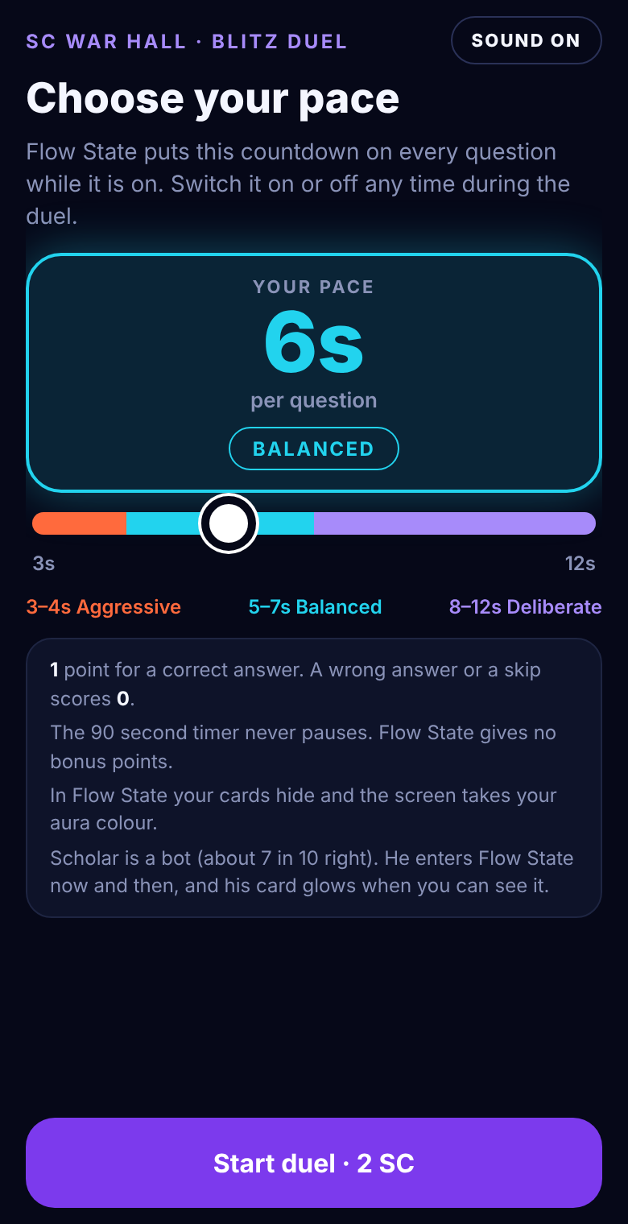 | SCREEN 1 OF 7  Pick your pace  Shown before the duel. The player sets how many seconds they get per question while Flow State is on.  - Slider: 3 to 12, step 1, default 6. The big number and the zone name update live.  - Colour follows the slider: the slider track, thumb, number and the Start button take the zone colour (orange/red, cyan/blue or violet) so the player previews their aura.  - Zones: AGGRESSIVE 3–4 s, BALANCED 5–7 s, DELIBERATE 8–12 s.  - Sound toggle: top right. Mute state is global for the session.  - Start: stores the pace, then goes to the Versus screen.  The pace is not shown again on the Versus screen. It only reappears in the results header.

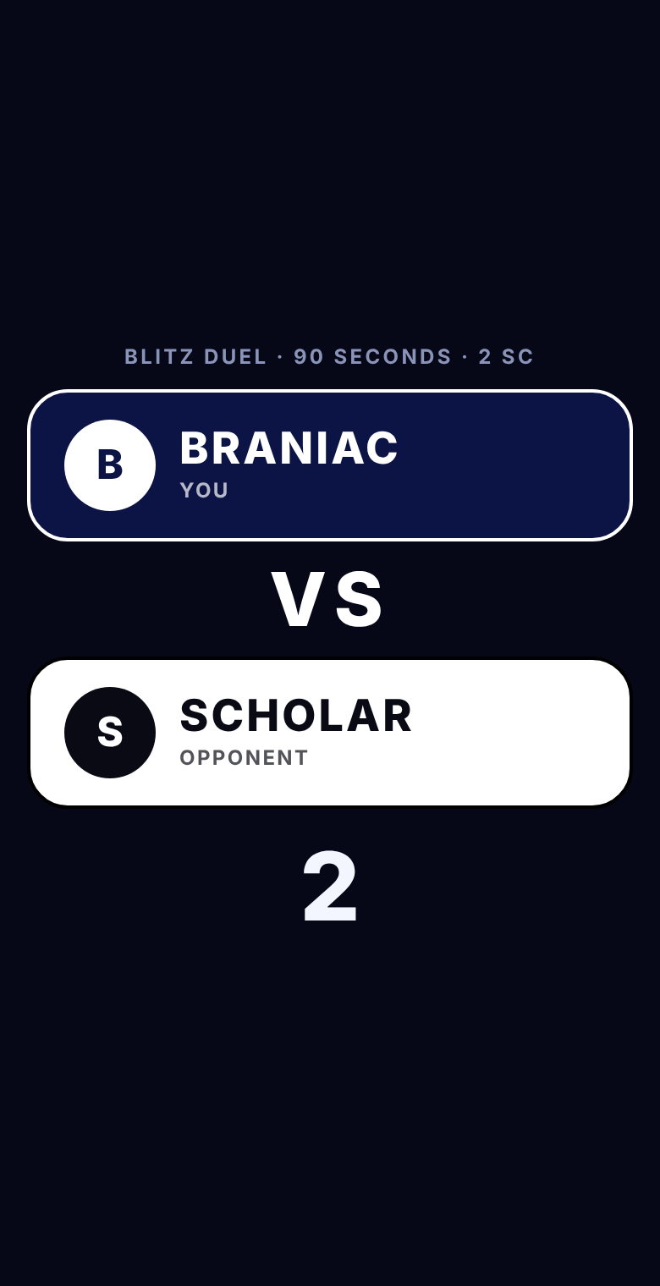 | SCREEN 2 OF 7  Versus  Pairing screen, about 4.3 s in the demo. In production this is the matchmaking wait.  - Two player cards: yours on top (navy fill, white outline), opponent below (white fill, black outline). Usernames in capitals, with “YOU” under yours and “OPPONENT” under theirs.  - Header: “BLITZ DUEL · 90 SECONDS · 2 SC”. No pace anywhere on this screen.  - Sequence: the opponent card shows a searching state, then pairs. A 3-2-1 countdown plays (soft beeps), then the match screen opens.  - Demo only: the opponent is always “Scholar”; the player is always “Braniac”. Use real usernames.

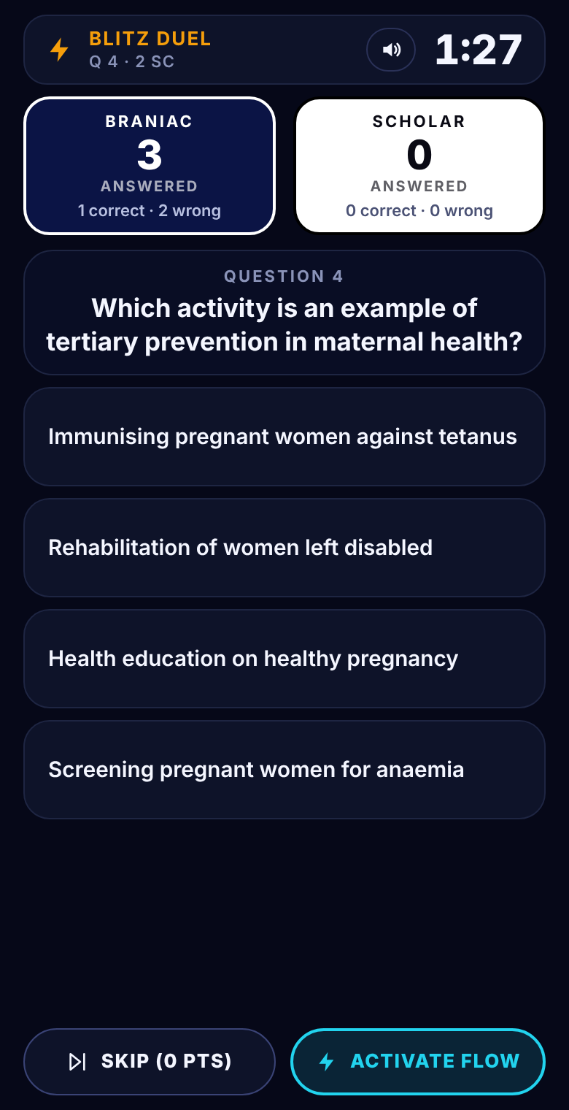 | SCREEN 3 OF 7  Duel, Flow State off  The normal duel. Same layout as the current app, with the Double button replaced.  - Top bar: mode name, question number and stake on the left; mute button and the 90 s match clock on the right.  - Player cards: big number = questions answered. Underneath: “x correct · y wrong”. Your card is navy with a white outline and shows your username; the opponent’s is white with a black outline. Keep the cards plain: no green or red here.  - Question + 4 options: tapping an option submits it. The tapped option flashes green if right, red if wrong. The correct answer is never revealed when you are wrong. Next question appears after about 300 ms.  - Bottom row, two equal pills: SKIP (0 PTS) on the left, ACTIVATE FLOW on the right. Both are shorter than an option so they cannot be mistaken for one.  - Activate button colour: tinted with the pace zone colour, 2 px outline, coloured text. Skip is white text with a grey-blue outline.  - No question timer is shown in this mode.

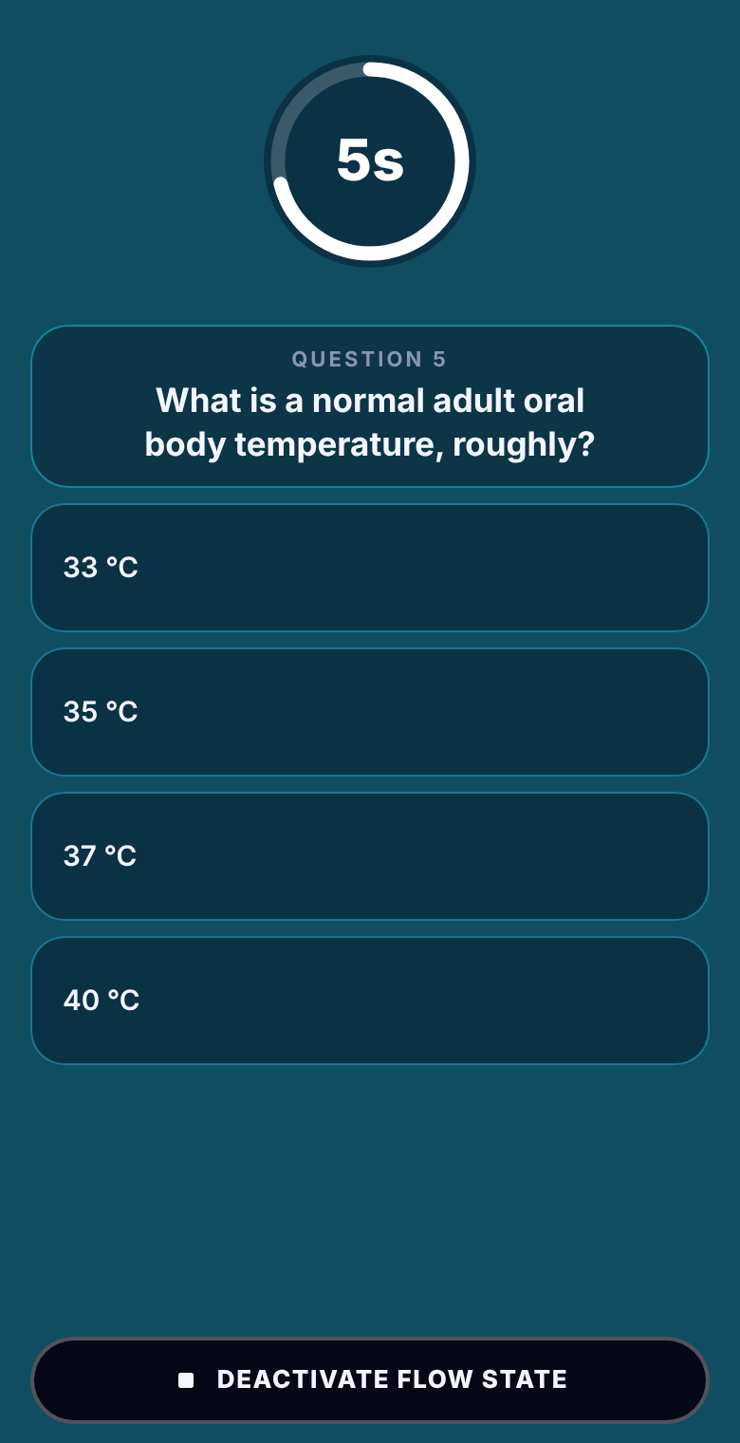 | SCREEN 4 OF 7  Duel, Flow State on  Tap ACTIVATE FLOW and the whole screen changes mood. Compare with the previous page: the question, options and button row have not moved.  - Background: floods with the aura colour (the zone colour mixed at 34% into the base navy). It spreads outward from the centre of the Activate button.  - Top zone swap: the match bar and both player cards fade out (0.4 s). A circular countdown fades in at the same place. The match clock and scores are hidden so the player stays inside the question.  - Circular timer: white ring, number inside (“5s”). The ring empties as time runs out and resets on each new question.  - Bottom: a single DEACTIVATE FLOW STATE pill, same row and the same 46 px height as the Skip and Activate pills. Navy fill, white outline, near-white text. Skip is hidden in Flow State: the timer does the skipping.  - Sound: the tick is replaced by a soft ambient pad; tapping an answer plays a swipe instead of a pop.  - Deactivate: the colour is pulled back into the button (0.65 s). Layout returns to Screen 3.

Element | Spec (demo values)
Top zone | One CSS grid cell holding both versions. They crossfade with opacity and visibility, so nothing reflows.
Ring | SVG circle r=52, stroke 8, circumference 326.7. Progress = stroke-dashoffset = 326.7 × (1 − fraction left).
Ring size | 112 × 112 px, centred in the same box the bar and cards used.

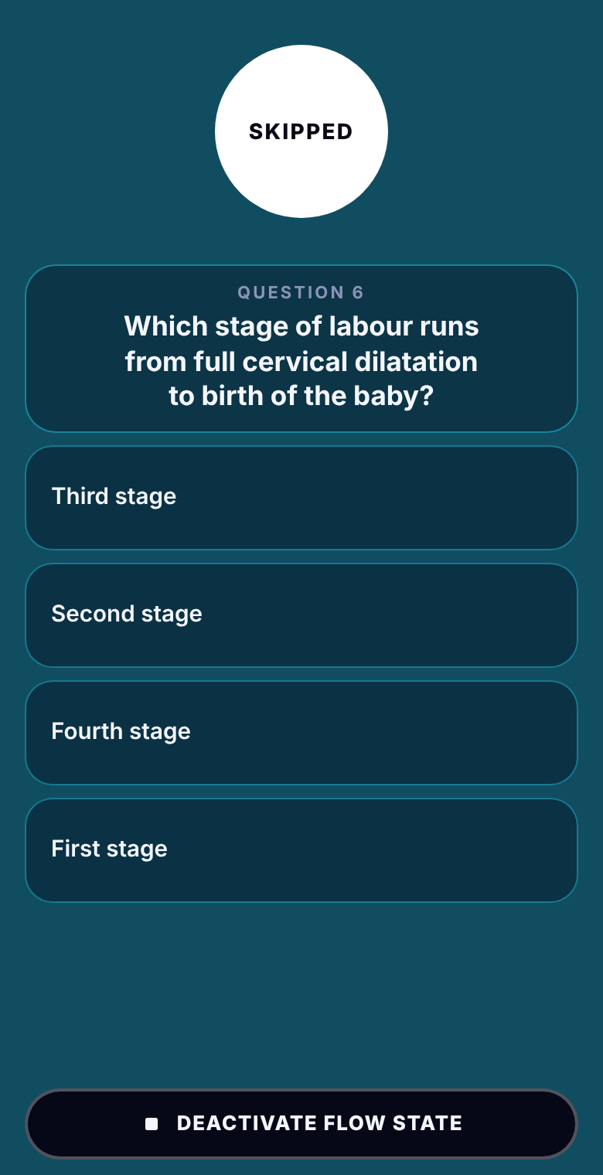 | SCREEN 5 OF 7  Auto-skip at zero  When the question countdown hits 0 the question is skipped automatically.  - Cue: the ring turns solid white with dark “SKIPPED” text for about 300 ms, then the next question appears with a fresh countdown.  - Score: a skip counts as 0 points, same as a manual skip. It is tallied as an “auto” skip in the results.  - Does not end Flow State. The player stays in the mode until they deactivate.  - Timer model: store a deadline timestamp for the current question (now + pace). Each frame, fraction = (deadline − now) / pace. Do not decrement a counter, so frame drops cannot cheat the timer.  - Race to avoid: if the player taps an option in the same frame the deadline passes, whichever event is processed first wins. Never score both.  - Deactivating right after a skip cannot undo it.

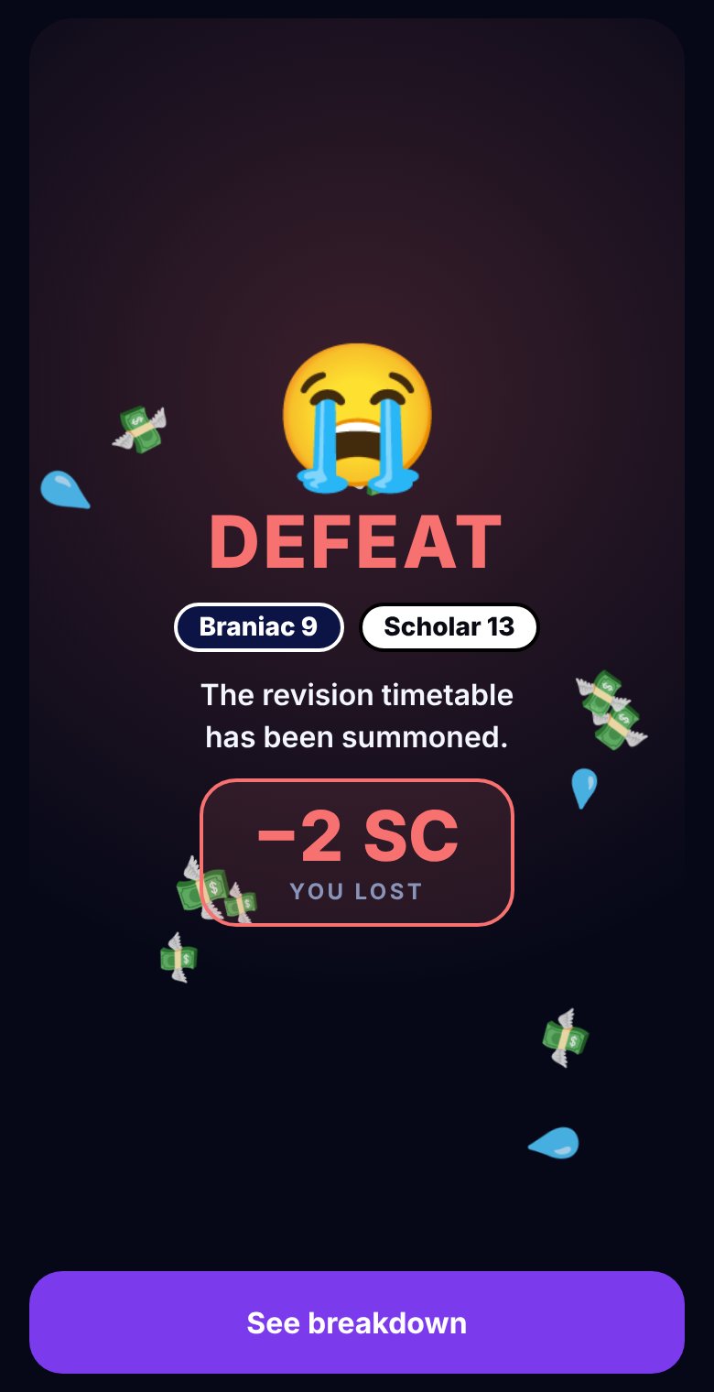 | SCREEN 6 OF 7  Verdict  A short celebration or consolation screen between the match and the breakdown, so the player learns win or loss before reading numbers.  - Variants: Victory, Defeat, Draw. Each has its own big emoji, title colour, background tint and sound jingle.  - Score chips: “Braniac 9” and “Scholar 13”, styled like the match cards. Score = correct answers.  - Funny quote: picked by score gap: small (under 4), medium (4–7), big (8 or more), separately for win and loss. Quotes are copy, so the team can rewrite them freely.  - Coin box: +4 SC on a win, −2 SC on a loss, “0 SC · Stakes returned” on a draw.  - Falling emoji: a few seconds of falling confetti-style emoji (money, tears, etc.). Skip it when the device has reduced-motion enabled.  - Button: “See breakdown” goes to the results.

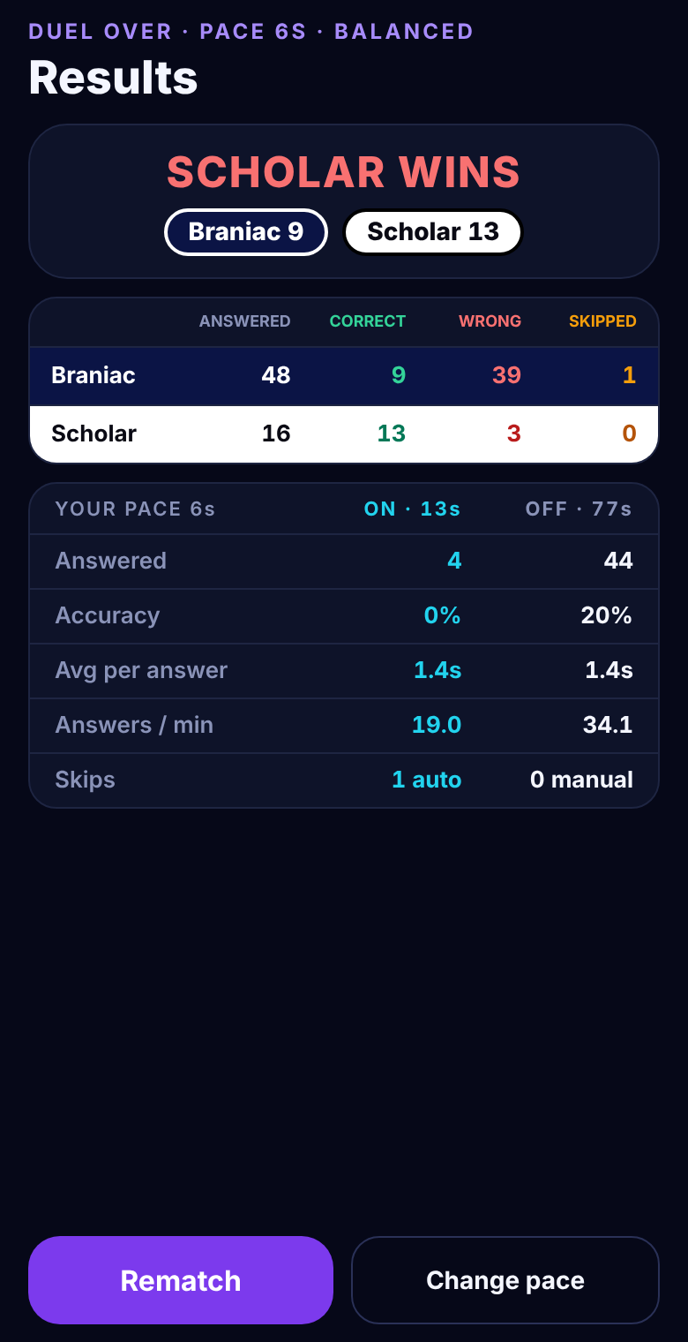 | SCREEN 7 OF 7  Results breakdown  This is the only place green and red are used for correct and wrong.  - Scoreboard: one row per player (yours navy, theirs white): Answered, Correct, Wrong, Skipped. Correct is green, Wrong is red, Skipped is amber.  - Flow On vs Off table (yours only): answered, accuracy, average time per answer, answers per minute, and skips (auto for On, manual for Off). The header shows total seconds spent in each mode.  - Why it exists: it lets the player see whether Flow State actually made them faster or less accurate. Record the time spent in each mode and attribute every answer to the mode active when it was submitted.  - Header: “DUEL OVER · PACE 6S · BALANCED”.  - Buttons: Rematch (same pace) and Change pace (back to Screen 1).  Demo numbers are random because the demo player is a script.

How it works under the hood

Screen flow
Setup → Versus → Match → Verdict → Results. Rematch returns to Versus with the same pace. Leaving the match always clears Flow State (background, wash, pad sound).

State to keep per match
Field | Meaning
pace | Seconds per question, 3–12. Fixed for the match.
flowOn | Boolean. Toggled by the player.
qDeadline | Timestamp when the current question auto-skips. Only used while flowOn. Reset on every new question and on activation.
matchEnd | Timestamp of the 90 s end. Never changed.
answered, correct, wrong, skippedAuto, skippedManual | Per player counters. answered = correct + wrong (skips are separate).
flowSegments | List of {start, end} for each Flow On interval, for the On vs Off table.
answerLog | Each answer with: time, correct?, mode (on/off). Source of the results table.

Per frame loop
- Update the match clock. At 0, stop everything and go to the verdict.
- If flowOn: fraction = (qDeadline − now) / pace; draw the ring; if now ≥ qDeadline, auto-skip.
- Opponent updates (in production this arrives over the network).

Activating and deactivating
- Activate: flowOn = true; qDeadline = now + pace (the current question gets a full countdown); apply the aura; start the pad sound; start the colour spread.
- Deactivate: flowOn = false; clear qDeadline; remove the aura; stop the pad; play the pull-back animation. The current question stays on screen and untimed.

Animation, sound and colour

Colour spread (the “wash”)
A fixed full-screen overlay is animated with clip-path: circle(). It sits above the background and below the interactive content.
 | Activate | Deactivate
Origin | Centre of the Activate button | Same point, stored when activating
Motion | Circle grows until it covers the screen | Circle shrinks back into the button, starting from the farthest-corner radius
Duration | 1100 ms | 650 ms
Easing | cubic-bezier(.25,.7,.25,1) (fast start, soft end) | cubic-bezier(.45,.05,.8,.5) (ease-in, pulled in)
Colour | Zone colour at 34% over #060818 | Reverse
The shrink is deliberately shorter and starts from the corner radius so it feels as quick as the spread. A mirrored curve felt slower in testing.

Zone colours
Zone | Pace | RGB | Pad sound base note
Aggressive (orange/red) | 3–4 s | 255, 106, 61 | C4 (261.6 Hz)
Balanced (cyan/blue) | 5–7 s | 34, 211, 238 | A3 (220 Hz)
Deliberate (violet) | 8–12 s | 167, 139, 250 | F3 (174.6 Hz)

Sound (all synthesised in the demo; use audio files in production if preferred)
Event | Sound
Normal mode, every second | Short tick. Higher pitch during the last 10 s of the match.
Normal mode, option tap | Soft pop.
Flow State on | Ambient pad (four slightly detuned pairs of sine waves through a low-pass filter with slow tremolo), pitched to the zone base note. A short rising sweep when entering and a falling sweep when leaving.
Flow State, option tap | Quiet noise swipe instead of the pop.
Versus 3-2-1 | Three short beeps.
Verdict | Win jingle, lose jingle or draw jingle.
Mute | Button on setup and in the match bar; silences everything.

Colour rules
- Duel cards stay plain (navy and white). Green and red appear only on option feedback and the results table.
- Wrong answer: only the tapped option turns red. Never highlight the correct one.
- Neutral accent is white, replacing the old gold.

Demo-only parts and open questions

Replace in production
- Opponent: in the demo a bot answers every 3.5–7.5 s with 70% accuracy and turns its own glow on and off every 8–16 s using one fixed colour per match. Use the real opponent’s answers.
- Question bank: 44 hand-written nursing and midwifery questions, shuffled. Use the real bank.
- Usernames: “Braniac” and “Scholar” are placeholders.
- Reduced motion: the demo disables falling emoji. Consider also shortening the colour spread.

Decisions for you
- Opponent visibility: does the opponent see that you are in Flow State? The demo shows the bot’s glow on its own card as a visual idea only. In production this needs a network flag (flowOn) and a decision on whether to show it.
- Network lag and the deadline: run the per-question timer locally, and send each answer with its client timestamp. Decide how the server validates auto-skips.
- App backgrounded: the match clock should keep running. Decide whether Flow State auto-skips continue or pause the question until the app returns.
- Last question: if the 90 s match clock ends mid-question, the question is dropped without a score or skip.
- Analytics: suggested events: flow_activated (pace), flow_deactivated (seconds active), flow_auto_skip, flow_manual_skip.

Acceptance checklist
- Question card, options and bottom buttons are at identical positions in both modes.
- Skip, Activate and Deactivate pills share the same row and the same height.
- The Versus screen shows usernames only, with no pace.
- Match clock never pauses. Activating and deactivating can be repeated freely.
- Auto-skip scores 0 and is counted separately from manual skips.
- Leaving the match always resets the background and sound.
The playable demo is the reference for feel and timing. When this document and the demo disagree, trust the demo and tell the designer.

