POLYNURSE
THE TOURNAMENT SYSTEM
Developer Pitch & Launch Specification
Four competitions. One currency. A path to the Seven.
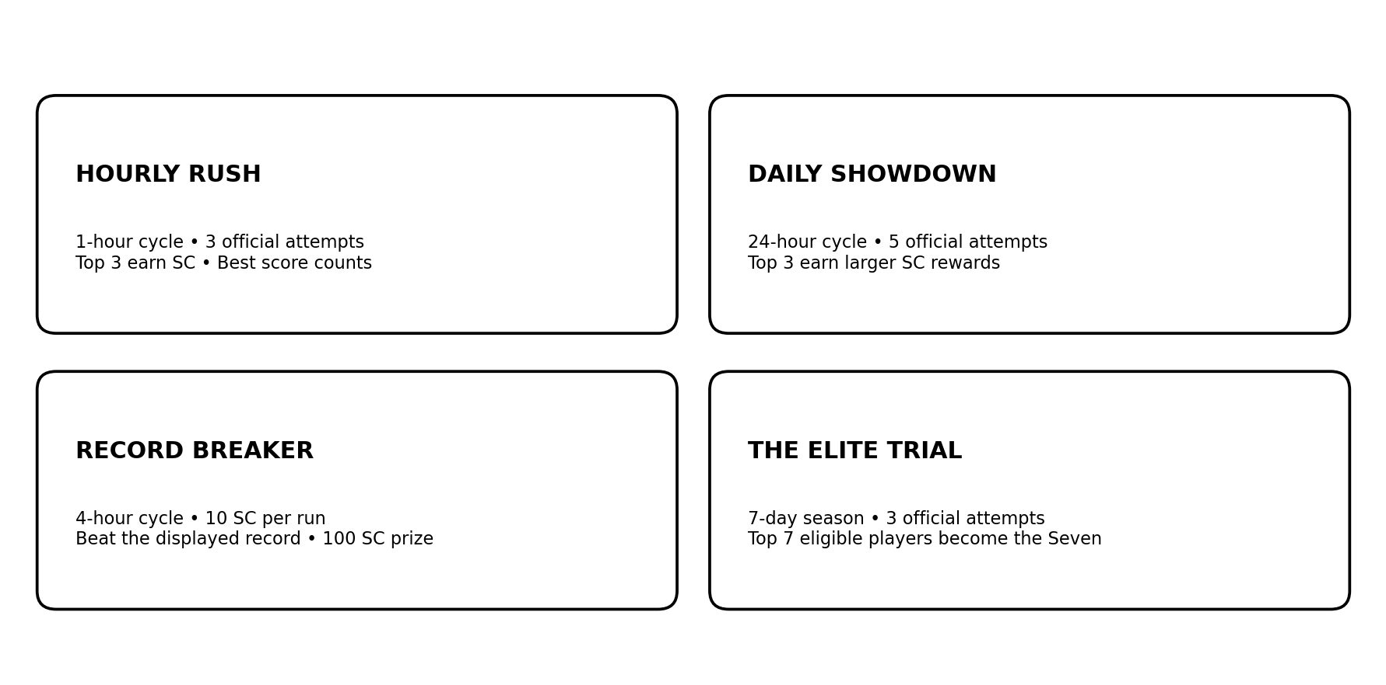
Prepared as a practical first-launch proposal

1. The idea in one minute
Polynurse should launch a small, easy-to-understand tournament layer on top of its existing timed quiz gameplay. Players see a clear challenge, play the same timed format, receive a score and a current placement, and have a reason to return when the next cycle begins. The four competitions serve different motivations: quick competition, daily improvement, record chasing, and long-term prestige.
The product rule
Do not introduce a second tournament currency or a separate points economy. SC coins remain the reward currency. Tournament scores are only for ranking within a competition; they are not spendable currency.

What success looks like
- A new user can understand what to play and what they can win without reading a long rules page.
- The hourly and daily challenges create repeat visits without unlimited grinding deciding every leaderboard.
- Record Breaker creates a simple personal rivalry: the player versus one visible record.
- The Elite Trial gives 1v1s a purpose and creates a visible, repeatable prestige cycle around the Seven.
- The system works with fewer than 20 active users and can scale without redesigning the basic rules.

2. Tournament overview
Competition | Cycle | Attempts / entry | What counts | Main reward
Hourly Rush | 1 hour | 3 official attempts | Best valid score; ranked standings | SC for top 3
Daily Showdown | 24 hours | 5 official attempts | Best valid score; ranked standings | Larger SC rewards for top 3
Record Breaker | 4 hours | 10 SC per run | Beat the single displayed record | 100 SC to record holder if cycle payout conditions are met
The Elite Trial | 7 days | 3 official attempts | Best valid score among eligible players | Elite status, placement rewards and champion recognition

Attempt counts above are recommended launch defaults. The cycle lengths, 10 SC Record Breaker entry fee, 100 SC Record Breaker prize concept, and Elite Seven structure come from the design discussion. Hourly/daily/Elite SC reward amounts and the Record Breaker payout safeguard still need a final economy decision.

3. Shared gameplay rules
All four modes should reuse the same familiar core quiz engine unless a mode explicitly adds a cosmetic or presentation difference.
- Fixed timed run: 90 seconds, using the existing scoring/gameplay mechanic.
- Every player gets the same number of questions available in a run. Do not arbitrarily restrict Hourly Rush to 5 questions or Daily Showdown to 10.
- Use a large question pool and randomized question selection/order so players do not all see a predictable sequence.
- Keep question difficulty and topic coverage comparable across runs; randomization should reduce memorization, not make one player's run systematically easier.
- A wrong answer does not automatically reveal the correct answer during the run.
- Show the score immediately after a run, plus the player's current position where the mode uses a leaderboard.
- Only the best valid score within the allowed attempts counts for Hourly Rush, Daily Showdown and Elite Trial.
Important distinction
A tournament score is a ranking result, not a new currency. SC coins are awarded separately according to placement or the Record Breaker rule.

4. Mode specifications

4.1 Hourly Rush
Purpose: a low-friction reason to open Polynurse repeatedly throughout the day.
- A new cycle starts every hour and has a clear countdown to closing.
- Recommended limit: 3 official attempts per cycle; the best valid score is used.
- Display tournament standings with ranks, usernames, avatars and scores. Highlight the current top three.
- Award SC to the top three after the cycle closes. Keep the reward modest because cycles happen frequently.
- At reset, close the previous standings, settle rewards, and start a fresh leaderboard.

4.2 Daily Showdown
Purpose: the more meaningful daily competition, with enough time for users in different schedules to participate.
- A new cycle starts every 24 hours.
- Recommended limit: 5 official attempts per cycle; the best valid score is used.
- Use the same 90-second gameplay format and comparable run conditions as Hourly Rush.
- Show the standings and the player's current rank after each attempt.
- The top three earn more SC than the Hourly Rush top three, making the daily event feel more valuable.
- At the deadline, finalize the standings and rewards before opening the next daily cycle.

4.3 Record Breaker
Purpose: a simple head-to-head contest against one record, not a crowded leaderboard.
- The cycle lasts four hours.
- Each attempt costs 10 SC. One 10 SC entry buys one timed run; a player may enter again by paying for another run. No extra tournament currency is introduced.
- The page prominently displays only the current record and record holder, rather than a full public leaderboard.
- After a run, tell the player whether they beat the record. If they do, update the displayed record and holder.
- The intended prize is 100 SC to the player holding the record when the four-hour cycle ends.
- Because the entry fee is paid and the prize is fixed, the payout safeguard must be visible before entry. Recommended safeguard: require at least 3 distinct valid entrants for a funded prize cycle; if the threshold is not met, refund entry fees and do not award the 100 SC that cycle. This avoids a low-participation cycle creating an easy coin exploit or leaving entrants feeling misled.
- At reset, start a new record cycle according to the chosen reset policy. The implementation decision is whether the new cycle starts with a clean record or carries forward the previous record; see decisions to finalize.
Trust requirement
Do not hide the minimum-participation rule in fine print. Show the 10 SC cost, the 100 SC prize, the cycle deadline and the payout condition before a player confirms entry.

4.4 The Elite Trial
Purpose: the flagship weekly competition and the main reason to keep playing 1v1s.

Eligibility
- A player outside the reigning Seven qualifies by winning 10 valid 1v1 matches against at least 5 different opponents during the qualification period.
- A match counts only when it is completed and valid. Forfeits, duplicate result submissions and suspicious match farming should not count.
- Eligibility resets for each new weekly season for players who did not make the previous Seven. This gives 1v1s a recurring purpose.
- The previous season's Seven receive automatic entry into the immediately following Elite Trial and do not need to repeat the 1v1 requirement.
- Automatic entry is not automatic survival: returning Elites receive no scoring bonus, extra attempts or immunity.

The weekly competition
- One seven-day selection leaderboard; do not add daily eliminations or a separate bracket in the first version.
- Recommended limit: 3 official attempts per season. Best valid score counts.
- All eligible competitors, including the returning Seven, compete under the same quiz rules and attempt allowance.
- At the deadline, the top seven eligible players become the new Seven. Rank #1 is the weekly champion.
- If fewer than seven eligible players participate, do not invent or auto-fill finalists. Show only the valid qualifiers/finalists and communicate the result clearly.
- Keep prior seasons' champion and Seven results in a simple history so the achievement remains visible.
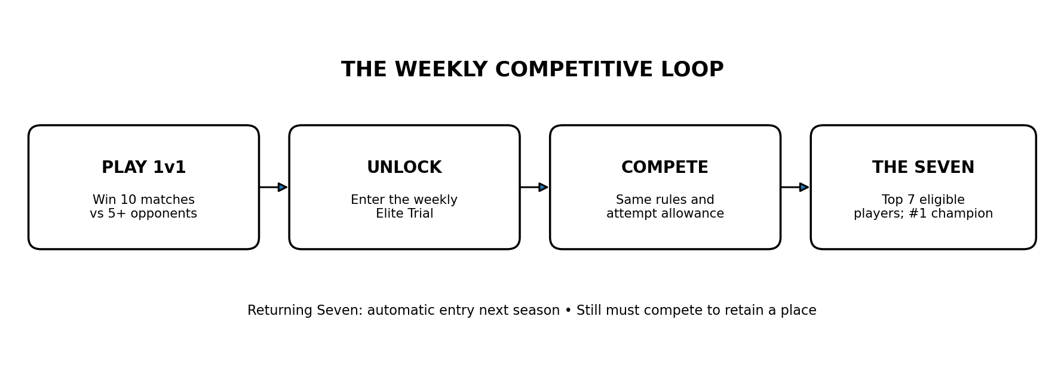

The Seven's benefits
- Automatic entry into the next weekly Elite Trial.
- A visible Elite designation on profile and tournament standings for the season they earned it.
- A public announcement of the new Seven and champion, where the product has an announcement surface.
- Placement rewards for all seven, with the champion receiving the strongest reward. Exact SC amounts should be set after reviewing the overall coin economy.

5. Attempt rules and anti-exploit handling
Mode | Launch attempt rule | Score rule
Hourly Rush | 3 official attempts per hour | Best valid score
Daily Showdown | 5 official attempts per day | Best valid score
Record Breaker | 10 SC for each run; re-entry costs another 10 SC | Beat the one displayed record
Elite Trial | 3 official attempts per 7-day season | Best valid score

An attempt should be consumed when the server confirms that the timed run has begun, not only when the player submits a finished result.
- Timer expires: score the run using answers submitted before time expired.
- Player leaves, refreshes or abandons after the run starts: consume the attempt. Preserve the server-recorded result if the implementation supports safe recovery; otherwise score the run so far.
- Network or server failure: allow a retry only when a verifiable technical failure occurred. Do not let ordinary disconnects become a free-reset strategy.
- Enforce attempts and result submission server-side; browser state alone is not authoritative.
- Reject duplicate submissions and prevent the same run from being scored twice.
- Keep correct-answer explanations out of the live tournament run. Explanations can be shown after the run if doing so does not expose a reusable answer sequence.

6. Standings and results UI
Borrow the clarity of the BombSquad standings inspiration: the player should immediately understand rank, score, time remaining and the prize.
Screen element | Recommended behavior
Tournament card | Mode name, short description, countdown, entry/attempt status, prize summary and one clear Play button.
After-run result | Personal score, best score, current rank, attempts remaining and next action.
Standings | Rank, avatar, username and score; show the top three prominently for hourly/daily.
Record Breaker | One record value, one holder, time remaining, 10 SC entry cost and 100 SC prize condition.
Elite Trial | Eligibility progress, attempts remaining, weekly countdown, current rank and the top-seven cutoff.
Cycle close | Final placements, SC rewards, champion/Seven announcement and a clear next-cycle countdown.

Keep the first version mobile-first and legible. Do not make users understand all four systems before they can play one. Each tournament card should explain its mechanic in one sentence.

7. SC rewards and economy
SC is the only currency. Do not add Aura, tournament points, tickets or another spendable balance for this system. Leaderboard scores exist only to rank a run; SC is what players receive.
Mode | Reward principle | Needs final configuration
Hourly Rush | Small rewards for ranks 1–3; keep issuance sustainable across 24 cycles/day. | Exact 1st/2nd/3rd SC amounts
Daily Showdown | Larger rewards for ranks 1–3 than Hourly Rush. | Exact 1st/2nd/3rd SC amounts
Record Breaker | 10 SC per attempt; intended 100 SC to cycle-end record holder if payout conditions are met. | Confirm minimum entrants/refund handling and record reset policy
Elite Trial | All Seven receive recognition/rewards; champion receives the largest placement reward. | Exact reward curve and whether rewards are SC-only or SC plus non-monetary status

Economy warning
A 100 SC prize every four hours can issue up to 600 SC per day before accounting for entry fees. Monitor total SC created, SC spent and number of valid entrants. Keep the intended prize, but make its participation safeguard explicit and review the economy after launch.

Do not launch with large, arbitrary hourly/daily prizes before estimating the total possible SC issuance. Start modestly and adjust based on real activity.

8. Cycle timing and edge cases
Mode | Cycle | At the deadline
Hourly Rush | Every 1 hour | Stop new runs, finalize valid results, pay top 3, open new cycle.
Daily Showdown | Every 24 hours | Stop new runs, finalize valid results, pay top 3, open new cycle.
Record Breaker | Every 4 hours | Freeze record, evaluate payout condition, pay holder or refund entrants if threshold failed, start next cycle.
Elite Trial | Every 7 days | Freeze standings, announce Seven and champion, pay configured rewards, open next season and carry forward only the Seven's entry privilege.

- A player must not start a run if there is insufficient time for the official attempt window, unless the server can guarantee that started runs are allowed to finish and scored consistently.
- Use server timestamps for all deadlines and settlement.
- Decide and display what happens to ties. Recommended: use the existing gameplay score first, then a clearly defined tie-breaker (for example, fewer total time/penalties if the scoring engine supports it). Avoid manual judgement.
- If the user count is too low for a meaningful leaderboard, still allow play, but be transparent when a mode's reward condition is not met.

9. Suggested build order
Phase | Build | Why
1. Core | Reusable timed-run session, server-side score validation, attempt tracking, countdowns and cycle settlement. | These are shared foundations; build once.
2. Hourly + Daily | Best-score leaderboards, top-three standings, SC reward settlement. | Easy to understand and useful even with a small audience.
3. Record Breaker | Paid entry, single-record display, cycle-end payout condition and refund logic. | Adds a distinct hook but needs careful coin safeguards.
4. Elite Trial | 1v1 win/opponent tracking, eligibility UI, weekly leaderboard, top-seven selection and season history. | More moving parts; build after the shared tournament engine is reliable.
5. Polish | Season announcements, Elite profile mark, tournament history, analytics and abuse monitoring. | Improves retention and social proof after core mechanics work.

For the first launch, prefer one reliable version of each mode over elaborate animations, multi-stage eliminations, squads or a complex bracket. Visual prestige can come from clear standings, a strong reveal moment and profile recognition.

10. What to measure after launch
- Unique participants per cycle and how many return for the next cycle.
- Attempt distribution: how many users use 1, 2, 3 or all available attempts.
- How often top-three placements change after repeat attempts.
- SC issued, SC spent on Record Breaker entries, and net SC inflation.
- Record Breaker distinct entrants per cycle and how often payout conditions fail.
- How many users start 1v1s, complete valid matches, reach 10 wins/5 opponents, enter the Elite Trial and become one of the Seven.
- Whether users who invite friends convert into active players and whether the invited users return.

11. Decisions to finalize before implementation
These are intentionally separated from the core agreed direction so the team can settle them without accidentally changing the whole concept.
Decision | Recommended starting point | Reason
Hourly/Daily/Elite SC amounts | Set small launch rewards after estimating daily issuance. | Frequent rewards can inflate the SC economy quickly.
Record Breaker minimum participation | 3 distinct valid entrants; refund fees if unmet. | Avoids a single-player cycle issuing 100 SC for a 10 SC entry.
Record Breaker reset | Choose explicitly: clean slate every four hours or carry the record forward. | Affects whether each cycle is a fresh contest or a persistent record chase.
Tie-breaks | Use a deterministic rule supported by existing score data. | Prevents disputes at rank 3 or the top-seven cutoff.
Elite qualification window | Open qualification early and show progress throughout the season. | Avoids forcing users to complete ten wins at the last minute.
Technical failure policy | Only verified server/network errors can restore an attempt. | Balances fairness with abuse prevention.

12. The pitch to the developer
The goal
Build a lightweight tournament system that makes the existing quiz game feel alive every hour, gives players a daily competitive goal, creates a record-chasing hook, and turns 1v1 play into a path toward the Seven. Keep it understandable, use SC only, and make the rules fair and enforceable server-side.

The first version should be small enough to ship and learn from. The differentiator is not a huge tournament bracket; it is the loop between quick timed challenges, visible standings, social 1v1 qualification and the prestige of becoming one of the Seven.

