Blanca Martinez

Data Bootcamp

6/04/23

Blanca martinez

1. Steps in Rstudio. Plots

1. Import clean_df in PowerBI

**Analysis of** clean_df **in Power bi**

Link to see powerBI analysis

<https://app.powerbi.com/links/mXGGGb9kma?ctid=6efd0f20-57c8-4447-b53f-00d4992ca50b&pbi_source=linkShare>

1. **Average tomato-genre**

Fantasy is the genre in highest number of average rotten total in a total of 73.000

1. **Movies-year**

2010 is the record in number of movies. 16 number of movies were produced with the highest contributing to 32millions in total of profitability across all the years.. (table above).

1. **Audience-film**

*A dangerous Method* film score the highest audience with a 89% followed by *tangled* in a 88%.

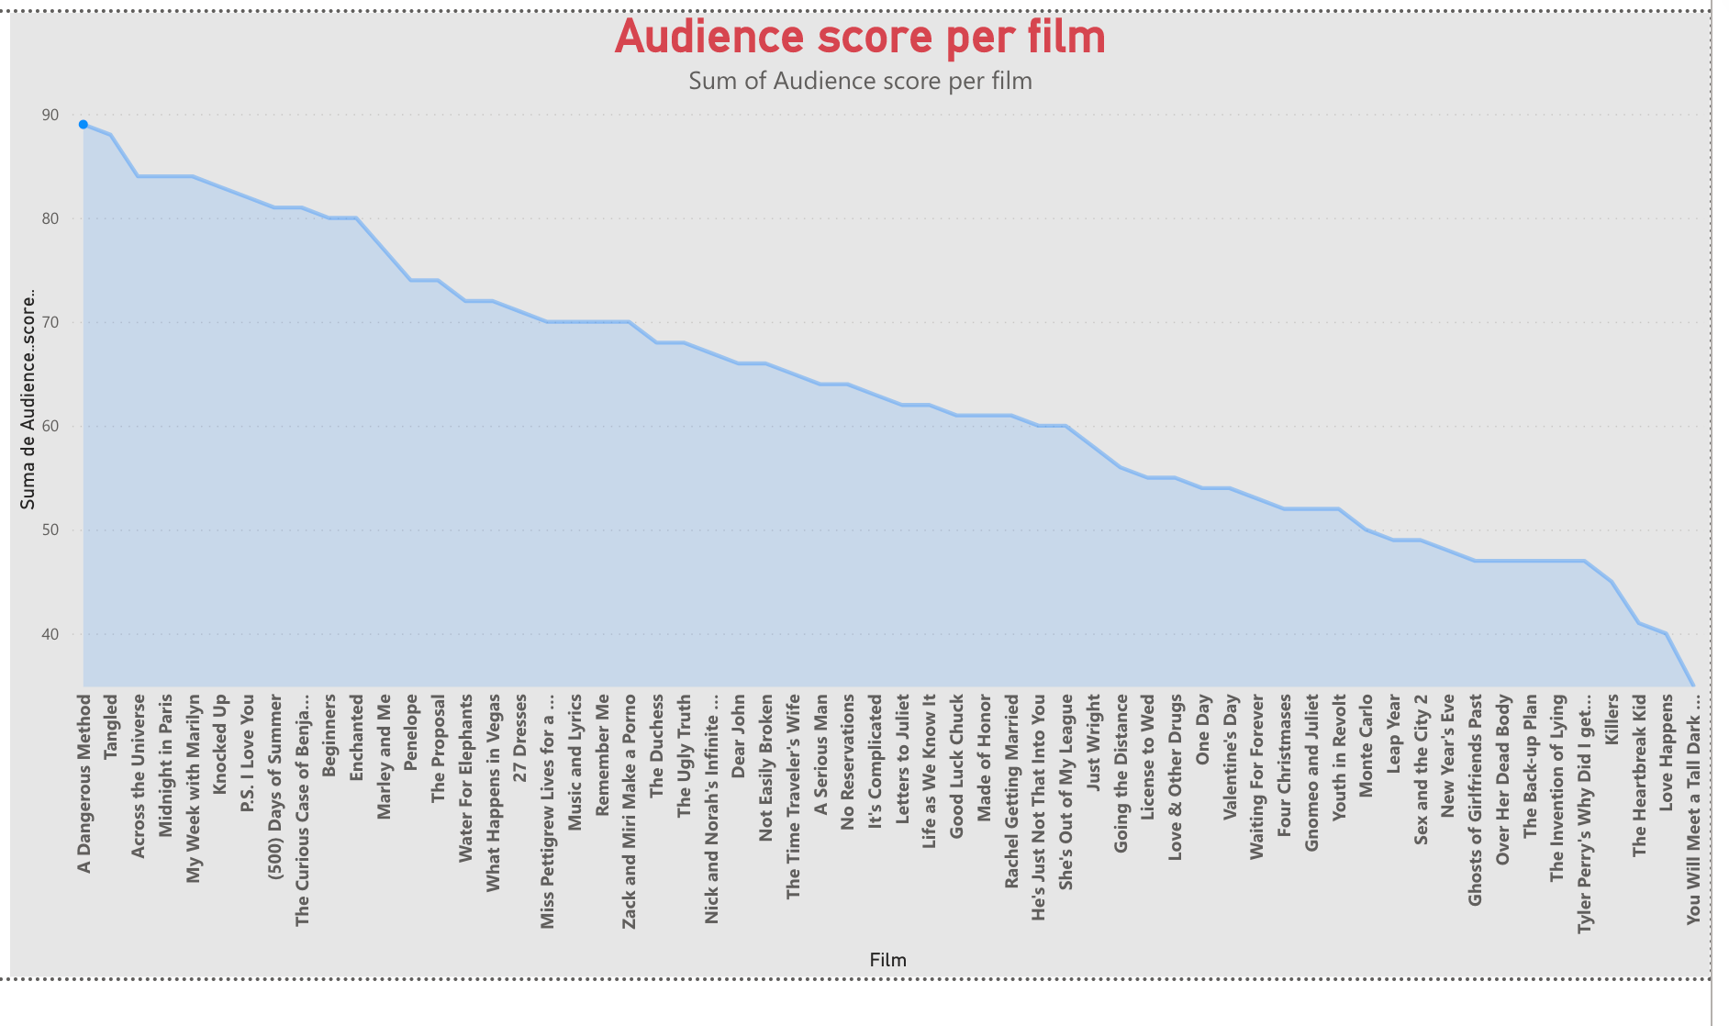

1. **Profitability-studio**

*Sony* on the top followed by *Fox* and *Disney* studio are the film studio companies with a highest number in profitability.

1. **Worldwide-genre**

Comedy leads the genre in highest number of worldwide gross with a 63%.

