- Download and import create-databases SQL script into MySQL Workbench.
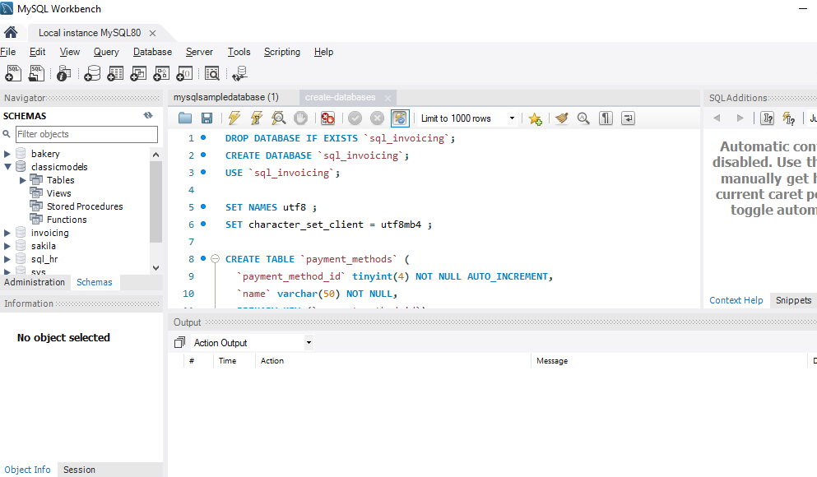

- Run the script and create databases.

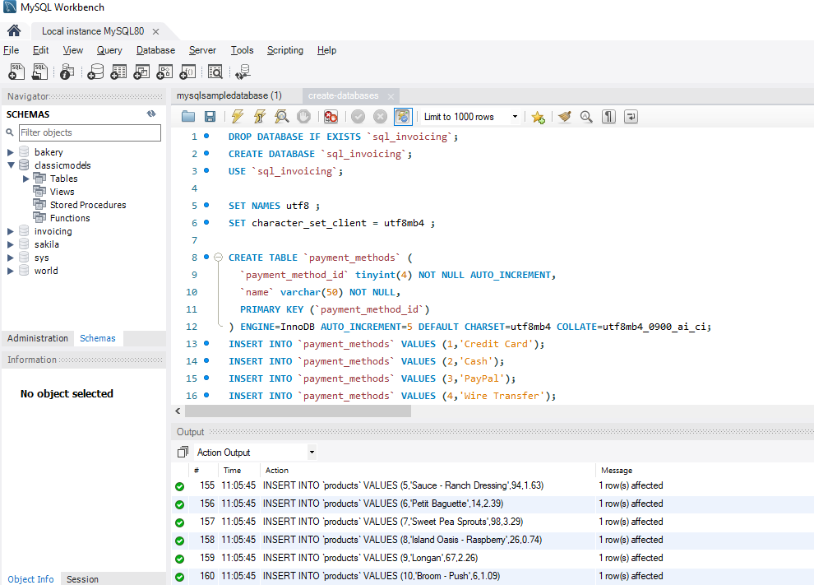
- Input the following into the file Query 1
- USE sql_store;
- SELECT *
- FROM customers;

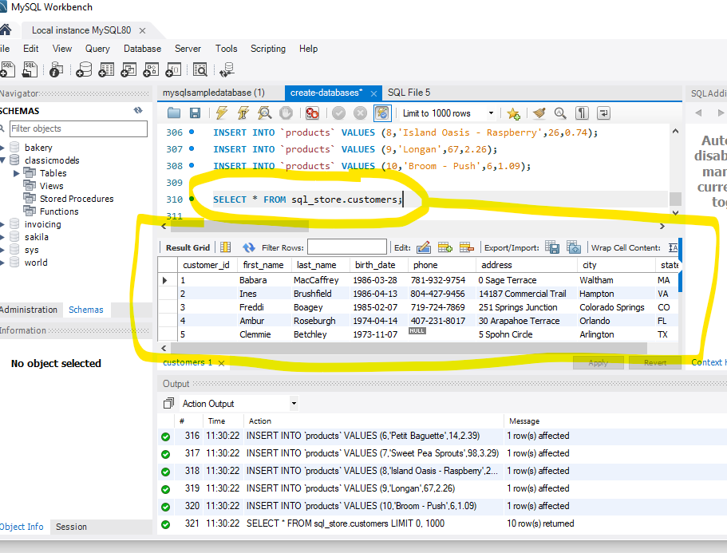

Query 1 continued… Add the following into the Query 1
-- WHERE CUSTOMER_ID=1
order by first_name

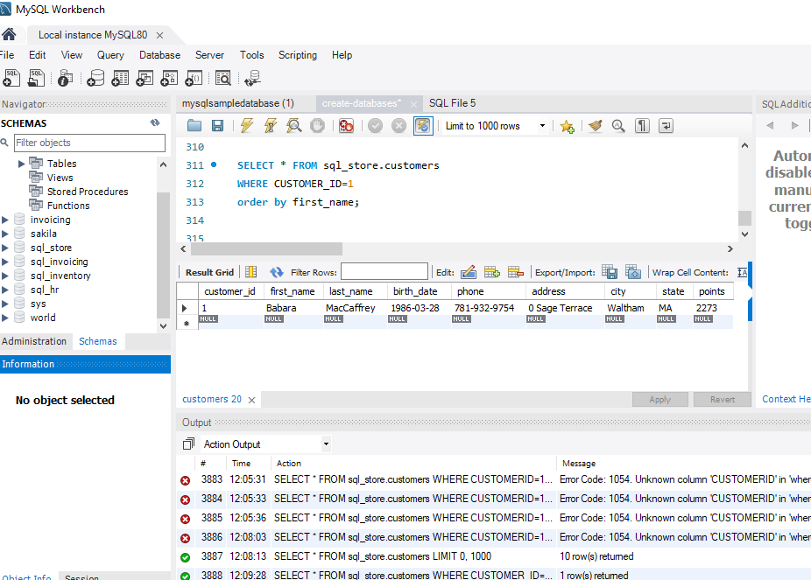

QUERY 2

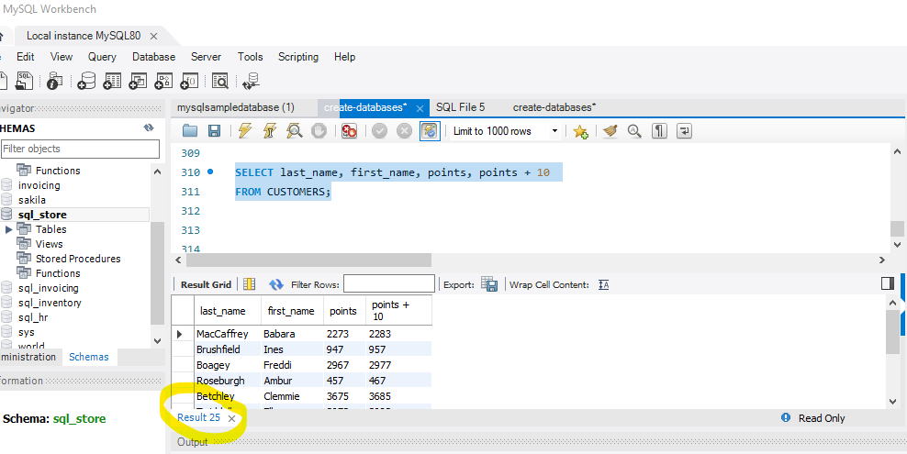

TASK 1

- Using the Query 2 you created change the points to reads times by 10 and plus 100. Record your results in your word document
- Change the Query 2 code to create a discount factor so the table now shows a discount header and changing the (point + 10) *100

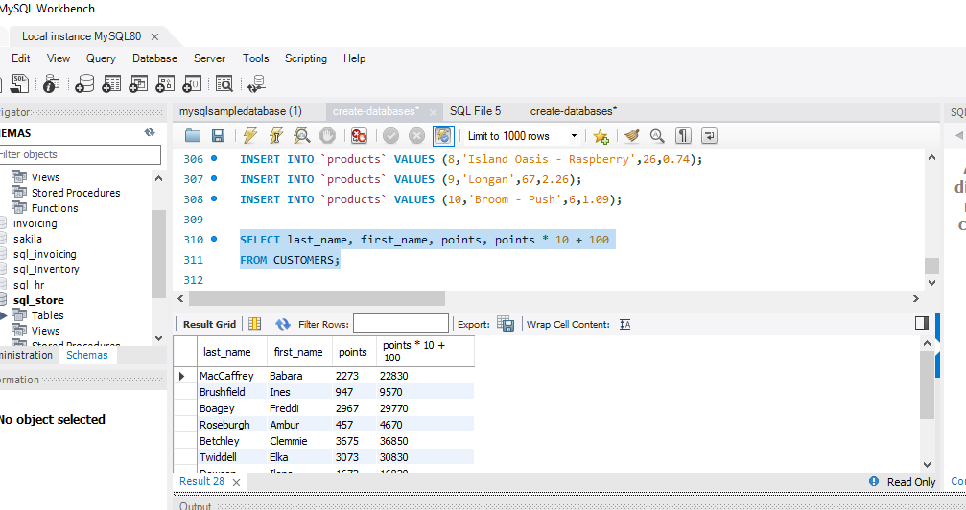

- Write a SQL query to return all the products in our database in the result set. I want you to show columns; name, unit price, and new column called new price which is based on this expression, (unit price * 1.1 ).
So what you are doing is increasing the product price of each by 10%.
So with the query we want all the products the original price and the new price.

SELECT *

SELECT product_id, name, quantity_in_stock, unit_price*10%
FROM products;

last_name, first_name, unit_price * 10%
FROM products

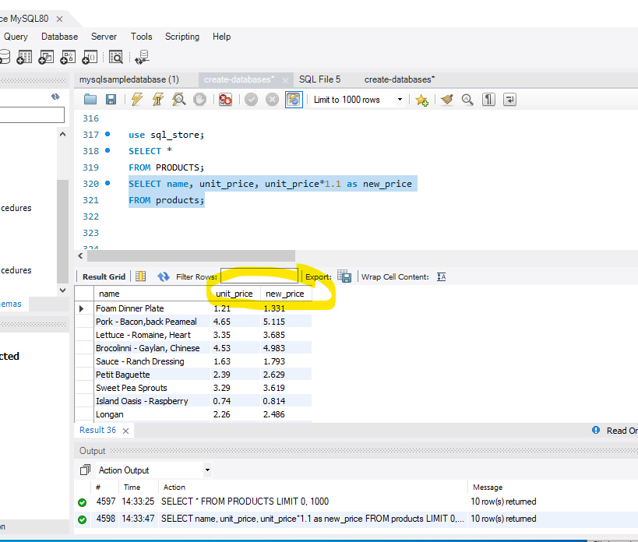

- In this task create a new query to find all the customers with a birth date of > '1990-01-01'

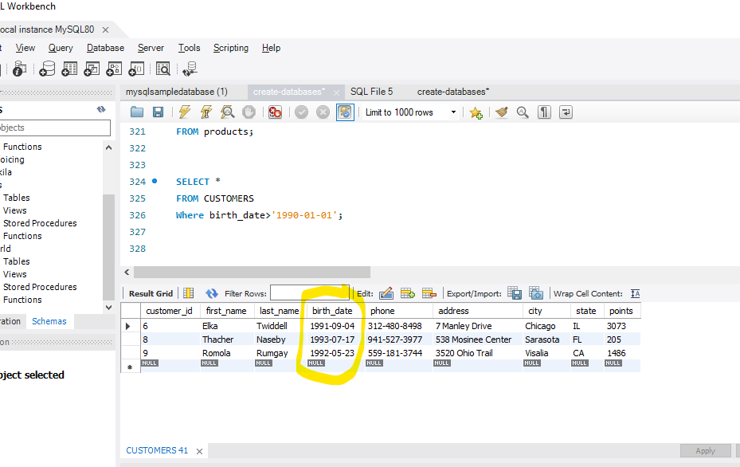

- Select sql_inventory.
- Write a query to find out the name of the product with most amount in stock.

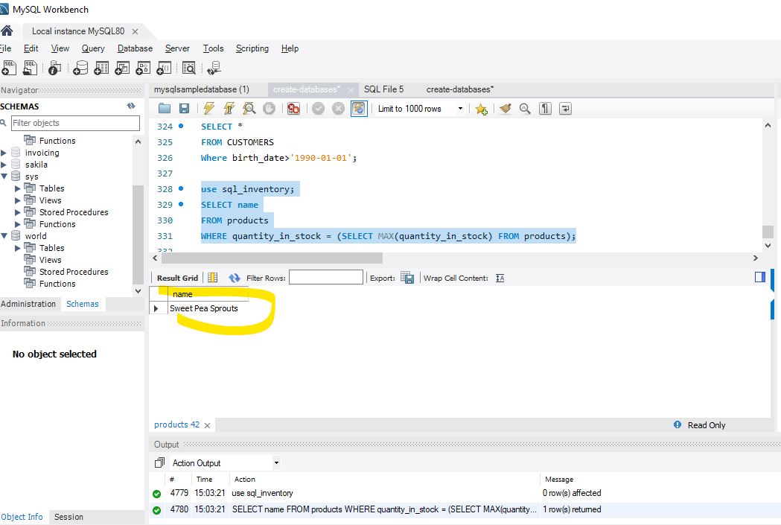

- Select sql_inventory.
Write a query to find out the name of the most expensive product

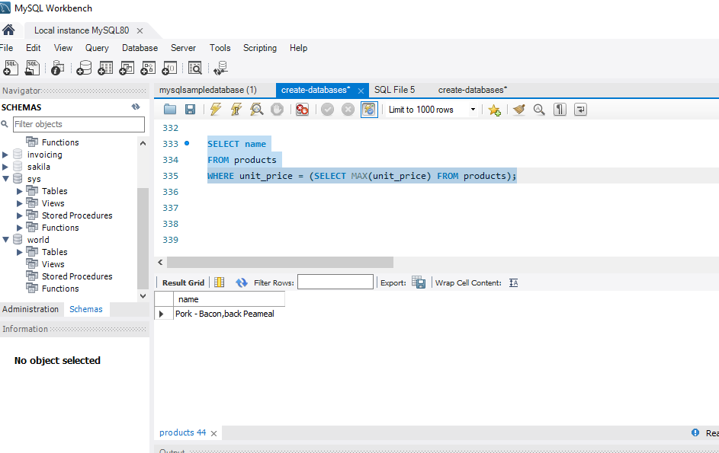

- Select sql_store.
- Write a query to find out the first name, last name, address and the birthdate of the oldest customer.

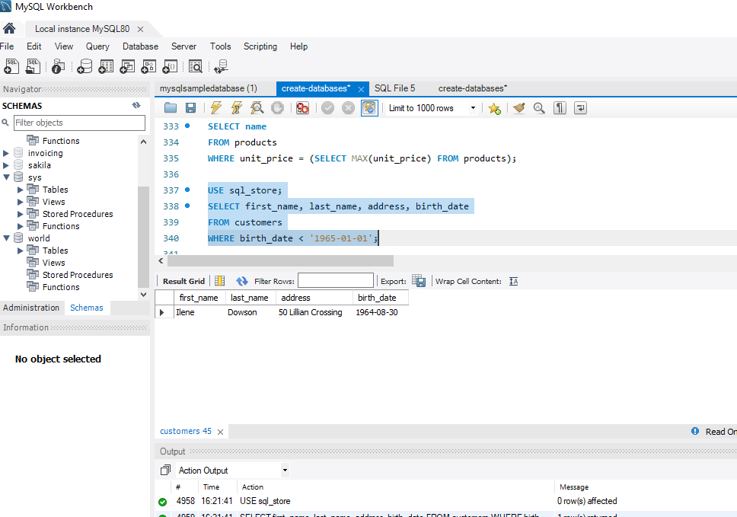

Creating an EER Diagram

