Description of Visual Relations

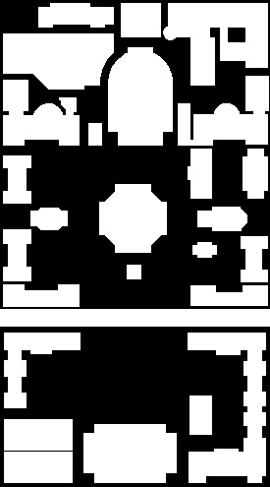

COMS W4735: Visual Interfaces to Computers

Assignment 3

due: 4/9/2015

Nina Baculinao

uni: nb2406

# Introduction

The goal of the Description of Visual Relations system is to explore how well a visual image can be described in human language terms. The program takes as input a 2D image of the Columbia campus plus a "source" and a "target" location, and then produces as output non-numeric descriptions of these locations (the "what") and non-numeric directions to follow ("the where") from the source to the target.

Information to aid the construction of the program is provided by the following files:

* ass3-campus.pgm
* ass3-labeled.pgm
* ass3-table.txt

Hardware and library specifications of the development environment are as follows:

* MacBook Air 11 inch running OSX Yosemite
* Python Standard Library 2.7.9
* OpenCV with a Python binding, v2.4.10.1
* NumPy 1.9.1

|  |  |
| --- | --- |
|  | 1="Pupin"  2="Schapiro CEPSR"  3="Mudd, Engineering Terrace, Fairchild & Computer Science"  4="Physical Fitness Center"  5="Gymnasium & Uris"  6="Schermerhorn"  7="Chandler & Havemeyer"  8="Computer Center"  9="Avery"  10="Fayerweather"  11="Mathematics"  12="Low Library"  13="St. Paul's Chapel"  14="Earl Hall"  15="Lewisohn"  16="Philosophy"  17="Buell & Maison Francaise"  18="Alma Mater"  19="Dodge"  20="Kent"  21="College Walk"  22="Journalism & Furnald"  23="Hamilton, Hartley, Wallach & John Jay"  24="Lion's Court"  25="Lerner Hall"  26="Butler Library"  27="Carman" |

Figure 1. Top to bottom, left ro right. Binary map of Columbia campus, grayscale labeled campus map where pixel values encode building keys (brightened here), and text listing of building keys and name values

# First part: describe how you determined each feature that you used. Give examples.

# Second part: talk about how you defined “near” and about how you pruned. Output all the surviving relations.

# Third part: talk about your clouds, and pictures of the largest/smallest clouds, show clouds for three interesting paths. Parentheses for describing them. Justify how you picked the paths.

# Fourth part: talk about which search algorithm used, talk about ambiguity - picking between paths, output the experiments

# 1. Basic infrastructure and building features and descriptions: the "what"

In this step we perform the "front end" vision processing to get "what" and find ways of describing each building in terms of a vocabulary of shapes. These are automatically computed from the visual properties of the given data. *It finds a way of describing each building in terms of a vocabulary of shapes. These can include geometric figures, sizes, orientations, and other identifying adjectives such as extremums.*

It finds a way of describing each building in terms of a vocabulary of shapes.

|  |  |
| --- | --- |
| Size  - explain magic numbers | 1. Building / Largest Building – threshold ratios  2. Building / Total Campus Area  3. Max, min, average area and calculate cutoff  area & perimeter / 6 > avg; area & perimeter / 4 < avg; the rest  Tiny/ Diminutive, Small, Medium, Large, Huge/Colossal |
| Shapes/ Geometric Figures | L or U/C shaped (check centroid – if not inside, check if 3 or 2 sides facing each other –else oddly/iregullar shaped)  Serif I’s (check midpoints of two facing sides)  Cross (empty corners)  Square (width/height similar)  Rectangular (fill bounding box)  Irregularly shaped  Partly curved  Sharp/chewed off corners  Symmetric |
|  | Multiple/single buildings (& in the building name) |
| Orientation | NS, EW, only if a width/height 1.5 the other  Centrally located, on campus border |
| Extrema | Smallest, Largest  Northernmost/southernmost/easternmost/westernmost  Longest, thinnest, squarest, most non-rectangular  Simple boundary, jagged boundary, has bumps/dents |

* "ass3-campus.pgm": a binary image of the main campus as seen from above, where a large number (white)represents the buildings and zeros represent the space between them
* "ass3-labeled.pgm": an integer-valued image based on the first, in which each building is given an encoded integer, and all the pixels belonging to the same building are encoded with the same integer; zero still means empty space.
* "ass3-table.txt": is a text file which translates the encoded integer into a string, so that some of your assignment’s answers (but not the visual interface itself) can come out in English.
* The "labeled" has been created explicitly to make these tasks easy; to get the shape features for Building N, one only has to scan the image for the occurrences of the encoded integer N. The file "atable.txt" makes the translation of the encoded integer to a string easy, too.

## System Output

Building Name

Center of Mass (x,y)

Area

MBR (UL, LR coordinates)

Description:

Identifying Contours

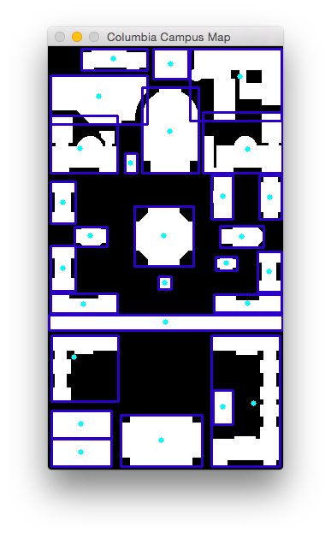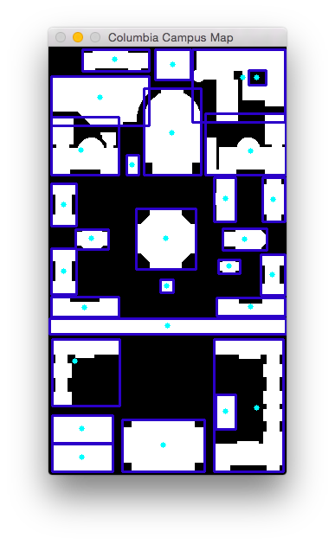

Identifying Buildings

Identifying Shapes

|  |  |  |  |  |
| --- | --- | --- | --- | --- |
| (x,y) |  | (x+w/2,y) |  | (x+w,y) |
|  |  |  |  |  |
|  |  |  |  |  |
|  |  |  |  |  |
| (x,y+h/2) |  |  |  | (x+w,y+h/2) |
|  |  |  |  |  |
|  |  |  |  |  |
|  |  |  |  |  |
| (x,y+h) |  | (x+w/2,y+h) |  | (x+w,y+h) |

Note: in numpy array x and y coordinates are flipped. This was the source of long time debugging. But this is the ordr for images.

|  |  |  |  |  |  |  |  |  |
| --- | --- | --- | --- | --- | --- | --- | --- | --- |
| (0,0) | (w,0) | | |  | (map_w-w, 0) | | (map_w,0) | |
| (0,h) |  |  | y < h | | |  |  | (map_w,h) |
|  | (w,h) | |  | (map_w –w, h) | |  |
|  |  |  |  |  |  |  |  |  |
|  |  |  |  |  |  |  |  |  |
|  |  |  |  |  |  |  |  |  |
| x < w |  | (map_w/2, map_h/2) | | | | |  | x > map_w-w |
|  |  |  |  |  |  |  | w |  |
|  |  |  |  |  |  | h | • |  |
|  |  |  |  |  |  |  |  |  |
|  |  |  |  |  |  |  |  | (map_w,map_h-h) |
| (0, map_h –h) |  | (w,map_h-h) | |  | (map_w-w), map_h-h) | |  |  |
|  |  | y > map_h-h | | |  |  |  |
| (0,map_h) | (w,h) | | |  | (map_w-w,map_h) | | (map_w,map_h) | |

|  |  |  |  |  |  |  |  |  |
| --- | --- | --- | --- | --- | --- | --- | --- | --- |
| (0,0) | (w,0) | | |  | (map_w-w, 0) | | (map_w,0) | |
| (0,h) |  |  | y < h | | |  |  | (map_w,h) |
|  | (w,h) | |  | (map_w –w, h) | |  |
|  |  |  |  |  |  |  |  |  |
|  |  | y < (map_h – 322) /2 and y > h | | | | |  |  |
|  |  |  |  |  |  |  |  |  |
| x < w |  | (map_w/2, map_h/2) | | | | |  | x > map_w-w |
|  |  |  |  |  |  |  | w |  |
|  |  | y < 322 and y > (map_h – 322)/2 | | | | | • |  |
|  | .. | (137,322) | | | | |  |  |
|  |  | y > 322 and y < map_h-h | | | | |  | (map_w,map_h-h) |
| (0, map_h –h) |  | (w,map_h-h) | |  | (map_w-w), map_h-h) | |  |  |
|  |  | y > map_h-h | | |  |  |  |
| (0,map_h) | (w,h) | | |  | (map_w-w,map_h) | | (map_w,map_h) | |

1. Harris method (buggy)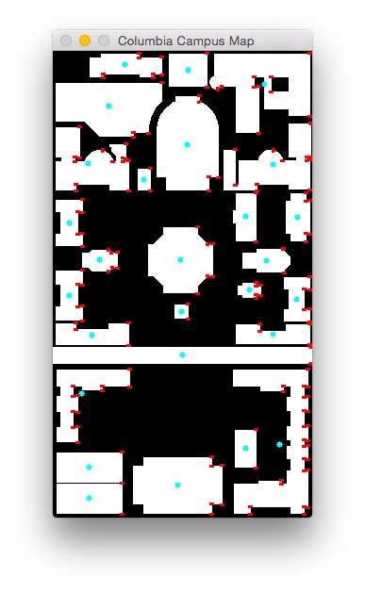

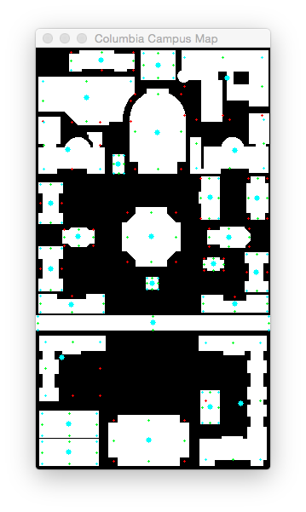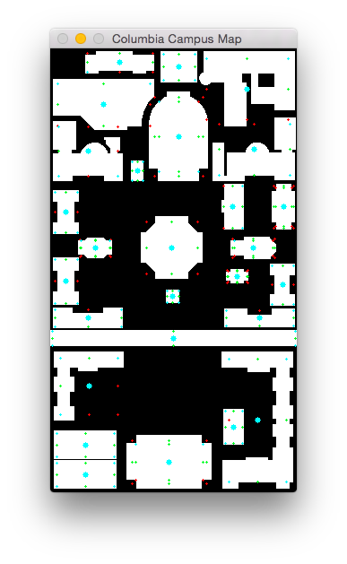

1 Pupin

Tolerance 2

[0, 0, 0, 1] Corners Count 1

[1, 1, 0, 1] Midpoints Count 3

Description ['irregularly shaped', 'oriented East-West']

2 Schapiro CEPSR

Tolerance 3

[1, 1, 1, 1] Corners Count 4

[1, 1, 1, 1] Midpoints Count 4

Description ['square']

3 Mudd, Engineering Terrace, Fairchild & Computer Science

Tolerance 8

[1, 0, 1, 0] Corners Count 2

[1, 1, 0, 0] Midpoints Count 2

Description ['irregularly shaped']

4 Physical Fitness Center

Tolerance 5

[1, 0, 1, 0] Corners Count 2

[1, 0, 1, 1] Midpoints Count 3

Description ['irregularly shaped', 'oriented East-West']

5 Gymnasium & Uris

Tolerance 6

[0, 0, 0, 0] Corners Count 0

[1, 1, 1, 1] Midpoints Count 4

Description ['cross-shaped', 'oriented North-South']

6 Schermerhorn

Tolerance 7

[0, 1, 1, 1] Corners Count 3

[0, 1, 1, 1] Midpoints Count 3

Description ['irregularly shaped']

7 Chandler & Havemeyer

Tolerance 6

[1, 1, 0, 1] Corners Count 3

[0, 0, 0, 1] Midpoints Count 1

Description ['irregularly shaped']

8 Computer Center

Tolerance 1

[1, 1, 1, 1] Corners Count 4

[1, 1, 1, 1] Midpoints Count 4

Description ['rectangular', 'oriented North-South']

9 Avery

Tolerance 2

[0, 1, 1, 0] Corners Count 2

[1, 1, 1, 1] Midpoints Count 4

Description ['T-shaped', 'oriented North-South']

10 Fayerweather

Tolerance 2

[0, 0, 0, 0] Corners Count 0

[1, 1, 1, 1] Midpoints Count 4

Description ['cross-shaped', 'oriented North-South']

11 Mathematics

Tolerance 2

[1, 1, 1, 1] Corners Count 4

[1, 0, 1, 0] Midpoints Count 2

Description ['I-shaped', 'oriented North-South']

12 Low Library

Tolerance 6

[0, 0, 0, 0] Corners Count 0

[1, 1, 1, 1] Midpoints Count 4

Description ['squarish', 'cross-shaped']

13 St. Paul's Chapel

Tolerance 2

[0, 0, 0, 0] Corners Count 0

[1, 1, 1, 1] Midpoints Count 4

Description ['cross-shaped', 'oriented East-West']

14 Earl Hall

Tolerance 2

[0, 0, 0, 0] Corners Count 0

[1, 1, 1, 1] Midpoints Count 4

Description ['cross-shaped', 'oriented East-West']

15 Lewisohn

Tolerance 2

[1, 1, 1, 1] Corners Count 4

[1, 0, 1, 0] Midpoints Count 2

Description ['I-shaped', 'oriented North-South']

16 Philosophy

Tolerance 2

[1, 1, 1, 1] Corners Count 4

[1, 0, 1, 0] Midpoints Count 2

Description ['I-shaped', 'oriented North-South']

17 Buell & Maison Francaise

Tolerance 1

[0, 0, 0, 0] Corners Count 0

[1, 1, 1, 1] Midpoints Count 4

Description ['cross-shaped', 'oriented East-West']

18 Alma Mater

Tolerance 1

[1, 1, 1, 1] Corners Count 4

[1, 1, 1, 1] Midpoints Count 4

Description ['square']

19 Dodge

Tolerance 2

[1, 1, 1, 1] Corners Count 4

[0, 1, 1, 1] Midpoints Count 3

Description ['C-shaped', 'oriented East-West']

20 Kent

Tolerance 2

[1, 1, 1, 1] Corners Count 4

[0, 1, 1, 1] Midpoints Count 3

Description ['C-shaped', 'oriented East-West']

21 College Walk

Tolerance 1

[1, 1, 1, 1] Corners Count 4

[1, 1, 1, 1] Midpoints Count 4

Description ['rectangular', 'oriented East-West']

22 Journalism & Furnald

Tolerance 7

[1, 0, 1, 1] Corners Count 3

[1, 0, 0, 1] Midpoints Count 2

Description ['L-shaped']

23 Hamilton, Hartley, Wallach & John Jay

Tolerance 8

[1, 1, 1, 1] Corners Count 4

[1, 1, 1, 0] Midpoints Count 3

Description ['C-shaped', 'oriented North-South']

24 Lion's Court

Tolerance 2

[1, 1, 1, 1] Corners Count 4

[1, 1, 1, 1] Midpoints Count 4

Description ['rectangular', 'oriented North-South']

25 Lerner Hall

Tolerance 3

[1, 1, 1, 1] Corners Count 4

[1, 1, 1, 1] Midpoints Count 4

Description ['rectangular', 'oriented East-West']

26 Butler Library

Tolerance 6

[0, 0, 0, 0] Corners Count 0

[1, 1, 1, 1] Midpoints Count 4

Description ['cross-shaped', 'oriented East-West']

27 Carman

Tolerance 3

[1, 1, 1, 1] Corners Count 4

[1, 1, 1, 1] Midpoints Count 4

Description ['rectangular', 'oriented East-West']

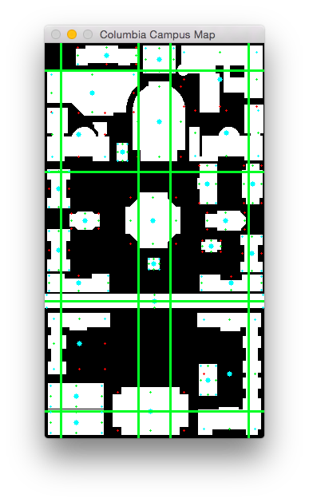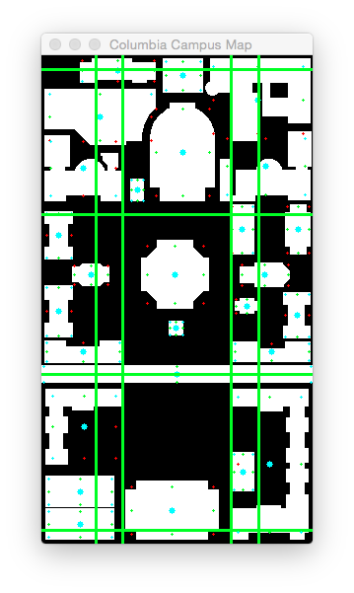

Kent

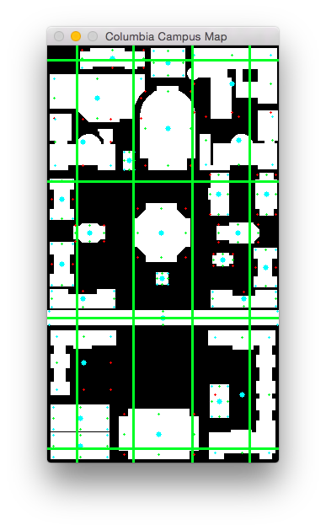St. Paul’s Chapel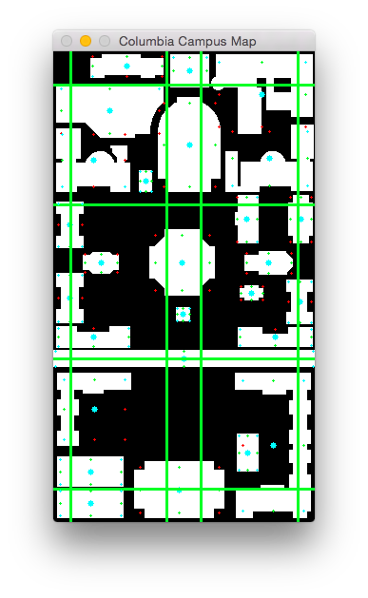

|  |  |
| --- | --- |
| 1="Pupin" |  |
| 2="Schapiro CEPSR" |  |
| 3="Mudd, Engineering Terrace, Fairchild & Computer Science" |  |
| 4="Physical Fitness Center" |  |
| 5="Gymnasium & Uris" |  |
| 6="Schermerhorn" |  |
| 7="Chandler & Havemeyer" |  |
| 8="Computer Center" |  |
| 9="Avery" |  |
| 10="Fayerweather" |  |
| 11="Mathematics" |  |
| 12="Low Library" |  |
| 13="St. Paul's Chapel" |  |
| 14="Earl Hall" |  |
| 15="Lewisohn" |  |
| 16="Philosophy" |  |
| 17="Buell & Maison Francaise" |  |
| 18="Alma Mater" |  |
| 19="Dodge" |  |
| 20="Kent" |  |
| 21="College Walk" |  |
| 22="Journalism & Furnald" |  |
| 23="Hamilton, Hartley, Wallach & John Jay" |  |
| 24="Lion's Court" |  |
| 25="Lerner Hall" |  |
| 26="Butler Library" |  |
| 27="Carman" |  |

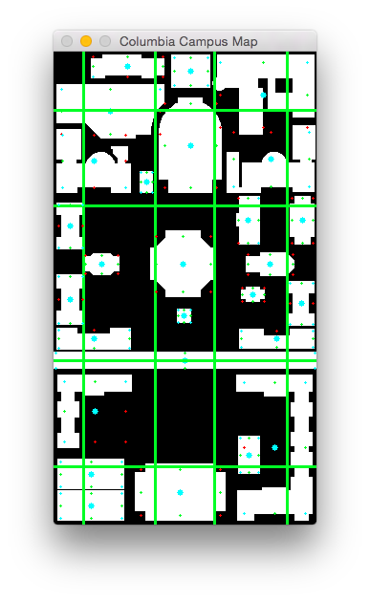1.2 Fay

# 

# 

Special Case:

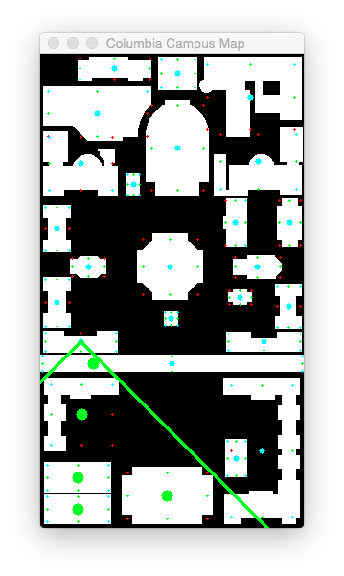

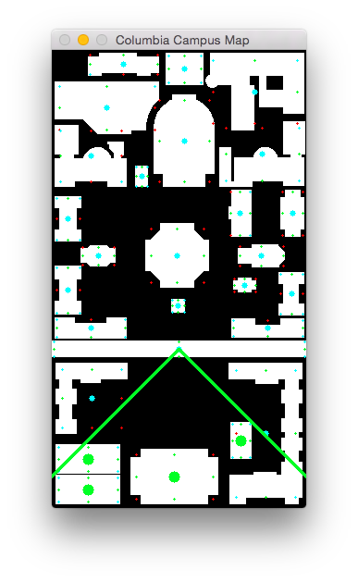 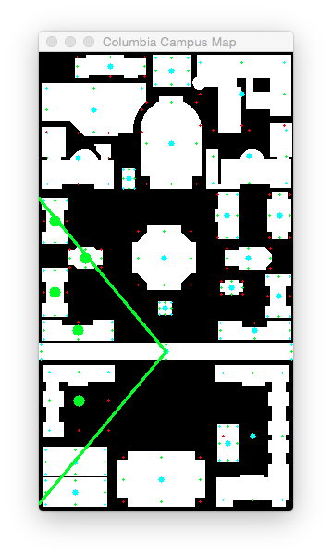

North relationships:

1 2 3 4 5 6 7 8 9 10 11 12 13 14 15 16 17 18 19 20 21 22 23 24 25 26 27

1 0 0 0 0 0 0 0 0 0 0 0 0 0 0 0 0 0 0 0 0 0 0 0 0 0 0 0

2 0 0 0 0 0 0 0 0 0 0 0 0 0 0 0 0 0 0 0 0 0 0 0 0 0 0 0

3 0 0 0 0 0 0 0 0 0 0 0 0 0 0 0 0 0 0 0 0 0 0 0 0 0 0 0

4 1 0 0 0 0 0 0 0 0 0 0 0 0 0 0 0 0 0 0 0 0 0 0 0 0 0 0

5 1 1 0 0 0 0 0 0 0 0 0 0 0 0 0 0 0 0 0 0 0 0 0 0 0 0 0

6 0 1 1 0 0 0 0 0 0 0 0 0 0 0 0 0 0 0 0 0 0 0 0 0 0 0 0

7 1 0 0 1 0 0 0 0 0 0 0 0 0 0 0 0 0 0 0 0 0 0 0 0 0 0 0

8 1 1 0 1 0 0 0 0 0 0 0 0 0 0 0 0 0 0 0 0 0 0 0 0 0 0 0

9 1 1 1 0 1 1 0 0 0 0 0 0 0 0 0 0 0 0 0 0 0 0 0 0 0 0 0

10 0 1 1 0 0 1 0 0 0 0 0 0 0 0 0 0 0 0 0 0 0 0 0 0 0 0 0

11 1 1 0 1 0 0 1 0 0 0 0 0 0 0 0 0 0 0 0 0 0 0 0 0 0 0 0

12 1 1 1 1 1 1 1 1 0 0 0 0 0 0 0 0 0 0 0 0 0 0 0 0 0 0 0

13 1 1 1 0 1 1 0 0 1 1 0 0 0 0 0 0 0 0 0 0 0 0 0 0 0 0 0

14 1 1 1 1 1 0 1 1 0 0 1 0 0 0 0 0 0 0 0 0 0 0 0 0 0 0 0

15 1 1 1 1 1 0 1 1 0 0 1 0 0 1 0 0 0 0 0 0 0 0 0 0 0 0 0

16 1 1 1 1 1 1 0 0 1 1 0 0 1 0 0 0 0 0 0 0 0 0 0 0 0 0 0

17 1 1 1 1 1 1 0 1 1 1 0 0 1 0 0 0 0 0 0 0 0 0 0 0 0 0 0

18 1 1 1 1 1 1 1 1 1 0 0 1 0 0 0 0 0 0 0 0 0 0 0 0 0 0 0

19 1 1 1 1 1 1 1 1 0 0 1 0 0 1 1 0 0 0 0 0 0 0 0 0 0 0 0

20 1 1 1 1 1 1 0 1 1 1 0 0 1 0 0 1 1 0 0 0 0 0 0 0 0 0 0

21 1 1 1 1 1 1 1 1 1 1 1 1 1 1 0 0 0 1 0 0 0 0 0 0 0 0 0

22 1 1 1 1 1 1 1 1 1 0 1 1 0 1 1 0 0 1 1 0 1 0 0 0 0 0 0

23 1 1 1 1 1 1 1 1 1 1 1 1 1 1 0 1 1 1 0 1 1 0 0 0 0 0 0

24 1 1 1 1 1 1 1 1 1 1 1 1 1 1 0 1 1 1 0 1 1 0 0 0 0 0 0

25 1 1 1 1 1 1 1 1 1 1 1 1 1 1 1 0 1 1 1 0 1 1 0 0 0 0 0

26 1 1 1 1 1 1 1 1 1 1 1 1 1 1 1 1 1 1 1 1 1 0 0 0 0 0 0

27 1 1 1 1 1 1 1 1 1 1 1 1 1 1 1 0 1 1 1 0 1 1 0 0 1 0 0

Number of true relationships: 237

South relationships:

1 2 3 4 5 6 7 8 9 10 11 12 13 14 15 16 17 18 19 20 21 22 23 24 25 26 27

1 0 0 0 1 1 0 1 1 1 0 1 1 1 1 1 1 1 1 1 1 1 1 1 1 1 1 1

2 0 0 0 0 1 1 0 1 1 1 1 1 1 1 1 1 1 1 1 1 1 1 1 1 1 1 1

3 0 0 0 0 0 1 0 0 1 1 0 1 1 1 1 1 1 1 1 1 1 1 1 1 1 1 1

4 0 0 0 0 0 0 1 1 0 0 1 1 0 1 1 1 1 1 1 1 1 1 1 1 1 1 1

5 0 0 0 0 0 0 0 0 1 0 0 1 1 1 1 1 1 1 1 1 1 1 1 1 1 1 1

6 0 0 0 0 0 0 0 0 1 1 0 1 1 0 0 1 1 1 1 1 1 1 1 1 1 1 1

7 0 0 0 0 0 0 0 0 0 0 1 1 0 1 1 0 0 1 1 0 1 1 1 1 1 1 1

8 0 0 0 0 0 0 0 0 0 0 0 1 0 1 1 0 1 1 1 1 1 1 1 1 1 1 1

9 0 0 0 0 0 0 0 0 0 0 0 0 1 0 0 1 1 1 0 1 1 1 1 1 1 1 1

10 0 0 0 0 0 0 0 0 0 0 0 0 1 0 0 1 1 0 0 1 1 0 1 1 1 1 1

11 0 0 0 0 0 0 0 0 0 0 0 0 0 1 1 0 0 0 1 0 1 1 1 1 1 1 1

12 0 0 0 0 0 0 0 0 0 0 0 0 0 0 0 0 0 1 0 0 1 1 1 1 1 1 1

13 0 0 0 0 0 0 0 0 0 0 0 0 0 0 0 1 1 0 0 1 1 0 1 1 1 1 1

14 0 0 0 0 0 0 0 0 0 0 0 0 0 0 1 0 0 0 1 0 1 1 1 1 1 1 1

15 0 0 0 0 0 0 0 0 0 0 0 0 0 0 0 0 0 0 1 0 1 1 0 0 1 1 1

16 0 0 0 0 0 0 0 0 0 0 0 0 0 0 0 0 0 0 0 1 1 0 1 1 0 1 0

17 0 0 0 0 0 0 0 0 0 0 0 0 0 0 0 0 0 0 0 1 1 0 1 1 1 1 1

18 0 0 0 0 0 0 0 0 0 0 0 0 0 0 0 0 0 0 0 0 1 1 1 1 1 1 1

19 0 0 0 0 0 0 0 0 0 0 0 0 0 0 0 0 0 0 0 0 1 1 0 0 1 1 1

20 0 0 0 0 0 0 0 0 0 0 0 0 0 0 0 0 0 0 0 0 1 0 1 1 0 1 0

21 0 0 0 0 0 0 0 0 0 0 0 0 0 0 0 0 0 0 0 0 0 0 0 1 1 1 1

22 0 0 0 0 0 0 0 0 0 0 0 0 0 0 0 0 0 0 0 0 0 0 0 0 1 0 1

23 0 0 0 0 0 0 0 0 0 0 0 0 0 0 0 0 0 0 0 0 0 0 0 0 0 0 0

24 0 0 0 0 0 0 0 0 0 0 0 0 0 0 0 0 0 0 0 0 0 0 0 0 0 0 0

25 0 0 0 0 0 0 0 0 0 0 0 0 0 0 0 0 0 0 0 0 0 0 0 0 0 0 1

26 0 0 0 0 0 0 0 0 0 0 0 0 0 0 0 0 0 0 0 0 0 0 0 0 0 0 0

27 0 0 0 0 0 0 0 0 0 0 0 0 0 0 0 0 0 0 0 0 0 0 0 0 0 0 0

Number of true relationships: 240

East relationships:

1 2 3 4 5 6 7 8 9 10 11 12 13 14 15 16 17 18 19 20 21 22 23 24 25 26 27

1 0 1 1 0 0 1 0 0 0 1 0 0 0 0 0 0 0 0 0 0 0 0 0 0 0 0 0

2 0 0 1 0 0 1 0 0 0 0 0 0 0 0 0 0 0 0 0 0 0 0 0 0 0 0 0

3 0 0 0 0 0 0 0 0 0 0 0 0 0 0 0 0 0 0 0 0 0 0 0 0 0 0 0

4 0 1 1 0 1 1 0 0 1 1 0 0 1 0 0 1 0 0 0 0 0 0 0 0 0 0 0

5 0 0 1 0 0 1 0 0 0 1 0 0 0 0 0 0 0 0 0 0 0 0 0 0 0 0 0

6 0 0 0 0 0 0 0 0 0 0 0 0 0 0 0 0 0 0 0 0 0 0 0 0 0 0 0

7 0 1 1 0 1 1 0 1 1 1 0 1 1 0 0 1 1 0 0 1 1 0 0 0 0 0 0

8 0 0 1 0 1 1 0 0 1 1 0 0 1 0 0 1 1 0 0 0 0 0 0 0 0 0 0

9 0 0 0 0 0 0 0 0 0 1 0 0 0 0 0 0 0 0 0 0 0 0 0 0 0 0 0

10 0 0 0 0 0 0 0 0 0 0 0 0 0 0 0 0 0 0 0 0 0 0 0 0 0 0 0

11 0 0 1 0 1 1 0 1 1 1 0 1 1 0 0 1 1 1 0 1 1 0 1 0 0 0 0

12 0 0 0 0 0 1 0 0 1 1 0 0 1 0 0 1 1 0 0 1 1 0 0 0 0 0 0

13 0 0 0 0 0 0 0 0 0 0 0 0 0 0 0 0 0 0 0 0 0 0 0 0 0 0 0

14 0 0 1 0 0 1 0 0 1 1 0 1 1 0 0 1 1 1 0 1 1 0 1 0 0 0 0

15 0 0 1 0 0 1 0 0 1 1 0 1 1 1 0 1 1 1 0 1 1 0 1 1 0 0 0

16 0 0 0 0 0 0 0 0 0 0 0 0 0 0 0 0 0 0 0 0 0 0 0 0 0 0 0

17 0 0 0 0 0 0 0 0 0 0 0 0 0 0 0 1 0 0 0 0 0 0 0 0 0 0 0

18 0 0 0 0 0 0 0 0 0 1 0 0 1 0 0 1 1 0 0 1 1 0 0 0 0 0 0

19 0 0 0 0 0 1 0 0 1 1 0 1 1 0 0 1 1 1 0 1 1 0 1 1 0 0 0

20 0 0 0 0 0 0 0 0 0 0 0 0 0 0 0 0 0 0 0 0 0 0 0 0 0 0 0

21 0 0 0 0 0 0 0 0 0 1 0 0 1 0 0 1 1 0 0 1 0 0 1 0 0 0 0

22 0 0 0 0 0 0 0 0 0 1 0 0 1 0 0 1 1 1 0 1 1 0 1 1 0 1 0

23 0 0 0 0 0 0 0 0 0 0 0 0 0 0 0 0 0 0 0 0 0 0 0 0 0 0 0

24 0 0 0 0 0 0 0 0 0 0 0 0 0 0 0 0 0 0 0 0 0 0 1 0 0 0 0

25 0 0 0 0 0 0 0 0 0 0 0 0 1 0 0 1 1 0 0 1 1 0 1 1 0 1 0

26 0 0 0 0 0 0 0 0 0 0 0 0 0 0 0 0 0 0 0 0 0 0 1 1 0 0 0

27 0 0 0 0 0 0 0 0 0 0 0 0 0 0 0 1 0 0 0 1 1 0 1 1 0 1 0

Number of true relationships: 139

West relationships:

1 2 3 4 5 6 7 8 9 10 11 12 13 14 15 16 17 18 19 20 21 22 23 24 25 26 27

1 0 0 0 0 0 0 0 0 0 0 0 0 0 0 0 0 0 0 0 0 0 0 0 0 0 0 0

2 1 0 0 1 0 0 1 0 0 0 0 0 0 0 0 0 0 0 0 0 0 0 0 0 0 0 0

3 1 1 0 1 1 0 1 1 0 0 1 0 0 1 1 0 0 0 0 0 0 0 0 0 0 0 0

4 0 0 0 0 0 0 0 0 0 0 0 0 0 0 0 0 0 0 0 0 0 0 0 0 0 0 0

5 0 0 0 1 0 0 1 1 0 0 1 0 0 0 0 0 0 0 0 0 0 0 0 0 0 0 0

6 1 1 0 1 1 0 1 1 0 0 1 1 0 1 1 0 0 0 1 0 0 0 0 0 0 0 0

7 0 0 0 0 0 0 0 0 0 0 0 0 0 0 0 0 0 0 0 0 0 0 0 0 0 0 0

8 0 0 0 0 0 0 1 0 0 0 1 0 0 0 0 0 0 0 0 0 0 0 0 0 0 0 0

9 0 0 0 1 0 0 1 1 0 0 1 1 0 1 1 0 0 0 1 0 1 0 0 0 0 0 0

10 1 0 0 1 1 0 1 1 1 0 1 1 0 1 1 0 0 1 1 0 1 1 0 0 0 0 0

11 0 0 0 0 0 0 0 0 0 0 0 0 0 0 0 0 0 0 0 0 0 0 0 0 0 0 0

12 0 0 0 0 0 0 1 0 0 0 1 0 0 1 1 0 0 0 1 0 0 0 0 0 0 0 0

13 0 0 0 1 0 0 1 1 0 0 1 1 0 1 1 0 0 1 1 0 1 1 0 0 1 0 0

14 0 0 0 0 0 0 0 0 0 0 0 0 0 0 1 0 0 0 0 0 0 0 0 0 0 0 0

15 0 0 0 0 0 0 0 0 0 0 0 0 0 0 0 0 0 0 0 0 0 0 0 0 0 0 0

16 0 0 0 1 0 0 1 1 0 0 1 1 0 1 1 0 1 1 1 0 1 1 0 0 1 0 1

17 0 0 0 0 0 0 1 1 0 0 1 1 0 1 1 0 0 1 1 0 1 1 0 0 1 0 0

18 0 0 0 0 0 0 0 0 0 0 1 0 0 1 1 0 0 0 1 0 1 1 0 0 0 0 0

19 0 0 0 0 0 0 0 0 0 0 0 0 0 0 0 0 0 0 0 0 0 0 0 0 0 0 0

20 0 0 0 0 0 0 1 0 0 0 1 1 0 1 1 0 0 1 1 0 1 1 0 0 1 0 1

21 0 0 0 0 0 0 0 0 0 0 1 0 0 1 1 0 0 0 1 0 0 1 0 0 0 0 0

22 0 0 0 0 0 0 0 0 0 0 0 0 0 0 0 0 0 0 0 0 0 0 0 0 0 0 0

23 0 0 0 0 0 0 0 0 0 0 1 0 0 1 1 0 0 0 1 0 1 1 0 1 1 1 1

24 0 0 0 0 0 0 0 0 0 0 0 0 0 0 1 0 0 0 1 0 1 1 0 0 1 1 1

25 0 0 0 0 0 0 0 0 0 0 0 0 0 0 0 0 0 0 0 0 0 0 0 0 0 0 0

26 0 0 0 0 0 0 0 0 0 0 0 0 0 0 0 0 0 0 0 0 0 1 0 0 1 0 1

27 0 0 0 0 0 0 0 0 0 0 0 0 0 0 0 0 0 0 0 0 0 0 0 0 0 0 0

Number of true relationships: 137

North relationships:

1 2 3 4 5 6 7 8 9 10 11 12 13 14 15 16 17 18 19 20 21 22 23 24 25 26 27

1

2

3

4 1

5 1 1

6 1 1

7 1 1

8 1 1 1

9 1 1 1 1 1

10 1 1 1

11 1 1 1 1

12 1 1 1 1 1 1 1 1

13 1 1 1 1 1 1 1

14 1 1 1 1 1 1 1 1

15 1 1 1 1 1 1 1 1 1

16 1 1 1 1 1 1 1 1 1

17 1 1 1 1 1 1 1 1 1 1

18 1 1 1 1 1 1 1 1 1 1

19 1 1 1 1 1 1 1 1 1 1 1

20 1 1 1 1 1 1 1 1 1 1 1 1

21 1 1 1 1 1 1 1 1 1 1 1 1 1 1 1

22 1 1 1 1 1 1 1 1 1 1 1 1 1 1 1 1

23 1 1 1 1 1 1 1 1 1 1 1 1 1 1 1 1 1 1 1

24 1 1 1 1 1 1 1 1 1 1 1 1 1 1 1 1 1 1 1

25 1 1 1 1 1 1 1 1 1 1 1 1 1 1 1 1 1 1 1 1

26 1 1 1 1 1 1 1 1 1 1 1 1 1 1 1 1 1 1 1 1 1

27 1 1 1 1 1 1 1 1 1 1 1 1 1 1 1 1 1 1 1 1 1

Number of true relationships: 237

South relationships:

1 2 3 4 5 6 7 8 9 10 11 12 13 14 15 16 17 18 19 20 21 22 23 24 25 26 27

1 1 1 1 1 1 1 1 1 1 1 1 1 1 1 1 1 1 1 1 1 1 1

2 1 1 1 1 1 1 1 1 1 1 1 1 1 1 1 1 1 1 1 1 1 1

3 1 1 1 1 1 1 1 1 1 1 1 1 1 1 1 1 1 1 1

4 1 1 1 1 1 1 1 1 1 1 1 1 1 1 1 1 1 1

5 1 1 1 1 1 1 1 1 1 1 1 1 1 1 1 1 1

6 1 1 1 1 1 1 1 1 1 1 1 1 1 1 1 1

7 1 1 1 1 1 1 1 1 1 1 1 1 1

8 1 1 1 1 1 1 1 1 1 1 1 1 1 1

9 1 1 1 1 1 1 1 1 1 1 1 1

10 1 1 1 1 1 1 1 1 1 1

11 1 1 1 1 1 1 1 1 1 1

12 1 1 1 1 1 1 1 1

13 1 1 1 1 1 1 1 1 1

14 1 1 1 1 1 1 1 1 1

15 1 1 1 1 1 1

16 1 1 1 1 1

17 1 1 1 1 1 1 1

18 1 1 1 1 1 1 1

19 1 1 1 1 1

20 1 1 1 1

21 1 1 1 1

22 1 1

23

24

25 1

26

27

Number of true relationships: 240

East relationships:

1 2 3 4 5 6 7 8 9 10 11 12 13 14 15 16 17 18 19 20 21 22 23 24 25 26 27

1 1 1 1 1

2 1 1

3

4 1 1 1 1 1 1 1 1

5 1 1 1

6

7 1 1 1 1 1 1 1 1 1 1 1 1 1

8 1 1 1 1 1 1 1 1

9 1

10

11 1 1 1 1 1 1 1 1 1 1 1 1 1 1

12 1 1 1 1 1 1 1 1

13

14 1 1 1 1 1 1 1 1 1 1 1 1

15 1 1 1 1 1 1 1 1 1 1 1 1 1 1

16

17 1

18 1 1 1 1 1 1

19 1 1 1 1 1 1 1 1 1 1 1 1

20

21 1 1 1 1 1 1

22 1 1 1 1 1 1 1 1 1 1

23

24 1

25 1 1 1 1 1 1 1 1

26 1 1

27 1 1 1 1 1 1

Number of true relationships: 139

West relationships:

1 2 3 4 5 6 7 8 9 10 11 12 13 14 15 16 17 18 19 20 21 22 23 24 25 26 27

1

2 1 1 1

3 1 1 1 1 1 1 1 1 1

4

5 1 1 1 1

6 1 1 1 1 1 1 1 1 1 1 1

7

8 1 1

9 1 1 1 1 1 1 1 1 1

10 1 1 1 1 1 1 1 1 1 1 1 1 1 1

11

12 1 1 1 1 1

13 1 1 1 1 1 1 1 1 1 1 1 1

14 1

15

16 1 1 1 1 1 1 1 1 1 1 1 1 1 1

17 1 1 1 1 1 1 1 1 1 1 1

18 1 1 1 1 1 1

19

20 1 1 1 1 1 1 1 1 1 1 1

21 1 1 1 1 1

22

23 1 1 1 1 1 1 1 1 1 1

24 1 1 1 1 1 1 1

25

26 1 1 1

27

Number of true relationships: 137

# 

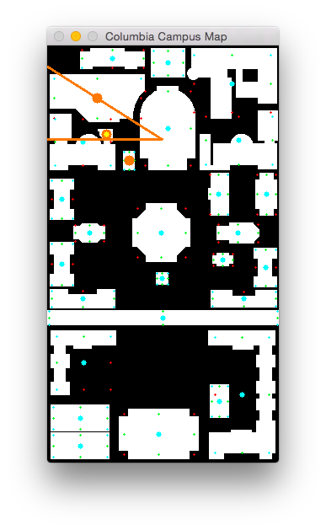 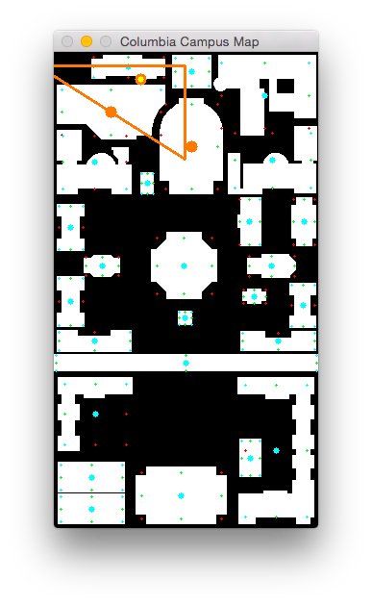

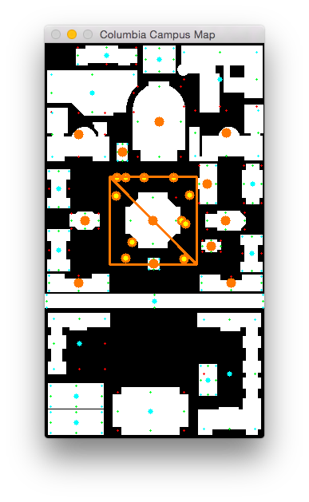Bug: need to check centroid too!

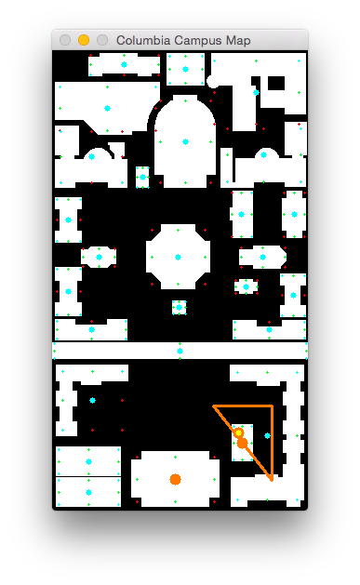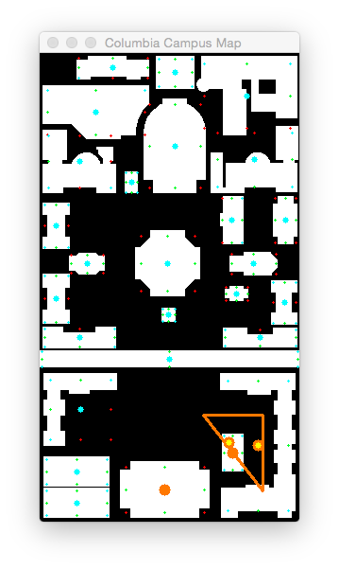

North relationships:

1 2 3 4 5 6 7 8 9 10 11 12 13 14 15 16 17 18 19 20 21 22 23 24 25 26 27

1

2

3

4 1

5 1 1

6 1 1

7 1 1

8 1 1 1

9 1 1 1 1 1

10 1 1 1

11 1 1 1 1

12 1 1 1 1 1 1 1 1

13 1 1 1 1 1 1 1

14 1 1 1 1 1 1 1 1

15 1 1 1 1 1 1 1 1 1

16 1 1 1 1 1 1 1 1 1

17 1 1 1 1 1 1 1 1 1 1

18 1 1 1 1 1 1 1 1 1 1

19 1 1 1 1 1 1 1 1 1 1 1

20 1 1 1 1 1 1 1 1 1 1 1 1

21 1 1 1 1 1 1 1 1 1 1 1 1 1 1 1

22 1 1 1 1 1 1 1 1 1 1 1 1 1 1 1 1

23 1 1 1 1 1 1 1 1 1 1 1 1 1 1 1 1 1 1 1

24 1 1 1 1 1 1 1 1 1 1 1 1 1 1 1 1 1 1 1

25 1 1 1 1 1 1 1 1 1 1 1 1 1 1 1 1 1 1 1 1

26 1 1 1 1 1 1 1 1 1 1 1 1 1 1 1 1 1 1 1 1 1

27 1 1 1 1 1 1 1 1 1 1 1 1 1 1 1 1 1 1 1 1 1

Number of true relationships: 237

South relationships:

1 2 3 4 5 6 7 8 9 10 11 12 13 14 15 16 17 18 19 20 21 22 23 24 25 26 27

1 1 1 1 1 1 1 1 1 1 1 1 1 1 1 1 1 1 1 1 1 1 1

2 1 1 1 1 1 1 1 1 1 1 1 1 1 1 1 1 1 1 1 1 1 1

3 1 1 1 1 1 1 1 1 1 1 1 1 1 1 1 1 1 1 1

4 1 1 1 1 1 1 1 1 1 1 1 1 1 1 1 1 1 1

5 1 1 1 1 1 1 1 1 1 1 1 1 1 1 1 1 1

6 1 1 1 1 1 1 1 1 1 1 1 1 1 1 1 1

7 1 1 1 1 1 1 1 1 1 1 1 1 1

8 1 1 1 1 1 1 1 1 1 1 1 1 1 1

9 1 1 1 1 1 1 1 1 1 1 1 1

10 1 1 1 1 1 1 1 1 1 1

11 1 1 1 1 1 1 1 1 1 1

12 1 1 1 1 1 1 1 1

13 1 1 1 1 1 1 1 1 1

14 1 1 1 1 1 1 1 1 1

15 1 1 1 1 1 1

16 1 1 1 1 1

17 1 1 1 1 1 1 1

18 1 1 1 1 1 1 1

19 1 1 1 1 1

20 1 1 1 1

21 1 1 1 1

22 1 1

23

24

25 1

26

27

Number of true relationships: 240

East relationships:

1 2 3 4 5 6 7 8 9 10 11 12 13 14 15 16 17 18 19 20 21 22 23 24 25 26 27

1 1 1 1 1

2 1 1

3

4 1 1 1 1 1 1 1 1

5 1 1 1

6

7 1 1 1 1 1 1 1 1 1 1 1 1 1

8 1 1 1 1 1 1 1 1

9 1

10

11 1 1 1 1 1 1 1 1 1 1 1 1 1 1

12 1 1 1 1 1 1 1 1

13

14 1 1 1 1 1 1 1 1 1 1 1 1

15 1 1 1 1 1 1 1 1 1 1 1 1 1 1

16

17 1

18 1 1 1 1 1 1

19 1 1 1 1 1 1 1 1 1 1 1 1

20

21 1 1 1 1 1 1

22 1 1 1 1 1 1 1 1 1 1

23

24 1

25 1 1 1 1 1 1 1 1

26 1 1

27 1 1 1 1 1 1

Number of true relationships: 139

West relationships:

1 2 3 4 5 6 7 8 9 10 11 12 13 14 15 16 17 18 19 20 21 22 23 24 25 26 27

1

2 1 1 1

3 1 1 1 1 1 1 1 1 1

4

5 1 1 1 1

6 1 1 1 1 1 1 1 1 1 1 1

7

8 1 1

9 1 1 1 1 1 1 1 1 1

10 1 1 1 1 1 1 1 1 1 1 1 1 1 1

11

12 1 1 1 1 1

13 1 1 1 1 1 1 1 1 1 1 1 1

14 1

15

16 1 1 1 1 1 1 1 1 1 1 1 1 1 1

17 1 1 1 1 1 1 1 1 1 1 1

18 1 1 1 1 1 1

19

20 1 1 1 1 1 1 1 1 1 1 1

21 1 1 1 1 1

22

23 1 1 1 1 1 1 1 1 1 1

24 1 1 1 1 1 1 1

25

26 1 1 1

27

Number of true relationships: 137

Near relationships:

1 2 3 4 5 6 7 8 9 10 11 12 13 14 15 16 17 18 19 20 21 22 23 24 25 26 27

1 1 1 1

2 1 1 1 1

3 1 1 1

4 1 1 1 1 1

5 1 1 1 1 1 1 1 1 1

6 1 1 1 1 1 1

7 1 1 1 1 1

8 1 1 1

9 1 1 1 1 1

10 1 1 1

11 1 1 1

12 1 1 1 1 1 1 1 1 1 1 1

13 1 1 1 1

14 1 1

15 1 1 1

16 1 1 1 1 1

17 1 1

18

19 1 1 1

20 1 1 1 1

21 1 1 1 1 1 1 1

22 1 1 1

23 1 1 1

24 1 1

25 1 1 1

26 1 1 1 1 1

27 1 1

Number of true relationships: 108

Total count: 861

Near to Physical Fitness Center is Computer Center but not other way around

Near to Gymnasium & Uris is Schapiro CEPSR but not other way around

Near to Schermerhorn is Avery but not other way around

Near to Schermerhorn is Fayerweather but not other way around

Near to Low Library is St. Paul's Chapel but not other way around

Near to Low Library is Earl Hall but not other way around

Near to Low Library is Alma Mater but not other way around

Near to Philosophy is Buell & Maison Francaise but not other way around

Near to Kent is Buell & Maison Francaise but not other way around

Near to College Walk is Lewisohn but not other way around

Near to College Walk is Philosophy but not other way around

Near to College Walk is Alma Mater but not other way around

Near to College Walk is Dodge but not other way around

Near to College Walk is Kent but not other way around

Near to College Walk is Journalism & Furnald but not other way around

Near to College Walk is Hamilton, Hartley, Wallach & John Jay but not other way around

After transitive reduction...

North relationships:

1 2 3 4 5 6 7 8 9 10 11 12 13 14 15 16 17 18 19 20 21 22 23 24 25 26 27

1

2

3

4 1

5 1 1

6 1 1

7 1

8 1 1

9 1 1

10 1

11 1 1

12 1 1 1 1

13 1 1

14 1 1 1 1

15 1

16 1 1

17 1 1

18 1 1

19 1 1

20 1 1

21 1 1 1

22 1 1

23 1 1

24 1 1

25 1 1

26 1 1 1

27 1

Number of true relationships: 49

South relationships:

1 2 3 4 5 6 7 8 9 10 11 12 13 14 15 16 17 18 19 20 21 22 23 24 25 26 27

1

2

3

4

5

6

7

8

9

10

11

12

13

14 1 1

15

16

17

18 1 1

19 1

20 1

21 1

22

23

24

25

26

27

Number of true relationships: 7

East relationships:

1 2 3 4 5 6 7 8 9 10 11 12 13 14 15 16 17 18 19 20 21 22 23 24 25 26 27

1 1 1

2 1 1

3

4 1 1 1 1 1

5 1 1 1

6

7 1 1 1

8 1 1 1 1

9 1

10

11 1 1 1 1

12 1 1 1

13

14 1 1 1 1

15 1 1

16

17 1

18 1

19 1 1 1

20

21 1 1 1 1 1

22 1 1

23

24 1

25 1 1

26 1

27 1 1 1

Number of true relationships: 52

West relationships:

1 2 3 4 5 6 7 8 9 10 11 12 13 14 15 16 17 18 19 20 21 22 23 24 25 26 27

1

2

3

4

5

6

7

8

9 1

10 1

11

12

13 1 1 1

14

15

16

17 1 1 1

18 1

19

20 1 1 1 1

21 1 1 1 1

22

23

24 1

25

26

27

Number of true relationships: 18

Near relationships:

1 2 3 4 5 6 7 8 9 10 11 12 13 14 15 16 17 18 19 20 21 22 23 24 25 26 27

1 1 1 1

2 1 1 1

3 1 1

4 1 1 1

5 1 1 1 1 1 1

6 1 1 1

7 1 1 1

8 1

9 1 1 1 1

10 1 1

11 1 1

12 1 1 1 1 1 1

13 1 1

14 1

15 1

16 1 1

17

18

19 1

20 1 1

21 1 1 1 1 1 1 1

22 1 1

23 1 1

24 1

25 1 1

26 1

27

Number of true relationships: 62

Total count: 188

North of Physical Fitness Center is Pupin

North of Gymnasium & Uris is Pupin

North of Gymnasium & Uris is Schapiro CEPSR

North of Schermerhorn is Schapiro CEPSR

North of Schermerhorn is Mudd, Engineering Terrace, Fairchild & Computer Science

North of Chandler & Havemeyer is Physical Fitness Center

North of Computer Center is Schapiro CEPSR

North of Computer Center is Physical Fitness Center

North of Avery is Gymnasium & Uris

North of Avery is Schermerhorn

North of Fayerweather is Schermerhorn

North of Mathematics is Schapiro CEPSR

North of Mathematics is Chandler & Havemeyer

North of Low Library is Gymnasium & Uris

North of Low Library is Schermerhorn

North of Low Library is Chandler & Havemeyer

North of Low Library is Computer Center

North of St. Paul's Chapel is Avery

North of St. Paul's Chapel is Fayerweather

North of Earl Hall is Mudd, Engineering Terrace, Fairchild & Computer Science

North of Earl Hall is Gymnasium & Uris

North of Earl Hall is Computer Center

North of Earl Hall is Mathematics

North of Lewisohn is Earl Hall

North of Philosophy is Physical Fitness Center

North of Philosophy is St. Paul's Chapel

North of Buell & Maison Francaise is Computer Center

North of Buell & Maison Francaise is St. Paul's Chapel

North of Alma Mater is Avery

North of Alma Mater is Low Library

North of Dodge is Schermerhorn

North of Dodge is Lewisohn

North of Kent is Philosophy

North of Kent is Buell & Maison Francaise

North of College Walk is St. Paul's Chapel

North of College Walk is Earl Hall

North of College Walk is Alma Mater

North of Journalism & Furnald is Dodge

North of Journalism & Furnald is College Walk

North of Hamilton, Hartley, Wallach & John Jay is Kent

North of Hamilton, Hartley, Wallach & John Jay is College Walk

North of Lion's Court is Kent

North of Lion's Court is College Walk

North of Lerner Hall is Buell & Maison Francaise

North of Lerner Hall is Journalism & Furnald

North of Butler Library is Dodge

North of Butler Library is Kent

North of Butler Library is College Walk

North of Carman is Lerner Hall

South of Earl Hall is Hamilton, Hartley, Wallach & John Jay

South of Earl Hall is Lion's Court

South of Alma Mater is Journalism & Furnald

South of Alma Mater is Hamilton, Hartley, Wallach & John Jay

South of Dodge is College Walk

South of Kent is College Walk

South of College Walk is Lerner Hall

East of Pupin is Schapiro CEPSR

East of Pupin is Fayerweather

East of Schapiro CEPSR is Mudd, Engineering Terrace, Fairchild & Computer Science

East of Schapiro CEPSR is Schermerhorn

East of Physical Fitness Center is Schapiro CEPSR

East of Physical Fitness Center is Gymnasium & Uris

East of Physical Fitness Center is Avery

East of Physical Fitness Center is St. Paul's Chapel

East of Physical Fitness Center is Philosophy

East of Gymnasium & Uris is Mudd, Engineering Terrace, Fairchild & Computer Science

East of Gymnasium & Uris is Schermerhorn

East of Gymnasium & Uris is Fayerweather

East of Chandler & Havemeyer is Schapiro CEPSR

East of Chandler & Havemeyer is Computer Center

East of Chandler & Havemeyer is Low Library

East of Computer Center is Gymnasium & Uris

East of Computer Center is Avery

East of Computer Center is St. Paul's Chapel

East of Computer Center is Buell & Maison Francaise

East of Avery is Fayerweather

East of Mathematics is Computer Center

East of Mathematics is Low Library

East of Mathematics is Alma Mater

East of Mathematics is Hamilton, Hartley, Wallach & John Jay

East of Low Library is Schermerhorn

East of Low Library is Avery

East of Low Library is College Walk

East of Earl Hall is Mudd, Engineering Terrace, Fairchild & Computer Science

East of Earl Hall is Low Library

East of Earl Hall is Alma Mater

East of Earl Hall is Hamilton, Hartley, Wallach & John Jay

East of Lewisohn is Earl Hall

East of Lewisohn is Lion's Court

East of Buell & Maison Francaise is Philosophy

East of Alma Mater is College Walk

East of Dodge is Low Library

East of Dodge is Alma Mater

East of Dodge is Lion's Court

East of College Walk is Fayerweather

East of College Walk is St. Paul's Chapel

East of College Walk is Buell & Maison Francaise

East of College Walk is Kent

East of College Walk is Hamilton, Hartley, Wallach & John Jay

East of Journalism & Furnald is Alma Mater

East of Journalism & Furnald is Butler Library

East of Lion's Court is Hamilton, Hartley, Wallach & John Jay

East of Lerner Hall is College Walk

East of Lerner Hall is Butler Library

East of Butler Library is Lion's Court

East of Carman is Philosophy

East of Carman is College Walk

East of Carman is Butler Library

West of Avery is College Walk

West of Fayerweather is Alma Mater

West of St. Paul's Chapel is Low Library

West of St. Paul's Chapel is Alma Mater

West of St. Paul's Chapel is Lerner Hall

West of Buell & Maison Francaise is Low Library

West of Buell & Maison Francaise is Alma Mater

West of Buell & Maison Francaise is Lerner Hall

West of Alma Mater is College Walk

West of Kent is Low Library

West of Kent is Alma Mater

West of Kent is Lerner Hall

West of Kent is Carman

West of College Walk is Mathematics

West of College Walk is Earl Hall

West of College Walk is Dodge

West of College Walk is Journalism & Furnald

West of Lion's Court is College Walk

Near to Pupin is Schapiro CEPSR

Near to Pupin is Physical Fitness Center

Near to Pupin is Gymnasium & Uris

Near to Schapiro CEPSR is Mudd, Engineering Terrace, Fairchild & Computer Science

Near to Schapiro CEPSR is Physical Fitness Center

Near to Schapiro CEPSR is Schermerhorn

Near to Mudd, Engineering Terrace, Fairchild & Computer Science is Gymnasium & Uris

Near to Mudd, Engineering Terrace, Fairchild & Computer Science is Schermerhorn

Near to Physical Fitness Center is Gymnasium & Uris

Near to Physical Fitness Center is Chandler & Havemeyer

Near to Physical Fitness Center is Computer Center

Near to Gymnasium & Uris is Schapiro CEPSR

Near to Gymnasium & Uris is Schermerhorn

Near to Gymnasium & Uris is Chandler & Havemeyer

Near to Gymnasium & Uris is Computer Center

Near to Gymnasium & Uris is Avery

Near to Gymnasium & Uris is Low Library

Near to Schermerhorn is Avery

Near to Schermerhorn is Fayerweather

Near to Schermerhorn is Low Library

Near to Chandler & Havemeyer is Computer Center

Near to Chandler & Havemeyer is Mathematics

Near to Chandler & Havemeyer is Low Library

Near to Computer Center is Low Library

Near to Avery is Fayerweather

Near to Avery is Low Library

Near to Avery is St. Paul's Chapel

Near to Avery is Philosophy

Near to Fayerweather is St. Paul's Chapel

Near to Fayerweather is Philosophy

Near to Mathematics is Earl Hall

Near to Mathematics is Lewisohn

Near to Low Library is St. Paul's Chapel

Near to Low Library is Earl Hall

Near to Low Library is Buell & Maison Francaise

Near to Low Library is Alma Mater

Near to Low Library is Dodge

Near to Low Library is Kent

Near to St. Paul's Chapel is Philosophy

Near to St. Paul's Chapel is Buell & Maison Francaise

Near to Earl Hall is Lewisohn

Near to Lewisohn is Dodge

Near to Philosophy is Buell & Maison Francaise

Near to Philosophy is Kent

Near to Dodge is Journalism & Furnald

Near to Kent is Buell & Maison Francaise

Near to Kent is Hamilton, Hartley, Wallach & John Jay

Near to College Walk is Lewisohn

Near to College Walk is Philosophy

Near to College Walk is Alma Mater

Near to College Walk is Dodge

Near to College Walk is Kent

Near to College Walk is Journalism & Furnald

Near to College Walk is Hamilton, Hartley, Wallach & John Jay

Near to Journalism & Furnald is Lerner Hall

Near to Journalism & Furnald is Butler Library

Near to Hamilton, Hartley, Wallach & John Jay is Lion's Court

Near to Hamilton, Hartley, Wallach & John Jay is Butler Library

Near to Lion's Court is Butler Library

Near to Lerner Hall is Butler Library

Near to Lerner Hall is Carman

Near to Butler Library is Carman

------

North of Pupin is:

North of Schapiro CEPSR is:

North of Mudd, Engineering Terrace, Fairchild & Computer Science is:

North of Physical Fitness Center is:

Pupin

North of Gymnasium & Uris is:

Pupin

Schapiro CEPSR

North of Schermerhorn is:

Schapiro CEPSR

Mudd, Engineering Terrace, Fairchild & Computer Science

North of Chandler & Havemeyer is:

Physical Fitness Center

North of Computer Center is:

Schapiro CEPSR

Physical Fitness Center

North of Avery is:

Gymnasium & Uris

Schermerhorn

North of Fayerweather is:

Schermerhorn

North of Mathematics is:

Schapiro CEPSR

Chandler & Havemeyer

North of Low Library is:

Gymnasium & Uris

Schermerhorn

Chandler & Havemeyer

Computer Center

North of St. Paul's Chapel is:

Avery

Fayerweather

North of Earl Hall is:

Mudd, Engineering Terrace, Fairchild & Computer Science

Gymnasium & Uris

Computer Center

Mathematics

North of Lewisohn is:

Earl Hall

North of Philosophy is:

Physical Fitness Center

St. Paul's Chapel

North of Buell & Maison Francaise is:

Computer Center

St. Paul's Chapel

North of Alma Mater is:

Avery

Low Library

North of Dodge is:

Schermerhorn

Lewisohn

North of Kent is:

Philosophy

Buell & Maison Francaise

North of College Walk is:

St. Paul's Chapel

Earl Hall

Alma Mater

North of Journalism & Furnald is:

Dodge

College Walk

North of Hamilton, Hartley, Wallach & John Jay is:

Kent

College Walk

North of Lion's Court is:

Kent

College Walk

North of Lerner Hall is:

Buell & Maison Francaise

Journalism & Furnald

North of Butler Library is:

Dodge

Kent

College Walk

North of Carman is:

Lerner Hall

South of Pupin is:

South of Schapiro CEPSR is:

South of Mudd, Engineering Terrace, Fairchild & Computer Science is:

South of Physical Fitness Center is:

South of Gymnasium & Uris is:

South of Schermerhorn is:

South of Chandler & Havemeyer is:

South of Computer Center is:

South of Avery is:

South of Fayerweather is:

South of Mathematics is:

South of Low Library is:

South of St. Paul's Chapel is:

South of Earl Hall is:

Hamilton, Hartley, Wallach & John Jay

Lion's Court

South of Lewisohn is:

South of Philosophy is:

South of Buell & Maison Francaise is:

South of Alma Mater is:

Journalism & Furnald

Hamilton, Hartley, Wallach & John Jay

South of Dodge is:

College Walk

South of Kent is:

College Walk

South of College Walk is:

Lerner Hall

South of Journalism & Furnald is:

South of Hamilton, Hartley, Wallach & John Jay is:

South of Lion's Court is:

South of Lerner Hall is:

South of Butler Library is:

South of Carman is:

East of Pupin is:

Schapiro CEPSR

Fayerweather

East of Schapiro CEPSR is:

Mudd, Engineering Terrace, Fairchild & Computer Science

Schermerhorn

East of Mudd, Engineering Terrace, Fairchild & Computer Science is:

East of Physical Fitness Center is:

Schapiro CEPSR

Gymnasium & Uris

Avery

St. Paul's Chapel

Philosophy

East of Gymnasium & Uris is:

Mudd, Engineering Terrace, Fairchild & Computer Science

Schermerhorn

Fayerweather

East of Schermerhorn is:

East of Chandler & Havemeyer is:

Schapiro CEPSR

Computer Center

Low Library

East of Computer Center is:

Gymnasium & Uris

Avery

St. Paul's Chapel

Buell & Maison Francaise

East of Avery is:

Fayerweather

East of Fayerweather is:

East of Mathematics is:

Computer Center

Low Library

Alma Mater

Hamilton, Hartley, Wallach & John Jay

East of Low Library is:

Schermerhorn

Avery

College Walk

East of St. Paul's Chapel is:

East of Earl Hall is:

Mudd, Engineering Terrace, Fairchild & Computer Science

Low Library

Alma Mater

Hamilton, Hartley, Wallach & John Jay

East of Lewisohn is:

Earl Hall

Lion's Court

East of Philosophy is:

East of Buell & Maison Francaise is:

Philosophy

East of Alma Mater is:

College Walk

East of Dodge is:

Low Library

Alma Mater

Lion's Court

East of Kent is:

East of College Walk is:

Fayerweather

St. Paul's Chapel

Buell & Maison Francaise

Kent

Hamilton, Hartley, Wallach & John Jay

East of Journalism & Furnald is:

Alma Mater

Butler Library

East of Hamilton, Hartley, Wallach & John Jay is:

East of Lion's Court is:

Hamilton, Hartley, Wallach & John Jay

East of Lerner Hall is:

College Walk

Butler Library

East of Butler Library is:

Lion's Court

East of Carman is:

Philosophy

College Walk

Butler Library

West of Pupin is:

West of Schapiro CEPSR is:

West of Mudd, Engineering Terrace, Fairchild & Computer Science is:

West of Physical Fitness Center is:

West of Gymnasium & Uris is:

West of Schermerhorn is:

West of Chandler & Havemeyer is:

West of Computer Center is:

West of Avery is:

College Walk

West of Fayerweather is:

Alma Mater

West of Mathematics is:

West of Low Library is:

West of St. Paul's Chapel is:

Low Library

Alma Mater

Lerner Hall

West of Earl Hall is:

West of Lewisohn is:

West of Philosophy is:

West of Buell & Maison Francaise is:

Low Library

Alma Mater

Lerner Hall

West of Alma Mater is:

College Walk

West of Dodge is:

West of Kent is:

Low Library

Alma Mater

Lerner Hall

Carman

West of College Walk is:

Mathematics

Earl Hall

Dodge

Journalism & Furnald

West of Journalism & Furnald is:

West of Hamilton, Hartley, Wallach & John Jay is:

West of Lion's Court is:

College Walk

West of Lerner Hall is:

West of Butler Library is:

West of Carman is:

Near to Pupin is:

Schapiro CEPSR

Physical Fitness Center

Gymnasium & Uris

Near to Schapiro CEPSR is:

Mudd, Engineering Terrace, Fairchild & Computer Science

Physical Fitness Center

Schermerhorn

Near to Mudd, Engineering Terrace, Fairchild & Computer Science is:

Gymnasium & Uris

Schermerhorn

Near to Physical Fitness Center is:

Gymnasium & Uris

Chandler & Havemeyer

Computer Center

Near to Gymnasium & Uris is:

Schapiro CEPSR

Schermerhorn

Chandler & Havemeyer

Computer Center

Avery

Low Library

Near to Schermerhorn is:

Avery

Fayerweather

Low Library

Near to Chandler & Havemeyer is:

Computer Center

Mathematics

Low Library

Near to Computer Center is:

Low Library

Near to Avery is:

Fayerweather

Low Library

St. Paul's Chapel

Philosophy

Near to Fayerweather is:

St. Paul's Chapel

Philosophy

Near to Mathematics is:

Earl Hall

Lewisohn

Near to Low Library is:

St. Paul's Chapel

Earl Hall

Buell & Maison Francaise

Alma Mater

Dodge

Kent

Near to St. Paul's Chapel is:

Philosophy

Buell & Maison Francaise

Near to Earl Hall is:

Lewisohn

Near to Lewisohn is:

Dodge

Near to Philosophy is:

Buell & Maison Francaise

Kent

Near to Buell & Maison Francaise is:

Near to Alma Mater is:

Near to Dodge is:

Journalism & Furnald

Near to Kent is:

Buell & Maison Francaise

Hamilton, Hartley, Wallach & John Jay

Near to College Walk is:

Lewisohn

Philosophy

Alma Mater

Dodge

Kent

Journalism & Furnald

Hamilton, Hartley, Wallach & John Jay

Near to Journalism & Furnald is:

Lerner Hall

Butler Library

Near to Hamilton, Hartley, Wallach & John Jay is:

Lion's Court

Butler Library

Near to Lion's Court is:

Butler Library

Near to Lerner Hall is:

Butler Library

Carman

Near to Butler Library is:

Carman

Near to Carman is:

--------

# 2. Describing compact spatial relations: the “where.”

The approximate field of view of an individual human eye is 95° away from the nose, 75° downward, 60° toward the nose, and 60° upward, allowing humans to have an almost 180-degree forward-facing horizontal field of view.

* Now, design and code the boolean-valued functions for building pairs: North(S, T), South(S, T), East(S, T), West(S, T), and Near(S, T). These are read, "North of S is T" and "Near to S is T". Each function takes the descriptions of the source building S and the target building T and returns true if they are in the given relationship; i.e., North(S, T) means that from source to target you go north. Note that there may be some necessary approximations: some buildings like Low do not completely fill their MBR, and Computer Science actually has a hole in it. Note also that the four directional relationships will use nearly the same code, but you should decide how best to define those four without reference to any specific building, just with reference to their generic shape features. It is probably more humanly accurate to have North be more complicated than simply comparing y coordinates alone. If you wish, North can be affected by size and shape, for example. Lastly, note that Near must be affected by the size of the building: it should be harder to be near to Alma Mater than to be near to Low.
* Now, create all the binary spatial "where" relationships that apply to every building pair, according to your definition of North (and its three compass equivalents) and Near. This part should generate on the order of O(B*B*R) binary relationships, where B = 27 buildings, and R = 5 relationships, as every building pair either has or does not have a given relationship. You can print these out if you wish to check them, but there are far too many to be useful. Note that the relationships need not be symmetric: Near(S, T) may not automatically imply Near(T, S), depending on how you define the relationships.
* Then, filter these "where" relationships leaving only the ones that cannot be inferred by the usual transitivity rules. This can be a bit tricky, as it is the opposite of transitive closure (technically, it is called
* 4
* transitive reduction). For example, CEPSR satisfies both North(Low, CEPSR) and North(Butler, CEPSR), but you can drop the second one. This is because we know from the map North(Butler, Low), so we can infer North (Butler, CEPSR) anyway. There are fast ways to filter the compass directions via transitivity, although some positions can legitimately be East (or West, etc.) of more than one building even after filtering. For example, North(St. Paul’s, Avery) and North(St. Paul’s, Fayerweather), but neither Avery nor Fayerweather are North of each other.
* But Near is tricky, as it interacts with compass directions in a more complex way, and it depends upon your definition. For example, it is likely that Near (Uris, Computer Center). If it is the case that according to your definitions that anything that is Near Uris would be always North of Low, then you might not have to keep North(Low, Computer Center). This is true even though there is no other building between Computer Center and Low that would allow you to drop North(Low, Computer Center) on the basis of using that building in the transitivity of North. Note also that there may be a number of buildings or places which aren’t Near anything, and a number of building or places that no other buildings or places are Near; these are not the same, as Near may not be symmetric.
* For this step, show your code, and for each building, whichever relationships have survived these filtering steps (even if you proceed to further Steps). For each building, this should be much fewer than the 27*5 possible relationships each building can enter into, although the exact number will vary by building. For this output, you should use building names rather than numbers.

# 3. Source and Target Description and User Interface

* You now create the infrastructure you need to solve the problem in general, but without testing it yet.
* Your system provides an S and a T by giving an (x,y) for both. You print out the description of S that is possible, whether or not it is in a building. Essentially, S is a tiny new virtual one-pixel building, so it has no "what". You must dynamically use the code you wrote above to describe its "where", its position relative to existing buildings. If this pixel is one that returns a positive encoded integer rather than a zero, you can also use "in". You should describe this virutal building just like you did in Step 2. That is, you can say something like "near Kent and south of St. Paul’s" or, "in Kent and south of St. Paul’s".
* (Note that theoretically, every possible (x,y) pixel description can be precomputed and stored, but this would be very costly: it would a problem with complexity O(W*H*B*R), where W is the width and H is the height of the image, and here W=275 and H=495. We won’t do this.)
* However, note that whatever description you give for the S will be shared by other pixels as well. You need now to display the uncertainty that this click causes, as a sort of pixel cloud. For example, if you click on a point near Carman, and then describe it as "near to Carman, south of Lerner, west of Butler", there will be many other pixels near S that are described in exactly the same way. For each (x,y), then, you must not only give the description, but display on the image *all* the pixels in this equivalence class. (For example, you can color them all green.) The second (x,y) gives the target T. You must do the same: describe its location and show its equivalence class of pixels that are described the same way. (For example, you can color them all red.) Please note that there is a way to do this without having to generate full descriptions for every pixel.
* To make this more practical, and to set the system up for the evaluation in the last Step, you should make the (x,y) interactive. That is, display the map, and allow yourself to click on it to determine the (x,y)
* 5
* by mouse input. It should work like this: your first click is taken to be the (x,y) of S, and your system shows a green cloud and prints out a text description of S. Then your second click is taken to be the (x,y) of T, and your system shows a red cloud and prints out a text description of T.
* For this step, show your code, and give three well-chosen S and T pairs, their clouds, and their descriptions as places using the "where" description with building names. Also: report the (x,y) that has the *smallest* cloud, and the one with the *biggest* cloud: you can do this either by experiment through clicking, or algorithmically through a brute-force search through all possible (x,y).

# 4. Creativity: Path Generation

* Finally, you must describe a path from S to T, and save it, in order to give to a friend. The most general real-world problem would be to describe a number of places along the way that are outside of buildings, and give directions to these places based purely on their "where" description. But describing places outside of buildings is too hard, and users might not know building names. Instead, what you want to do is first give a direction from S to a Building 1 center, then a direction from Building 1 center to a Building 2 center, and so on until you can finally give a direction from Building N center to T. (This last direction is sometimes called "terminal guidance".) This will allow you to use both "where" and "what", without building names.
* Clearly you want some sort of shortest path algorithm on some graph, from S, through intermediate buildings, to T. For this, you need to use a graph that links Building I to Building J only if Building J can be described in relation to Building I. For example, it is very unlikely, no matter what you definitions that use, that you will be able to describe Butler using CEPSR or the reverse: there are simply too many buildings between them to expect that North(Butler, CEPSR) has survived pruning. Or, viewed another way, if you are at Butler, saying "Go north" won’t get you to CEPSR at all; you will end up at Alma Mater (or possibly some other buildings that are equally possible as well). In general, this J-can-be-described-from-I graph is sparse, and binary. For his assignment, you can ignore physical distances; solve the problem using just binary relationships.
* The best way to create this sequence of directions is to do a search. At each step of the search, you pick a "good" sequence of directions, and extend it by one more direction, and then see if you are at T. Whether you use breadth-first, depth-first, best-first, A*, greedy, etc., is up to you, but the problem is simple enough to pick a simple method. You can consider the goodness of the final sequence of directions to be measured by how likely you are to end up at G once you follow it; try to pick unambiguous directions.
* Note that because directions are approximate, what you get from any search may not be very useful. For example, to get from S = St. Paul’s to T = Avery, you may find that the only direction is "Go north and near (to the vertically-oriented medium-sized building)" But that may also describe Fayerweather. So your likelihood of success is only .5. But, surprisingly, if you were to go from S = St. Paul’s to GT= Schermerhorn, which is a longer trip, and you said "Go to the building that is north and near, then go to the building that is north and near", you would probably end up in exactly in the right place, whether you went via Avery correctly or via Fayerweather incorrectly. That is, sometimes the semantics are self- correcting.
* So, for this step, you need to take your directions generated for eight paths, and find two friends to
* 6
* follow them. Use the interface you developed in Step 3. Randomize them as talked about in the introduction to this assignment. Your friend is given the directions, then clicks on each location that they describe. At each click, your interface shows the clicked location and records the click. When your friend finishes, you measure how close the final location is to the intended T. Since sometimes your friend may find themselves in a position where the next direction makes no sense, your friend indicates this with an "I’m lost" click. For a given friend, and for each of the eight paths, record the path the friend took, and its closeness to T when it was completed (or abandoned).
* For this step, show your code, the 16 experiments (two friends with eight paths each), and discuss what your user study means. That is, you will have to describe how well your system for taking an image in and producing natural language out worked, and why.5. Code Listing

# 6. Checklist

1. Your assignment consists of a writeup with examples, then a listing of all the code used. Any code that you did not write yourself has to be documented with a statement about its source and an explanation of why you have permission to use it.
2. For all steps, your writeup explains: what design choices you made and why, what algorithms you used, what you observed in the output, and how well you believe your design worked.
3. For step 1, you must show your computer vision processing of buildings into quantitative location and shape numbers. You must also show your choice of descriptive categories, and the algorithms that translate the numbers into descriptions.
4. For step 2, you must describe each of the 27 buildings with their pruned spatial relationships.
5. For step 3, you must show the S and T "clouds" for three interesting paths, and the set of directions, including the parentheses, that describe them. Show also the most confused place (biggest cloud) and least confused place (smallest cloud) that your system generates.
6. For step 4, you must record 16 experiments, display the accuracy of their results, and comment on how the different kinds of descriptions were or were not helpful.

Intro:

* More exactly, you are to write a visual user interface that displays a binary image of the main campus as seen from above, and which then responds to your (x,y) designation of a source with an English description of that location--which is not necessarily within a building, and which need not give the building’s name. For example, it could print out: "This is south of and east of and near to a building (which is central and squarish)". Note that this is a description of a place southeast of Low, but "Low" doesn’t ever have to be mentioned, since a user, especially a novice one (i.e., a visitor) probably doesn’t know place names.
* This first location also serves as the source (S) of a journey. A second (x,y) designation of a target (T) could also be a building, or a general place. The program would then respond by giving a series of directions from S to G. For example: "Go to the building that is east and near (which is cross-shaped). Then go to the building that is north (which is oriented east-to-west). Then go to the building that is north and east (which is medium-sized and oriented north-to-south)". The descriptions of the buildings (the ones in the parens) may or may not be part of the directions. Then, you give the map, a mouse, and the set of directions to the user, and ask the user to click on each of the places. You report the accuracy of their path-following.
* So, your first main job is to write programs that use computer vision and a primitive form of inference: first, encode the buildings’ shapes, from a map given online (the "what"); then, determine their spatial relationships to each other (the "where"); lastly, filter out any relationships that are unnecessary because they can be easily inferred. This filtering is not difficult, but critical to the next step. This allows you to convert any (x,y) absolute numbers into natural language relative descriptions.
* Your second main job is to use these descriptions, which may be inexact, to choose whatever path from S to G that is as reliable as possible. You give this full set of directions to two friends, and then ask the friends to follow the directions one step at a time, by recording the mouse clicks that the friend makes as he or she follows the directions. Your program then reports how closely your friend was able to follow your description of the visual input.
* In more detail, your friend gets eight different tasks, each with a different path, and each with a different path description. Each task is to follow a set of directions from S1 to G1, four without the information in parentheses so that it is just based on "where", and four with the information in parentheses so that it is also based on "what". You do this with two friends, so that you can test both conditions on all paths in a random way. For example, Friend A gets S1G1 through S4G4 no parens, S5G5 through S8G8 with parens; Friend B gets S5G5 through S8G8 no parens, S1G1 through S4G4 with parens. You then report on the accuracy (did they get to the target at all?) and any other behavior that is notable.
* The required images and other aids to the construction of the program are found on the class web pages, in standard portable formats (.pgm, .txt). You can create your own point-and-click interface or modify any existing one, but it is your obligation to make your approach understandable to the grading staff.
* To help structure the assignment, it is broken down into four steps with equal credit, with the full assignment worth the 20 points toward your final grade. As a general rule, whatever you do in code or in writeup, style counts. It is your obligation to write it all up so that the instructor and/or the TA can understand it on the very first try.

Part 1:

* It finds a way of describing each building in terms of a vocabulary of shapes. These can include geometric figures, sizes, orientations, and other identifying adjectives such as extremums. For example, you might have "rectangular", "L-shaped", "narrow", "lumpy" as geometric descriptions; you might have "tiny", "small", average", "large" as size descriptions; you might have "oriented east-to-west", "oriented north-to-south", "symmetric" as orientation descriptions; you might have "most-central", "south-eastern- most" as extrema. For example, Low Library can be encoded as "squarish large symmetric most-central".
* But anything you produce as a description must be automatically computed from the given data. For example, sizes must be computed based on a measurement, not from a hard-coded table. This means that, except for the extrema, more than one building can have same adjective: there should be a number of "L-shaped" buildings, a number of "small" ones, a number of "east-to-west", etc. **You should do this by having a method or function for each shape description that evaluates a shape, and returns a boolean value for the description.**
* These methods can have magic numbers within them (for example, for "small", you can compare areas or diagonal lengths against a constant), as long as the magic number is justified with a comment: how or why did you set it at the value you did. But it is not fair to hard code your descriptions in a manually- generated table or code. That is, you can’t say "return (buildingNumber == 5)" or its equivalents; you have to compute the answer based on visual properties.
* You can consider the following descriptions to start with, but you can use a subset, or change them, or add new descriptions:
* small(est) / medium / large(st)
* long(est) / thin(est)
* square(st) / rectangular / (most)nonRectangular
* simpleBoundary / jaggedBoundary / hasBumps / hasDents
* singleBuilding / multipleBuilding
* I-shaped / L-shaped / C-shaped / partlyCurved
* cornersSharp / cornersChewedOff
* symmetricEastWest / symmetricNorthSouth / irregularlyShaped
* orientedEastWest / orientedNorthSouth
* centrallyLocated / onBorder
* northernmost / southernmost / eastermost / westernmost
* The following data files were created for the assignment: "ass3-campus.pgm", "ass3-labeled.pgm", "ass3-table.txt". The first file is a binary image of the main campus as seen from above, where a large number represents the buildings and zeros represent the space between them. The second file is an integer-valued image based on the first, in which each building is given an encoded integer, and all the pixels belonging to the same building are encoded with the same integer; zero still means empty space. The third file is a text file which translates the encoded integer into a string, so that some of your assignment’s answers (but not the visual interface itself) can come out in English. There are 27 buildings in all, since some of them (like the Chemistry buildings, or the southeastern dorms) have been combined.
* The file "ass3-labeled.pgm" has been created explicitly to make these tasks easy; to get the shape features for Building N, one only has to scan the image for the occurrences of the encoded integer N. The file "ass3-table.txt" makes the translation of the encoded integer to a string easy, too.
* For this step, have your system print out, for each building, the usual geometric features (such as you used in Assignment 1) and also these additional new descriptions. You should then, for each of the 27 shapes, print out: the building name, the (x,y) of the center of mass, the area, and the upper left and lower right coordinates of its minimum bounding rectangle (MBR), and then the description of its shape. You must clearly indicate what vocabulary of descriptions you used, and how you do the computer vision to natural language translation in a general way.

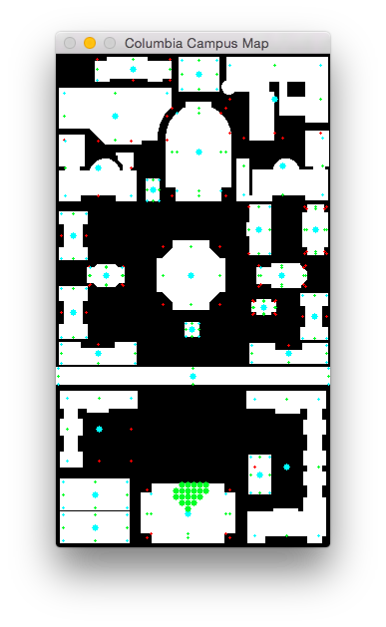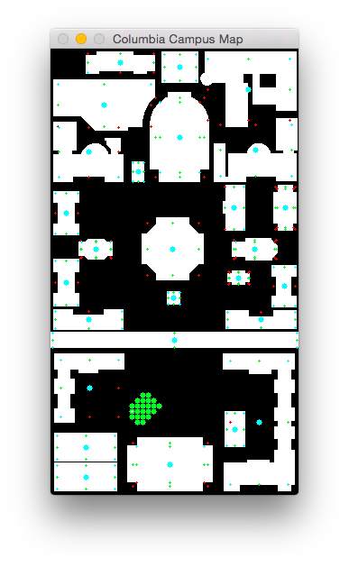

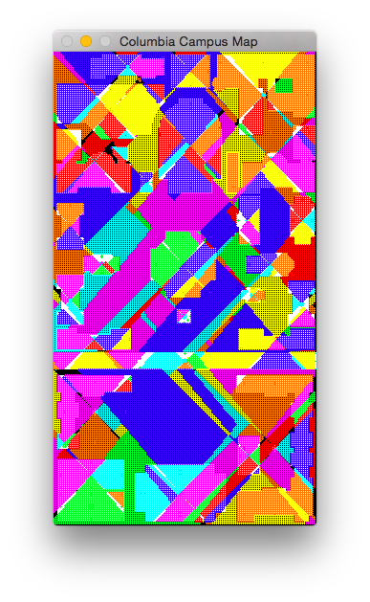

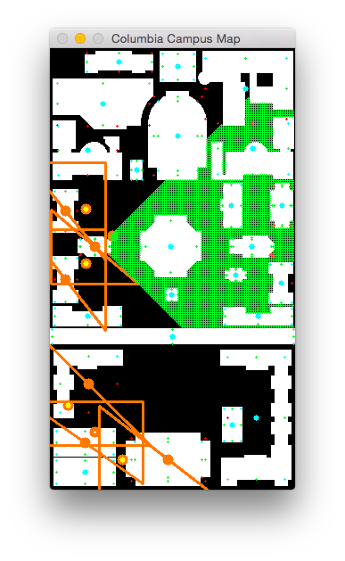

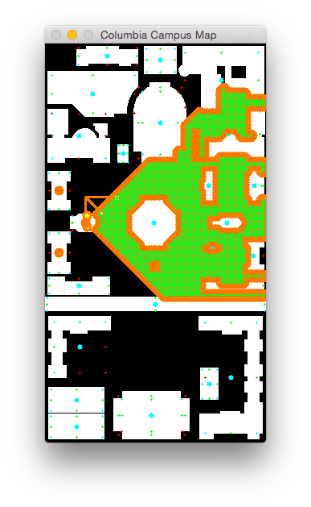

Source:

Click (70,210) is east of the small, cross-shaped, central campus structure (Earl Hall), east of the more northern, middling-sized, I-shaped, westernmost structure (Mathematics), and west of the large, squarish cross-shaped, central campus structure (Low Library).

Size of cloud: 674 (recursive calls: 419)

Target:

Click (50,430) is inside and to the north of and east of the middling-sized, rectangular, westernmost, lower campus structure (Lerner Hall), south of the large, L-shaped, westernmost, lower campus structure (Journalism & Furnald), and west of the colossal, cross-shaped, southernmost structure (Butler Library).

Size of cloud: 2 (recursive calls: 5)

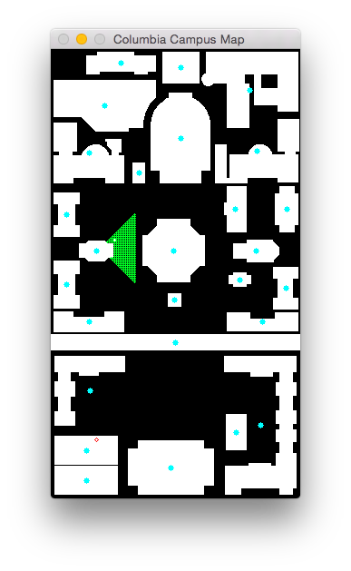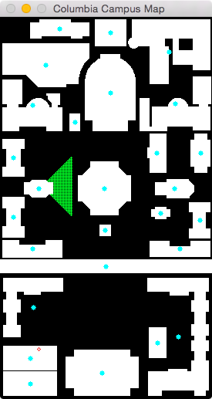

Source:

Click (70,210) is east of the small, cross-shaped, central campus structure (Earl Hall), east of the more northern, middling-sized, I-shaped, westernmost structure (Mathematics), and west of the squarish cross-shaped structure (Low Library).

Size of cloud: 674 (recursive calls: 419)

Target:

Click (50,430) is inside and to the north of and east of the middling-sized, rectangular, westernmost, lower campus structure (Lerner Hall), south of the L-shaped structure (Journalism & Furnald), and west of the colossal, cross-shaped, southernmost structure (Butler Library).

Size of cloud: 2 (recursive calls: 5)

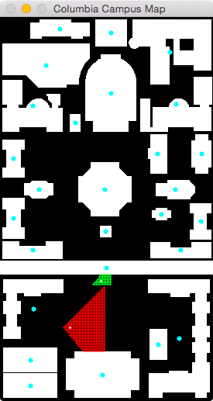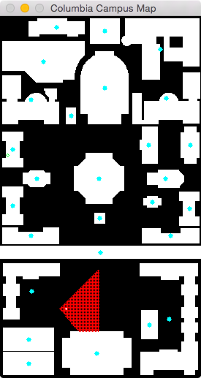

Source:

Click (10,190) is inside and to the south of and west of the more northern, middling-sized, I-shaped, westernmost structure (Mathematics), west of the small, cross-shaped, central campus structure (Earl Hall), and north of the more southern, middling-sized, I-shaped, westernmost structure (Lewisohn).

Size of cloud: 2 (recursive calls: 5)

Target:

Click (90,400) is east of the L-shaped structure (Journalism & Furnald), east of the middling-sized, rectangular, westernmost, lower campus structure (Lerner Hall), and north of the colossal, cross-shaped, southernmost structure (Butler Library).

Size of cloud: 1360 (recursive calls: 779)

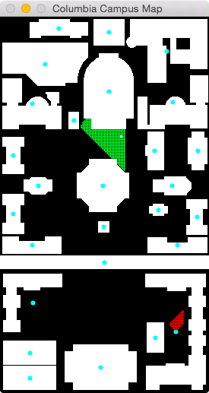

Source:

Click (159,157) is west of the middling-sized, almost rectangular, central campus structure (Avery), south of the colossal, bell-shaped, upper campus structure (Gymnasium & Uris), and east of the tiny, rectangular, upper campus structure (Computer Center).

Size of cloud: 826 (recursive calls: 510)

Target:

Click (230,403) is north of the southeast corner structure (Hamilton, Hartley, Wallach & John Jay), east of the small, rectangular, lower campus structure (Lion's Court), and east of the colossal, cross-shaped, southernmost structure (Butler Library).

Size of cloud: 130 (recursive calls: 94)

PART 4

FRIEND 1:

PARENS: S1G1 – S4G4

NO PARENS: S5G5 – S8G8

FRIEND 2:

NO PARENS: S1G1 – S4G4

PARENS: S5G5 – S8G8

Bug:

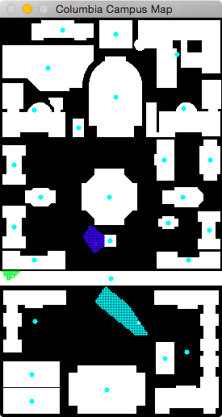Source:

Click (15,320) is inside and to the west of the midsized, U-shaped, westernmost structure (Dodge), south of the more southern, midsized, I-shaped, westernmost structure (Lewisohn), and north of the L-shaped structure (Journalism & Furnald).

Size of cloud: 78 (recursive calls: 65)

214,49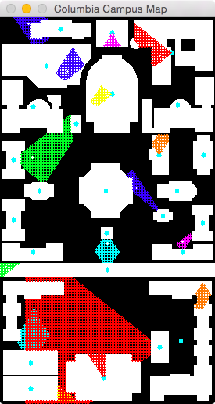

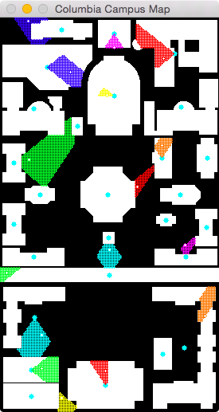

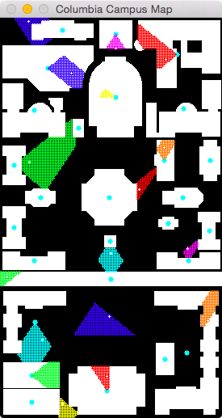

Source:

Click (8,320) is INSIDE and to the WEST of the longest structure (College Walk), WEST of the midsized, U-shaped, westernmost structure (Dodge), and SOUTH of the more southern, midsized, I-shaped, westernmost structure (Lewisohn).

Size of cloud: 142 (recursive calls: 98)

Target:

Click (205,51) is INSIDE and to the WEST of the northeast corner structure (Mudd, Engineering Terrace, Fairchild & Computer Science), NORTH of the large, irregularly shaped, easternmost, upper campus structure (Schermerhorn), and EAST of the midsized, square, northernmost structure (Schapiro CEPSR).

Size of cloud: 492 (recursive calls: 318)

Source:

Click (35,4) is WEST of the midsized, irregularly shaped, northernmost structure (Pupin), and NORTH of the colossal, irregularly shaped, westernmost, upper campus structure (Physical Fitness Center).

Size of cloud: 306 (recursive calls: 219)

Target:

Click (137,291) is SOUTH of the smallest structure (Alma Mater), and NORTH of the longest structure (College Walk).

Size of cloud: 316 (recursive calls: 201)

Source:

Click (78,477) is to the EAST of the southwest corner structure (Carman), SOUTHEAST of the midsized, rectangular, westernmost, lower campus structure (Lerner Hall), and WEST of the colossal, cross-shaped, southernmost structure (Butler Library).

Size of cloud: 174 (recursive calls: 115)

TARGET:

Click (257,374) is inside and to the NORTH of the southeast corner structure (Hamilton, Hartley, Wallach & John Jay), NORTHEAST of the small, rectangular, lower campus structure (Lion's Court), and EAST of the longest structure (College Walk).

Size of cloud: 282 (recursive calls: 195)

SOURCE:

Click (232,285) is NORTH of the midsized, U-shaped, easternmost structure (Kent), and SOUTHWEST of the midsized, I-shaped, easternmost structure (Philosophy).

Size of cloud: 94 (recursive calls: 74)

TARGET:

Click (36,178) is EAST of the more northern, midsized, I-shaped, westernmost structure (Mathematics), and NORTH of the small, cross-shaped, central campus structure (Earl Hall).

Size of cloud: 1360 (recursive calls: 788)

SOURCE:

Click (132,443) is INSIDE and to the NORTH of the colossal, cross-shaped, southernmost structure (Butler Library), WEST of the small, rectangular, lower campus structure (Lion's Court), and EAST of the midsized, rectangular, westernmost, lower campus structure (Lerner Hall).

Size of cloud: 198 (recursive calls: 141)

TARGET:

Click (88,68) is INSIDE and to the EAST of the colossal, irregularly shaped, westernmost, upper campus structure (Physical Fitness Center), SOUTH of the midsized, irregularly shaped, northernmost structure (Pupin), and WEST of the colossal, bell-shaped, upper campus structure (Gymnasium & Uris).

Size of cloud: 498 (recursive calls: 304)

SOURCE:

Click (52,398) is SOUTH of the L-shaped structure (Journalism & Furnald), and NORTH of the midsized, rectangular, westernmost, lower campus structure (Lerner Hall).

Size of cloud: 590 (recursive calls: 359)

TARGET:

Click (134,97) is INSIDE and to the WEST of the colossal, bell-shaped, upper campus structure (Gymnasium & Uris), NORTHEAST of the tiny, rectangular, upper campus structure (Computer Center), and SOUTH of the midsized, square, northernmost structure (Schapiro CEPSR).

Size of cloud: 54 (recursive calls: 48)

SOURCE:

Click (203,160) is INSIDE and to the NORTH of the midsized, almost rectangular, central campus structure (Avery), SOUTH of the large, irregularly shaped, easternmost, upper campus structure (Schermerhorn), and WEST of the midsized, cross-shaped, easternmost structure (Fayerweather).

Size of cloud: 164 (recursive calls: 115)

TARGET:

Click (143,37) is INSIDE and to the SOUTH of the midsized, square, northernmost structure (Schapiro CEPSR), NORTH of the colossal, bell-shaped, upper campus structure (Gymnasium & Uris), and EAST of the midsized, irregularly shaped, northernmost structure (Pupin).

Size of cloud: 108 (recursive calls: 84)

SOURCE:

Click (135,369) is SOUTH of the longest structure (College Walk), and WEST of the small, rectangular, lower campus structure (Lion's Court).

Size of cloud: 750 (recursive calls: 458)

TARGET:

Click (172,212) is EAST of the squarish cross-shaped structure (Low Library), and SOUTHWEST of the midsized, almost rectangular, central campus structure (Avery).

Size of cloud: 182 (recursive calls: 135)

Final results:

ITINERARY 1

------

You are inside a building to the WEST.

------

Now go to the nearby building that is NORTH and WEST.

------

Now go to the nearby building that is NORTH.

------

Now go to the nearby building that is EAST.

------

Now go to the nearby building that is NORTH.

------

Now go to the nearby building that is NORTH.

------

Your final destination is inside this building. Go SOUTH.

------

Clicked location: (27,298)

Clicked location: (14,257)

Clicked location: (50,217)

Clicked location: (16,165)

Clicked location: (28,120)

Clicked location: (27,130)

Final destination: (205, 51)

Distance: 194.743420942

Good job! Next Itinerary!

------

ITINERARY 2

------

You are inside a building to the WEST.

------

Now go to the nearby building that is SOUTH.

------

Now go to the nearby building that is SOUTH.

------

Now go to the nearby building that is WEST.

------

Now go to the nearby building that is SOUTH.

------

Your final destination is inside this building. Go SOUTH.

------

Clicked location: (61,54)

Clicked location: (122,97)

Clicked location: (97,138)

Clicked location: (121,222)

Clicked location: (121,231)

Final destination: (137, 291)

Distance: 62.096698785

Good job! Next Itinerary!

------

ITINERARY 3

------

You are inside a building to the EAST.

------

Now go to the nearby building that is EAST.

------

Now go to the nearby building that is EAST.

------

Your final destination is inside this building. Go NORTH and WEST.

------

Clicked location: (112,464)

Clicked location: (205,469)

Clicked location: (197,460)

Final destination: (257, 374)

Distance: 104.861813831

Good job! Next Itinerary!

------

Parens

ITINERARY 1

------

You are inside a building (the longest structure) to the WEST.

------

Now go to the nearby building that is NORTH and WEST (the smallest structure).

------

Now go to the nearby building that is NORTH (the squarish cross-shaped structure).

------

Now go to the nearby building that is EAST (the midsized, almost rectangular, central campus structure).

------

Now go to the nearby building that is NORTH (the large, irregularly shaped, easternmost, upper campus structure).

------

Now go to the nearby building that is NORTH (the northeast corner structure).

------

Your final destination is inside this building. Go SOUTH within the building.

------

Clicked location: (138,274)

Clicked location: (153,216)

Clicked location: (231,219)

Clicked location: (227,121)

Clicked location: (205,44)

Clicked location: (153,90)

Final destination: (205, 51)

Distance: 65.0

Good job! Next itinerary! Click any white space to begin.

------

ITINERARY 2

------

You are outside. Go to the nearby building that is EAST (the midsized, irregularly shaped, northernmost structure).

------

Now go to the nearby building that is SOUTH (the colossal, bell-shaped, upper campus structure).

------

Now go to the nearby building that is SOUTH (the midsized, almost rectangular, central campus structure).

------

Now go to the nearby building that is WEST (the squarish cross-shaped structure).

------

Now go to the nearby building that is SOUTH (the smallest structure).

------

Your final destination is inside this building. Go SOUTH within the building.

------

Clicked location: (73,7)

Clicked location: (132,93)

Clicked location: (220,219)

Clicked location: (148,204)

Clicked location: (136,275)

Final destination: (137, 291)

Distance: 16.0312195419

Good job! Next itinerary! Click any white space to begin.

------

ITINERARY 3

------

You are outside. Go to the nearby building that is WEST (the southwest corner structure).

------

Now go to the nearby building that is EAST (the colossal, cross-shaped, southernmost structure).

------

Now go to the nearby building that is EAST (the southeast corner structure).

------

Your final destination is inside this building. Go NORTH and WEST within the building.

------

Clicked location: (45,440)

Clicked location: (122,468)

Clicked location: (218,473)

Final destination: (257, 374)

Distance: 106.404887106